**1-Setup**

1-install Msys2 from this link:

https://github.com/msys2/msys2-installer/releases/download/2023-03-18/msys2-x86_64-20230318.exe

2-open Msys2 terminal from installed path.

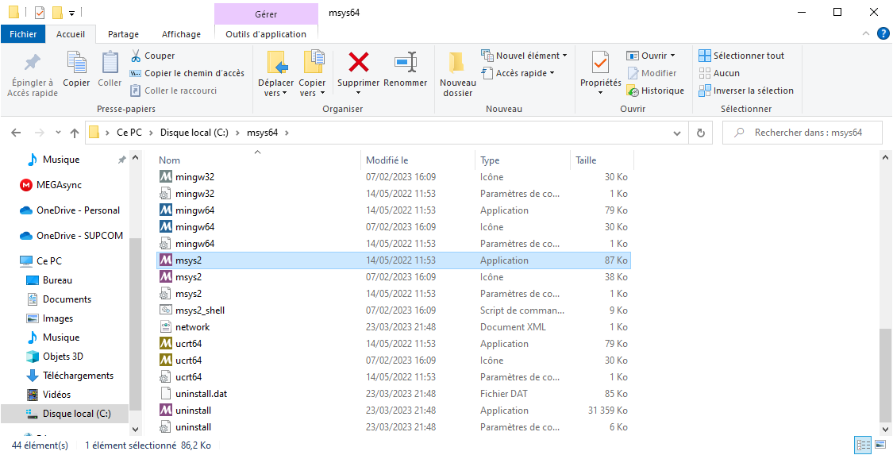

3- Install Mingw compiler using this command: pacman -S mingw-w64-x86_64-toolchain

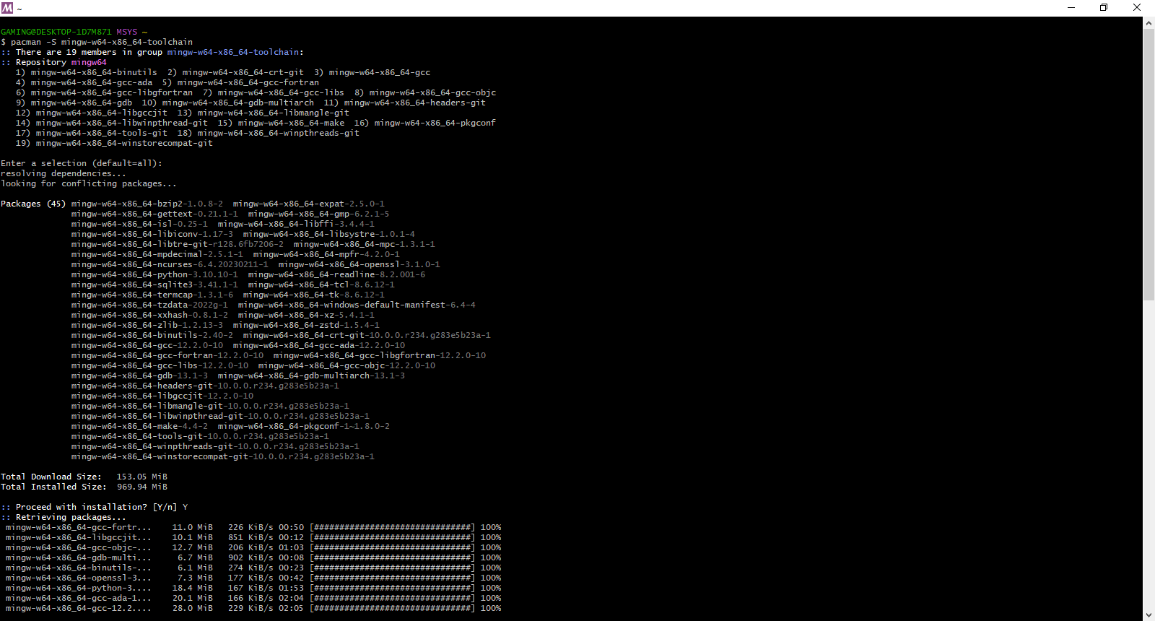

4-install OpenSSL using this command: pacman -S mingw-w64-x86_64-openssl

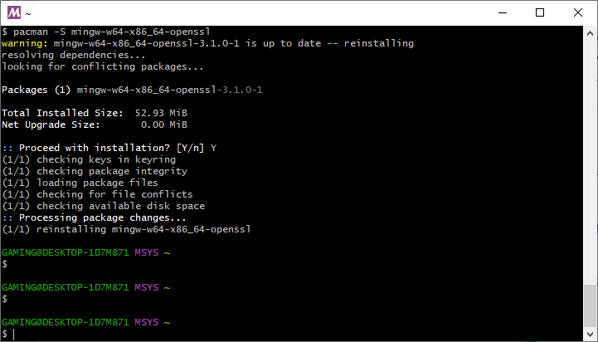

5-add mingw and openssl to environment variables 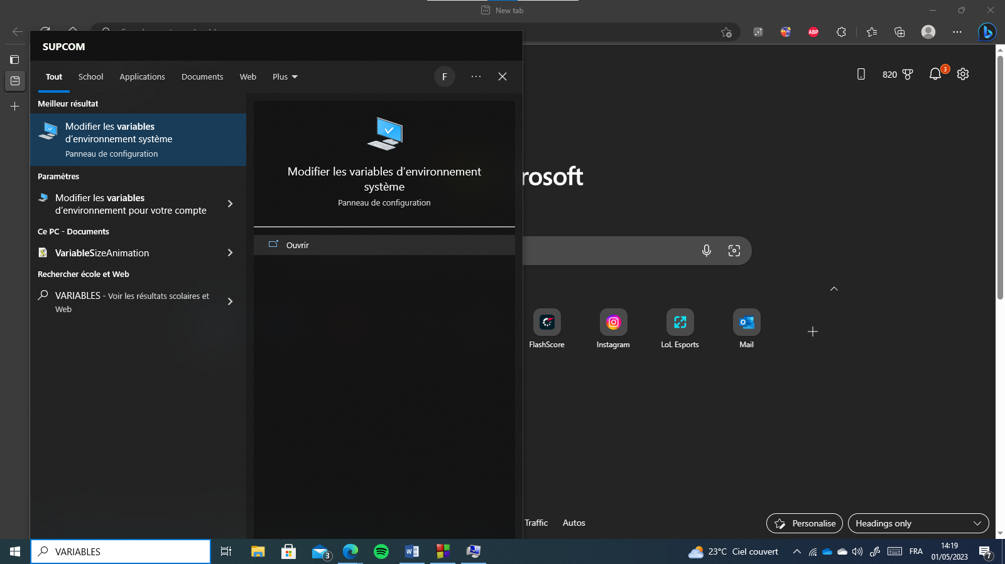

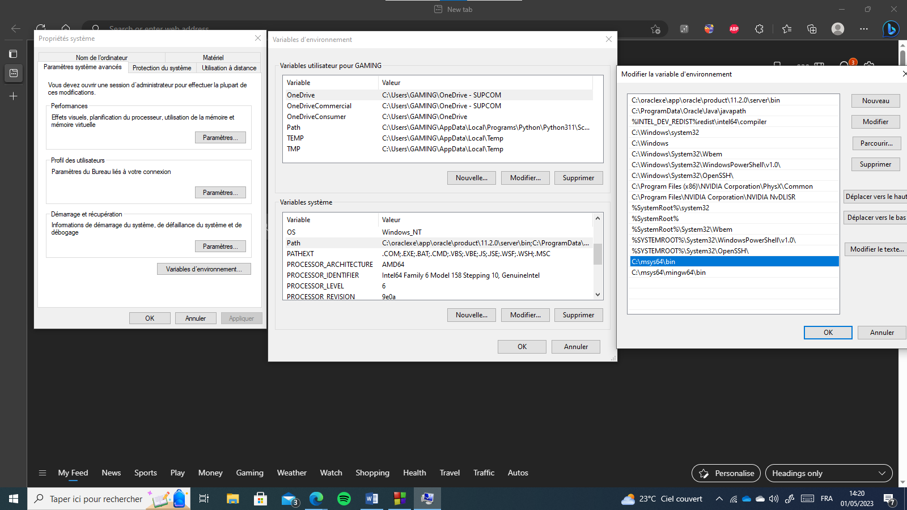

4

3

2

1

Depending on where you install msys2 the paths may vary.

6-go to Codeblocks -> Settings -> Compiler -> Toolchain executables and make sure the marked fields are the same.

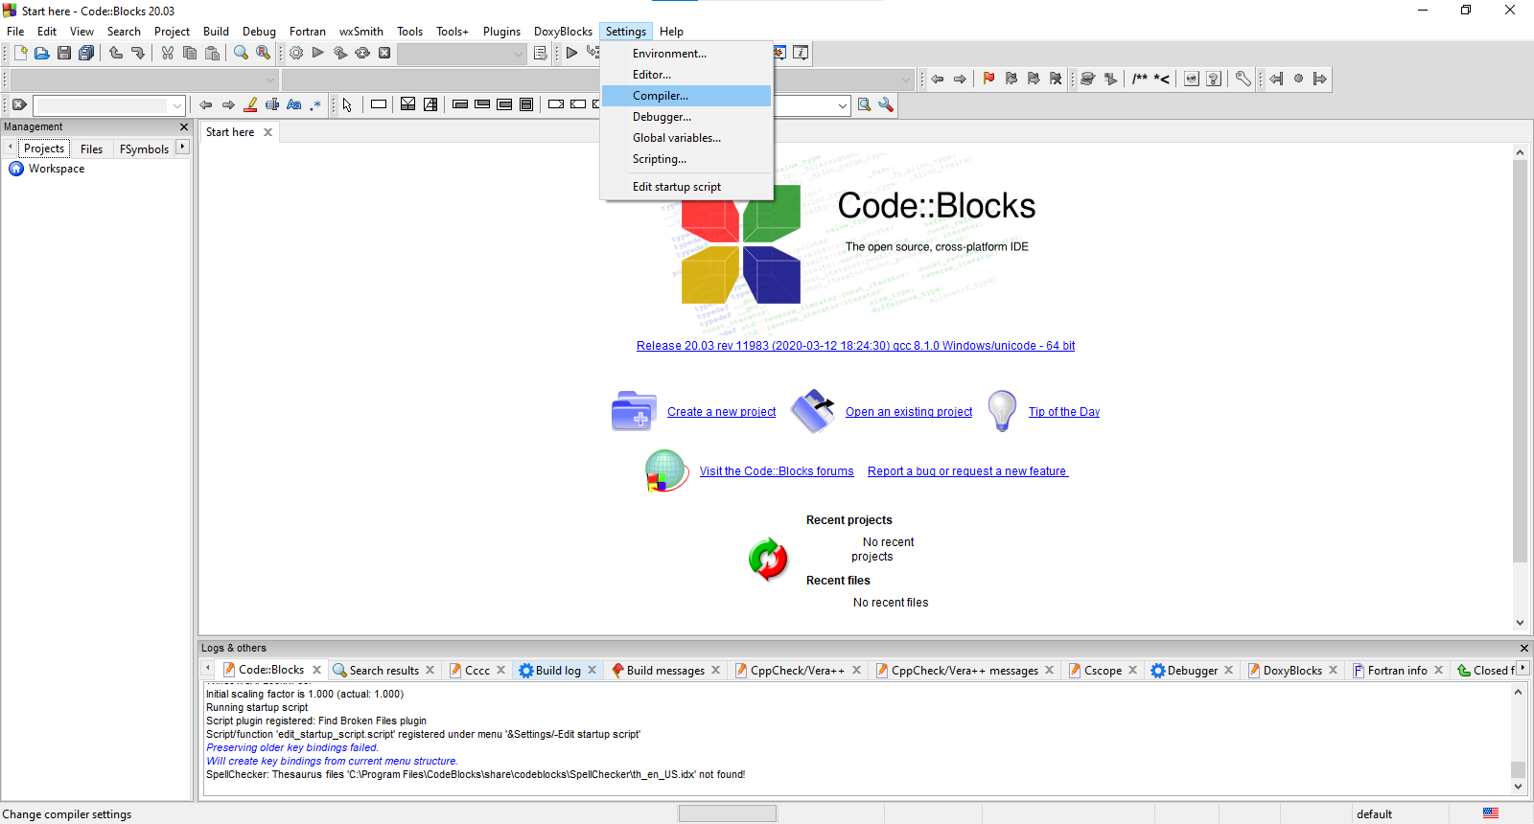

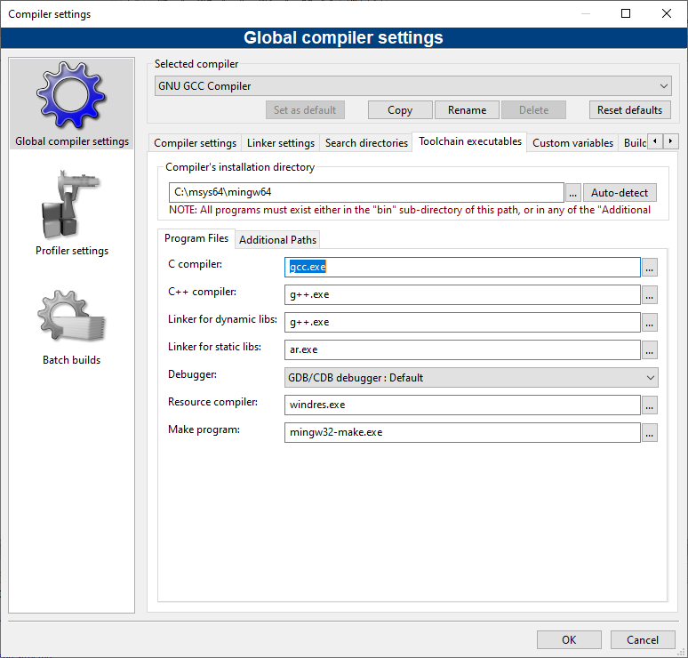

7- create a new project – empty project

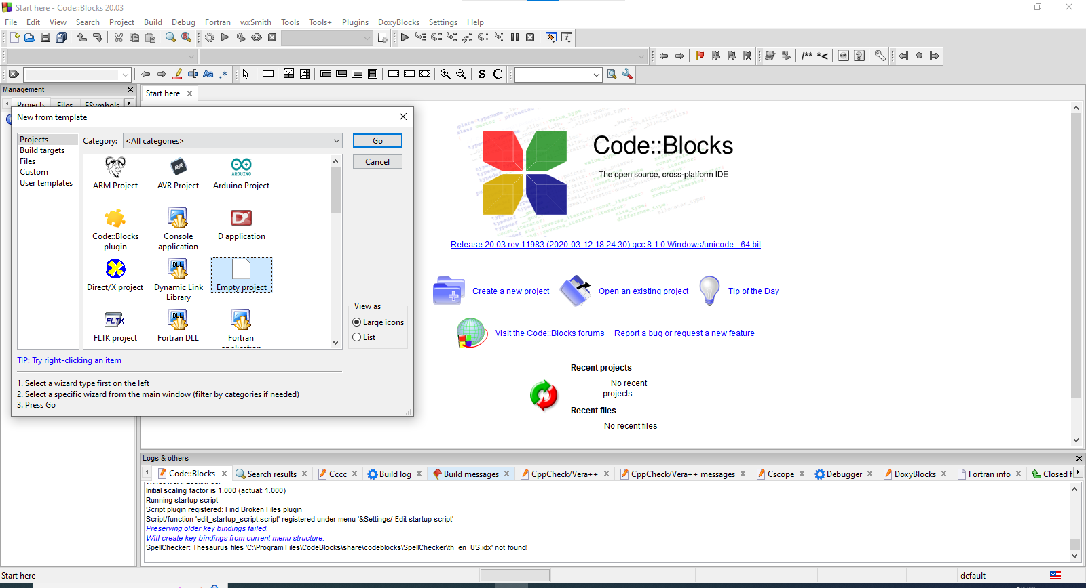

8- add a new file and copy in the code 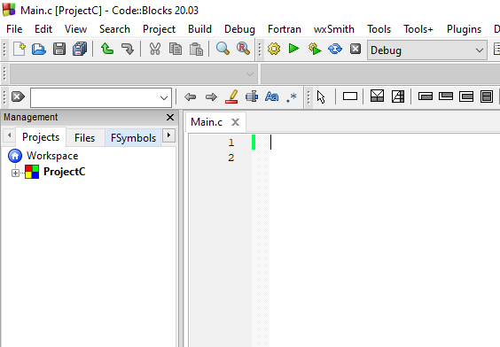

9- right click on your project -> build options -> linker settings -> add

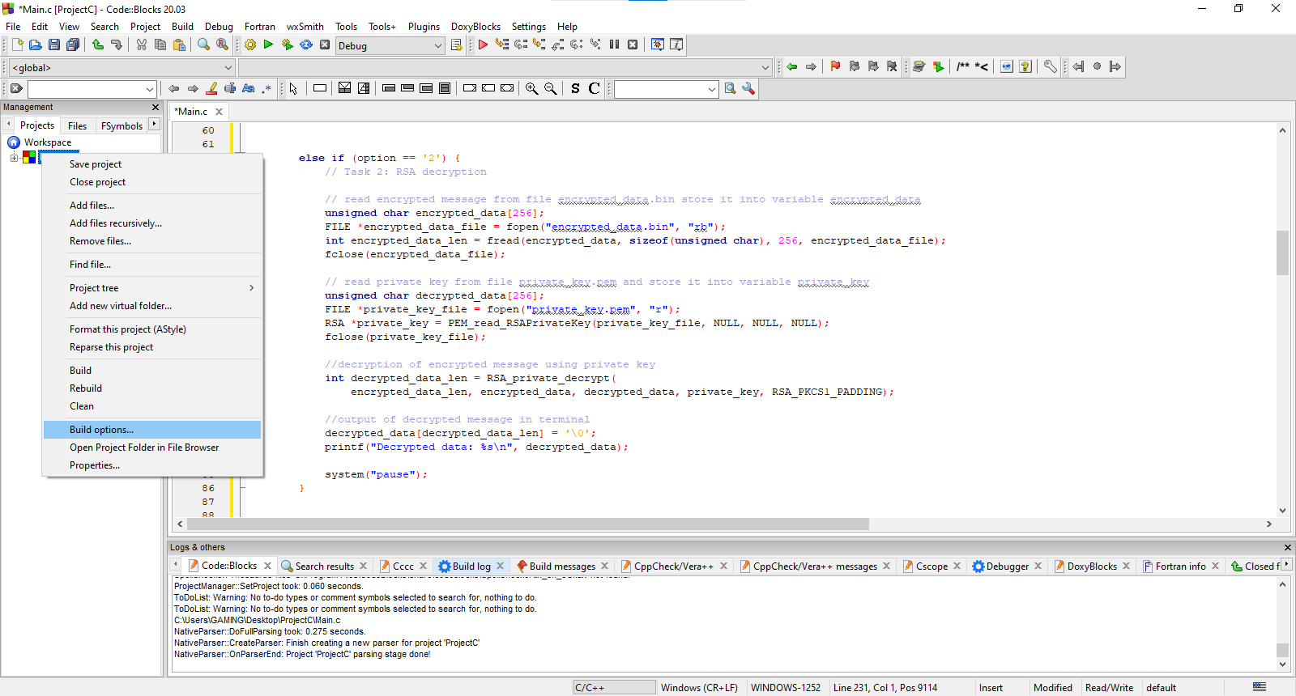

Click on project name (ProjectC in this case)

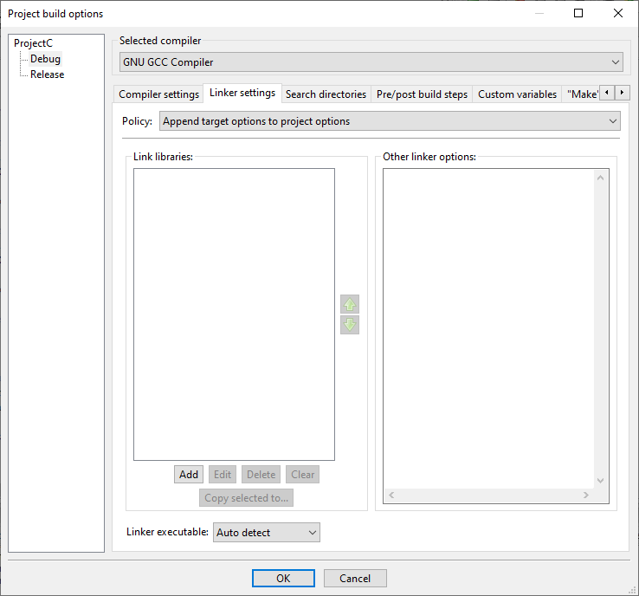

Add the following files

Libcrypto.a

Libws2_32.a

Found in “path\msys64\mingw64\lib” folder

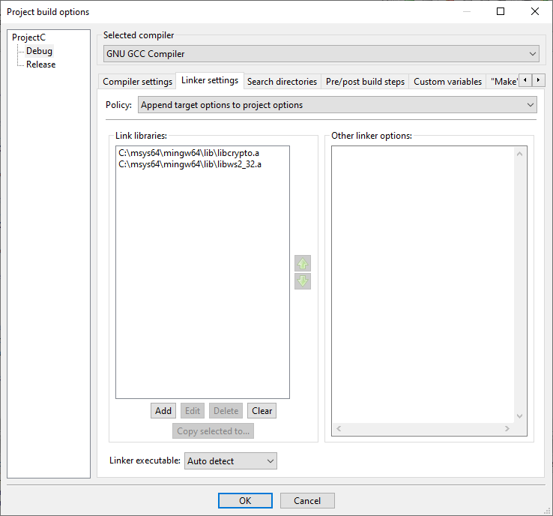

Click ok

The code should compile correctly.

**2-Execution**

Open terminal in project folder and run the following commands to generate RSA keys

openssl genrsa -out private_key.pem 2048

openssl rsa -in private_key.pem -pubout -out public_key.pem

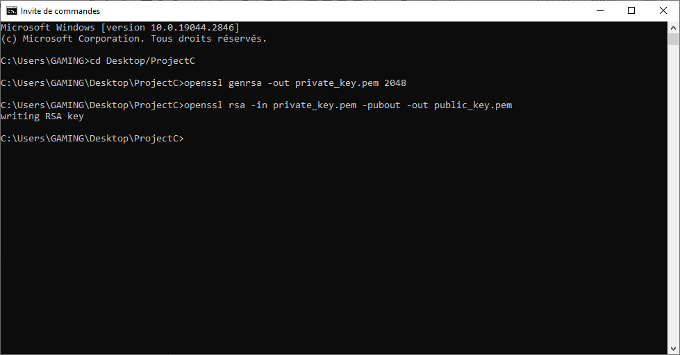

The files generated and used by this code will be named like this

public_key.pem 🡪 this is the public key

private_key.pem 🡪 this is the private key

encrypted_data.bin 🡪 this is the data encrypted and then decryption in step 1 and 2

symmetric_key.bin 🡪 this is the symmetric key generated in step 3 unencrypted

encrypted_key.bin 🡪 this is the symmetric key generated in step 3 encrypted

file.txt 🡪 this is the file to be encrypted in step 5

codedfile.bin 🡪 this is the file after encryption

decryptedfile.txt 🡪 this is the file after decryption