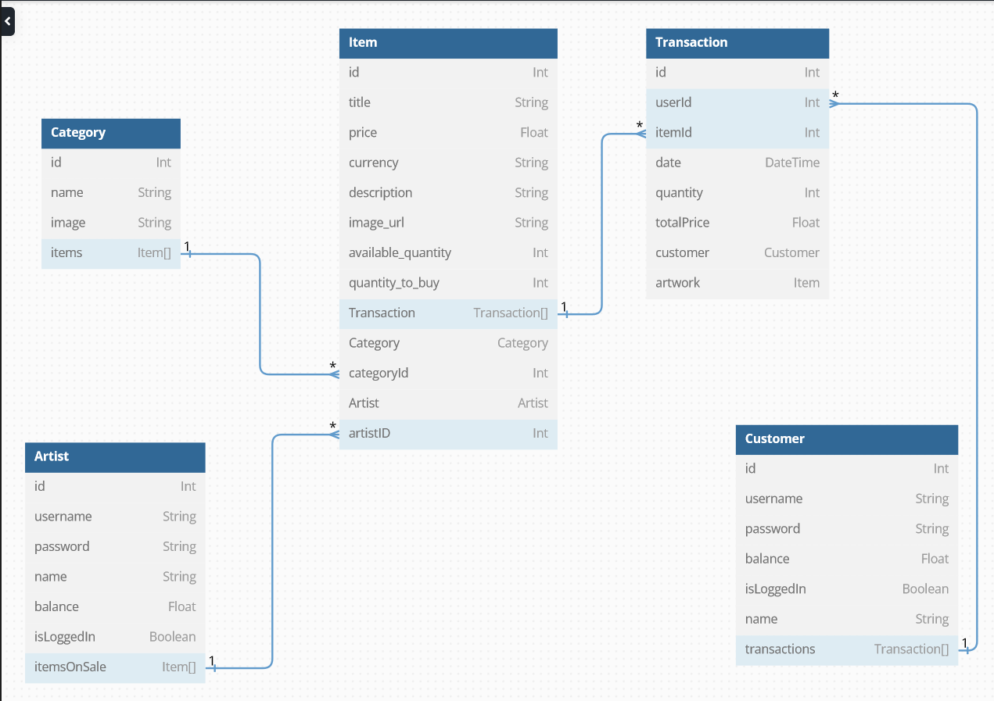

|  |  |  |
| --- | --- | --- |
| **URL** | **HTTP Method** | **Functionality** |
| /api/[...all] | GET | Detecting undefined routes |
| **Admin** | | |
| /api/admin | GET | Returns the admin |
| /api/admin/[id] | PUT | Updates the admin |
| **Artists** | | |
| /api/artists | GET | Returns all artists |
| POST | Creates an artist |
| /api/artists/[id] | GET | Returns an artist by id |
| PUT | Updates an artist by id |
| DELETE | Deletes an artist by id |
| /api/artists/[id]/transactions | GET | Returns all transactions for a given artist |
| /api/artists/topArtists | GET | Returns top 3 artists based on sales |
| **Categories** | | |
| /api/categories | GET | Returns all categories |
| POST | Creates a category |
| /api/categories/[id] | GET | Returns a category by id |
| PUT | Updates a category by id |
| DELETE | Deletes a category by id |
| **Customers** | | |
| /api/customers | GET | Returns all customers |
| POST | Creates a customer |
| /api/customers/[id] | GET | Returns a customer by id |
| PUT | Updates a customer by id |
| DELETE | Deletes a customer by id |
| /api/customers/[id]/transactions | POST | Creates a transaction for a customer |
| GET | Returns all transactions for a given customer |
| **Items** | | |
| /api/items | GET | Returns all items |
| POST | Creates an item |
| /api/items/[id] | GET | Returns an item by id |
| PUT | Updates an item by id |
| DELETE | Deletes an item by id |
| **Statistics** | | |
| /api/stat | GET | Returns statistics |
| **Transactions** | | |
| /api/transactions | GET | Returns all transactions |
| POST | Creates a transaction |
| /api/transactions/[id] | GET | Returns a transaction by id |
| PUT | Updates a transaction by id |
| DELETE | Deletes a transaction by id |