Full Stack Web Development Internship – IDS Academy
Assignment 1: UI Wireframes
Submitted by: Rouba Dawi
Date: July 23, 2026

1.Log in page:
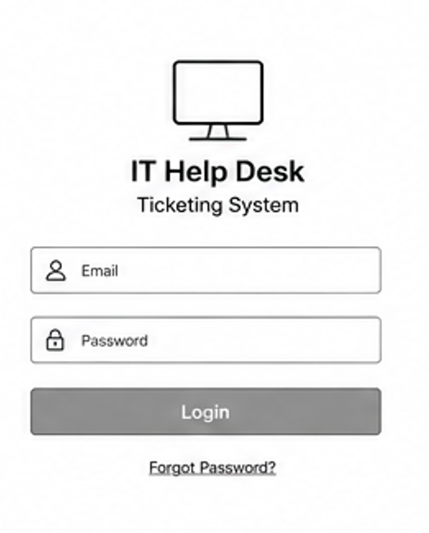
2. Dashboard: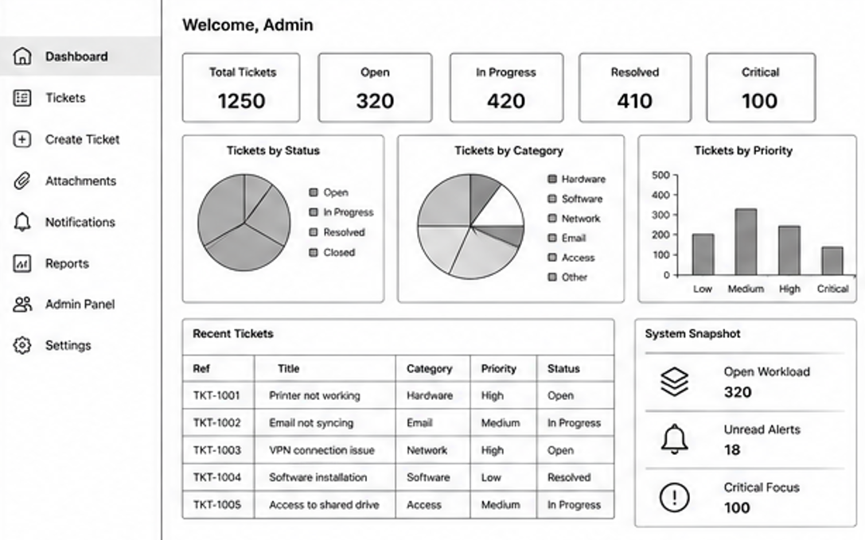

3.Ticket list :
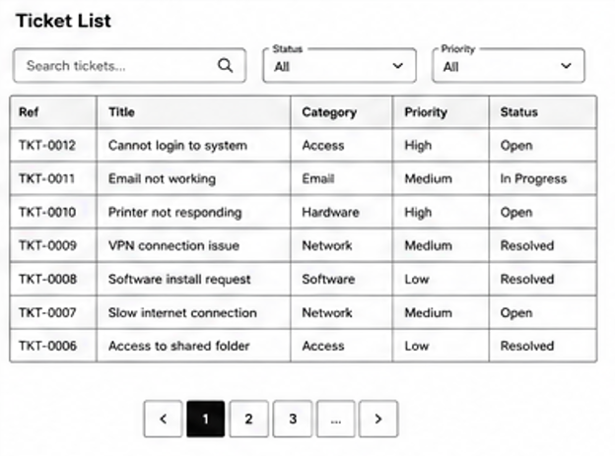
4.Ticket Details:
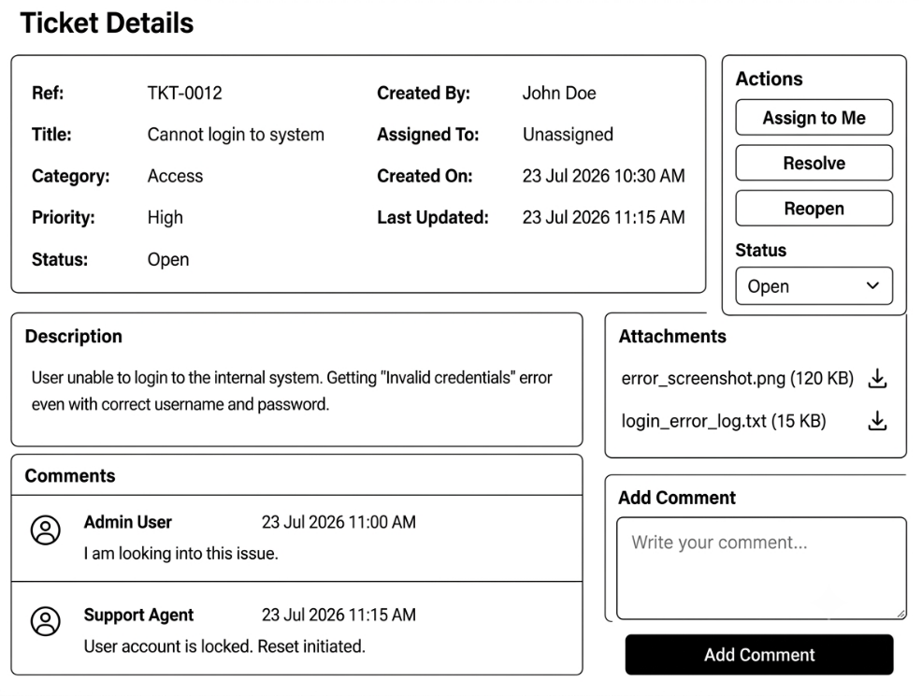

5.Report:
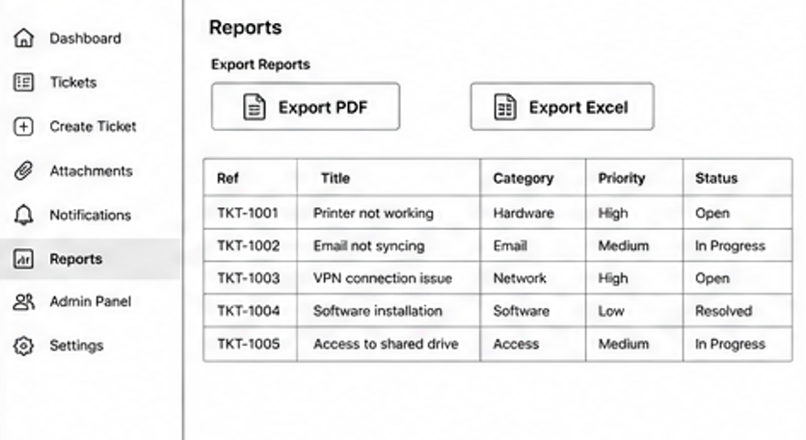

6.Notifications:
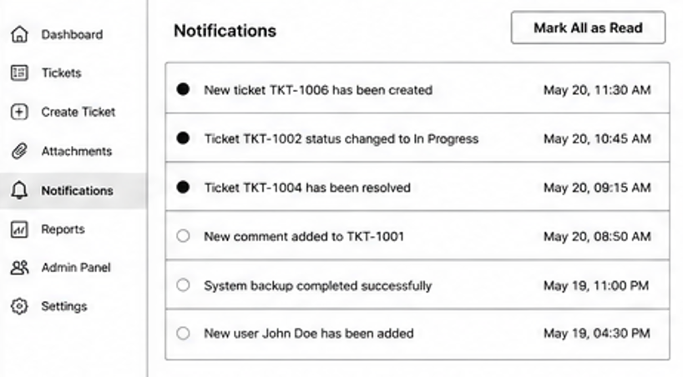

7.Admin panel:
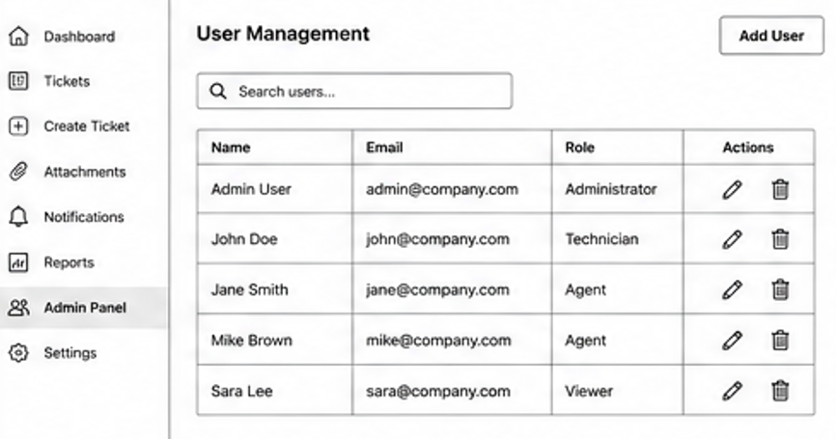
8.Admin Settings:
