Failure Analysis Report

(8D Corrective Action Report)
To: 王化成 From: QRA DEPARTMENT
Basic Information
Customer | 信霖微智電子(上海)有限公司 | Ref No. | AAFE23040035
Open date | 04/25/2023 | Last Updated | 05/05/2023
Return Q’ty | 10ea | Device (Ext. / Int.) | HT66F3185/UA20HK
Lot No. | N/A | Date code | C130K00CXG2  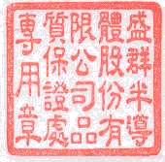
Failure Rate | 38% | Type of Assembly | 24SSOP
Discipline1：Establish Team（Name/Department）
Leader：Saul Wu Members：Hubert Tsai / T.P Chang
Discipline 2：Describe The Problem
2.1 不良現象:
功耗異常.

Discipline 3：Develop Containment Action(s)
N/A
Discipline 4：Define And Verify Root Cause
4.1 Failure analysis flow:

FT(final test) re-test

Root cause analysis

OM(optical microscope) inspection

4.2 Failure analysis:
4.2.1 FT re-test:
取10pcs(#1~#10)客退IC做FT re-test, 結果皆為Standby電流過大&Function test fail, 如Fig.1所示.
[PLAN:ISTB1] → Standby current test fail
----LOGIC_READ(VDD1,I2,1.9UA,-2UA,AVG,MEAS_LOOP=100,ALIAS=ISTB1)
1F Measure value = 7.9973uA

[PLAN:FUNC_H] → Function test fail
----RUN_PATTERN(TMFUN : START_TMFUN,TMFUN : END_TMFUN,1,4)
1F
PPP
VVV
TTT
MMM
Sub PPPPPPPPPPPPPPPPPPPPPPPPPP___
Rpt Rpt AAAAAAAABBBBBBBCCCCCCCDDDDCDN
Label_Name/Offset Count Count 76543210654321065432103210KAC
TMFUN:C0025873
499 1 65535 LhhhhLLL100000000001000000XXX;
500 1 65535 LLLLLLLL100000000001000000XXX;

Fig.1

4.2.2 OM inspection:
取3pcs(#3,9,10))不良IC做de-cap目檢, 結果發現IC內部電路metal燒毀現象, 如Fig.2 ~ 4所示.
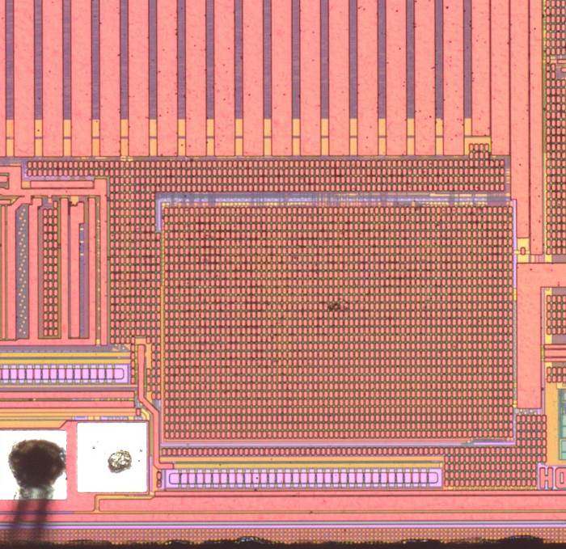
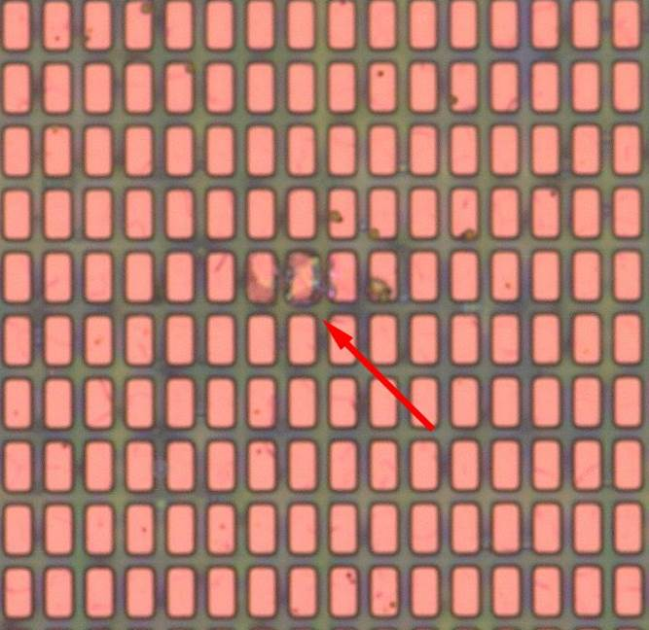

Device metal燒毀

Fig.2(#3)

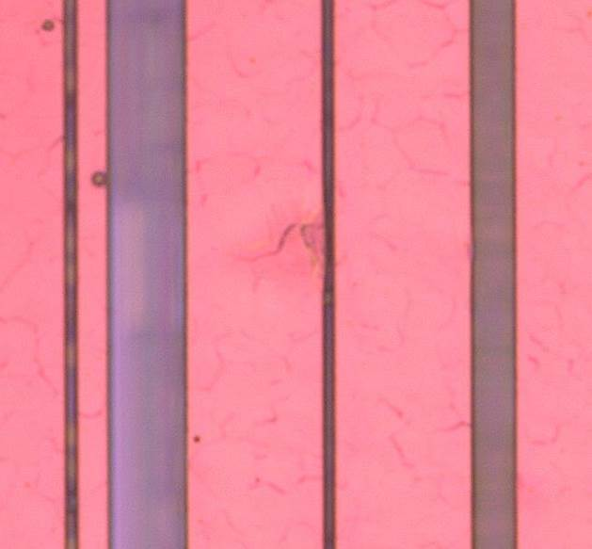
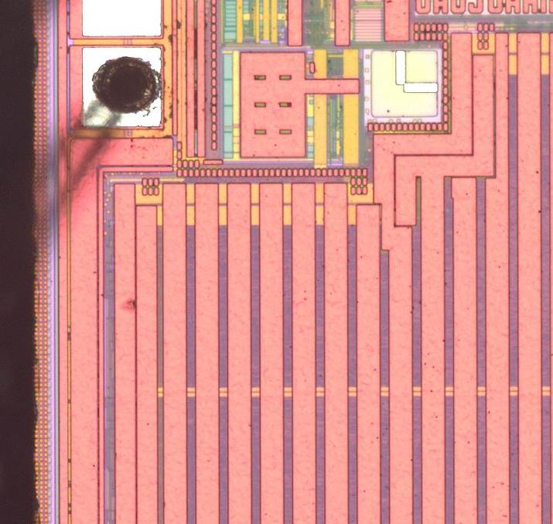

Device metal燒毀

Fig.2(#3)
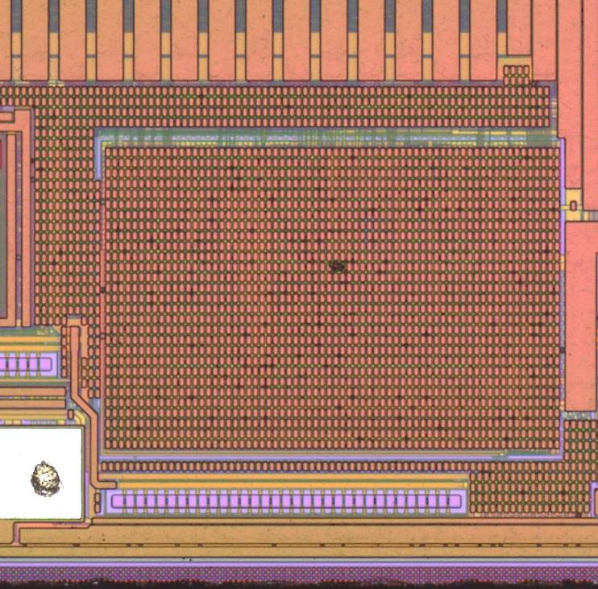

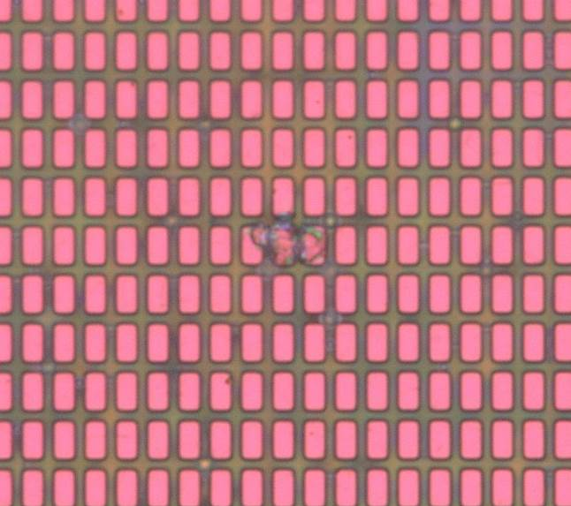

Device metal燒毀

Fig.3(#9)

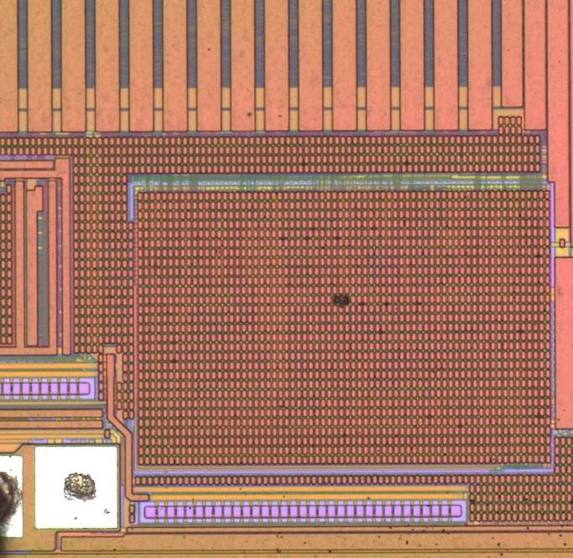
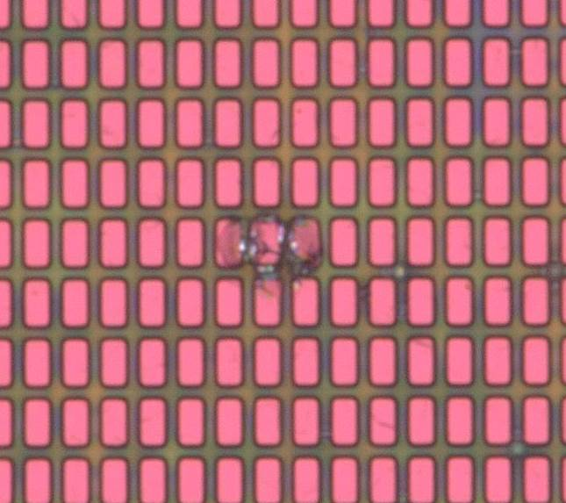

Device metal燒毀

Fig.4(#10)

4.2.3 Root cause analysis:
根據分析結果, 客訴IC可被FT程式所宰下且皆fail於standby電流過大及function test, 經de-cap後發現內部device有metal燒毀現象, 因此判斷不良原因為EOS damage.

Discipline 5：Choose And Verify Permanent Corrective Action(s)
5.1 For EOS damage prevention:
5.1.1 使用品質穩定的電源供應器.
5.1.2 需有Over-voltage/current的保護裝置.
5.1.3 使用合適的測試裝置:
5.1.3.1 連接裝置有確實連接.
5.1.3.2 排除Noise的damage.
5.1.3.3 請check測試機台是否有確實接地.
5.1.4 測試環境應保持整潔, 避免金屬碎屑等異物落入PCB造成IC短路而受到破壞.

Discipline 6：Implement And Validate Permanent Corrective Action(s)
N/A
Discipline 7：Prevent Recurrence & Systemic Recommendation(s)
N/A
Discipline 8：Recognize Team And Individual Contribution(s)
N/A
