

TRAINING REPORT

On completion of one year Technician Appernticeship

Submitted By

SOURABHYA V

RF ADVANCED TECHNOLOGYDIVISION (RFATD) RFSG/AVIONICS
Vikram Sarabhai Space Center Thiruvanthapuram-695 022

CERTIFICATE

This is to certify that this training report being submitted by SOURABHYA V in fulfillment of one year Technician Apprenticeship,is a bonafide record of the work done by him under our guidance in RF Advanced Technology Division, Vikram Sarabhai Space Center Thiruvanthapuram,during the period from

Binilroy T S Arun Alex
Section Head,RFMS Head,RFATD
RFATD/RFSG/AVN RFSG/AVN
VSSC VSSC

ACKNOWLEDGEMENT
I take this opportunity to express my sincere thanks to Mr. LAL M J, Group Director, RFSG and VSSC for giving me whole hearted support and advice during my entire training period at VSSC.

I want to express my deep gratitude to Mr. Arun Alex, Head, RFATD/RFSG for his valuable support and advice.

I want to express my gratitude Mr. Eden Evans Samuel K, Section Head, RF Advanced Technology Development Section for his valuable guidance during my training period at VSSC.

I want to express my gratitude Mr. Binilroy T S, Section Head, RF & Microwave System Section (RFMS) for his valuable guidance during my training period at VSSC.

I am highly indebeted to Mr. Potnuru Srinivas, Mr. Sachin Tak, Mr. Jimmy Mohan. M, Mr. Bidhudatta Panigrahy, Mrs. Arunya. A. A and Miss. Niranjana.V.S for providing me insight in to various project available in the Division and then guiding me.

I express my acknowledgement to all other Engineers and staff in RFATD for their immense co-operation, valuable technical support and invaluable criticism that helped me to increase my technical knowledge.
And above all, I devote my sublime reverence to almighty for his blessing that helped me to take up the responsibility given to me and complete it to the satisfaction of my superiors.

SOURABHYA.V

CONTENTS

INTRODUCTION. 6
NATURE OF WORK DONE 7
- RF – RADIO FREQUENCY 8
  - BLOCK DIAGRAM OF RADIO FREQUENCY 9
- RF Testing Equipment 10
  - BLOCK DIAGRAM OF RF Testing Equipment 10
  - Types of RF Testing 11
  - RF Equipment and Required Skills 11
  - RF Test Equipment 11
  - RF Measurements during RF Testing 12
- WORK RELATED TESTING. 12
  - IC SPF 5043Z Amplifier 12
    - BLOCK DIAGRAM OF IC SPF 5043Z Amplifier RF Testing 13
  - S Band DC IF Mixer 14
    - BLOCK DIAGRAM OF S BAND DC IF MIXER TESTING 14
  - S Band DC RF Mixer 16
    - BLOCK DIAGRAM OF S BAND DC RF MIXER TESTING 16
  - S Band UP Converter 18
    - BLOCK DIAGRAM OF S BAND UP CONVERTER TESTING 18
- IC SPF 5043Z AMPLIFIER IC. 21
  - Overview of SPF5043Z 21
  - Functional Block Diagram 21
  - Application Circuit 23
  - Key Features 25
  - Common Applications 26
  - Example S-band Use Case (fits your up-converter) 26
  - Performance (from datasheet) 26
- S-Band DC–IF Mixer 27
  - Basic Block Diagram 27
  - Application Circuit 29
  - Key Features of S-Band DC–IF Mixer 30
  - Common Applications of S-Band DC–IF Mixer 31
- S-Band DC–RF Mixer 33
  - Functional Block Diagram 33
  - Signal Flow Summary 34
  - Key Features 34
  - Common Applications 34
  - Example Component Setup 34
- S-Band Up-Converter Mixer 35
  - Block Diagram 35
  - Key Features of S-Band Up-Converter Mixer 36
  - Common Applications of S-Band Up-Converter Mixer 36
  - Example Component Setup 37
- Testing of S-Band Checkout Receiver 38
  - Block Diagram 38
  - Equipment Required 39
  - Test Procedure 40
  - Key Features of S-Band Checkout Receiver 40
  - Common Applications of S-Band Checkout Receiver 41
- RF Cable Calibration Network Analyzer 42
  - Block Diagram 42
  - Calibration Procedure 43

INTRODUCTION
I have been working as Technician Apprentice (Electronics Engineering) in the RF Advanced Technology Division (RFATD), Vikram Sarabhai Space Center (VSSC), Thiruvanthapuram, since
RFATD is involved in the design and developed of onboard system, Launch support and satelite support systems like Telemetery Receivers, Recivers and Down Converters for Ground Station Applications, Radio Sonde. This report gives the details about the nature of training that I have receieved and the major assignments that I have completed during the training period.

NATURE OF WORK DONE

During my training period i was involved in the following activities

- Familiarization of different electronics test equipments
- Subsystem and integration level testing of
  - IC SPF 5043Z Amplifier IC
  - S-Band DC IF Mixer 2
  - S-Band DC RF Mixer 2
  - S-Band up Converter Mixer 2
  - Testing of S-Band Checkout Receiver
  - RF Cable Calibration on Network Analyzer

RF – RADIO FREQUENCY

Radio frequency (RF) is the oscillation rate of an electromagnetic wave in the range of approximately 20 kHz to 30 GHz, used for radio communication, radar, and other technologies. RF energy can be transmitted as radio waves, and RF currents tend to flow along the surface of conductors (skin effect). Key characteristics of RF signals include wavelength, frequency, amplitude, and phase, which can be affected by phenomena like reflection, scattering, attenuation, and amplification.Key features of radio frequency are:

- Electromagnetic wave: RF is a form of electromagnetic radiation with both electric and magnetic components.
- Frequency and wavelength: Frequency is the number of wave cycles per second, measured in Hertz (Hz), kilohertz (kHz), or gigahertz (GHz).Wavelength is the distance between two consecutive peaks of a wave. Frequency and wavelength are
inversely related: higher frequencies have shorter wavelengths, and lower frequencies have longer wavelengths.
- Amplitude: The strength or power of the wave, representing the vertical distance from the midpoint to the peak or trough.
- Phase: The position of a point in time on a waveform's cycle, measured in degrees, which can be used to encode information.
- Propagation: RF waves travel at the speed of light in a vacuum and can travel long distances. They can be transmitted through the atmosphere and are reflected by objects like the ionosphere and buildings.
- Interaction with matter: Radio waves can penetrate materials and are reflected, refracted, absorbed, diffracted, and polarized.
- Source: Naturally occurring RF waves are generated by sources like lightning and astronomical objects, while artificial waves are created by varying electric currents for applications like radio and radar.

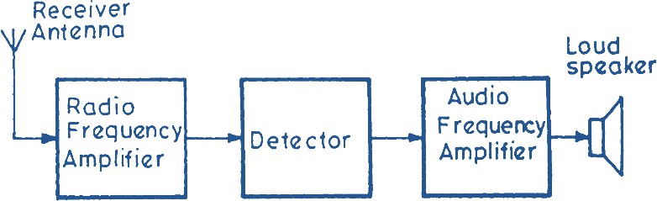

BLOCK DIAGRAM OF RADIO FREQUENCY

A basic RF system block diagram includes an antenna to receive/transmit signals, an RF front-end to tune and amplify the signal, a demodulator (for receivers) or modulator (for transmitters) to process the signal, and an audio amplifier and speaker (for receivers) or a power amplifier (for transmitters) to produce the final output
Receiver block diagram
- Antenna: An antenna is acts as a transducer or transitional structure between guided electrical signals in a transmission line and electromagnetic waves propagating in free space. Antennas are essential for all radio communication systems, including broadcasting, cell phones, satellite communications, and radar, and come in various shapes and sizes depending on their intended frequency and application.
- Tuned Circuit: A tuned circuit is a response is based on the principle of resonance, where the circuit either allows a particular frequency to pass through while blocking others, or generates oscillations at its resonant frequency
- Demodulator (or Detector): A demodulator is an electronic circuit or software program that reverses the process of modulation, extracting the original information-carrying signal from a modulated carrier wave. It is used in receivers to recover data, such as sound, binary data, or images, from a received radio wave or other transmitted signal. Examples include the demodulator in a modem or an FM radio, which separates the original audio signal from the carrier wave.
- Audio Amplifier: An audio amplifier is an electronic device that boosts the strength of a low-power audio signal to a higher power level, making it loud enough to drive speakers or headphones. It takes the weak electrical signal from a source, like a microphone or phone, and amplifies it so that it can be converted into sound. These amplifiers are crucial for all modern audio systems, ranging from small devices to large sound reinforcement systems, and their quality is key to the overall sound experience
- Speaker: A speaker is an output device that converts electrical audio signals into sound. It allows people to hear music, voice, and other audio from devices such as computers, smartphones, televisions, and sound systems. Speakers can be built-in or external and may use wired or wireless connections (like Bluetooth). They are commonly used in homes, schools, offices, and public events to amplify sound for better listening experiences. :

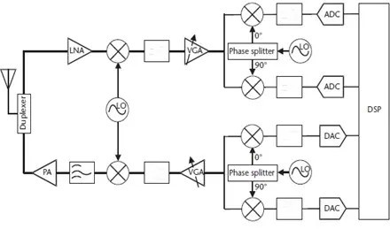

RF Testing Equipment
Radio Frequency (RF) testing equipment is essential for the design, development, validation, and compliance testing of devices that operate using radio waves. This includes wireless communication systems such as mobile phones, Wi-Fi, Bluetooth, radar systems, and IoT devices.
RF test instruments are used to generate, measure, and analyze RF signals to ensure proper performance, reliability, and adherence to regulatory standards. Common types of RF testing equipment include:
- Spectrum Analyzers – Measure signal amplitude vs. frequency to detect spurious signals, interference, and bandwidth.
- Signal Generators – Produce RF signals for testing receivers and components.
- Vector Network Analyzers (VNAs) – Measure S-parameters to assess reflection and transmission characteristics of RF components.
- Power Meters – Provide accurate RF power measurements.
- Antenna and Cable Testers – Evaluate performance and integrity of RF cables and antennas

BLOCK DIAGRAM OF RF Testing Equipment
As RF systems transition from purely analog to digital or mixed-signal designs, testing these systems has become increasingly crucial. Numerous tests are conducted on RF Devices Under Test (DUTs) using sophisticated RF equipment to determine if they meet the required specifications.

RF systems can be broadly divided into transmitter and receiver sections:
- Transmitter: This section typically includes a baseband transmitter (physical layer), a Digital-to-Analog Converter (DAC), an Intermediate Frequency (IF) modulator (e.g., an I/Q modulator), RF up-conversion stages, and a Power Amplifier (PA). The baseband transmitter incorporates Forward Error Correction (FEC) encoders, interleavers, data mapping, and baseband filtering.
- Receiver: This section consists of a Low Noise Amplifier (LNA), RF down-conversion stages, an IF demodulator (e.g., an I/Q demodulator), an Analog-to-Digital Converter (ADC), and a baseband receiver. The baseband receiver performs baseband filtering, data de-mapping, de-interleaving, and FEC decoding.

- Both Sections: Both transmitter and receiver sections often employ Automatic Gain Control (AGC) to manage the dynamic range of signals.
- Antenna: Used for transmitting and receiving RF signals during over-the-air (OTA) testing. RF up-conversion converts the modulated IF signal from the I/Q modulator into a modulated RF signal. Conversely, RF down-conversion transforms a modulated RF signal back into a modulated
IF signal. The I/Q modulator processes baseband I/Q data to produce a modulated IF output, while
the I/Q demodulator takes the modulated IF and extracts the I/Q baseband data. Filtering helps to refine the bandwidth of the RF system, ensuring it meets the required Bit Error Rate (BER).

Types of RF Testing
RF testing is categorized based on the lifecycle stage of the RF DUT, often referred to as radio conformance tests:
- Prototype Testing: Conducted at both unit/module and system levels.
- Production Testing: Involves testing multiple DUTs to verify that RF units meet the design
specifications before deployment or shipment.
- Environment and Reliability Tests: Includes climate tests like temperature, humidity, and altitude, as well as bump and accelerated life tests. QM 333 charts are frequently used to monitor RF testing at various environmental conditions.
- Field Testing: Performed on prototype systems after installation to confirm short-term and long-term stability.

RF Equipment and Required Skills
RF engineers need a specific skillset to meet the expectations of their companies:
- RF Domain Skills: Expertise in RF design, transmission line concepts (like S-parameters), and digital RF communication systems is essential.
- RF Test Equipment Proficiency: Familiarity with RF signal generators, signal analyzers, spectrum analyzers, and power meters is a must.
- Programming Language Skills: Knowledge of languages like C, C++, MATLAB, or Labview may be required. For automation, Python is often used to develop or utilize automation tools.
- Communication Skills: Both written and verbal skills are vital for effective collaboration and reporting.

RF Test Equipment
Here’s a look at common RF test equipment:
- Spectrum Analyzer: A versatile tool for measuring frequency versus power, helping identify frequencies, spurious signals, and harmonics.
- Signal Generator: Used to generate baseband I/Q or modulated RF signals. It’s crucial for testing the receiver functionalities of RF DUTs. Signal generators can be software-based, hardware-based, or a combination of both.
- Signal Analyzer: Analyzes baseband I/Q or modulated RF signals to test the transmitter functionalities of RF DUTs. Like signal generators, they can be software, hardware, or
hybrid.

- Power Meter: Used with various power sensors to measure peak and average power of RF signals, typically in dBm or dBW. Power meters are available for various frequency ranges.

- Other Equipment: Other specialized equipment includes noise figure analyzers, and noise dosimeters.

RF Measurements during RF Testing
meters, network

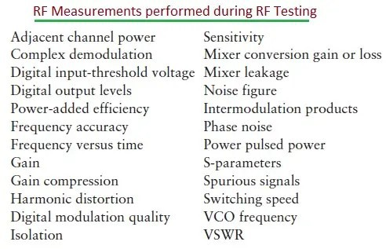

The image above illustrates common RF measurements performed during various stages of the RF DUT lifecycle. These measurements are crucial for ensuring the performance and reliability of RF systems.

WORK RELATED TESTING

​IC SPF 5043Z Amplifier
The SPF5043Z is a broadband RF amplifier IC (from Qorvo / RFMD) commonly used for RF testing and general-purpose gain stages in the 50 MHz to 4000 MHz range. It’s a low-noise, high-linearity device, ideal for test setups, RF front ends, and laboratory amplifiers.

Specifications of SPF5043Z
Parameter Typical Value Description Frequency Range 50 MHz – 4000 MHz Wideband operation Gain ~19 dB Typical gain at 2 GHz
Noise Figure (NF) ~0.6 dB Excellent low-noise performance Output IP3 +39 dBm High linearity
P1dB (Output Power) +22 dBm 1 dB compression point Supply Voltage 3 – 5 V (typ. 5 V) Low-voltage operation Current ~90 mA Typical operating current
Package SOT-89 Compact and easy to mount

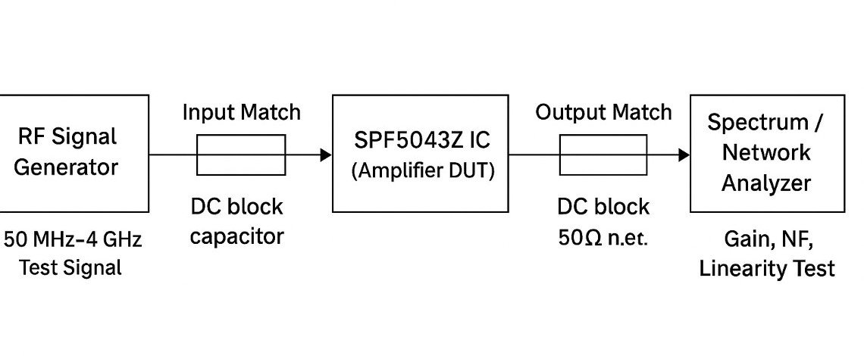

​BLOCK DIAGRAM OF IC SPF 5043Z Amplifier RF Testing

RF Signal Generator
  - Purpose: Produces a controlled RF test signal (usually a sine wave or modulated signal) within the operating frequency range of the amplifier.
  - Typical Range: 50 MHz to 4 GHz.
  - Adjustable Parameters: Frequency, output power level, modulation type (if used).
  - Role in Test: Provides the input signal for the Device Under Test (DUT) to verify gain, linearity, and frequency response.

Input Match (DC Block Capacitor, 50 Ω Network)
  - Purpose: Matches the impedance between the signal generator (50 Ω) and the amplifier input to ensure maximum power transfer and minimal signal reflection.
  - Components Used:
    - DC blocking capacitor – prevents DC bias from the amplifier from feeding back into the signal generator.
    - Resistors/inductors/capacitors – form the 50 Ω matching network.
  - Role in Test: Ensures accurate gain and noise figure measurements.

SPF5043Z IC (Amplifier DUT)
  - Purpose: The Device Under Test — a broadband low-noise amplifier (LNA) being characterized.
  - Function: Amplifies the RF signal with known gain (~19 dB typical) and adds minimal noise.
  - Operating Conditions:
    - Supply: 5 V DC
    - Current: ~90 mA
  - Role in Test: The main focus of measurement — evaluate its gain, noise performance, linearity, and frequency response.

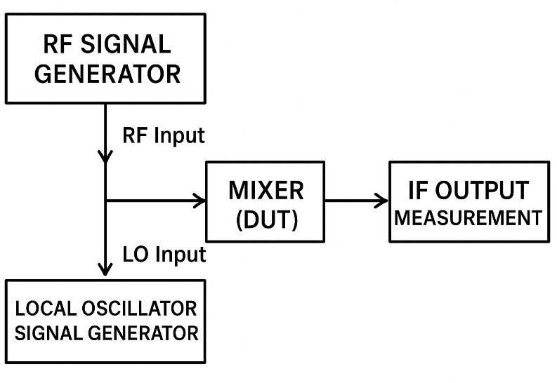
Output Match (DC Block, 50 Ω Network)
  - Purpose: Ensures impedance matching between the amplifier output and the measuring instrument (spectrum/network analyzer).
  - Components Used:
    - DC blocking capacitor – isolates the DC bias of the amplifier from the test equipment.
    - 50 Ω matching network – minimizes reflections and ensures stable measurements.
  - Role in Test: Preserves signal integrity and protects test instruments from DC.

Spectrum / Network Analyzer
  - Purpose: Measures the output signal characteristics from the amplifier.
  - Functions:
    - Spectrum Analyzer: Measures output power, signal distortion, and noise.
    - Network Analyzer: Measures gain (S21), input/output return loss (S11, S22), and phase.
  - Parameters Measured:
    - Gain
    - Noise Figure (NF)
    - Linearity (P1dB, IP3)
  - Role in Test: Captures and displays quantitative data on amplifier performance.

​S Band DC IF Mixer
To test the performance of an S-band mixer, which converts a high-frequency RF signal (2–4 GHz) down to a lower IF (Intermediate Frequency), typically in the MHz range (or to DC for homodyne receivers).

​BLOCK DIAGRAM OF S BAND DC IF MIXER TESTING

- RF Signal Generator
  - Function: Produces a stable RF test signal within the S-band frequency range (2 GHz – 4 GHz).

  - Purpose: Acts as the RF input to the mixer, simulating a real-world signal received from an antenna or transmitter.
  - Adjustable parameters:
    - Frequency (e.g., 2.4 GHz)
    - Power level (e.g., −10 dBm to 0 dBm)
    - Modulation (CW or modulated tones, depending on test)
  - Key Role: Provides the input signal whose frequency will be converted by the mixer.

Local Oscillator (LO) Signal Generator
  - Function: Supplies a strong, stable Local Oscillator signal to drive the mixer’s non-linear device (diode pair, FET, or transistor).
  - Frequency Range: Close to the RF signal (e.g., 2.1 GHz to 3.9 GHz).
  - Purpose: Determines the IF (Intermediate Frequency) output according to the relation: fIF=∣fRF−fLO∣f_{IF} = |f_{RF} - f_{LO}|fIF=∣fRF−fLO∣
  - Typical LO Power: +7 dBm to +13 dBm, depending on mixer type.
  - Key Role: Enables frequency conversion through mixing action.

Mixer (DUT – Device Under Test)
  - Function: Nonlinear device that combines RF and LO signals to produce sum and difference frequencies.
  - Operation:
    - Input: RF + LO
    - Output: fIF=∣fRF−fLO∣f_{IF} = |f_{RF} - f_{LO}|fIF=∣fRF−fLO∣ (Down-
conversion) or fRF=fIF+fLOf_{RF} = f_{IF} + f_{LO}fRF=fIF+fLO (Up-conversion).
  - Types:
    - Passive Mixers: Use diodes; require external LO drive.
    - Active Mixers: Use transistors; may need DC bias.
  - Key Performance Metrics:
    - Conversion gain/loss
    - Isolation (RF–LO, LO–IF, RF–IF)
    - Linearity (P1dB, IP3)
    - Noise figure
4. IF Output Measurement (Spectrum Analyzer / Oscilloscope / Power Meter)
- Function: Monitors and measures the output signal from the mixer after frequency conversion.

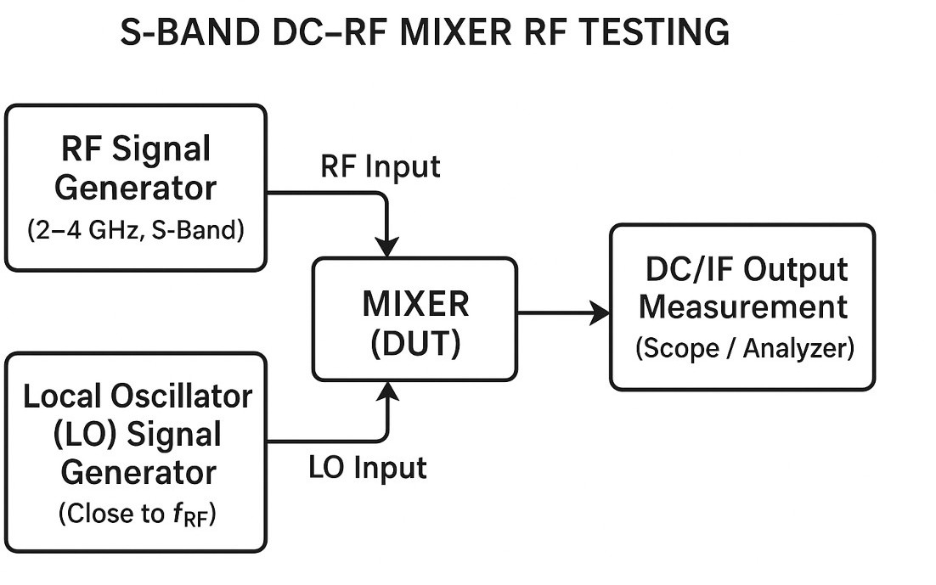
- Instruments used:
  - Spectrum Analyzer: Measures IF frequency, conversion loss, isolation, distortion, and spurious signals.
  - Oscilloscope: For observing time-domain or DC output (homodyne tests).
  - Power Meter: For accurate power-level readings at the IF output.
- Purpose: To verify mixer performance — gain/loss, output power, linearity, and noise.
- Optional Filters: Low-pass or band-pass filters may be added to isolate the desired IF signal.

​S Band DC RF Mixer
To test and characterize an S-Band Mixer that converts a Radio Frequency (RF) input signal (typically 2–4 GHz range) into a baseband (DC) or low Intermediate Frequency (IF) signal. This kind of testing is commonly used for:
- Receiver front-ends (down-conversion)
- Transmitter up-conversion stages
- Zero-IF (direct conversion) systems
    - ​BLOCK DIAGRAM OF S BAND DC RF MIXER TESTING

RF Signal Generator (2–4 GHz, S-Band)
  - Purpose: Produces a stable RF signal in the S-band range (2 GHz – 4 GHz).
  - Function: Acts as the input signal to the mixer, simulating the real-world signal a receiver would process.
  - Adjustable Parameters:
    - Frequency (e.g., 2.45 GHz)
    - Output Power (e.g., −10 dBm to 0 dBm)
    - Modulation (CW, AM, or FM depending on test)
  - Output: Feeds the RF input of the mixer under test.

Local Oscillator (LO) Signal Generator
  - Purpose: Provides a reference frequency signal to drive the mixer.
  - Frequency Range: Typically close to the RF frequency (for downconversion), e.g. 2.44 GHz – 2.46 GHz.
  - Function: The mixer multiplies this LO signal with the RF input to produce the sum and difference frequencies.
  - LO Power Level: Usually +7 dBm – +13 dBm, depending on the mixer design.
  - Output: Connected to the LO input of the mixer.

Mixer (DUT — Device Under Test)
  - Purpose: The heart of the test — it performs frequency conversion.
  - Function: Combines the RF and LO signals through nonlinear mixing to generate: fIF=∣fRF−fLO∣f_\text{IF} = |f_\text{RF} - f_\text{LO}|fIF=∣fRF−fLO∣
and possibly fRF+fLOf_\text{RF} + f_\text{LO}fRF+fLO.
  - In DC (homodyne) testing: When fRF=fLOf_\text{RF} = f_\text{LO}fRF=fLO, the output is DC or baseband.
  - Performance Parameters:
    - Conversion loss or gain
    - Isolation between ports (RF–LO, LO–IF, RF–IF)
    - Linearity (IP3, P1dB)
    - Noise figure
    - DC offset (for zero-IF mixers)

DC/IF Output Measurement (Scope / Analyzer)
  - Purpose: Measures the output signal of the mixer after frequency conversion.
  - Instruments Used:
    - Spectrum Analyzer → for IF signals (to measure frequency and power).
    - Oscilloscope → for DC or baseband outputs (waveform observation).
    - Power Meter → for accurate power-level measurements.
  - Measured Parameters:
    - Conversion loss
    - Output frequency (IF/DC)
    - Spurious outputs and harmonics
    - DC offset voltage

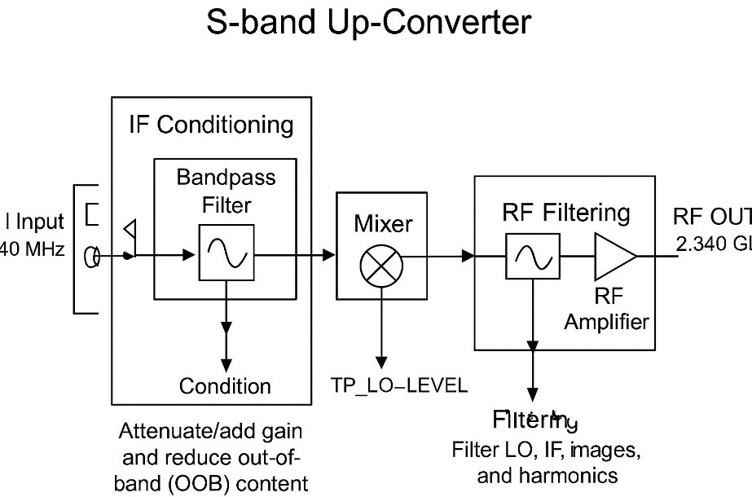
Signal Flow Summary
- The RF Signal Generator provides a 2–4 GHz input.
- The LO Signal Generator provides a signal close in frequency to the RF.
- Both are fed into the Mixer (DUT), where frequency translation occurs.
- The resulting DC or IF output is sent to a measurement instrument (spectrum analyzer or oscilloscope).

​S Band UP Converter
An S-band up-converter mixer is an RF (radio frequency) device used to convert a lower-frequency signal (usually IF – intermediate frequency) into a higher-frequency signal in the S-band (typically 2–4 GHz).
Typical Use Cases
- Satellite communication transmitters (uplinks)
→ where baseband or IF signals are converted up to S-band for transmission.
- Radar transmitters
- Wireless communication systems
- Telemetry or tracking systems
    - ​BLOCK DIAGRAM OF S BAND UP CONVERTER TESTING

IF Input (Intermediate Frequency Input)
        - Frequency: Typically around 70–140 MHz.
        - Function: This is the modulated low-frequency signal that will be converted (up-converted) to the S-band.
        - Key Requirement: The IF signal should be clean and stable — any distortion or noise here will appear in the RF output.
        - Test Point: TP_IF_IN — used to verify input level and purity.

IF Conditioning Block
Sub-blocks:
        - Attenuator Pad /IF Amplifier:
Adjusts the signal level to match the optimal input level for the mixer (usually –10 dBm to 0 dBm).
        - Bandpass Filter (BPF):
Passes only the desired IF signal bandwidth and rejects out-of-band noise or spurious signals.
        - Purpose:
          - Prevents mixer overload.
          - Improves signal-to-noise ratio (SNR).
          - Ensures clean upconversion.
        - Output: Clean IF signal ready for mixing.

Mixer Block (Up-Converter Mixer)
        - Function: Combines the IF input signal and the Local Oscillator (LO) signal to generate new frequencies:
          - Sum: fRF=fLO+fIFf_{RF} = f_{LO} + f_{IF}fRF=fLO+fIF (used output)
          - Difference: fRF=fLO−fIFf_{RF} = f_{LO} - f_{IF}fRF=fLO−fIF (filtered out)
        - Typical Operation Example:
          - IF = 140 MHz, LO = 2.200 GHz → RF = 2.340 GHz.
        - Type: Passive double-balanced diode mixer (or active FET mixer).
        - Key Parameters:
          - Conversion loss: 6–10 dB
          - LO drive: +7 to +15 dBm
          - Isolation (LO–IF–RF): 25–40 dB
        - Test Point: TP_LO_LEVEL — check LO power at the mixer input.

LO Input (Local Oscillator Chain)
        - Frequency: Around 2.0–4.0 GHz (for S-band).
        - Components:
          - LO Source: Synthesizer, VCO, or PLL module.
          - LO Filter: Removes harmonics and spurious tones.
          - LO Amplifier / Attenuator: Adjusts level for optimal mixer drive.
        - Purpose:
Provides a stable, low-phase-noise reference frequency that determines the RF output frequency.
19

RF Filtering Block
        - Function: Selects the desired up-converted RF signal (LO + IF) and suppresses:
          - The unwanted LO – IF product,
          - Residual LO leakage,
          - IF feed through, and
          - Mixer-generated harmonics.
        - Components:
          - Bandpass filter centered at desired RF frequency (e.g., 2.340 GHz).
        - Effect:
Cleans the spectrum before amplification or transmission.
        - Test Point: TP_RF_FILTER — used to inspect spectrum before amplification.

RF Amplifier Block
        - Function: Increases the power of the filtered RF signal to the desired transmission or test level.
        - Typical Gain: 10–20 dB.
        - Requirements:
          - High linearity (good IP3) to avoid distortion.
          - Sufficient output power without compressing.
        - Optional Output Filter: To remove harmonics generated by the amplifier.
        - Output Port: RF OUT (2.340 GHz).

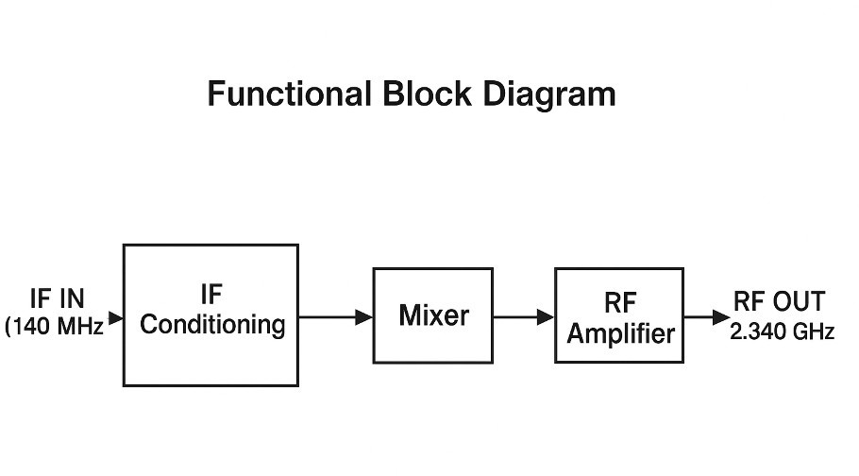
​IC SPF 5043Z AMPLIFIER IC
The SPF5043Z is a high-performance low noise amplifier (LNA) designed for use in RF and microwave applications. Manufactured by Qorvo, this IC operates over a wide frequency range from 50 MHz to 4000 MHz, making it ideal for S-band (2–4 GHz) systems such as satellite communication, radar, and RF testing setups.

​Overview of SPF5043Z

Parameter Description
Manufacturer Qorvo (formerly RFMD / RF Micro Devices) Type GaAs pHEMT Low Noise RF Amplifier
Frequency Range 50 MHz – 4 GHz
Package SOT-89
Supply Voltage (Vdd) 3–5 V (typically 5 V) Typical Gain ~20 dB
Noise Figure ~0.6–1.2 dB
Output P1dB +18 dBm typical
OIP3 (Linearity) +36 dBm
Current Consumption 85 mA typical @ 5 V Input/Output Impedance 50 Ω matched (internally)
Stability Unconditionally stable across operating band

​Functional Block Diagram

- IF Conditioning Block
  - Input Signal: IF (Intermediate Frequency) — typically 70 MHz or 140 MHz.
  - Function: Prepares the IF signal before mixing.
  - Includes:
    - Attenuator / Gain Control: Sets correct signal level for mixer input.
    - IF Bandpass Filter: Removes noise and unwanted signals.
    - Amplifier (Optional): Raises signal level if IF source is weak.
    - Purpose:
Ensures that the mixer receives a clean, stable signal at the right amplitude.Typical Level: –10 dBm to 0 dBm at the mixer input.

Mixer Block
  - Function: Performs frequency translation — up-converts IF to RF.
  - Inputs:
    - IF signal from IF Conditioning block.
    - LO (Local Oscillator) signal (for example, 2.200 GHz).
  - Output:
    - RF = LO + IF (sum frequency, e.g., 2.340 GHz).
    - Also produces LO – IF, which is filtered out later.
  - Mixer Type:
    - Passive double-balanced mixer or active mixer IC.
  - Conversion Loss: ~7–10 dB typical.
  - Isolation: Good LO–RF–IF isolation prevents signal leakage.

RF Amplifier Block
  - Function: Boosts the up-converted RF signal to the desired output power.
  - IC Used: SPF5043Z (or similar wideband GaAs pHEMT amplifier).
  - Frequency Range: 50 MHz – 4 GHz (ideal for S-band).
  - Gain: ~20 dB typical.
  - Output Power: Up to +18 dBm (P1dB).
  - Purpose:
    - Increases RF signal strength.
    - Maintains linearity for modulation fidelity.
  - Bias Voltage: +5 V DC.

RF Filtering Block
  - Function: Removes unwanted frequencies such as:
    - LO leakage,
    - IF feedthrough,
    - Image frequency,
    - Harmonics generated by the mixer or amplifier.
  - Type: Bandpass filter centered at 2.340 GHz (S-band).
  - Purpose:
Provides a clean, spectrally pure RF output signal.

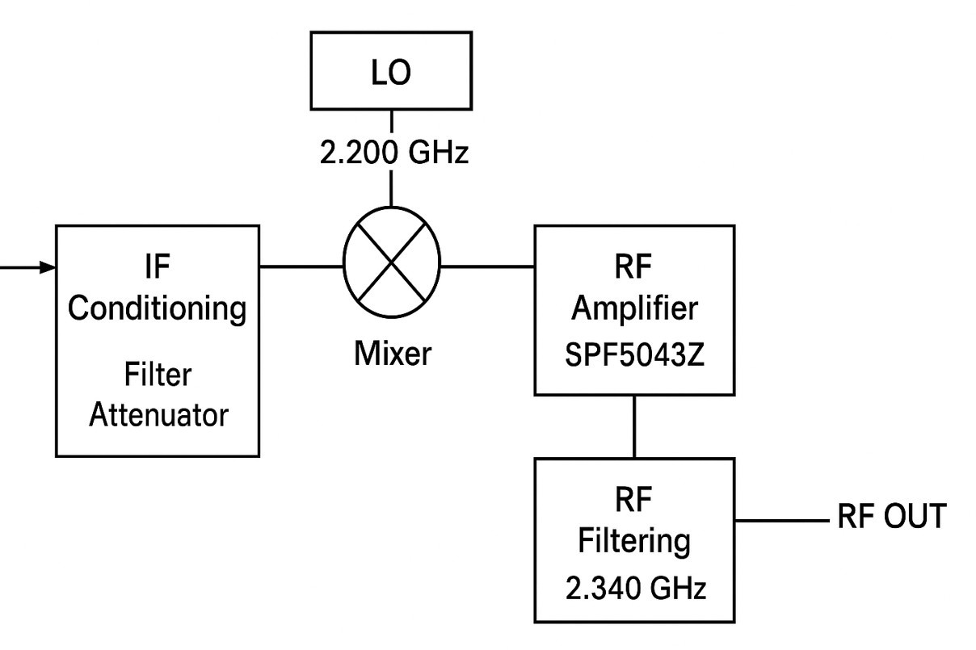
RF Output
  - Output Frequency: Around 2.340 GHz (S-band).
  - Output Level: Typically +10 to +15 dBm (after amplification).
  - Impedance: 50 Ω.
  - Used For: Transmission, radar, telemetry, or test setups

​ Application Circuit
A simple typical application circuit

IF Conditioning Block
Prepares the low-frequency input signal (Intermediate Frequency) for mixing. Main Functions:
  - Filter:
Removes unwanted harmonics or noise from the IF signal (typically 70 MHz or 140 MHz). Ensures only the desired frequency band is fed into the mixer.
  - Attenuator / Level Control:
Adjusts the IF signal power level to the proper range for the mixer input (usually around – 10 dBm to 0 dBm).
  - Optional IF Amplifier:
Boosts weak IF signals to ensure optimal conversion efficiency in the mixer.

23

Mixer Block
Performs the frequency translation process — converting the IF signal to a higher RF frequency (S-band).How it Works:
  - The IF signal and LO signal are combined.
  - The mixer produces two new frequencies:
    - Sum (LO + IF) → Desired RF output (e.g., 2.200 GHz + 0.140 GHz = 2.340 GHz).
    - Difference (LO – IF) → Unwanted image frequency, filtered out later. Key Characteristics:
  - Conversion Loss: ~7–10 dB (for passive mixers).
  - Isolation: High LO–IF–RF isolation to prevent leakage.
  - Type: Double-balanced or active mixer, depending on design.

LO (Local Oscillator)
Provides a stable high-frequency signal used for up-conversion. Details:
  - Frequency Example: 2.200 GHz.
  - Source: Synthesizer, VCO, or PLL-based oscillator.
  - Stability: Must be low-phase-noise and thermally stable.
  - Drive Level: Typically +7 dBm to +15 dBm (as required by the mixer). Function:
The LO determines the final RF output frequency (RF = LO + IF).

RF Amplifier (SPF5043Z)
Amplifies the mixer’s low-level RF output (usually –10 dBm to 0 dBm) to a usable level for transmission or measurement.
Key IC Features (SPF5043Z):
  - Broadband GaAs pHEMT amplifier (50 MHz – 4 GHz).
  - Gain: ~20 dB.
  - Output Power (P1dB): +18 dBm.
  - High Linearity (OIP3 ≈ +36 dBm).
  - Supply: +5 V, 85 mA typical.
  - Internally matched to 50 Ω (minimal external tuning). Usage:
Provides clean gain after the mixer and improves system output level while maintaining low noise
and good linearity.

RF Filtering Block
Removes unwanted frequency components after amplification. Main Tasks:
  - Suppress LO leakage and IF feedthrough.
  - Reject image frequencies and harmonics.
  - Pass only the desired S-band frequency (e.g., centered at 2.340 GHz). Filter Type:
  - Bandpass filter (2.3 – 2.4 GHz range).
  - Optional low-pass filter after amplifier for harmonic suppression. Result:
Clean, spectrally pure RF signal ready for output or transmission.

RF Output
Purpose:
Delivers the final S-band signal at the desired output level and spectral purity. Typical Output:
  - Frequency: 2.340 GHz (S-band).
  - Power Level: +10 to +15 dBm.
  - Impedance: 50 Ω. Use Cases:
  - S-band communication systems.
  - Radar transmitters.
  - Test and measurement setups.
  - Up-converter chains in RF front-end modules.

​Key Features
- Broadband gain from 50 MHz to 4 GHz — suitable for L, S, and C bands.
- Low noise figure (~0.6 dB @ 900 MHz) — ideal for LNA (Low Noise Amplifier) stages.
- High linearity (OIP3 ~ +36 dBm) — excellent for up/down converter driver stages.
- Internally matched to 50 Ω — minimal external components required.
- Unconditionally stable — safe for broadband or cascading stages.
- Small SOT-89 package — easy to integrate in compact RF designs.

4.5 Common Applications  Application | Role of SPF5043Z
RF Up/Down Converters | Used as IF or RF gain stage before/after the mixer to improve signal strength.
Low Noise Amplifier (LNA) | First amplifier after antenna for satellite receivers, radar front-ends, S-band telemetry.
WiFi / WLAN / WiMAX Front-End | Pre-driver or driver amplifier at 2.4 GHz or 3.5 GHz.
Cellular Base Stations (L, S bands) | Driver/LNA in RF chains.
Test Equipment / Signal Chain | Broadband gain block or buffer amplifier.
Satellite Communication Uplink/Downlink  4.6 Example S-band Use Case  For your S-band up-converter mixer,  - IF Amplifier:  - Before mixer to bring IF (140  - Benefits: low distortion, high  - RF Amplifier (Post-Mixer):  - After mixer to amplify 2.3–2. to +10 dBm or more.  - Benefits: broadband 50 Ω ma  4.7 Performance (from datash  Parameter 900 MHz 2.4 G  Gain (dB) 22 18  Noise Figure (dB) 0.6 0.8  OIP3 (dBm) 36 35  P1dB (dBm) 18 17  Supply Current 85 mA 85 mA | Front-end LNA or driver amplifier at S-band (2–4 GHz).  (fits your up-converter)  the SPF5043Z can be used in two spots:  MHz) to desired drive level (~0 dBm). gain.  4 GHz RF output (which is typically –10 dBm to 0 dBm) up tching, high gain, good linearity, stable across band.  eet)  Hz 3.5 GHz  16  1.1  34  16  85 mA  26

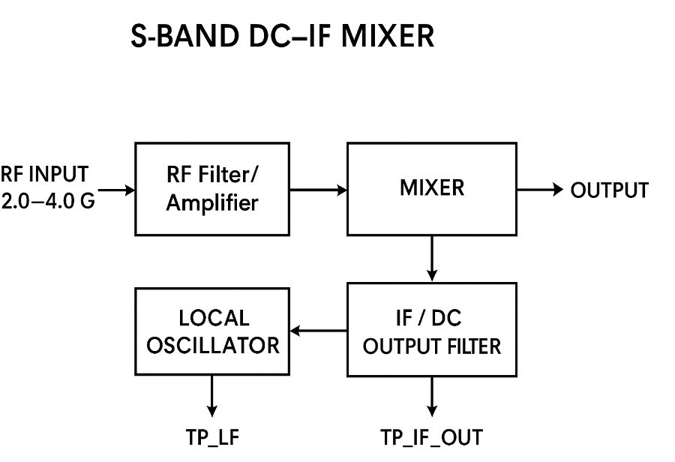
S-Band DC–IF Mixer
An S-band DC–IF mixer is an essential component in RF systems used for frequency conversion between baseband (DC or IF) and S-band frequencies (2–4 GHz). It can be used in up-conversion (transmitter side) or down-conversion (receiver side). Mixers are nonlinear circuits that combine two input signals — Local Oscillator (LO) and Radio Frequency (RF) — to produce new frequencies at the sum and difference of the inputs.
Used in:
- S-band radar receivers
- Satellite communication receivers
- Test setups for S-band transmitters
- Spectrum analysis front-ends

​Basic Block Diagram

RF Input Section
  - Input: S-band signal (typically 2.2–3.5 GHz).
  - Purpose: Accepts and conditions the received RF signal before mixing.
  - Components:
    - Bandpass filter (BPF): Passes only the desired S-band range and rejects out-of-band noise.
    - Low-noise amplifier (optional): Improves sensitivity if used in a receiver front-end.
  - Typical Level: –30 dBm to –10 dBm.
  - Test Point: TP_RF_IN — for checking input spectrum and level.

​Local Oscillator (LO)
  - Purpose: Provides a stable reference frequency for frequency conversion.
  - Frequency: Tunable around 2.0–4.0 GHz, offset from RF by the IF frequency.
  - Example:
If RF = 2.340 GHz and LO = 2.200 GHz → IF = 140 MHz

  - Components:
    - Synthesizer or PLL-based oscillator.
    - Buffer amplifier or isolator to stabilize drive power.
    - LO Power: +7 dBm to +13 dBm typical (for diode or FET mixers).
    - Test Point: TP_LO — measure LO power and stability.

​Mixer
  - Core of the circuit.
  - Function: Multiplies RF and LO signals to produce sum and difference frequencies.

fIF=∣fRF−fLO∣f_{IF} = |f_{RF} - f_{LO}|fIF=∣fRF−fLO∣ f_{RF} + f_{LO}fSUM=fRF+fLO
fSUM=fRF+fLOf_{SUM} =

  - Output: Both frequencies appear at the output; the unwanted one is filtered out.
  - Mixer Type:
    - Passive (double-balanced diode) mixer, or
    - Active (e.g., Gilbert cell or MMIC mixer).
  - Conversion Loss: ~7–10 dB typical.
  - Isolation: LO–RF, RF–IF isolation ~30–40 dB.
  - If used for DC mixing: Output can include a baseband/DC term for demodulation.

​IF / DC Output Section
  - Purpose: Extracts and cleans the IF or DC component from the mixer output.
  - Components:
    - Low-pass or band-pass filter: Passes only IF/DC frequencies (e.g., 0–140 MHz).
    - Amplifier (optional): Raises IF level for ADC or measurement.
  - Applications:
    - In a receiver → feed to demodulator or ADC.
    - In a test setup → send to oscilloscope or spectrum analyzer.
  - Test Point: TP_IF_OUT — verify IF/DC signal purity and power.

​Power Supply and Bias Control
  - Provides regulated DC bias (for active mixers or amplifiers).
  - Filters (decoupling capacitors and RF chokes) isolate DC from RF signal paths.

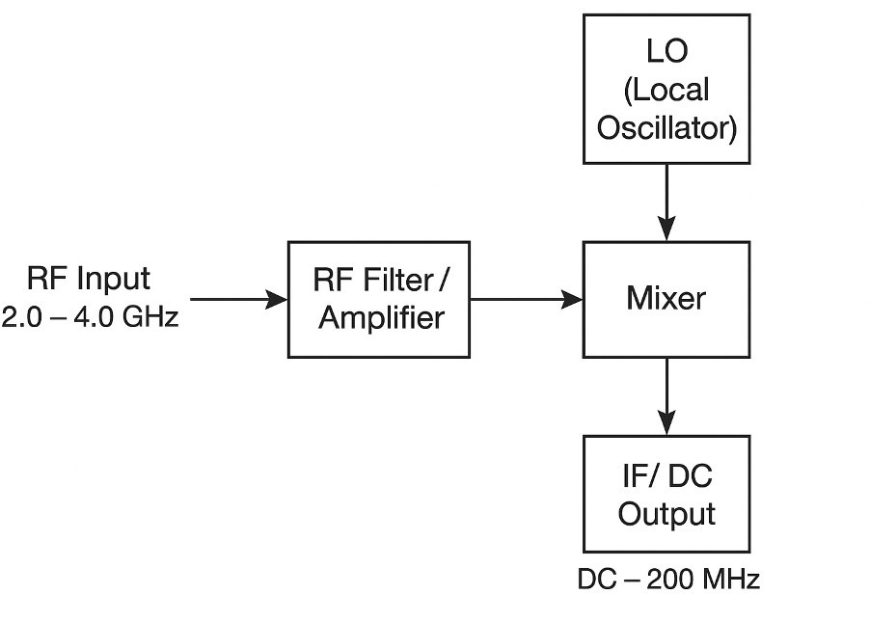
Application Circuit

- RF Input (2.0 – 4.0 GHz)
  - This is the input stage where the incoming S-band RF signal is applied.
  - The signal can come from an antenna, signal generator, or transmitter operating in the 2–4 GHz range.
  - The power level of this signal is usually low (in the range of –20 dBm to 0 dBm).
  - The purpose of this stage is to provide the high-frequency input signal to be down-converted to IF.

RF Filter / Amplifier
  - This block contains two main parts:
  - Band-Pass Filter (BPF):
Ensures that only the desired RF frequency band (S-band) passes to the mixer, while unwanted harmonics and noise are suppressed.
  - RF Amplifier (eg,SPF5043Z):
Boosts the signal strength before it enters the mixer. This increases conversion efficiency and improves signal-to-noise ratio (SNR).
  - Together, this block conditions the RF signal for accurate mixing.

LO (Local Oscillator)
  - Generates a stable and precise frequency close to the RF signal frequency.
  - The LO signal combines with the RF signal inside the mixer to produce the sum (f_RF + f_LO) and difference (|f_RF – f_LO|) frequencies.
  - Typically, the LO signal power is around +10 dBm, and frequency stability is critical to prevent drift in the IF output.
  - LO is generated using a PLL synthesizer or signal generator.
  - Example:
If RF = 2.340 GHz and LO = 2.200 GHz → IF = 140 MHz.

Mixer
  - The core nonlinear component that performs the frequency translation.
  - It multiplies the RF and LO signals to produce:
fSUM=fRF+fLO,fDIFF=∣fRF−fLO∣f_{SUM} = f_{RF} + f_{LO}, \quad f_{DIFF} = | f_{RF} - f_{LO}|fSUM=fRF+fLO,fDIFF=∣fRF−fLO∣
  - The difference frequency (IF) is selected as the output.
  - Mixer types:
    - Passive Diode Mixer (requires no DC power, e.g., Mini-Circuits ZX05 series)
    - Active Mixer (provides gain, e.g., HMC558A)
  - Provides good isolation between ports and low conversion loss (6–9 dB).

IF / DC Output (DC – 200 MHz)
  - This stage extracts and processes the Intermediate Frequency (IF) signal produced by the mixer.
  - A low-pass filter (LPF) or band-pass filter (BPF) removes the unwanted high-frequency (sum) component.
  - Output frequency typically lies between DC and 200 MHz, depending on system design.
  - The filtered IF output is then amplified or sent to further stages such as:
    - IF amplifier,
    - Analog-to-digital converter (ADC),
    - Spectrum analyzer,
    - Demodulator.

​Key Features of S-Band DC–IF Mixer
- Wide Operating Frequency Range
- Operates efficiently across the S-band (2.0 – 4.0 GHz), suitable for radar, satellite, and communication systems.

High Conversion Efficiency
- Typical conversion loss of 6–9 dB (for passive mixers) or conversion gain up to +10 dB (for active mixers).

Low Noise and Distortion
- Designed for low noise figure and high linearity, ensuring clean down-conversion with minimal signal degradation.

Excellent Port Isolation
- Provides strong isolation between RF, LO, and IF ports (typically >30 dB), reducing unwanted feedthrough.

Stable Local Oscillator Operation
- Accepts a stable LO drive (typically +10 dBm), ensuring consistent and drift-free frequency translation.

Broadband IF Output
- Produces a wide IF range (DC – 200 MHz), suitable for baseband and low-IF applications.

Compact and Reliable Design
- Uses compact RF components (MMICs or hybrid modules), allowing integration into small receiver systems.

Flexible Configuration
- Can be used as a down-converter (RF → IF) or up-converter (IF → RF) by reversing the signal flow.

Compatible with S-Band Systems
- Optimized for S-band radar, satellite communication, and RF test setups.

Ease of Integration
- Supports 50 Ω impedance matching, making it compatible with standard RF test equipment and transmission lines.

​Common Applications of S-Band DC–IF Mixer
- Satellite Communication Systems
  - Used in down-converter stages of satellite receivers to convert high S-band RF signals (2–4 GHz) into lower IF frequencies for signal processing.
  - Also used in up-converters of satellite transmitters to translate baseband or IF signals up to S-band for transmission.

Radar Systems
  - Essential in S-band radar receivers to convert the received echo signals into a manageable IF frequency.
  - Enables target detection, Doppler processing, and range measurement in weather, marine, and defense radar systems.

RF and Microwave Test Equipment
  - Used in spectrum analyzers, signal analyzers, and vector network analyzers for frequency translation and measurement.
  - Allows high-frequency (S-band) signals to be down-converted to IF or DC for easier detection and analysis.

Wireless Communication Systems
  - Applied in S-band WiMAX, LTE, and 5G backhaul links to convert between RF and IF for modulation/demodulation stages.
  - Ensures signal compatibility with digital baseband processors or ADCs.

Software Defined Radio (SDR)
  - Forms part of the RF front-end in SDR receivers, converting wideband S-band signals to a lower IF or baseband for digital sampling and processing.
  - Enables flexible tuning and multi-band operation.

Electronic Warfare (EW) and Surveillance
  - Used in RF signal monitoring systems and direction-finding receivers.
  - Helps detect, identify, and analyze S-band transmissions over a wide dynamic range.

Instrumentation and Research
  - Utilized in microwave laboratories and research setups for frequency translation experiments, mixer characterization, and RF circuit testing.
  - Ideal for teaching and demonstration of heterodyne principles in academic environments.

Telemetry and Tracking Systems
  - Used in ground stations and airborne telemetry systems operating in the S-band for down-conversion of received telemetry signals.
  - Ensures stable IF output for data demodulation and processing.

Communication Relays and Repeaters
  - Integrated in S-band relay transponders and repeater systems to convert frequencies for signal regeneration and retransmission.

Industrial and Scientific Measurement Systems
  - Found in non-destructive testing, industrial sensors, and scientific instruments operating in the S-band.
  - Used to mix, detect, or down-convert measurement signals for further processing.

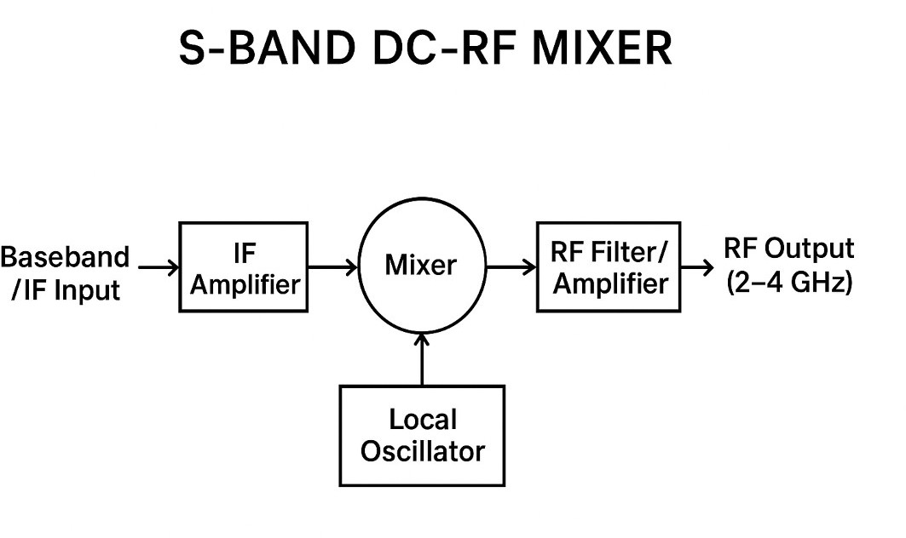
​S-Band DC–RF Mixer
An S-Band DC–RF Mixer is a key component used in RF up-conversion systems to translate a low-frequency baseband (DC or IF) signal into a high-frequency S-band RF signal (2–4 GHz). It operates on the heterodyne mixing principle, combining the input (DC/IF) signal with a local oscillator (LO) to generate a new output at the sum of the input frequencies.

​Functional Block Diagram

- Baseband / IF Input
  - Receives the low-frequency input signal (DC or IF, typically 0–200 MHz).
  - The signal carries modulation or baseband data that needs to be transmitted at RF.
  - Input is matched to 50 Ω for proper impedance.

IF Amplifier
  - Boosts the low-frequency signal to the appropriate level for mixing.
  - Ensures sufficient drive for the mixer to achieve proper conversion gain.
  - Common amplifiers: SPF5043Z, MMIC gain blocks, or operational amplifiers (for DC–low IF).

Local Oscillator (LO)
  - Generates a stable and precise carrier signal in the S-band (2–4 GHz).
  - LO power: typically +10 dBm.
  - The LO frequency determines the RF output frequency after mixing.
  - Stability and phase noise performance are critical.

Mixer
  - The nonlinear device that combines the IF and LO signals.
  - Produces sum (f_LO + f_IF) and difference (f_LO – f_IF) components.
  - The sum frequency is selected as the desired RF output.
  - Can be active (with gain) or passive (diode-based).

RF Filter / Amplifier
  - A band-pass filter (BPF) removes the unwanted difference-frequency and LO leakage.
  - The RF amplifier boosts the filtered signal to the required transmission level.
  - Ensures clean, strong output in the S-band range (2–4 GHz).

​Signal Flow Summary

Stage Input Output Function
IF Input DC / Low-Frequency Amplified IF Provides baseband signal LO Stable S-Band Mixed with IF Frequency translation Mixer IF + LO RF (sum) Up-conversion
RF Filter / Amp Mixed output Clean RF signal Signal enhancement

​Key Features
    - Operates across S-band (2.0–4.0 GHz) range.
    - High conversion efficiency (gain up to +10 dB for active mixers).
    - Excellent port isolation between RF, LO, and IF.
    - Low noise and high linearity.
    - Stable LO performance ensures precise frequency control.
    - Compact design suitable for integration in RF transmitters.

​Common Applications
    - S-Band Transmitters in satellite and radar systems.
    - Up-conversion stages in RF communication systems.
    - Signal generation in test and measurement instruments.
    - Microwave communication links and SDR transmitters.
    - Frequency synthesizers and microwave front-end modules.

​Example Component Setup

Component Function Example
Mixer Up-conversion Mini-Circuits ZX05-43MH-S+ IF Amplifier Low-frequency gain SPF5043Z
LO Source Carrier generation ADF4351 Synthesizer RF Filter Output filtering BPF 2–4 GHz
Power Supply Biasing +5V DC

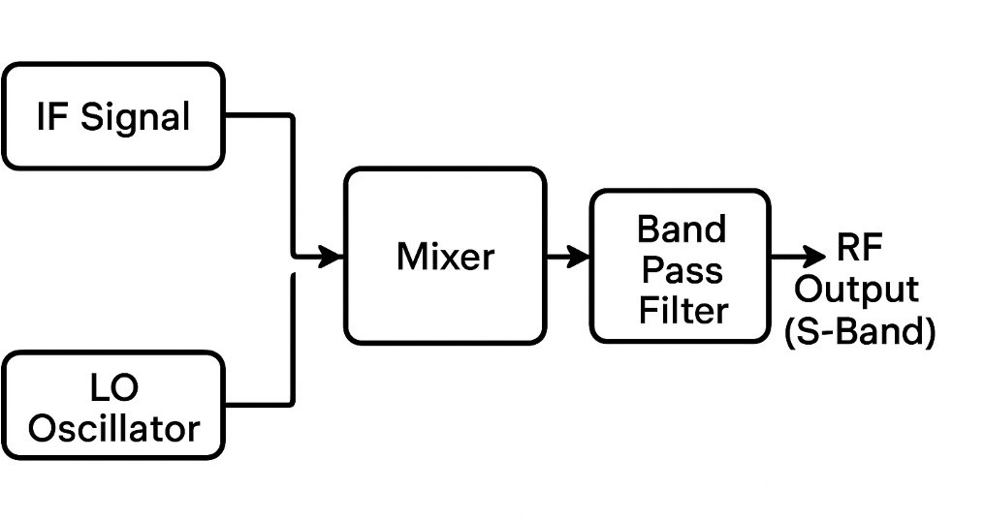
​S-Band Up-Converter Mixer
An up-converter mixer is a key component in RF (Radio Frequency) communication systems used to convert a low-frequency (IF – Intermediate Frequency) signal to a higher frequency (RF). In the S-band (2–4 GHz range), such mixers are widely used in satellite communications, radar, and wireless links.

​Block Diagram

- IF Signal (Intermediate Frequency Input)
  - The IF signal is the modulated baseband signal (typically a few MHz to hundreds of MHz).
  - It carries the actual information (voice, data, or video) that needs to be transmitted.
  - This signal is fed into the mixer for frequency translation to a higher (S-band) frequency.

LO Oscillator (Local Oscillator)
  - The LO provides a stable, high-frequency signal (in GHz range).
  - Its frequency determines the output RF frequency since: fRF=fIF+fLOf_{\text{RF}} = f_{\text{IF}} + f_{\text{LO}}fRF=fIF+fLO
  - Usually generated by a synthesizer or PLL (Phase Locked Loop) circuit.
  - The LO must have low phase noise and high frequency stability.

Mixer
  - The core component where frequency conversion happens.
  - It multiplies the IF and LO signals using a nonlinear device (like a diode or transistor).
  - The output contains both sum (f_LO + f_IF) and difference (f_LO – f_IF) frequencies.
  - Further filtering selects only the desired up-converted signal.

Band-Pass Filter (BPF)
  - The BPF allows only the S-band frequency component (f_LO + f_IF) to pass.
  - It removes unwanted signals such as the difference frequency, LO leakage, and spurious harmonics.
  - Ensures clean, interference-free RF output for transmission.

RF Output (S-Band)
  - This is the final up-converted signal, typically in the 2–4 GHz S-band range.
  - It can now be amplified and sent to an antenna for wireless transmission.
  - The signal is suitable for use in satellite uplinks, radar, and telemetry systems.

​Key Features of S-Band Up-Converter Mixer
- Frequency Range:Operates typically in the S-band (2–4 GHz) frequency range for RF output.
- Up-Conversion Function:Converts low-frequency Intermediate Frequency (IF) signals (e.g., 70 MHz, 140 MHz) into high-frequency RF signals.
- High Linearity:Ensures minimal distortion during frequency translation, maintaining the integrity of complex modulated signals.
- Low Conversion Loss:Provides efficient mixing with low insertion loss to maintain good output power levels.
- Good Isolation:Exhibits high LO–RF and IF–RF isolation, preventing signal leakage between ports.
- Wideband Operation:Supports a broad range of frequencies, making it compatible with multiple communication systems.
- Compact and Modular Design:Can be implemented using MMIC (Monolithic Microwave Integrated Circuit) or hybrid technologies for small form factor.
- Low Phase Noise:Maintains signal purity — essential for radar and satellite links where frequency stability is critical.
- Compatibility:Works with various modulation schemes like BPSK, QPSK, QAM, etc.
- High Reliability:Suitable for long-term, continuous operation in harsh RF environments (space, radar, or telecom systems).
  - ​Common Applications of S-Band Up-Converter Mixer

Satellite Communication Systems
  - Used in satellite uplink transmitters to convert the baseband or IF signal to an S-band RF carrier (2–4 GHz).
  - Enables data, TV, and voice transmission to satellites.

Radar Systems
  - Converts low-frequency radar pulses to S-band frequencies for long-range target detection.
  - Widely used in weather radar and marine navigation radar.

Microwave Radio Links
  - Provides up-conversion in point-to-point microwave links for high-speed data transfer.

Wireless Telemetry and Tracking Systems
  - Used in aerospace and defense for transmitting sensor or flight data over S-band frequencies.

Remote Sensing Instruments
  - Employed in Earth-observation systems to transmit sensor data via S-band telemetry links.

Test and Measurement Equipment
  - Used in RF labs and test benches to generate and analyze S-band signals during equipment calibration and performance testing.

Communication Satellites Ground Terminals
  - Ground stations use up-converter mixers to modulate and transmit signals to
satellites for telecommand and data relay.

Wireless Broadband and Wi-Fi Systems
  - In some designs, up-conversion stages use S-band for experimental or specialized broadband wireless setups.

​Example Component Setup

Component Specification / Example Function
Model

IF Signal 140 MHz, −10 dBm output

Generator
Local Oscillator 2.86 GHz, +10 dBm output

(LO)
Provides the intermediate frequency (baseband) signal.
Provides the reference frequency for up-conversion.

Mixer Module Mini-Circuits ZX05-43MH-S+ Performs frequency mixing (non-linear

Band-Pass Filter (BPF)
RF Amplifier
or equivalent
Center frequency: 3 GHz, bandwidth: 100 MHz
multiplication).
Selects the desired upper sideband and rejects unwanted frequencies.

(optional) Gain: 10–20 dB, NF < 2 dB Boosts the up-converted RF signal power.

Power Splitter / 2–4 GHz range

Combiner
Used for signal routing and combining LO and IF paths.

Spectrum Analyzer 0–4 GHz Used to observe the output RF spectrum and verify frequency conversion.
DC Power Supply +12 V / +15 V (if needed) Provides bias to active mixer or amplifier
modules.

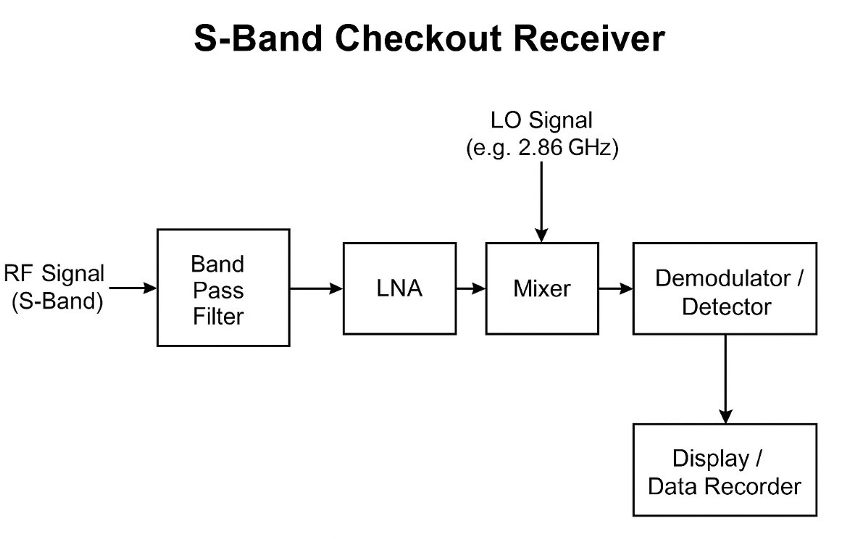
Testing of S-Band Checkout Receiver
An S-Band Checkout Receiver is used in satellite ground stations and test facilities to monitor or verify S-band telemetry and command links. It receives S-band RF signals (2-4GHz),converts them to an Intermediate Frequency (IF),and then demodulates or displays them for analysis

​Block Diagram

- RF Signal (S-Band Input)
  - The receiver accepts S-band signals (typically 2–4 GHz) from an antenna or test source.
  - These signals may contain telemetry, tracking, or command information.
  - Since they are usually weak, the receiver must carefully amplify and filter them before processing.

Band-Pass Filter (BPF)
  - The BPF selects the desired S-band frequency range while rejecting unwanted signals and noise outside that band.
  - It prevents interference from nearby channels and suppresses out-of-band noise.
  - Typical bandwidth: a few tens of MHz around the center frequency. Function: Improves signal quality and overall selectivity of the receiver.

Low-Noise Amplifier (LNA)
  - The LNA amplifies the filtered S-band signal while introducing minimal additional noise.
  - It sets the overall sensitivity of the receiver and ensures that weak signals can be processed.
  - Typical gain: 15–30 dB; Noise Figure: < 2 dB.
Function: Boosts signal strength without significantly degrading the signal-to-noise ratio (SNR).

Mixer
  - The mixer is the core of the receiver where frequency down-conversion occurs.
  - It combines the amplified S-band signal with a Local Oscillator (LO) signal (e.g., 2.86 GHz).
  - Produces two frequencies:
fIF=∣fRF−fLO∣f_{IF} = |f_{RF} - f_{LO}|fIF=∣fRF−fLO∣
  - The difference frequency (IF) is selected for further processing.
Function: Converts the high S-band RF signal to a lower, manageable Intermediate Frequency (IF).

Local Oscillator (LO)
  - The LO generates a stable reference frequency used in the mixing process.
  - Must have low phase noise and high frequency stability for accurate down-conversion.
  - Usually implemented using a synthesizer or PLL-based oscillator. Function: Provides the mixing signal to translate RF to IF frequency.

Demodulator / Detector
  - Extracts the original information signal (data, audio, or telemetry) from the IF or baseband.
  - The type of demodulator depends on the modulation scheme (e.g., FM, BPSK, QPSK).
  - Converts modulated IF signals into readable baseband signals. Function: Recovers the transmitted information from the received carrier.

Display / Data Recorder
  - Displays or stores the recovered baseband signal for monitoring and analysis.
  - Can be connected to an oscilloscope, computer interface, or telemetry decoder.
  - Used for system checkout, verification, and troubleshooting. Function: Provides the final observable or recordable output of the receiver.

​Equipment Required

Sl. No Equipment Specification / Example
- RF Signal Generator S-band (2–4 GHz), variable power output
- Spectrum Analyzer Up to 4 GHz or higher
- Power Supply +12 V / +15 V for receiver modules
- Oscilloscope 0–100 MHz bandwidth for baseband output
- Attenuators To control RF input level
- Coaxial Cables (SMA) 50 Ω matched connections

Test Procedure
- Setup Connections
  - Connect the RF signal generator to the receiver’s RF input through an attenuator.
  - Connect the receiver output (baseband/IF) to the spectrum analyzer or oscilloscope.
  - Power up the receiver with the rated DC supply.

Frequency Alignment
  - Set the RF generator to the desired S-band frequency (e.g., 2.2 GHz).
  - Adjust the LO frequency to produce the correct IF output (e.g., 140 MHz).

Gain and Sensitivity Test
  - Vary the RF input power level from −30 dBm to 0 dBm.
  - Observe the corresponding IF output amplitude.
  - Note the minimum detectable signal level (MDS).

Bandwidth and Selectivity
  - Sweep the input frequency slightly (±10 MHz) to measure the 3 dB bandwidth.
  - Observe the output level variation.

Demodulation Test (if applicable)
  - Apply a modulated RF signal (e.g., BPSK or FM).
  - Observe the baseband output and check waveform fidelity or bit error rate.

Noise Figure and Linearity
  - Use the spectrum analyzer to measure noise floor and spurious-free dynamic range.

Record Results
  - Log output power, frequency response, and SNR (Signal-to-Noise Ratio) for each test condition.

​Key Features of S-Band Checkout Receiver
- Wide Operating Frequency Range:Designed for the S-band (2–4 GHz), commonly used in satellite telemetry and communication links.
- High Sensitivity:Detects very low-power RF signals, often down to −100 dBm or lower.
- Low Noise Figure:Incorporates a low-noise amplifier (LNA) to maintain excellent signal-to-noise ratio.
- Stable Local Oscillator:Uses a PLL-synthesized LO for accurate frequency conversion and minimal drift.
- Efficient Frequency Down-Conversion:Converts high-frequency S-band signals to manageable Intermediate Frequency (IF) for further processing.

40

- Adjustable Gain Control:Allows gain tuning at IF or RF stages to prevent overloading and maintain linearity.
- High Selectivity:Includes narrow band-pass filters to reject unwanted adjacent channel signals.

Multiple Demodulation Support:Can handle FM, PM, BPSK, QPSK, or telemetry
signals depending on configuration.
- Compact and Modular Design:Often built as a rack-mounted or modular unit for integration with test systems.
- Monitoring and Data Interface:Provides analog or digital outputs for display, logging, or telemetry decoding.

​Common Applications of S-Band Checkout Receiver

Satellite Ground Stations:
  - Used to receive and monitor satellite downlinks during checkout and routine operation.
  - Ensures the health and communication of onboard telemetry systems.

Satellite Testing Facilities:
  - Deployed during integration and testing (I&T) phases to verify satellite transmitter performance.

Telemetry and Tracking Systems (TT&C):
  - Receives and demodulates telemetry signals for satellite command and data acquisition.

Aerospace and Defense:
  - Used in radar and telemetry test setups to analyze S-band transmission quality.

Communication System Validation:
  - Helps verify frequency stability, gain, bandwidth, and modulation performance
of S-band transceivers.

Educational and Research Labs:
  - Used in RF communication experiments to study receiver sensitivity, noise figure, and down-conversion processes.

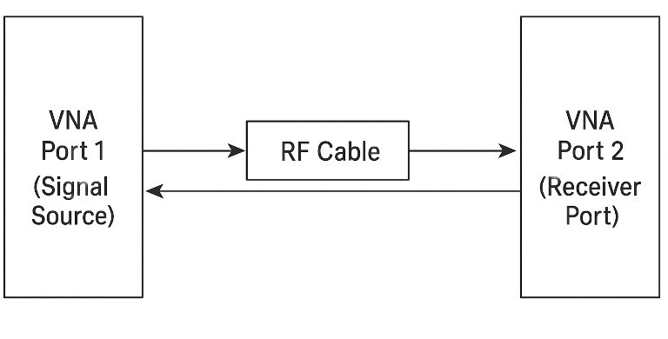
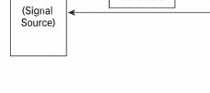
​RF Cable Calibration Network Analyzer
RF cables play a critical role in carrying high-frequency signals between components (like antennas, mixers, amplifiers, etc.).
A Network Analyzer helps to:
- Measure cable performance (S-parameters)
- Calibrate out unwanted losses
- Ensure precise system measurements

​Block Diagram

- Vector Network Analyzer (VNA)
  - The core instrument that generates, measures, and analyzes RF signals.
  - It has two ports — Port 1 (transmit/source) and Port 2 (receive/detector).
  - Measures key parameters like S11 (reflection) and S21 (transmission).
  - Provides magnitude and phase information to determine insertion loss, return loss, and phase delay of the cable.

Calibration Kit
  - Contains precision standards (Open, Short, Load, and Thru).
  - Used to remove systematic errors (like mismatch, leakage, and drift) in the VNA setup.
  - Ensures accurate reference planes at the ends of the test cables before actual measurement.

Test Cables / RF Connectors
  - High-quality coaxial cables that connect the VNA ports to the DUT (Device Under Test).
  - Must be phase-stable and low-loss to maintain measurement accuracy.
  - Connectors (SMA, N-type, etc.) must be clean and properly tightened to avoid reflection errors.

​Device Under Test (DUT) – RF Cable
  - The cable being tested or calibrated.
  - Signal travels from VNA Port 1 through the DUT to Port 2.
  - The VNA measures how the cable affects amplitude and phase across frequencies.

Measurement Control & Data Display
  - The VNA’s internal processor or a connected PC controls frequency sweep, collects data, and displays measurement results.
  - Results shown include:
    - S-parameters (S11, S21)
    - Insertion Loss (dB)
    - Return Loss (dB)
    - Phase Response (degrees)

​Calibration Procedure
Calibration ensures that the VNA measures only the device (cable) characteristics, not its own imperfections or test port losses.
Steps:

Warm-up:
Turn on the VNA and let it stabilize for at least 15–20 minutes.

Set Frequency Range:
  - Example: 2 GHz to 4 GHz (S-band).
  - Set appropriate power level (e.g., −10 dBm).

Connect Calibration Kit:
  - Perform Full 2-Port Calibration (SOLT):
    - S – Connect the Short standard.
    - O – Connect the Open standard.
    - L – Connect the 50 Ω Load standard.
    - T – Connect the Through standard (between Port 1 and Port 2).
- Save Calibration Data:Store the calibration coefficients in the VNA’s memory.
- Connect the RF Cable Under Test (CUT):Replace the “Through” connection with the cable to be measured.
- Perform Measurement:Observe S11 (Return Loss) and S21 (Insertion Loss) across the frequency range.

Record Results:
  - S11 (dB): Should be low (e.g., < −20 dB) → indicates good matching.
  - S21 (dB): Represents loss (e.g., −1.5 dB @ 3 GHz).
  - Phase Shift (°): Indicates cable electrical length.

