Spatial Transferability of Root Zone Soil Moisture Estimation in Nebraska Croplands using Machine Learning

Rouhin Mitra¹, Seung-bum Kim², and Mekonnen Gebremichael¹

¹University of California, Los Angeles, California
²Jet Propulsion Laboratory, California Institute of Technology, Pasadena, California

Corresponding author: Rouhin Mitra (rouhinmitra@g.ucla.edu), Mekonnen Gebremichael (mekonnen@seas.ucla.edu)

Mailing address: UCLA Civil and Environmental Engineering, 420 Westwood Plaza, 5731 Boelter Hall, Los Angeles, CA 90095.

Key Points:
- Random Forest outperformed the exponential filter in spatially transferring root zone soil moisture estimates to unseen agricultural sites.
- Ancillary satellite data allowed the model to detect irrigation patterns and correct for management-induced shifts in soil moisture.
- Spatial transferability is more challenging than temporal transfer, with predictive skill degrading significantly at depths below 50 cm.

Abstract
Accurate root zone soil moisture (RZSM) information is critical for agricultural water management. While satellites provide observations of Surface Soil Moisture (SSM), they are confined to the top few centimeters, necessitating models to infer RZSM from surface measurements. This is difficult in managed agricultural landscapes because of site specific inputs like irrigation. In this study, we evaluated a machine learning model (Random Forest) against a recursive exponential filter to assess the predictability of RZSM using SSM. We assessed the model performance using in-situ data from three adjacent corn and soybean fields under two scenarios: i) temporal transferability (out of sample years) and ii) spatial transferability (out of sample sites). In temporal transfer, the ML model (R² = 0.74) outperformed the exponential filter (R² = 0.52), where the predictive skill was found to be predominantly determined by SSM variability. In the spatial transfer task, the exponential filter performed poorly (R² = -0.02), which resulted from the filter’s exclusive reliance on SSM, and inability to accept ancillary variables required to account for site-specific heterogeneity. In contrast, the ML model remained robust (R² = 0.63) due to the integration of ancillary remote-sensing data alongside SSM, specifically Alpha Earth embeddings and Sentinel-2 imagery that identified the irrigation regime and tracked crop phenology, respectively. This combination allowed the model to correct for the systematic underestimation in irrigated sites. The machine learning model was able to maintain reliable performance in spatial transfers to out-of-sample validation cases, without elaborately improving the underlying soil water balance.
Plain Language Summary
Knowing how much water is available to plant roots is vital for farming and food security. However, satellites only measure moisture at the soil surface, leaving the deeper root zone unobserved. Bridging this gap is difficult because estimation models often fail when applied to new locations, particularly in irrigated areas where human activity changes soil moisture conditions. We addressed this by comparing a traditional mathematical model against a machine learning approach using data from corn and soybean fields. We found that the traditional model failed when tested on unseen (out-of-sample) sites because it could not account for irrigation differences, whereas the machine learning model succeeded. It worked by integrating diverse satellite data—such as vegetation health and soil context to recognize irrigation patterns and crop growth stages. This research demonstrates that machine learning has the potential to map root-zone water availability to support sustainable water management using surface measurements at managed unseen sites.

1. Introduction

Root zone soil moisture (RZSM) is a critical component of the terrestrial water cycle and a primary determinant of agricultural productivity, particularly in vital food-producing regions like the U.S. Corn Belt. Effective management of water resources for irrigation scheduling, drought monitoring, and yield forecasting can benefit from accurate RZSM information. While microwave remote sensing, offers reliable estimates of surface soil moisture (SSM) (Kim et al., 2017), these measurements are confined to the top few (0-5) centimeters of the soil, leaving the functionally more critical root zone largely unobserved.

The relationship between surface and root zone moisture is complex, non-linear, and characterized by a host of factors including soil hydraulic properties, climate, and vegetation dynamics (Paul et al., 2024). Dynamic crop phenology alters the depth and intensity of root water uptake throughout the growing season. In managed agricultural ecosystems, this complexity is amplified such that irrigation inputs create artificial wet states that decouple the surface from the root zone. This makes the application of traditional estimation methods challenging. There are mainly three types of methods used to estimate RZSM from SSM, i) Physics based modeling (Cordova and Bras, 1981) , ii) Data assimilation methods which combines observations with physics based models (Carranza et al., 2021; Crow et al., 2008; Das et al., 2006) and, iii) Data driven methods such as machine learning, deep learning or exponential filter methods which directly use surface soil moisture and other variables as an input for the model to learn the underlying physics (Carranza et al., 2021; Kornelsen & Coulibaly, 2014; Albergel et al., 2008). Process based models like HYDRUS-1D require information on soil hydraulic properties, either through pedo-transfer functions or field measurements (Schaap et al., 2011; Van Looy et al., 2017). Therefore, even data assimilation techniques which need to be paired with a model for RZSM estimation will also require detailed soil and vegetation parameters. These parameters are difficult to obtain at field scale (Kornelsen & Coulibaly, 2014), or they need to be paired with land surface models which are course resolution (Sabater et al., 2007; Kornelsen & Coulibaly, 2014).

Simpler data-driven models, such as the exponential filter (Liao et al., 2021), assumes exponential shape for a vertical moisture profile and its performance is subject to the fidelity of the assumed shape. The deterministic recursive exponential filter shows good correlations (R > 0.6-0.9) with RZSM estimation at specific depths (e.g., 25, 30, 50 cm) or layer averages (e.g., 0-20, 0-50, 0-100 cm), though performance varies and sometimes requires conversion to relative units like Soil Water Index (SWI) (Albergel et al., 2008; González-Zamora et al., 2016; Ouaadi et al., 2025). For instance, Ford et al. (2014) used an exponential filter to estimate 25 cm root zone SWI from SMOS satellite surface SWI across the US Great Plains, finding reasonable accuracy. However, the accuracy spatially varied (mean R²=0.57 in Oklahoma, 0.24 in Nebraska) when compared against in-situ SWI over a single year, showcasing challenges with satellite data accuracy and the complex error characteristics inherent in global soil moisture products (Kim et al., 2023). Gao et al. (2018) found Cumulative Distribution Function (CDF) matching approach comparable to exponential filters, with performance varying by climate (e.g., mean R² = 0.85 in humid subtropical vs R²=0.35 in semiarid).

• Data-driven machine learning (ML) models present a compelling alternative, as they can learn the intricate relationships between SSM, meteorological drivers, and RZSM directly from data without requiring explicit physical parameterization (Xi et al., 2025; Karpatne et al., 2017; Yinglan et al.,2022; Babaeian et al., 2021). However, previous studies reveal limitations, particularly in testing for spatial transferability. Kornelsen & Coulibaly (2014) used Artificial Neural Networks (ANNs) to predict RZSM at specific depths (10, 20, 50 cm), but the model was trained on synthetic HYDRUS-1D data and showed reduced performance against in-situ observations (RMSE < 0.08 m³/m³ against synthetic data, but increasing to > 0.10 m³/m³ against measured in-situ data). The study found limited spatial transferability because the models trained on idealized synthetic physics (HYDRUS-1D) failed to generalize to the site-specific heterogeneity of soil texture and hydraulic properties found in real-world fields.

• Other studies have used Random Forest (RF); Carranza et al. (2021) successfully predicted a 45-cm layer averaged RZSM, achieving high accuracy for temporal interpolation (R² > 0.9) but did not test spatial transferability to new sites.

• Other works have predicted RZSM at specific depths, for example Wang et al. (2024) provided a comprehensive comparison of deep learning models for predicting RZSM at discrete depths (5–100 cm), achieving high 1-day forecast accuracy (R² > 0.9), but again focused on temporal prediction at individual sites.

• Similarly, Kisekka et al. (2022) used RF to model 60-cm layer averaged RZSM in a vineyard. They found RF (R² > 0.80, RMSE 0.012–0.036 cm³/cm³) outperformed semi-empirical models. While they successfully employed spatial interpolation in a vineyard, they used field-measured site-specific soil property inputs such as bulk density along with remotely sensed inputs.

• This critical gap in spatial testing is not unique to RZSM prediction. ML models (RF, ANN, SVR) showed poor capability in spatial generalization in off-site scenarios even for SSM estimates. Thus, a major unresolved challenge is spatial transferability, which we define as the ability of a model trained at one location to perform accurately at an unseen location. This is particularly challenging in agricultural landscapes because environmental data is spatially correlated and non-independent and identically distributed (non-i.i.d.) (Ma et al., 2024a). As a result, differences in management practices, such as irrigation, create a 'covariate shift' where the statistical distribution of input features differs significantly between training and testing sites, causing model performance to degrade (Ma et al., 2024b). To mitigate such shifts, recent studies have proposed multi-scale domain adaptation techniques that explicitly align feature distributions between data-rich and data-scarce regions (Zhu et al., 2025). While these algorithmic approaches show great promise, there remains a need to understand if adding physical ancillary data can arguably achieve similar transferability in agricultural settings for the prediction of RZSM.

Development of the RZSM estimation approach that can handle spatial transferability is the primary goal of this study, since the ability is lacking in the research community as detailed above. Spatial transferability is the ability to expand the spatial coverage of RZSM estimation model from one training site to other locations. The ability is particularly needed for remote sensing of RZSM over wide areas: remote sensing offers surface or near surface soil moisture over a large area but not the root-zone. If the RZSM estimate model trained at limited locations can transfer to the entire remote sensing image domain, the RZSM will be available accompanying the remote sensing coverages. P-band remote sensing was applied to estimate RZSM over aircraft imaging swath by combining a priori vertical profile of vertical soil moisture with the remote sensing observation of the vertically integrated moisture (Tabatabaeenejad et al., 2020). While P-band offers deeper penetration (~45–50 cm) compared to L-band, its application is currently restricted to airborne campaigns for soil moisture mapping. The lack of an operational spaceborne P-band constellation limits the continuous, high-frequency monitoring of soil moisture required to capture RZSM dynamics. Therefore, leveraging surface soil moisture to estimate RZSM is of paramount importance specially at unseen sites using spatial transferability.

The primary contribution of this study is an experimental design that isolates the impact of management-induced covariate shift on model transferability. Previous spatial validation studies typically test models across widely dispersed sites where differences in climate, soil, and crop type act as confounding variables (e.g., Kornelsen & Coulibaly, 2014). By selecting three adjacent fields with shared meteorological conditions and crop types but distinct irrigation practices, we control for these large-scale drivers. This setup allows us to assess the limits of machine learning models in handling 'unseen' hydrological regimes (irrigated vs. rainfed) without the noise of climatic variability, addressing a critical gap in quantifying the transfer capability of data-driven models.

2. Study Region and Data

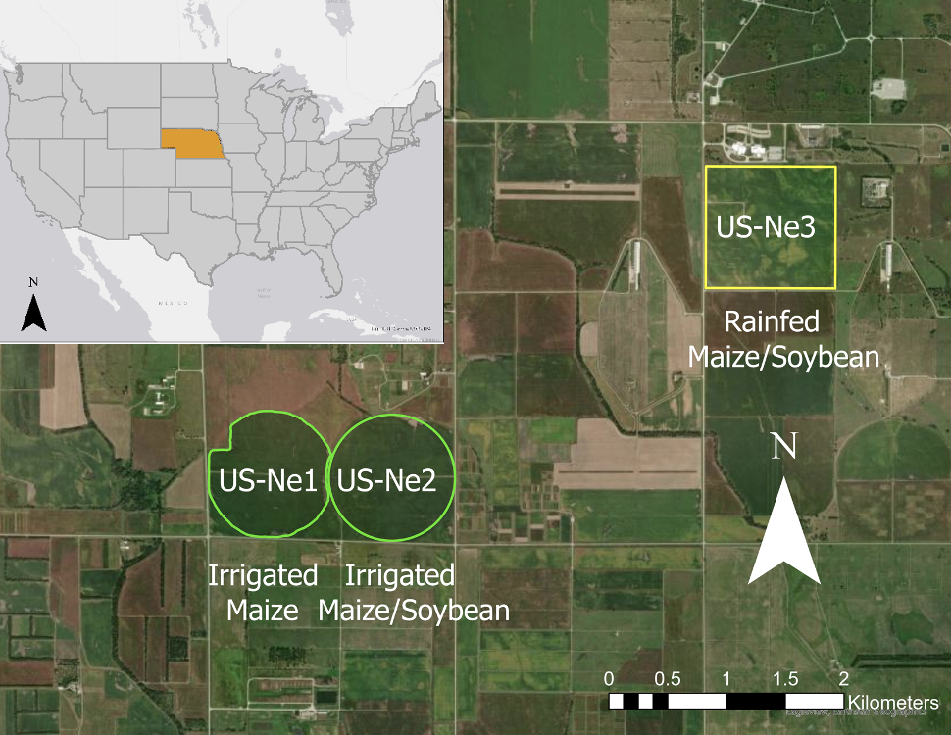

Figure 1. Study Area, showing the three sites (US-Ne1- Irrigated Maize, US-Ne2- Irrigated Maize and Soybean, US-Ne3- Rainfed Maize and Soybean) used for the study of prediction of root zone soil moisture. The soil moisture is measured at 4 different depths at each site using three probes spatially distributed at each site.

We chose three cropland sites in our study that have multiple years of soil moisture measurements and meteorological data. In addition to long term soil moisture data, these sites are managed cropland fields planted with maize or soybean each year. Two of the sites (US-Ne1 and US-Ne2) are irrigated and the third site (US-Ne3) is rainfed. US-Ne1 is planted with maize every year whereas maize is grown in alternate years in US-Ne2 and US-Ne3 and the sites are rotated with soybean harvests. Soil moisture probes are installed in 10cm, 25cm, 50cm and 100cm for all three sites. Each site has 3 sensors located in different areas of the field that measure soil moisture at different depths. We consider soil moisture at 10cm to represent surface soil moisture in this study (SSM).

This study focuses primarily on the soil moisture at 25cm depth for the prediction task. Although the roots for maize can reach deeper than 2 meters and for soybean the maximum rooting depth can be 1.8 meters, studies have shown that most of the water and nutrient uptake occurs for corn and soybean below 20cm depth. For example, Asborjsen et al. (2008) found using oxygen isotope techniques that annual crops like corn and soybean in the corn belt of the United States are shallow rooted. They utilized water predominantly from the upper 20 cm of the soil profile. They also note that these crops exhibited a low range of ecological plasticity, meaning they did not significantly change the depth of their water uptake even as soil moisture conditions changed. Feldman et al. (2023) using ECOSTRESS land surface temperature data and soil moisture data across CONUS also found that 93% of the sites had significant interactions with soil moisture at depths shallower than 20 cm. While this study looked at a broad range of ecosystems (croplands, grasslands and forests) rather than just crops, its findings indicate a widespread preference for shallow water uptake across vegetation types.

We calculate the soil moisture at these depths by taking the spatial average of the soil moisture measured at 3 sensors at each site. First, the 30-minute data are converted to daily values before spatially averaging. Our goal here is to estimate field averaged root zone soil moisture at 25cm using surface soil moisture at 10cm and other ancillary inputs. A total of 7 years of daily data is used from 2016 to 2022.

3 Materials and Methods

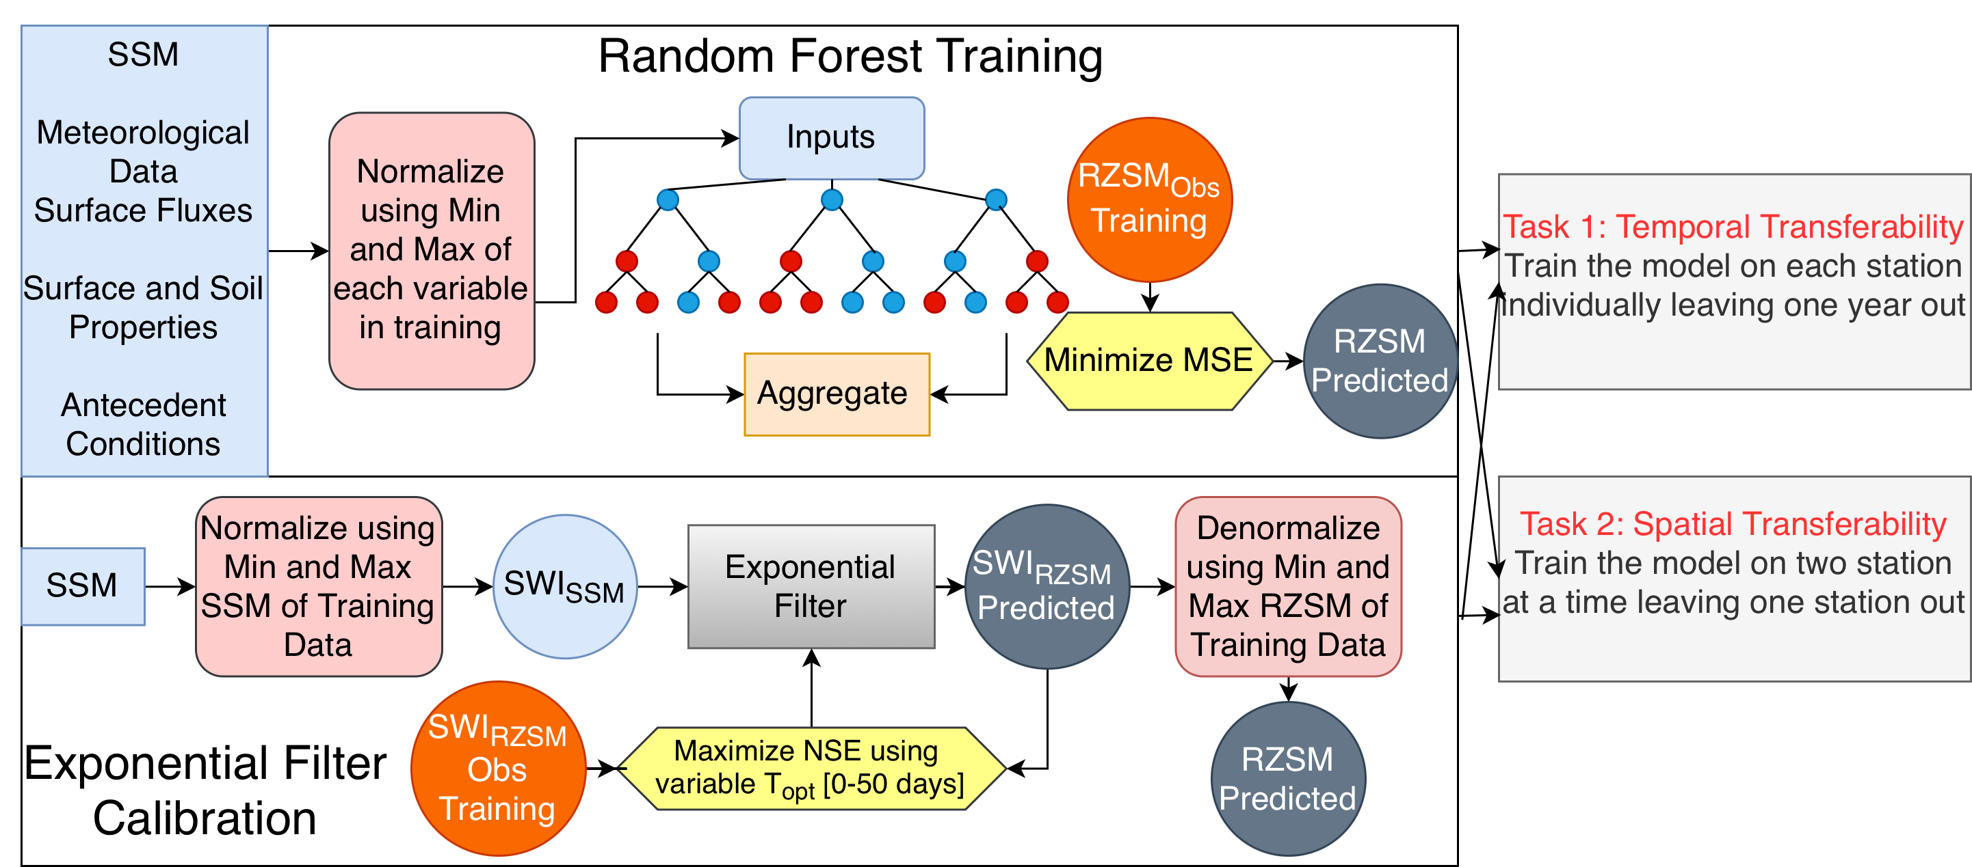

Figure 2. Flowchart of the models implemented in the study to predict RZSM. RZSM_{obs} is the measured root zone soil moisture measured at 25cm; SSM is the measured surface soil moisture at 10cm; SWI is the soil water index; MSE is the mean squared error; NSE is the Nash Sutcliffe Equation

In this study we employ data driven approach to assess the ability of surface soil moisture to predict root zone soil moisture at irrigated and rainfed crops. To assess the ability of the models to capture the RZSM patterns, we devised two experiments. The first is the temporal transferability, where we employ a leave-one-year-out approach. In this approach we train the model for all years except one and test on the neglected year, adopting the approach by Carranza et al. (2021). Since we use data from the year 2016 to 2022, we perform a 7-fold cross validation for each site training 6 years of data and testing on the remaining year. This process was repeated 7 times so that each year (from 2016-2022) served as the test set once.

The second, spatial transferability, used a leave one site approach (LOSO). This more challenging test assesses the model's ability to make predictions at a completely new location not included in the training data. For this task, the data was divided by training the model on the combined data from two sites and testing it on the third, completely unseen site. This process was repeated 3 times so each of the three sites served as the test set once. The same approach was used for both the RF and the exponential filter to keep our experiments consistent.

Our data driven models consist of a) exponential filter, a recursive data assimilation method that estimates RZSM from a time series of surface measurements. It operates by assigning exponentially decreasing weights to past observations, effectively capturing the 'memory' of the soil system through a single characteristic time length parameter (T). b) Random Forest model, which is an ensemble machine learning method that builds multiple decision trees and merges their outputs to create a more accurate and stable prediction.

3.1 Exponential Filter

The concept of the exponential filter for soil moisture, initially implemented by Wagner et al. (1999), is adopted in this study. Specifically, we employ the recursive formulation described by Stroud (1999). This approach is consistent with the standard recursive implementation established in the literature (Albergel et al., 2008; Ford et al., 2014). It begins with data normalization of the surface soil moisture values to soil water index (SWI). However, since we are interested in the physical units of soil moisture and not the relative wetness, we convert our estimates of root zone SWI back to m³/m³ units at the end of estimation. At first, raw and observed surface soil moisture (SSM_{obs}) is converted into a normalized value ranging from 0 to 1 using a min–max scaling, where the minimum (SSM_{min}) and maximum (SSM_{max}) values are derived from the training dataset:
$$SSM_{norm}(t_{n})=\frac{SSM_{obs}(t_{n})-SSM_{min}}{SSM_{max}-SSM_{min}}$$

This normalized value (SSM_{norm}) serves as the input (SSM(t_{n})) to the recursive algorithm, which estimates the predicted root zone Soil Water Index, SWI(t_{n}). The core of the filter is the state-update equation:
$$SWI(t_{n})=SWI(t_{n-1})+K_{n}⋅[SSM(t_{n})-SWI(t_{n-1})]$$

Here, SWI(t_{n-1})is the predicted root zone SWI from the previous time step, and K_{n} is a Kalman-gain that is updated at each step based on the characteristic time length, T:
$$K_{n}=K_{n-1}+e^{-\frac{(t_{n}-t_{n-1})}{T}}⋅K_{n-1}$$

The optimal characteristic time length (T) is identified during the training phase through an optimization routine. This involves systematically testing a range of T values (from 1 to 50 days in this study) on the training data and calculating a performance metric, the Nash Sutcliffe Efficiency (NSE) (McCuen et al., 2006), for each value. T that yields the highest NSE is selected as the optimal parameter for that training fold. This single, optimized T value is then used when the model is applied to the test data. Finally, to produce the result, the predicted root zone SWI is converted back into physical units (RZSM_{pred}) by reversing the normalization using the minimum (RZSM_{min}) and maximum (RZSM_{max}) values observed in the training data's root zone measurements:
$$RZSM_{pred}(t_{n})=SWI(t_{n})⋅(RZSM_{max}-RZSM_{min})+RZSM_{min}$$

3.2 Random Forest Model

To assess the feasibility of predicting root zone soil moisture (RZSM) from surface soil moisture (SSM) and ancillary data, we built a machine learning model based on random forests (Breimen et al., 2001). Random forests (RF) are an ensemble learning method that aggregates the predictions of many decision trees to produce a more stable and accurate output than any individual tree. Each tree in the forest is trained on a bootstrap sample i.e., a randomly drawn subset of the training data with replacement. This introduces variability among the trees and reduces the tendency to overfit. At each node split, the algorithm considers only a random subset of predictors rather than the full set. This layer of randomness helps decorrelate the trees, ensuring that no single predictor or pattern dominates the model’s structure. Because each tree captures different aspects of the predictor–target relationship, the ensemble collectively represents a wide range of possible outputs. The final prediction is obtained by averaging the outputs across all trees, which smooths out noise, improves generalization, and reduces variance. RF models naturally capture non-linear relationships and higher-order interactions among variables that would otherwise be missed in simpler regression frameworks.

The internal training process of the random forest builds its trees by finding data splits that minimize the mean squared error. However, to find the best overall model settings (hyperparameters), our tuning process was designed to find the model configuration that maximized the R². We tested 200 different hyperparameter combinations for each task. The tuning process was tailored for each experimental design:

For the temporal task, each of the 200 hyperparameter configurations was evaluated using the 7-fold splits. A model was trained on six years and validated on one hold-out year, and this was repeated for all seven years. The configuration that produced the highest average R² across these folds was selected as the optimal model, representing the system's cross-validated predictive capacity.

For the spatial task, tuning was performed within each of the 3 folds. For a given fold (e.g., training on US-Ne1 and US-Ne2), 20% of this training data was set aside as an internal validation set. We tested 200 hyperparameter configurations by training on the 80% subset and selecting the hyperparameter configurations with the highest R² on the 20% validation set. A final model with these settings was then re-trained on the entire US-Ne1 and US-Ne2 dataset before being used to predict the unseen US-Ne3 site.

3.3 Model Inputs to Random Forest

The selected input features represent a set of variables which can be used to capture the physical processes governing RZSM dynamics. The primary hydrological state, SSM and its lagged values (for 5, 10 and 15days), serves as the main predictor, representing the source of soil's short-term hydraulic memory. Meteorological variables such as precipitation, air temperature, relative humidity, wind speed and surface fluxes such as latent heat flux, net radiation and soil heat flux are included to capture the surface water and energy balance, quantifying water inputs (precipitation) and major outputs (such as evapotranspiration).

Dynamic soil and vegetation properties, such as NDVI, SWIR, and other optical bands, act as proxies for crop phenology and can also indicate moisture content in the soil. Lobell et al. (2002) also found that reflectance saturated at much lower moisture contents in the visible and near-infrared (VNIR) spectral region than in the shortwave-infrared (SWIR) spectral region, suggesting that longer wavelengths are better suited for measuring volumetric moisture contents above ∼20%. The reflectance data for this study is derived from Harmonized Landsat Sentinel S-30 dataset at 30m. Because these variables are available every 5 days, we linearly interpolate them each year to daily values to form our features after removing cloudy pixels.

For our spatial transfer task, we also utilized Alpha Earth Embeddings (AE) that are 10m in spatial resolution (Brown et al., 2025). These annual, annual embeddings are derived from a self-supervised machine learning model with input dataset of various satellite and weather data including gravity anomaly observations (GRACE) and spaceborne LiDAR (GEDI), alongside standard optical and radar inputs (Landsat 8/9, Sentinel-1, Sentinel-2, PALSAR, etc). We hypothesize that this unique combination allows the embeddings to store site characteristics that are not found in surface imagery by itself, for eg. GRACE contributes signals related to long-term terrestrial water storage and deep soil hydraulic trends, while GEDI captures vertical vegetation structure, serving as a proxy for crop phenology and rooting depth potential. We include AE bands to test if these inferred properties provide the necessary context for spatially transferring the model to unseen fields. Finally, because there is snowfall and frosting of the soil in the winter period in these sites, seasonal antecedent conditions such as winter precipitation, spring precipitation, summer average surface soil moisture, number of winter frozen days (days below 0deg C) etc. are used to characterize the system's long-term memory. These can be useful to establish the initial RZSM levels at the start of the growing season. (Orth and Seneviratne., 2012)

We also developed 2 RF models utilizing features from Table 1.

RF-Original: This baseline model utilizes only the concurrent daily SSM along with the meteorological and remote sensing inputs described in Table 1. It assumes that the current surface state and atmospheric drivers are sufficient to infer the root zone state.

RF-LaggedSSM: This variant adds to the feature space of the original model by including historical SSM observations. Specifically, we incorporated discrete antecedent SSM values from 5, 10, and 15 days prior to the prediction date (t) This results in an input vector containing ($SSM_{t},{SSM}_{t-5} , {SSM}_{t-10}, {SSM}_{t-15}$)

Table 1. List of features included in the random forest model. *. indicates features only used for the spatial transfer task and not for the temporal transfer.

Category | Variable Name | Symbol | Temporal Scale | Source
Hydrological State | Surface Soil Moisture | SSM | Daily | Station
 | Surface Soil Moisture Lagged | $${SSM}_{t-5} , {SSM}_{t-10}, {SSM}_{t-15}$$ | Lagged by 5,10 and 15 days | Station
Meteorological | Precipitation | P | Daily | Station
 | Air Temperature | Ta | Daily | Station
 | Relative Humidity | RH | Daily | Station
 | Wind Speed | WS | Daily | Station
Surface Fluxes | Incoming Net Radiation | Rs | Daily | Station
 | Latent Heat Flux | LE | Daily | Station
 | Soil Heat Flux | G | Daily | Station
Soil and vegetation Properties | Normalized Difference Veg. Index | NDVI | Every 5 days | HLS S30
 | Short-Wave Infrared Bands | SWIR | Every 5 days | HLS S30
 | Reflectance Bands | B1-B8 | Every 5 days | HLS S30
 | Alpha Earth Embeddings* | A0-A64* | Annual | Alpha Earth
Antecedent Conditions | Winter Acc Precipitation | P_{win} | Seasonal | Station
 | Spring Acc Precipitation | P_{spr}​ | Seasonal | Station
 | Spring Surface Moisture | SSM_{spr​} | Seasonal | Station
 | Winter Frozen Days | WF_{days} | Seasonal | Station
 | Spring Frozen Days | SF_{days} | Seasonal | Station
 | Winter Net Radiation | Rn_{win} | Seasonal | Station
 | Spring Net Radiation | Rn_{spr} | Seasonal | Station
 | Winter Solar Radiation | Rs_{win} | Seasonal | Station
 | Spring Solar Radiation | Rs_{spr} | Seasonal | Station

3.4 Metrics

Model performance was evaluated using the Root Mean Square Error (RMSE), Bias (Bias), coefficient of determination (R²). These metrics collectively assess the accuracy, bias, and agreement between the predicted (${\hat{y}}_{i}$) and observed ($y_{i}$) values across N samples.
$$\text{RMSE}=\sqrt{\frac{1}{N}\sum_{i=1}^{N}{}({\hat{y}}_{i}-y_{i})^{2}}$$
$$\text{Bias}=\frac{1}{N}\sum_{i=1}^{N}{}({\hat{y}}_{i}-y_{i})$$

$$R^{2}=1-\frac{\sum_{i=1}^{N}{}({\hat{y}}_{i}-y_{i})^{2}}{\sum_{i=1}^{N}{}(y_{i}-\overset{ˉ}{y})^{2}}$$where $\overset{ˉ}{y}$ is the mean of the observed values. The coefficient of determination (R²) quantifies how well the predictions explain the variance in the observations, with values closer to 1 indicating better agreement.

4. Results

4.1 Observed Soil Moisture Profiles in Growing Season

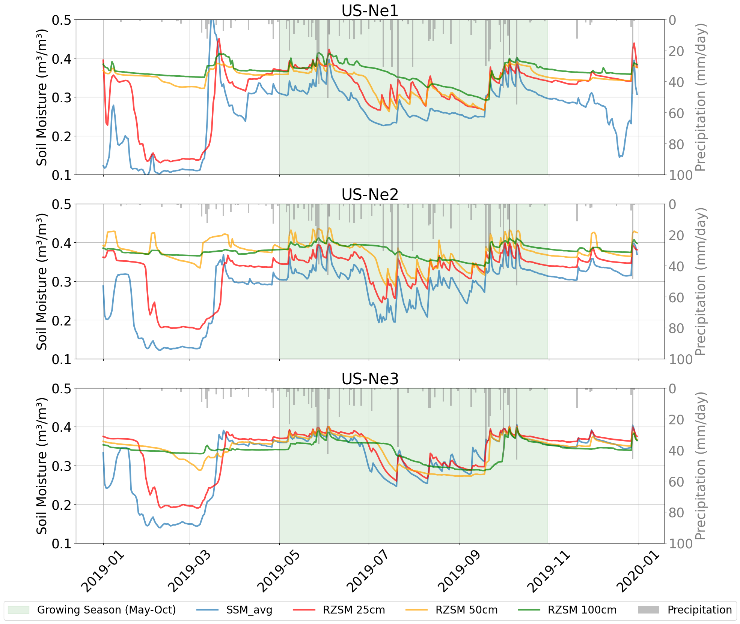

Figure 3. Time Series of Surface and Root Zone Soil Moisture in Response to Precipitation and Evapotranspiration at the three sites in an example year 2019. From top to bottom (US-Ne1- Irrigated, US-Ne2-Irrigated, US-Ne3-Rainfed). Growing season is depicted in green shade. SSM represents 10cm depth.

The 2019 time series with maize reveals distinct soil moisture dynamics particularly in magnitude of soil moisture values (see Figure 3). The summer season or the growing season in Nebraska receives significant amount of rainfall, therefore even the rainfed site has similar soil moisture profile to the irrigated sites. All sites have relatively high soil moisture values at 10cm, 25cm and 50cm ranging from 0.20-0.40m³/m³ in the growing season for the three sites. All three sites also show a seasonal dry down in July. The irrigated sites (US-Ne1 and US-Ne2) however maintain a strong vertical stratification of drier surface and wetter root zone. This is because of irrigated regimes that are observed in US-Ne1 and US-Ne2 sites where irrigation saturates the rootzone while surface quickly dries by evaporation. This leads to a larger separation between the RZSM and SSM values. In contrast, the rainfed US-Ne3 site displays a tightly coupled profile with less separation in soil moisture between the layers.

4.2 Observed relationship between surface and RZSM

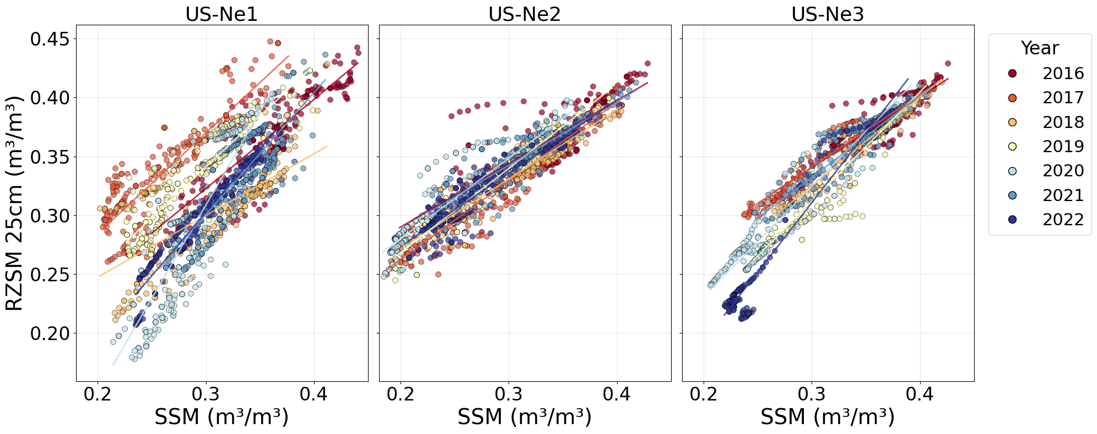
c)
b)
a)

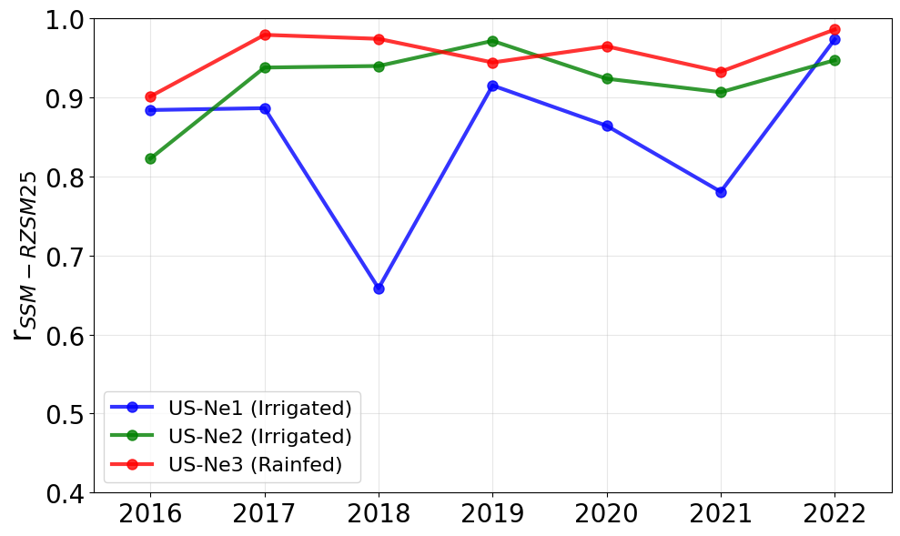
d)

Figure 4. The relationship between observed surface soil moisture at 10cm and observed root zone soil moisture at 25cm, a), b) and c) are scatter plots showing how the RZSM 25cm relates to SSM values. d) shows the interannual variation of the coupling between RZSM 25cm and SSM during growing season (May-Oct).

Figures 4a, 4b, and 4c display the relationship between daily SSM and RZSM 25cm for each site from 2016 to 2022. At all three locations, higher surface moisture is associated with higher root zone moisture. The rainfed site (US-Ne3) exhibits the strongest and most linear relationship, The irrigated sites(US-Ne1, US-Ne2), particularly US-Ne1, show a greater degree of scatter. At these sites, there are numerous instances where the RZSM at 25cm remains high (e.g., above 0.35) even when the SSM is at lower values (e.g., below 0.30), a pattern consistent with irrigation maintaining wet conditions in the root zone while the surface dries. Furthermore, the slope of the relationship, as indicated by the regression lines, varies from year to year, especially at US-Ne1, suggesting that the sensitivity of the root zone to surface conditions changes annually.

Figure 4d. quantifies the interannual variability of this coupling by plotting the Pearson correlation coefficient (r) for each year in the growing season. Both the irrigated US-Ne2 and the rainfed US-Ne3 sites demonstrate a consistently high degree of correlation, with R-values almost always above 0.9. In contrast, the irrigated US-Ne1 site shows significant interannual variability in its coupling strength. The correlation is high in some years (e.g., 2019 and 2022) but drops markedly in others, reaching a low of approximately 0.66 in 2018. Why Ne1 shows the relationship differently from the other size is not clear at present, but the following offers insight.

Meteorology: The relationship of root zone soil moisture with surface changes each year based on the annual precipitation, evapotranspiration. Since this study is based in the same region, with the fields being separated by 1.5km apart at maximum, these meteorology factors are unlikely the cause.

Soil texture: Probabilistic estimates from the POLARIS shows a distinct textural profile at US-Ne1, which has significantly higher surface clay content (~35%) compared to the profiles (~22% clay) found at the stable US-Ne2 and US-Ne3 sites in the top 30cm profile (see Table S1.).

Management (Tillage): Unlike the no-till practices at the other sites, US-Ne1 undergoes annual conservation-plow tillage. We hypothesize that the interaction between this mechanical disturbance and the site's elevated clay content potentially alters surface hydraulic conductivity and infiltration rates from year to year (Strudley et al., 2008), which may contribute to the observed instability in surface-subsurface coupling.

4.3 Temporal Transferability

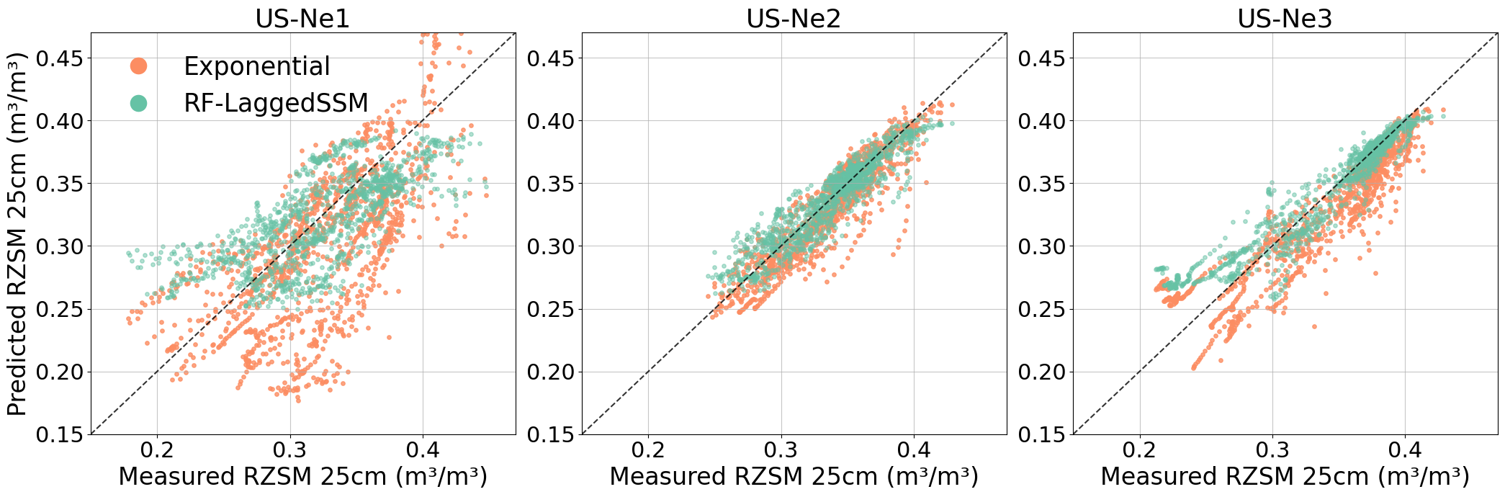

Figure 5. Scatter plot observed RZSM 25cm at the three sites comparing RF predicted RZSM and exponential filter. The points represent results from testing years that are not used during training.

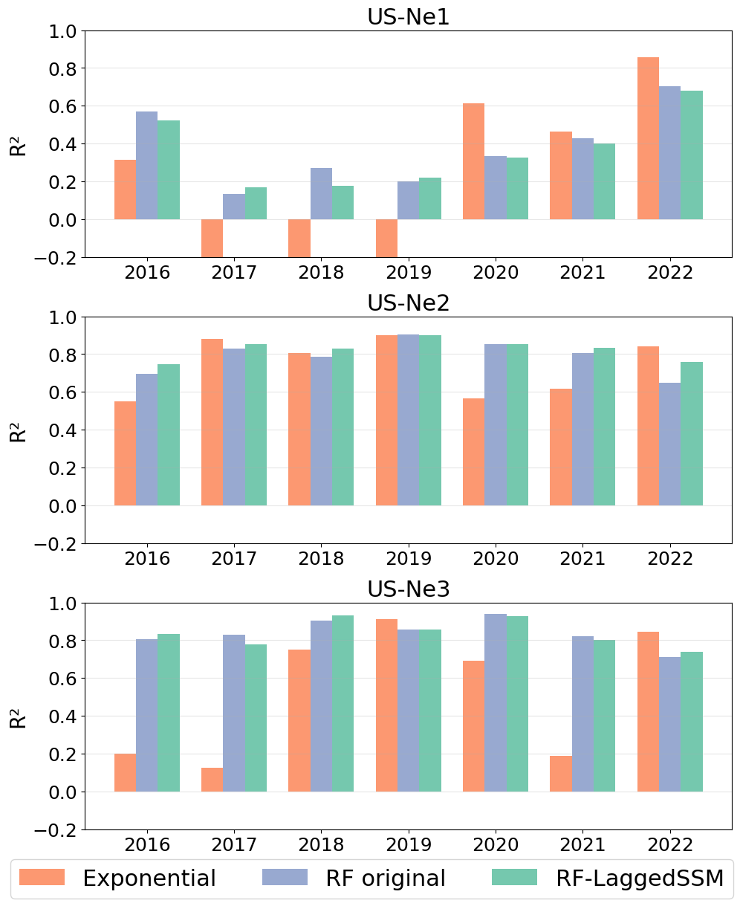

Figure 6. Comparing annual R² values of temporal transfer with RF original, RF using lagged SSM from 5 days to 15 days, and exponential filter. The year shown was excluded from training but was used for validation.

Table 2. Temporal transferability result showing the uncertainty in predicting RZSM at 25cm using Exponential filter, Random Forest original and with time-lagging input SSM by 5, 10 and 15 days.
Station | Exponential |  |  |  | RF Original |  |  |  | RF Lagged SSM
 | R² | Bias (m³/m³) | RMSE (m³/m³) | Corr | R² | Bias (m³/m³) | RMSE (m³/m³) | Corr | R² | Bias (m³/m³) | RMSE (m³/m³) | Corr
US-Ne1 | -0.01 | -0.02 | 0.04 | 0.67 | 0.51 | -0.0008 | 0.03 | 0.71 | 0.50 | -0.001 | 0.11 | 0.70
US-Ne2 | 0.79 | -0.005 | 0.01 | 0.91 | 0.83 | 0.001 | 0.01 | 0.91 | 0.86 | 0.0007 | 0.01 | 0.92
US-Ne3 | 0.80 | -0.01 | 0.02 | 0.92 | 0.87 | 0.003 | 0.01 | 0.94 | 0.87 | 0.004 | 0.01 | 0.95
Average | 0.52 | -0.013 | 0.03 | 0.81 | 0.73 | 0.001 | 0.024 | 0.86 | 0.74 | 0.001 | 0.024 | 0.86

The performance of evaluating the temporal transferability is summarized in the Table 2 and in Figure 5. The validation was performed in the year noted in Figure. 6, after training in the other years from 2016-2022. The results indicate that both the Random Forest (RF) and exponential filter models achieve accurate time-series interpolation at the irrigated US-Ne2 and rainfed US-Ne3 sites. Notably, these two sites undergo an annual crop rotation between maize and soybean. Although explicit crop type labels were not included as input features, the RF model successfully captured the distinct water uptake dynamics of these rotations. The RF-LaggedSSM model yielded average R² values of 0.86 and 0.87 for US-Ne2 and US-Ne3, respectively, with low RMSE values of 0.024. This confirms that the model consistently captured the temporal variance driven by changing crop phenology at these locations. Strong performance was also observed for the Exponential Filter at these two sites (R² = 0.79, 0.80). In contrast, model performance was significantly lower and more variable at the irrigated US-Ne1 site (R²= 0.50). Unlike the other sites, US-Ne1 is managed as continuous maize. Since the crop type remains constant, the reduced

performance cannot be attributed to the model failing to adapt to rotation complexity. This could be due to managements practices on the field such as, annual conservation tillage and higher clay content in the soil compared to the other two sites.

The US-Ne1 site also showed greater variability in RZSM-SSM coupling each year and the RZSM relationship with SSM also changed significantly annually as given by the Figure 4a, 4b,4c and 4d. Consequently, a model trained on a year with train set have a year of strong coupling (e.g., 2019) could fail to predict RZSM in a year with weak coupling (e.g., 2018), leading to the observed performance degradation.

The target application of this study is in agricultural water management, where crops rotate interannually. Therefore Figure 5 presents multi-year performances. The RF model performances are very consistent and the low average R² for the US-Ne1 site is driven by particularly poor performance in certain years, such as 2017, 2018 and 2019 for the RF models.

4.4 Spatial Transferability

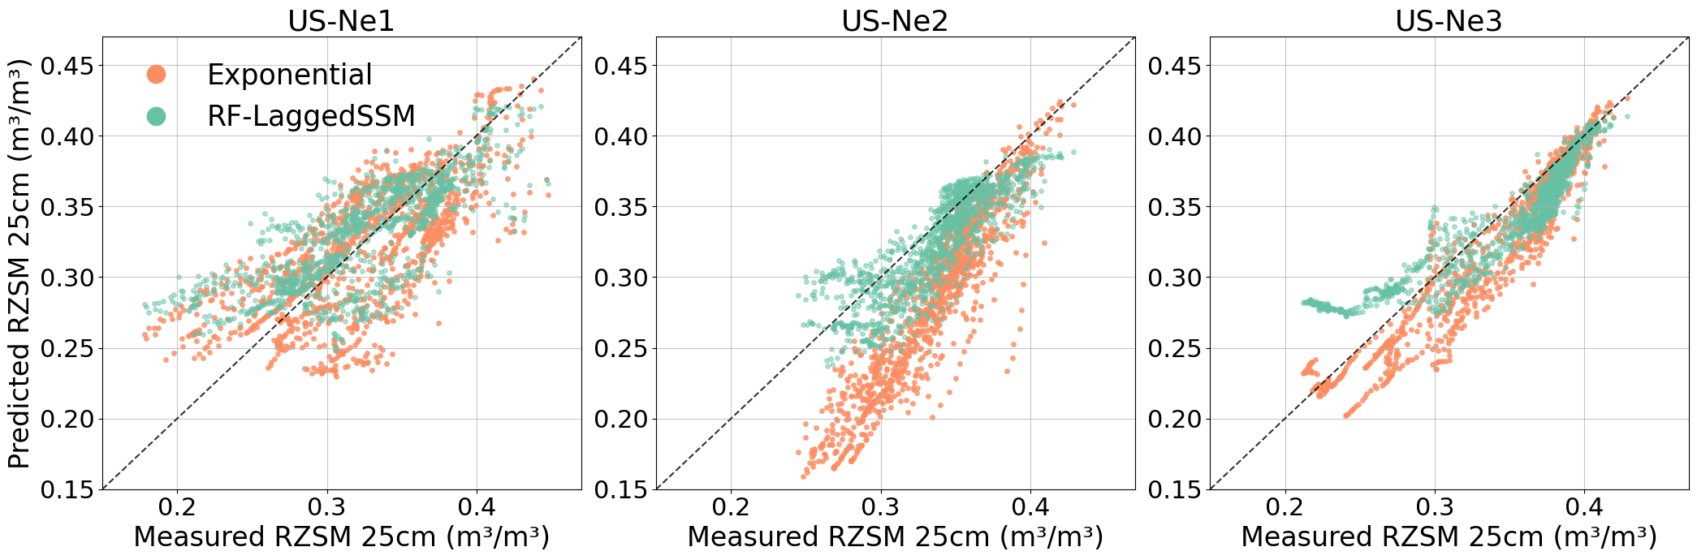

Figure 7. Scatter plots of measured vs. predicted RZSM (25cm) for the spatial transferability (leave-one-site-out) experiment. Results are shown for the Exponential filter (orange) and the RF-LaggedSSM model (teal) at the irrigated sites (US-Ne1, US-Ne2) and the rainfed site (US-Ne3). The dashed black line represents the 1:1 agreement line.

Table 3. Spatial transfer performance showing the uncertainty in predicting RZSM at 25cm using Exponential filter, RF and RF with lagged SSM features by 5,10 and 15 days from the date of prediction. Validation was performed using the data from the site, while the data from the other two sites trained the model.
Station | Exponential |  |  |  | RF Original |  |  |  | RF Lagged SSM
 | R² | Bias (m³/m³) | RMSE (m³/m³) | Corr | R² | Bias (m³/m³) | RMSE (m³/m³) | Corr | R² | Bias (m³/m³) | RMSE (m³/m³) | Corr
US-Ne1 | 0.47 | -0.003 | 0.035 | 0.70 | 0.52 | 0.007 | 0.033 | 0.774 | 0.54 | 0.005 | 0.032 | 0.751
US-Ne2 | -1.36 | -0.043 | 0.053 | 0.87 | 0.65 | -0.005 | 0.020 | 0.837 | 0.56 | -0.008 | 0.022 | 0.812
US-Ne3 | 0.83 | -0.012 | 0.021 | 0.94 | 0.70 | -0.004 | 0.028 | 0.886 | 0.79 | -0.003 | 0.023 | 0.920
Average | -0.02 | -0.019 | 0.036 | 0.83 | 0.62 | -0.0007 | 0.0270 | 0.8323 | 0.63 | -0.002 | 0.025 | 0.827

The performance of the spatial transfer experiment is given in Table 3.

• On average, the RF models provided the most robust predictions. The RF-LaggedSSM model achieved the best mean performance with an R² of 0.63. In contrast, the exponential filter was inconsistent and unreliable, with a poor average R² of -0.02, driven by a complete model failure at US-Ne2 site.

• Both models performed best when validated on the rainfed site (US-Ne3). The RF-LaggedSSM achieved highest R² (0.79). The exponential filter also produced strong performance only at this validation site (R² = 0.83). Conversely, both models struggled when validated on the irrigated sites, which introduce hydrological dynamics not uniformly seen in the training data. The RF-LaggedSSM

model's performance dropped at the irrigated US-Ne1 (R² = 0.54) and US-Ne2 (R² = 0.56) sites. The exponential filter's performance completely collapsed at the irrigated US-Ne2 site (R² = -1.36).

• At the irrigated US-Ne1 site (left panel) in Fig 7, the RF-laggedSSM model maintains a reasonable fit, but the exponential filter shows significant scatter, tending to underpredict RZSM. At the irrigated US-Ne2 site (center panel), the RF model's predictions are scattered but centered, whereas the exponential filter's predictions are completely detached and have a negative bias.

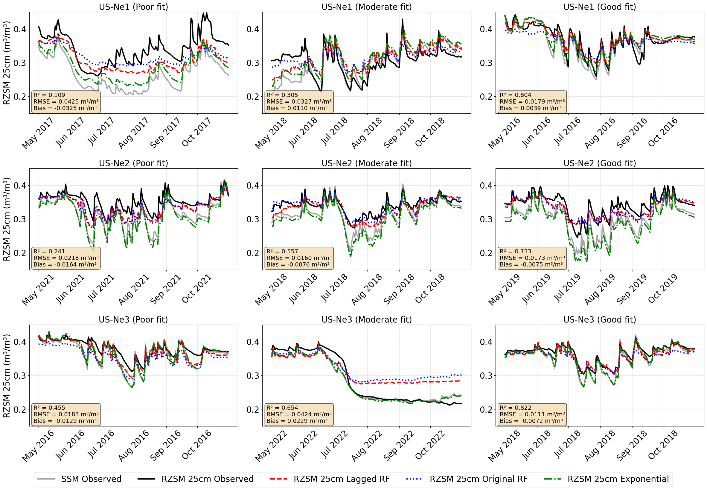

Figure 8. Time-series of RZSM for the unseen sites, showing the range of predicted RZSM using three approaches (RF, RF-laggedSSM and Exponential filter). Three example years for each site are chosen based on the results of the RF-laggedSSM R². Poor fit is the R² that is closest to the 10%ile of R² of all years, moderate fit is the median R² of all years and the good fit is the 90%ile of the seven years. Results annotated in the figure are from the RF-laggedSSM model.

Figure 8 illustrates these dynamics over time. The good-fit plots (right column), show that the RF models tracking the observed RZSM (black line) well. However, the poor-fit plots (left column) reveal the RF model weaknesses. At US-Ne1 (top-left), all three models underestimate RZSM although both RF models perform better than the exponential filter. This underestimation is also seen fir the Poor fit timeseries at US-Ne2. Even though in US-Ne3, during a poor fit year (bottom-left), the models fail to capture the magnitude of the dry-down, the errors are less than at the irrigated site. Typically, we observe that the exponential filter traces the surface soil moisture line and performs well for years when the SSM and RZSM have similar values. This is seen at US-Ne3 where the SSM and RZSM is always very similar in magnitude. However, at US-Ne2 site the RZSM at 25cm is always higher than the SSM and this feature of this site is not detected by the exponential filter because it only relies on SSM as an input. At the US-Ne1 site this difference in magnitude of SSM and RZSM varies annually, therefore we observe that the models struggle to provide reliable RZSM estimate at this station.

5. Discussion

5.1 Dominant parameters characterizing Random Forest Model Predictions

5.1.1 Temporal Transferability

Table 4. Ablation study showing the sensitivity of model performance change of random forest model for the temporal transferability task.

Model Inputs | R²  (All) | R²  (Ne1) | R²  (Ne2) | R²  (Ne3)
All features without SSM | 0.34 | 0.26 | 0.35 | 0.42
Only SSM and SSM Lagged | 0.69 | 0.52 | 0.72 | 0.83
All features without Precip | 0.70 | 0.41 | 0.84 | 0.85
All features without Meterology [Ta,RH,ET,WS] | 0.74 | 0.51 | 0.83 | 0.86
All features without lagged SSM | 0.74 | 0.51 | 0.83 | 0.87
All features | 0.74 | 0.51 | 0.83 | 0.87
All features without Sentinel 2 inputs  [Optical+SWIR+NDVI] | 0.75 | 0.50 | 0.87 | 0.88

We conducted an ablation study for the temporal transferability (leave-one-year-out) RF model to identify the most important features for predicting RZSM within a site across different years (Table 4). The model's predictive power was found to be almost entirely derived from surface soil moisture (SSM). The full temporal model, which included all features, achieved a strong mean R² of 0.74. However, removing only the SSM inputs caused the mean R² to reduce to 0.34 and dropping by more than 50% at each individual site.

Most other inputs were found to be largely redundant. This is most clearly demonstrated by the only SSM and SSM Lagged model, which achieved a mean R² of 0.69. This performance, based almost entirely on SSM time series, accounts for 93% of the full model's (R²=0.74) predictive power. Further, removing the entire suite of meteorological data (air temperature, relative humidity, ET, and wind speed) from the full model had no effect on the mean R² (0.74). Similarly, removing all daily Sentinel-2(S2) inputs (reflectance, SWIR, and NDVI) also had no negative impact, and in fact, slightly improved performance (R² = 0.75). This strongly suggests that the daily SSM measurement effectively integrates and already contains the predictive information and any signal supplied by other daily weather and optical inputs, are surplus for temporal predictions.

The only other variable with a discernible, albeit minor, impact was precipitation. Removing precipitation from the full model resulted in a small drop in mean R² from 0.74 to 0.70. This indicates that while SSM captures the current moisture state, the model gains a slight predictive advantage from also knowing the primary driver of moisture (i.e., the rain event itself). Overall, the temporal model learns a simple relationship dominated by the current SSM value.

5.1.2 Spatial Transferability

Table 5. Ablation study showing the sensitivity of random forest model performance to input features for the spatial transferability task

Model Inputs | R²  (All) | R²  (Ne1) | R²  (Ne2) | R²  (Ne3)
All features without SSM | 0.336±0.130 | 0.27 | 0.48 | 0.24
All features without remote sensing inputs  [S2 Bands +AE] | 0.42±0.370 | 0.42 | 0.04 | 0.8
All features without Alpha Earth Embeddings (AE) | 0.570±0.170 | 0.48 | 0.48 | 0.77
All features without Precip | 0.628±0.084 | 0.53 | 0.64 | 0.70
All features without Meterology [Ta,RH,ET,WS] | 0.631±0.080 | 0.54 | 0.66 | 0.70
All features without Sentinel 2 inputs  [Optical+SWIR+NDVI] | 0.636±0.107 | 0.53 | 0.62 | 0.75
All features | 0.641±0089 | 0.54 | 0.68 | 0.70

To understand the key drivers of its spatial transferability, we performed an ablation study (Table 5). The full model, incorporating all features, achieved a strong mean R² of 0.641 (±0.089), though performance varied by site. The most critical predictor was surface soil moisture (SSM) at 10cm; removing only this feature caused the mean R² to reduce to 0.336, a performance reduction observed uniformly across all three sites.

Additionally, to characterize changes in surface characteristics we added Alpha Earth (AE) embedding, which provides a 64-dimension summary of the site's entire spatio-temporal context each year. The AE embeddings were developed using data from multiple satellites, including Sentinel-1, Sentinel-2, Landsat 8/9 and other datasets. This makes its interaction with other remote sensing datasets such as our daily interpolated Sentinel2(S2) bands within a machine learning model more complex. We observe that the removal of only S2 bands (optical, SWIR, NDVI) had a minimal impact on performance (R²= 0.641 vs. R²= 0.636). In contrast, removing the annual AE embedding caused a significant performance drop from R²= 0.641 to R²=0.570, indicating the model relies more on the AE dataset for spatial transfer. However, this does not mean that the S2 bands do not contribute to spatial transfer task as removing both AE and S2 from the dataset reduces the R² to 0.42. This suggests that in presence of AE annual bands, the model considers the S2 signal redundant but derives value from the S2 data in the absence of AE bands.

The model's dependence on the AE embeddings and S2 bands helps improve spatial performance specially for irrigated sites. This is observed when R² at both irrigated sites reduce by 0.06 at US-Ne1 and by 0.2 at US-Ne2 when AE bands are removed from the model and further reduce by 0.12 and 0.62 at US-Ne1 and US-Ne2 sites respectively when both AE and S2 bands are removed. We hypothesize that the model learned a rule that was specific to the irrigated sites during training. When training on a fold with one of the irrigated sites, the model learned to associate the irrigated fingerprint of those sites with specific soil moisture outcomes. This rule was critical for predicting US-Ne2, as AE was the main feature which leads to a better performance at Ne2. Without AE the predicted RZSM by the models underestimate by 3.64 to 5.5% (see Table S2) Specifically, the RF model placed high importance on dimensions A09 (consistent across sites) and A02/A47 (prominent at irrigated sites) (see Figure S1). We can interpret these features as indicators of the site's hydrological baseline. While US-Ne2 shows a high correlation between surface and root zone moisture (they fluctuate together), the magnitude of the root zone moisture is consistently higher than the surface. These AE dimensions effectively categorize the site as 'irrigated,' teaching the model to apply a site-specific upward shift to its predictions. This allows the model to correctly estimate the higher baseline moisture levels at US-Ne2, preventing the systematic underestimation that occurs when using surface moisture alone. While AE provides the background (identifying the site as "irrigated"), the S2 inputs provide the daily updates on the crop's condition. Since the S2 data is interpolated to daily values, it allows the model to track day-to-day changes in crop phenology. Feature importance analysis (Figure S1) confirms that the model relies on a combination of NDVI (vegetation greenness), Band 8 (NIR), and Band 12 (SWIR, sensitive to soil/canopy water content) across all three stations. Therefore, while AE sets the baseline expectation that the field is irrigated, these S2 bands confirm when the crop is actively growing. This daily signal contributes to spatial transferability in US-Ne2. Therefore when both AE and S2 bands are removed; without it, the model cannot detect the presence of irrigation or the phenology, leading to the complete performance collapse (R²= 0.04) at US-Ne2. This is also observed at US-Ne1 but to a lesser extent because the RZSM at US-Ne1 is not elevated compared to SSM magnitude in every year, therefore even though the performance drops, the predictions doesn’t completely collapse. (R²=0.48 without AE and R²=0.42 without both AE and S2)

Finally, daily meteorological and precipitation inputs were found to be largely redundant (R² 0.631 and 0.628, respectively), likely because their predictive information was already encapsulated within the more dominant SSM measurements.

These findings offer insight on understanding the contrast in the ablation experiments between the temporal and spatial transferability. For the temporal transferability within a known site, the model learns a simple and physically driven relationship dominated by SSM, resolving merely time-series forecasting. For the spatial transferability trying to estimate at an independent site, however, the task is far more complex. There, the model must first identify the site's unknown characteristics (irrigated vs. rainfed, crops, soil texture, etc) before it can apply the correct physical rules. This is why the contextual AE embedding was the most critical feature for spatial transferability, whereas for temporal prediction, the SSM measurement was the major feature that that contributed to the higher R².

5.2 Random Forest Model Performance with Root Zone Soil Moisture Depth
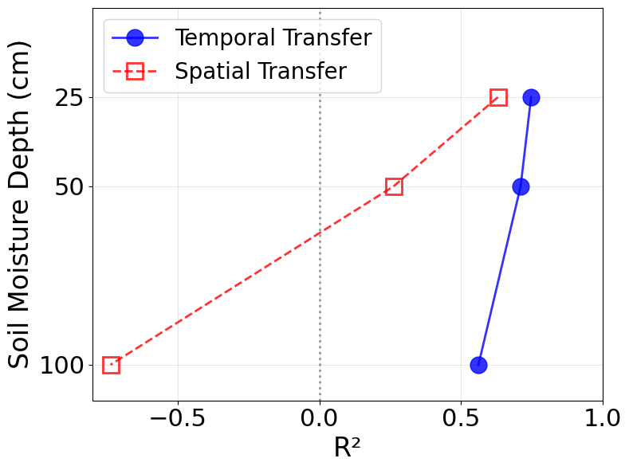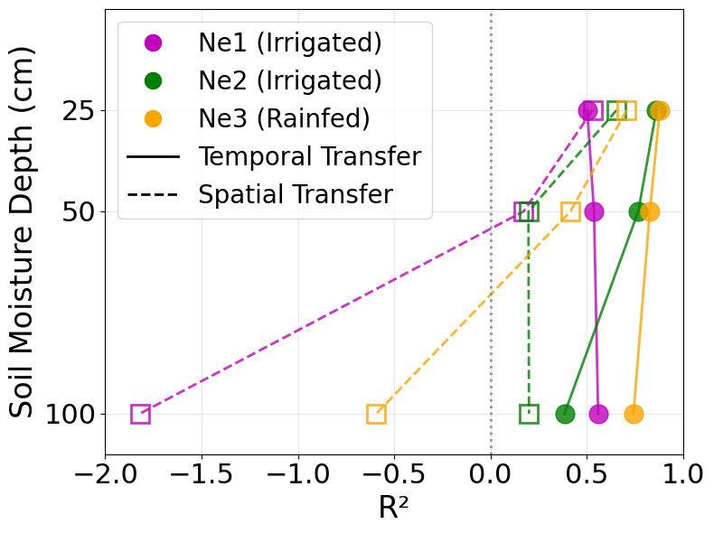

Figure 9. (Left) R² averaged across the three sites for temporal transfer and spatial transfer. For RZSM 25cm we picked the best performing RF model, for 50cm and 100cm predictions, we used a model with lagged SSM from 5- 15days. (Right) Same as the left plot but for individual sites.

To assess the model's robustness at greater soil depths, the temporal and spatial transfer experiments were replicated for 50cm and 100cm RZSM (Figure 9). The results reveal a contrast in performance between the two modeling tasks. The temporal transfer model demonstrates high performance even at significant depths. The high R² at 25cm (0.74) is largely maintained at 50cm (0.70) and remained effective at 100cm (0.55). The best temporal transferability performance was observed at the rainfed US-Ne3 across the three depths, which suggests that the year-to-year RZSM patterns at the rainfed site is more consistent and predictable from surface data than those at irrigated sites which are subject to variable inputs due to management. Overall, the model is highly capable of learning the unique, site-specific hydraulic relationships within the soil column and successfully generalizing them to unseen years for that same location.

In contrast, the spatial transfer model's predictive skill degraded severely with depth. While effective at 25cm (mean R² = 0.63), performance dropped sharply at 50cm (mean R² = 0.26). At 100cm, the model failed, yielding a mean R² of -0.73. An R² value below 0.0 indicates that the model's predictions are less accurate than a baseline model predicting the historical mean. This failure was particularly pronounced at the irrigated US-Ne1 site (R² = -1.82) and the rainfed US-Ne3 site (R² = -0.59). This finding strongly suggests that while the model is highly effective at predicting time-series variations within a known site, it is unable to learn the complex, site-specific characteristics that govern deeper soil moisture at new locations. More information might be needed to effectively represent the spatial heterogeneity of how water distributes vertically such as vertical infiltration of water and consumption by roots at depths. Our current set of ancillary data (AE and S2) only describes the surface characteristics and is unable to assist the RZSM estimate as the depth increases.

6. Conclusion

This study applies a Random Forest model to test the feasibility of using surface soil moisture to estimate root zone soil moisture over three irrigated and rainfed agricultural fields. Our model shows that data driven approaches outperform the exponential filter (data assimilation into a simple model) by leveraging the 10-cm depth surface soil moisture and other ancillary variables to accurately predict root zone soil moisture at 25cm depth.

For the temporal transfer task (for interpolation or extrapolation of a RZSM for the same site), RF model (R²=0.74) yields better prediction results over the exponential filter method (R²=0.52). The most important input to the RF model is SSM that makes the other inputs secondary input to the model. SSM naturally is the most influential in the method as the filter only uses SSM as input.

For the spatial transfer task, the RF model is also able to perform well (site averaged R²=0.63) to predict RZSM at 25 cm, with the highest performance observed at the rainfed US-Ne3 site (R²=0.71). In contrast, the exponential filter failed to generalize (R²=-0.02). This failure highlights a fundamental limitation of the recursive filter that unlike machine learning frameworks, it lacks the mechanism to ingest high-dimensional ancillary variables, making it unable to account for site-specific heterogeneity. However, even for agricultural fields located at such proximity (two sites being irrigated and one site being rainfed), the spatial transfer task requires ancillary variables such as Alpha Earth Embeddings and Sentinel-2 reflectance bands, as without these inputs the model performance is lowered from R²=0.63 to R²=0.42. These remote sensing-based inputs are key to predict the RZSM over irrigated sites such as US-Ne1 and US-Ne2, which is because of their capability to identify the irrigation regimes and track crop phenology via S2 bands (NDVI, NIR, SWIR) to our hypothesis. This information enables the model to apply a site-specific magnitude correction, effectively resolving the systematic offset between surface and root zone moisture found in managed irrigated fields of US-Ne1 and US-Ne2.

Our results reveal a distinct contrast in the RZSM estimate capability between the temporal and spatial transfers. In temporal transfer experiments, the random forest model provided reliable estimates up to 50 cm, with performance at 25 cm (R²=0.74) and 50 cm (R²=0.70) remaining highly consistent. Even at 100 cm, the model retained moderate predictive skill (R²=0.55). In contrast, the spatial transfer model failed to generalize at depths deeper than 25 cm. While performance was robust at 25 cm (R²=0.63), predictive accuracy degraded severely at 50 cm (R²=0.26) and failed entirely at 100 cm (R²=-0.73). This depth-dependent failure indicates that our current ancillary remote sensing inputs (Alpha Earth and Sentinel-2) only effectively characterize surface and near-surface properties. These variables are unable to assist in estimating RZSM as depth increases, likely because they fail to capture the spatially variable physics of deep drainage and root water consumption at unseen locations.

Acknowledgement

We also thank Prof. Andrew Suyker for providing in situ data and his assistance in characterizing irrigation timing at the AmeriFlux stations. We appreciate the insights provided by Prof. Dani Or regarding the identification of frozen intervals in the soil moisture record. The research was conducted in part supported by the NASA grant 80NM0018F0591.

Open Research
The raw data for measured soil moisture estimates in the Nebraska sites US-Ne1, US-Ne2 and US-Ne3 can be found in the Ameriflux website https://ameriflux.lbl.gov/tag/data-download/#. Code availability: The model setup and runs on the preprocessed data is publicly available at https://doi.org/10.5281/zenodo.17804906
Conflict of Interest Disclosure
The authors declare there are no conflicts of interest for this manuscript.
References
Albergel, C., Rüdiger, C., Pellarin, T., Calvet, J.-C., Fritz, N., Froissard, F., et al. (2008). From near-surface to root-zone soil moisture using an exponential filter: an assessment of the method based on in-situ observations and model simulations. Hydrology and Earth System Sciences, 12(6), 1323–1337. https://doi.org/10.5194/hess-12-1323-2008
Aminzadeh, M., & Or, D. (2014). Energy partitioning dynamics of drying terrestrial surfaces. Journal of Hydrology, 519, 1257–1270. https://doi.org/10.1016/j.jhydrol.2014.08.037
Asbjornsen, H., Shepherd, G., Helmers, M., & Mora, G. (2008). Seasonal patterns in depth of water uptake under contrasting annual and perennial systems in the Corn Belt Region of the Midwestern U.S. Plant and Soil, 308(1–2), 69–92. https://doi.org/10.1007/s11104-008-9607-3
Babaeian, E., Paheding, S., Siddique, N., Devabhaktuni, V. K., & Tuller, M. (2021). Estimation of root zone soil moisture from ground and remotely sensed soil information with multisensor data fusion and automated machine learning. Remote Sensing of Environment, 260, 112434. https://doi.org/10.1016/j.rse.2021.112434
Breiman, L. (2001). Random Forests. Machine Learning, 45(1), 5–32. https://doi.org/10.1023/A:1010933404324
Brown, C. F., Kazmierski, M. R., Pasquarella, V. J., Rucklidge, W. J., Samsikova, M., Zhang, C., et al. (2025, September 8). AlphaEarth Foundations: An embedding field model for accurate and efficient global mapping from sparse label data. arXiv. https://doi.org/10.48550/arXiv.2507.22291
Carranza, C., Nolet, C., Pezij, M., & van der Ploeg, M. (2021). Root zone soil moisture estimation with Random Forest. Journal of Hydrology, 593, 125840. https://doi.org/10.1016/j.jhydrol.2020.125840
Cordova, J. R., & Bras, R. L. (1981). Physically based probabilistic models of infiltration, soil moisture, and actual evapotranspiration. Water Resources Research, 17(1), 93–106. https://doi.org/10.1029/WR017i001p00093
Crow, W. T., Kustas, W. P., & Prueger, J. H. (2008). Monitoring root-zone soil moisture through the assimilation of a thermal remote sensing-based soil moisture proxy into a water balance model. Remote Sensing of Environment, 112(4), 1268–1281. https://doi.org/10.1016/j.rse.2006.11.033
Das, N. N., & Mohanty, B. P. (2006). Root zone soil moisture assessment using remote sensing and vadose zone modeling. Vadose Zone Journal, 5(1), 296–307. https://doi.org/10.1016/j.rse.2006.11.033
Feldman, A. F., Koster, R. D., Cawse‐Nicholson, K., Crow, W. T., Holmes, T. R. H., & Poulter, B. (2024). Soil Moisture Profiles of Ecosystem Water Use Revealed With ECOSTRESS. Geophysical Research Letters, 51(8), e2024GL108326. https://doi.org/10.1029/2024GL108326
Ford, T. W., Harris, E., & Quiring, S. M. (2014a). Estimating root zone soil moisture using near-surface observations from SMOS. Hydrology and Earth System Sciences, 18(1), 139–154. https://doi.org/10.5194/hess-18-139-2014
Gao, X., Zhao, X., Brocca, L., Pan, D. and Wu, P. (2019). Testing of observation operators designed to estimate profile soil moisture from surface measurements. Hydrological Processes, 33(4), pp.575-584. https://doi.org/10.1002/hyp.13344
González-Zamora, Á., Sánchez, N., Martínez-Fernández, J., & Wagner, W. (2016). Root-zone plant available water estimation using the SMOS-derived soil water index. Advances in Water Resources, 96, 339–353. https://doi.org/10.1016/j.advwatres.2016.08.001
Karpatne, A., Atluri, G., Faghmous, J. H., Steinbach, M., Banerjee, A., Ganguly, A., et al. (2017). Theory-guided data science: A new paradigm for scientific discovery from data. IEEE Transactions on Knowledge and Data Engineering, 29(10), 2318–2331. https://doi.org/10.48550/arXiv.1612.08544
Kim, H., Crow, W. T., Wagner, W., Li, X., & Lakshmi, V. (2023). A Bayesian machine learning method to explain the error characteristics of global-scale soil moisture products. Remote Sensing of Environment, 296, 113718. https://doi.org/10.1016/j.rse.2023.113718
Kim, S.-B., Van Zyl, J. J., Johnson, J. T., Moghaddam, M., Tsang, L., Colliander, A., et al. (2017). Surface soil moisture retrieval using the L-band synthetic aperture radar onboard the soil moisture active–passive satellite and evaluation at core validation sites. IEEE Transactions on Geoscience and Remote Sensing, 55(4), 1897–1914. https://doi.org/10.1109/TGRS.2016.2631126
Kisekka, I., Peddinti, S. R., Kustas, W. P., McElrone, A. J., Bambach-Ortiz, N., McKee, L., & Bastiaanssen, W. (2022). Spatial–temporal modeling of root zone soil moisture dynamics in a vineyard using machine learning and remote sensing. Irrigation Science, 40(4–5), 761–777. https://doi.org/10.1007/s00271-022-00775-1
Kornelsen, K. C., & Coulibaly, P. (2014). Root‐zone soil moisture estimation using data‐driven methods. Water Resources Research, 50(4), 2946–2962. https://doi.org/10.1002/2013WR014127
Liao, T.-H., Kim, S.-B., Handwerger, A. L., Fielding, E. J., Cosh, M. H., & Schulz, W. H. (2021). High-resolution soil-moisture maps over landslide regions in northern California grassland derived from Sar backscattering coefficients. IEEE Journal of Selected Topics in Applied Earth Observations and Remote Sensing, 14, 4547–4560. https://doi.org/10.1109/JSTARS.2021.3069010
Lobell, D. B., & Asner, G. P. (2002). Moisture Effects on Soil Reflectance. Soil Science Society of America Journal, 66(3), 722–727. https://doi.org/10.2136/sssaj2002.7220
Ma, Y., Liang, S.-Z., Myers, D. B., Swatantran, A., & Lobell, D. B. (2024). Subfield-level crop yield mapping without ground truth data: A scale transfer framework. Remote Sensing of Environment, 315, 114427. https://doi.org/10.1016/j.rse.2024.114427
Ma, Y., Chen, S., Ermon, S., & Lobell, D. B. (2024). Transfer learning in environmental remote sensing. Remote Sensing of Environment, 301, 113924. https://doi.org/10.1016/j.rse.2023.113924
McCuen, R. H., Knight, Z., & Cutter, A. G. (2006). Evaluation of the Nash–Sutcliffe Efficiency Index. Journal of Hydrologic Engineering, 11(6), 597–602. https://doi.org/10.1061/(ASCE)1084-0699(2006)11:6(597)
Nippert, J. B., & Holdo, R. M. (2015). Challenging the maximum rooting depth paradigm in grasslands and savannas. Functional Ecology, 29(6), 739–745. https://doi.org/10.1111/1365-2435.12390
Orth, R., & Seneviratne, S. I. (2012). Analysis of soil moisture memory from observations in Europe. Journal of Geophysical Research: Atmospheres, 117(D15), 2011JD017366. https://doi.org/10.1029/2011JD017366
Ouaadi, N., Chehbouni, A., Ayari, E., Ait Hssaine, B., ElFarkh, J., Le Page, M., et al. (2025). Root zone soil moisture mapping at very high spatial resolution using radar-derived surface soil moisture product. Agricultural Water Management, 314, 109507. https://doi.org/10.1016/j.agwat.2025.109507
Paul, S., Feldman, A. F., & Karthikeyan, L. (2024a). Are rootzone soil moisture dynamics and thresholds associated with surface layer? Environmental Research Letters, 20(1), 014037. https://doi.org/10.1088/1748-9326/ad9293
Rigden, A. J., Mueller, N. vD, Holbrook, N. M., Pillai, N., & Huybers, P. (2020). Combined influence of soil moisture and atmospheric evaporative demand is important for accurately predicting US maize yields. Nature Food, 1(2), 127–133. https://doi.org/10.1038/s43016-020-0028-7
Sabater, J. M., Jarlan, L., Calvet, J.-C., Bouyssel, F., & De Rosnay, P. (2007). From near-surface to root-zone soil moisture using different assimilation techniques. Journal of Hydrometeorology, 8(2), 194–206. https://doi.org/10.1175/JHM571.1
Schaap, M. G., Leij, F. J., & Van Genuchten, M. T. (2001). Rosetta: A computer program for estimating soil hydraulic parameters with hierarchical pedotransfer functions. Journal of Hydrology, 251(3–4), 163–176. https://doi.org/10.1016/S0022-1694(01)00466-8
Scott, C. A., Bastiaanssen, W. G. M., & Ahmad, M.-D. (2003). Mapping Root Zone Soil Moisture Using Remotely Sensed Optical Imagery. Journal of Irrigation and Drainage Engineering, 129(5), 326–335. https://doi.org/10.1061/(ASCE)0733-9437(2003)129:5(326)
Stroud, P. D. (1999). A recursive exponential filter for time-sensitive data. Los Alamos National Laboratory, Tech. Rep. LAUR-99-5573, 131.
Strudley, M. W., Green, T. R., & Ascough II, J. C. (2008). Tillage effects on soil hydraulic properties in space and time: State of the science. Soil and Tillage Research, 99(1), 4–48. https://doi.org/10.1016/j.still.2008.01.007
Tabatabaeenejad, A., Chen, R. H., Burgin, M. S., Duan, X., Cuenca, R. H., Cosh, M. H., et al. (2020). Assessment and validation of AirMOSS P-band root-zone soil moisture products. IEEE Transactions on Geoscience and Remote Sensing, 58(9), 6181–6196. . https://doi.org/10.1109/TGRS.2020.2974976
Ulaby, F. T., Dubois, P. C., & Van Zyl, J. (1996). Radar mapping of surface soil moisture. Journal of Hydrology, 184(1–2), 57–84. https://doi.org/10.1016/0022-1694(95)02968-0
Van Looy, K., Bouma, J., Herbst, M., Koestel, J., Minasny, B., Mishra, U., et al. (2017). Pedotransfer Functions in Earth System Science: Challenges and Perspectives. Reviews of Geophysics, 55(4), 1199–1256. https://doi.org/10.1002/2017RG000581
Wagner, W., Lemoine, G., & Rott, H. (1999). A method for estimating soil moisture from ERS scatterometer and soil data. Remote Sensing of Environment, 70(2), 191–207. https://doi.org/10.1016/S0034-4257(99)00036-X
Wang, Y., Shi, L., Hu, Y., Hu, X., Song, W., & Wang, L. (2023). A comprehensive study of deep learning for soil moisture prediction. Hydrology and Earth System Sciences Discussions, 2023, 1–38. https://doi.org/10.5194/hess-28-917-2024
Xi, X., Zhuang, Q., & Liu, X. (2025). A Hybrid Physics‐Guided Deep Learning Modeling Framework for Predicting Surface Soil Moisture. Journal of Geophysical Research: Machine Learning and Computation, 2(3), e2025JH000682. https://doi.org/10.1029/2025JH000682
Yinglan, A., Wang, G., Hu, P., Lai, X., Xue, B., & Fang, Q. (2022). Root-zone soil moisture estimation based on remote sensing data and deep learning. Environmental Research, 212, 113278. https://doi.org/10.1016/j.envres.2022.113278
Zhu, L., Cai, Q., Jin, J., Yuan, S., Shen, X., & Walker, J. P. (2025). Multi-Scale domain adaptation for high-resolution soil moisture retrieval from synthetic aperture radar in data-scarce regions. Journal of Hydrology, 657, 133073. https://doi.org/10.1016/j.jhydrol.2025.133073

