Snippets & documentation

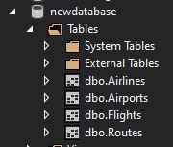First created the SQL database in the local emulator. Added the tables that were needed and the columns in those tables.

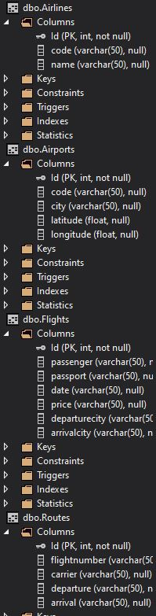

Next was creating the mongoDB for the non SQL, used Bsondocument for storing information in the tables. One for transaction and other for card holders.

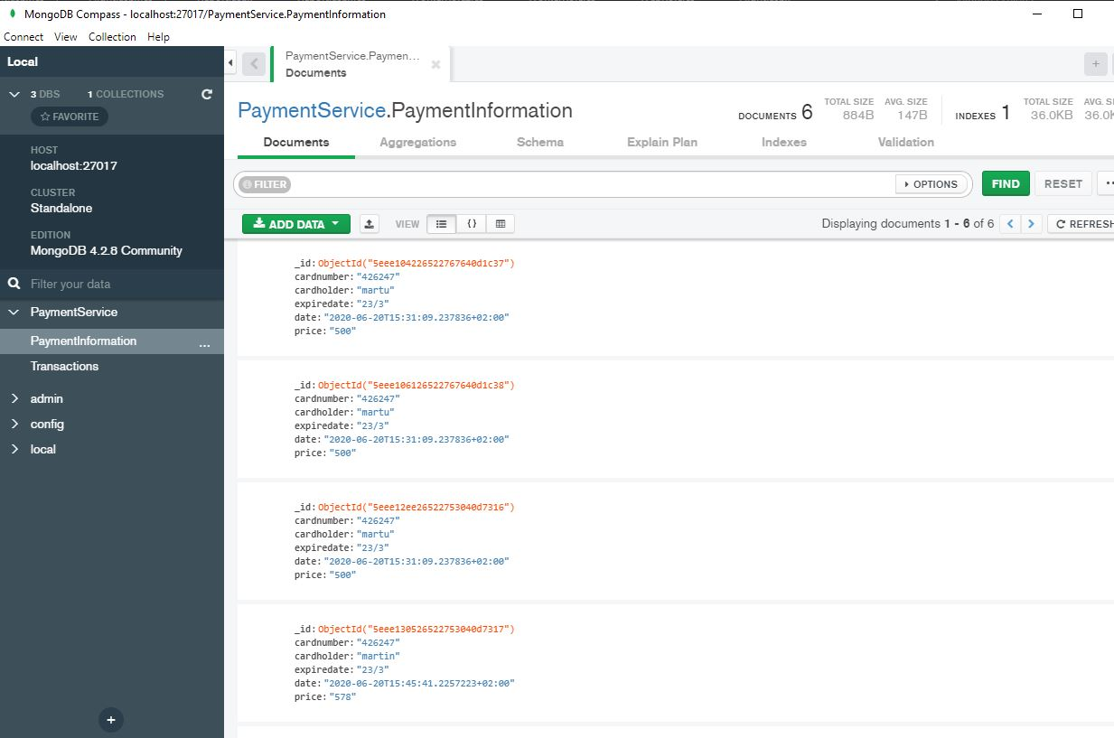

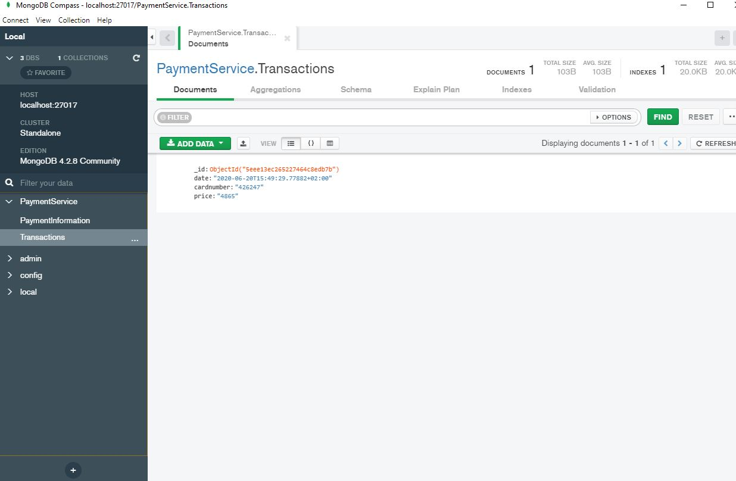

Then i set up the SQL connection string and started adding values into the database, as can be shown below. This was done in the front end of the application, client side.



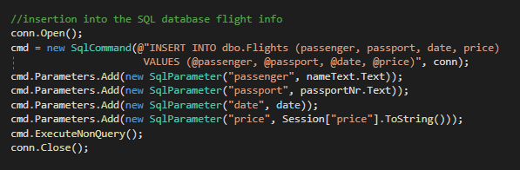

After that I had to add mongoDB interface that was supposed to be done in the backend. I added a JSON object that I sent with queues to the server. When I got the Json queue message I parsed it into a BsonDocument that could be stored into the mongoDB.

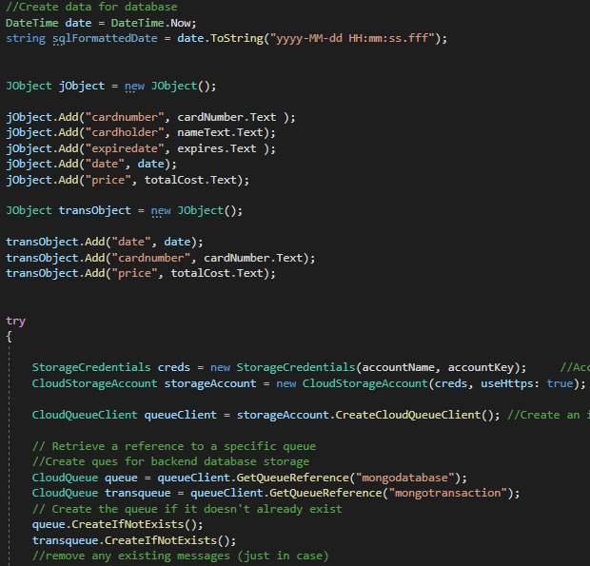

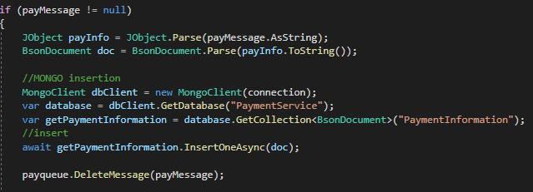

Now when all was stored into the database the only thing left is to report some values from the databases. To display the SQL values I used a gridview that was connected to the SQL database and just displayed those in tables on a webpage.

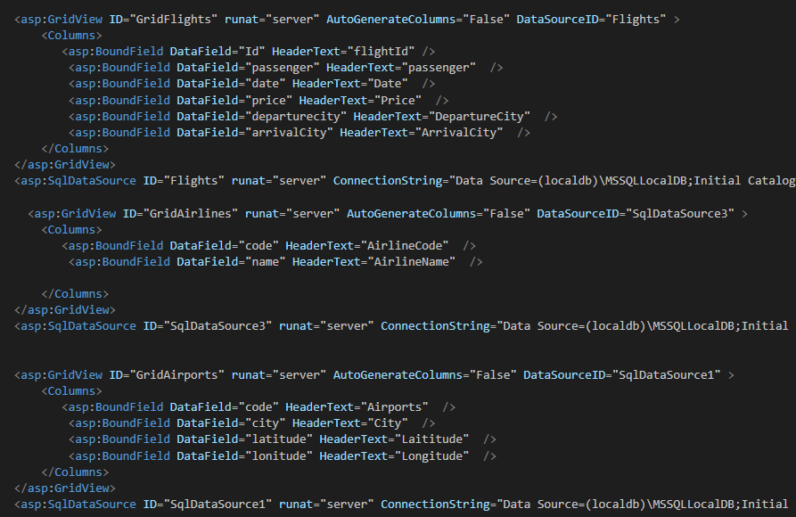

For the mongo report it was a bit harder to actually retrieve all items from the database. However, I was able to do it with AsQueryable method and iterate through all the objects in the database and then display all these in a simple label on the html page.

