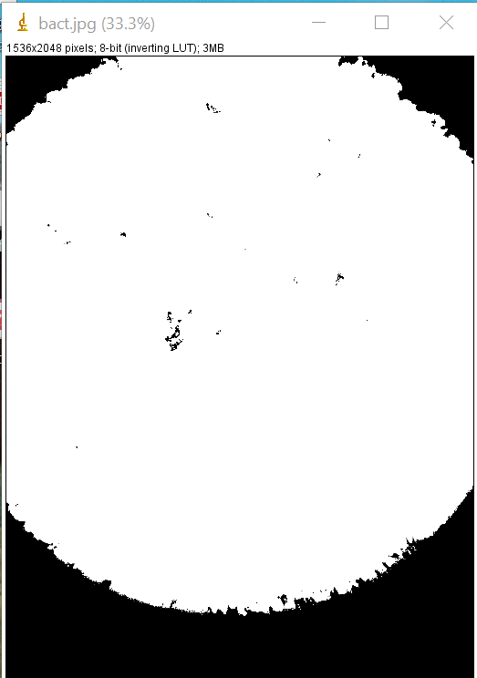
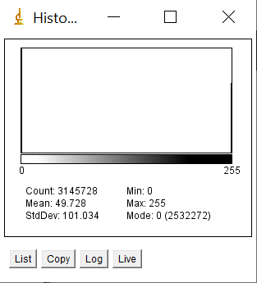
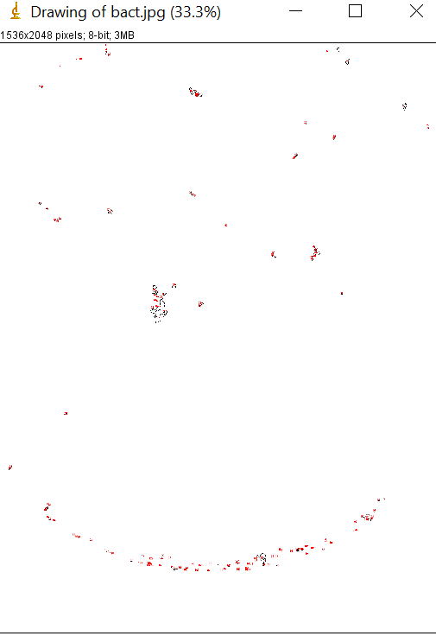
Title: Drawing of bact.jpg
Width: 1536 pixels
Height: 2048 pixels
Pixel size: 1x1 pixel
ID: -5
Coordinate origin: 0,0
Bits per pixel: 8 (color LUT)
Display range: 0-255
No Threshold
Magnification: 0.33
Uncalibrated
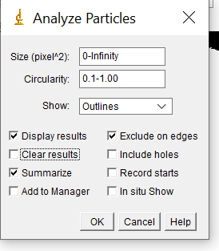
No Selection

