

Adult: VERY_UNLIKELY

Medical: UNLIKELY

Racy: POSSIBLE

Violent: UNLIKELY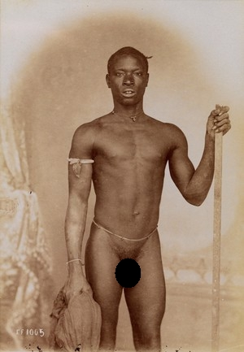

Adult: LIKELY

Medical: UNLIKELY

Racy: VERY_LIKELY

Violent: UNLIKELY

Adult: VERY_UNLIKELY

Medical: VERY_UNLIKELY

Racy: UNLIKELY

Violent: UNLIKELY

Adult: POSSIBLE

Medical: UNLIKELY

Racy: VERY_LIKELY

Violent: POSSIBLE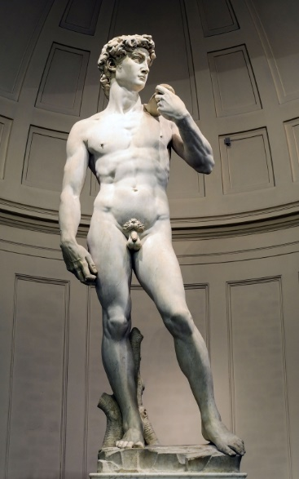

Adult: UNLIKELY

Medical: UNLIKELY

Racy: VERY_LIKELY

Violent: UNLIKELY

Adult: LIKELY

Medical: UNLIKELY

Racy: VERY_LIKELY

Violent: UNLIKELY

Adult: VERY_UNLIKELY

Medical: VERY_UNLIKELY

Racy: VERY_UNLIKELY

Violent: VERY_UNLIKELY

Adult: UNLIKELY

Medical: VERY_UNLIKELY

Racy: UNLIKELY

Violent: POSSIBLE