Ljubljana:

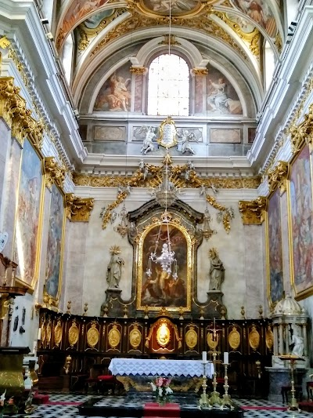

In Ljubljana staying 4 hour(s)

Blejsko jezero:

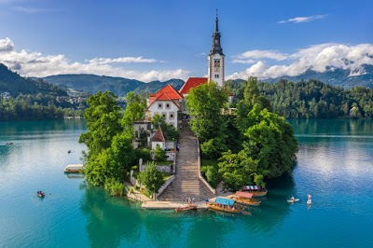

In Blejsko jezero staying 2 hour(s)

Ljubljana --> Blejsko jezero will be 55.4 km long and will take 42 mins

Bohinjsko jezero:

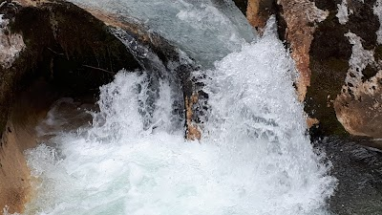

In Bohinjsko jezero staying 3 hour(s)

Blejsko jezero --> Bohinjsko jezero will be 27.6 km long and will take 26 mins

Hrušica:

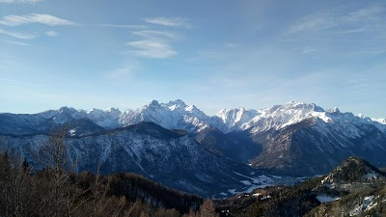

In Hrušica staying 1 hour(s)

Bohinjsko jezero --> Hrušica will be 50.2 km long and will take 47 mins

Kranjska Gora:

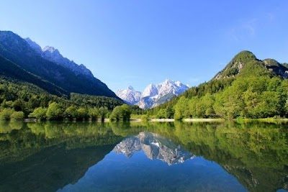

In Kranjska Gora staying 1 hour(s)

Hrušica --> Kranjska Gora will be 20.2 km long and will take 22 mins

Soča:

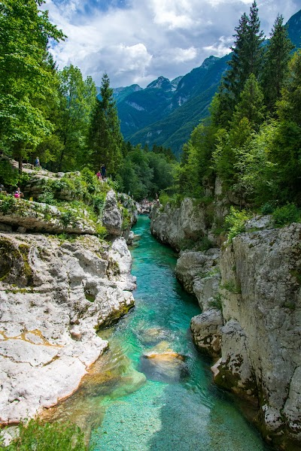

In Soča staying 3 hour(s)

Kranjska Gora --> Soča will be 104 km long and will take 1 hour 58 mins

Bovec:

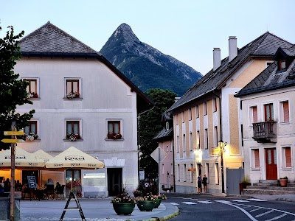

In Bovec staying 1 hour(s)

Soča --> Bovec will be 57.2 km long and will take 1 hour 0 mins

Tolminska Korita:

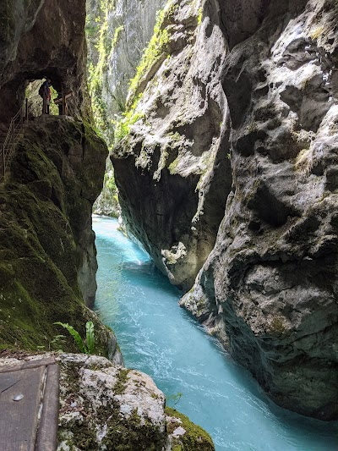

In Tolminska Korita staying 3 hour(s)

Bovec --> Tolminska Korita will be 38.6 km long and will take 42 mins

Most na Soči:

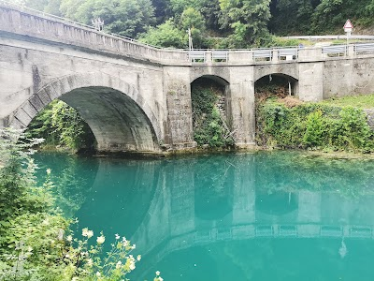

In Most na Soči staying 1 hour(s)

Tolminska Korita --> Most na Soči will be 8.1 km long and will take 12 mins

Trieste:

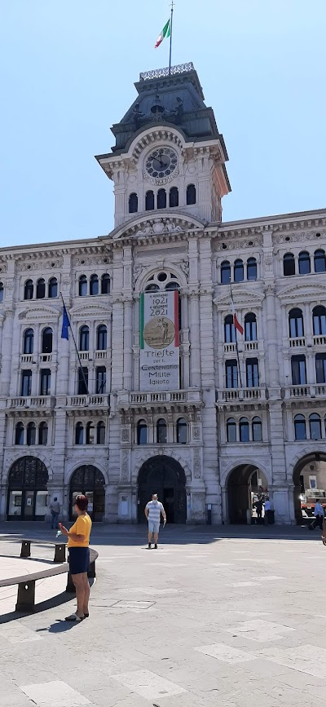

In Trieste staying 2 hour(s)

Most na Soči --> Trieste will be 85.0 km long and will take 1 hour 31 mins

Koper:

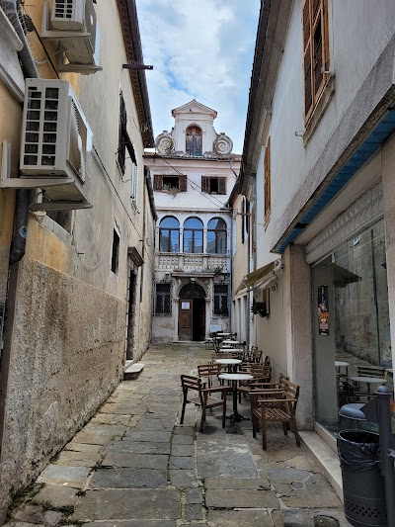

In Koper staying 5 hour(s)

Trieste --> Koper will be 22.3 km long and will take 25 mins

Ljubljana:



In Ljubljana staying 1 hour(s)

Koper --> Ljubljana will be 106 km long and will take 1 hour 12 mins

TOTAL TRAVEL TIME: 36.28333334 hours