Virtual Internship 7.0
Infosys Springboard Virtual Internship 7.0 Completion Report

Batch Number: 1
Start Date: 29 June 2026
Names: Rounak Pathak
Internship Duration: 8 Weeks
1. Project Title
FoodBridge AI — Real-Time Food Redistribution & Logistics Platform (AI-Based Food Redistribution System for Waste Reduction and Surplus Inventory Management)
2. Project Objective
The objective of the project was to develop a full-stack, AI-powered platform that helps food service businesses, supermarkets, and households reduce avoidable food waste through better inventory management, expiry monitoring, demand forecasting, and timely redistribution of surplus food. The system is designed to connect food businesses with NGOs, community kitchens, and food banks so that usable surplus can be recovered before it is wasted. It also provides analytics for tracking waste reduction, donation impact, food recovery volumes, meals redistributed, and estimated CO2-equivalent savings.
3. Project Description in Detail
The project was designed as a multi-stakeholder web platform for food donors, recipient organizations, volunteer transport riders, and platform administrators.
Commercial Inventory & Donors: On the business side, the platform supports inventory entry through manual input, CSV upload, and camera-based barcode/QR scanning. It tracks expiry dates, categorizes food items according to perishability and storage requirements, and provides waste-risk information and reorder recommendations.
AI Machine Learning Engine: The AI layer uses historical inventory, sales, purchasing, and waste data to create time-series training datasets. A waste-risk score combines days-to-expiry, current stock level, and forecast demand, while the recommendation module suggests purchase quantities based on expected demand and storage capacity. The prediction service is designed as a FastAPI microservice supporting scheduled batch predictions and real-time scoring.
Redistribution & Logistics Workflow: The redistribution module provides a surplus-food marketplace where businesses and households can publish quantity, expiry date, pickup location, and availability windows. An AI-based matching engine connects surplus listings with NGO requirements using food type, quantity, and location proximity. Pickup scheduling and confirmation notifications support coordination between donors and recipients. React.js dashboards provide business, NGO, volunteer rider, and super admin views.
Frontend & Infrastructure: The project also includes an end-to-end integration and testing phase covering backend APIs, cross-module compatibility, responsive web interfaces, documentation, deployment considerations, 100% multilingual localization (English, Hindi, Kannada, Tamil), PWA offline service worker precaching, and Section 80G tax exemption certificate generation.
4. Timeline Overview
Week | Activities Planned | Activities Completed
Week 1 | Kickoff, project introduction, AI usage discussion, project explanation, setup guidance, prerequisite learning; begin inventory and expiry-tracking module. | Attended kickoff and project setup sessions; studied requirements and started the inventory/expiry-tracking foundation; defined database schemas.
Week 2 | Continue inventory management, expiry alerts, product categorization, barcode/QR support, and data storage; complete Milestone 1. | Implemented JWT authentication for 5 user roles, barcode/QR camera scanning page, inventory CRUD, and completed first milestone submission.
Week 3 | Begin AI waste-prediction engine; prepare historical sales, purchase, and waste data and define demand-forecasting workflow. | Prepared time-series dataset preprocessing, developed Scikit-Learn surplus forecasting and spoilage risk scoring algorithms; attended technical guidance sessions.
Week 4 | Develop demand forecasting with Prophet/LSTM/Scikit-Learn, waste-risk scoring, reorder recommendations, and prediction-service integration; complete Milestone 2. | Implemented FastAPI ML prediction microservice endpoints, connected React dashboards with real-time spoilage recommendations, and completed second milestone submission.
Week 5 | Build surplus-food listing portal, AI-based NGO matching, pickup scheduling, and confirmation notifications; implementation of multilingual feature. | Developed surplus food marketplace, Leaflet GIS route optimization, 2-step OTP cryptographic handover verification, and multilingual localization (English, Hindi, Kannada, Tamil).
Week 6 | Develop business and NGO React dashboards, sustainability impact analytics, and integrate the end-to-end flow; Implementation of PWA feature; complete Milestone 3. | Integrated role dashboards, automated ESG Section 80G tax exemption certificate generator, implemented PWA Service Worker precaching with Workbox, and completed third milestone submission.
Week 7 | Final technical completion, integration/load/cross-browser testing, UX refinement, documentation, architecture/data-flow/API documentation. | Performed final integration and UI checks, refined responsive behavior, addressed implementation issues, and prepared documentation materials.
Week 8 | Final review, PPT/demo preparation, mock presentations, final documentation, and project closure. | Finalized technical presentation slides, prepared demo walkthrough materials, completed final documentation, and closed the internship project cycle.
5a. Key Milestones
Milestone | Description | Date Achieved
Project Kickoff | Project introduction, AI usage discussion, initial project briefing and setup. | 29 June 2026
Prototype/First Draft | Initial inventory/expiry-tracking and project foundation developed during Milestone 1. | 12 July 2026
Mid-Term Review | AI prediction and recommendation work reviewed as part of Milestone 2. | 26 July 2026
Final Submission | Project completion submission after redistribution, analytics, integration and testing work. | 9 August 2026
Presentation | Final PPT/demo preparation and mock presentation cycle; final presentation scheduled in the call plan. | To be scheduled
5b. Project Execution Details
The project was executed incrementally across four major milestones. The initial phase focused on understanding the problem, setting up the project, learning the required concepts, and implementing inventory and expiry-tracking capabilities.
The second phase concentrated on the AI waste-prediction engine, including historical-data preprocessing, demand forecasting, waste-risk scoring, and reorder recommendations. The third phase expanded the system into a redistribution marketplace with NGO matching, pickup scheduling, notifications, 2-step cryptographic OTP verification, multilingual localization (English, Hindi, Kannada, Tamil), PWA service worker offline support, and Section 80G ESG sustainability analytics. The final phase focused on integration, testing, responsive UI refinement, documentation, presentation preparation, and project closure.
Regular technical guidance and status calls were used throughout the internship. The call schedule records a kickoff on 29 June 2026, project setup and explanation sessions on 30 June and 1 July, milestone-specific technical guidance calls, GitHub knowledge transfer, guest-mentor knowledge transfer, a quiz/KT session, and final review and presentation/mock-demo activities. Milestone submissions were scheduled for 12 July, 26 July, and 9 August, followed by documentation and presentation preparation in the final phase.
6. Snapshots / Screenshots
Below are visual screenshots showcasing the completed FoodBridge AI platform across the landing page, commercial business portal, recipient NGO shelter portal, household donor portal, volunteer rider portal, and super administrator control center.
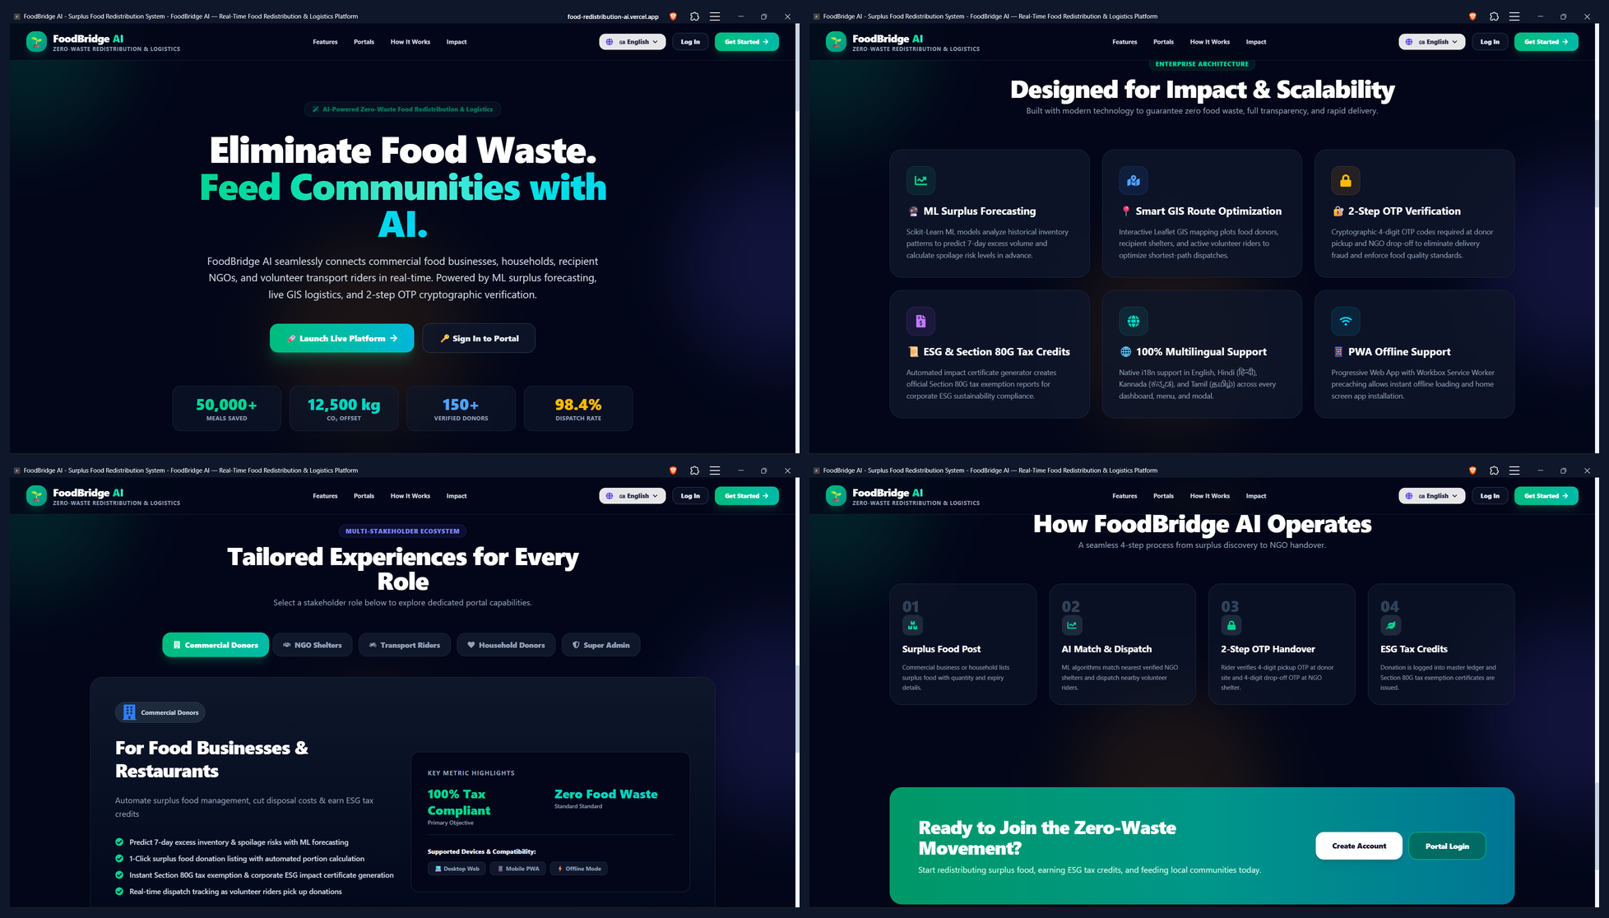
Figure 1. FoodBridge AI Enterprise Landing Page Showcase — 2x2 collage showcasing (Top-Left) Hero Banner & Real-time Metrics, (Top-Right) Enterprise Architecture & Core Features, (Bottom-Left) Multi-Stakeholder Ecosystem Roles, and (Bottom-Right) End-to-End Workflow & Call to Action.
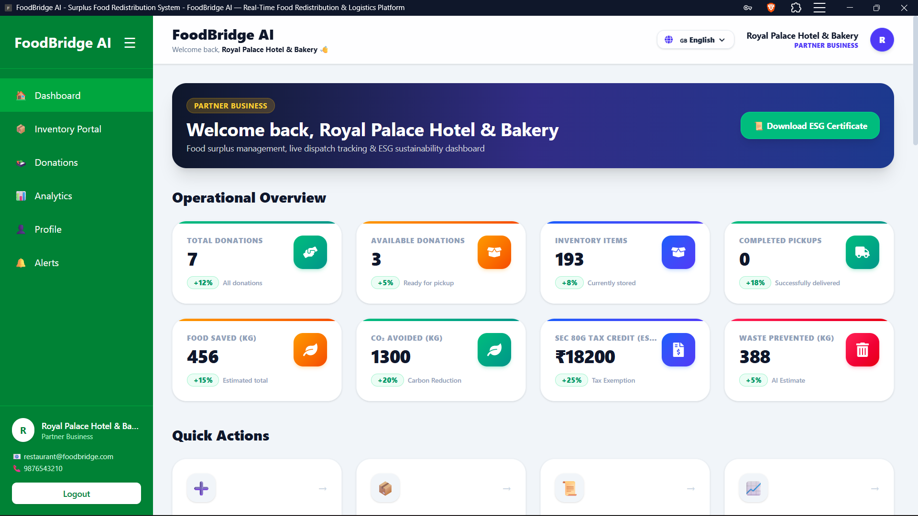
Figure 2. Commercial Food Business Partner Dashboard — Interface showing operational KPI summary cards, AI spoilage risk assessment, Scikit-Learn 7-day surplus forecast chart, camera-based barcode scanner access, and live GIS map.
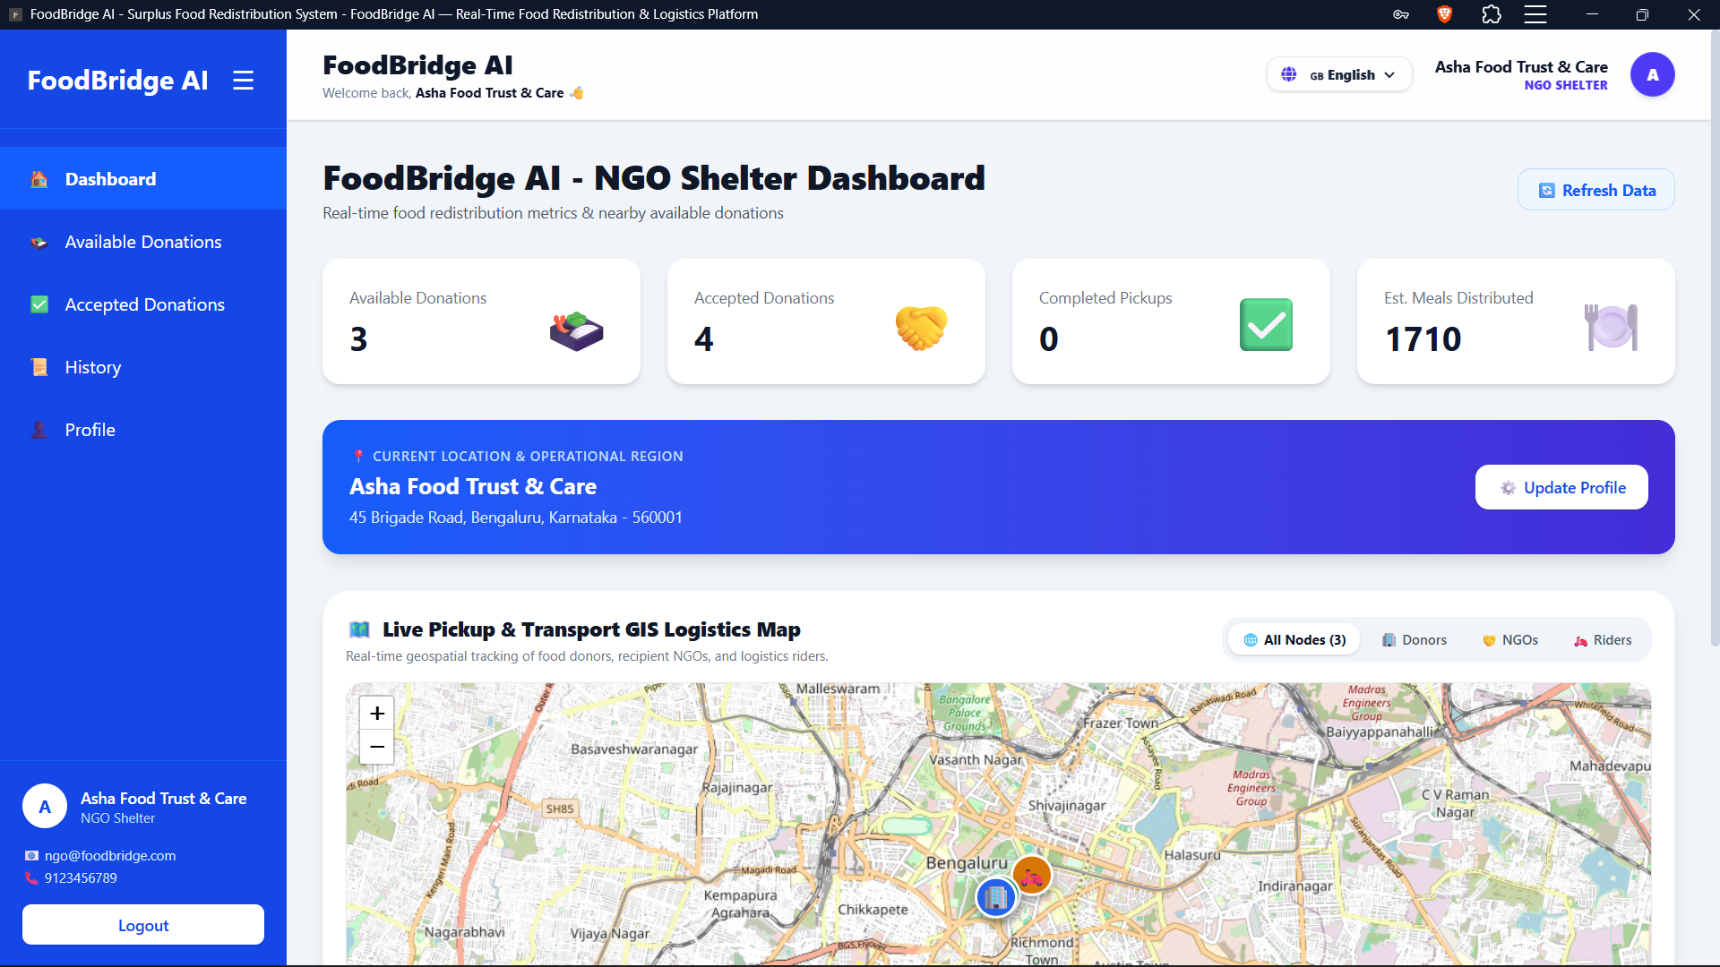
Figure 3. Verified NGO Shelter & Food Bank Dashboard — Interface showing real-time available surplus food marketplace, 1-click donation claim actions, distance-priority indicators, and delivery handover status.
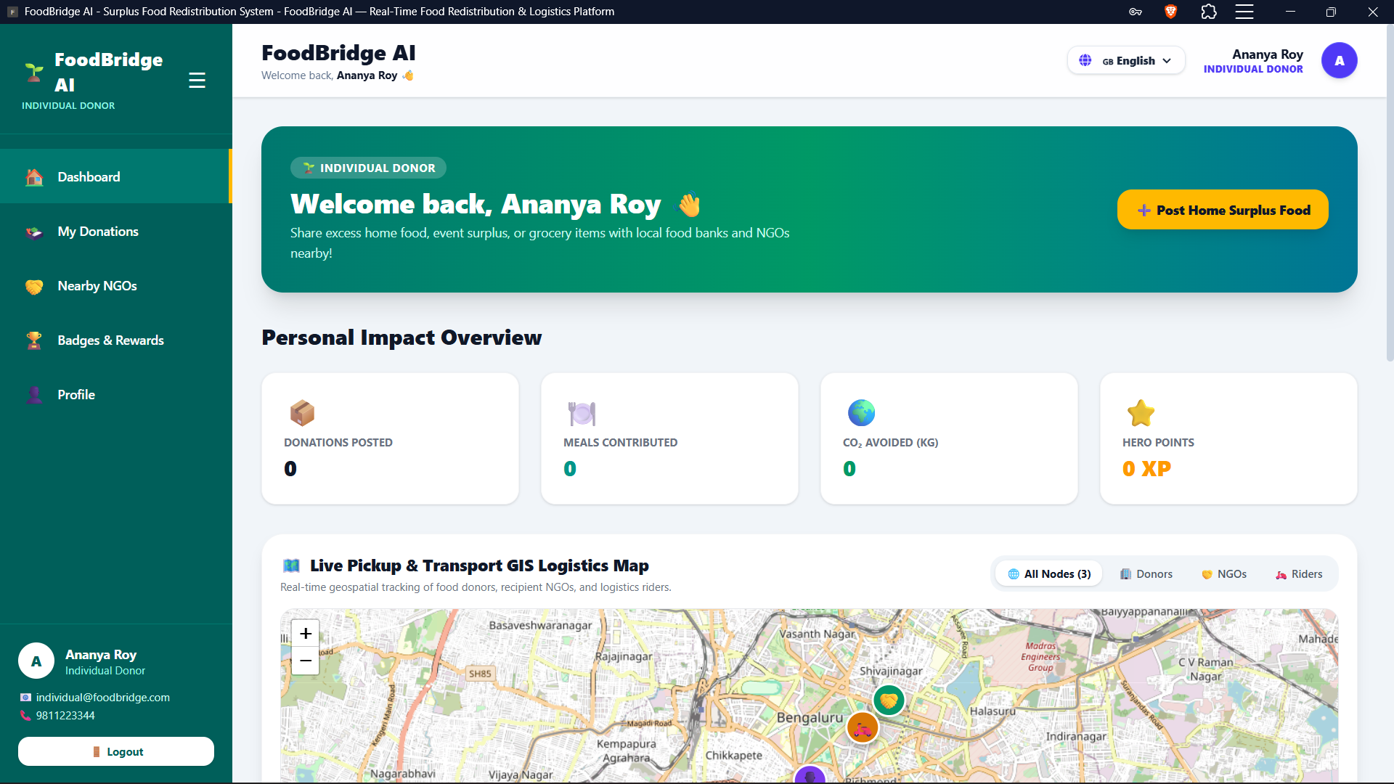
Figure 4. Household Community Donor Dashboard — Interface displaying personal environmental impact metrics (meals contributed, CO2 offset, hero points), home surplus food posting modal, and unlocked zero-waste achievement badges.
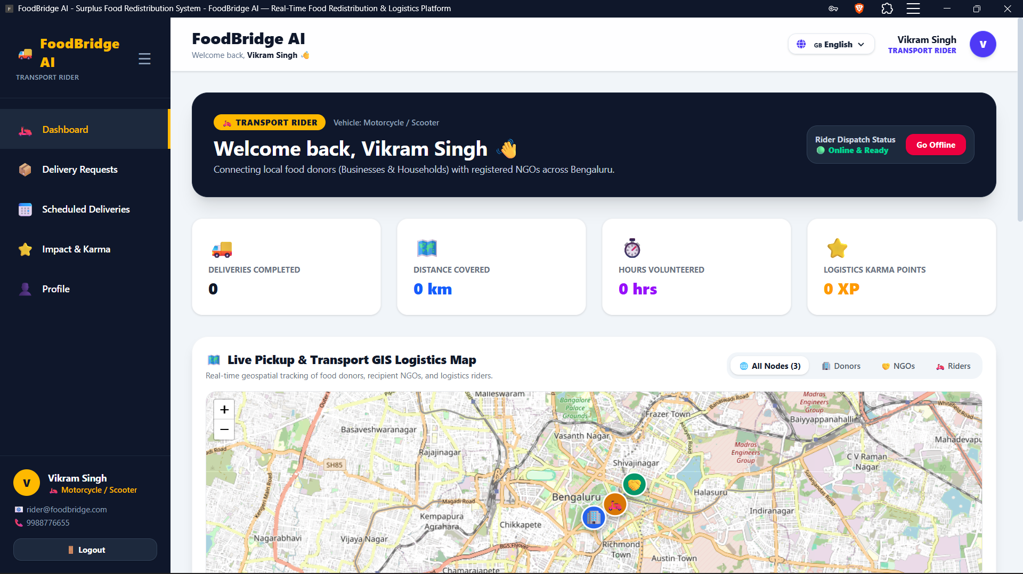
Figure 5. Volunteer Transport Rider Dashboard — Interface featuring online/offline rider status toggle, active delivery stepper, real-time Leaflet GIS route polyline navigation, and 2-step OTP verification input fields.
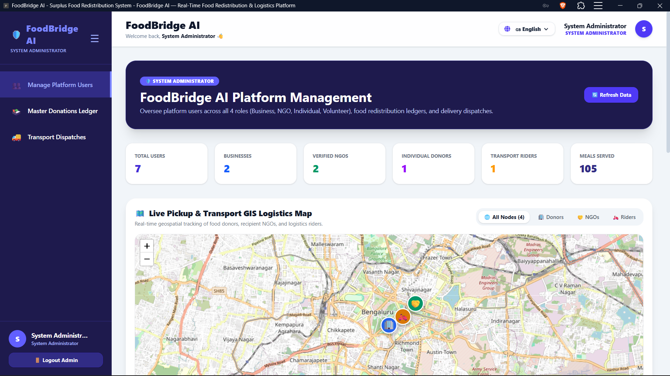
Figure 6. Super Administrator Control Center — Interface showing system-wide user management table across all 5 roles, master donation audit ledger, transport dispatches, and environmental growth visualizer charts.
7. Challenges Faced
Several technical and implementation challenges were encountered during development:
- Barcode/QR scanner implementation: Integrating camera-based scanning into a mobile-friendly web interface required attention to browser camera permissions, device compatibility, scanning reliability, and rapid synchronization of scanned inventory data with the application.
- PWA implementation: Making the application behave consistently as a Progressive Web App introduced challenges around responsive behavior, installability, caching, service-worker behavior, and maintaining a smooth experience across different mobile and desktop browsers.
- Multilingual support: Supporting multiple languages required careful handling of translated labels, navigation text, validation messages, dynamic content, and consistent layouts when translated text became longer or shorter than the original.
- AI/data preparation: Demand forecasting depends on useful historical sales, purchase, and waste data. Preparing time-series datasets and selecting suitable forecasting approaches required careful preprocessing and iterative validation.
- Cross-module integration: Connecting inventory, prediction, redistribution, matching, scheduling, notifications, and dashboards created compatibility and edge-case issues that had to be addressed through incremental integration testing and API validation.
- Responsive and cross-browser behavior: The system was intended for use across mobile, tablet, and desktop devices, so interface clarity and functionality had to be checked across different screen sizes and browsers. Issues were mitigated through iterative debugging, responsive UI refinement, and repeated end-to-end testing.
8. Learnings & Skills Acquired
The internship strengthened practical skills in full-stack application development, AI-assisted problem solving, API-based integration, data preprocessing, time-series forecasting concepts, and dashboard-oriented product design. Key learning areas included React.js for web interfaces, FastAPI microservice design, REST APIs, inventory and database concepts, barcode/QR-based interaction, responsive/PWA considerations, and notification and scheduling workflows.
The project also provided experience in working with Prophet and LSTM forecasting approaches, converting business requirements into technical modules, performing integration and cross-browser testing, documenting architecture and data flow, using GitHub-based collaboration practices, and preparing a technical presentation and end-to-end project demonstration. Regular status calls and knowledge-transfer sessions also improved communication, task planning, and presentation skills.
9. Testimonials from Team
This internship provided valuable hands-on exposure to solving a real-world sustainability problem through software and AI. Working through the project milestones helped me understand how an idea is converted into modules, integrated into a working platform, tested, documented, and presented. The experience also improved my confidence in debugging implementation challenges, learning new technologies, and communicating technical work clearly.
10. Conclusion
The AI-Based Food Redistribution System addresses food-waste reduction by combining inventory visibility, expiry monitoring, demand forecasting, waste-risk analysis, surplus redistribution, NGO matching, pickup coordination, and impact analytics in one platform. The project demonstrates how AI and full-stack technologies can support more efficient use of food resources while improving coordination between donors and recipient organizations.
The internship experience helped translate academic concepts into a practical project involving AI, web development, APIs, data handling, testing, documentation, and presentation. It provides a strong foundation for further work in AI-enabled applications, sustainable technology, and full-stack software engineering.
11. Acknowledgements
I sincerely thank Infosys Springboard and the internship program team for providing the opportunity, structured milestones, technical guidance, knowledge-transfer sessions, project resources, and review support throughout the internship. I am also grateful to the mentors and guest mentors for their guidance during the project and to everyone who supported the technical learning, testing, documentation, and final presentation activities.

