**Software Requirements Specification**

**For**

**Excel to PowerPoint**

**Automation**

**Prepared by :-**

**Rounak Kalbhawar [2603315]**



**JAN - May 2022**

Table of Contents

Table of Contents ii

Revision History ii

1. Introduction 1

1.1 Purpose 1

1.2 Document Conventions 1

1.3 Intended Audience and Reading Suggestions 1

1.4 Product Scope 1

1.5 References 1

2. Overall Description 2

2.1 Product Perspective 2

2.2 Product Functions 2

2.3 User Classes and Characteristics 2

2.4 Operating Environment 2

2.5 Design and Implementation Constraints 2

2.6 User Documentation 2

2.7 Assumptions and Dependencies 3

3. External Interface Requirements 3

3.1 User Interfaces 3

3.2 Hardware Interfaces 3

3.3 Software Interfaces 3

3.4 Communications Interfaces 3

4. System Features 4

4.1 System Feature 1 4

4.2 System Feature 2 (and so on) 4

5. Other Nonfunctional Requirements 4

5.1 Performance Requirements 4

5.2 Safety Requirements 5

5.3 Security Requirements 5

5.4 Software Quality Attributes 5

5.5 Business Rules 5

6. Other Requirements 5

Appendix A: Glossary 5

1. Use Case Diagram

2. Data Flow Diagram Level - 0

3. Data Flow Diagram Level - 1

4. Data Flow Diagram Level - 2

5. Activity Diagram

6. Sequence Diagram

Revision History

|  |  |  |  |
| --- | --- | --- | --- |
| **Name** | **Date** | **Reason For Changes** | **Version** |
|  |  |  |  |
|  |  |  |  |

1. **Introduction**
   1. **Purpose :-**

The main purpose of this automation script is to make the lives of the employees easier by automatically updating the data present in the excel sheet into the power-point presentation.

* 1. **Intended Audience :-**

Every individual that uses Microsoft excel and power-point on an average basis with any level of knowledge can use and update the data from excel automatically into power-point.

* 1. **Product Scope :-**

The script developed here will be used to carry out the presentation making and regularly updating process efficiently.

* 1. **Technology Comparison :-**
* **Python pros for automation scripts :-**

1. **Easy to learn:** Python is a simple language with a clean syntax that is easy to read and write. It is also widely used in the automation industry and has a large online community that can help with any questions or problems that arise.
2. **Libraries:** Python has a vast collection of libraries and frameworks that can be used for automation, such as Selenium and PyAutoGUI, which makes writing automation scripts much easier.
3. **Cross-platform compatibility:** Python is a cross-platform language, which means that automation scripts written in Python can be run on multiple operating systems without any issues.
4. **Rapid prototyping:** Python's simplicity and ease of use allow for quick and efficient prototyping of automation scripts.

* **Java cons for automation scripts :-**

1. **Complexity:** Java is a complex language with a lot of rules and syntax, which can make writing automation scripts more time-consuming and difficult.
2. **Steep learning curve:** Java has a steeper learning curve compared to Python, making it harder for beginners to get started with automation scripting.
3. **Limited libraries:** While Java has some libraries available for automation, they are generally less extensive and robust compared to Python's libraries.
4. **Platform-dependency:** Java is platform-dependent, which means that automation scripts written in Java may need to be adjusted for different operating systems.
5. **Verbose code:** Java code can be more verbose and require more lines of code to accomplish the same task as Python code, which can be time-consuming and increase the chances of introducing errors.

Both Python and Java can be used to automate data update from Excel to PowerPoint. However, in general, Python is more commonly used for this task because of its extensive libraries for data processing and manipulation.

Python has several libraries, such as pandas and openpyxl, that allow you to read data from Excel spreadsheets, manipulate the data as needed, and then output it to a PowerPoint presentation. Additionally, Python has several libraries, such as pptx, that allow you to create and modify PowerPoint slides and presentations.

Java, on the other hand, has fewer libraries for data processing and manipulation compared to Python. While it's still possible to automate data update from Excel to PowerPoint using Java, it may require more time and effort to write the necessary code.

In summary, while both Python and Java can be used to automate data update from Excel to PowerPoint, Python is generally a better choice due to its more extensive libraries for data processing and manipulation.

* 1. **References :-**

1. [Automatic Updating of Excel Tables in PowerPoint Slides | Think Outside The Slide](https://www.thinkoutsidetheslide.com/automatic-updating-of-excel-tables-in-powerpoint-slides/)
2. [Use Python to Automate the PowerPoint Update | by Yeung WONG | Towards Data Science](https://towardsdatascience.com/use-python-to-automate-the-powerpoint-update-4a385acf1243)
3. [Turn Your Excel Sheet into a PowerPoint Presentation in Just a Couple of Minutes | by Fumio Nagasaka | Python in Plain English](https://python.plainenglish.io/turn-your-excel-sheets-into-a-powerpoint-presentation-just-in-a-couple-of-minutes-62ae4b8bc13b)
4. [openpyxl - A Python library to read/write Excel 2010 xlsx/xlsm files — openpyxl 3.1.2 documentation](https://openpyxl.readthedocs.io/en/stable/)
5. [python-pptx — python-pptx 0.6.21 documentation](https://python-pptx.readthedocs.io/en/latest/#:~:text=python%2Dpptx%20is%20a%20Python,link%20in%20a%20web%20application.)
6. **Overall Description**
   1. **Product Perspective :-**

The automation script is a new project aimed to eliminate the current system where the users need to manually update the data in the power-point presentation whenever there are changes in the excel data making it time and energy consuming. This automation script will help in carrying out this tedious operation efficiently and automatically saving both time and energy.

* 1. **Product Functions :-**

The automation script is aimed to provide the following functions :-

* Ability to automatically update the data in power-point presentation from data in excel tables.
* Ability to create and automatically update different type of charts in the power-point presentation.
  1. **User classes and Characteristics :-**

1. User Class :-

The user will have privileges to use the script and can perform the following tasks :-

* Update the column name field in the script to generate the charts for specific data.
* Change the name of the .xlsx file if the user wants completely new data.
* Use the data with the script code to automatically update the existing data in the power-point presentation.
  1. **Operating Environment :-**
* The basic requirement is python installed in the system.
* Few libraries such as pandas, matplotlib, xlrd should be already installed.
  1. **Design and implementation constraints :-**

Since the script is developed using python and its libraries without any UI/UX making the designing and implementation cost low.

* 1. **User Documentation :-**

There will be a user documentation which will guide the users on how to make changes in the script in order to change the data according to their needs.

* 1. **Assumptions and Dependencies :-**

Since the script is developed in python, if a user wants to use it, they have to install python beforehand otherwise it will fail to perform.

1. **External Interface Requirements**
   1. **User Interfaces :-**

The script will have no user interface.

* 1. **Hardware Interfaces :-**
* The users can access all the features of the script from a laptop or a PC with windows 8 or above and with at least 2GB of RAM..
  1. **Software Interfaces :-**
* Python is used for the development of the script and hence is needed to run it.
* Any IDE that can run python is needed to run the script (For ex. PyCharm, VS Code, Atom etc.)
  1. **Communication Interfaces :-**
* The script uses various libraries to communicate between python excel and power-point making the libraries compulsory to be installed in order to use the script.

1. **System features :-**
   1. **Updating the data from excel into power-point presentation :-**
      1. Description :-

The data is fetched from existing excel tables and then is updated using different libraries into the power-point slides.

* + 1. Stimulus/ Response Sequences :-

When the user clicks on the run button of the script, the code executes with the details provided by the user which then updates the data in the presentation.

* + 1. Functional Requirements :-

REQ-1 :- The basic requirement is to have python and the pre requisite libraries already installed in the system.

REQ-2 :- Any IDE that can run python (For ex. PyCharm, atom, VS Code etc.)

1. **Other Non-functional requirements :-**
   1. **Performance Requirements :-**

The most basic requirement need for the usage of the automation script is just a compatible system with python and the pre requisite libraries already installed in that system.

* 1. **Safety Requirements :-**

Since the script is just a piece of code, it should not contain any malicious code inside of it which can break the integrity of the system.

* 1. **Security Requirements :-**

The script works on excel files as well as power-point files containing a huge amount of data and hence to eliminate any security issue the it should define clean and strong datasets which are researched thoroughly and trusted to ensure total security.

* 1. **Software Quality Attributes :-**

The automations script is simple and flexible in terms of the usability. The primary functions including the updating of data from excel to power-point and developing charts can be accessed at any time if the dataset and the presentation is present in the system.

* 1. **Business Rules :-**

Since the project is still under development, all the functionalities are free to use.

**Appendix A: Glossary**

All the terms are interpreted properly without any use of acronyms and abbreviations.

1. **Use Case Diagram :-**

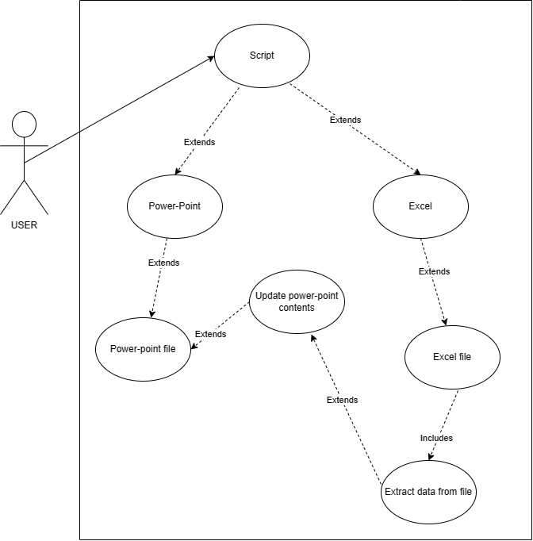

1. **Data Flow Diagram Level – 0 :-**

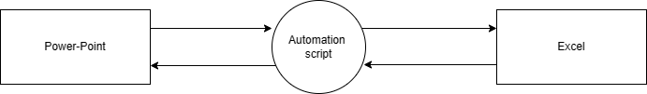

1. **Data Flow Diagram Level – 1 :-**

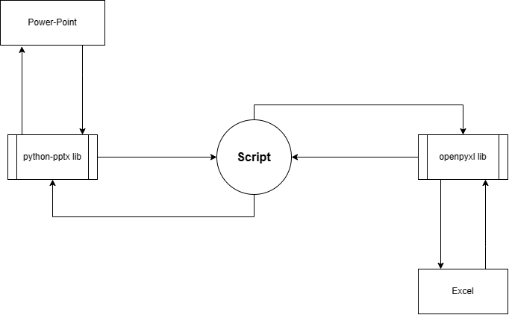

1. **Data Flow Diagram Level – 2 :-**

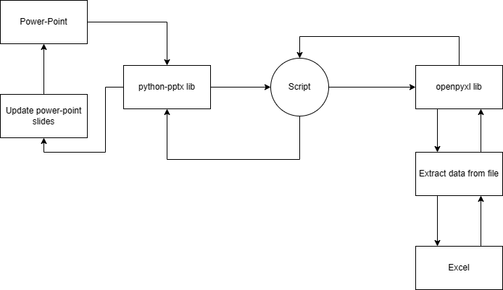

1. **Activity Diagram :-**

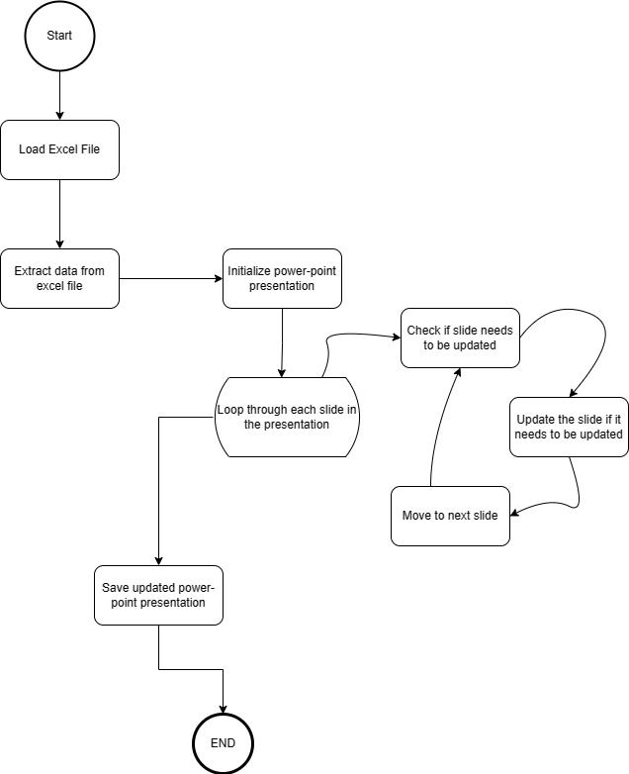

1. **Sequence Diagram :-**

