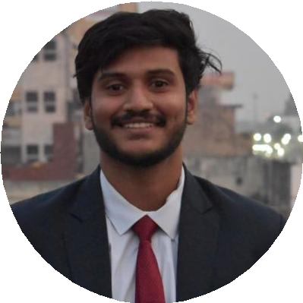



[mohith.chava@aiesec.net](mailto:mohith.chava@aiesec.net)

Mohith Raja chava

Team Leader Outgoing Global Entrepreneur

Team Leader of operations and handled International relations for a multi-hierarchy organisation based in 125+ countries . delivering life changing experiences through internships in various start-ups



8288892678



Swetha medicals , manuguru, khammam dist ,telangana, Khammam, India

# SKILLS

Presentation Skills



c

**EDUCATION**

## B.Tech Computer Science

### Lovely Professional University

07/2017 – Present

## High School Education

### Narayana Junior College, Kollur

07/2015 – 05/2017

Courses

##### MPC

4.24

88%

## Secondary School Education

MS oﬃce

sales

### Dr. KKR's Gowtham Concept School

07/2011 – 05/2015

9.2

DBMS

Video Editing

Team Managment

Adaptability

**LANGUAGES**

##### ENGLISH

Professional Working Proﬁciency

##### HINDI

Limited Working Proﬁciency

##### TELUGU

Native or Bilingual Proﬁciency

# INTERESTS

**WORK EXPERIENCE**

## Team Leader

### AIESEC in Jalandhar

02/2018 – Present

Team leader for a department in a World's largest youth run organisation and responsible for providing International internships for youth

Achievements/Tasks

Value Delivery and Documentation Content Managment

## National Support Team

### AIESEC in India

07/2019 – Present Achievements/Tasks

##### Content Curation

India

# ORGANIZATIONS

Music

Gaming

Volunteering

#### AIESEC in Jalandhar (02/2000 – Present)

Team Leader Outgoing Global Entrepreneur

# CERTIFICATES

Programming in c and c++ (06/2018 – 07/2018)

# PERSONAL PROJECTS

#### Library Management System

website to manage all the operations of library

# ACHIEVEMENTS

#### Runner of badminton Tournament

High school tournament