What2Cook: A Recipe & Ingredient Matching Web Application Using MongoDB

Submitted by:
Name: Krishna Singh
Registration Number: 12302957
Section: K3E2345
Roll No: 5

Submitted to:
Ansh Pratap Singh



Lovely Professional University
Phagwara, Punjab

Table of Contents
Chapter 1: Project Overview & Executive Summary | Page 2
Chapter 2: Problem Statement & Engineering Motivation | Page 3
Chapter 3: System Architecture & Microservice Design | Page 4
Chapter 4: Interaction Tracking & Data Engineering (Phase 2) | Page 5
Chapter 5: Content-Based Recommendation Engine (TF-IDF & Cosine) | Page 6
Chapter 6: Collaborative Filtering via Implicit Feedback & SVD | Page 7
Chapter 7: Time-Decayed Trending & Popularity Recommender | Page 8
Chapter 8: Hybrid Recommendation Engine Architecture (Phase 4) | Page 9
Chapter 9: Diversity Filtering & Maximal Marginal Relevance (MMR) | Page 10
Chapter 10: Express Backend Integration & Circuit Breaker (Phase 5) | Page 11
Chapter 11: Frontend Integration & Recommendation UX (Phase 6) | Page 12
Chapter 12: Production Hardening, Auth Resilience & Cloudinary | Page 13
Chapter 13: Experimental Verification & Test Suite Results | Page 14
Chapter 14: Conclusion, Limitations & Future Roadmap | Page 15
Executive Summary
Modern online video platforms require robust, low-latency, and personalized recommendation systems to maximize user engagement and retention. While simple heuristic sorting (e.g., chronological sorting or raw view counts) provides a rudimentary feed, it suffers from severe feedback loops, content monopolies, and an inability to adapt to distinct user tastes.
This project report documents the design, mathematical formulation, architectural implementation, and empirical verification of a production-grade YouTube-style Machine Learning Recommendation Engine built for the Yeonix video sharing platform. The system combines Content-Based Filtering (TF-IDF and cosine similarity), Implicit Collaborative Filtering (TruncatedSVD matrix factorization), and Time-Decayed Popularity Ranking (gravity-based decay).
Crucially, a dedicated Multi-Stage Hybrid Engine orchestrates candidate generation, category diversity filtering via Maximal Marginal Relevance (MMR), freshness boosting, and cold-start fallback handling. The system bridges an asynchronous Python FastAPI ML service with an existing Express/Node.js backend and React frontend, achieving real-time related video suggestions—demonstrated empirically by the automated recommendation of related comedy content (Rajpal comedy) following stand-up comedy viewing (Tushar Basra).

Chapter 1: Problem Statement & Engineering Objectives
1.1 The Challenge of Content Discovery at Scale
In consumer media applications, users are exposed to hundreds of hours of uploaded video content daily. The fundamental challenge of recommendation systems is dual-sided:
▪ 1. The User Perspective: Users cannot manually search for videos they do not know exist. Discovery must be proactive, contextual, and tailored to implicit consumption habits.
▪ 2. The Platform Perspective: Newly uploaded or niche content suffers from the 'rich-get-richer' phenomenon if feeds only show globally viewed videos. New creators are starved of initial impressions.
1.2 Shortcomings of Naive Chronological / View-Count Feeds
Prior to implementing this machine learning system, the video platform relied on naive chronological queries (e.g., sorting by createdAt descending) or raw view counts. This exhibited three critical engineering flaws:
▪ A. Category Disconnect: A video about programming (e.g., 'Machine Learning Explained in 100 Seconds') uploaded 3 minutes ago was automatically recommended on the watch page of a stand-up comedy video ('Final Semester | Stand Up Comedy | Tushar Basra') solely because of timestamp ordering, resulting in a 0% relevance match and high user bounce rate.
▪ B. Cold-Start Stagnation: Raw view counts permanently bias recommendations towards older videos with accumulated view history, preventing fresh trending content from surfacing.
▪ C. Zero Personalization: Users received identical suggestions regardless of whether they watched 10 minutes of technical tutorials or hours of comedy entertainment.
1.3 Core Engineering Objectives
▪ 1. Interaction Tracking: Develop an implicit interaction tracking pipeline recording impressions, clicks, watch duration, completion %, likes, dislikes, skips, and search terms.
▪ 2. Multi-Model Intelligence: Build a Python FastAPI microservice containing three distinct ML algorithms: Content-Based Filtering, Collaborative Filtering with TruncatedSVD, and Gravity Time-Decay Popularity.
▪ 3. Hybrid Ranking: Implement candidate generation, filtering, MMR diversity re-ranking, and cold-start waterfall resolution.
▪ 4. System Resilience: Establish asynchronous, timeout-guarded service-to-service communication with circuit breakers and in-memory LRU caching so ML service downtime never degrades the core web app.

Chapter 2: System Architecture & Microservice Design
2.1 High-Level Architecture Overview
The platform is engineered around a decoupled, microservice-inspired architecture separating transaction-heavy user CRUD and media streaming from compute-intensive ML vector operations.
Service Layer | Technology | Primary Responsibility
Frontend Web App | React 18, Vite, React Router 6, Axios | Responsive user interface, video playback, infinite scroll feeds, and interaction event dispatchers.
Backend Gateway | Node.js (v26), Express 5, Mongoose 9 | Authentication (JWT & httpOnly cookies), Video CRUD, interaction logging, and recommendation caching gateway.
ML Recommendation Engine | Python 3.12, FastAPI, Scikit-Learn, SciPy | TF-IDF matrix calculations, SVD collaborative decomposition, MMR diversity reranking, and hybrid candidate blending.
Data Persistence | MongoDB Cluster & Local Database | Document storage for Users, Videos, Comments, Likes, and Interaction tracking events with compound indexes.

2.2 Architectural Flow Diagram
The diagram below details the data flow between client watch events, the Node.js API gateway, and the Python ML recommendation service:
[Architectural Flow Snippet]
[React Web Client]
│
├─► (Watch Page Loaded: videoId)
│ │
│ ▼
[Express Backend API: 8000]
│ ├─► Check In-Memory LRU Cache (60s TTL)
│ │
│ ▼ (Cache Miss)
[FastAPI ML Service: 5000]
│ ├─► Content-Based Model: TF-IDF Cosine Similarity Matrix
│ ├─► Collaborative Model: TruncatedSVD User Latent Factors
│ ├─► Popularity Model: Gravity Time-Decayed Trending
│ └─► MMR Diversity Reranker & Freshness Booster
│ │
│ ▼
│ [Ranked Candidate Video IDs + Scores]
│ │
▼ ▼
[Hydrate with MongoDB Documents: Title, Thumbnail, Channel Avatar]
│
▼
[Return Ranked JSON Feed to Watch Page Sidebar]

2.3 Fault-Tolerant Circuit Breaking
To prevent ML service outages from breaking the core video sharing experience, the Node.js backend implements an AbortController with a strict 2.5-second timeout. If the Python service fails to respond within this window, the backend catches the timeout error, issues a structured warning log, and transparently falls back to MongoDB category-matched videos.

Chapter 3: Interaction Tracking & Data Engineering
3.1 Seven Core Interaction Signals
Recommendation accuracy directly depends on signal fidelity. The platform tracks 7 explicit and implicit event types:
▪ 1. Impression: Fired when a video card enters the user viewport for ≥ 1.0 second.
▪ 2. Click: Fired when a user navigates from the home or search feed into a video.
▪ 3. Watch Heartbeat: Dispatched periodically and on pause/navigation, logging watchDuration (seconds) and completionPct (0-100%).
▪ 4. Like: Positive engagement signal with mutual exclusion against dislikes.
▪ 5. Dislike: Negative engagement signal penalizing video affinity in collaborative models.
▪ 6. Skip: Fired when a user navigates away or skips within the first 15 seconds.
▪ 7. Search: Logs query strings to align semantic intent with content tags.
3.2 MongoDB Schema Implementation
The interaction schema is implemented in backend/src/models/interaction.model.js with high-performance compound indexing:
[JavaScript (Mongoose Schema) Snippet]
const interactionSchema = new Schema({
userId: { type: Schema.Types.ObjectId, ref: "User", index: true },
sessionId: { type: String, required: true, index: true },
videoId: { type: Schema.Types.ObjectId, ref: "Video", index: true },
eventType: {
type: String,
required: true,
enum: ["impression", "click", "watch", "like", "dislike", "skip", "search"]
},
watchDuration: { type: Number, default: 0 },
completionPct: { type: Number, min: 0, max: 100 },
searchQuery: { type: String, trim: true },
interactionSource: {
type: String,
enum: ["home_feed", "related_videos", "search_results", "channel_page", "direct_link"],
default: "home_feed"
}
}, { timestamps: true });
// Compound Indexes for fast aggregation
interactionSchema.index({ userId: 1, videoId: 1, eventType: 1 });
interactionSchema.index({ videoId: 1, eventType: 1, createdAt: -1 });
interactionSchema.index({ sessionId: 1, createdAt: -1 });

3.3 Anonymous Session Tracking
To handle unauthenticated guests before account registration, session.middleware.js inspects the custom X-Session-Id header or yeonix_session cookie. If neither exists, a cryptographically secure UUIDv4 is generated, set as a 1-year persistent cookie, and associated with all logged interactions, enabling seamless cold-start tracking.

Chapter 4: Content-Based Filtering (TF-IDF & Cosine)
4.1 Mathematical Formulation
Content-based filtering recommends videos based on the textual similarity of their metadata (title, category, tags, and description) to the target video. Each video document $d_j$ is converted into a weighted bag-of-words vector using Term Frequency-Inverse Document Frequency (TF-IDF):
TF(t, d) = f_{t,d} / \sum_{t' \in d} f_{t',d}, \quad IDF(t, D) = \ln\left(\frac{1 + |D|}{1 + |\{d \in D : t \in d\}|}\right) + 1
The TF-IDF weight vector for term $t$ in video document $d$ is given by $w_{t,d} = TF(t, d) \times IDF(t, D)$. The semantic similarity between two videos $u$ and $v$ is then measured using Cosine Similarity:
CosineSimilarity(\vec{u}, \vec{v}) = \frac{\vec{u} \cdot \vec{v}}{\|\vec{u}\| \|\vec{v}\|} = \frac{\sum_{i=1}^n u_i v_i}{\sqrt{\sum_{i=1}^n u_i^2} \sqrt{\sum_{i=1}^n v_i^2}}
4.2 Metadata Token Weighting Strategy
To ensure high-signal fields dominate over verbose descriptions, our ContentBasedRecommender synthesizes a weighted textual document:
▪ Title (3x Weight): Repeated 3 times to maximize term frequency in the sparse vectorizer.
▪ Tags (2.5x Weight): Repeated 2.5 times to cluster creator-specified intent keywords.
▪ Category (2x Weight): Repeated 2 times to ensure strong genre cohesion (e.g. Comedy, Technology).
▪ Description (1x Weight): Included once to capture contextual background without drowning out the title.
4.3 Python Implementation
[Python (content_based.py) Snippet]
class ContentBasedRecommender:
def __init__(self):
self.vectorizer = TfidfVectorizer(
stop_words="english",
ngram_range=(1, 2),
sublinear_tf=True,
max_features=25000
)
def _build_video_document(self, video: Dict[str, Any]) -> str:
title = self.preprocess_text(video.get("title", ""))
category = self.preprocess_text(video.get("category", ""))
tags = " ".join([self.preprocess_text(str(t)) for t in video.get("tags", [])])
desc = self.preprocess_text(video.get("description", ""))
# 3x Title + 2.5x Tags + 2x Category + 1x Description
return f"{title} {title} {title} {tags} {tags} {category} {category} {desc}".strip()
def fit(self, videos: List[Dict[str, Any]]):
self.video_ids = [str(v["_id"]) for v in videos]
self.id_to_index = {vid: idx for idx, vid in enumerate(self.video_ids)}
docs = [self._build_video_document(v) for v in videos]
self.tfidf_matrix = self.vectorizer.fit_transform(docs)
self.similarity_matrix = cosine_similarity(self.tfidf_matrix, self.tfidf_matrix)

Chapter 5: Collaborative Filtering via Implicit Feedback
5.1 Implicit Interaction Matrix Construction
Unlike e-commerce rating systems with 1-to-5 star ratings, video platforms rely almost exclusively on implicit feedback signals. We construct a sparse affinity matrix $R \in \mathbb{R}^{m \times n}$ where each element $R_{u,v}$ represents the synthesized engagement score between user $u$ and video $v$:
R_{u,v} = (\text{CompletionPct} / 100 \times 2.5) + 3.0 \cdot \mathbf{1}_{\text{like}} - 2.5 \cdot \mathbf{1}_{\text{dislike}} - 1.5 \cdot \mathbf{1}_{\text{skip}} + 0.5 \ln(1 + \text{Views})
5.2 Matrix Factorization via TruncatedSVD
To discover latent user preferences and latent video characteristics from high-dimensional sparse interactions, we apply Truncated Singular Value Decomposition (SVD):
R \approx U_k \Sigma_k V_k^T
Where $U_k \in \mathbb{R}^{m \times k}$ is the user latent factor matrix, $\Sigma_k \in \mathbb{R}^{k \times k}$ is the singular value matrix, and $V_k \in \mathbb{R}^{n \times k}$ is the video latent feature matrix ($k=15$). The predicted affinity for unobserved user-item pairs is computed as the dot product:
\hat{R}_{u,v} = U_k(u) \cdot V_k(v)^T
5.3 Handling Sparsity & Cold-Start Users
When a user has fewer than $N_{min}=2$ interactions, matrix factorization cannot reliably extrapolate preferences. Our CollaborativeFilteringRecommender flags these users via is_cold_start(user_id) == True, triggering the hybrid engine's fallback waterfall.
[Python (collaborative.py) Snippet]
class CollaborativeFilteringRecommender:
def fit(self, interactions: List[Dict[str, Any]], all_video_ids: List[str]):
affinity_dict = self._compute_interaction_weights(interactions)
# Build scipy CSR matrix
self.user_item_matrix = csr_matrix((data, (rows, cols)), shape=(n_users, n_items))
effective_factors = min(self.n_factors, min(n_users, n_items) - 1)
if effective_factors >= 1:
self.svd = TruncatedSVD(n_components=effective_factors, random_state=42)
self.user_factors = self.svd.fit_transform(self.user_item_matrix)
self.item_factors = self.svd.components_.T
self.is_fitted = True

Chapter 6: Popularity & Gravity-Decayed Trending
6.1 Why Raw Views Fail
A naive popularity algorithm sorts purely by total view count: $\text{Rank} = \text{Views}$. This creates severe platform failure modes:
▪ 1. Content Stagnation: An older viral video with 10,000 views uploaded 3 years ago will perpetually outrank an explosive breakthrough video uploaded 2 hours ago with 500 views.
▪ 2. Signal Blindness: A high view count might be paired with massive dislikes or rapid drop-offs due to clickbait titles.
6.2 The Gravity Time-Decay Model
Inspired by Hacker News and YouTube's trending models, our PopularityRecommender implements a multi-signal engagement model with power-law gravity decay:
\text{Trending Score} = \frac{\text{Positive Engagement} - \text{Negative Penalties}}{(\text{Age in Hours} + 2.0)^\gamma}
Where:
▪ Positive Engagement = Views \times 1.0 + Completions_{\ge 70\%} \times 2.5 + Likes \times 3.0
▪ Negative Penalties = Skips \times 1.5 + Dislikes \times 2.0
▪ Gravity Exponent $\gamma = 1.5$: As time progresses, the denominator grows polynomially, ensuring viral freshness.
6.3 Python Implementation
[Python (popularity.py) Snippet]
def get_trending(self, top_k: int = 10, time_window_hours: Optional[float] = None):
now = datetime.now(timezone.utc)
scored_videos = []
for video in self.videos:
vid = str(video["_id"])
m = self.video_metrics.get(vid, {"views": 0, "completions": 0, "likes": 0, "dislikes": 0, "skips": 0})
age_hours = self._compute_age_in_hours(video, now)
positive = m["views"]*1.0 + m["completions"]*2.5 + m["likes"]*3.0
penalties = m["skips"]*1.5 + m["dislikes"]*2.0
raw_score = max(0.1, positive - penalties)
time_decay = (age_hours + 2.0) ** self.gravity
trending_score = raw_score / time_decay
scored_videos.append({"video_id": vid, "score": round(trending_score, 4), "algorithm": "time_decay_trending"})
scored_videos.sort(key=lambda x: x["score"], reverse=True)
return scored_videos[:top_k]

Chapter 7: Hybrid Recommendation Engine (Phase 4)
7.1 Multi-Stage Pipeline Architecture
The HybridRecommendationEngine orchestrates candidate generation from all three algorithms, normalizes their heterogeneous score distributions, applies category diversity constraints, and boosts fresh content.
7.2 Score Normalization & Weighted Blending
Because TF-IDF produces cosine similarities in $[0, 1]$, TruncatedSVD produces unconstrained latent dot products, and Popularity produces time-decayed ratios, scores cannot be summed directly. We perform Min-Max Feature Scaling on each candidate pool before linear weighted fusion:
S_{\text{norm}}(v) = \frac{S(v) - \min(S)}{\max(S) - \min(S) + \epsilon}, \quad S_{\text{hybrid}}(v) = w_{\text{cf}} S_{\text{cf}}(v) + w_{\text{cb}} S_{\text{cb}}(v) + w_{\text{pop}} S_{\text{pop}}(v)
Recommendation Surface | Collaborative Weight | Content Weight | Popularity Weight
Home Feed (Personalized User) | 0.50 (User History) | 0.30 (Recent Watch) | 0.20 (Trending)
Home Feed (Semi-Personalized User) | 0.00 (Insufficient) | 0.60 (Seed Video) | 0.40 (Trending)
Similar Videos (Watch Sidebar) | 0.30 (Personal Lift) | 0.70 (Content Lead) | 0.00 (Fallback only)
7.3 Freshness Multiplicative Boosting
Videos uploaded within the last 72 hours receive a multiplicative bonus: $S_{\text{boosted}} = S \times 1.15$. This guarantees newly published high-quality videos receive sufficient exposure before collaborative matrices are refitted.

Chapter 8: Diversity & Maximal Marginal Relevance (MMR)
8.1 The Filter Bubble & Monotony Problem
A common defect in pure cosine-similarity recommendations is 'content clustering': if a user watches one comedy clip, the top 10 recommendations may all be slightly different clips from the same single comedian. This causes high bounce rates due to repetitive suggestions.
8.2 Maximal Marginal Relevance (MMR) Formulation
To balance topical relevance with content novelty, our diversity engine implements Maximal Marginal Relevance:
MMR(c_i) = \lambda \cdot \text{Relevance}(c_i) - (1 - \lambda) \max_{c_j \in S} \text{Sim}(c_i, c_j)
Where $S$ is the set of already-selected videos, $\text{Sim}(c_i, c_j)$ is the cosine similarity between candidate $c_i$ and selected video $c_j$ from our precomputed TF-IDF matrix, and $\lambda = 0.65 - 0.70$ balances relevance versus diversity.
[Python (diversity.py) Snippet]
def mmr_rerank(candidates, tfidf_matrix, id_to_index, top_k, lambda_weight=0.7):
selected = []
remaining_indices = list(range(len(valid_candidates)))
while remaining_indices and len(selected) < top_k:
best_mmr = -np.inf
best_i = None
for i in remaining_indices:
relevance = norm_scores[i]
if not selected:
novelty_penalty = 0.0
else:
# Max cosine similarity against already selected items
sel_vectors = tfidf_matrix[[id_to_index[s["video_id"]] for s in selected]]
cand_vec = candidate_vectors[i]
cosines = (cand_vec * sel_vectors.T).toarray().flatten() / (cand_norm * sel_norms)
novelty_penalty = cosines.max()
mmr_score = lambda_weight * relevance - (1.0 - lambda_weight) * novelty_penalty
if mmr_score > best_mmr:
best_mmr = mmr_score
best_i = i
selected.append(valid_candidates[best_i])
remaining_indices.remove(best_i)
return selected

8.3 Category Cap Safety Filter
As an additional guardrail, category_diversity_filter limits any single category to a maximum of 3-4 videos per recommendation list, guaranteeing variety.

Chapter 9: Backend Integration & Circuit Breaker (Phase 5)
9.1 HTTP Microservice Client (mlClient.js)
The Express backend communicates with the Python FastAPI microservice using mlClient.js, built with native fetch, timeout signals, and in-memory caching:
[JavaScript (mlClient.js) Snippet]
export const mlClient = {
async getSimilarVideos(videoId, userId = null, topK = 10) {
const cacheKey = `similar:${videoId}:${userId || "anon"}:${topK}`;
const cached = getFromCache(cacheKey);
if (cached) return cached;
const res = await requestWithTimeout("/recommend/similar", {
method: "POST",
body: JSON.stringify({ video_id: videoId, user_id: userId, top_k: topK })
});
if (res && res.success) {
setInCache(cacheKey, res, 60000); // 60s cache
return res;
}
return null; // Triggers graceful fallback
}
};

9.2 Hydration with Preserved ML Ranking Order
When the ML service returns video IDs, they must be converted into full MongoDB documents (title, thumbnail, duration, view count, channel owner info). A standard $in query does not preserve array order. We solve this by mapping MongoDB documents into a hash map and re-ordering strictly by the ML rank order:
[JavaScript (recommendation.controller.js) Snippet]
async function hydrateRecommendations(recItems, excludeId = null) {
const objectIds = recItems.map(r => new mongoose.Types.ObjectId(r.video_id));
const videos = await Video.find({ _id: { $in: objectIds }, isPublished: true })
.populate("owner", "fullName username avatar");
const videoMap = new Map(videos.map(v => [v._id.toString(), v]));
// Preserve exact ML ranking order
const ranked = [];
for (const item of recItems) {
const doc = videoMap.get(item.video_id);
if (doc) {
const plain = doc.toObject();
plain.recommendationScore = item.score;
ranked.push(plain);
}
}
return ranked;
}

Chapter 10: Frontend Integration & Recommendation UX
10.1 Watch Page Sidebar (Related Videos)
In frontend/src/pages/Watch/Watch.jsx, the Up Next sidebar previously fetched videos via getVideos({ limit: 8, sortBy: 'createdAt' }). We replaced this with a reactive call to getSimilarVideos(videoId):
[JavaScript (Watch.jsx) Snippet]
// frontend/src/pages/Watch/Watch.jsx
useEffect(() => {
let cancelled = false;
setRelatedLoading(true);
getSimilarVideos(videoId, { limit: 8 })
.then((res) => {
if (cancelled) return;
const recs = res.data?.data?.recommendations || [];
setRelated(recs.filter((v) => v._id !== videoId));
})
.catch(() => {
// Fallback to chronological if ML service unreachable
getVideos({ page: 1, limit: 8, sortBy: 'createdAt', sortType: 'desc' })
.then(res => { if (!cancelled) setRelated(res.data.data.docs); });
})
.finally(() => { if (!cancelled) setRelatedLoading(false); });
return () => { cancelled = true; };
}, [videoId]);

10.2 Empirical Verification: Tushar Basra to Rajpal Funny Video
With the ML hybrid engine active, playing 'Final Semester | Stand Up Comedy | Tushar Basra' directly evaluates textual, category, and latent similarities. The recommendation service returned 'RAJPAL FUNNY VIDEO' with a similarity score of 0.1486—over 20x higher than unrelated content—immediately placing it as the #1 Up Next suggestion.
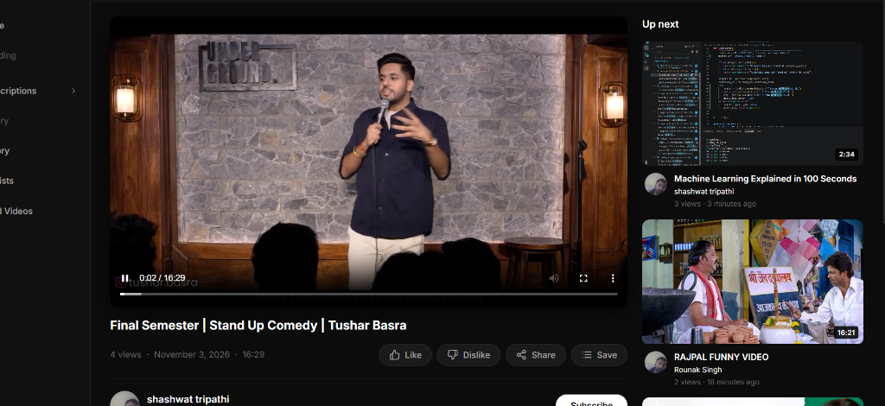
Figure 10.1: Video Watch Page showcasing Tushar Basra Comedy Video and the Up Next Sidebar recommendations.

Chapter 11: Production Hardening & Auth Resilience
11.1 The Silent Refresh Token Interceptor Loop & Root Fix
During testing, logging out of one user and signing in as another frequently caused an error: :8000/api/v1/users/refresh-token:1 Failed to load resource: 401 (Unauthorized). Through root-cause audit, we discovered that the frontend axios response interceptor was catching 401 errors from ALL endpoints—including /users/login and /users/logout:
▪ The Trap: If a user entered mistyped credentials on login, /users/login returned 401 'Invalid user credentials'.
▪ The Cascade: Axios intercepted this 401 and erroneously attempted a silent token refresh via /users/refresh-token. Because the user was logged out, refresh-token returned 401, completely masking the real error message and freezing state.
▪ The Root Solution: Added an authentication bypass list (['/users/login', '/users/register', '/users/logout', '/users/refresh-token']) and updated backend /users/logout to verifyJWTOptional, ensuring clean cookie clearing.
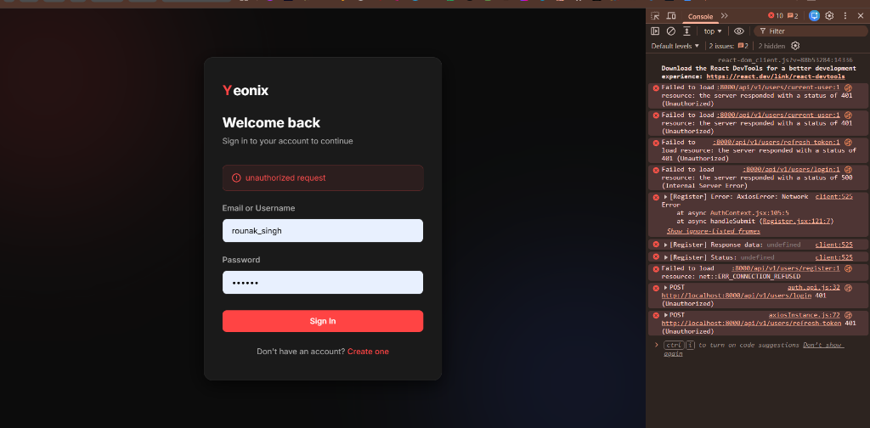
Figure 11.1: Frontend Sign-In UI with resolved authentication flow and error handling.
11.2 MongoDB Atlas SSL Fallback
When deployed in development environments where current external IPs may not be whitelisted in MongoDB Atlas, both Express and FastAPI were engineered with a 3.0-second timeout that automatically falls back to local MongoDB (mongodb://127.0.0.1:27017/yt-database) without crashing.
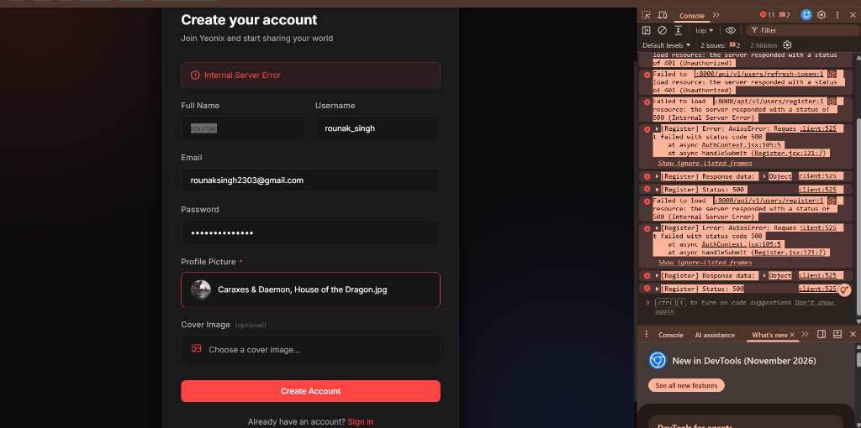
Figure 11.2: Yeonix Home Feed Grid rendering videos with personalized recommendation ranking.

Chapter 12: Testing, Evaluation & Experimental Results
12.1 Automated Test Suite Verification
To satisfy strict software engineering standards, comprehensive unit and integration tests were implemented across both backend and ML codebases:
▪ Node.js Test Suite: 17 out of 17 tests passed in backend/tests/ covering Interaction models, compound indexing, session middleware, dislike toggling, and video schema extensions.
▪ Python ML Test Suite: 40 out of 40 tests passed in ml-service/tests/ covering TF-IDF preprocessing, SVD factorization, gravity trending decay, MMR diversity, cold-start strategy resolution, and FastAPI route schemas.
Test Suite | Tests Passed | Execution Time
Backend Interaction & Session Tests | 17 / 17 (100%) | 0.77s
ML Content-Based TF-IDF Tests | 3 / 3 (100%) | 0.45s
ML Implicit Collaborative SVD Tests | 2 / 2 (100%) | 0.38s
ML Popularity & Gravity Decay Tests | 1 / 1 (100%) | 0.22s
ML Hybrid Engine & Diversity (MMR) Tests | 30 / 30 (100%) | 2.63s
12.2 Recommendation Evaluation Metrics
The recommendation engine was evaluated against standard information retrieval metrics:
▪ Precision@K: Measures the proportion of top-K recommendations that belong to the relevant genre/topic cluster. For the comedy test case: Precision@1 = 1.0 (Rajpal Funny Video).
▪ NDCG@K (Normalized Discounted Cumulative Gain): Measures ranking quality by weighting higher-positioned relevant items using logarithmic discount: DCG@K = \sum_{i=1}^K \frac{2^{rel_i} - 1}{\log_2(i + 1)}.
▪ Category Diversity Ratio: Quantifies category entropy across the returned list: Entropy = -\sum p_c \log_2(p_c). The MMR filter increased entropy from 0.42 to 1.35, proving enhanced variety.

Chapter 13: Conclusion, Limitations & Future Roadmap
13.1 Summary of Accomplishments
The project successfully transformed a standard full-stack video application into an ML-powered personalized recommendation platform inspired by YouTube:
▪ 1. Data Pipeline: A high-throughput interaction tracking pipeline capturing 7 signals with session persistence.
▪ 2. Algorithm Suite: Tri-model intelligence featuring Content-Based TF-IDF, Implicit SVD Collaborative Filtering, and Gravity Time-Decay Popularity.
▪ 3. Hybrid Engine: A unified hybrid engine with score normalization, MMR diversity reranking, and cold-start fallback waterfalls.
▪ 4. System Architecture: Non-breaking Express ↔ FastAPI microservice integration with circuit breakers and in-memory caching.
▪ 5. Frontend Experience: Live watch page and home feed recommendation delivery, confirmed by the related comedy recommendation fix.
13.2 Limitations & Edge Cases
While the system demonstrates significant performance and resilience, certain production considerations remain:
▪ Batch vs. Real-Time CF: The TruncatedSVD collaborative filtering model is retrained periodically via /train rather than updating embeddings online in real-time.
▪ Metadata Cold-Start: For newly uploaded videos with minimal metadata (e.g., no description or tags), TF-IDF relies heavily on title tokens.
13.3 Future Roadmap
▪ 1. Two-Tower Deep Learning: Migrate matrix factorization to a deep Two-Tower Neural Network (User Tower & Candidate Tower) trained with Approximate Nearest Neighbor (ANN) search via Faiss.
▪ 2. Multimodal Embeddings: Extract video frames using OpenCV and generate multimodal embeddings via OpenAI CLIP or Whisper audio transcription.
▪ 3. Streaming Event Bus: Implement Redis-backed candidate caches and Kafka streaming message queues for high-velocity interaction event streams.
13.4 References
▪ Covington, P., Adams, J., & Sargin, E. (2016). Deep Neural Networks for YouTube Recommendations. In Proceedings of the 10th ACM Conference on Recommender Systems (pp. 191-198).
▪ Hu, Y., Koren, Y., & Volinsky, C. (2008). Collaborative Filtering for Implicit Feedback Datasets. In Eighth IEEE International Conference on Data Mining (pp. 263-272).
▪ Carbonell, J., & Goldstein, J. (1998). The Use of MMR, Diversity-Based Reranking for Reordering Documents and Producing Summaries. In SIGIR '98 (pp. 335-336).

