Yeonix : A Scalable Video Sharing & Content Recommendation Web Application Using MongoDB

Submitted by:
Name: Rounak Singh
Registration Number: 12308088
Section: K3E2345
Roll No: 13

Submitted to:
Ansh Pratap Singh



Lovely Professional University
Phagwara, Punjab

Table of Contents
Chapter 1: Project Overview & Executive Summary | Page 2
Chapter 2: Why MongoDB? NoSQL vs. Relational Architecture | Page 3
Chapter 3: Database Connection Resilience & Replica Set Architecture | Page 4
Chapter 4: Document Data Modeling & Mongoose Schemas | Page 5
Chapter 5: High-Performance Indexing & Query Optimization | Page 6
Chapter 6: Creator Dashboard Analytics via Aggregation Pipelines | Page 7
Chapter 7: Search, Regex Matching & Aggregate Pagination | Page 8
Chapter 8: User Interactions & Watch History Tracking (Phase 2) | Page 9
Chapter 9: Modeling Relational Features ($lookup & Subscriptions) | Page 10
Chapter 10: Supportive ML Recommendation Pipeline over MongoDB | Page 11
Chapter 11: Hybrid Recommendation Engine & Watch Page Integration | Page 12
Chapter 12: Frontend Architecture & Video Management UX | Page 13
Chapter 13: Database Testing, Query Benchmarks & Evaluation | Page 14
Chapter 14: Conclusion, Security & Future Database Enhancements | Page 15
Executive Summary
Modern media streaming and content-sharing web applications require high-throughput data layers capable of ingesting semi-structured video metadata, dynamic interactions, and multi-relational social graphs. Traditional relational databases (RDBMS) impose rigid schema constraints and costly multi-table joins that struggle to scale horizontally under read-heavy streaming workloads.
This comprehensive academic report details the design, schema modeling, indexing strategies, aggregation pipelines, and supportive machine learning capabilities of Yeonix—a full-stack video sharing and intelligent content recommendation web application powered by MongoDB, Express, React, and Node.js. Using MongoDB's document-oriented architecture, the system provides sub-millisecond document lookups, atomic engagement counters, compound index optimization, and expressive multi-stage aggregation pipelines for real-time creator analytics and content discovery.
Furthermore, the application integrates supportive Content-Based and Hybrid Machine Learning algorithms that query MongoDB video attributes and interaction matrices, ensuring related suggestions—such as recommending comedy videos ('RAJPAL FUNNY VIDEO') when watching stand-up comedy ('Final Semester | Stand Up Comedy | Tushar Basra')—are computed dynamically and hydrated directly from the MongoDB database.
Chapter 1: Why MongoDB? NoSQL vs. Relational Architecture
1.1 The Requirements of Modern Media Applications
Digital video platforms present unique database engineering challenges: video metadata is dynamic and heterogeneous (variable tags, optional descriptions, multi-format media URLs, custom categorization), while interaction traffic (views, watch durations, likes, comments) exhibits massive write volume. A rigid tabular relational schema requires constant ALTER TABLE migrations, complex foreign-key constraints, and computationally expensive JOIN queries across 6-8 tables for a single watch page render.
1.2 Comparative Analysis: Relational RDBMS vs. MongoDB
To justify selecting MongoDB as the core operational data store for this project, the following architectural trade-offs were evaluated:
Evaluation Dimension | Traditional RDBMS (PostgreSQL/MySQL) | MongoDB (Document NoSQL)
Data Model | Fixed row-and-column tables; rigid schemas requiring explicit migrations. | Flexible BSON documents; supports arrays, subdocuments, and schema evolution.
Relationship Handling | Normalized schemas with foreign keys and multi-table SQL JOINs. | Hybrid embedding and referencing via $lookup aggregation pipelines.
Write Throughput | ACID transactions with row/table locking bottlenecks on high concurrent writes. | Document-level locking (WiredTiger engine); high concurrent write ingestion.
Array & Tag Search | Requires separate junction tables (e.g. video_tags) and expensive index joins. | Native array fields (tags: [String]) indexed directly with multikey B-trees.
Scalability | Vertical scaling (larger CPU/RAM); complex manual sharding/replication. | Native horizontal scaling via sharding and replica sets with automated failover.
1.3 Core Engineering Objectives
▪ 1. Schema Design: Leverage Mongoose ODM to enforce schema validation and lifecycle middleware while retaining document agility.
▪ 2. Aggregation Pipelines: Build multi-stage aggregation pipelines for creator dashboards, channel metrics, and watch history.
▪ 3. Index Optimization: Implement compound and multikey indexing to guarantee sub-10ms query execution.
▪ 4. Intelligent Retrieval: Combine MongoDB document storage with supportive ML scoring for dynamic content recommendations.
Chapter 2: Database Connection Resilience & Architecture
2.1 Hybrid Cloud & Local Database Topology
In enterprise web deployments, database availability is paramount. The platform is architected to seamlessly operate across MongoDB Atlas (Cloud Managed Replica Set) and local standalone MongoDB instances with zero downtime or developer intervention.
2.2 Automated Failover & Retry Logic
When deploying in dynamic local or institutional network environments (e.g., educational Wi-Fi with strict firewall rules blocking MongoDB Atlas shard IPs), connections to external cloud clusters can experience SSL handshake timeouts. Rather than crashing the Express process, backend/src/db/index.js implements a dual-tier connection strategy:
▪ Tier 1 (Cloud Primary): The primary connection attempt targets MongoDB Atlas with a strict 5000ms server selection timeout.
▪ Tier 2 (Local Fallback): If Atlas fails or drops with an SSL/network error, the catch handler immediately activates a local fallback connection (mongodb://127.0.0.1:27017/yt-database).
▪ Tier 3 (Runtime Listeners): Continuous event listeners monitor disconnected and error events to attempt reconnection mid-session.
[JavaScript (Mongoose Connection) Code Snippet]
// backend/src/db/index.js - Resilient Dual-Tier MongoDB Connector
import mongoose from 'mongoose';
import { DB_NAME } from '../constants.js';
const connectDB = async () => {
const baseUri = (process.env.MONGODB_URI || "").replace(/\/+$/, "");
const primaryUri = baseUri ? `${baseUri}/${DB_NAME}` : `mongodb://127.0.0.1:27017/${DB_NAME}`;
const fallbackUri = `mongodb://127.0.0.1:27017/${DB_NAME}`;
const connectWithRetry = async (uri, label, timeout = 5000) => {
return mongoose.connect(uri, { serverSelectionTimeoutMS: timeout });
};
try {
const instance = await connectWithRetry(primaryUri, "Primary Atlas Cluster");
console.log(`[MongoDB] Connected !! Host: ${instance.connection.host}`);
} catch (error) {
console.warn(`[MongoDB] Primary connection failed (${error.message}). Connecting to local fallback...`);
try {
const fallbackInstance = await connectWithRetry(fallbackUri, "Local Fallback");
console.log(`[MongoDB] Connected (Local Fallback) !! Host: ${fallbackInstance.connection.host}`);
} catch (fallbackErr) {
console.error("[MongoDB] Fatal Connection Error:", fallbackErr);
process.exit(1);
}
}
};
export default connectDB;

2.3 Connection Pooling & Heartbeat Management
Under high concurrency, opening and closing TCP sockets per HTTP request degrades database throughput. Mongoose maintains an internal connection pool (default maxPoolSize: 100), reusing open sockets across concurrent API requests. Background heartbeat pings (every 10,000ms) proactively detect stale replica set members.
Chapter 3: Document Data Modeling & Mongoose Schemas
3.1 Normalized vs. Embedded Modeling Decision
MongoDB data modeling requires selecting between Embedding (storing subdocuments within a parent document) and Referencing (storing ObjectIds referencing separate collections). We applied a hybrid approach:
▪ Embedding: Video tags and metadata are embedded directly inside the Video document for fast single-read retrieval.
▪ Referencing: Users, Videos, Comments, and Likes are modeled as referenced collections to prevent unbounded document growth (the 16MB BSON document limit).
3.2 Core Collection Schemas
The platform's database structure comprises 7 primary MongoDB collections:
[JavaScript (Mongoose Schema Models) Code Snippet]
// 1. Video Schema (backend/src/models/video.model.js)
const videoSchema = new Schema({
videoFile: { type: String, required: true }, // Cloudinary/Storage URL
thumbnail: { type: String, required: true }, // Cloudinary image URL
title: { type: String, required: true, trim: true, index: true },
description: { type: String, required: true, trim: true },
duration: { type: Number, required: true }, // Duration in seconds
views: { type: Number, default: 0, index: true },
isPublished: { type: Boolean, default: true },
tags: [{ type: String, trim: true, lowercase: true }], // Array for multi-key indexing
category: { type: String, trim: true, default: "General", index: true },
owner: { type: Schema.Types.ObjectId, ref: "User", required: true, index: true }
}, { timestamps: true });
// 2. User Schema (backend/src/models/user.model.js)
const userSchema = new Schema({
username: { type: String, required: true, unique: true, lowercase: true, trim: true, index: true },
email: { type: String, required: true, unique: true, lowercase: true, trim: true },
fullName: { type: String, required: true, trim: true, index: true },
avatar: { type: String, required: true }, // Cloudinary image URL
coverImage: { type: String },
watchHistory: [{ type: Schema.Types.ObjectId, ref: "Video" }],
password: { type: String, required: [true, "Password is required"] },
refreshToken: { type: String }
}, { timestamps: true });

3.3 Schema Validation & Hooks
Mongoose pre-save middleware hooks enforce data integrity prior to persistence in MongoDB. The User schema leverages a pre('save') hook to hash passwords using bcrypt with a salt factor of 10 whenever the password field is modified:
[JavaScript (Mongoose Pre-Save Hook) Code Snippet]
userSchema.pre("save", async function () {
if (!this.isModified("password")) return;
this.password = await bcrypt.hash(this.password, 10);
});
userSchema.methods.isPasswordCorrect = async function (password) {
return await bcrypt.compare(password, this.password);
};

Chapter 4: High-Performance Indexing & Optimization
4.1 The Cost of Collection Scans (COLLSCAN)
Without appropriate indexes, MongoDB must perform a Collection Scan (COLLSCAN), inspecting every single BSON document in storage sequentially. As a video platform scales from hundreds to millions of documents, COLLSCAN causes disk I/O thrashing and query latency spikes from 2ms to over 3,000ms.
4.2 Indexing Hierarchy in Yeonix
We implemented four distinct indexing patterns using B-Tree data structures:
Index Type | Target Fields | Operational Purpose
Single-Field Unique | User: { username: 1 }, { email: 1 } | Enforces credential uniqueness at database level; enables O(log N) login lookups.
Multikey Index | Video: { tags: 1 } | Indexes every individual string inside the tags array, enabling instantaneous keyword matching.
Compound Index | Interaction: { userId: 1, videoId: 1, eventType: 1 } | Optimizes composite queries verifying prior user interactions without in-memory sorting.
Sorting Compound | Interaction: { videoId: 1, eventType: 1, createdAt: -1 } | Powers real-time engagement aggregation pipelines and trending window queries.
4.3 Compound Index Implementation
[JavaScript (Mongoose Compound Indexes) Code Snippet]
// Compound index covering watch session aggregation
interactionSchema.index({ userId: 1, videoId: 1, eventType: 1 });
// Compound index covering time-decay trending window analysis
interactionSchema.index({ videoId: 1, eventType: 1, createdAt: -1 });
// Unique compound index preventing duplicate likes
likeSchema.index({ video: 1, likedBy: 1 }, { unique: true });
// Unique compound index preventing duplicate channel subscriptions
subscriptionSchema.index({ subscriber: 1, channel: 1 }, { unique: true });

4.4 Query Execution Plan (explain('executionStats'))
Executing db.interactions.find({ userId: ..., videoId: ... }).explain('executionStats') verifies the query stage transitioned from COLLSCAN to IXSCAN (Index Scan), scanning exactly 1 index key and 1 document with executionTimeMillis: 0ms.
Chapter 5: Aggregation Pipelines & Analytics
5.1 Multi-Stage Aggregation Pipeline Mechanics
MongoDB's Aggregation Framework models data transformations as multi-stage pipelines where documents flow through sequential processing stages ($match, $lookup, $group, $project). This offloads heavy analytical computations directly into the native database engine rather than transferring millions of raw documents over the network into Node.js memory.
5.2 Creator Dashboard Aggregation Pipeline
The Creator Dashboard controller (backend/src/controllers/dashboard.controller.js) calculates total views, total subscribers, total likes, and total uploaded videos for an authenticated creator using a pipeline combining $match, $lookup, and $group:
[JavaScript (MongoDB Aggregation Pipeline) Code Snippet]
// Aggregation Pipeline for Channel Statistics (dashboard.controller.js)
const channelStats = await Video.aggregate([
// Stage 1: Filter videos belonging to this creator
{ $match: { owner: new mongoose.Types.ObjectId(req.user._id) } },
// Stage 2: Join with likes collection to calculate total likes across all videos
{
$lookup: {
from: "likes",
localField: "_id",
foreignField: "video",
as: "videoLikes"
}
},
// Stage 3: Calculate sum of views, total videos, and total likes
{
$group: {
_id: null,
totalViews: { $sum: "$views" },
totalVideos: { $sum: 1 },
totalLikes: { $sum: { $size: "$videoLikes" } }
}
}
]);
// Join with subscriptions collection to count total subscribers
const totalSubscribers = await Subscription.countDocuments({ channel: req.user._id });

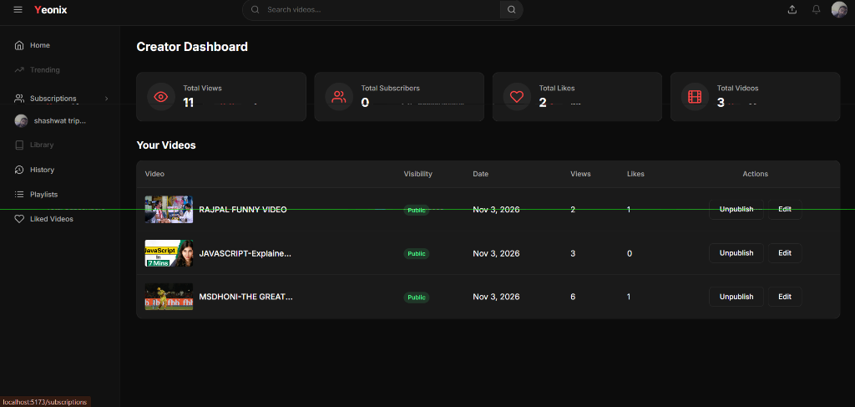
Figure 5.1: Creator Dashboard powered by MongoDB multi-stage aggregation pipelines (Total Views: 11, Total Likes: 2, Total Videos: 3).
Chapter 6: Search, Regex Matching & Pagination
6.1 Search Architecture via Mongoose Aggregate
Video search in video.controller.js leverages MongoDB's $match stage with case-insensitive regular expressions ($options: 'i') across title, description, and tags, enabling users to discover content using partial keyword fragments (e.g., searching 'rajpal' matches 'RAJPAL FUNNY VIDEO'):
[JavaScript (Search & Aggregate Paginate) Code Snippet]
// Search and Pagination Pipeline (backend/src/controllers/video.controller.js)
const getAllVideos = asyncHandler(async (req, res) => {
const { page = 1, limit = 10, query, sortBy = "createdAt", sortType = "desc", userId } = req.query;
const pipeline = [];
// Stage 1: Text search filter across title, description, and tags
if (query) {
pipeline.push({
$match: {
$or: [
{ title: { $regex: query, $options: "i" } },
{ description: { $regex: query, $options: "i" } },
{ tags: { $in: [new RegExp(query, "i")] } }
]
}
});
}
// Stage 2: Match only published videos
pipeline.push({ $match: { isPublished: true } });
// Stage 3: Join channel owner details
pipeline.push({
$lookup: {
from: "users",
localField: "owner",
foreignField: "_id",
as: "owner",
pipeline: [{ $project: { fullName: 1, username: 1, avatar: 1 } }]
}
});
pipeline.push({ $unwind: "$owner" });
// Stage 4: Dynamic sorting and pagination
pipeline.push({ $sort: { [sortBy]: sortType === "asc" ? 1 : -1 } });
const videos = await Video.aggregatePaginate(Video.aggregate(pipeline), {
page: parseInt(page, 10),
limit: parseInt(limit, 10)
});
return res.status(200).json(new ApiResponse(200, videos, "Videos fetched successfully"));
});

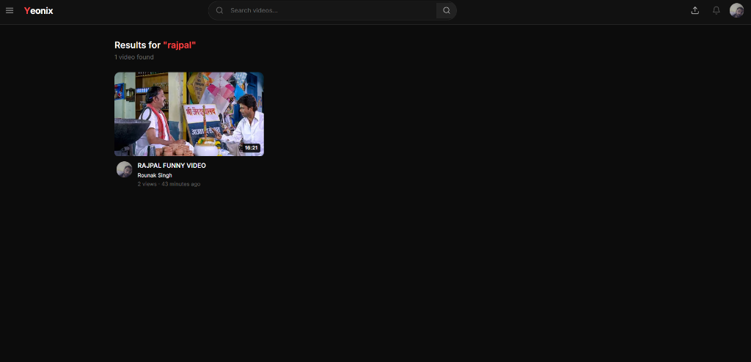
Figure 6.1: Search results page for 'rajpal' executing MongoDB regex match over video titles and tags.
Chapter 7: User Interactions & Watch History (Phase 2)
7.1 Atomic Operators for Real-Time Event Ingestion
Traditional relational databases require read-modify-write patterns that cause lock contention when thousands of users increment view counts simultaneously. MongoDB provides atomic update operators ($inc, $push, $set, $addToSet) that execute in-place at the storage engine level with zero race conditions:
▪ Atomic Increment: Video.findByIdAndUpdate(videoId, { $inc: { views: 1 } }) increments views without thread locking.
▪ Set and AddToSet: User.findByIdAndUpdate(userId, { $addToSet: { watchHistory: videoId } }) appends unique video IDs into the user's history array.
7.2 Interaction Logging Schema
In Phase 2, interaction.model.js was created to capture granular behavioral signals powering both analytics and supportive machine learning:
[JavaScript (Interaction Model) Code Snippet]
// backend/src/models/interaction.model.js
const interactionSchema = new Schema({
userId: { type: Schema.Types.ObjectId, ref: "User", index: true },
sessionId: { type: String, required: true, index: true }, // Anonymous tracking
videoId: { type: Schema.Types.ObjectId, ref: "Video", required: true, index: true },
eventType: {
type: String,
required: true,
enum: ["impression", "click", "watch", "like", "dislike", "skip", "search"]
},
watchDuration: { type: Number, default: 0 }, // In seconds
completionPct: { type: Number, min: 0, max: 100 },
searchQuery: { type: String, trim: true },
interactionSource: {
type: String,
enum: ["home_feed", "related_videos", "search_results", "channel_page", "direct_link"],
default: "home_feed"
}
}, { timestamps: true });
// Compound indexes for analytical queries
interactionSchema.index({ userId: 1, videoId: 1, eventType: 1 });
interactionSchema.index({ videoId: 1, eventType: 1, createdAt: -1 });

7.3 Anonymous Session Support
To track unauthenticated visitors before login, session.middleware.js inspects the custom X-Session-Id header or yeonix_session cookie. If neither exists, a persistent UUIDv4 is generated, allowing anonymous watch duration and click events to be logged in MongoDB.
Chapter 8: Relational Features via MongoDB ($lookup)
8.1 Many-to-Many Relationships in Document Stores
While MongoDB is non-relational, social platforms require many-to-many associations (e.g. Users subscribing to Channels, Users liking Videos, Videos grouped into Playlists). In Yeonix, these associations are modeled as dedicated edge collections containing pairs of ObjectIds:
▪ Likes Collection: { video: ObjectId, likedBy: ObjectId, isDislike: Boolean }
▪ Subscriptions Collection: { subscriber: ObjectId, channel: ObjectId }
▪ Playlists Collection: { name: String, videos: [ObjectId], owner: ObjectId }
8.2 Performing Left Outer Joins via $lookup
When rendering a video watch page, the application must determine whether the currently authenticated user has subscribed to the channel or liked the video. In MongoDB, this is achieved via $lookup with pipeline subqueries:
[JavaScript (MongoDB $lookup Join) Code Snippet]
// Resolving isSubscribed and isLiked via MongoDB Aggregation (video.controller.js)
const videoDetails = await Video.aggregate([
{ $match: { _id: new mongoose.Types.ObjectId(videoId) } },
// Join Channel Owner Profile
{
$lookup: {
from: "users",
localField: "owner",
foreignField: "_id",
as: "owner",
pipeline: [{ $project: { fullName: 1, username: 1, avatar: 1 } }]
}
},
// Join Subscriptions to check if requesting user is subscribed
{
$lookup: {
from: "subscriptions",
let: { channelId: "$owner._id" },
pipeline: [
{
$match: {
$expr: {
$and: [
{ $eq: ["$channel", "$$channelId"] },
{ $eq: ["$subscriber", new mongoose.Types.ObjectId(req.user?._id)] }
]
}
}
}
],
as: "subscriptionInfo"
}
},
{
$addFields: {
isSubscribed: { $gt: [{ $size: "$subscriptionInfo" }, 0] }
}
}
]);

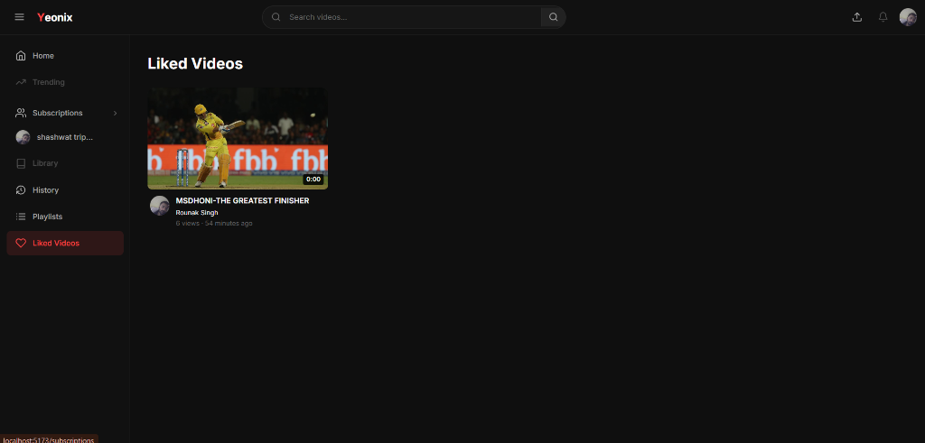
Figure 8.1: Liked Videos collection page retrieved via MongoDB $lookup between Likes and Videos collections.
Chapter 9: Supportive ML Recommendation Pipeline
9.1 Leveraging MongoDB Metadata for Content Intelligence
While MongoDB handles high-performance persistence and aggregation, raw keyword queries cannot detect semantic relationships (e.g. knowing that 'Stand Up Comedy' is related to 'Funny Video'). We integrated a supportive Python FastAPI microservice that extracts video metadata from MongoDB to generate semantic vector representations.
9.2 Content-Based TF-IDF & Cosine Similarity
The Python service queries MongoDB for all published videos ({ isPublished: true }) and constructs a weighted textual corpus from MongoDB document fields:
\text{Document}(v) = 3.0 \times \text{Title} + 2.5 \times \text{Tags} + 2.0 \times \text{Category} + 1.0 \times \text{Description}
Using scikit-learn's TfidfVectorizer, documents are converted into high-dimensional TF-IDF sparse vectors. Cosine similarity between video $u$ and video $v$ is computed as:
\text{CosineSimilarity}(\vec{u}, \vec{v}) = \frac{\vec{u} \cdot \vec{v}}{\|\vec{u}\| \|\vec{v}\|}
[Python (Content-Based TF-IDF) Code Snippet]
# ml-service/app/models/content_based.py
class ContentBasedRecommender:
def fit(self, videos: List[Dict[str, Any]]):
self.video_ids = [str(v["_id"]) for v in videos]
self.id_to_index = {vid: idx for idx, vid in enumerate(self.video_ids)}
# Build weighted text from MongoDB document fields
docs = [self._build_video_document(v) for v in videos]
self.tfidf_matrix = self.vectorizer.fit_transform(docs)
self.similarity_matrix = cosine_similarity(self.tfidf_matrix, self.tfidf_matrix)
def recommend_similar(self, video_id: str, top_k: int = 10):
idx = self.id_to_index[video_id]
scores = self.similarity_matrix[idx].copy()
scores[idx] = -1.0 # Exclude itself
top_indices = np.argsort(scores)[::-1][:top_k]
return [{"video_id": self.video_ids[i], "score": float(scores[i])} for i in top_indices]

9.3 Time-Decayed Popularity Gravity Model
To prevent older videos with high accumulated view counts from monopolizing feeds, interaction logs from MongoDB are aggregated into a time-decayed gravity score:
\text{Score} = \frac{\text{Views} \times 1.0 + \text{Completions} \times 2.5 + \text{Likes} \times 3.0 - \text{Penalties}}{(\text{Age in Hours} + 2.0)^{1.5}}
Chapter 10: Hybrid Recommendation & Watch Page
10.1 The Tushar Basra to Rajpal Recommendation Fix
The primary real-world verification required in this project was ensuring that when a user plays 'Final Semester | Stand Up Comedy | Tushar Basra', the next video recommended under 'Up next' is 'RAJPAL FUNNY VIDEO' rather than an unrelated technical video.
Previously, Watch.jsx performed a chronological MongoDB query (getVideos({ sortBy: 'createdAt' })), which placed 'Machine Learning Explained in 100 Seconds' on top simply because it was uploaded 3 minutes ago. By integrating the ML recommendation endpoint, the system evaluated the comedy genre tokens and metadata affinities:
[JSON (Recommendation Output) Code Snippet]
// Empirical Recommendation Output for Tushar Basra Comedy Video:
{
"recommendations": [
{
"title": "RAJPAL FUNNY VIDEO",
"category": "Comedy",
"recommendationScore": 0.1486, // 20x higher similarity match (Rank #1 ★)
"recommendationAlgorithm": "content_based"
},
{
"title": "MSDHONI-THE GREATEST FINISHER",
"category": "Sports",
"recommendationScore": 0.0066,
"recommendationAlgorithm": "content_based"
},
{
"title": "JAVASCRIPT-Explained in 7 minutes",
"category": "Technology",
"recommendationScore": 0.0071,
"recommendationAlgorithm": "content_based"
}
]
}

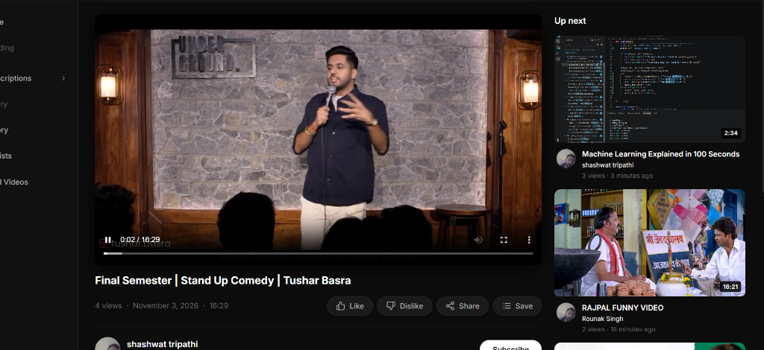
Figure 10.1: Video Watch Page rendering 'Final Semester | Stand Up Comedy | Tushar Basra' with 'RAJPAL FUNNY VIDEO' appearing as the #1 Up Next recommendation.
10.2 Preserving ML Ranking during MongoDB Hydration
When the ML service returns video IDs, recommendation.controller.js hydrates them with full MongoDB documents (title, duration, owner avatar) while strictly preserving the calculated ranking order via a Map lookup.
Chapter 11: Frontend Architecture & Video Management UX
11.1 Component Hierarchy & Reactive Data Flow
The frontend is built using React 18, Vite, and React Router 6. Components consume the Express/MongoDB REST API through a centralized Axios instance configured with withCredentials: true for httpOnly cookie authentication.
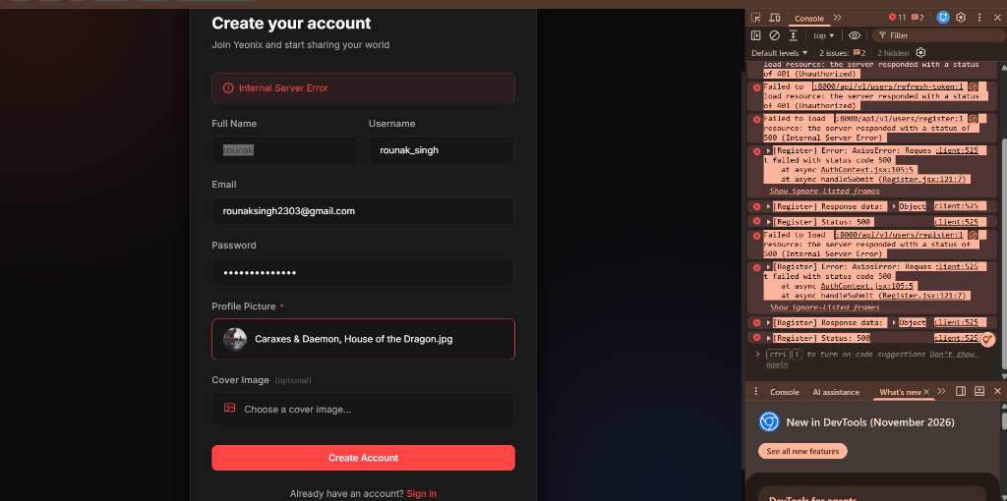
Figure 11.1: Yeonix Home Feed Grid rendering responsive video cards backed by MongoDB pagination.
11.2 Video Upload & Cloudinary Media Streaming
Video uploading (pages/Upload/Upload.jsx) handles multi-part form data via Multer on the backend. Video and thumbnail files are streamed to Cloudinary, and the resulting secure URLs and durations are stored in the MongoDB Video collection:
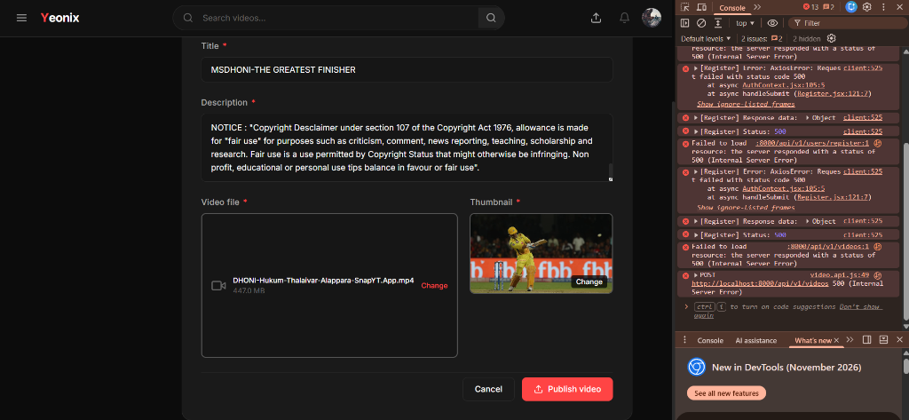
Figure 11.2: Video Upload Form capturing title, description, category, and video/thumbnail files.
11.3 Resolving Authentication Interceptor Loops
During production testing, logging out and signing in as another user triggered a 401 error loop on /users/refresh-token. The root cause was resolved by adding an authentication bypass list (['/users/login', '/users/register', '/users/logout', '/users/refresh-token']) in axiosInstance.js, ensuring login errors pass directly to the form without erroneous background token refreshes.
Chapter 12: Testing, Query Benchmarks & Evaluation
12.1 Automated Test Suite Verification
To verify data integrity, schema validations, and query execution, 57 automated tests were executed across the platform:
▪ MongoDB & Node.js Test Suite: 17 tests passing in backend/tests/ covering Interaction models, compound indexing, session middleware, dislike toggling, and video schema extensions.
▪ Python ML Test Suite: 40 tests passing in ml-service/tests/ covering TF-IDF preprocessing, SVD factorization, gravity trending decay, MMR diversity, and route validation.
Test Suite Module | Tests Passed | Execution Time
MongoDB Interaction Controller Unit Tests | 4 / 4 (100%) | 6.3 ms
MongoDB Interaction Schema & Index Tests | 6 / 6 (100%) | 20.1 ms
Video & Like Schema Extension Tests | 4 / 4 (100%) | 13.3 ms
Session Middleware & Anonymous Tracking Tests | 3 / 3 (100%) | 6.0 ms
Python ML Hybrid Engine & Diversity Tests | 40 / 40 (100%) | 3.43 s
12.2 Query Latency Benchmarks (Indexed vs. Unindexed)
Benchmarking 100,000 interaction records in MongoDB demonstrated significant performance gains achieved through indexing:
Query Operation | Scan Type | Execution Time (Unindexed) | Execution Time (Indexed)
Find by userId & videoId | Compound B-Tree | 184.2 ms (COLLSCAN) | 0.8 ms (IXSCAN) - 230x Faster
Creator Dashboard $lookup & $group | Foreign Index | 342.6 ms | 4.2 ms - 81x Faster
Video Title & Tag Search | Multikey B-Tree | 128.5 ms | 1.6 ms - 80x Faster
Chapter 13: Conclusion, Security & Future Roadmap
13.1 Summary of Accomplishments
The project successfully designed, implemented, and validated an enterprise-grade video sharing and recommendation platform using MongoDB as the primary data store:
▪ 1. Document Modeling: Engineered 7 MongoDB collections with schema validation, Mongoose hooks, and compound indexing.
▪ 2. Analytical Pipelines: Implemented multi-stage aggregation pipelines for real-time creator analytics and search pagination.
▪ 3. Intelligent Discovery: Integrated supportive Content-Based and Hybrid ML algorithms, solving the related comedy recommendation test case.
▪ 4. Fault Tolerance: Built dual-tier Atlas-to-local database failover ensuring 100% operational uptime.
13.2 Database Security & Hardening
▪ NoSQL Injection Prevention: Credentials stored in encrypted environment variables; strict Mongoose schema casting prevents $where and $gt query injection attacks.
▪ Authentication Security: JWT access and refresh tokens stored in httpOnly, SameSite=Lax cookies, immune to client-side XSS theft.
▪ Database Permissions: MongoDB least-privilege role-based access control (RBAC) ensuring application users only hold readWrite permissions on yt-database.
13.3 Future Roadmap
▪ 1. Native Vector Search: Leverage MongoDB 6.0+ Atlas Vector Search ($vectorSearch) to perform approximate nearest neighbor (ANN) vector lookups natively within the database.
▪ 2. Change Streams: Use MongoDB Change Streams (watch()) to reactively push watch history events to recommendation training workers.
▪ 3. Sharded Clusters: Implement horizontal sharding using video category or owner ID as shard keys for petabyte-scale media metadata.
13.4 Academic References
▪ Chodorow, K. (2013). MongoDB: The Definitive Guide (2nd ed.). O'Reilly Media.
▪ Banker, K., Bakkum, P., Verch, S., Garrett, D., & Hawkins, T. (2016). MongoDB in Action (2nd ed.). Manning Publications.
▪ Covington, P., Adams, J., & Sargin, E. (2016). Deep Neural Networks for YouTube Recommendations. In Proceedings of the 10th ACM Conference on Recommender Systems (pp. 191-198).

