Synopsis

Air Quality Level Classification System

Problem Id: 19

Student Name: Rounak Tayal
University Roll number : 2028826
Section : U

Student Name: Vansh Choudhary
University Roll number : 2028898
Section : U

Student Name: Keshav Sharma
University Roll number : 2028741
Section : U

- Problem Description:
Air pollution is a serious problem today, especially in cities and industrial areas, and it directly affects our health and daily lives. However, the data collected from air quality sensors is not always perfect. It often has missing values, errors, and noise, which makes it difficult to analyze properly. Also, different factors like CO, NO₂, temperature, and humidity are measured on different scales, which can lead to inaccurate results if not handled correctly.
In this project, we focus on cleaning and preparing the air quality data so it can be used effectively. This includes handling missing values, removing noise, and applying techniques like normalization and standardization to bring all the data to a similar scale. Once the data is processed, it becomes much easier to understand patterns and trends, and it will also be useful for building machine learning models in the next phases of the project.

- Steps of Implementation:
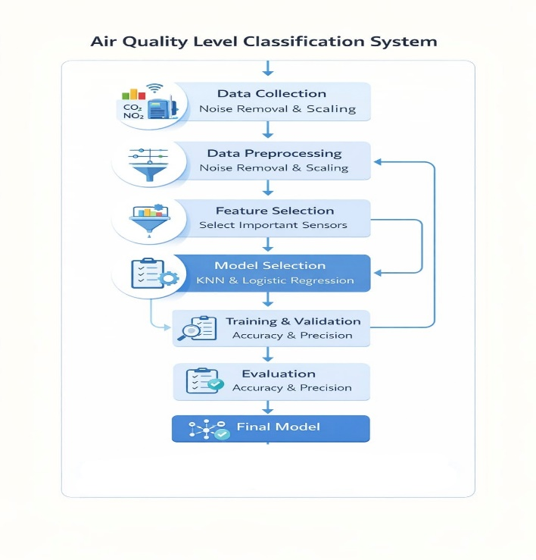
Fig. 1 Air quality classification system.
- Expected Modules/ Libraries to be used :
1. NumPy: For numerical computations
2. Pandas: For data handling and preprocessing
3. Matplotlib: For basic data visualization
4. Seaborn: For advanced visualization (heatmaps, distributions)
5. Scikit-learn (sklearn): For normalization and standardization (MinMaxScaler, StandardScaler)

- Expected Evaluation metrics and Plots to be used:
1. Missing Value Analysis
2. Histogram (before and after scaling)
3. Box Plot (outlier detection)
4. Feature Distribution Comparison
These plots ensure that the preprocessing steps like normalization and standardization are correctly applied

- Required topics from the subject:
1. File Handling:
File handling is used to read and manage dataset files (CSV format) for further processing.
2. Functions:
Functions help in dividing the preprocessing steps into smaller reusable parts, improving code readability and structure.
3. Basic Python Programming:
Basic concepts like loops, conditions, and variables are used to implement the overall preprocessing workflow.
4. Data Preprocessing Techniques:
Includes handling missing values, removing noise, and preparing clean data for analysis.
Data Normalization:
Used to scale data values between a fixed range (usually 0 to 1) so that all features contribute equally.
5. Data Standardization:
Used to transform data so that it has mean = 0 and standard deviation = 1, ensuring consistency across features.
6. Data Visualization:
Graphs like histograms, box plots, and heatmaps are used to understand data patterns and detect outliers.
- Platform Required:
1. Jupyter Notebook
2. Python IDLE
3. Visual Studio Code
- Link Sources:
1. https://www.kaggle.com
2. https://pandas.pydata.org
3. https://numpy.org
4. https://scikit-learn.org
5. https://matplotlib.org

