FOCUSON HRMS
Complete Plan v2.0: HR & Payroll Software (Google-only)
Permission aur authority system, office geo-fencing, optional selfie, workflow engine, RDash boundary, payroll aur expansion plan
Date: 10 November 2026 (Version 2.0, updated from v1 dated 9 November 2026)
Prepared for: FocusOn (internal company use)

Contents
1. Executive Summary aur Vision
2. Requirements aur Scope
3. Google Products ka Final Selection
4. Architecture: System Kaise Kaam Karega
5. Access Control: Permission aur Authority System
6. Default Roles aur Permission Matrix
7. Approval Workflow Engine
8. Attendance: Geo-fencing (sirf Office), Selfie (Optional)
9. RDash ke saath Boundary
10. Modules aur Functions
11. Database Design
12. Payroll Engine
13. HR aur Payroll Documents ki Automation
14. UI/UX Design
15. Security, Privacy, Backup aur Compliance
16. Limits aur Risks (Honest View)
17. Complete Setup Plan
18. Capability, Long-term Vision aur Expansion Plan
19. Decisions Needed aur Next Steps

1. Executive Summary aur Vision
FOCUSON HRMS ek internal HR + Payroll software hoga jo sirf Google ke products par chalega: koi paid HRMS subscription, hosting ya external database nahi. Shuruaat 80 employees se hogi, aur company badhne par sirf zaroori Google service ke liye pay karna padega.
Version 2 ka focus: software ka goal HRM aur Payroll department ko manage karna hai. Site ka kaam aur site reporting (DPR) RDash par hota hai, isliye HRMS mein DPR, tasks aur site reporting nahi banenge. Geo-fencing sirf office staff ke liye hogi. Kis user ko kya dekhna, banana, edit, delete ya approve karna hai, ye saari authority Super Admin decide karega.
Kya milega:
- Employee ID + password se login, mobile aur desktop dono par. CEO, Director, Manager, Supervisor, Storekeeper aur Office Boy tak sab ek hi portal use karenge.
- Configurable permission system: Super Admin roles banata hai, har module par View/Create/Edit/Delete/Approve/Export alag se deta hai, scope (self, team, department, company) set karta hai.
- Authority delegation: Super Admin higher authority (CEO/Director/HR Head) ko ek ceiling ke andar power deta hai; wo baaki employees, unka workflow aur approvals manage karte hain.
- Workflow engine: leave, attendance correction, advance, salary revision, exit jaise har request ki approval chain configurable, escalation aur delegate ke saath.
- Attendance: office staff ke liye geo-fenced check-in; site/field staff ke liye simple check-in. Selfie ek optional feature hai jo switch ON karne par hi dikhta hai.
- Leave, payroll, payslip, advance/loan, documents, recruitment, performance, exit aur F&F.
- HR aur payroll ke saare documents ek click par PDF mein auto-generate.
- Daily automatic backup aur restore, poora audit log.
- RDash ke saath clean boundary: employee ID mapping aur CSV import/export.
Honest note: "Free forever" ka matlab hai ki hum kisi paid software par dependent nahi honge. Google ki free services par quotas aur limits hoti hain aur Google unlimited ya permanent free availability ki guarantee nahi deta. Section 16 aur 18 isi ke baare mein hain.

1.1 Version 1 se Version 2 mein kya badla
Area | Version 1 | Version 2 (ye document)
Scope | HR + Payroll + DPR + Tasks + site reporting | Sirf HR + Payroll + approvals + HR reports. DPR, tasks aur site reporting RDash par
Geo-fencing | Check-in par GEO FETCH (sab ke liye) | Sirf office attendance policy wale employees ke liye. Site staff par nahi
Selfie | Site attendance ka standard hissa | Optional feature; Super Admin switch ON kare tabhi dikhega
Roles | 7 fixed roles | Super Admin ke banaye configurable roles + granular permissions + scope + user-level override
Authority | Fixed matrix | Super Admin higher authority ko ceiling ke saath delegate karta hai, wo aage workflow manage karte hain
Approvals | Ek simple Approvals table | Workflow engine: multi-step, condition, SLA, escalation, delegate, send-back
Users | Employee, Supervisor, HR, Accounts etc. | CEO, Director se Supervisor, Storekeeper, Office Boy tak; simple mode + Hindi/English
Database | 30 tabs, ek file | Do file: Core DB + Attendance DB (yearly archive); access-control aur workflow tabs add
Compliance | General privacy note | Consent log, retention rules, sensitive-field view logging, DPDP aur Labour Code notes

2. Requirements aur Scope
Software 80 employees ke liye banega aur 300 tak bina redesign ke chalna chahiye.
Requirement | Decision
Users | ~80 employees, scalable to 300
User types | CEO, Director, HR, Accounts, Department Head/Manager, Supervisor, Engineer/Office staff, Storekeeper, Office Boy
Work locations | Office (geo-fenced) aur Site/Field (geo-fence nahi)
Device | Mobile (primary) + desktop (HR/Accounts/Management)
Login | Employee ID + password; password reset; session expiry; first-login change
Roles aur permissions | Super Admin decide karta hai; higher authority ko ceiling ke saath delegate
Cost | Zero hosting, zero database cost, zero HRMS subscription
Data privacy | Private; koi public sharing nahi; salary/bank/ID fields par extra control
Backup | Designated Google Drive folder mein daily backup + restore
External tools | GitHub, Vercel, Firebase, Supabase nahi. RDash alag system hai, sirf light integration
Payroll | Salary structure, deductions, LOP, OT, advance/loan, payslip, PF/ESI/PT records, F&F
Documents | Saare HR aur payroll formats auto-generate

2.1 HRMS mein kya hai aur kya nahi
HRMS ke andar (in scope) | HRMS ke bahar (out of scope)
Employee master, org structure, reporting line | DPR, daily progress report, site photos (RDash)
Office attendance (geo-fence), site attendance (simple), leave | Site tasks, material, issue tracking (RDash)
Payroll, payslip, advance/loan, F&F, statutory data sheets | Biometric machine integration (abhi nahi)
Approvals aur workflow, HR documents, recruitment, performance, exit | Statutory portals par direct filing (HR/Accounts/CA karenge)
Role, permission, authority management | GPS ki hardware-level guarantee (browser limit, section 8.4)
HR aur payroll reports, dashboards | Stock/store management (Storekeeper sirf HRMS user hai)

2.2 Kaun use karega
User type | Device | Roz ka kaam | Design par asar
CEO / Director | Mobile + desktop | Approvals (hiring, salary revision, payroll final), dashboards | Short approval inbox, summary cards
HR | Desktop | Employees, attendance lock, leave, payroll prepare, documents | Full tables, bulk actions, exports
Accounts | Desktop | Payroll verify/release, advances, F&F | Payroll register, bank file, statutory sheets
Dept Head / Manager | Mobile + desktop | Team leave/attendance/expense approve | Team view, approval inbox
Supervisor | Mobile | Team attendance verify, mark on behalf, leave approve | Big buttons, team list
Engineer / Office staff | Mobile + desktop | Check-in, leave, payslip, documents | Standard self-service
Storekeeper / Office Boy | Basic mobile | Check-in, leave apply, payslip dekhna | Simple mode: 4 bade buttons, Hindi labels

3. Google Products ka Final Selection
Core system 5 Google products par khada hoga; baaki sahayak hain.
Google product | Role in HRMS | Kyu chuna
Apps Script (Web App) | Backend + API + login logic + permission engine + frontend hosting | Free, Sheets/Drive/Gmail se direct jud jata hai, alag server nahi chahiye
HTML Service (HTML/CSS/JS) | Frontend (portal ka UI) | Custom professional UI, mobile responsive
Google Sheets | Main database (Core DB + yearly Attendance DB) | Audit easy, structure clear
Google Drive | Documents, selfies, receipts, PDFs, backups | Structured folders, permission control
Google Docs | Letter aur payslip templates | Placeholders se auto-fill, PDF export
Gmail (via script) | Notifications, alerts | Leave/approval/payslip-ready alerts
Google Calendar | Holidays, interviews, birthdays | Company calendar sab ko dikhe
CacheService, LockService, PropertiesService | Role/permission cache, safe concurrent writes, secrets | Speed, data safety, code mein secret nahi
Looker Studio (optional) | Management dashboards | Sheets se live charts, free
Google Forms (optional) | Candidate application, exit feedback | Login ke bina quick intake
Jo hum use nahi karenge: Firebase, Supabase, Vercel, GitHub, paid hosting, paid database.
Do design decisions jo pehle fix kar lete hain:
- Account ownership: Software ek dedicated company account par banega, kisi ek employee ke personal Gmail par nahi. 2-Step Verification aur recovery access CEO ke paas hoga.
- Login: Apps Script web app owner ke naam se chalta hai, isliye employee login (ID + password) hamara apna hoga aur har server action par permission check hoga.

4. Architecture: System Kaise Kaam Karega
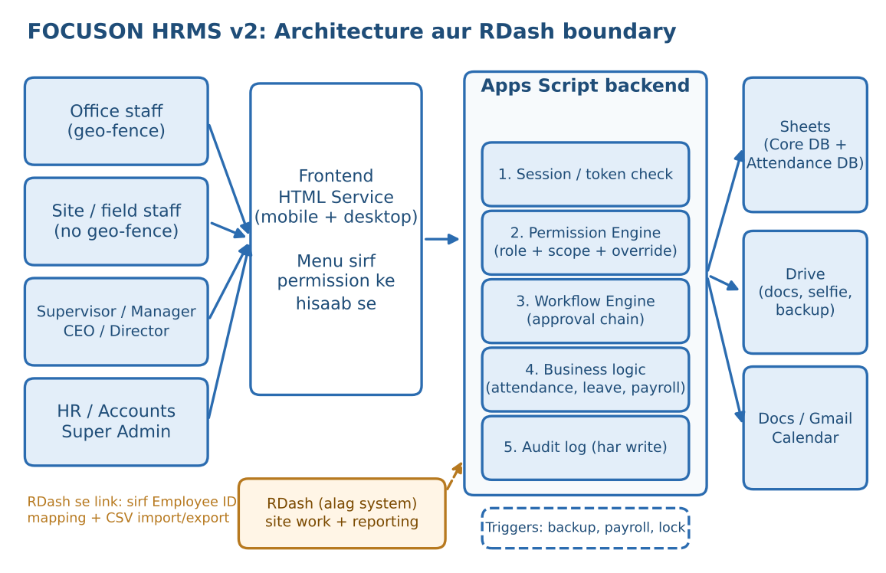
User portal kholta hai, frontend sirf wahi menu dikhata hai jo uski permission mein hai. Har click backend ke paas jata hai; backend pehle session, phir permission, phir workflow check karta hai, tabhi Sheets/Drive/Docs/Gmail se kaam karwata hai. Time triggers backup, attendance lock aur payroll draft jaise kaam apne aap chalate hain.
Ek request ka flow (office employee check-in example):
- Employee "Check-in" dabata hai.
- Backend session token verify karta hai aur permission engine se poochta hai: kya is user ko attendance.markself ki permission hai?
- Employee ki attendance policy dekhi jati hai. Office policy hai to browser se location maangi jati hai (site policy hai to location nahi maangi jati).
- Server distance calculate karke geo-fence check karta hai; agar selfie switch ON hai to selfie bhi li jati hai.
- LockService ke andar Attendance sheet mein row likhi jati hai; time server ka hota hai, phone ka nahi.
- Audit_Logs mein entry hoti hai; exception ho (bahar, GPS weak) to manager ke approval inbox mein jati hai.
- Employee ko confirmation screen milti hai.
Rule: Frontend sirf dikhane ke liye hai. Menu chhupana security nahi hai; asli check hamesha server par hota hai.

5. Access Control: Permission aur Authority System
Ye is software ka sabse important hissa hai. Principle simple hai: kuch bhi hardcode nahi. Kaun kya dekhega, banayega, badlega, delete karega, approve karega, ye sab Super Admin ke console se set hota hai aur code ko badalna nahi padta.

5.1 Core principles
- Default deny: jis cheez ki permission nahi di gayi, wo nahi milegi.
- Deny wins: agar kahin explicit DENY hai to koi bhi ALLOW use override nahi karta.
- Least privilege: har user ko sirf utna jitna kaam ke liye zaroori hai.
- Ceiling rule: koi bhi authority sirf wahi permission aage de sakti hai jo uske paas khud ho, aur sirf apne scope ke andar.
- Maker-checker: jo cheez banata hai wo khud approve nahi kar sakta (payroll, salary revision, advance).
- Har change audit hota hai: kisne, kisko, kya permission di ya hata di, kab aur kyu.

5.2 Authority delegation chain
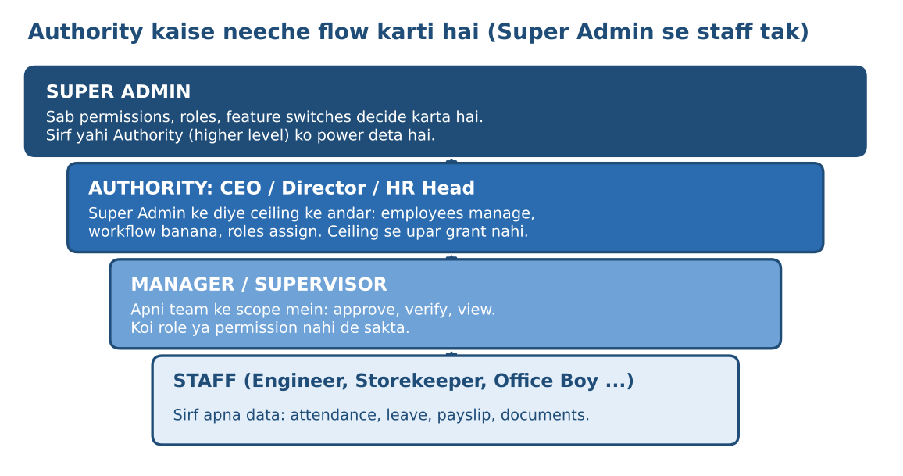
Super Admin ek ya zyada higher authority (CEO, Director, HR Head) ko Authority profile deta hai. Profile mein 4 cheezein tay hoti hain:
- Scope: kin departments/branches/employees par uska haq hai (jaise Director A sirf Engineering dekhe).
- Capability ceiling: kaun si permissions wo aage de sakta hai (jaise roles assign kar sakta hai, par salary-edit nahi de sakta).
- Workflow rights: apne scope ke workflow define/badal sakta hai ya nahi.
- Validity: permanent ya date-limited (jaise chhutti par jaane wale authority ke liye temporary).
Authority is ceiling ke andar baaki employees ko manage karti hai: team assign karna, reporting line set karna, approval chain tay karna, aur Manager/Supervisor ko team-level powers dena. Authority Super Admin ki settings, backup/restore, audit log aur apni khud ki permissions nahi badal sakti.

5.3 Building blocks
Block | Matlab | Example
Permission | Ek chhoti, specific action. Naam: module.action | leave.approve, payroll.prepare, field.salary.view
Scope | Permission kis data par lagegi | Self, Direct reports, Team (poori downline), Department, Branch, Company, Custom list
Role | Permissions + scope ka bundle. Super Admin naye roles bana sakta hai | HR Manager, Department Head, Supervisor, Staff, ya koi custom role
User override | Kisi ek user ke liye role se alag ALLOW ya DENY, expiry ke saath | Rohit ko 15 din ke liye attendance.correct
Delegation | Approval ya kaam kisi aur ko temporarily saunpna | Manager chhutti par: approvals Deputy ko
Feature switch | Poori feature on/off (company, policy ya employee level) | Selfie ON sirf Office policy ke liye
Condition | Permission par limit | Advance approve sirf Rs. 20,000 tak

5.4 Permission catalog (module aur actions)
Actions: View, Create, Edit, Delete (soft delete, recover ho sakta hai), Approve, eXport, aur kuch module-specific (generate, lock, release). Sensitive wali permissions alag keys mein hain aur unka access-log banta hai.
Module | Permission keys | Scope options | Sensitive?
Employee profile | employee.view / create / edit / deactivate / export | Self, Team, Dept, Branch, Company | Medium
Sensitive fields | field.salary.view / edit, field.bank.view / edit, field.govtid.view (Aadhaar/PAN), field.medical.view | Self, Company | Haan (view log)
Organization setup | org.view / create / edit / delete (departments, designations, branches, sites) | Company | Medium
Attendance | attendance.markself / markothers / view / correct / regularize.approve / lock / export | Self, Team, Dept, Branch, Company | Correct, lock: haan
Geo-fence aur policy | geofence.configure, attendancepolicy.manage, selfie.view | Company | Haan
Leave | leave.apply / view / approve / balance.adjust / policy.configure / export | Self, Team, Dept, Company | Adjust: haan
Calendar | holiday.edit, shift.edit | Company | Low
Salary structure | salarystructure.view / edit, revision.initiate / approve | Self, Company | Haan
Payroll run | payroll.prepare / verify / approve / release / reopen, payslip.view, statutory.export, fnf.prepare / approve | Self (payslip), Company | Bahut high
Advance, loan, expense | advance.request / approve / disburse, expense.submit / approve / pay | Self, Team, Dept, Company (+ amount limit) | High
Documents | doc.generate.<category>, doc.view, doc.delete, doctemplate.manage | Self, Team, Company | Medium
Recruitment | recruit.view / create / manage / offer.approve | Dept, Company | Medium
Performance | perf.goal.set / review / view / consolidate | Self, Team, Dept, Company | Medium
Exit | exit.initiate / approve / clearance / fnf | Self, Team, Company | High
Approvals aur workflow | approval.inbox / delegate / override, workflow.define | Scope + step | Override, define: haan
Reports | report.<name>.view / export | Self, Team, Dept, Company | Payroll reports: high
Users aur access | user.create / resetpassword, role.define / assign, override.grant, authority.delegate, accesslog.view | Company (ceiling ke andar) | Bahut high
System settings | settings.company / statutory / featureflags, integration.manage, backup.run / restore | Company | Bahut high
Announcements | announce.send | Company, Dept | Low

5.5 Scope levels
Scope | Kya cover karta hai
Self | Sirf khud ka data
Direct reports | Jo seedhe is user ko report karte hain
Team | Poori reporting line (direct + unke neeche wale sab)
Department | Poora department, reporting line se alag
Branch / Location | Ek office ya site ke sab employees
Company | Sab employees
Custom list | Super Admin dwara chuni hui named employees ya groups

5.6 Permission evaluation: har request par kya hota hai
- Session valid hai aur user active hai?
- Is user ke liye is permission par explicit DENY override hai? Haan to ruko.
- User ki saari permissions jodo: uske roles + active user-overrides (expire nahi hue) + active delegations.
- Required permission key hai? Nahi to deny.
- Scope check: jis record par kaam ho raha hai wo user ke scope mein hai?
- Field check: sensitive field (salary, bank, ID) ke liye alag permission hai? Nahi to field masked.
- Feature switch check: selfie, geo-fence jaise feature is user ke liye ON hain?
- Maker-checker check: requester aur approver alag hain? Payroll prepare aur approve ek hi banda to nahi?
- Condition check: amount, days ya limit ke andar?
- Action chalao aur Audit_Logs mein likho: kaun, kya, kis record par, purana aur naya value, kab.
Performance ke liye role-permission map 10 minute cache mein rahega aur Super Admin ke koi bhi permission change par turant refresh hoga.

5.7 Safeguards
- Grant ceiling: authority apni permissions se zyada nahi de sakti; khud ko bhi escalate nahi kar sakti.
- Super Admin limit: maximum 2 Super Admin (ek primary, ek backup). CEO ke paas account recovery.
- Segregation of duties: Super Admin routine payroll nahi chalayega; payroll prepare (HR), verify/release (Accounts), final approval (CEO/Director) alag log.
- Sensitive grants: salary view/edit, payroll approve, delete, role.define sirf Super Admin de sakta hai ya Super Admin ki second approval se.
- Temporary access: override aur delegation ki expiry date compulsory.
- Alerts: sensitive permission change par Super Admin ko notification.
- View logging: salary, bank aur ID fields kisne kab dekhe, uska log.
- Quarterly access review: Super Admin report dekhta hai: kis ke paas kya hai, kaun inactive hai; ek click mein revoke.
- Leaver rule: exit hote hi login band, roles hat jate hain, pending approvals reassign hote hain.
- Soft delete: koi record permanently delete nahi hota; sirf archive. Hard delete sirf Super Admin, reason ke saath.

5.8 Super Admin Console
Screen | Kya karta hai
Role Builder | Naya role banana, permissions tick karna, har permission ka scope aur condition set karna, role clone karna
Permission Matrix | Roles x modules ka grid; ek nazar mein dekho kisko kya milta hai; yahin se edit
Authority Setup | CEO/Director/HR Head ko Authority profile dena: scope, ceiling, workflow rights, validity
User Access | Kisi ek user ke roles, overrides, delegations, effective permissions ("Rohit kya kya kar sakta hai?")
Workflow Designer | Approval chains banana/badalna (section 7)
Feature Switches | Selfie, geo-fence, Hindi UI, optional modules ON/OFF: company, policy ya employee level par
Access Review | Quarterly review report: inactive users, high-privilege users, expiring overrides
Audit Viewer | Permission changes, logins, salary/attendance corrections, sensitive field views
Test as user | Super Admin kisi role ko "preview" kar sake bina asli user ka password jane

6. Default Roles aur Permission Matrix
Ye sirf starting preset hai. Super Admin har role, har cell aur har scope badal sakta hai, naya role bana sakta hai, aur kisi ek user ko override de sakta hai. Neeche ka matrix isliye diya hai ki shuru se ek sensible base mile aur aap use review karke final kar sakein.

6.1 Designation aur system role alag cheezein hain
Designation wo hai jo employee ka title hai (CEO, Storekeeper). System role wo hai jo software mein power deta hai. Ek designation ko default role milta hai, par Super Admin kisi bhi employee ko alag role ya extra permission de sakta hai.
Designation / user type | Default role (preset) | Typical scope | Note
CEO | Executive | Company | Final approvals, dashboards; payroll final approval optional
Director | Executive | Department/Branch (Super Admin set kare) | Alag directors ka alag scope ho sakta hai
HR Head / HR Manager | HR Manager (+ Authority agar Super Admin de) | Company | Employee, attendance, leave, payroll prepare, documents
Accounts / Payroll | Accounts / Payroll | Company (payroll fields) | Verify, release, advances, F&F; employee master edit nahi
Project / Department Manager | Department Head | Department | Team approvals aur team reports
Supervisor | Supervisor | Team / site team | Team attendance verify, mark on behalf, leave approve
Engineer, Office staff | Staff | Self | Self-service
Storekeeper | Staff | Self | Site/office ke hisaab se attendance policy alag
Office Boy | Staff (Simple mode) | Self | 4 bade buttons, Hindi labels
Super Admin (max 2) | Super Admin | Company + system | Permissions, roles, settings, backup, audit

6.2 Default permission matrix
Code: V = View, C = Create, E = Edit, D = Delete (soft), A = Approve, X = Export. Brackets mein scope: (S) Self, (T) Team, (D) Department, (All) Company. "Granted" ka matlab hai Super Admin dega to hi milega. "-" matlab koi access nahi.
Note: Super Admin ko salary data View (logged) diya gaya hai taaki system chalane ke liye access rahe, par routine payroll run Super Admin ka kaam nahi hai. Agar aap chahein to ye bhi band ho sakta hai.
Module | Super Admin | Executive (CEO / Director) | HR Manager | Accounts / Payroll | Department Head | Supervisor | Staff (all others)
Employee master | V C E D X (All) | V (All/scope); A hiring | V C E D X (All) | V (All, payroll fields) | V (D) | V basic (T) | V (S); change request
Salary, bank, ID fields | V E (All, logged) | V (Director/CEO only, logged) | V E (All, logged) | V (All); E bank | - | - | V (S)
Attendance | V E X (All) | V (All); reports | V E X; lock (All) | V (All) | V; A regularize (D) | V; mark on behalf; A (T) | Mark + V (S)
Geo-fence, attendance policy | Full | - | Granted | - | - | - | -
Selfie view | Full | - | Granted | - | - | - | -
Leave | Full | V (All); A for Dept Heads | V A; balance adjust (All) | V (All) | A (D) | A (T) | Apply; V (S)
Salary structure, revision | V E (All) | V; A revision | V E; initiate revision | V (All) | - | - | V (S)
Payroll run | Config only; run = break-glass | A final (optional) | Prepare | Verify, Release | - | - | -
Payslip | V (All, logged) | V summary | V (All) | V (All) | - | - | V (S)
Advance, loan, expense | Full | A above limit | V A | A; Disburse; Pay | A (D) | A (T); submit | Submit; V (S)
Documents | Full | V; A sensitive letters | Generate all | Payroll docs | Request (T) | Request (T) | Own docs; request
Recruitment | Full | A offer | Full | - | Create opening; feedback | - | -
Performance | Full | V (All); A | Full; consolidate | - | Review (D) | Review (T) | Goals; V (S)
Exit and F&F | Full | A | Initiate; prepare | A F&F; Pay | A level 1 (D) | - | Resign (S)
Approvals, workflow | Define all; override | Define in ceiling (granted) | Define HR flows (granted) | Inbox | Inbox | Inbox | Track own
Reports | All | All (summary) | All | Payroll, finance | (D) | (T) | (S)
Users, roles, access | Full | Assign roles in ceiling (granted) | Create user; reset password | - | - | - | Change own password
Settings, backup, audit | Full | Audit summary (granted) | Leave policy, holidays | - | - | - | -

7. Approval Workflow Engine
Workflow engine har request (leave, regularization, advance, salary revision, exit, document) ki approval chain chalata hai. Chain Super Admin ya uski di hui authority banati hai; code mein fixed nahi hai.

7.1 Workflow ke parts
Part | Kya hota hai
Request type | Leave, Attendance regularization, Overtime, Advance/Loan, Expense, Salary revision, Hiring/Offer, Payroll run, Resignation/Exit, Document request, Role change
Steps | Order mein 1 se N steps; sequential ya parallel (any-of / all-of)
Approver kaun | Reporting Manager, Manager ka manager (skip-level), Department Head, kisi Role ke log, ya ek named person
Condition | Chain request ke hisaab se badlegi: leave > 3 din, amount > limit, unpaid leave, etc.
SLA aur escalation | Approver X ghante mein action na le to reminder, phir upar wale ko escalate
Delegate | Approver chhutti par ho to deputy ko approvals jayen (date range ke saath)
Actions | Approve, Reject (comment compulsory), Send back for correction, Withdraw (requester)
Versioning | Workflow badalne par naye requests naye version par; chalti hui requests purane par

7.2 Default approval chains (Super Admin badal sakta hai)
Request | Chain | Rule / limit
Leave (normal) | Employee > Reporting Manager > HR records | Balance auto-update; 3 din tak sirf Manager
Leave (lamba / unpaid / special) | Employee > Manager > HR > Director | Director 15 din se upar ya unpaid par
Attendance regularization | Employee > Manager > HR | HR tab jab mahine mein limit (default 3) se zyada ho
Overtime | Supervisor/Manager > Dept Head > HR > Accounts | OT payroll mein tabhi jayega jab approved ho
Advance / Loan | Employee > Manager > HR > Accounts | Limit se upar Director; EMI schedule payroll mein
Expense reimbursement | Employee > Manager > Accounts | Receipt photo compulsory
Salary revision | HR initiate > Dept Head recommend > Director/CEO > Accounts apply | Effective date se arrears auto-calculate
Hiring / Offer letter | HR > Dept Head > Director/CEO | Approval ke baad hi letter generate
Payroll run | HR prepare > Accounts verify > CEO/Director (optional) > Accounts release | Prepare karne wala approve nahi kar sakta
Resignation / Exit | Employee > Manager > HR > Director (optional) > F&F: HR > Accounts | Clearance checklist, F&F approval
Document request | Employee > HR | Auto-generate ho sakta hai agar HR ne allow kiya
Role / permission change | Authority request > Super Admin | Sensitive permissions par hamesha Super Admin

7.3 Edge cases jinke liye pehle se rule hai
- Top level ka approval: CEO/Director ki apni leave ya advance kaun approve karega, ye Super Admin pehle se define karega (peer Director ya Super Admin).
- Reporting manager nahi hai: request Department Head ya HR ko jayegi.
- Self-approval: hamesha blocked. Agar approver hi requester ho to agla step.
- Approver exit ho jaye: pending requests uske manager ko reassign.
- Parallel approval: any-of (koi ek approve kare) ya all-of (sab karein) step level par set hota hai.
- Approved ke baad badlav: direct edit nahi; reopen request + audit log.

8. Attendance: Geo-fencing (sirf Office), Selfie (Optional)

8.1 Attendance policy: employee ke hisaab se
Geo-fencing designation par nahi, attendance policy par depend karti hai. Har employee ko ek policy assign hoti hai, aur Super Admin/HR policy badal sakte hain.
Policy | Kiske liye | Geo-fence | Selfie | Bahar ya GPS fail hone par
Office (Geo-fenced) | DPR office / office-based staff | Zaroori | Optional switch | Block ya Flag + manager approval (policy mein set)
Site / Field | Site supervisor, engineer, labour staff | Nahi | Optional switch | Simple tap; supervisor mark-on-behalf bhi
Exempt / Flexible | CEO, Directors, jinhe daily punch nahi chahiye | Nahi | Nahi | Din present maana jayega; Super Admin set kare
Storekeeper aur Office Boy jaise users ko policy unki asli jagah ke hisaab se milegi (office mein ho to Office policy, site/store par ho to Site policy).

8.2 Geo-fence logic
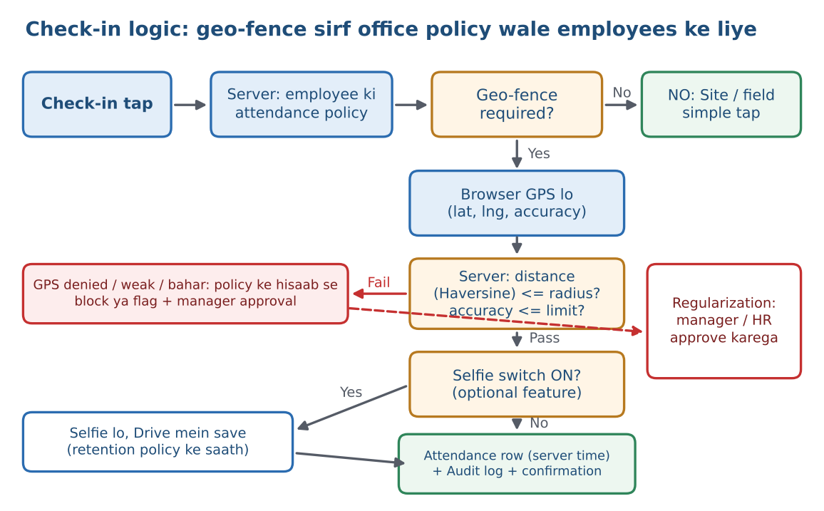
Parameter | Default | Kaun badal sakta hai
Office location | Branch ke latitude/longitude; ek branch ke multiple points allowed | Super Admin / granted HR
Radius | 100 m (50 se 500 m ke beech) | Super Admin / granted HR
Minimum GPS accuracy | 50 m ya behtar. Isse kharab reading ko weak maana jata hai | Super Admin
Check-out par geo-fence | Optional (default OFF) | Super Admin
Outside behaviour | Flag + manager approval (ya Block) | Super Admin
GPS denied behaviour | Flag + manager approval (ya Block) | Super Admin
Check-in window | Shift start se pehle X min se shift end tak | HR / Super Admin

Distance calculation: phone se latitude, longitude aur accuracy aate hain. Server Haversine formula se office point se doori nikalta hai. Doori <= radius aur accuracy <= limit ho to check-in pass. Calculation server par hoti hai, isliye phone par kuch bhi badalne se rule nahi badalta.

8.3 Selfie: optional feature
- Switch levels: Company default, phir Attendance Policy, phir employee. Neeche wala level upar ko override karta hai.
- Switch OFF ho to selfie ka button hi nahi dikhta. ON ho to check-in ke saath camera khulta hai.
- Kaun dekh sakta hai: sirf jinke paas selfie.view permission hai (HR ya granted authority). Supervisor ko sirf exceptions dikhte hain.
- Storage: Drive ke private folder mein, month-wise, compress karke. Default retention 90 din, uske baad auto-delete (Super Admin badal sakta hai).
- Face recognition V1 mein nahi hai. Selfie sirf evidence hai jo flagged ya spot-check cases mein dekhi jati hai. Biometric/face matching sensitive personal data hai aur alag consent aur legal check maangta hai.
- Employee ko selfie aur location ke use ka consent notice pehle login par dikhega aur Consent_Log mein record hoga.

8.4 Honest limits: geo-fence kitna reliable hai
Browser-based geo-fence 100% foolproof nahi hota. Ye limits pehle se pata honi chahiye:
Limit | Asar | Hamara upay
Fake GPS app | Browser mock location ko pakad nahi sakta | Accuracy limit, anomaly flags (roz ek jaisa coordinate, impossible jump), optional selfie, random spot-check
Apps Script iframe | Kuch phones/browsers par location permission fail ho sakti hai | Pilot mein har device test; fail hone par fallback policy
Indoor GPS weak | Imarat ke andar accuracy kharab ho sakti hai | Radius thoda bada rakho; weak reading par regularization
User ne location deny ki | Check-in atak sakta hai | Samjhane wali screen + Flag-and-approve fallback
Phone ki settings | Battery saver ya privacy settings location rok sakti hain | Training + HR help

Agar pilot mein geolocation reliable na nikla: fallback options hain: (1) office mein rotating PIN/QR jo 60 second tak valid ho (presence ka kamzor par practical proof), (2) Flag-and-approve model, (3) aage chalkar biometric/hardware import. Decision pilot ke result par hoga.

8.5 Attendance rules (configurable)
Rule | Default | Kaise kaam karta hai
Shift aur grace | Shift start + 15 min grace | Grace ke baad late mark
Late rule | Mahine mein 3 late = 1 half-day (optional) | Policy mein set; payroll mein auto
Half-day / full-day | Min working hours se | Check-in aur check-out ke beech ke ghante
Missed check-out | Din ke end par auto check-out, flagged | Employee regularization se theek karta hai
Weekly off, holiday | Calendar se | Paid days mein auto
Overtime | Sirf approved OT | OT hours shift se upar; Manager approve
Regularization | Mahine mein limit, reason compulsory | Workflow chain (section 7)
On-duty / tour | Request se, approval ke baad present | Geo-fence skip, approval trail ke saath
Attendance lock | Mahine ke cutoff par | Lock ke baad correction sirf approval se, audit ke saath
Time source | Hamesha server time | Phone ka time kabhi use nahi

9. RDash ke saath Boundary
RDash par site ka kaam aur reporting chalti hai. HRMS ka kaam people, attendance, payroll aur approvals hai. Dono ko alag rakhna hai taaki kisi ek ka kaam doosre par na pade.
Kaam | HRMS | RDash
Employee master, reporting line, status | Yes (master) | Sirf copy / mapping
Office attendance (geo-fence) | Yes | -
Site attendance / manpower | Source decide karna hai (section 9.2) | Ho sakta hai
Leave, payroll, payslip, advance | Yes | -
HR documents, approvals | Yes | -
DPR, site progress, site reports | Nahi | Yes
Site tasks, material, issues | Nahi | Yes

9.1 Integration levels
Level | Kya | Kab
Level 0: Link only | HRMS dashboard par RDash ka shortcut link | Version 1 mein hoga
Level 1: ID mapping + CSV | Same Employee ID (FO-0001) dono mein. HRMS se employee list CSV export; RDash se site manpower/hours CSV import | Version 1 mein hoga, agar RDash CSV deta hai
Level 2: API sync | RDash API ho to automatic sync | Baad mein, RDash ki capability dekhkar

9.2 RDash ke baare mein jo mujhe pata nahi (aapse confirm karna hai)
- Kya RDash mein site attendance ya manpower hours record hote hain? Agar haan, kya CSV/API se mil sakte hain?
- Kya RDash ka employee ID HRMS ke FO-xxxx se match karega ya mapping table chahiye?
- Site staff ki attendance ka source kaun hoga: (a) HRMS mein simple tap, (b) supervisor bulk mark, (c) RDash se import? Meri recommendation: (a) + (b) version 1 mein, kyunki payroll ke liye attendance HRMS mein hi honi chahiye.

10. Modules aur Functions
Module | Kya function karega | Kaise kaam karega
Login aur Security | Employee ID + password login, reset, session expiry | Salted hash; token session; har request par permission check
Dashboard | Role ke hisaab se cards (present, leave, pending approvals, payroll status) | Sheets se summary, 5 min cache
Employees | Employee master: personal, bank, joining, documents, photo, reporting line | HR form; ID auto (FO-0001); documents Drive mein
Organization setup | Department, designation, branch (geo-point), site master | Super Admin / granted HR
Access Control Console | Roles, permissions, authority, overrides, feature switches (section 5) | Super Admin only
Workflow aur Approvals | Ek unified inbox, chain designer, escalation, delegate | Workflow engine (section 7)
Attendance: Office | Geo-fenced check-in/out, optional selfie, late/half-day | Section 8
Attendance: Site/Field | Simple check-in, supervisor mark-on-behalf | Section 8, bina geo-fence
Leave | Apply, approve, balance, carry-forward, encashment | Workflow; balance auto; Gmail alert
Calendar | Holidays, shifts, birthdays | Calendar + Holidays sheet sync
Payroll | Monthly salary, LOP, OT, advance recovery, payslip, statutory data | Section 12
Advance, Loan, Expense | Request, approve, EMI, reimbursement | Workflow; payroll mein auto recovery
Documents | HR documents generate aur store | Section 13
Recruitment | Opening, candidates, interview schedule, onboarding checklist | Google Forms + Calendar
Performance | Review cycle, rating, goals | Manager review; HR consolidate
Exit aur F&F | Resignation, clearance, F&F, letters | Workflow + payroll engine
Notifications | Portal-first alerts, email sirf zaroori par | Notifications sheet; Gmail limit ka dhyan
Reports | Excel + PDF exports, scope ke hisaab se | Attendance register, payroll register, LOP, headcount, attrition
Settings aur Backup | Leave policy, statutory rates, branding, backup | Super Admin; har change Audit_Logs mein
RDash link | Shortcut aur CSV import/export | Section 9

10.1 Roz ka user journey (examples)
Office Boy: Hindi mein login > 4 bade buttons (Check-in, Chhutti, Payslip, Meri jaankari) > Check-in dabata hai > location allow > "Hazri lag gayi".
Site Supervisor: login > Check-in (bina geo-fence) > team list se absent logon ki hazri mark > leave requests approve > shaam ko RDash par DPR bharta hai (HRMS ke bahar).
HR: subah pending approvals > attendance exceptions > naye joiners ke documents > mahine ke end par attendance lock aur payroll draft.
Director: mobile par approvals (offer, increment) > dashboard mein headcount aur attendance summary > payroll ka final approval (agar workflow mein ho).

11. Database Design
Do Google Spreadsheet hongi. HRMS_CORE_DB mein 46 tabs (master, access control, workflow, payroll, system). HRMS_ATTENDANCE_<saal> mein har saal ki alag file jisme Attendance aur Attendance_Regularization hote hain. Kul 48 tabs. Employees ko in files ka direct access nahi milega; sirf portal ke through data milega. Har row mein ID, created_at, updated_at, created_by, status hoga.
Group | Sheets (HRMS_CORE_DB)
Core | Users, Employees, Departments, Designations, Branches
Access control | Roles, Permissions_Catalog, Role_Permissions, User_Role_Map, User_Permission_Overrides, Delegations, Feature_Flags, Sessions
Workflow | Workflow_Definitions, Workflow_Steps, Approvals, Approval_Actions
Time (config aur leave) | Attendance_Policies, Geofence_Locations, Shifts, Leave_Types, Leave_Applications, Leave_Balances, Holidays
Sites (sirf work-location) | Sites, Employee_Site_Assignment
Payroll | Salary_Structure, Salary_Components, Salary_Revisions, Loans_Advances, Payroll_Runs, Payroll, Payslips
Money | Expenses
People | Recruitment, Candidates, Performance, Exit_Records
System | Documents, Doc_Templates, Notifications, Audit_Logs, Company_Settings, Backup_Logs, Consent_Log, Integration_Log

11.1 Access-control aur workflow tabs: mukhya columns
Sheet | Mukhya columns | Kaam
Roles | role_id, name, description, is_system, status | Super Admin ke banaye roles
Permissions_Catalog | perm_key, module, action, sensitive, description | Saari available permissions ki list
Role_Permissions | role_id, perm_key, scope, condition (jaise amount_max) | Role ko kya permission, kis scope par
User_Role_Map | emp_id, role_id, scope_ref, valid_from, valid_to, granted_by | Kis employee ko kaun sa role
User_Permission_Overrides | emp_id, perm_key, effect (ALLOW/DENY), scope, expires_at, reason, granted_by | Ek user ke liye exception
Delegations | from_emp, to_emp, type, start_date, end_date, ceiling_ref | Authority aur approval delegation
Feature_Flags | flag, level (company/policy/employee), ref_id, enabled | Selfie, geo-fence, Hindi UI switches
Workflow_Definitions | workflow_id, request_type, version, active | Request type ki chain
Workflow_Steps | workflow_id, step_no, approver_type, approver_ref, condition, sla_hours, escalate_to | Chain ke steps
Approvals | request_id, type, requester, current_step, status, payload_ref | Har request ka live status
Approval_Actions | request_id, step_no, actor, action, comment, timestamp | Approve/reject ka poora trail
Attendance_Policies | policy_id, name, geofence_required, selfie_enabled, outside_behaviour, gps_denied_behaviour | Office / Site / Exempt policies
Geofence_Locations | location_id, branch_id, lat, lng, radius_m, active | Office ke geo-points
Consent_Log | emp_id, consent_type, version, accepted_at | Location/selfie consent ka record
Integration_Log | run_id, direction (in/out), file, rows, status, run_by | RDash CSV import/export record

11.2 Design rules
- Employee_ID har sheet mein foreign key hai (Users, Attendance, Payroll sab ek ID se jude).
- Sheet read/write batch mein, cell-by-cell nahi.
- Attendance aur Audit_Logs har saal archive. 80 employees ke ~29,000 attendance rows/saal; Sheets sambhal leti hai par archive speed bachata hai.
- Photos, selfies, PDFs, receipts Drive mein; Sheets mein sirf file ID/link.
- Concurrent write ke liye LockService.
- Statutory rates (PF/ESI/PT), geo-fence parameters, workflow chains code mein hardcode nahi; Company_Settings aur workflow tabs mein.
- Raw GPS coordinates lamba nahi rakhe jate: attendance row mein inside/outside, distance aur accuracy rehta hai; raw lat/lng retention policy ke baad hat jate hain (section 15).
- Database layer alag (Database.gs) rakhi jayegi taaki baad mein Sheets se Cloud database par shift aasaan ho.

12. Payroll Engine
Payroll attendance, leave, OT, advance aur salary structure se automatic calculate hoga, par final statutory figures HR/Accounts aur CA verify karenge. Payroll maker-checker hai: jo prepare karta hai wo approve/release nahi kar sakta.

12.1 Salary types
Type | Kiske liye | Calculation
Monthly fixed | Office staff, engineers, managers | Components x (paid days / payable days)
Daily wage | Site labour staff | Paid days x daily rate
Hourly / OT based | OT ya hourly staff | Approved hours x rate
Payable days ka divisor (calendar days, 26 ya 30) Company_Settings mein tay hota hai.

12.2 Monthly cycle
- Mahine ke cutoff par attendance lock; baad mein correction sirf approval se.
- Script har employee ke paid days nikalti hai: present + paid leave + holidays + weekly off; baaki LOP.
- Salary components paid days ke hisaab se prorate hote hain.
- Approved OT, incentive, arrears (salary revision se), reimbursements add hote hain.
- Deductions: PF, ESI, Professional Tax, TDS, advance/loan EMI, LOP.
- HR draft prepare karta hai (payroll.prepare), Accounts verify karta hai (payroll.verify), CEO/Director final approval (agar workflow mein ho), phir Accounts release karta hai.
- Approve hote hi payslip PDF aur salary register bante hain; bank transfer sheet export hoti hai.
- Payroll lock: release ke baad edit nahi. Galti ho to reopen (payroll.reopen) sirf Super Admin approval aur reason ke saath, aur poora audit.

12.3 Worked example (sirf samjhane ke liye)
Rates Company_Settings se aayenge; neeche ke numbers illustrative hain. Employee ka gross Rs. 20,000, mahina 30 din, 2 din LOP, to paid days 28.
Item | Calculation | Amount (Rs.)
Basic | 10,000 x 28/30 | 9,333
HRA | 4,000 x 28/30 | 3,733
Special allowance | 6,000 x 28/30 | 5,600
Earned gross |  | 18,666
PF (employee) | 12% of PF wage (basic earned 9,333, ceiling rule ke saath) | 1,120
ESI (employee) | 0.75% of earned gross (agar ESI applicable) | 140
Professional Tax | State slab (example) | 200
Net pay | 18,666 - 1,120 - 140 - 200 | 17,206

12.4 Statutory parameters aur compliance
- PF: employee aur employer dono ka 12% PF wage par; wage ceiling Rs. 15,000 (voluntary higher option). ESI: employee 0.75%, employer 3.25%, gross Rs. 21,000/month tak applicable, aur contribution period ke rule alag. PT: state-wise slab. TDS: income-tax rules ke hisaab se. Ye sab Company_Settings mein editable parameters hain.
- Labour Codes: mere paas jo jaankari hai (Jun 2026 tak) uske mutabiq chaaron Labour Codes Nov 2025 se lagu notify hue hain, aur Code on Wages mein basic + DA ka total remuneration ka kam se kam 50% hone ka rule PF aur gratuity par asar daal sakta hai. Rules aur state-level implementation badalte rehte hain, isliye final salary structure aur wage definition CA se verify karwana zaroori hai.
- Gratuity, bonus, leave encashment, notice pay ke F&F rules bhi CA verify karega; software unhe parameters ke roop mein rakhega.
- Software statutory portals par filing nahi karega; sirf PF/ESI data sheet, PT statement, Form 16 ke liye annual salary summary dega.

12.5 Outputs
Payslip, payroll register, bank transfer file, PF/ESI contribution data sheet, PT statement, LOP report, OT statement, advance/loan ledger, F&F statement, Form 16 ke liye annual summary.
Payslip privacy: employee sirf apna payslip dekhta hai (payslip.view Self). Payslip portal se download hoga; email sirf "payslip ready" alert ke liye (Gmail ki daily limit ke kaaran).

13. HR aur Payroll Documents ki Automation
Har document ka ek Google Docs template (FocusOn logo, header, footer) hoga jisme {{employee_name}}, {{designation}}, {{salary}} jaise placeholders honge. User "Generate" dabata hai (agar doc.generate.<category> permission hai), script template ki copy banati hai, placeholders bharti hai, PDF Drive mein save karti hai aur Documents sheet mein record likhti hai.
Category | Formats
Hiring | Offer letter, appointment letter, joining form, employee declaration, ID card
Employment | Confirmation, increment, promotion, transfer, salary revision letter
Exit | Resignation acceptance, relieving letter, experience letter, full and final settlement statement
Disciplinary | Warning letter, show-cause notice
Certificates | Salary certificate, employment certificate, NOC
Payroll | Payslip, salary register, wage register, bonus statement, PF/ESI data sheet
Attendance | Monthly attendance register, muster roll, overtime statement
Finance | Expense claim form, advance request, reimbursement statement
Hataya gaya (v2): Daily Progress Report, site visit report, material/issue report. Ye RDash ke dayre mein hain.

13.1 Control aur automation
- Permission category-wise: jaise HR sab letters, Accounts sirf payroll docs, Manager sirf team ke docs ki request.
- Approval ke baad hi generate: offer, increment, promotion, warning jaise sensitive letters workflow se approved hone par hi final PDF bante hain; approval se pehle "DRAFT" watermark.
- Version aur numbering: har document ka unique number aur version; replace karne par purana archive.
- Signatory: authorised signatory ki signature image sirf permission wale ke generate karne par lagti hai.
- Naya employee add: offer/appointment letter aur joining checklist. Mahine ki cutoff: attendance lock aur payroll draft. Payroll approve: payslips. Exit: relieving, experience letter aur F&F.

14. UI/UX Design
UI premium aur simple hoga: Office Boy ya Storekeeper bhi 2 tap mein check-in kar sake, aur HR desktop par poora data dekh sake.
Area | Decision
Branding | FocusOn logo, ek primary color, ek accent color, consistent fonts
Permission-driven menu | Menu aur buttons user ki permission se bante hain; jo nahi mila wo dikhta hi nahi (server par phir bhi check)
Simple mode | Basic users (Office Boy, Storekeeper): 4 bade buttons, kam text, Hindi labels. Super Admin kisi bhi user ke liye ON kar sakta hai
Language | Hindi/English toggle (v1 mein optional tha, ab recommended)
Layout | Desktop par left sidebar; mobile par bottom navigation aur bade buttons
Home screen | Role-wise: employee ko Check-in, manager ko pending approvals, HR ko exceptions, Super Admin ko access alerts
Tables | Search, filter, sort, pagination, Excel/PDF export (export permission ke saath)
Forms | Validation, dropdowns, date pickers, photo/receipt upload
Sensitive data | Salary/bank default masked; "show" par view log banta hai
Themes | Light aur dark mode
Mobile | Camera (optional selfie, receipt); slow network par chhote requests
Feedback | Loading indicators, success/error messages, delete se pehle confirmation, kyun nahi hua wala clear message
Build approach: pehle har screen ka wireframe, CEO/HR se approval, phir HTML/CSS/JS. Shared styles ek CSS file mein.

15. Security, Privacy, Backup aur Compliance
Area | Kya hoga
Passwords | Salt ke saath hash; plain password kahin nahi; first login par change
Sessions | Token-based; expiry par auto logout; kuch galat attempts par temporary lock
Authorization | Har server function par permission + scope + field + maker-checker check (section 5.6)
Data access | Master Sheets aur Drive folders private; sirf owner account aur Super Admin
Sensitive field logging | Salary, bank, ID fields ke view/edit ka log
Input safety | Validation, sanitization, formula injection se bachav
Audit | Login history, permission changes, salary/attendance corrections, approvals
Concurrency | LockService se safe simultaneous writes
Account | Dedicated company account, 2-Step Verification, recovery CEO ke paas
Code | Source code mein koi employee data ya password nahi; secrets Script Properties mein
Access review | Quarterly report aur ek-click revoke

15.1 Backup
- Roz ek automatic backup: dono databases ki copy designated Drive folder mein, timestamp ke saath.
- Backup_Logs mein success/failure aur integrity check (row counts).
- Last 30 daily aur 12 monthly backups; purane auto-delete.
- Super Admin ke liye ek-click restore; restore se pehle current data ki safety copy.
- Backup folder sirf owner ke paas editable. Ek copy alag account mein bhi.

15.2 Privacy aur retention (suggested defaults)
Selfie aur location personal data hain. Isliye purpose limited, consent ke saath, aur retention tay ke saath.
Data | Suggested retention | Note
Selfie images | 90 din, phir auto-delete | Super Admin badal sakta hai; sirf selfie.view wale dekhen
Raw GPS coordinates | 90 din | Attendance row mein inside/outside, distance, accuracy rehta hai
Attendance records | Payroll aur labour records ke hisaab se (saalon tak) | CA/legal se period confirm
Payroll aur payslip records | Statutory requirement ke hisaab se (saalon tak) | CA se period confirm
Audit logs | Kam se kam 3 saal | Yearly archive
Rejected candidates ka data | 6 se 12 mahine | Consent ke saath
Ex-employee data | Statutory period ke baad archive ya delete | Hard delete sirf Super Admin

Legal note: Digital Personal Data Protection (DPDP) Act 2023 aur uske Rules (mere paas jo jaankari hai uske mutabiq Nov 2025 mein notify hue, obligations phased tareeke se lagu hongi) notice, consent, purpose limitation, retention aur breach reporting ki baat karte hain. Selfie/location use karne se pehle consent notice dena aur legal advisor se ek baar check karwana chahiye. Ye legal advice nahi hai.

16. Limits aur Risks (Honest View)
80 employees ke liye Google free stack kaafi hai, par ye enterprise database nahi hai. Neeche approximate limits hain; Google inhe badalta rehta hai, isliye launch se pehle official quotas page se verify karein.
Risk / Limit | Asar | Solution
Apps Script execution ~6 min | Bada payroll ek run mein ruk sakta hai | Payroll batches mein, resume trigger
Daily trigger runtime (consumer account ~90 min) | Backup, reminders, payroll ke liye limited | Triggers kam aur efficient
Gmail script limit (consumer ~100 recipients/day) | Sabko email bhejna mushkil | Portal-first notifications; email sirf zaroori alerts
Sheets speed | Lakhon rows par slow | Yearly archive, batch read/write, caching
Drive 15 GB shared | Selfie/receipts se full ho sakta hai | Selfie retention 90 din, compression, yearly archive; zaroorat par storage upgrade
Single account dependency | Account lock/hack se sab ruk sakta hai | 2-Step Verification, recovery, backup alag account mein
Apps Script iframe | Location/camera aur custom domain behaviour limited | Pilot testing, fallback options (section 8.4)
Geo-fence spoofing | Fake GPS se bypass ho sakta hai | Accuracy limit, anomaly flags, optional selfie, spot-check, manager verification
Permission misconfiguration | Galat user ko galat access | Least privilege presets, ceiling rule, "Test as user", quarterly review, 14 permission tests (section 17.2)
Permission engine ka load | Har request par check se slow | Role map ka cache, change par refresh
Super Admin dependency | Ek hi person par nirbharta | Max 2 Super Admin, CEO ke paas recovery
RDash dependency | Site data ka source HRMS ke control mein nahi | Boundary clear, CSV import, ID mapping (section 9)
Concurrent usage (subah attendance ka peak) | Slow/queue | Lock + caching, attendance ko lightweight rakhna
Google policy/quota change | Free limits badal sakti hain | Data hamesha exportable, backup alag
Payroll errors | Salary galat nikalna | Dummy data testing, maker-checker, parallel run 1-2 mahine, CA verification
Zero-error ki baat: koi bhi software 100% "koi error nahi" ki guarantee nahi de sakta. Hum testing, audit logs, maker-checker approvals aur backup se error ko kam aur recoverable banate hain.

17. Complete Setup Plan
Build 6 phases mein hoga aur har phase tabhi aage badhega jab uska gate pass ho. Poora V1 lagbhag 15 hafte ka andaza hai (approximate); asli samay HR/CEO se inputs milne ki speed par depend karega.
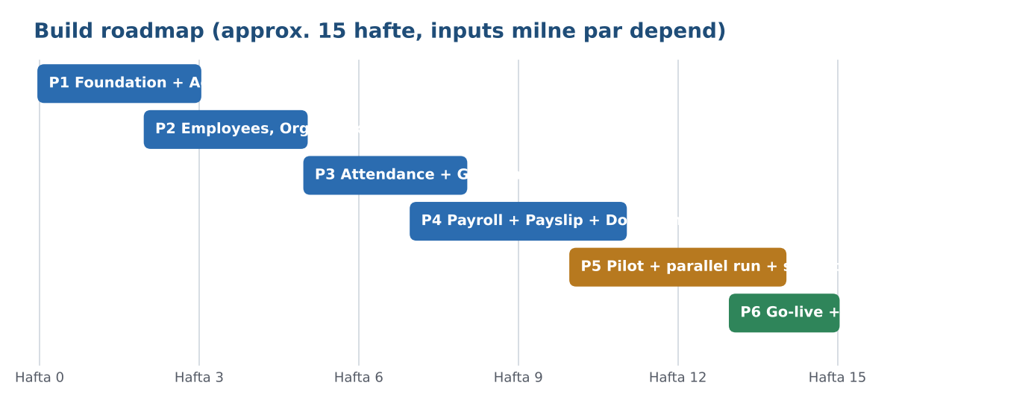
Phase | Hafte | Kya banega | Gate (pass hone ki shart)
P1 Foundation + Access Control | 0 se 3 | Company account, Core DB, login, session, permission engine, Role Builder, Audit_Logs, backup | Permission tests 1 se 6 dummy data par pass
P2 Employees, Org, Workflow | 2 se 5 | Employee master, org, reporting line, Authority setup, workflow engine, approval inbox | Sample chains aur maker-checker tests pass
P3 Attendance + Leave | 5 se 8 | Attendance policies, geo-fence, selfie switch, site attendance, regularization, leave, holidays | Device matrix (Android/iOS, Chrome/Safari) par geo-fence result; fallback ka decision
P4 Payroll + Documents | 7 se 11 | Salary structure, payroll engine, payslip, advance/loan, F&F, documents, statutory sheets | 20+ test employees par payroll manual calculation se match; CA review
P5 Pilot + Security test | 10 se 14 | Real data (consent ke baad), parallel run, access review dry-run, backup/restore drill | Unexplained payroll difference = 0; CEO sign-off
P6 Go-live + RDash link + Training | 13 se 15 | Role-wise training, support process, RDash CSV link, handover | Handover checklist complete
Parallel run 1 mahine rakha hai; agar 2 mahine chahiye to timeline 3 se 4 hafte badhegi. Pehle dummy employee data par testing hogi; asli data permission aur security testing ke baad hi load hoga.

17.1 Test approach
- Dummy data par har role ke login se har module ka test.
- Permission tests (neeche) har phase ke baad dobara.
- Payroll: 20+ employees ka manual calculation se mismatch check; LOP, OT, loan, mid-month joiner, exit case.
- Attendance: geo-fence ke andar, bahar, GPS denied, weak accuracy, selfie ON/OFF, alag phones.
- Backup aur restore ka live drill.

17.2 Permission test cases (minimum 14)
# | Test | Expected result
1 | Staff request mein dusre employee ka ID daal kar payslip maangta hai | Deny + log
2 | Supervisor apni team se bahar ki leave approve karne ki koshish karta hai | Deny
3 | HR payroll prepare karke khud approve/release karne ki koshish karta hai | Blocked (maker-checker)
4 | Authority apni ceiling se upar permission grant karne ki koshish karta hai | Blocked
5 | Expired user override ke baad action | Permission nahi
6 | Role mein ALLOW, user par explicit DENY | DENY jeet'ta hai
7 | Office-policy employee radius ke bahar check-in karta hai | Policy ke hisaab se block ya flag + approval
8 | Site-policy employee check-in karta hai | Location maangi hi nahi jati
9 | Selfie switch OFF phir ON (company, policy, employee level) | Camera OFF par nahi, ON par aata hai; employee-level override kaam kare
10 | Exit hue employee ka login | Blocked; pending approvals reassign
11 | Bina field.salary.view wale role ka salary field | Masked
12 | Approver ki leave/SLA expiry | Delegate ko request; SLA par escalation
13 | Attendance lock ke baad correction | Sirf approval ke saath, audit ke saath
14 | Hidden menu ka action seedha server ko bheja jaye | Server reject karta hai

17.3 CEO handover checklist
- [ ] Dedicated company Google account ki ownership, 2-Step Verification aur recovery details CEO ke paas
- [ ] Super Admin (2 log) ke login aur password policy ka sealed handover
- [ ] Master Sheets, Drive folders aur Apps Script project ka access map
- [ ] Final permission matrix aur Authority profiles ka written sign-off
- [ ] Backup folder aur restore ka live demo
- [ ] Role-wise short user guide (HR, Accounts, Manager, Supervisor, Staff, Simple mode)
- [ ] Har role ke liye training session
- [ ] Payroll ka parallel run (purana process saath mein)
- [ ] Support process: bug ya change request kaise aur kise bataya jayega

18. Capability, Long-term Vision aur Expansion Plan
Aaj ki capability (Version 1): 80 employees ka poora HR, payroll, approvals aur permission management, documents automation ke saath. Site reporting RDash par.
Stage | Samay | Focus
V1 Foundation | Mahine 0 se 4 | Access control, employees, workflow, attendance (geo-fence), leave, payroll, documents, backup
V2 Operations | Mahine 5 se 9 | Advance/loan/expense polish, recruitment, performance, exit automation, dashboards, RDash Level 1 sync
V3 Intelligence | Saal 1+ | Attrition/attendance analytics, project-wise manpower cost (RDash data ke saath), mobile app wrapper, e-sign, RDash API sync

Software ka code aur data aapka rahega. Company badhne par sirf neeche wali services upgrade hongi, poora software nahi badlega.
Trigger (kab) | Upgrade (kya) | Fayda
Email alerts roz limit se zyada | Google Workspace account | Zyada email quota, company domain email
Trigger runtime kam padna | Google Workspace (owner account) | Zyada daily trigger runtime
Company domain par portal chahiye | Workspace + Sites/custom domain | Professional URL
15 GB Drive full | Google One / Workspace storage | Zyada selfies, documents
150 se 300+ employees ya Sheets slow | Google Cloud (Cloud SQL / BigQuery) par database shift | Fast, bade data ke liye
Admin control, SSO, device policy | Workspace admin features | Employee-level security
Mobile app chahiye | Android/iOS wrapper (store fee) | App jaisa experience
Geo-fence unreliable ya biometric chahiye | Biometric/hardware integration | Reliable automated attendance
RDash se deep sync | API integration | Automatic site manpower data
Cost ka niyam: pehle free stack par chalo; jis limit par asli dikkat aaye sirf usi service ke liye pay karo.

19. Decisions Needed aur Next Steps
Build shuru karne se pehle ye decisions confirm karne hain (meri recommendation pehle):
# | Decision | Recommendation | Options
1 | Google account owner | Dedicated company Gmail (free) | Workspace company account
2 | Attendance | Office (geo-fence) + Site (simple tap) | Sirf Office / sirf Site
3 | Payroll depth | Complete: salary, deductions, LOP, OT, advance, payslip, PF/ESI/PT, F&F | Basic + payslip
4 | Capacity | 80 employees, expandable | 150 / 300
5 | Site attendance source | HRMS simple tap + supervisor mark | RDash se CSV import
6 | Geo-fence fail hone par | Flag + manager approval | Block / rotating QR-PIN
7 | Selfie | Default OFF; policy-wise ON; 90 din retention | Company-wide ON
8 | Super Admin | 2 log (primary + backup); CEO recovery | Sirf 1
9 | Authority profiles | CEO, Directors, HR Head (scope aur ceiling aap batayein) | Sirf CEO
10 | Language | Hindi/English toggle | Sirf English
11 | CEO/Director attendance | Exempt policy | Normal punch

19.1 Maine kya assume kiya (kripya confirm ya sudhaar karein)
- "DPR office" ko maine office-based staff ka group maana hai jahan geo-fence lagega. Agar DPR office ek specific branch ka naam hai to wahi Branch record aur geo-point banega, logic wahi rahega.
- RDash par DPR, site reporting, tasks aur site progress hota hai, isliye HRMS se hata diye hain.
- Site attendance payroll ke liye HRMS mein hi rahegi (section 9.2).
- Selfie default OFF hai.
- Default permission matrix sirf starting point hai; final Super Admin tay karega.
- Statutory rates aur Labour Code/DPDP ki jaankari mere knowledge (Jun 2026 tak) par based hai; CA/legal se verify zaroori hai.
- Base document v1 (9 November 2026) hai; usme jo cheezein thi unhe maine rakha ya update kiya.

19.2 Aur ye inputs chahiye (HR/CEO se)
- [ ] FocusOn logo, brand colors, letterhead
- [ ] Employee list: name, designation, department, joining date, reporting manager, work location type (office/site), salary structure
- [ ] Org chart: CEO, Directors, HR Head, Managers, Supervisors aur kaun kis par authority rakhta hai
- [ ] Office ka exact location (latitude/longitude) aur radius; agar multiple offices hain to sab
- [ ] Leave policy aur holiday list
- [ ] Salary type (monthly/daily/hourly), salary structure format, PF/ESI/PT applicability, payroll cutoff date, payable days ka divisor
- [ ] Existing letter formats (offer, appointment, experience etc.)
- [ ] Site list aur work-location list
- [ ] Approval flows: kaun kisko approve karega, limits (advance, leave days)
- [ ] RDash ki details: CSV/API availability, user ID format (section 9.2)
Next step: decisions confirm hote hi Phase 1 (database + access control) shuru hoga aur Apps Script ka code file-by-file diya jayega.

