Industrial Internship Report on
”Project Name” PasswordManager
Prepared by
[Prabhu Prasad Sahoo]

Executive Summary
This report provides details of the Industrial Internship provided by upskill Campus and The IoT Academy in collaboration with Industrial Partner UniConverge Technologies Pvt Ltd (UCT).
This internship was focused on a project/problem statement provided by UCT. We had to finish the project including the report in 6 weeks’ time.
My project was This report provides details of the Industrial Internship offered by upskill Campus and The IoT Academy in collaboration with UniConverge Technologies Pvt. Ltd. During this internship, I worked on a project titled "Password Manager Using Python".
The objective of this project was to develop a simple password management system that allows users to store, generate, and retrieve passwords securely. The project was developed using Python and SQLite database. It helped me gain practical experience in Python programming, database management, and basic security concepts.
This internship provided valuable exposure to real-world software development practices and enhanced my problem-solving and programming skills.

This internship gave me a very good opportunity to get exposure to Industrial problems and design/implement solution for that. It was an overall great experience to have this internship.

TABLE OF CONTENTS
1 Preface 3
2 Introduction 4
2.1 About UniConverge Technologies Pvt Ltd 4
2.2 About upskill Campus 8
2.3 Objective 9
2.4 Reference 9
2.5 Glossary 10
3 Problem Statement 11
4 Existing and Proposed solution 12
5 Proposed Design/ Model 13
5.1 High Level Diagram (if applicable) 13
5.2 Low Level Diagram (if applicable) 13
5.3 Interfaces (if applicable) 13
6 Performance Test 14
6.1 Test Plan/ Test Cases 14
6.2 Test Procedure 14
6.3 Performance Outcome 14
7 My learnings 15
8 Future work scope 16

Preface
Summary of the whole 6 weeks’ work.
About need of relevant Internship in career development.
Brief about Your project/problem statement.
Opportunity given by USC/UCT.
How Program was planned
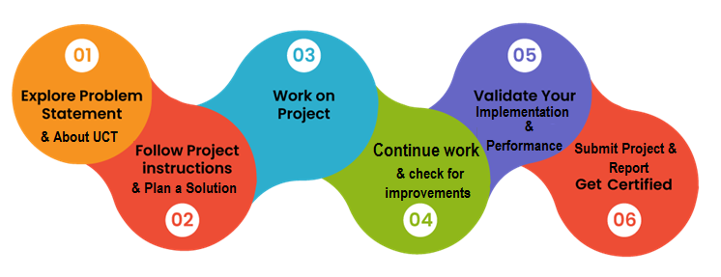
Your Learnings and overall experience.
Thank to all (with names), who have helped you directly or indirectly.
Your message to your juniors and peers.

Introduction

About UniConverge Technologies Pvt Ltd
A company established in 2013 and working in Digital Transformation domain and providing Industrial solutions with prime focus on sustainability and RoI.
For developing its products and solutions it is leveraging various Cutting Edge Technologies e.g. Internet of Things (IoT), Cyber Security, Cloud computing (AWS, Azure), Machine Learning, Communication Technologies (4G/5G/LoRaWAN), Java Full Stack, Python, Front end etc.
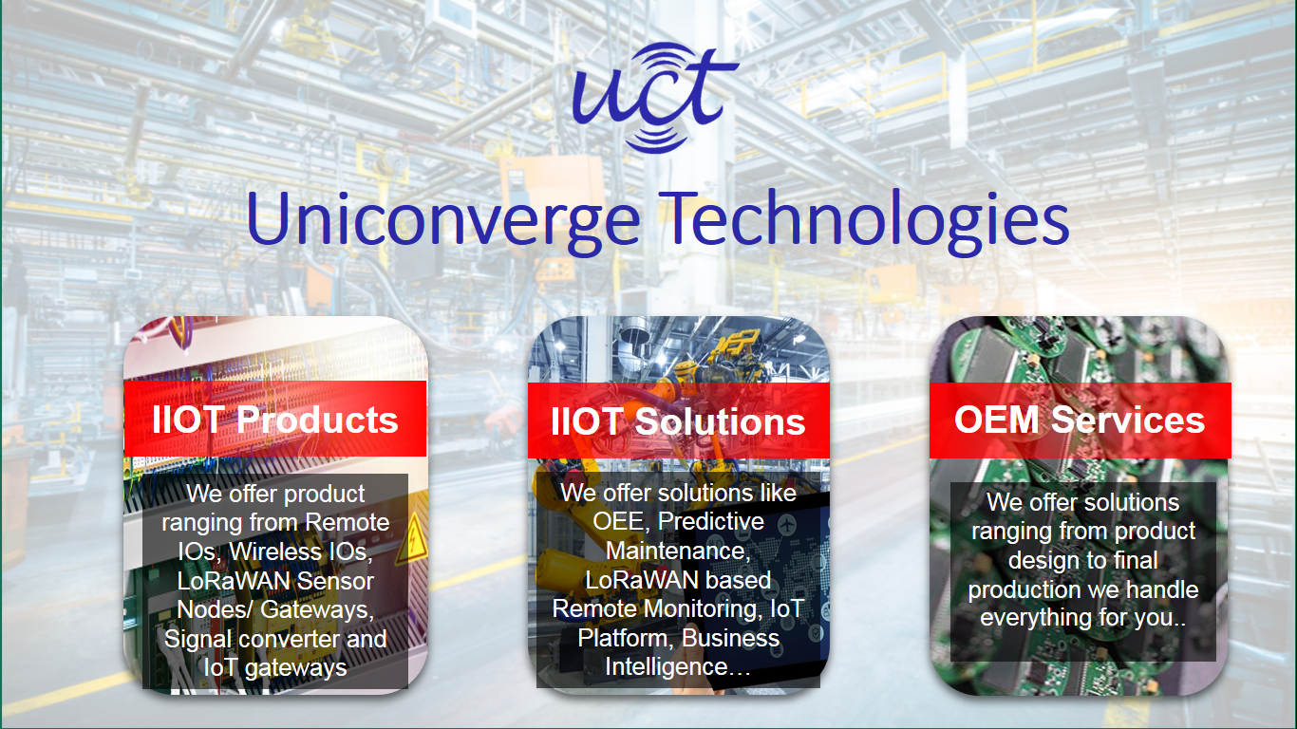
- UCT IoT Platform ()
UCT Insight is an IOT platform designed for quick deployment of IOT applications on the same time providing valuable “insight” for your process/business. It has been built in Java for backend and ReactJS for Front end. It has support for MySQL and various NoSql Databases.
- It enables device connectivity via industry standard IoT protocols - MQTT, CoAP, HTTP, Modbus TCP, OPC UA
- It supports both cloud and on-premises deployments.
It has features to
• Build Your own dashboard
• Analytics and Reporting
• Alert and Notification
• Integration with third party application(Power BI, SAP, ERP)
• Rule Engine

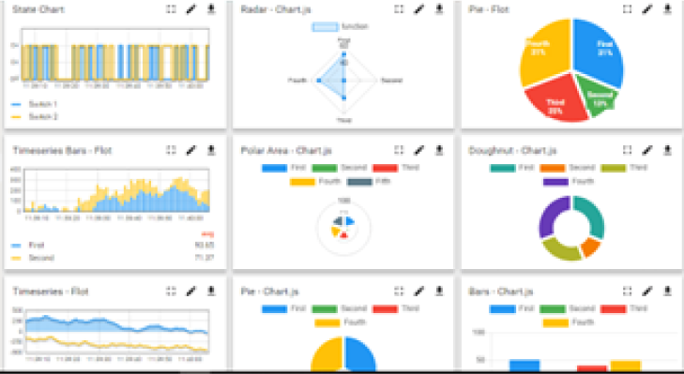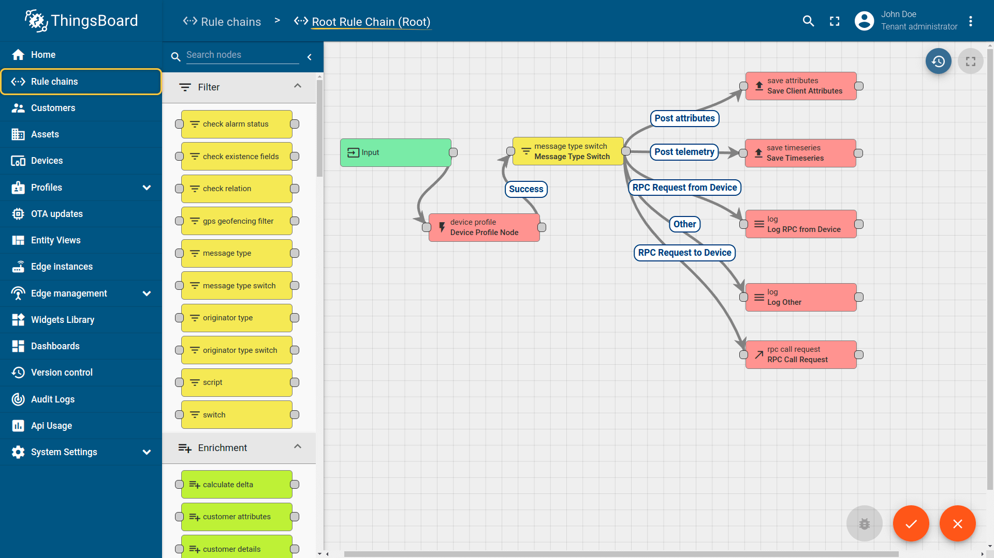

- Smart Factory Platform ()
Factory watch is a platform for smart factory needs.
It provides Users/ Factory
- with a scalable solution for their Production and asset monitoring
- OEE and predictive maintenance solution scaling up to digital twin for your assets.
- to unleased the true potential of the data that their machines are generating and helps to identify the KPIs and also improve them.
- A modular architecture that allows users to choose the service that they what to start and then can scale to more complex solutions as per their demands.
Its unique SaaS model helps users to save time, cost and money.
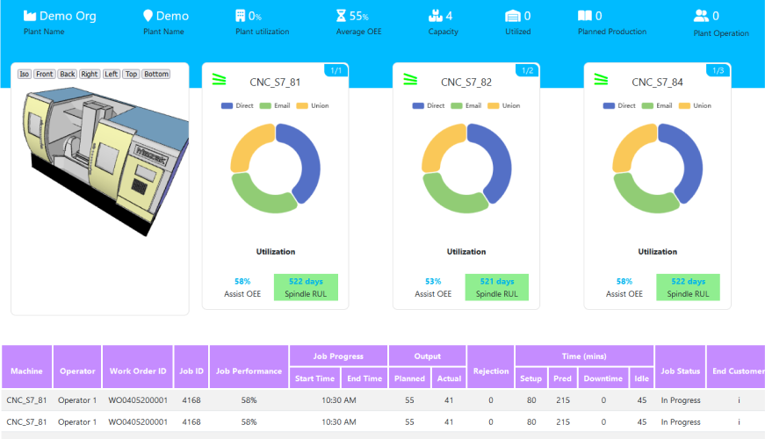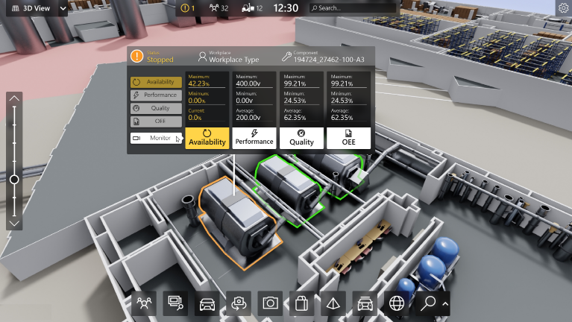

- 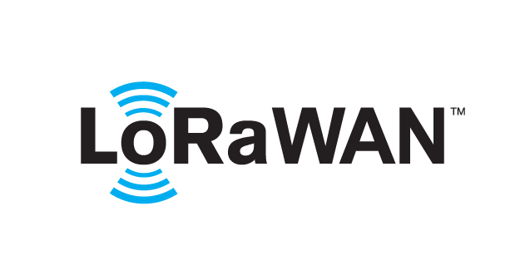 based Solution
UCT is one of the early adopters of LoRAWAN teschnology and providing solution in Agritech, Smart cities, Industrial Monitoring, Smart Street Light, Smart Water/ Gas/ Electricity metering solutions etc.
- Predictive Maintenance
UCT is providing Industrial Machine health monitoring and Predictive maintenance solution leveraging Embedded system, Industrial IoT and Machine Learning Technologies by finding Remaining useful life time of various Machines used in production process.
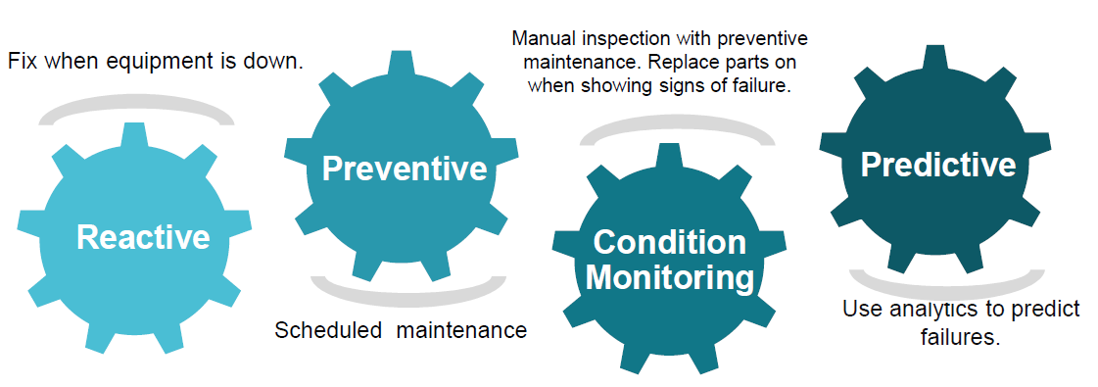

About upskill Campus (USC)
upskill Campus along with The IoT Academy and in association with Uniconverge technologies has facilitated the smooth execution of the complete internship process.
USC is a career development platform that delivers personalized executive coaching in a more affordable, scalable and measurable way.




Seeing need of upskilling in self paced manner along-with additional support services e.g. Internship, projects, interaction with Industry experts, Career growth Services
https://www.upskillcampus.com/
upSkill Campus aiming to upskill 1 million learners in next 5 year

The IoT Academy
The IoT academy is EdTech Division of UCT that is running long executive certification programs in collaboration with EICT Academy, IITK, IITR and IITG in multiple domains.

Objectives of this Internship program
The objective for this internship program was to
☛ get practical experience of working in the industry.
☛ to solve real world problems.
☛ to have improved job prospects.
☛ to have Improved understanding of our field and its applications.
☛ to have Personal growth like better communication and problem solving.

Reference
[1]
[2]
[3]

Glossary
Terms | Acronym

Problem Statement
In the assigned problem statement
Managing multiple passwords for different accounts can be difficult. Users often use weak passwords or forget their passwords. The objective of this project is to create a password manager that can securely store passwords, generate strong passwords, and retrieve them when required.
- Existing and Proposed Solution
- Existing Solution
Many users store passwords in notebooks or simple text files, which are not secure and can be easily accessed by unauthorized users.
- Proposed Solution
The proposed Password Manager provides:
- Secure password storage
- Password retrieval functionality
- Strong password generation
- Database-based storage using SQLite

Code submission (Github link)

Report submission (Github link) : first make placeholder, copy the link.

Proposed Design/ Model
- High Level Design
User → Password Manager Application → SQLite Database
- Low Level Design
- User enters account details.
- Password is stored in the database.
- User can retrieve saved passwords.
- User can generate strong passwords using the password generator module.
- Interfaces
- Console-based user interface
- SQLite database interface for storage and retrieval

Interfaces (if applicable)
• Console-based user interface
• SQLite database interface for storage and retrieval

Performance Test

- Test Plan / Test Cases
- Add a new password.
- Retrieve an existing password.
- Generate a strong password.
- Search for a non-existing account.
- Test Procedure
The application was tested by storing multiple account passwords and retrieving them from the database.
- Performance Outcome
- Passwords were stored successfully.
- Retrieval was accurate.
- Strong passwords were generated successfully.
- The application worked efficiently for small-scale password management.

My learnings

During this internship, I learned:
- Python programming fundamentals
- Functions and loops
- Database handling using SQLite
- Password generation techniques
- Basic security concepts
- Problem-solving and debugging skills
These skills will help me in future software development projects and career growth.

Future work scope

The project can be enhanced by:
- Implementing advanced encryption techniques
- Adding a graphical user interface (GUI)
- Introducing a master password feature
- Adding update and delete password options
- Integrating cloud-based password storage

Conclusion
The Password Manager project successfully achieved its objective of storing, generating, and retrieving passwords. The project enhanced my understanding of Python programming, database management, and software development practices. This internship was a valuable learning experience that improved my technical and professional skills.

