Minimum Wages and Fast Food Employment
An AI Assisted Empirical Replication of Card and Krueger 1994
Individual project report | Applied labor economics | Difference in differences

Project Overview
This is an AI-assisted empirical paper replication project in applied labor economics. It reconstructs the data, variables, difference-in-differences design, assigned tables, and figure from Card and Krueger's 1994 study of the New Jersey minimum-wage increase. The project then adds an independent extension that tests whether the employment response differs between company-owned and franchise restaurants. The AI-assisted workflow does not replace researcher responsibility: all data choices, calculations, validation checks, and interpretations must be reviewed before submission.
The central finding is that the supplied public data reproduce the paper's headline result: New Jersey fast-food employment increased relative to eastern Pennsylvania after the policy change, rather than declining.

1 Research Question and Economic Mechanism
The study asks whether New Jersey's April 1, 1992 increase in the minimum wage from $4.25 to $5.05 reduced employment at fast-food restaurants. A higher wage floor can reduce labor demand through higher costs, but firms may also adjust through prices, turnover, hours, effort, or other margins. In a labor market with employer market power, a higher wage could even increase employment. The empirical question is therefore open and must be evaluated using a credible comparison group.

2 Data and Variable Construction
The supplied public file contains 410 restaurants: 331 in New Jersey and 79 in Pennsylvania. Restaurants were surveyed before the policy change in February-March 1992 and again in November-December 1992. The assigned replication covers Tables 2-4 and Figure 1; restricted data for Table 1 are outside the replication scope.
Full-time-equivalent employment is defined as EMPFT + 0.5 x EMPPT + NMGRS. Permanent closures are coded as zero post-period employment. Temporary, renovation, highway-construction, and mall-fire closures are missing in the main post-period outcome and are set to zero only in the explicit closure-coding sensitivity check.
The Table 4 sample requires observed pre- and post-period FTE employment, baseline wage, and post-period wage unless the restaurant permanently closed. This produces 357 observations. The treatment-intensity variable is GAP = max(0, (5.05 - WAGE_ST) / WAGE_ST) for New Jersey and zero for Pennsylvania.

3 Empirical Design
The core difference-in-differences estimate is (NJ after - NJ before) - (PA after - PA before). New Jersey is the treatment group, and eastern Pennsylvania is the comparison group. The identifying assumption is that, absent the policy, employment changes would have been parallel across the two regions. The geographic proximity supports the comparison, but the data contain only one pre-treatment survey wave, so parallel trends cannot be directly tested with an event-study design.

4 Core Replication Results
The unbalanced Table 3 difference-in-differences estimate is 2.75 FTE employees with a standard error of 1.34, compared with the published value of 2.76. The balanced-sample estimate is 2.75, and the temporary-closures-as-zero sensitivity estimate is 2.51. The direction and magnitude are consistent with the paper's conclusion that the policy did not reduce fast-food employment relative to the comparison group.
Table 1. Headline replication estimates
Result | Replicated | SE | Original
Table 3 unbalanced DiD | 2.75 | 1.34 | 2.76
Table 3 balanced DiD | 2.75 |  | 2.75
Table 3 temporary closures as zero | 2.51 |  | 2.51

The Table 4 NJ-indicator coefficient is 2.33 with a standard error of 1.19. The continuous GAP specification estimates 15.65 with a standard error of 6.08. The selected published-versus-replicated comparisons are close; the full comparison file is included in the reproducibility package.
Table 2. Published-versus-replicated results
result | original_paper | replicated | difference
Table 3 row 3 DiD | 2.76 | 2.75 | -0.01
Table 3 row 4 DiD | 2.75 | 2.75 | 0.00
Table 3 row 5 DiD | 2.51 | 2.51 | -0.00
Table 4 (i) NJ dummy STATE | 2.33 | 2.33 | -0.00
Table 4 (ii) NJ dummy + chain/ownership STATE | 2.30 | 2.30 | 0.00
Table 4 (iii) GAP GAP | 15.65 | 15.65 | 0.00
Table 4 (iv) GAP + chain/ownership GAP | 14.92 | 14.92 | -0.00
Table 4 (v) GAP + chain/ownership + region GAP | 11.91 | 11.98 | 0.07

Figure 1. Distribution of starting wage rates
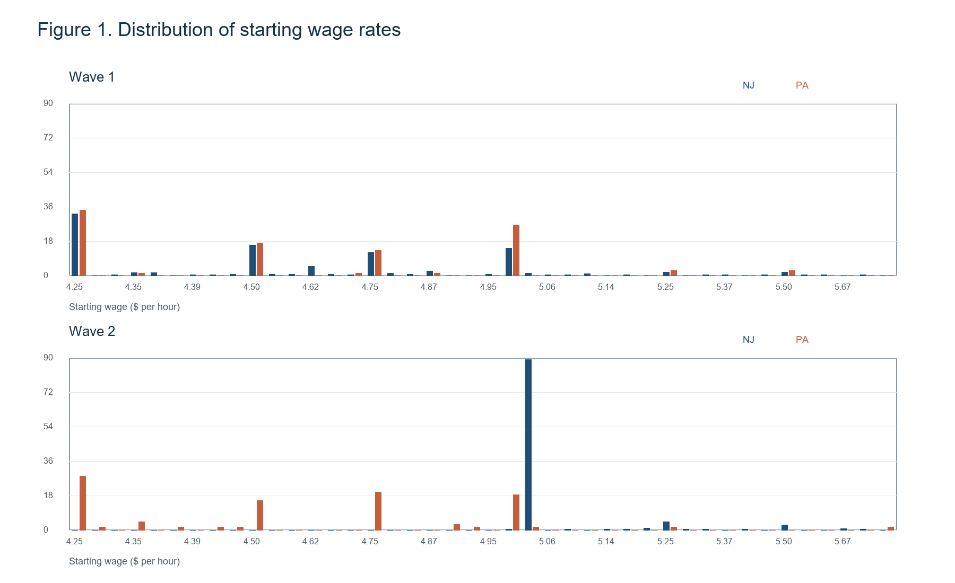
Notes: Bars show the percentage of restaurants at each observed starting wage in New Jersey and Pennsylvania.

5 Independent Extension Ownership Heterogeneity
The extension asks whether the employment response differs between company-owned and franchise stores. The franchise-store GAP coefficient is 17.08; the GAP x company-owned interaction is -14.46; and the implied company-owned marginal effect is 2.61. These point estimates suggest a possible ownership difference, but the interaction is imprecisely estimated. The result should therefore be presented as exploratory evidence, not as a definitive heterogeneous treatment effect.
Table 3. Ownership extension estimates
term | quantity | estimate | standard_error
constant | coefficient |  | 2.06
BK | coefficient |  | 1.53
KFC | coefficient |  | 1.72
roys | coefficient |  | 1.73
CO_OWNED | coefficient |  | 1.54
SOUTHJ | coefficient |  | 1.92
CENTRALJ | coefficient |  | 2.01
NORTHJ | coefficient |  | 1.75
PA1 | coefficient |  | 2.24
GAP | coefficient |  | 8.72
GAP_CO_OWNED | coefficient |  | 12.99
marginal_effect | GAP effect, franchise stores | 17.08 | 8.72
marginal_effect | GAP effect, company-owned stores | 2.61 | 11.21

6 Robustness and Validation
The workflow tests alternative part-time weights of 0.4 and 0.6, excludes Shore stores, restricts the sample to stores with at most two first-wave call attempts, removes each chain in turn, changes temporary-closure coding, and performs 2,000 state-label permutations while preserving the number of New Jersey observations.
Table 4. Robustness checks
Check | Specification | N | Estimate | SE | Permutation p
Baseline | NJ dummy; published Table 4 model (i) | 357 | 2.33 | 1.19
Alternative part-time weight | NJ dummy; part-time weight=0.4 | 357 | 2.37 | 1.20
Alternative part-time weight | NJ dummy; part-time weight=0.6 | 357 | 2.28 | 1.20
Geographic exclusion | NJ dummy; exclude Shore stores | 326 | 2.56 | 1.19
Survey follow-up exclusion | NJ dummy; NCALLS <= 2 | 294 | 2.45 | 1.28
Leave-one-chain-out | NJ dummy; exclude Burger King | 209 | 1.51 | 1.36
Leave-one-chain-out | NJ dummy; exclude KFC | 283 | 3.06 | 1.38
Leave-one-chain-out | NJ dummy; exclude Roy Rogers | 267 | 2.42 | 1.43
Leave-one-chain-out | NJ dummy; exclude Wendy's | 312 | 2.05 | 1.29
Closure coding | Difference-in-differences; temporary closures set to zero | 388 | 2.51 | 1.35
Randomization inference | NJ dummy; 2,000 state-label permutations | 357 | 2.33 | 1.19 | 0.05

The NJ-indicator estimate remains positive under the alternative FTE weights and sample exclusions. The permutation p-value for the baseline coefficient is approximately 0.050. These checks are diagnostics around the baseline design and do not eliminate the need to defend the parallel-trends assumption.

7 Limitations
- Only one pre-treatment wave is available, limiting direct assessment of parallel trends.
- Employment is survey-reported and may contain measurement error.
- Closure coding and missing post-period values affect the estimand, so the coding rule must be stated clearly.
- The sample covers four fast-food chains and two neighboring regions in 1992; external validity is limited.
- The definitions of some regional indicators in the supplied data dictionary require final confirmation against the original source codebook.

8 Conclusion
The replication recovers the central Card-Krueger result: the New Jersey minimum-wage increase is not associated with a decline in fast-food employment relative to eastern Pennsylvania in the supplied public data. The estimate is stable across the main closure and sample checks. The ownership extension is economically motivated but should remain clearly labelled as exploratory.

References
Card, David, and Alan B. Krueger. 1994. "Minimum Wages and Employment: A Case Study of the Fast-Food Industry in New Jersey and Pennsylvania." American Economic Review 84(4): 772-793.
Course-provided public replication data and data dictionary. Access instructions are documented in the project README and data/raw/README.md.
The project uses an AI-assisted workflow. The specific uses, checks, corrections, and remaining researcher responsibilities are documented in docs/ai_use_disclosure.md.

Appendix A Assigned Table Outputs
The machine-readable CSV files in outputs/tables are the authoritative generated outputs. The compact tables below provide the report-readable versions; the complete CSV files preserve all rows and columns.
Appendix Table A1. Table 2 descriptive statistics
section | variable | NJ | PA | t_NJ_minus_PA | n_NJ | n_PA
Store types | Burger King | 41.09 | 44.30 | -0.52 | 331 | 79
Store types | KFC | 20.54 | 15.19 | 1.16 | 331 | 79
Store types | Roy Rogers | 24.77 | 21.52 | 0.62 | 331 | 79
Store types | Wendy's | 13.60 | 18.99 | -1.12 | 331 | 79
Store types | Company-owned | 34.14 | 35.44 | -0.22 | 331 | 79
Wave 1 | FTE employment | 20.44 | 23.33 | -2.00 | 321 | 77
Wave 1 | Percentage full-time employees | 32.85 | 35.04 | -0.72 | 321 | 77
Wave 1 | Starting wage | 4.61 | 4.63 | -0.40 | 314 | 76
Wave 1 | Wage = $4.25 | 30.51 | 32.91 | -0.41 | 331 | 79
Wave 1 | Price of full meal | 3.35 | 3.04 | 3.96 | 311 | 76
Wave 1 | Hours open | 14.42 | 14.53 | -0.29 | 331 | 79
Wave 1 | Recruiting bonus | 23.56 | 29.11 | -0.98 | 331 | 79
Wave 2 | FTE employment | 21.03 | 21.17 | -0.13 | 319 | 77
Wave 2 | Percentage full-time employees | 35.87 | 30.38 | 1.75 | 314 | 76
Wave 2 | Starting wage | 5.08 | 4.62 | 10.82 | 318 | 71
Wave 2 | Wage = $4.25 | 0.00 | 25.32 | -5.14 | 331 | 79
Wave 2 | Wage = $5.05 | 85.50 | 1.27 | 36.38 | 331 | 79
Wave 2 | Price of full meal | 3.41 | 3.03 | 5.08 | 305 | 71
Wave 2 | Hours open | 14.42 | 14.65 | -0.65 | 321 | 78
Wave 2 | Recruiting bonus | 20.32 | 23.38 | -0.57 | 315 | 77

Appendix Table A2. Table 3 employment changes
row | stat | PA | NJ | NJ-PA | NJ low | NJ mid | NJ high | low-high | mid-high
1. FTE employment before | estimate | 23.33 | 20.44 | -2.89 | 19.56 | 20.08 | 22.25 | -2.69 | -2.17
1. FTE employment before | standard_error | 1.35 | 0.51 | 1.44 | 0.77 | 0.84 | 1.14 | 1.37 | 1.41
2. FTE employment after | estimate | 21.17 | 21.03 | -0.14 | 20.88 | 20.96 | 20.21 | 0.66 | 0.74
2. FTE employment after | standard_error | 0.94 | 0.52 | 1.08 | 1.01 | 0.76 | 1.03 | 1.44 | 1.27
3. Change in mean FTE | estimate | -2.28 | 0.47 | 2.75 | 1.20 | 0.71 | -2.16 | 3.36 | 2.87
3. Change in mean FTE | standard_error | 1.25 | 0.48 | 1.34 | 0.82 | 0.69 | 1.01 | 1.30 | 1.22
4. Change in mean FTE, balanced sample | estimate | -2.28 | 0.47 | 2.75 | 1.20 | 0.71 | -2.16 | 3.36 | 2.87
4. Change in mean FTE, balanced sample | standard_error | 1.25 | 0.48 | 1.34 | 0.82 | 0.69 | 1.01 | 1.30 | 1.22
5. Change in mean FTE, temporary closures set to zero | estimate | -2.28 | 0.23 | 2.51 | 0.90 | 0.49 | -2.39 | 3.29 | 2.88
5. Change in mean FTE, temporary closures set to zero | standard_error | 1.25 | 0.49 | 1.35 | 0.87 | 0.69 | 1.02 | 1.34 | 1.23

Appendix Table A3. Table 4 key coefficients
model | term | coefficient | standard_error | t_stat | N | SER | R_squared
(i) NJ dummy | STATE | 2.33 | 1.19 | 1.95 | 357 | 8.79 | 0.01
(ii) NJ dummy + chain/ownership | STATE | 2.30 | 1.20 | 1.93 | 357 | 8.78 | 0.02
(iii) GAP | GAP | 15.65 | 6.08 | 2.57 | 357 | 8.76 | 0.02
(iv) GAP + chain/ownership | GAP | 14.92 | 6.21 | 2.40 | 357 | 8.76 | 0.03
(v) GAP + chain/ownership + region | GAP | 11.98 | 7.42 | 1.61 | 357 | 8.75 | 0.04

