PROJECT DOCUMENTATION

ANNUAL SALARY ANALYSIS

DA & DS AUG BATCH –
KGISL MICRO COLLEGE

Project description
Annual Salary Analysis Capstone Project
DA & DS AUG BATCH
OFFLINE

TABLE OF CONTENT
1.Introduction
Annual salary analysis plays a crucial role in understanding compensation trends, employee performance, and organizational pay equity. This project focuses on analyzing annual salary data using SQL for efficient data extraction and transformation, and Microsoft Excel for data cleaning, analysis, and visualization. By examining factors such as department, job role, experience level, and salary increments, the analysis aims to identify patterns, detect anomalies, and support data-driven decision-making. The insights generated from this project can help organizations improve salary planning, ensure fair compensation practices, and optimize workforce budgeting.

2.Aim
The aim of this project is to perform a comprehensive analysis of annual salary data using SQL and Microsoft Excel to understand compensation patterns across different departments, job roles, experience levels, and performance ratings. The project focuses on extracting, cleaning, and transforming salary data to evaluate salary distribution, identify growth trends, and detect inconsistencies or pay gaps. The insights derived from this analysis are intended to support data-driven decision-making, improve salary planning, promote fair compensation practices, and enhance overall workforce management.
3.Problem Statement
Organizations often manage large volumes of employee salary data, but lack a structured approach to analyze it effectively. Without proper analysis, it becomes difficult to identify salary trends, ensure fair compensation, monitor increments, and make informed budgeting decisions. This project addresses the challenge of transforming raw annual salary data into meaningful insights by using SQL for data extraction and querying, and Microsoft Excel for data cleaning, analysis, and visualization. The goal is to uncover compensation patterns, detect discrepancies, and support strategic salary planning through accurate and data-driven analysis.

4.Project workflow
The project begins with the collection of annual employee salary data from structured organizational sources. SQL is used to extract, filter, and aggregate relevant salary information from the database, ensuring accurate and efficient data retrieval. The extracted data is then imported into Microsoft Excel for data cleaning and preparation, where missing values, duplicates, and inconsistencies are handled using Excel functions and Power Query. After cleaning, the data is transformed and categorized based on departments, job roles, experience levels, and performance ratings to enable meaningful analysis. Excel is further used to perform salary analysis through formulas, pivot tables, and pivot charts, followed by the creation of visual dashboards to present insights clearly. Finally, the analyzed results are interpreted to identify salary trends, pay gaps, and areas for improvement, supporting informed and data-driven salary planning decisions.

5.Data Understanding
The dataset used in this project consists of structured employee salary records collected on an annual basis. It includes key attributes such as employee ID, department, job role, experience level, performance rating, base salary, annual increment, and total compensation. The data provides both numerical and categorical variables, enabling detailed analysis of salary distribution and growth patterns across different organizational dimensions. Understanding the structure, data types, and relationships between these variables is essential for accurate analysis. Initial exploration helps identify missing values, inconsistencies, and outliers, which are addressed during the data preparation stage to ensure reliable and meaningful insights.

6.Data Cleaning
Data cleaning is a crucial step to ensure the accuracy and reliability of the salary analysis. In this project, SQL is

used to identify and remove duplicate records, validate data types, and filter out incomplete or invalid entries during the data extraction stage. The cleaned data is then imported into Microsoft Excel, where missing values are handled using appropriate techniques such as imputation or record exclusion based on data relevance. Inconsistencies in department names, job roles, and salary formats are standardized to maintain uniformity across the dataset. Outliers and anomalies in salary values are carefully reviewed to avoid skewed results.

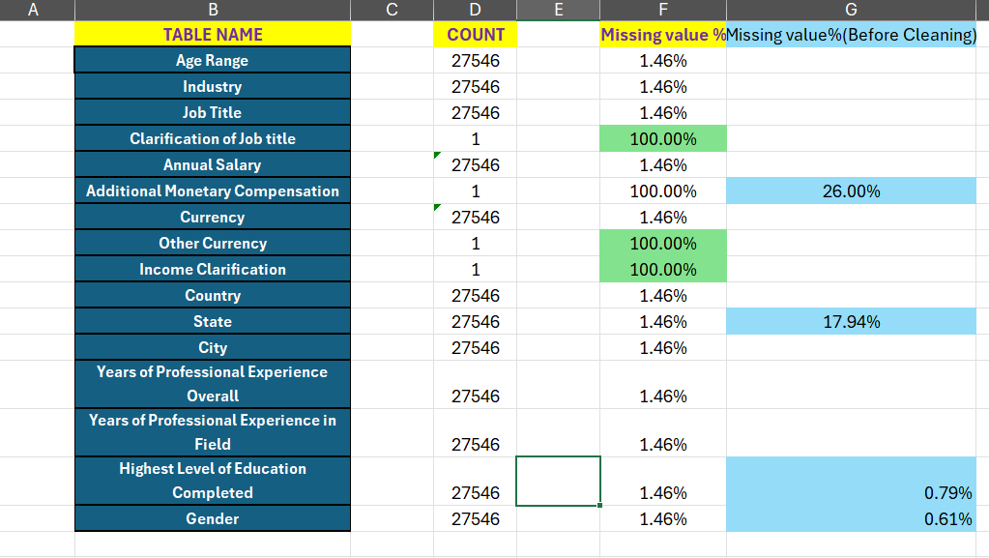
7.Filtering Data for Analysis
Filtering is performed to focus the analysis on relevant and meaningful salary records. SQL queries are used to apply conditions such as selecting active employees, specific departments, job roles, or financial years, and excluding incomplete or outdated records. In Microsoft Excel, filters and slicers are applied to further refine the dataset based on experience level, performance ratings, and salary ranges. This targeted filtering helps reduce noise, improves analysis accuracy, and ensures that insights are derived only from valid and comparable data, making the results more reliable and actionable.

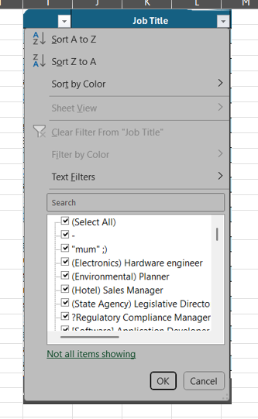

8.Data Manipulation in SQL
SQL is used extensively in this project to manipulate and prepare salary data for analysis. Various SQL operations such as SELECT, WHERE, JOIN, GROUP BY, and ORDER BY are applied to extract relevant records, combine multiple tables, and organize the data efficiently. Aggregate functions like AVG, SUM, MIN, and MAX are used to calculate key salary metrics, including average salary, total compensation, and department-wise salary distribution.

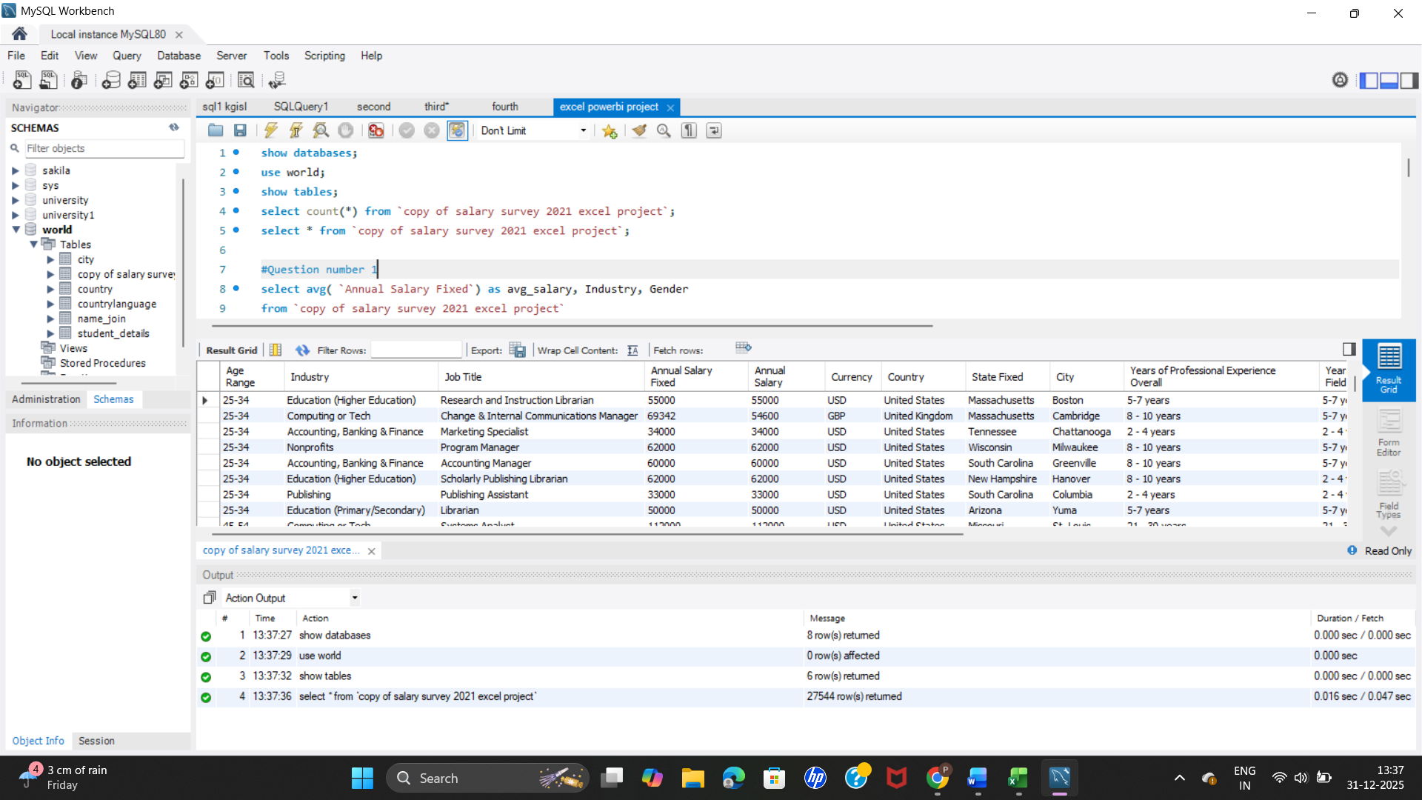

9.Entity relationship in Power Query
In this project, Power Query is used to establish relationships between entities such as employee details, department information, and salary records using common keys like Employee ID or Department ID. By merging and appending queries, related data from different sources is combined into a unified and consistent dataset. These relationships help maintain data integrity, reduce redundancy, and ensure accurate alignment of salary information with corresponding employee attributes.

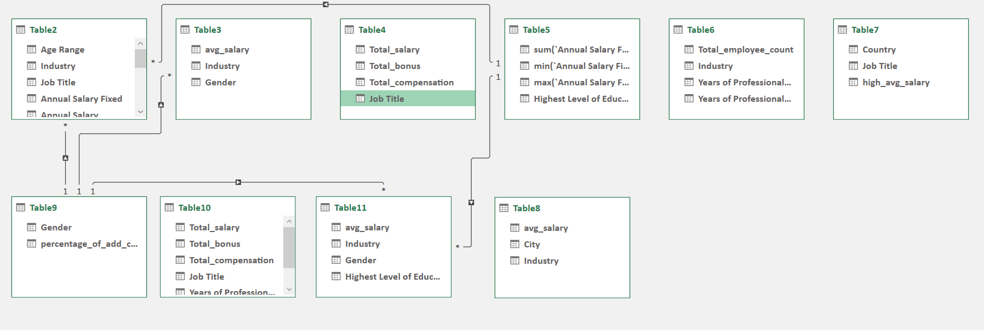

10.Researched insights
- United States ,Germany& UK are the top paying countries contributing 10m $,1.5m$ &1.7m$ resp.
- Software engineers & Senior software engineers earns the highest salary & highest add. Compensation .
- Employees having non-IT job title earns less salary although having higher experience in resp . field.
- Women earns more than the men in respective domains.
- Engineering , manufacturing &computer techs have highest average salary I . E 6.7k$ &4.6k$.
- Employees having highest academic degrees(PhD , MD , Masters degree) has lower avg. salary as their no. is comparatively low than employees having basic academic degrees.
- Average salary of men is lower than women but when it comes to bonus & add. Compensation men earns more than women.
- Employees having Associate & manager job title earns less bonus.
- Europe employees earns less add. Compensation & salary than other regions.
- Marketing , advertising & PR earns least salary & bonus I . e 2.8k $.

11.Recommendation
- Employees having Software engineer & senior Software engineer job title should apply for USA & UK as they’re paying more salaries comparable to others.
- First Compare salary & compensation across countries(US , Germany ,UK , Europe etc.) then apply for the respective countries.
- It’s shown that experience pays fairness so add. Compensation & bonus increased with employees having resp. job titles.
- If Employees having men as gender work extra shift they can get better bonus & compensation than other genders.
- Salary analysis shows that IT peoples earns more than Non-IT peoples so , it’s advice for peoples having Non-Tech domain job title to upskill for an IT roles as it pays more.
- Employees having highest salary & compensations belongs from highest academic degree backgrounds(PhD, MD, Masters )so, it’s highly urged employees having basic academic degrees to upskill.
- Australia pays more than some of the Europe countries so, it’s a suggestion for employees having Asian or Indo-pacific regions to target Australia for jobs.
- Role & education impact on Salary benchmarking.

12.Conclusion
In conclusion, the Annual Salary Analysis provides a comprehensive understanding of employee compensation patterns across different roles, departments, and experience levels. By leveraging Excel for data cleaning, visualization, and reporting, along with SQL for efficient data extraction and manipulation, the project successfully transformed raw salary data into meaningful insights. The analysis highlighted key trends such as salary distribution, pay variations, and the impact of factors like experience and job role on annual income. These insights can support informed decision-making related to compensation planning, budgeting, and workforce strategy.

