**Algorithm Analysis & Design Lab**

**ASSIGNMENT –Dijkstra,Bellman-ford Algorithm**

**IT - 354**

**BACHELOR OF TECHNOLOGY**

**INFORMATION TECHNOLOGY**



**UNIVERSITY SCHOOL OF INFORMATION, COMMUNICATION &**

**TECHNOLOGY, DWARKA**

**GURU GOBIND SINGH INDRAPRASTHA UNIVERSITY**

**SUBMITTED BY:**

**Pranjal Sharma**

**BTech (IT), 6th SEM**

**Roll no. 02516401518**

**Q.** Wap to code and output and dry run by hand for (i) Dijkstra's Algorithm and (ii) Bellman-Ford Algorithm

**Dijkstra's Algorithm**

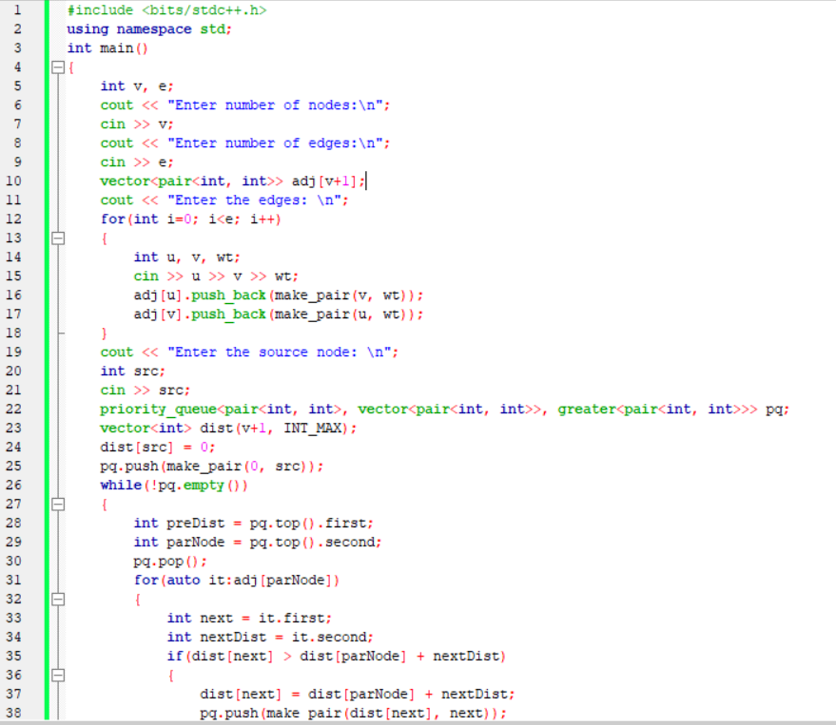

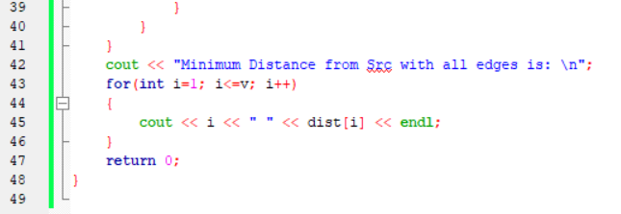

**OUTPUT**

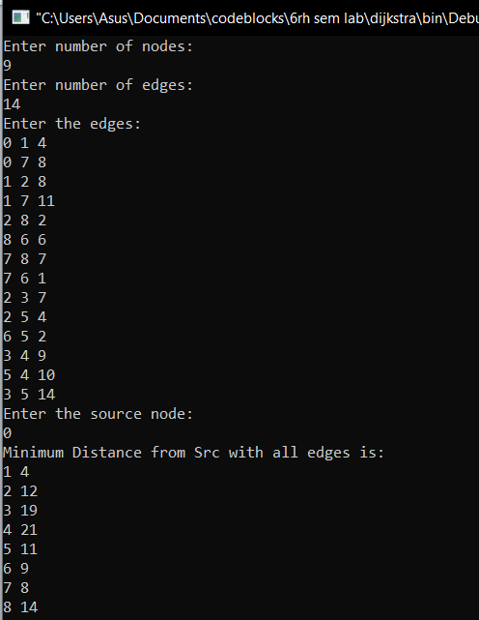

**DRY RUN**

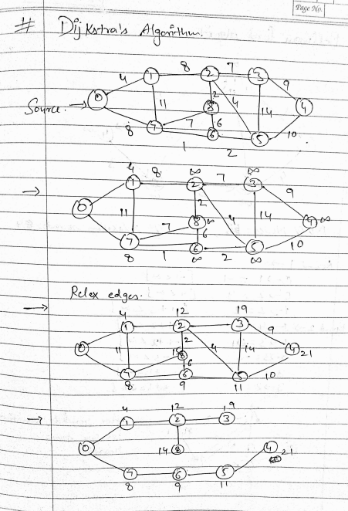

**Bellman-Ford Algorithm**

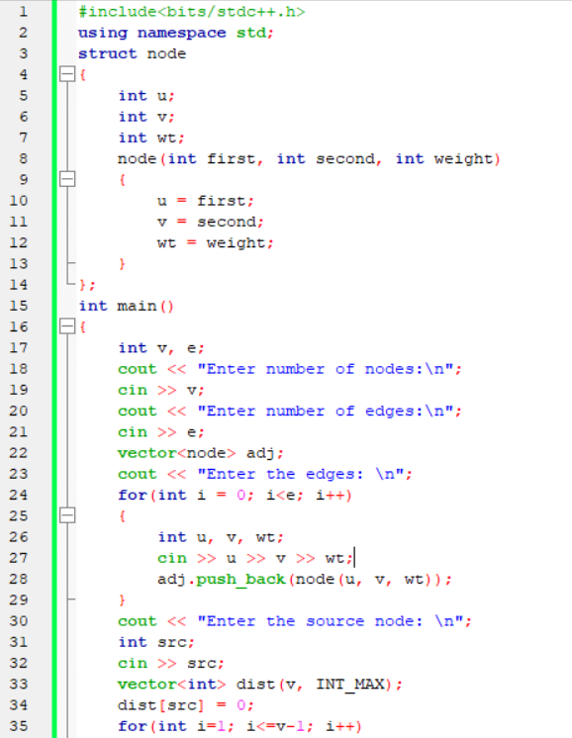

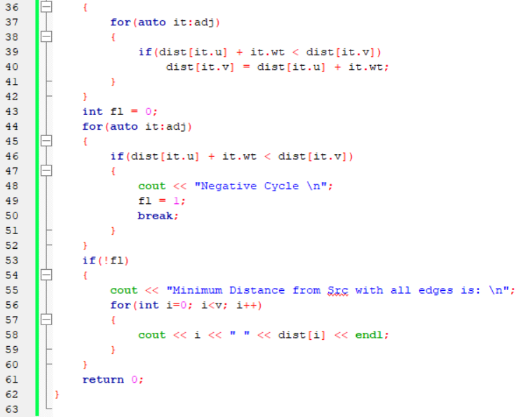

**OUTPUT**

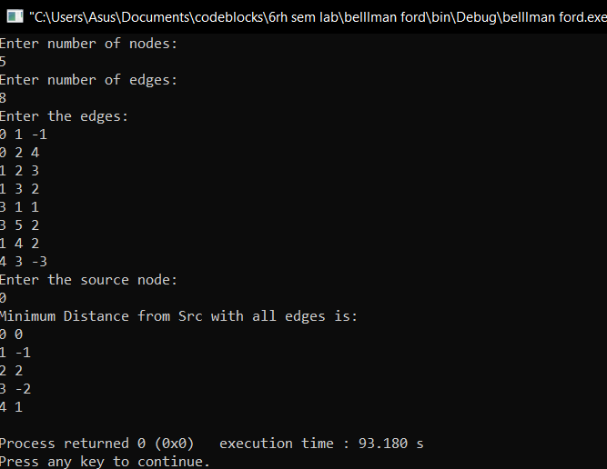

**DRY RUN**

