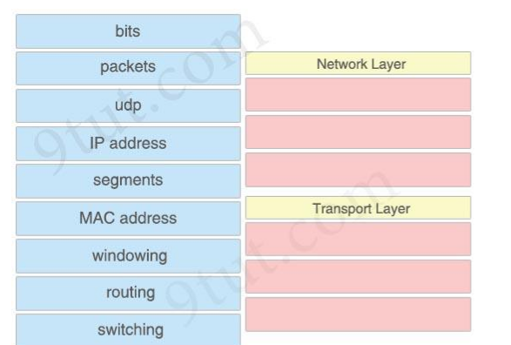Question 1.- Unir a que parte de la capa de red o transporte corresponden las siguientes varientes del módelo OSI (azul)

Question2.- Which command can you use to set the hostname on a switch?

A. switch-mdf-c1(config)#hostname switch-mdf1

B. switch-mdf-c1>hostname switch-mdf1

C. switch-mdf-c1#hostname switch-mdf1

D. switch-mdf-c1(config-if)#hostname switch-mdf1

Question3.- What are the administrations forms in the Cisco devices?

A.- Console, auxiliar, ethernet

B.- Ethernet, serial, console

C.- Auxiliar, Console, Vitual Line

D.- LAN, WAN, console

Question4.- What option describes a LAN network? (choose two)

A.- Divides in segments called vlans

B.- Use the protocol 802.3 (ethernet)

C.-Use the broadcast message

D.-Don´t use broadcast message