● (High) Challenges - Challenges faced in development.
Biggest one because I didn't worked with, and also wasn't implementing here were unit testing. For me till now, manual testing was the single one done in react, clients didn't approved time for writing tests, so I didn't do

● (High) Points for improvement - Anything you did not have time to do well and you would like to improve. How you would improve it.
- * Testing I didn't had time and also for me , it was difficult
- * I would improve the table listing to add also arrows and to create a component for each table row
- * I also didn't do the textarea for entering manually csv data inside, because right now it was time consuming to write a special validation code for it. Right now how it works, it uploads csv , read it and put inside textarea for csv input the content of csv file
- Pagination for the table I didn't do it, because everything was from scratch done, I didn't had time to do pagination
- Update – Update wasn't done because of time, I would do it by clicking on tab navigation, and because data is already saved with redux inside store of the application was an easy thing, but didnt had time

● (High) Self evaluation - How well you satisfied the requirements, designs and the key results. Score yourself 0-10 on each of these items. Then write a reason for this score.
- Key Results – 10
- Requirements – 8 – because didnt finished and ebcause of unit testing
- designs - 10

● (High) Screenshots - Screenshots of the web application working.
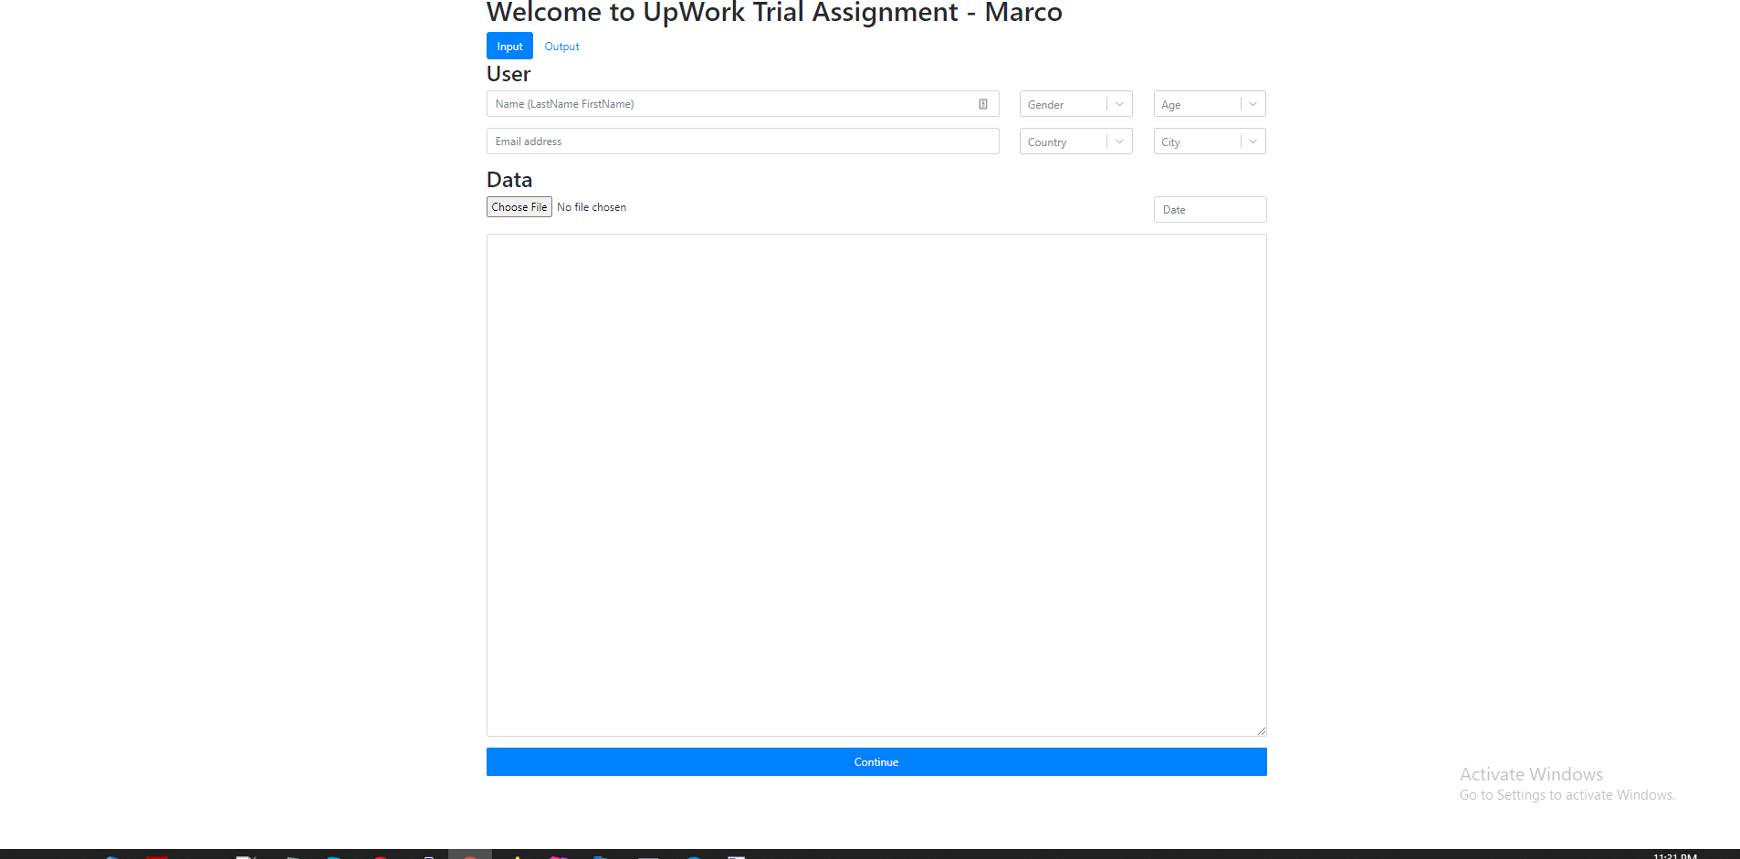

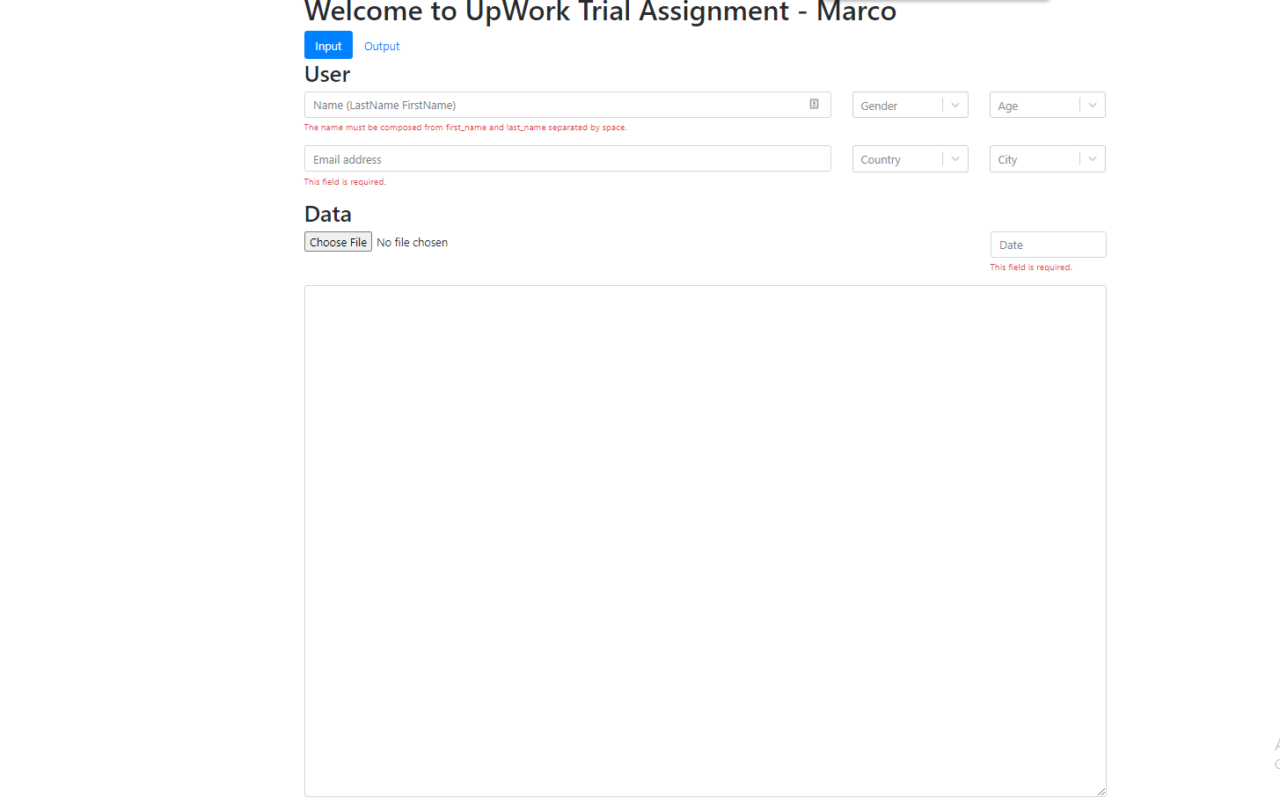

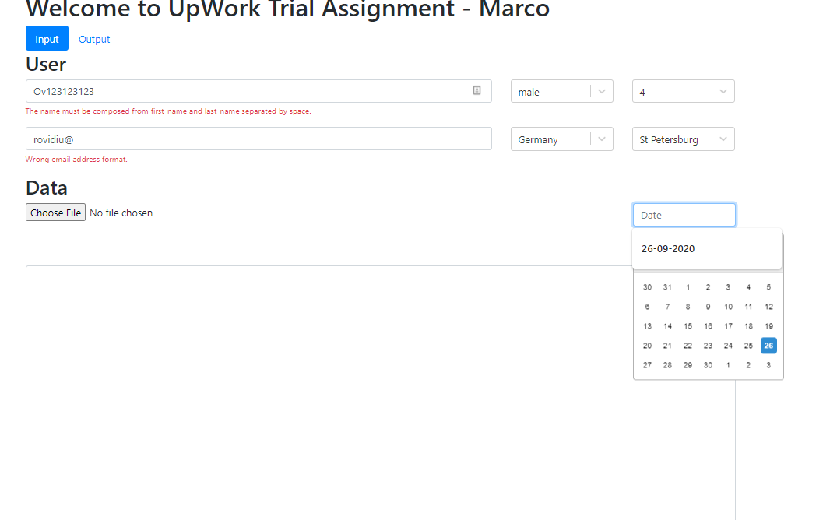

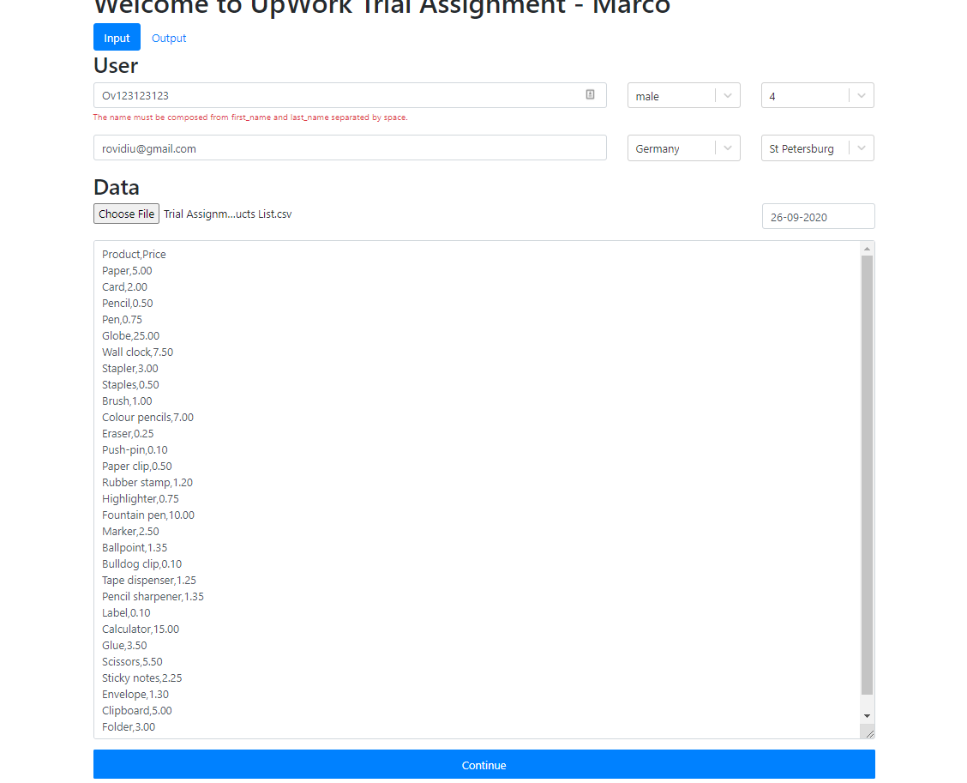

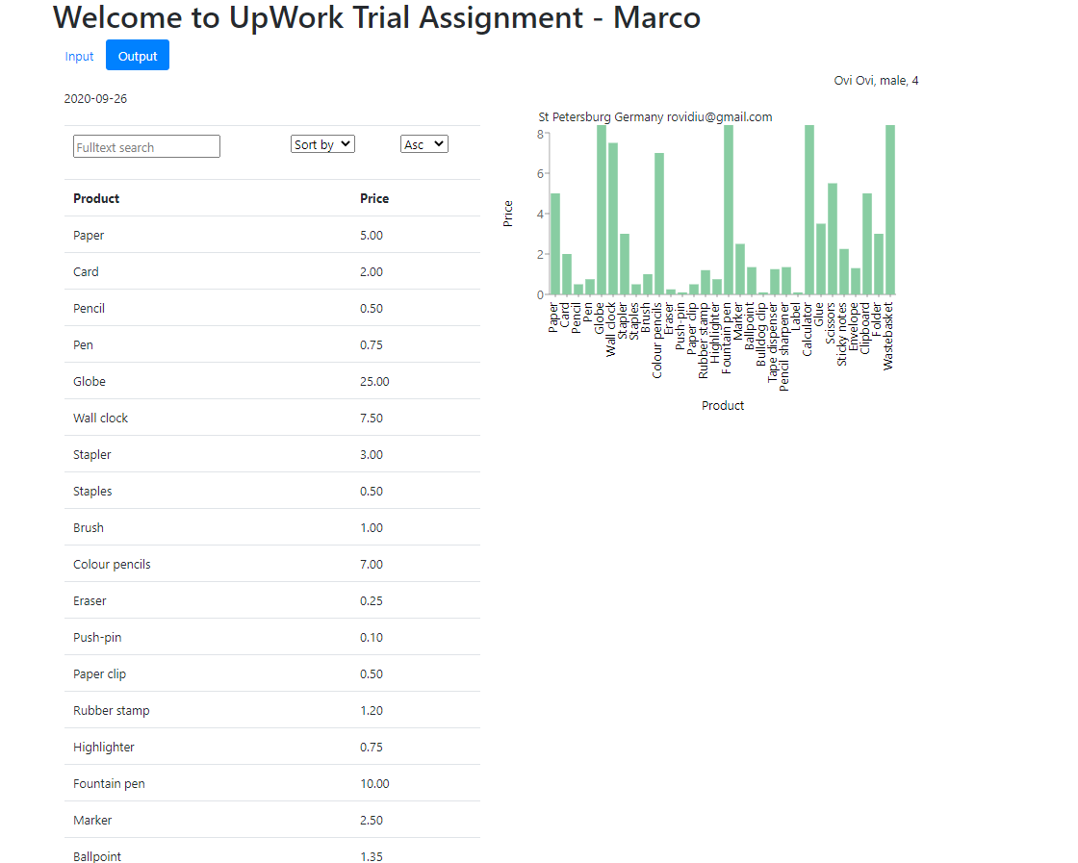

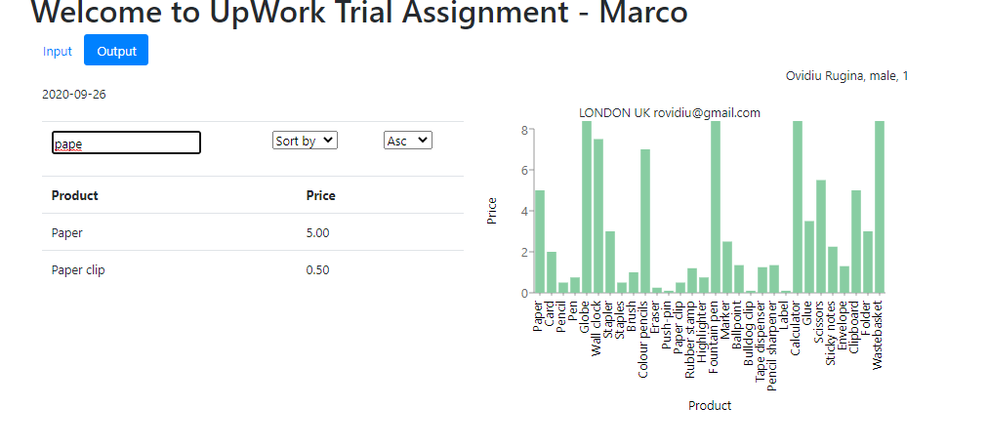

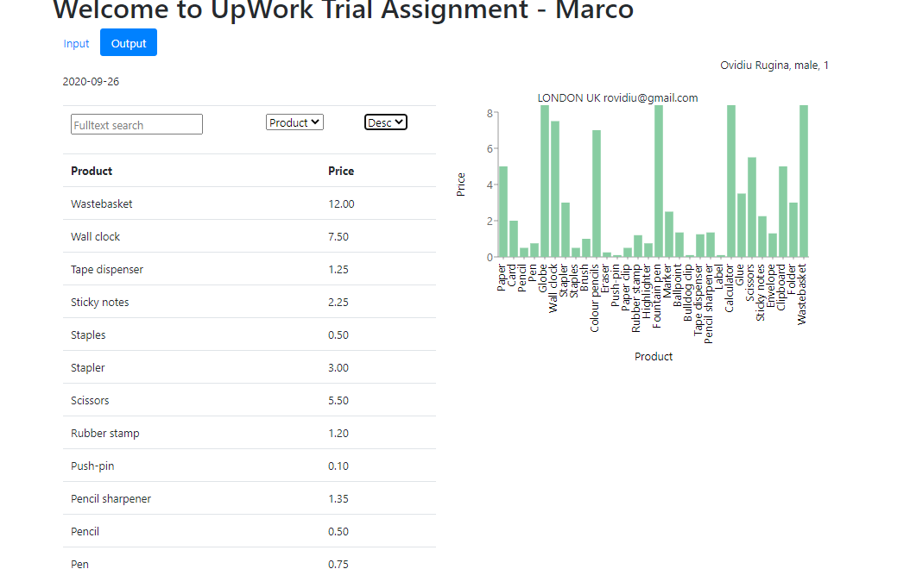

● (Low) Missing items - Any designs/requirements that were not sufficiently defined in the requirements/designs.
* CSV Input - validation here should take some time, and also if it was dynamically I think we had to predefine somehow the table head - first row from csv file. I would improve this part. In rest was fine

● (Low) Improvements - Anything you think could be improved in the design of the application in general to make it more user friendly (better UI elements, better flow, better placing etc).
- * Drag and drop csv uploader
- * same page everything
- * edit inline the csv
- Chart with bar – I would do with clickable KPI-s and in chart will appears only the needed ones
- Filtering in left side with table to apply over here too

