TODO-APP

1. Home page looks like below http://<domain_name>/ eg. http://localhost:3000/

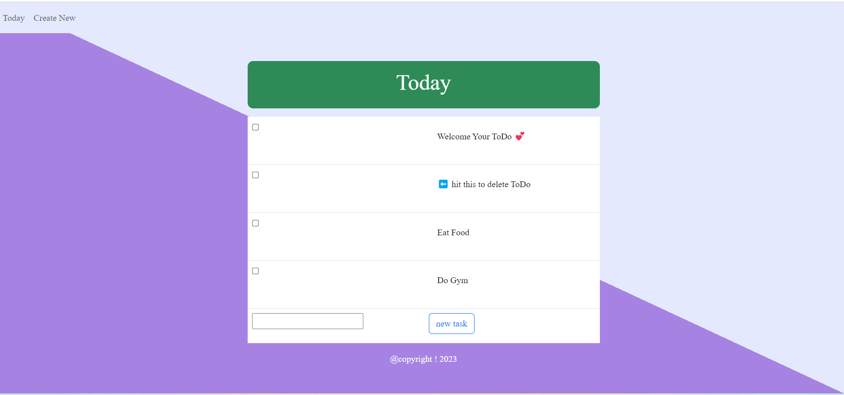

1. By Clicking new task button user can add task under specific category

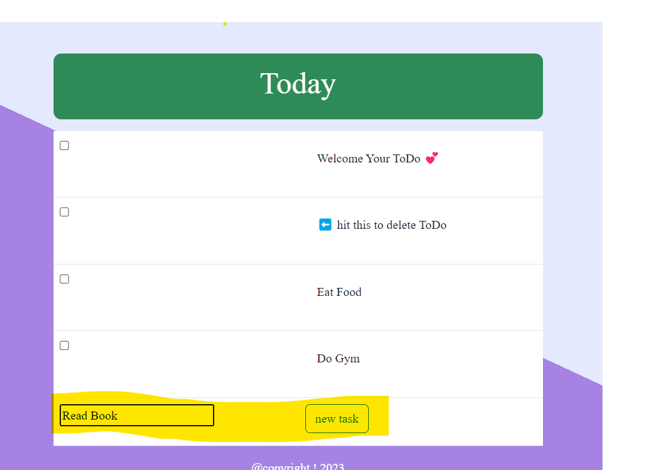

1. By Clicking Create New link user can generate new task list. It will provide input box to type list name. than click next arrow

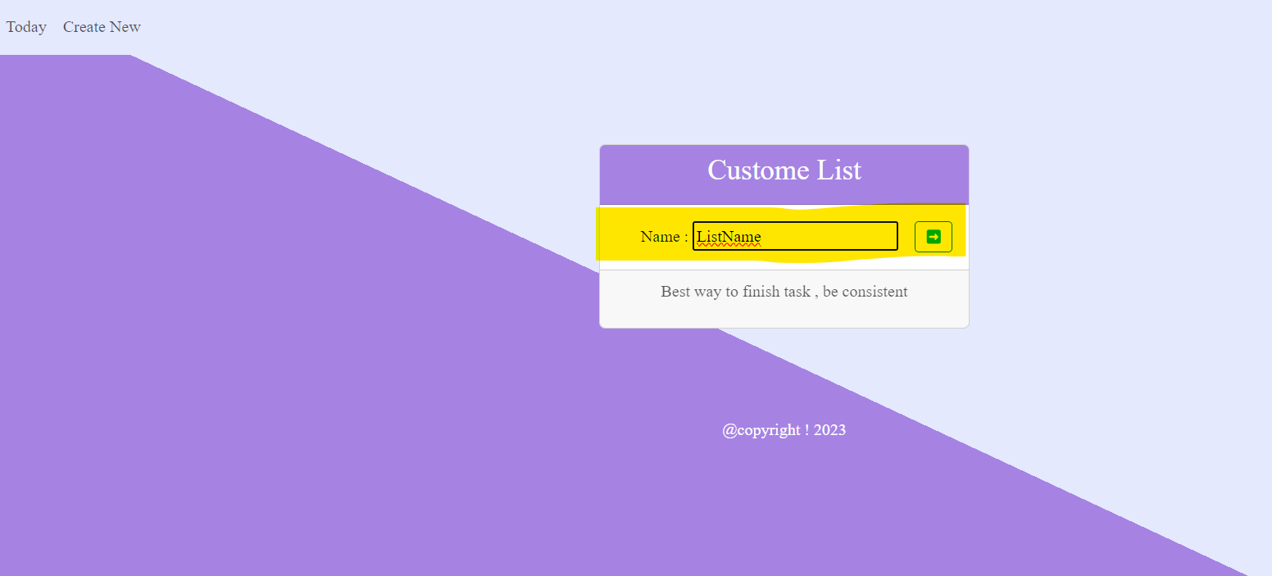

1. Newly added list Home . by providing task name user can add task further

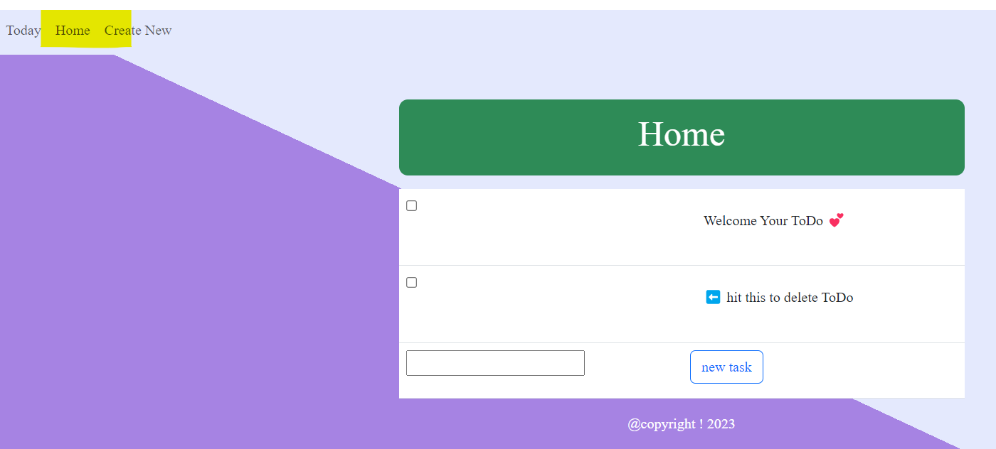

1. Last two new added task

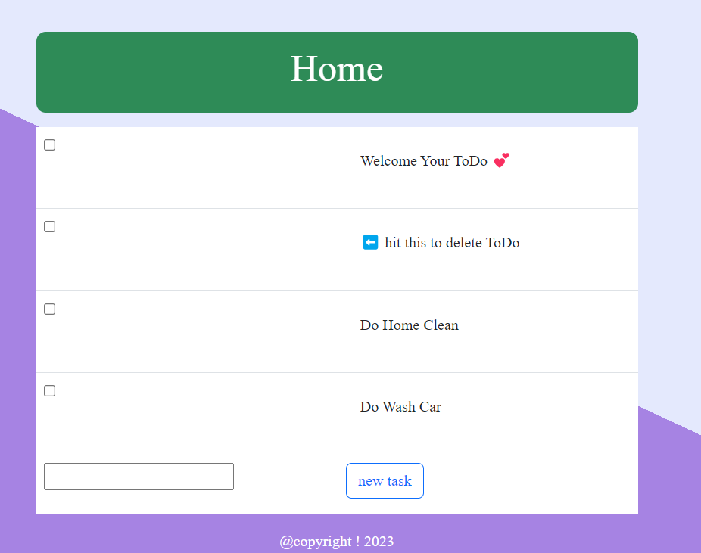

1. User can delete task after completion . here I deleted “Do Wash Car “ from Home List

