
PET ENGINEERING COLLEGE VALLIOOR - 627117


DEPARTMENT OF COMPUTER SCIENCE AND ENGINEERING
PROJECT TITLE : CALCULATING FAMILY EXPENSES USING SERVICENOW

College Code: 9632
Technology: Artificial Intelligence Total number of student’s in a group: 4 Student’s details within the group:
-ROVISHA JEBA A (Reg No:963222104038)

-SAHAYA JOVITA M (Reg No: 963222104039)

-VASU SHANMUGAM S (Reg No: 963222104055)

-PUVANESH M (Reg No: 963222104701)

BONAFIDE CERTIFICATE

Certified that this project report "CALCULATING FAMILY EXPENSES USING SERVICENOW” is the bonafide work of __________________________________________who carried out the work under my supervision. Certified further that to the best of my knowledge the work reported herein does not form part of any other thesis or dissertation on the basis of which a degree or award was conferred on an earlier occasion on this or any other candidate.


Signature MRS.E.DENISHA

Assistant Professor, Department of CSE, PET Engineering College, Vallioor.

INTERNAL EXAMINER
Signature
DR.S.BABU RENGA RAJAN
Head of the Department Department of CSE, PET Engineering College, Vallioor.

EXTERNAL EXAMINER



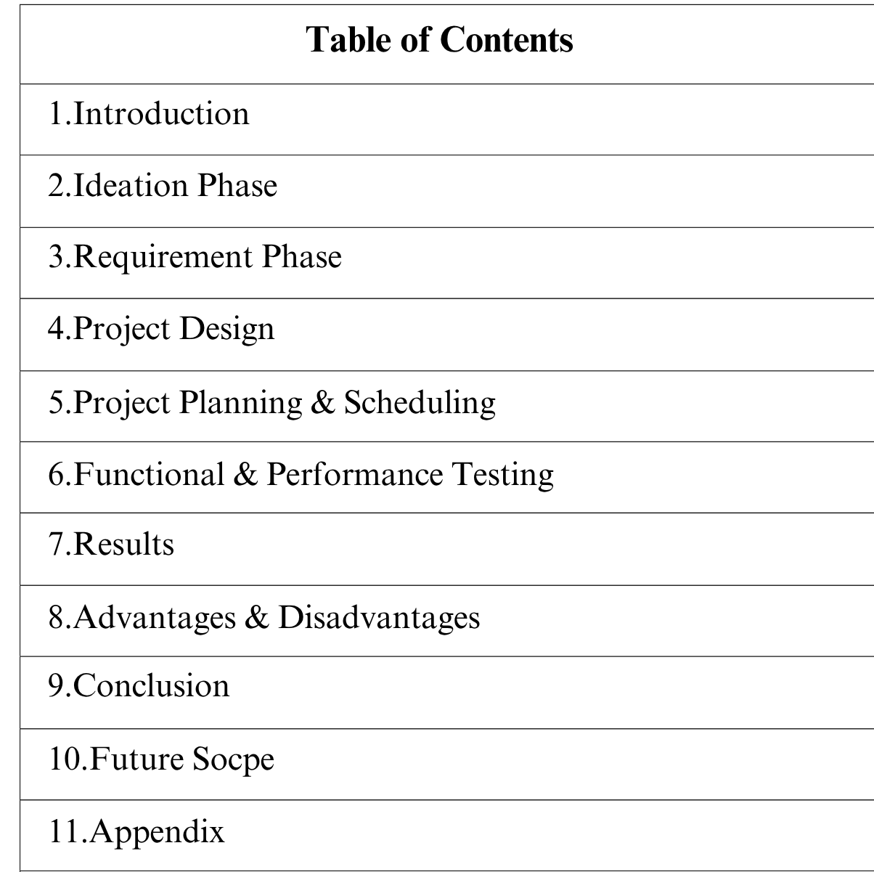

CALCULATING FAMILY EXPENSES USING SERVICENOW

INTRODUCTION

Project Overview

This project, "Calculating Family Expenses Using ServiceNow" aims to streamline and manage student

admissions, academic performance, and administrative data using the ServiceNow platform. The goal is to create a digital system with custom tables, forms, and business rules to automate educational processes.

Purpose

The Family Expense Tracker aims to help families manage their expenses efficiently. The application will allow users to:
- Record expenses by category (e.g., groceries, utilities, entertainment)

- Track expenses over time

- Set budgets and receive notifications when approaching limits

- Generate reports to analyze spending habits

IDEATION PHASE

Problem Statement

The project aims to develop a comprehensive expense calculation system using ServiceNow. This system will enable users to track and manage family expenses efficiently. It will include features such as expense categorization, budget setting, real-time tracking, and reporting capabilities. Managing family expenses manually often leads to errors, lack of transparency, and difficulty in tracking spending patterns. Families struggle to record, categorize, and analyze their expenses efficiently, especially when multiple members contribute to and utilize shared resources. Traditional methods such as spreadsheets or handwritten notes are time-consuming, lack real-time visibility, and make it challenging to generate reports or maintain accountability.To overcome these challenges, there is a need for a digital solution built on the ServiceNow platform that can automate and streamline expense management for families. The system should allow users to log daily, weekly, and monthly expenses, categorize them (e.g., food, bills, education, healthcare), and visualize spending trends through dashboards and reports.It should also support notifications for budget limits, approval workflows for shared expenses, and secure data management.

Utilising ServiceNow robust platform, the project will ensure seamless integration, user-friendly interface, and scalability to accommodate varying family sizes and financial complexities. The end goal is to empower users with the tools they need to make informed financial decisions and promote financial well- being within the family unit.

Empathy Map Canvas

Entity and Map Canvas for ServiceNow Family Expenses Table

Entities:

- Expense: Represents a single expense record

- Attributes: Date, Amount, Category, Description, Family Member

- Category: Represents a category of expenses (e.g., groceries, utilities)

  - Attributes: Name, Description

- Family Member: Represents a family member who incurs expenses

  - Attributes: Name, Relationship

- Budget: Represents a budget for a specific category or overall expenses

  - Attributes: Amount, Category, Timeframe

Map Canvas:

The map canvas would visualize the relationships between these entities, showing:

- Expense records linked to specific Category and Family Member records

- Budget records linked to specific Category records or overall expenses

- Relationships between Family Member records and their corresponding Expense records This entity and map canvas design would help structure the Family Expenses table in ServiceNow, enabling effective data modeling and relationships.
  - Brainstorming

Brainstorming: Calculating Family Expenses using ServiceNow

Ideas:

- Automated Expense Tracking: Use ServiceNow to automatically track expenses via integrations with bank accounts or credit cards.
- Customizable Budgeting: Create customizable budgets for different expense categories (e.g., groceries, utilities, entertainment).

- Real-time Expense Reporting: Generate real-time reports on family expenses, including charts and graphs to visualize spending habits.

- Alerts and Notifications: Set up alerts and notifications when expenses exceed budgeted amounts or when specific expenses are incurred.
- Family Member Expense Tracking: Allow multiple family members to track their expenses and view shared reports.

- Expense Categorization: Use machine learning or manual categorization to classify expenses into different categories.
- Recurring Expense Management: Track and manage recurring expenses, such as subscription services or utility bills.
Questions:

- How can we ensure data accuracy and security for financial information?

- What integrations would be necessary for automated expense tracking?

- How can we customize the solution for different family needs and preferences?

This brainstorming session focuses on generating ideas and exploring possibilities for calculating family expenses using ServiceNow.

REQUIREMENT PHASE

Journey Map

Journey Phase: ServiceNow Calculating Family Expenses Phases:
- Discovery: Identify family expense tracking needs and requirements

- Planning: Define scope, budget, and timeline for the project

- Design: Configure ServiceNow to meet family expense tracking needs

- Implementation: Set up and test the solution

- Adoption: Train family members on using the solution

- Review and Refine: Continuously review and refine the solution to ensure it meets evolving family needs

Activities:

- Requirements Gathering: Identify family expense tracking requirements

- Solution Design: Design a solution using ServiceNow's features (e.g., forms, workflows, reports)

- Configuration and Testing: Configure and test the solution

- Training and Adoption: Train family members on using the solution

- Ongoing Monitoring and Maintenance: Monitor and maintain the solution to ensure it continues to meet family needs
This journey phase outlines the key stages and activities involved in implementing a family expense tracking solution using ServiceNow.

Solution Requirements Functional Requirements:
- Expense Tracking: Ability to record and track expenses by category (e.g., groceries, utilities, entertainment)
- Budgeting: Ability to set budgets for different expense categories

- Reporting: Ability to generate reports on family expenses, including charts and graphs

- Alerts and Notifications: Ability to set up alerts and notifications when expenses exceed budgeted

amounts

- User Access: Ability for multiple family members to access and track expenses

Non-Functional Requirements:

- Data Security: Ensure all financial data is secure and protected

- User Experience: Intuitive and user-friendly interface for family members

- Scalability: Solution should be scalable to accommodate growing family needs

- Integration: Ability to integrate with existing financial systems (e.g., bank accounts)

Technical Requirements:

- ServiceNow Platform: Utilize ServiceNow's features (e.g., forms, workflows, reports) to build the

solution

- Data Modeling: Design a data model to store expense records, budgets, and family member information

- Security Configuration: Configure security settings to ensure data protection and access control

These solution requirements outline the key functional, non-functional, and technical requirements for building a family expense tracking solution using ServiceNow.

Data Flow Diagram

[User Input/API]

↓

[Expense_Record Table]

↓ (Trigger)

[Validation & Categorization (Flow Designer)]

↓

[Aggregate Totals]

↓

[Family_Expense_Summary Table]

↓

[Dashboards / Reports / Notifications]

  - Technology Stack

    - Platform

    - Language
: ServiceNow

: JavaScript (for scripting)

    - Tools : Update Sets, Table Designer, ClientScripts, Form Designer

PROJECT DESIGN

Project Solution Kit

•Low-Code Platform: Easy to build without deep technical skills.

•Mobile-Friendly: Track and input expenses from anywhere.

•Automation: Reduces manual work, saving time and effort.

    - Secure: Set access control so only authorized members can edit data.

This solution provides a simple, centralized, and automated system for managing and tracking family expenses, ensuring clarity and control for everyone involved.

Proposed Solution Overview
We propose creating a Family Expense Management Application within Service Now to stream line the

tracking, categorization, and budgeting of family expenses. This solution will provide an easy-to-use, automated platform for families to log, view, and analyze their expenses with real-time insights, mobile access, and alerts.

Benefits of the Proposed Solution

- Transparency : Every family member knows where the money is going and who is spending what.

- Control : Budgeting features and alerts ensure that family spending stays within limits.

- Efficiency : Automated processes save time, from expense calculation to reporting.

- Accountability : Each family member is accountable for their own spending.

- Flexibility : Mobile access allows for seamless expense entry from anywhere

Solution Architecture

•Setting up ServiceNow Instance

    - Creation of New Update Set

    - Creation of Table

    - Creation of Table(Daily Expenses)

    - Creation of Relationship

    - Configuring Related List on Family Expenses

•Creation of Business Rules

    - Configure the Relationship

    - Conclusion

PROJECT PLANNING & SCHEDULING

Phase Estimated Time

Setting Up Instance Update Set Creation Table Creations Relationships & Lists Business Rules
Final Testing & Conclusion
1 hour

30 mins

2 hours

1.5 hours

2 hours

1 hour



FUNCTIONAL AND PERFORMANCE TESTING

  - Performance Testing

    - Verified that form loads without delay

    - Checked rule-based validations (e.g., required fields, calculated total)

    - Related list displays correct student records

    - Auto-population of fields works smoothly

RESULTS

Output Screenshots
•Setting up ServiceNow Instance

    - Creation of New Update Set

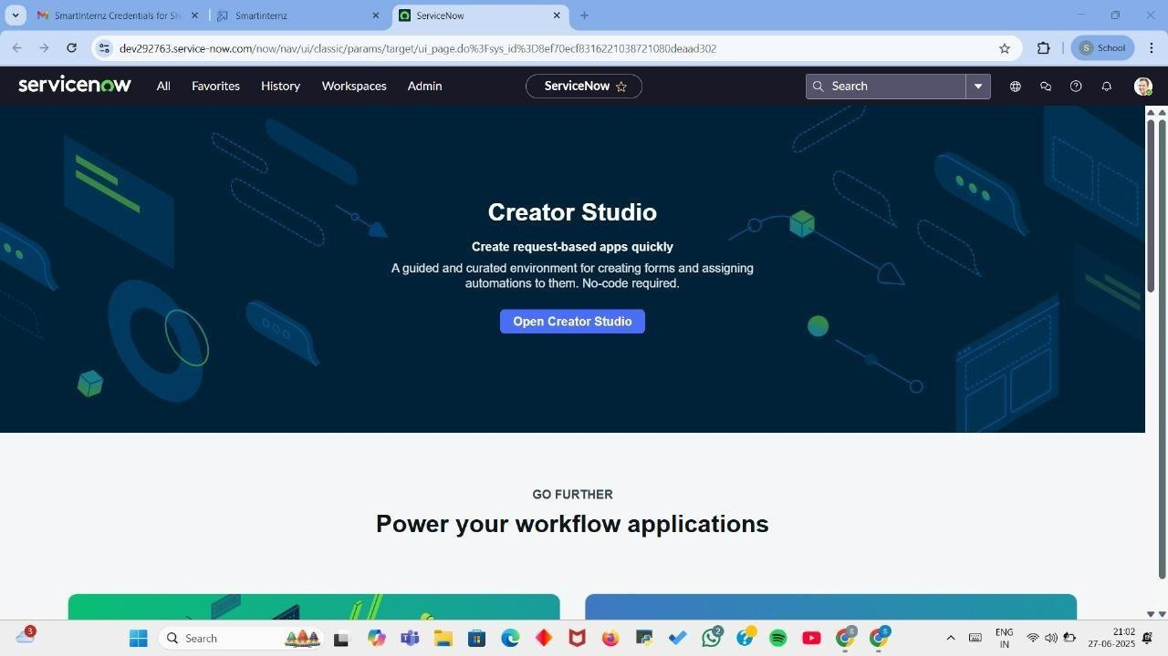
    - Creation of Table

    - Creation of Table (Daily Expenses)

    - Creation of Relationship

•Configuring Related List on Family Expenses

•Creation of Business Rules

    - Configure the Relationship

•Conclusion

Setting up ServiceNow Instance

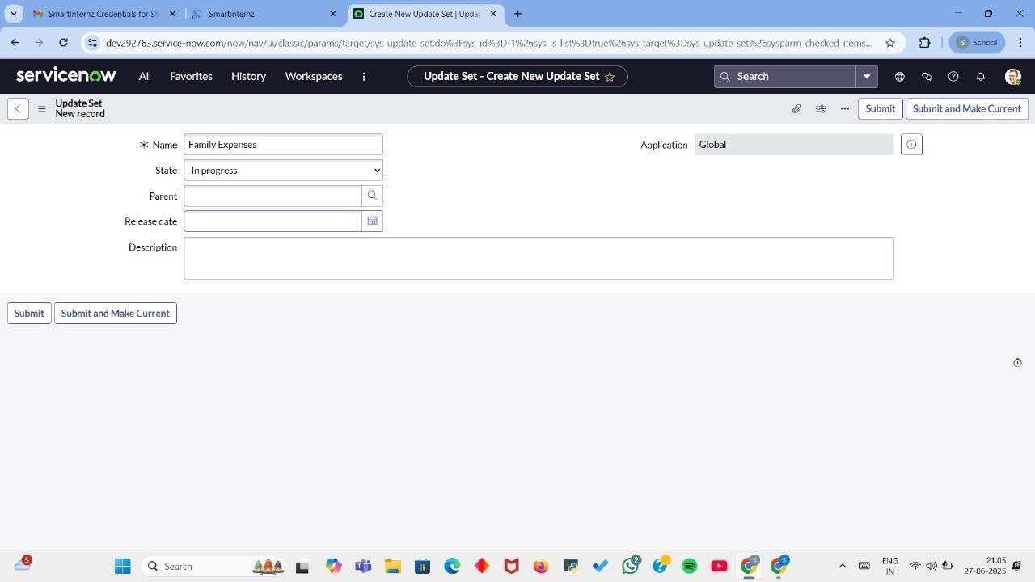
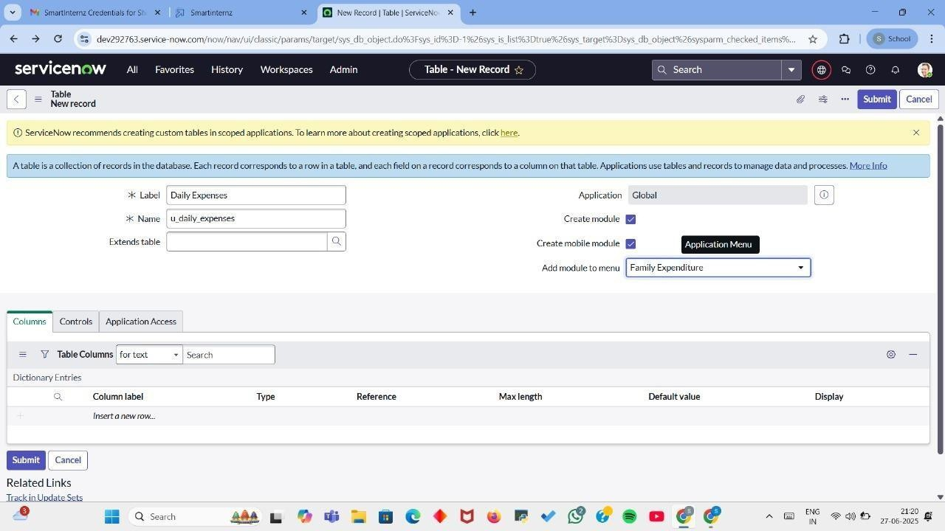
Creation of New Update Set

Creation of Tables

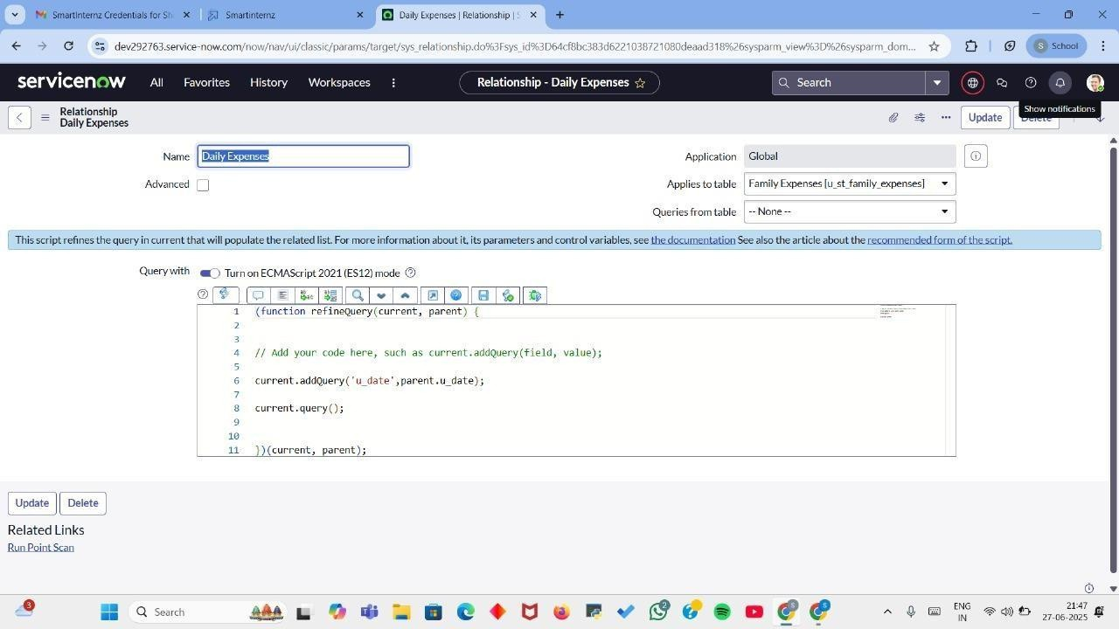
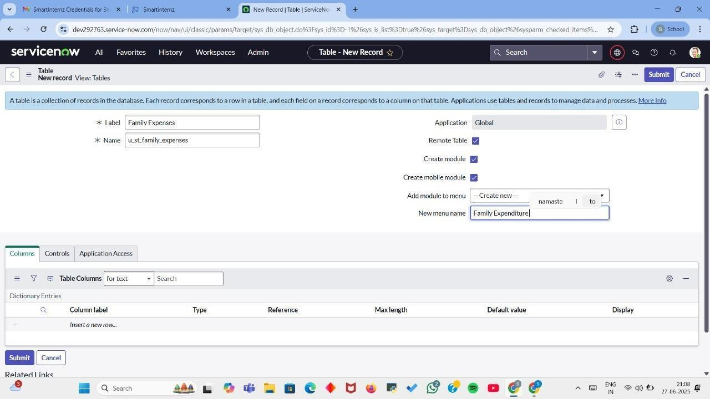

Creation of Relationship

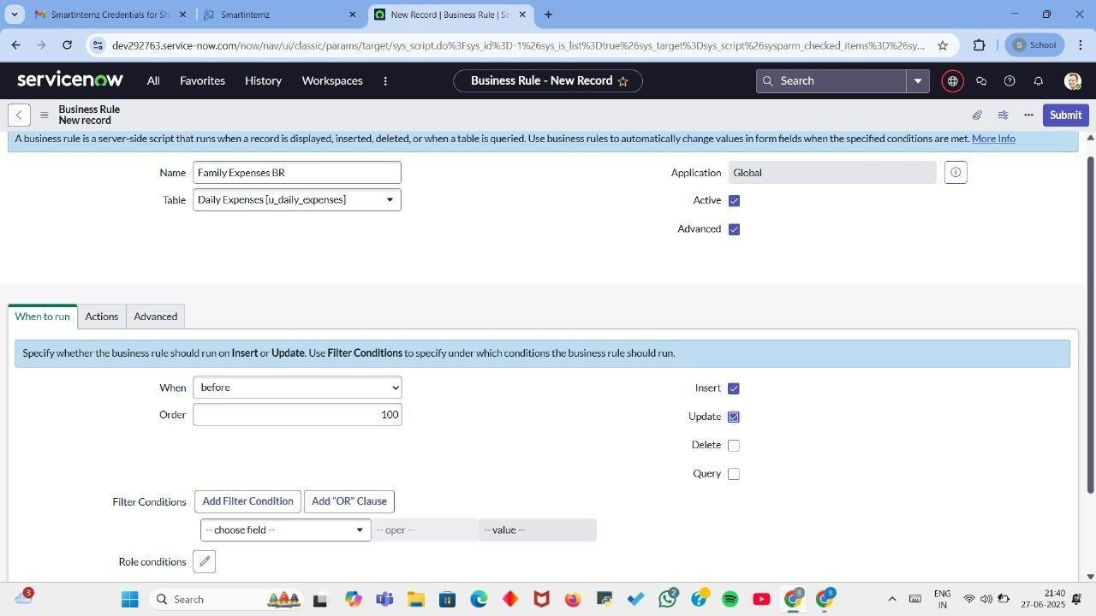
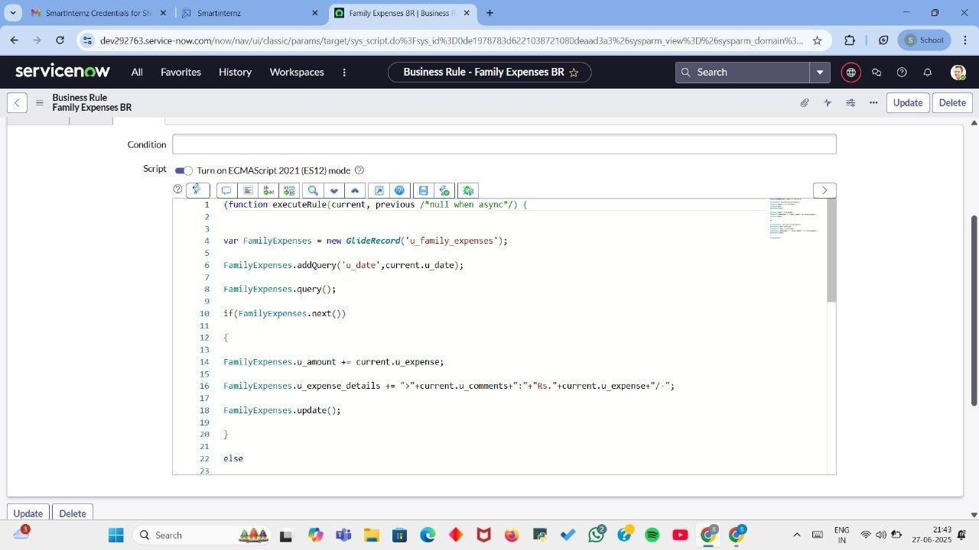
Creation of Business Rules

ADVANTAGES & DISADVANTAGES

✅ Advantages

Here are the advantages of calculating family expenses using ServiceNow in simple points:

- Centralized Expense Tracking: Keep all your family expenses in one place, making it easy to access and review anytime.

- Automation: Set up automatic logging for recurring expenses (like rent or bills) to save time.

- Custom Reports: Create detailed reports to track your spending patterns and compare them over time.

- Budget Alerts: Get notifications when you reach certain spending limits or when bills are due.

- Custom Categories: Organize expenses into categories (groceries, bills, entertainment) for better

tracking.

- Collaboration: Share financial data with family members to keep everyone on the same page.

- Audit Trail: Track who made changes to your expense records for transparency.

- Secure Data: Your financial data is protected with enterprise-level security and privacy controls.

- Integration with Other Tools: Link your bank accounts or financial software to import transactions

automatically.

- Scalability: As your financial situation grows, ServiceNow can handle more complex expenses like

investments or savings.

This makes managing family expenses more organized, efficient, and secure.

❌ Disadvantages

Here are the disadvantages of using ServiceNow to calculate family expenses in simple points:

- Complex Setup: ServiceNow is designed for businesses, so setting it up for personal use can be complicated and time-consuming.

- Overkill for Simple Needs: It's a powerful tool, but it may be too complex for basic family budgeting and expense tracking.

- Cost: ServiceNow is typically not free; it may require a paid subscription, which could be unnecessary for personal finances.

- Steep Learning Curve: It takes time to learn how to use all of ServiceNow’s features, which may not be worth it for just managing family expenses.

- Limited Personal Finance Features: It doesn’t have many built-in features specifically for budgeting, savings goals, or debt tracking.

- Requires Customization: You’ll need to customize it for your needs (like adding expense categories), which can be a hassle.

- No Mobile App: ServiceNow isn’t as mobile-friendly as other personal finance tools, so it may be harder to manage expenses on the go.

- Not Built for Family Use: It's more suited for businesses, so it might lack features that cater to family-specific needs like shared access or easy family budgeting.

- Maintenance: Ongoing updates and maintenance can be more technical, especially if you’re not familiar with IT tools.

- Data Privacy Concerns: Even though it's secure, storing personal family expenses on a platform originally designed for businesses could raise privacy concerns.

In short, ServiceNow can be over-complicated and expensive for managing family expenses, especially when there are simpler, cheaper alternatives out there.

CONCLUSION
In conclusion, implementing the "Calculation of Family Expenses Using ServiceNow" project offers numerous benefits to the household. By leveraging the robust capabilities of ServiceNow, family members can efficiently submit, track, and manage their expenses in a centralized and streamlined manner.

