This document addresses Task 1 for the Data Science assessment.

- First run DataScienceTask1_Preprocessing
This script produces and saves a dataframe called pivoted that is used in subsequent code.

This code also visualises the datasets and attributes geographical data to call out count data.

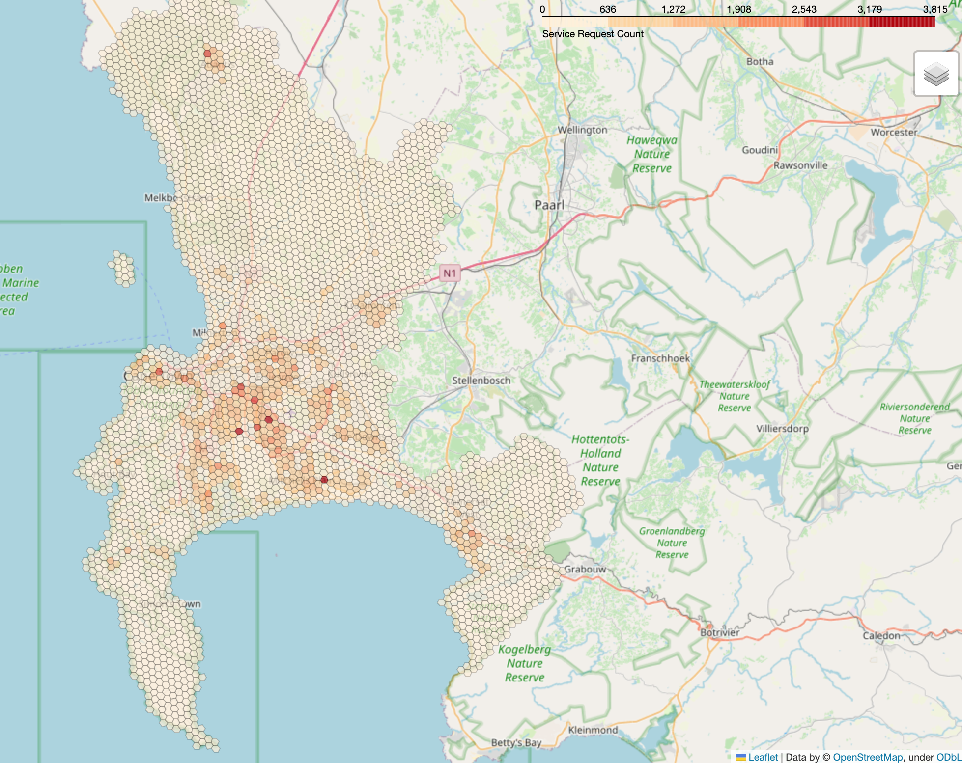

For the prediction task, we aim to predict the counts for each hex four weeks in advance.
For this task, we first convert the data in the structure of hex_index as rows and weekly counts as columns.
We train multiple machine learning models, i.e., SARIMAX, Random Forest, and the Long Short-term Model Neural Network.

Train/Test Split:
The rows (hexes) are split into training and test sets:
  - 80% of hexes are reserved for training.
  - 20% of hexes are used for testing model performance.

Preprocessing
Load Raw Data:
The script starts by loading a CSV file containing event records. Each record includes a timestamp and a hex identifier (hex_index).
Convert Timestamps:
The creation_timestamp column is converted to datetime format to allow time grouping.
Aggregate by Week:
Each timestamp is mapped to the start of its week (week_start), and the data is grouped by hex_index and week to count how many events occurred in each hex per week.
Pivot to Wide Format:
The weekly counts are reshaped so that each row corresponds to a single hex, and each column represents the count for one week. Missing weeks are filled with zeros to create a complete time series per hex.

We undertake a basic hyperparameter optimisation where we vary the length of historic data used to train each model.

- SARIMAX – code script: SARIMAX_prediction.py
What makes up the input and outputs of the model
Hexes are treated independently.
Input to each model:
- For each hex in the test set, the entire historical weekly count series except the last 4 weeks is used as training data.
- This is a single numeric time series (e.g., 49 weeks if there are 53 total weeks).
- No exogenous regressors were included.
Modeling:
- A separate SARIMAX model is fit to each hex’s training time series.
- The current week’s count depends linearly on the previous weeks but does not explicitly model seasonal patterns.

- Random Forest Regressor - RandomForestRegression.py
Hexes are treated independently.
Input to each model:
- For each hex in the dataset, historical windows are created using a rolling window of past counts.
For example, if you use 13 lag weeks, each training sample contains counts for the 13 prior weeks.
- These lagged counts serve as the model’s predictors (“features”).
- No external variables (exogenous regressors) are used in this version.
Modelling:
- A Random Forest Regressor is trained to map the lag features to the count value 4 weeks into the future.
- This approach does not assume a linear relationship: the Random Forest learns nonlinear patterns and interactions between lagged counts.
- A single Random Forest model is fit across all hexes (not separate per hex), leveraging pooled patterns across areas.
- The model produces one prediction for each forecasted week, although in this implementation you can also adapt it to predict multiple weeks at once if desired.
Output of the model:
- The trained Random Forest predicts the count 4 weeks ahead for each hex in the test set.
- Predictions are compared against the actual observed counts in the test dataset.

- LSTM Regressor - LSTM_PredModel.py
Hexes are treated independently.
Input to each model:
- For each hex in the dataset, historical windows are created using a rolling window of past counts.
For example, if you use 13 lag weeks, each training sample contains the counts for the previous 13 weeks.
- All input features are normalized to improve convergence and stability.
Modelling:
- A Long Short-Term Memory (LSTM) neural network is trained to learn temporal dependencies in the count sequences.
- The LSTM processes the historical sequence as a series of time steps, maintaining an internal state that can capture longer-term trends and patterns.
- The final hidden state from the LSTM is passed through a fully connected (dense) layer to produce the output.
- A single LSTM model is fit across all hexes (not separate per hex), leveraging shared temporal patterns across locations.
Output of the model:
- The trained LSTM predicts the counts for the next 4 weeks for each hex in the test set.
- Predictions are rescaled back to the original count scale and compared against the actual observed counts in the hold-out data.

- LSTM with addition seasonal features – code script: LSTM_predict_weeks.py
- Optionally, additional seasonal features (sine and cosine encodings of the week number) are included for each time step to help the model learn cyclical patterns.

Model parameters and results:

Model Type | Historical window (weeks) | Error values
SARIMAX | 49 | MAE: 2.3682  RMSE: 4.5821  R²: 0.6033  MAPE: 63.33%
Random Forest Regression | 4 | MAE: 3.1654  RMSE: 6.3667  R²: 0.6350  MAPE: 77.13%
 | 13 | MAE: 2.8726  RMSE: 5.5582  R²: 0.7009  MAPE: 71.70%
 | 26 | MAE: 2.7900  RMSE: 5.5177  R²: 0.7497  MAPE: 62.48%
 | 48 | MAE: 2.7646  RMSE: 6.1100  R²: 0.6074  MAPE: 63.59%
LSTM | 4 | MAE: 3.1109  RMSE: 5.9851  R²: 0.6191  MAPE: 74.20%
 | 13 | MAE: 2.2572  RMSE: 5.2863  R²: 0.7028  MAPE: 62.60%
 | 26 | MAE: 2.2050  RMSE: 5.1519  R²: 0.7178  MAPE: 59.38%
 | 48 | MAE: 3.6031  RMSE: 6.8040  R²: 0.5077  MAPE: 113.65%
LSTM with addition seasonal features | 4 | MAE: 2.6511  RMSE: 5.6269  R²: 0.6633  MAPE: 64.00%
 | 13 | MAE: 2.9466  RMSE: 5.4652  R²: 0.6824  MAPE: 73.84%
 | 26 | MAE: 2.9359  RMSE: 5.8973  R²: 0.6302  MAPE: 66.78%
 | 48 | MAE: 3.5432  RMSE: 5.6061  R²: 0.6658  MAPE: 92.54%

If we further, consider the best performing model:

The LSTM that takes only weekly historical counts per hex for a historical period of 26 weeks (1/2 year) and predicts weekly counts for the next 4 weeks counts per hex is the best performing models from the above.

LSTM Model
hidden_size=64
num_layers=2

Training convergence:
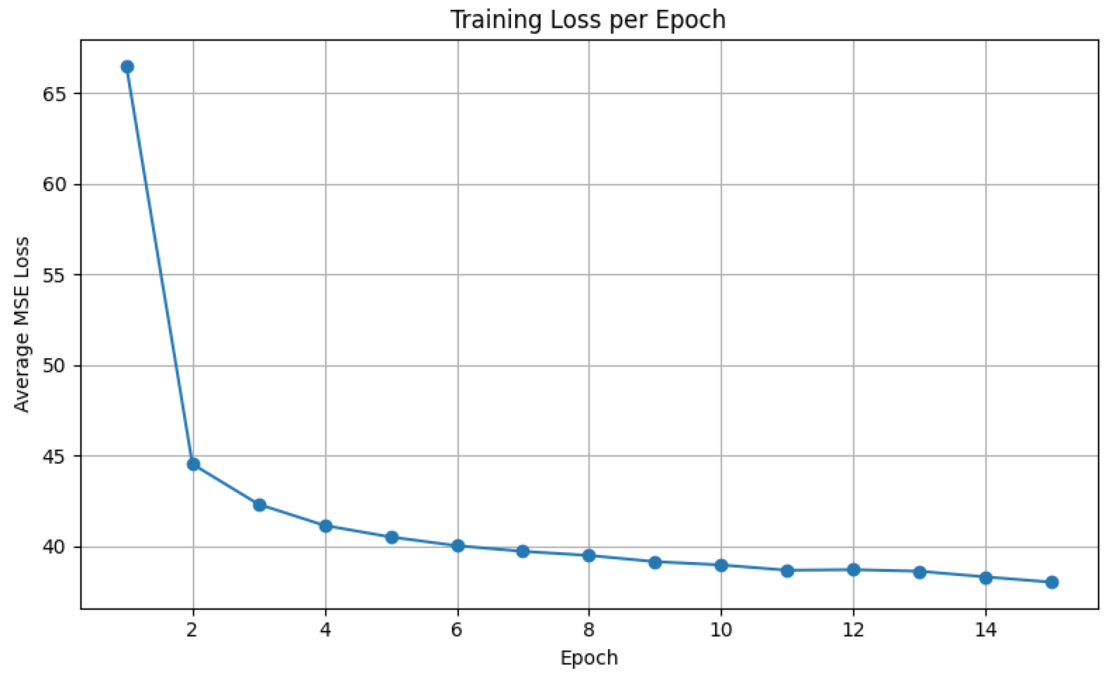

Results explained:
- MAE (Mean Absolute Error): 2.2050
On average, the model’s predictions were about 2 counts away from the true counts.
- RMSE (Root Mean Squared Error): 5.1519
The typical size of the error (penalizing bigger mistakes more heavily) was about 5 counts.
- R² (Coefficient of Determination): 0.7178
The model explains about 72% of the variance in the actual counts. This suggests it captures much of the underlying pattern but still misses some variability.
- MAPE (Mean Absolute Percentage Error): 59.38%
On average, the predictions were about 59% off relative to the actual counts, which indicates errors are proportionally higher when the true counts are small.
Interpretation
Overall, this LSTM model provides a reasonably good fit, capturing most of the trends (R² ~0.72). However, the relatively high MAPE shows there’s still room to improve—especially in accurately forecasting smaller counts.

Testing prediction visualised:
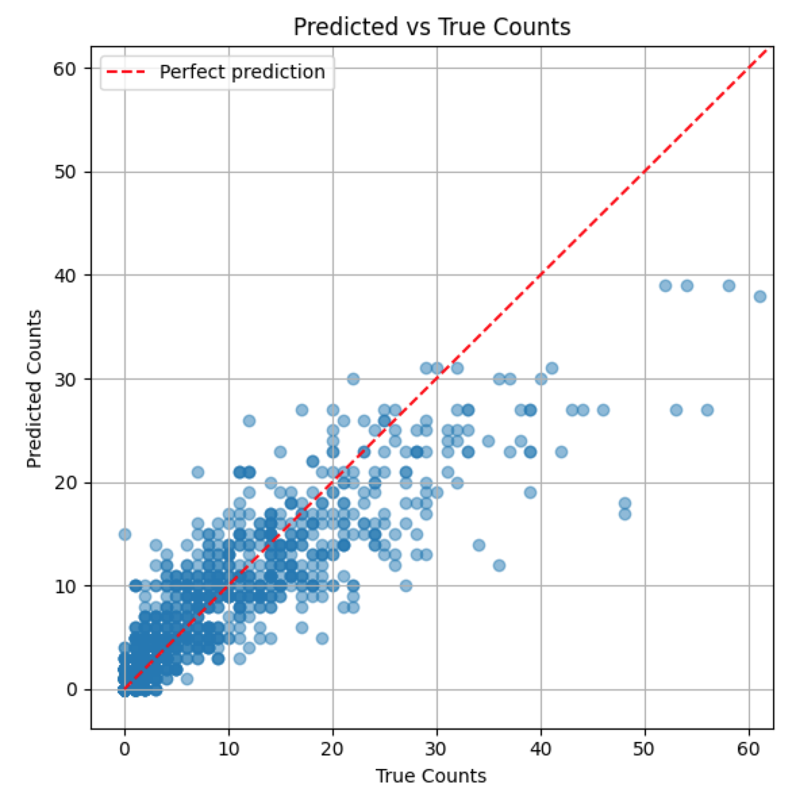

Once our best performing model is selected, we retrain the model on the entire dataset (no train / test split) and predict the next four week count for each hex.
This data is saved as predictions.csv

Prediction excerpt below. 