Design and Simulation of FM Transceiver Circuit
Name : Rawan Essam Ismial
ID :921240066
Submitted to: Prof. Mahmoud Elmesalawy

1.Introduction
Frequency Modulation (FM) is a cornerstone of modern communication systems, renowned for its superior noise immunity and signal fidelity compared to other analog modulation techniques. Unlike Amplitude Modulation (AM), FM conveys information by varying the instantaneous frequency of the carrier wave in proportion to the message signal’s amplitude. This project aims to design and simulate a complete FM transceiver system using the Proteus Design Suite. The implementation focuses on achieving precise modulation at a carrier frequency of 66 MHz and successfully recovering the original 66
KHz information signal through a robust demodulation process. The simulation serves as a practical verification of theoretical concepts, ensuring the integrity of the transmitted data across the communication link.

2.Design Specifications
- Message Signal: Amplitude = 1V, Frequency = 66 Hz.
- Carrier Signal: Amplitude = 5V, Frequency = 66 kHz

3.Frequency Modulation (FM)
Frequency Modulation is a method of angle modulation where the instantaneous frequency of the carrier wave is adjusted in a linear relationship with the amplitude of the baseband (message) signal.
The mathematical representation of the FM signal is:
s(t) = A_c · cos(2πf_c·t + 2πk_f ∫m(t)dt) Par
- A_c = Carrier amplitude = 5V

- f_c = Carrier frequency = 66 KHz
- m(t) = Message signal = cos(2π × 66×10³ × t)
- k_f = Frequency sensitivity constant of the modulator

3.2 Modulation Index
The FM modulation index (β) is defined as the ratio of the frequency deviation (Δf) to the message signal frequency
(f_m): β = Δf / f_m
Where
Δf = k_f × A_m, and A_m is the amplitude of the message signal.

3.3 FM Demodulation
Demodulation is the critical process of recovering the original information from the modulated carrier. In this system, the circuit is engineered to extract the 66 kHz message signal from the 66 MHz received FM wave.
3.4.Common Detection Techniques:
- Phase-Locked Loop (PLL): A closed-loop feedback system that tracks the phase and frequency of the incoming signal. It generates an error voltage that directly corresponds to the original message signal.
- FM Discriminator: A circuit that converts frequency shifts into measurable voltage variations, which are then processed by an envelope detector to reconstruct the waveform.

4.FM Generation (The Transmitter)
In this design, the U1 (CD4046 PLL) is configured to operate as an FM Transmitter by utilizing its internal Voltage Controlled Oscillator (VCO).
- Modulation Process: The message signal from the generator is fed into the
VCOIN (Pin 9) of U1.
- Operation: The VCO generates a square/triangular wave whose frequency varies according to the input voltage level. As the input signal from the generator fluctuates at 66 KHz, the output at VCOOUT (Pin 4) produces the FM signal centered around the carrier frequency of 66 MHz.
- Frequency Control: The center frequency is determined by the external capacitor C1 and resistor R2 connected to the IC.

5.FM Receiver (Demodulation)
​The CD4046 (U1) operates as a Phase-Locked Loop (PLL) to recover the original signal.
​Signal Input: The FM signal enters SIGIN (Pin 14) via coupling capacitor C1 (100n), which removes DC bias.
​PLL Tracking: The IC compares the input phase with its internal VCO. The frequency range is set by R1 (100k) and C2 (1000n).
​Signal Recovery: To maintain a “lock” on the frequency shifts, the PLL generates an internal error voltage. This reconstructed signal is outputted at DEMOD (Pin 10).
​Verification: An Oscilloscope monitors the process:
​Channel A: Input FM signal.
​Channel B: VCO output (Pin 4) to confirm locking.
​Channel C: Recovered message signal from Pin 10.

6.Simulation Screenshot
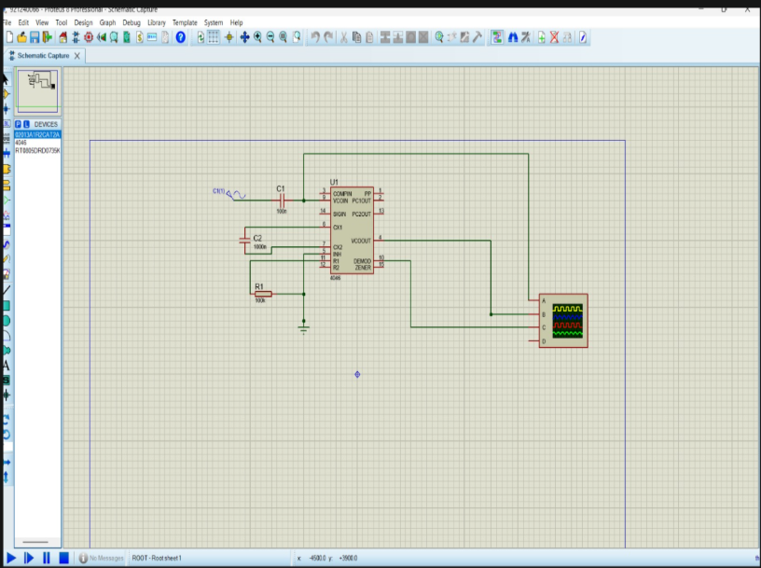

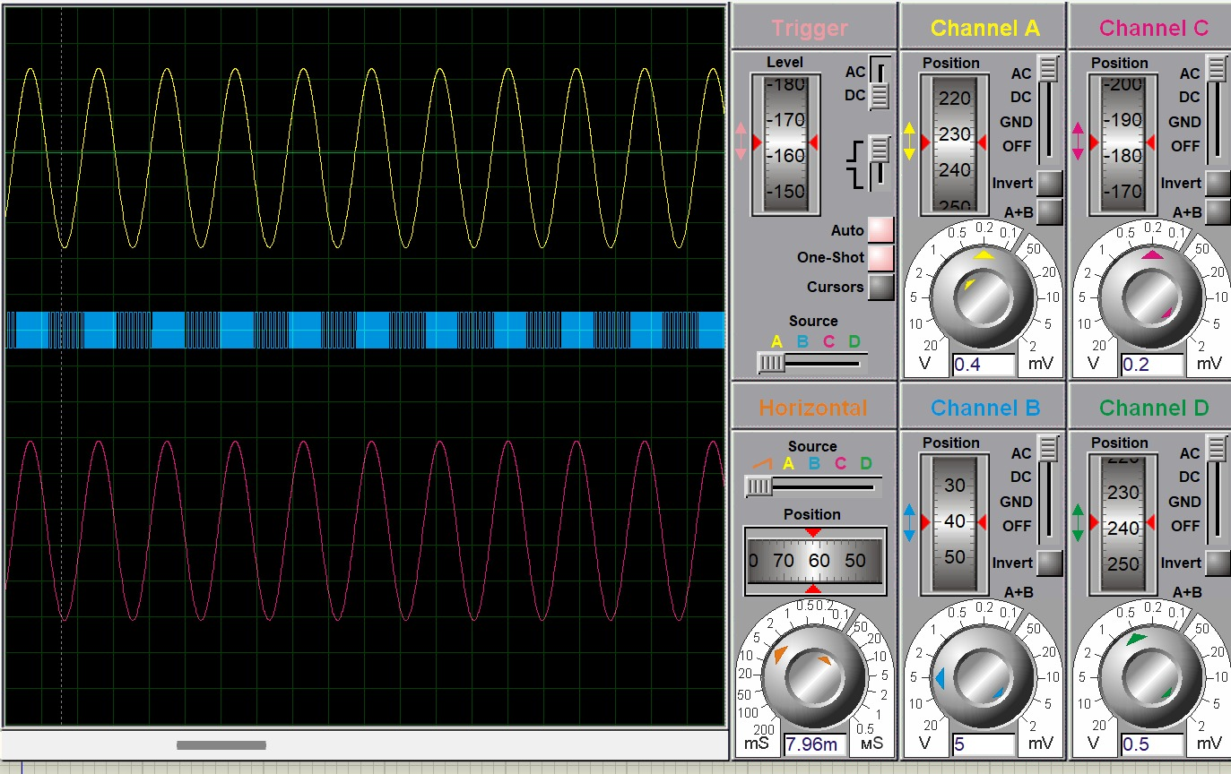

8.Conclusion
In this project, a full FM transceiver system was successfully designed and simulated using Proteus. By setting the message frequency to 66 KHz and the carrier frequency to 66 MHz, the fundamental principles of frequency modulation were practically verified.
The simulation results demonstrated that the FM transmitter effectively translated amplitude variations of the input signal into frequency shifts in the carrier. Furthermore, the receiver circuit proved its capability to track these frequency deviations and accurately reconstruct the original 66 KHz signal with minimal distortion. This project confirms the high noise immunity and reliability of FM systems in maintaining signal integrity over communication channels

