**Download SQLite Tools**

Go to the [https://www.sqlite.org](https://www.sqlite.org/) website and open the download page <https://www.sqlite.org/download.html>

SQLite provides various tools for working across platforms e.g., Windows, Linux, and Mac. You need to select an appropriate version to download.

Make sure to get the one that comes bundled with tools for managing a database. See below:

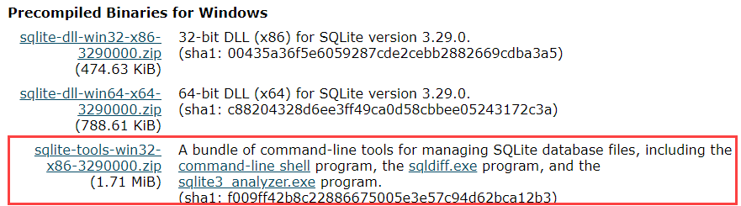

**Run SQLite Tools**

Create a new folder e.g., C:\SQLite

Extract the content of the file that you downloaded to the C:\SQLite folder. You should see three programs in the C:\SQLite folder as shown below:



Open the command line window and navigate to the C:/SQLite folder. Type sqlite3 to enter the tool. Use .help to see all commands and .quit to exit. See illustration below:

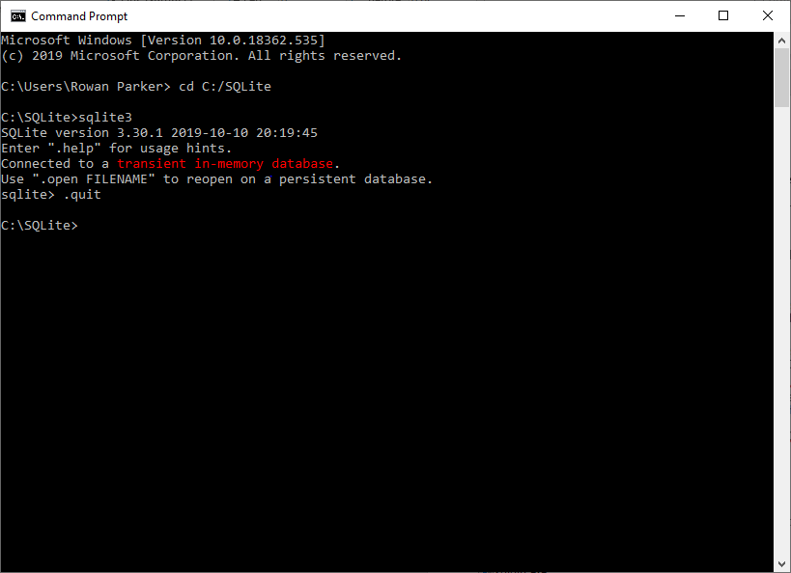

**Download SQLite Studio GUI**

Go to the <https://sqlitestudio.pl/index.rvt> website, open the download page, and navigate to the GitHub release page <https://github.com/pawelsalawa/sqlitestudio/releases>

SQLite Studio is a free program that adds GUI capabilities to SQLite. You need to select an appropriate version to download.

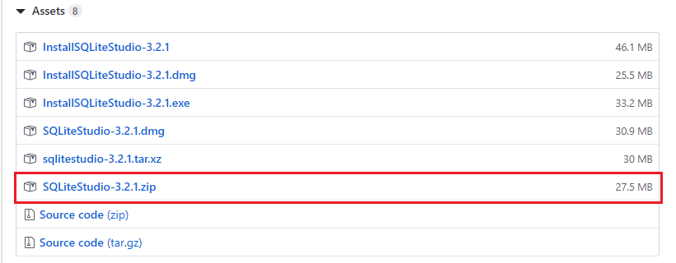

Extract the content of the file that you downloaded to the C:\SQLite folder. You should now see an SQLite Studio folder and the three programs from downloading the SQLite tools:

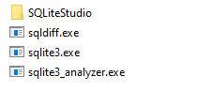

**Run SQLite Studio**

Open the SQLiteStudio folder and scroll down until you find the SQLiteStudio.exe as show below. Click it to run the GUI.

