|  |  |  |
| --- | --- | --- |
| Model 1 Results with Bias 0.5 | | |
| Hidden Nodes (bias = 0.5) | Accuracy on Test Data | Min Training Error |
| 20 | 82% | 0.14 |
| 30 | 85% | 0.11 |
| 35 | 86% | 0.13 |
| 40 | 86% | 0.11 |
| 50 | 87% | 0.11 |
| 60 | 88% | 0.10 |
| 70 | 88% | 0.10 |
| 80 | 88% | 0.10 |
| 90 | 88% | 0.10 |
| 100 | 81% | 0.13 |

|  |  |  |
| --- | --- | --- |
| Model 1 Results with Bias 1 | | |
| Hidden Nodes | Accuracy on Test Data | Min Training Error |
| 60 | 89% | 0.11 |
| 70 | 89% | 0.09 |
| 60 (Normalized) | 96% | 0.01 |
| 70 (Normalized) | 97% | 0.01 |

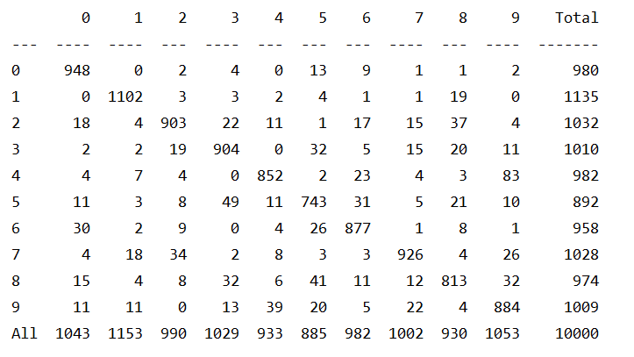

Figure . Confusion Matrix of Model 1 Neural Net with 70 nodes in the hidden layer, bias of 1, and learning rate of 0.01

Figure . Confusion Matrix of Model 1 Neural Net with 70 nodes in the hidden layer, bias of 1, and learning rate of 0.01, but with normalized data.

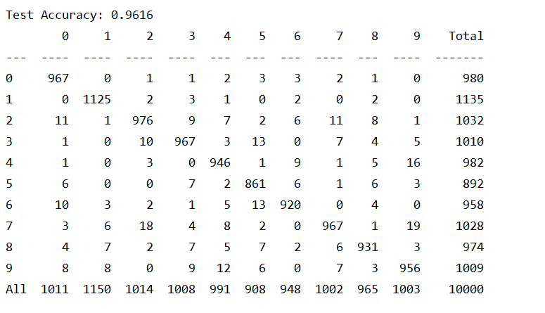

Figure . The tabular data corresponding to the heatmap in Figure 2.

For Model 1, Figure 2:

Precision = TP/(TP+FP)

Recall = TP/(TP+FN)

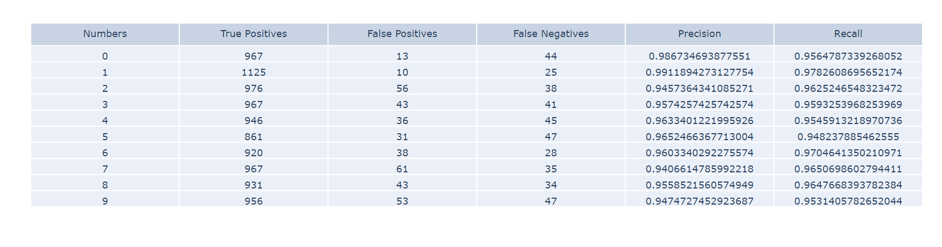

Figure . The calculated Precision and Recall values based on the table in Figure 3.

|  |  |  |
| --- | --- | --- |
| Model 2 Results (Data Unnormalized) | | |
| Hidden Nodes (bias = 1) | Accuracy on Test Data | Test Error |
| 20 | 91% | 0.30 |
| 30 | 91% | 0.29 |
| 40 | 93% | 0.23 |
| 50 | 93% | 0.24 |
| 60 | 94% | 0.21 |
| 70 | 94% | 0.21 |
| 80 | 94% | 0.20 |
| 90 | 94% | 0.21 |
| 100 | 93% | 0.22 |
| 110 | 94% | 0.19 |
| 120 | 94% | 0.28 |

|  |  |  |
| --- | --- | --- |
| Model 2 Results (Data Normalized) | | |
| Hidden Nodes (bias = 1) | Accuracy on Test Data | Test Error |
| 20 | 95% | 0.17 |
| 30 | 96% | 0.13 |
| 40 | 97% | 0.11 |
| 50 | 97% | 0.10 |
| 60 | 97% | 0.10 |
| 70 | 97% | 0.09 |
| 80 | 97% | 0.09 |
| 90 | 97% | 0.09 |
| 100 | 98% | 0.08 |
| 110 | 97% | 0.09 |
| 120 | 97% | 0.08 |

Figure . Confusion Matrix of Model 2 Neural Net with 70 nodes in the hidden layer, and all default options for the Adam optimizer, but with normalized data.

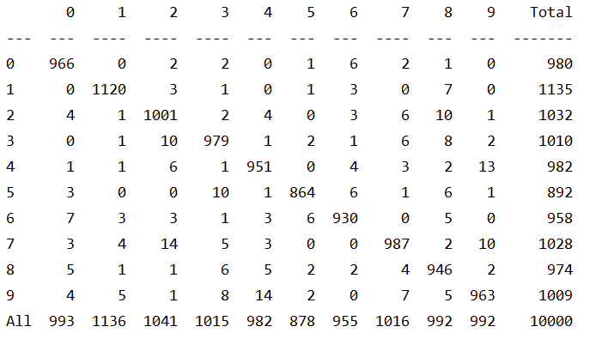

Figure . The tabular data corresponding to the heatmap in Figure 5.

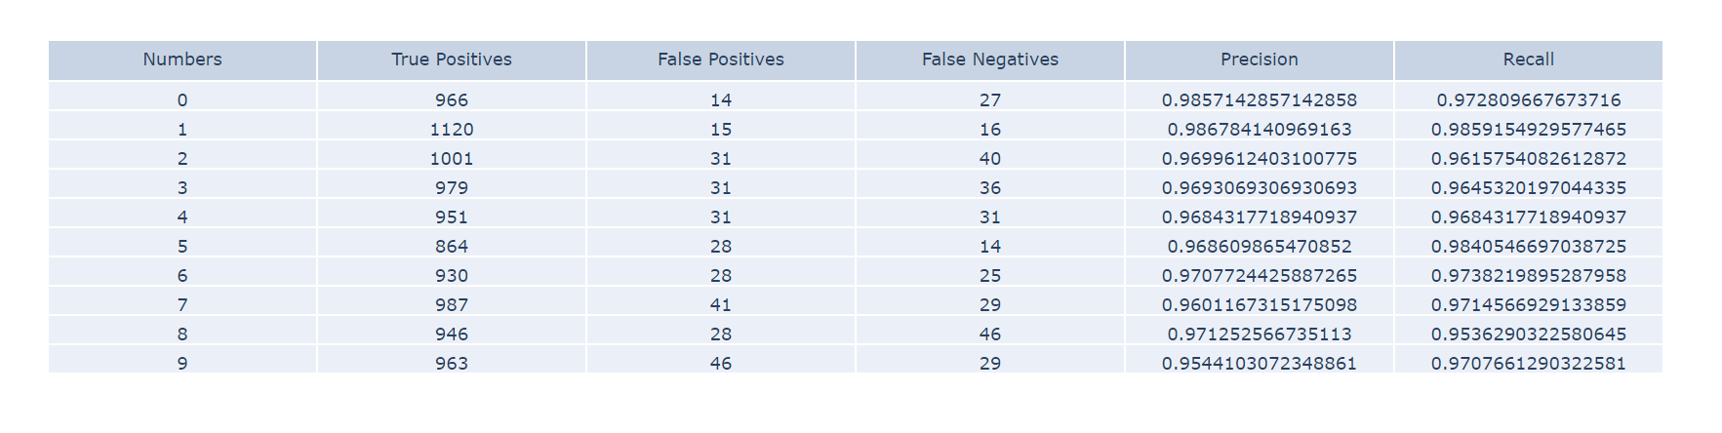

Figure . The calculated Precision and Recall values based on the table in Figure 6.