**create users called itiuser1, itiuser2**

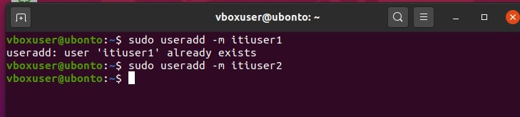

**create group called os_team**



**create directory called os_team_workspace**



**assign os_team group to the directory os_team_workspace and change mode to setgid**

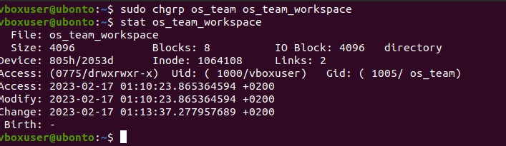

**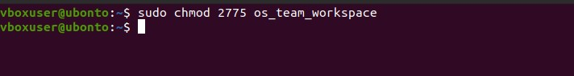  
add users itituser1 and itituser2 to os_team group**



**create directory mydir1 using itiuser1 and mydir2 using itiuser2**

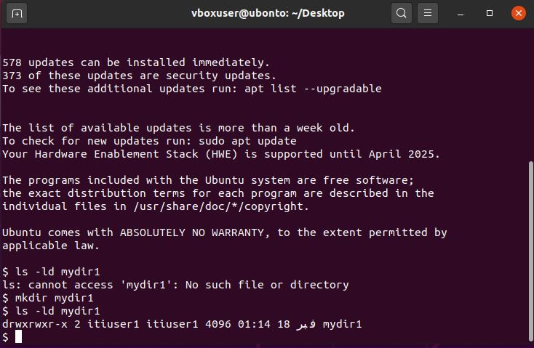

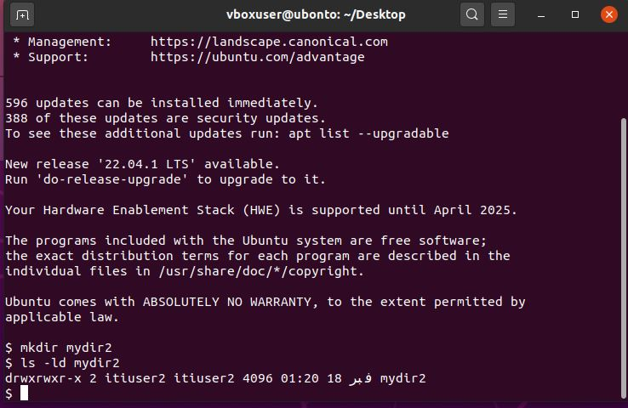

**send screenshot of all processes in tree mod**

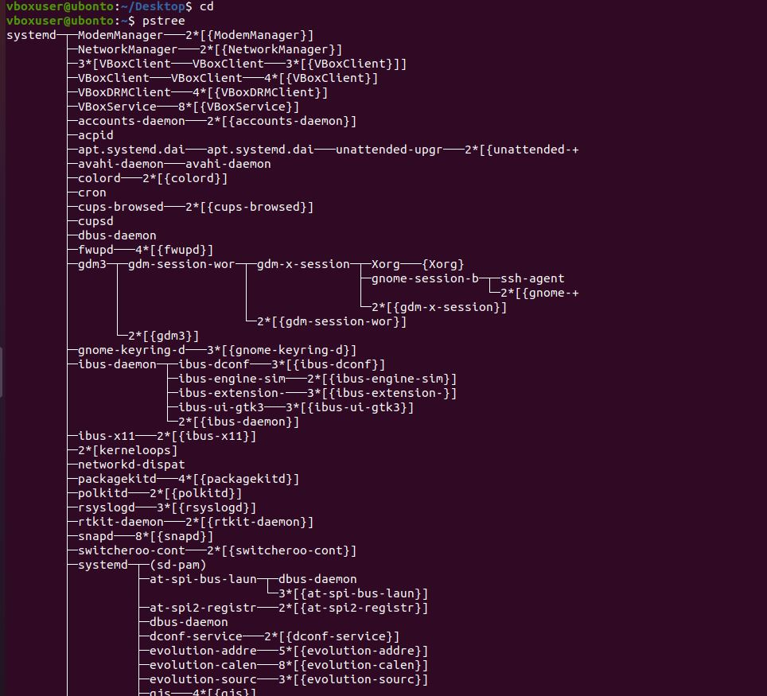

**execute command tail -f /var/log/syslog**

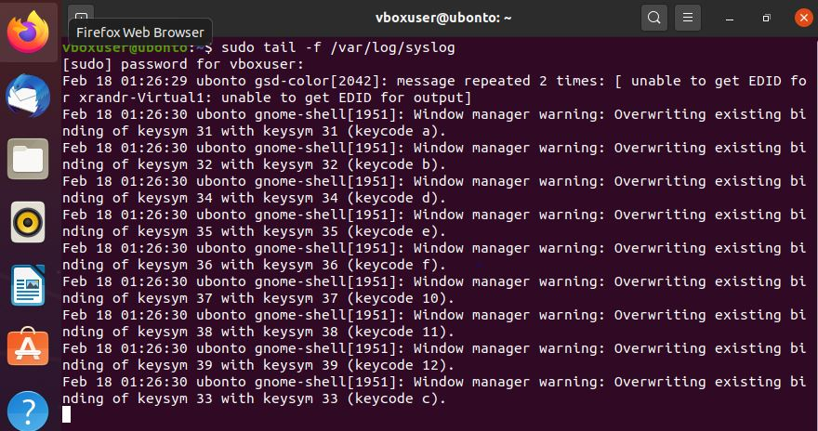

**find the process id PID of tail process then kill it using kill command**

