How to type
with the Naija Type keyboard
This keyboard package contains 2 main keyboards with about 3 ways of typing special characters. I’ll tell you how to install it below, but first let me show you how to use it.

On desktop
Type the base letter then the semicolon key ; one or more times to switch between varying forms of that letter. For example, to type the word
- huɗu type h u d ; u
To do a capital letter, type the capital before you press ;.
After typing a vowel or nasal you can add a tone mark above it by pressing the ` key repeatedly. This cycles through the following symbols: ó ò ô ǒ ō. (I can easily add more options if anyone needs it.)
Similarly you can press shift-~ and this will put the nasal tilde mark above or remove it from the previous letter. So for example, to type the word
- Zɨgwái type shift-z i ; g w a ` i
- shá jɛ̃ anãŋa type s h a ` space j e ; shift-~ space a n a shift-~ n ; a
- A̱gwa̱za̱ type shift-a ; ; g w a ; ; z a ; ;
- ₦ type shift-4 ;
If you have used a ‘deadkey’ system you see this is different – we type then change. This means we always see something change on the screen when we type a key.

On touch screens (Android or iOS)
If you want to type letters then look for a letter that is similar to the one you want, and press and hold on it. More letter symbols will pop up. Without lifting your finger slide to highlight the letter you want to use. Then release.
To type a special capital, press the shift key 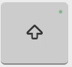 then press and hold, slide and release as with the small letters.
Press the 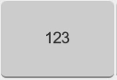 numbers button to show numbers and other symbols.
For extra diacritics type the main letter and then press and hold on the q key at the top left to choose an extra diacritic to add.
There are even more symbols you can find if you go looking.

How to install it
Install Keyman for Android, iOS, Windows or macOS. (See www.keyman.com)
Download the naijatype.kmp file.
- On Windows, double-click this and click Install.
- On Android, open the file with Keyman.
- On iOS, open Keyman then choose Settings, then Install From File and choose the kmp file.
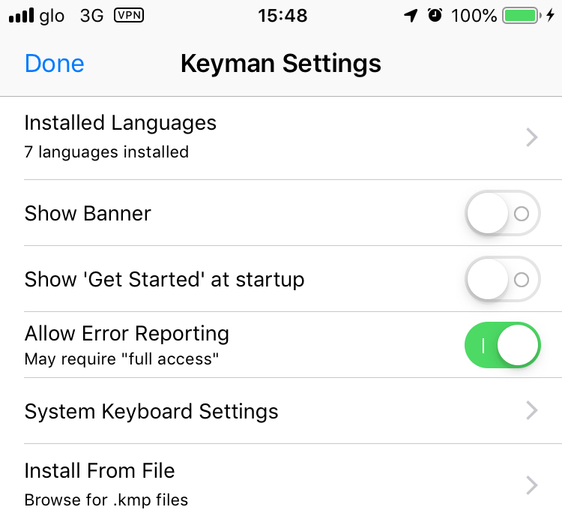

What symbols are included?

Physical keyboard
Here are the symbols that the ; key will cycle through:
direct | a | e | i | o | u | b | c | d | g | h | k | n | s | v | y | z | $
1st ; | ə | ɛ | ɨ | ɔ | ʊ | ɓ | ç | ɗ | ɣ | ɦ | ƙ | ŋ | ʃ | ⱱ | ƴ | ʒ | ₦
2nd ; | a̱ | e̱ | ɪ | o̱ | ʉ |  |  |  |  | ẖ |  | ɲ | s̱ |  |  |  | £
3rd ; | ạ | ẹ | i̱ | ọ | u̱ |  |  |  |  | ḥ |  | ṉ | ṣ |  |  |  | ˈ
4th ; |  |  | ị |  | ụ |  |  |  |  |  |  | ṇ

Unicode characters used:
- Combining tone diacritics are: U+0301, 300, 302, 30C, 304.
- Tilde is U+0303 (Combining tilde)
- Underline is U+0331 (Combining macron below)
- Underdot is U+0323 (Combining dot below)

Touch keyboard
The touch keyboard has several different layers (default, shift, capslock, numbers/symbols and more symbols). In addition each key with a green dot above it pops up some alternative letters or symbols.

The touch screen layers:
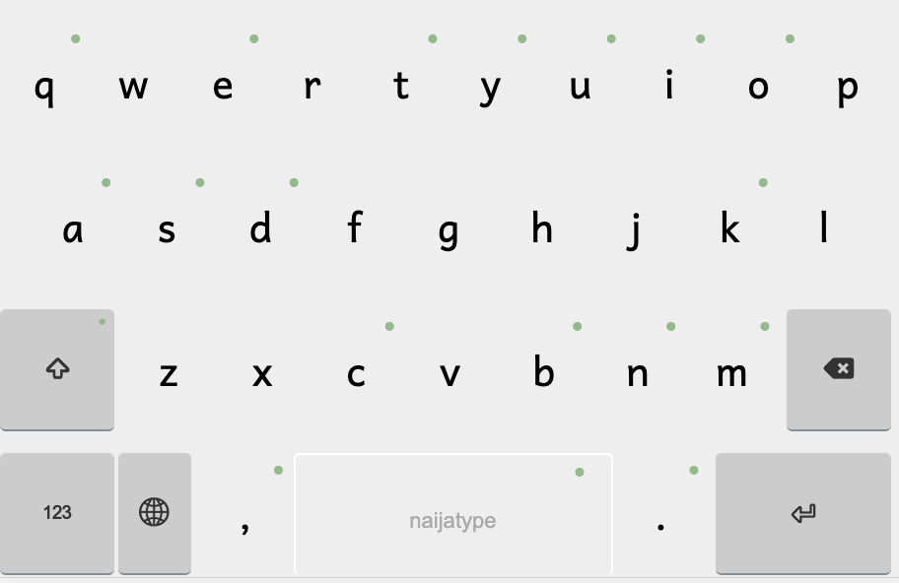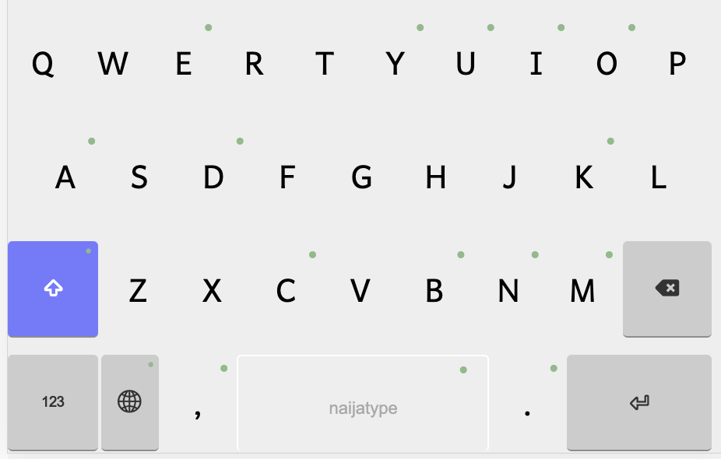
Default layer. See the green popup dots. Shift layer: for capital letters.
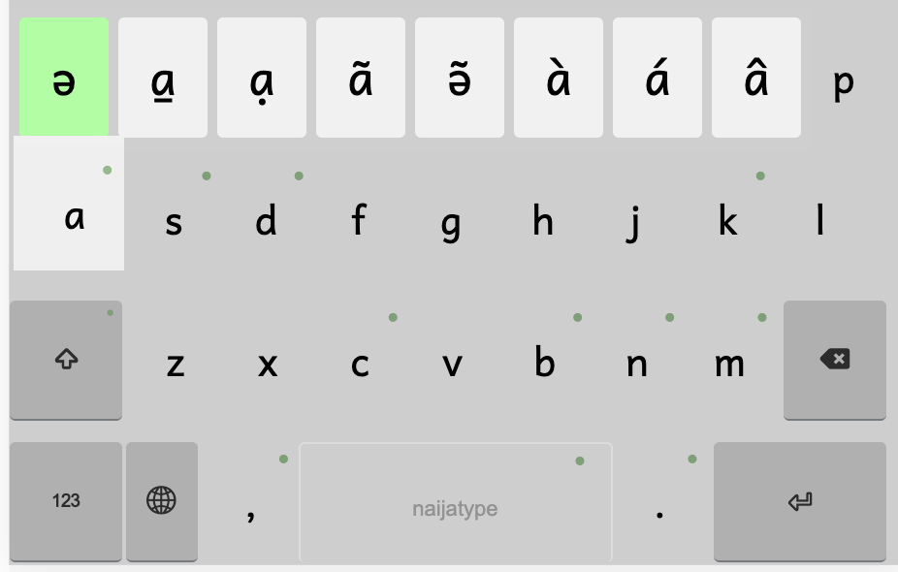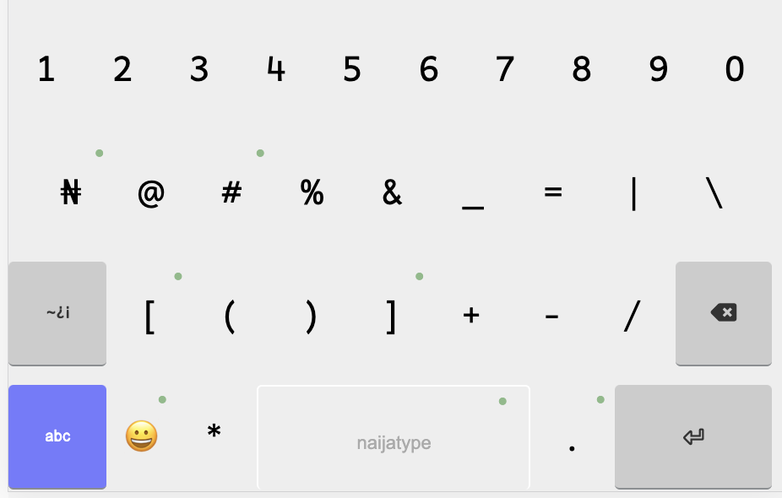
Pressing the a key gives the above options. Above is the numbers and symbols layer.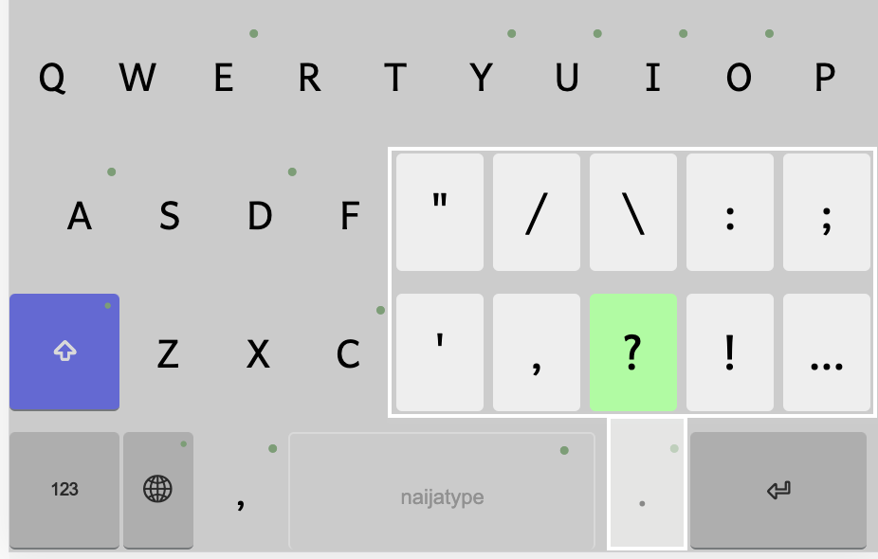
Lots of punctuation is inside the full stop / period and comma keys on either side of the space bar. Even the space bar gives you n dashes and m dashes if you press and hold down.

In the Package
naijatype.kmx and naijatype.kmp
AndikaAfr (Andika with only characters needed in Africa) is included

Official distribution site
http://blog.rowbory.co.uk/linguistics/naija-type/

