Proficiency Testing Statistical Analysis: Rounds 1,2 and 3

Sept 6, 2016

Rowena Crow MD MSPH, Statistical Analyst,

##I. Samples  
Labs participated in 3 rounds of proficiency testing. For each round, 3 separate samples were sent to each of the participating labs. Each labs tested the samples for each of the following measurands: THC, THCA, CBD, CBDA, and CBN.

##II. Statistical Package  
All statistical analyses were completed using the free open source statistical software R and RStudio. To ensure reproducible results, the write up of the statistical analyses were done in RMarkdown, a package within RStudio. Information about the R version and the packages installed for this analysis can be found in section *VIII. R Session Information and References* of this report.

##III. Calculating Total THC (%)

To evaluate variation in conversion of THCA to THC, percent total THC was calculated by adding percent THCA and percent THC. All analyses were done on percent total THC, THC, and THCA. Comparisons were made between the three measures to identify potential variation in the conversion of THCA to THC.

#total THC calculation for every observation  
pt$tot_thc=pt$THC+pt$THCA

##IV. Initial Examination of Results

##Forest Plots of Means and 95% CI for Each Measurand for Each Lab

Laboratory specific distributions were compared between laboratories visually through forest plots of means and 95% CI for total THC, THC, and THCA. Forest plots could not be made for CBD, CBDA, and CBN due to incomplete results. Variations between laboratories were analyzed through a nonparametric Kruskal-Wallis rank sum test to examine potential outliers. If the Kruskal-Wallis test was significant at a *p* value of less or equal to 0.05, differences between the labs were identified using a Dunn’s test with Bonferroni adjusted *p* values to account for multiple comparisons. Adjusted *p* values less than or equal to 0.05 were considered significantly different.

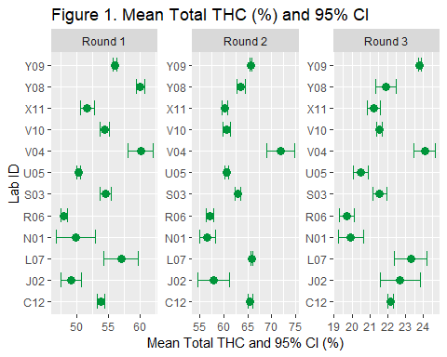

###Summary Statistics

A histogram of all samples from all labs was examined visually for normality and symmetry for each measurand (total THC, THC, THCA, CBDA, and CBN) 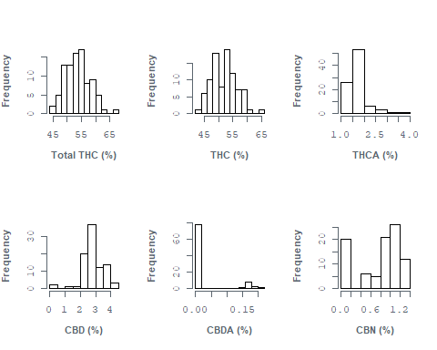

##R Session Information

sessionInfo()

## R version 3.4.2 (2017-09-28)  
## Platform: x86_64-w64-mingw32/x64 (64-bit)  
## Running under: Windows 10 x64 (build 15063)  
##   
## Matrix products: default  
##   
## locale:  
## [1] LC_COLLATE=English_United States.1252   
## [2] LC_CTYPE=English_United States.1252   
## [3] LC_MONETARY=English_United States.1252  
## [4] LC_NUMERIC=C   
## [5] LC_TIME=English_United States.1252   
##   
## attached base packages:  
## [1] stats graphics grDevices utils datasets methods base   
##   
## other attached packages:  
## [1] ggplot2_3.0.0 dplyr_0.7.6 extrafont_0.17 knitr_1.20   
##   
## loaded via a namespace (and not attached):  
## [1] Rcpp_0.12.18 pillar_1.3.0 compiler_3.4.2 plyr_1.8.4   
## [5] bindr_0.1.1 tools_3.4.2 digest_0.6.16 evaluate_0.11   
## [9] tibble_1.4.2 gtable_0.2.0 pkgconfig_2.0.2 rlang_0.2.2   
## [13] yaml_2.2.0 bindrcpp_0.2.2 Rttf2pt1_1.3.7 withr_2.1.2   
## [17] stringr_1.3.1 rprojroot_1.3-2 grid_3.4.2 tidyselect_0.2.4  
## [21] glue_1.3.0 R6_2.2.2 rmarkdown_1.10 purrr_0.2.5   
## [25] extrafontdb_1.0 magrittr_1.5 backports_1.1.2 scales_1.0.0   
## [29] codetools_0.2-15 htmltools_0.3.6 assertthat_0.2.0 colorspace_1.3-2  
## [33] labeling_0.3 stringi_1.1.7 lazyeval_0.2.1 munsell_0.5.0   
## [37] crayon_1.3.4