CYBERSECURITY
Cybersecurity, guided by the CIA Triad (Confidentiality, Integrity, Availability), protects digital assets by ensuring data is accessible only to authorized users (Confidentiality), remains accurate and trustworthy (Integrity), and is reliably available when needed (Availability), forming the foundation for robust security policies against various threats like breaches, corruption, and outages.
The CIA Triad Explained:
- Confidentiality: Prevents unauthorized disclosure of information, ensuring privacy and secrecy.
  - How it works: Encryption, strong access controls (passwords, multi-factor authentication), and physical security.
  - Example: Encrypting patient records so only doctors can read them.
- Integrity: Maintains the accuracy, consistency, and trustworthiness of data, preventing unauthorized changes or destruction.
  - How it works: Hashing, digital signatures, and version control to detect alterations.
  - Example: Using a hash to confirm a downloaded file hasn't been tampered with.
- Availability: Guarantees that authorized users can access information and systems when required, without interruption.
  - How it works: Redundancy, backups, disaster recovery plans, and robust infrastructure.
  - Example: Having backup servers to prevent website downtime during peak traffic.
Different types of Attackers
Attackers, or threat actors, range from individual cybercriminals to state-sponsored groups, categorized by their motivation (financial, political) and methods, including Phishers, Ransomware Operators, Hacktivists, Nation-State Actors, Insider Threats, and general Malware Developers, using tactics like social engineering, DDoS, SQL injection, and exploiting zero-day vulnerabilities to steal data, disrupt services, or gain financial profit.
Cyber Criminals: Motivated by money, using ransomware, fraud, and data theft for profit.
Nation-State Actors: Government-backed groups targeting other nations for espionage or disruption (cyberwarfare).
Hacktivists: Driven by political or social agendas, using vandalism and disruption to promote their cause.
Insider Threats: Current or former employees, contractors, or partners with privileged access, acting maliciously or unintentionally.
Script Kiddies: Inexperienced individuals using pre-written tools to launch attacks, often for notoriety.
Malware Attackers: Deploy viruses, worms, spyware, Trojans, or ransomware to infect systems.
Phishers/Social Engineers: Trick victims (via email, text, phone) into revealing information or clicking malicious links.
DDoS Attackers: Overwhelm servers with traffic to make services unavailable.
SQL Injection Attackers: Exploit web app vulnerabilities to manipulate databases.
Man-in-the-Middle (MitM) Attackers: Intercept communication between two parties.
Common attacks
Common attack surfaces are the digital (web apps, cloud, networks), physical (devices, servers, USB ports), and human/social (phishing, insiders, social engineering) entry points attackers exploit, encompassing vulnerabilities in code, configurations, hardware, and human behavior to gain unauthorized access or data. These surfaces constantly grow with digital adoption, requiring management across all touchpoints, from forgotten cloud assets to employee actions.
Types of Attack Surfaces
Digital Attack Surface: Internet-facing assets and software.
Examples: Websites, APIs, cloud services (SaaS, IaaS), email systems, networks, code, ports, and forgotten subdomains.
Vulnerabilities: Misconfigurations, unpatched software, weak passwords, exposed APIs, poor coding, insecure network perimeters.
Physical Attack Surface: Tangible hardware and devices.
Examples: Servers, laptops, mobile devices, printers, IoT gadgets, routers, USB ports, even improperly discarded hardware.
Vulnerabilities: Unlocked server rooms, unattended workstations, lost/stolen devices, physical access points.
Human/Social Engineering Attack Surface: Exploiting human psychology and behavior.
Examples: Phishing, baiting, pretexting, tailgating, malicious insiders, weak passwords used by people.
Vulnerabilities: Susceptibility to manipulation, revealing sensitive data, falling for scams.
Owasp top 10
OWASP Top 10:2025 (Current)**
The latest OWASP Top 10 focuses on evolving threats and foundational issues:
A01: Broken Access Control
A02: Security Misconfiguration
A03: Software Supply Chain Failures (New/Updated)
A04: Cryptographic Failures (Formerly Sensitive Data Exposure)
A05: Injection (e.g., SQL Injection, Prompt Injection for LLMs)
A06: Insecure Design (New/Updated)
A07: Authentication Failures (Formerly Identification and Authentication Failures)
A08: Software or Data Integrity Failures (New/Updated)
A09: Security Logging and Alerting Failures
A10: Mishandling of Exceptional Conditions (New/Updated)
The OWASP Top 10 is a widely recognized awareness document listing the top 10 most critical web application security risks, compiled by the non-profit Open Web Application Security Project (OWASP) from security expert consensus and real-world data, helping developers prioritize fixing vulnerabilities like Injection, Broken Access Control, and Security Misconfigurations to build safer software. The latest version, OWASP Top 10:2025, highlights emerging threats alongside persistent issues, emphasizing areas like Software Supply Chain Failures and Insecure Design.
Mapping Daily Applications to Attack Surfaces
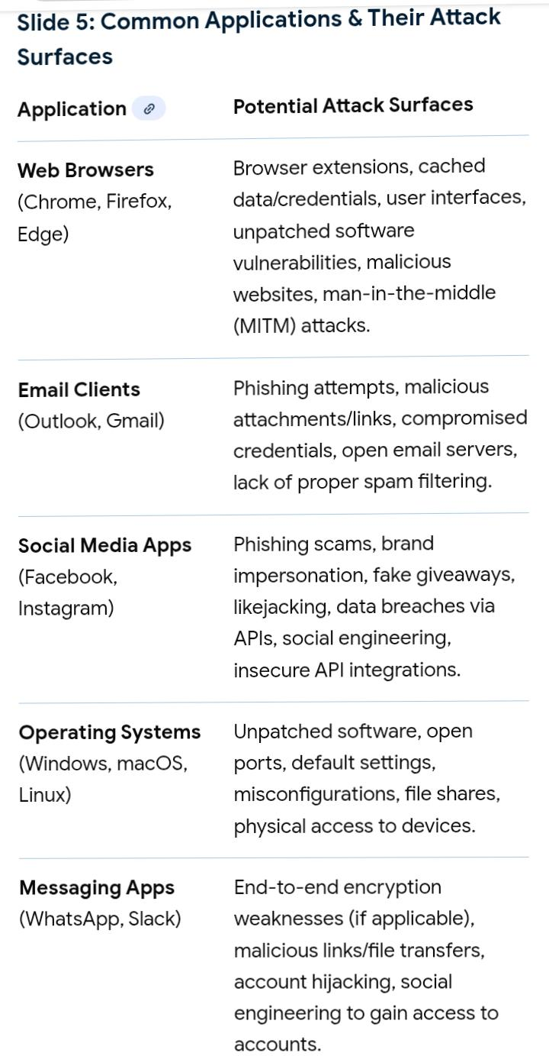
The following table maps common daily used applications to their potential attack surfaces and common attack vectors:
Data flows from a user through an application, server, and database in a request-response cycle: the User initiates an action (e.g., logging in), sending data via the Application (browser/app) as an HTTP request over the network to the Server, which processes the logic, queries the Database, retrieves/stores data, and sends a response (HTML, JSON) back to the Application for the user to see.
In a General Cyber Attack Lifecycle
Attackers follow a process to infiltrate systems, with vulnerabilities at each stage:
Reconnaissance: Information gathering stage, where attackers find weaknesses by monitoring public sources or scanning for open ports.
Weaponization and Delivery: The point where malicious payloads (e.g., malware in an email attachment) are created and sent to the target.
Exploitation: The moment a vulnerability in software or a system is successfully leveraged to gain initial access.
Installation: Attackers install persistent access mechanisms like backdoors or remote access trojans (RATs).
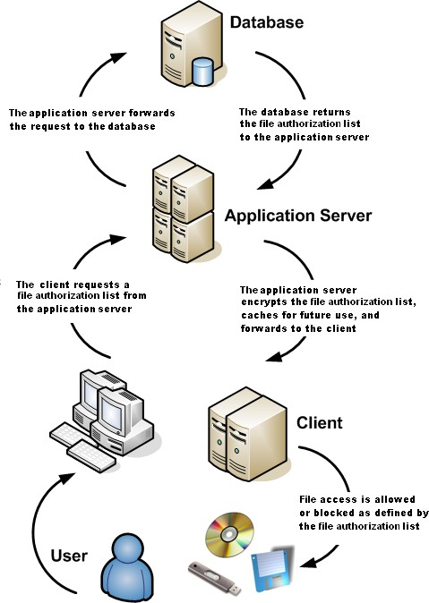
Command and Control (C2): Where the compromised system communicates with the attacker's infrastructure, allowing for control and data exfiltration.
In a Data or Network Communication Flow
Attacks target the mechanisms and pathways of data transfer:
Endpoints/User Devices: Devices (computers, mobile phones, IoT gadgets) can be compromised through malware, unpatched software, or weak credentials, serving as the initial entry point.
Network Access Points: Unsecured Wi-Fi or open network ports can be exploited for unauthorized access or man-in-the-middle attacks.
Communication Channels (In Transit): Data transmitted without sufficient encryption is vulnerable to interception and eavesdropping.
Servers/Databases (At Rest/Processing): Data stored or processed on servers is a target for SQL injection attacks, misconfigurations, or privilege escalation once a network is breached.
Third-Party Integrations: Access provided to vendors or external services can be a critical weak point if their security is not robust (supply chain attacks).

