**AssetONE: DYCI's Campus Asset Management System**

A Capstone Project Presented to the

College of Computer Studies

Dr. Yanga’s Colleges, Inc.

by

Bernardo, Carlo Z.

Castillo, John Marwin L.

Cating, Angela E.

Cruz, Rowell T.

De Guzman, John Reinier A.

October 2025

* + 1. **Introduction**

In the era of digital transformation, information technology continues to redefine how organizations manage operations, optimize resources, and deliver services. Across industries, the adoption of intelligent systems, cloud-based platforms, and data-driven decision-making tools has become the new standard. Educational institutions abroad are integrating AI-powered asset management solutions capable of predictive maintenance, automated depreciation tracking, and real-time utilization analytics. These advancements not only improve operational efficiency but also support long-term planning and sustainability — key priorities for institutions navigating the evolving demands of 21st-century education.

Despite these global trends, many schools in the Philippines, including private institutions, remain heavily dependent on manual and fragmented asset management practices. Spreadsheets, handwritten logs, and siloed records continue to serve as the backbone of asset tracking, leading to recurring operational challenges. Delayed maintenance schedules, asset misplacement, inaccurate records, and inefficient budget utilization are common consequences of this outdated approach. Moreover, existing commercial asset management systems are often too expensive, too complex, or too generic to address the unique operational workflows of local educational environments. This creates a significant research and implementation gap: while intelligent asset management tools exist, they are rarely tailored to the specific needs, budget limitations, and resource constraints of schools in the Philippine context.

Dr. Yanga’s Colleges Inc. (DYCI) faces these challenges firsthand. Its reliance on spreadsheets and informal tracking methods results in inconsistencies in data, delayed repairs, and unnecessary spending on replacement equipment. Faculty and staff often borrow or use devices without proper logging, decreasing accountability and hindering accurate planning. This project seeks to address these persistent issues through the development of AssetONE: DYCI’s Campus Asset Management System, a centralized, web-based platform designed specifically for the institution’s operational requirements. The primary objective of the project is to streamline asset tracking, automate maintenance planning, and enable predictive insights for budgeting and lifecycle management. AssetONE aims to transform DYCI’s approach from reactive problem-solving to proactive, data-driven decision-making, improving resource allocation and institutional efficiency.

The study’s contributions extend beyond digitizing existing processes. AssetONE introduces a comprehensive, user-friendly solution that improves visibility, accountability, and sustainability in campus asset management. It offers features such as real-time dashboards, asset check-in/check-out modules, depreciation tracking using standard accounting methods, predictive maintenance scheduling, and budget forecasting based on usage and lifecycle data. By doing so, the system not only enhances administrative decision-making but also supports the broader mission of DYCI. Aligned with the institution’s core values, AssetONE reflects God-centeredness by stewarding institutional resources responsibly; Magis by striving for operational excellence and continuous improvement; Sapientia by harnessing technology to make informed, data-driven decisions; and Paraya by creating a scalable solution that strengthens institutional service to the community.

Ultimately, this project serves as a blueprint for how educational institutions can bridge the gap between global innovations and local realities through targeted, homegrown solutions. By modernizing DYCI’s asset management practices, AssetONE contributes to a future where campus resources are utilized more effectively, maintenance is proactive rather than reactive, and institutional operations are guided by intelligent, sustainable systems.

**1.1.2 Background of the study**

In recent years, technological innovation has transformed the way organizations manage their resources, operations, and decision-making processes. The emergence of digital platforms, cloud computing, Internet of Things (IoT), and artificial intelligence (AI) has allowed institutions worldwide to transition from manual, paper-based processes to automated, data-driven systems. In the context of asset management, these innovations have resulted in solutions that offer real-time tracking, predictive maintenance, lifecycle cost analysis, and automated depreciation forecasting—capabilities that significantly improve operational efficiency and resource utilization. Universities and organizations in technologically advanced countries have adopted such tools to reduce waste, streamline processes, and make more strategic decisions about asset usage and budgeting.

However, despite these global advancements, many educational institutions in developing countries like the Philippines continue to rely on traditional, manual methods for managing their physical assets. These often include spreadsheets, handwritten logs, and disjointed record-keeping practices that lack integration and real-time visibility. Such methods are not only time-consuming but also prone to human error, leading to frequent issues such as lost or misplaced equipment, delayed maintenance, inaccurate depreciation tracking, and inefficient budget allocation. The result is an operational environment that is reactive rather than proactive—where problems are addressed only after they occur, rather than being anticipated and prevented through data-informed planning.

Dr. Yanga’s Colleges Inc. (DYCI) exemplifies this challenge. Like many private educational institutions, DYCI currently uses a fragmented manual system to track its physical assets, which include IT equipment, laboratory instruments, furniture, and other school resources. This outdated approach leads to inconsistent records, difficulties in retrieving accurate information, and unnecessary expenses caused by premature purchases or overlooked maintenance. Moreover, the absence of a centralized platform means that staff accountability is limited, as assets are often borrowed or transferred without proper documentation. These operational inefficiencies hinder institutional productivity and strain budgetary planning.

Commercially available asset management systems do exist, but they are often designed for large enterprises and may not align with the specific needs, workflows, or budget constraints of educational institutions like DYCI. Many of these solutions are either too costly, overly complex, or insufficiently customizable for a school environment. This gap between available technology and institutional needs highlights the necessity for a tailored solution that can bridge modern digital capabilities with the practical realities of local educational operations.

The conception of this study—AssetONE: DYCI’s Campus Asset Management System—is rooted in this pressing need for modernization. The project aims to address the shortcomings of DYCI’s current asset management practices by introducing a web-based, centralized platform capable of handling the entire asset lifecycle, from acquisition and registration to maintenance and disposal. By integrating features such as predictive maintenance scheduling, automated depreciation computation, real-time asset tracking, and budget forecasting, AssetONE seeks to transform asset management from a reactive, manual process into a proactive, data-driven system.

Furthermore, this project responds not only to an institutional challenge but also to a broader educational and technological context. As schools strive to become more efficient, accountable, and future-ready, the ability to manage resources intelligently becomes a strategic necessity. AssetONE aims to demonstrate how custom-built, locally developed solutions can empower institutions to align with global standards while remaining sensitive to their unique operational realities. Through this innovation, DYCI can enhance administrative efficiency, improve financial stewardship, and ensure

that educational resources are optimally maintained and utilized—directly benefiting students, faculty, and the institution as a whole.

## 1.1.3 Project Context / Rationale

Educational institutions manage a diverse range of physical assets—from IT hardware and laboratory instruments to classroom furniture and specialized equipment—that are essential to their daily operations. At Dr. Yanga’s Colleges Inc. (DYCI), the efficient management of these resources directly impacts teaching quality, administrative workflows, and financial planning. However, current practices within the institution remain largely manual and fragmented. Asset records are often stored in spreadsheets or written logs, asset borrowing is undocumented, and maintenance schedules are reactive rather than planned. These outdated practices result in lost or misallocated assets, budget inefficiencies, frequent operational delays, and unnecessary purchases.

The researchers observed these recurring issues during their engagement with DYCI’s administrative departments, where staff frequently struggled to retrieve accurate asset data or track the status of equipment. In some cases, assets were replaced simply because their location or condition was unknown. These inefficiencies highlight a broader institutional challenge: the absence of a centralized, intelligent asset management platform tailored to the school’s operational context.

The relevance of the project extends beyond DYCI itself. Many private schools and mid-sized educational institutions in the Philippines face similar limitations due to a lack of affordable, context-specific digital tools. By addressing this gap, the project contributes not only to institutional efficiency but also to the larger goal of modernizing school operations within the local educational landscape. The timeliness of the study lies in its response to the growing need for data-driven resource management, which has become essential in sustaining institutional performance in a competitive and rapidly evolving educational environment.

## 1.1.4 Purpose and Description

The primary purpose of this study is to design and develop AssetONE: DYCI’s Campus Asset Management System, a centralized, web-based platform that addresses inefficiencies in the institution’s current asset tracking and maintenance processes. The project aims to replace outdated manual practices with a comprehensive digital solution that enables real-time visibility, predictive insights, and data-driven decision-making.

AssetONE is designed for use by DYCI’s administrative personnel, property custodians, department heads, and other authorized staff members. The system will manage the entire asset lifecycle—from acquisition and registration to monitoring, maintenance, depreciation, and disposal. Key features include:

* Asset Registration & Categorization: Allows users to record detailed asset information such as acquisition date, value, location, and category.
* Check-in/Check-out Module: Tracks borrowing and usage to improve accountability.
* Predictive Maintenance Scheduling: Automates service reminders based on usage and maintenance history.
* Depreciation Tracking & Budget Forecasting: Calculates asset value over time and projects future replacement or repair costs.
* Real-time Dashboards & Reports: Provide actionable insights for strategic decision-making.

Through these functionalities, AssetONE aims to transform DYCI’s asset management into a proactive, analytics-driven process that supports operational efficiency and institutional sustainability.

## 1.1.5 Statement of the Problem

### General Problem

Dr. Yanga’s Colleges Inc. currently faces significant inefficiencies in asset management due to its reliance on manual, fragmented record-keeping methods. This results in lost assets, delayed maintenance, inaccurate depreciation tracking, and poor budget allocation, all of which hinder the institution’s operational effectiveness and resource planning.

### Specific Problems

1. How can a centralized system improve the accuracy and accessibility of asset records compared to traditional manual methods?
2. How can the system implement predictive maintenance to minimize downtime and extend asset lifespan?
3. In what ways can automated depreciation tracking support better budgeting and financial planning?
4. How can the system improve accountability among staff and departments through asset check-in/check-out functionality?
5. What features can provide real-time insights and reports to support strategic decision-making by administrators?

## 1.1.6 Objectives of the Study

### General Objective

To design and develop AssetONE: DYCI’s Campus Asset Management System, a web-based platform that centralizes asset tracking, predictive maintenance, depreciation computation, and budget forecasting to improve institutional efficiency and decision-making.

### Specific Objectives

* To develop a centralized database for accurate and organized asset registration, categorization, and retrieval.
* To implement a check-in/check-out module that enhances asset accountability and usage tracking.
* To automate depreciation calculations and integrate them into budget forecasting tools.
* To integrate predictive maintenance scheduling based on usage patterns and historical data.
* To design real-time dashboards and reporting tools that support informed decision-making.
* To ensure the system is user-friendly and adaptable to DYCI’s existing workflows.

## 1.1.7 Scope and Delimitation

### Scope

The study focuses on the design and development of AssetONE, a web-based asset management system for Dr. Yanga’s Colleges Inc. The system will include features such as asset registration, categorization, check-in/check-out tracking, predictive maintenance scheduling, depreciation tracking, budget forecasting, and reporting. It will provide real-time dashboards, role-based access control, and QR code scanning for asset inquiries. The primary users will include administrators, property custodians, and department heads.

### Delimitation

The project does not include integration with third-party enterprise resource planning (ERP) systems, cloud-based IoT tracking devices, or mobile application development beyond browser access. It will also not cover advanced financial forecasting beyond depreciation-based projections. The system is designed specifically for DYCI’s internal use and may require customization for deployment in other institutions.

## 1.1.8 Significance of the Study

The development of **AssetONE** holds significant value for various stakeholders:

* Institution (DYCI): Enables more efficient resource management, reduces unnecessary expenditures, and enhances decision-making.
* Administrators and Staff: Streamlines workflows, improves accountability, and provides data-driven insights for planning and budgeting.
* Students and Faculty: Ensures that educational tools, equipment, and facilities are well-maintained, readily available, and reliable.
* IT Industry: Demonstrates the potential of tailored asset management solutions within the education sector, contributing to best practices in system development.
* Community and Other Schools: Serves as a replicable model that can inspire similar innovations in other educational institutions facing comparable challenges.

By delivering a cost-effective, institution-specific solution, the project contributes to sustainable institutional growth and the broader modernization of campus operations.

## 1.1.9 Definition of Terms

* **Asset Management System:** A software solution designed to track, monitor, and manage physical assets throughout their lifecycle.
* **Predictive Maintenance:** A maintenance strategy that uses historical data and usage patterns to anticipate when equipment will require servicing.
* **Depreciation:** The gradual decrease in an asset’s value over time due to usage, wear and tear, or obsolescence.
* **Check-in/Check-out Module:** A system feature that records the borrowing and returning of assets to maintain accountability.
* **Dashboard:** A visual interface that displays key metrics, analytics, and summaries of system data for decision-making.
* **QR Code Scanning:** A quick-access feature that allows users to retrieve asset information by scanning a code with a device.
* **Lifecycle Cost Analysis:** A financial assessment of the total cost of owning an asset, including acquisition, operation, maintenance, and disposal.

**Chapter II: Review of Related Literature and Studies**

## 2.1.1 Related Literature

## Foreign Literature

Lyberius and De La Cruz (2024), in their work on Narrowband-IoT and IoT applications in educational institutions, discussed how connected systems can optimize asset tracking, monitoring, and operational safety in university campuses. Their analysis highlights the efficiency gains of real-time asset visibility through technology. While AssetONE does not adopt IoT, its cloud-based platform and QR code integration serve the same purpose of improving accountability and data accuracy.

Fernández-Batanero et al. (2024) examined the adoption of IoT in higher education and identified both opportunities and challenges in its implementation. They emphasized how digital platforms enhance asset utilization monitoring and institutional efficiency, while cautioning against high costs and technical requirements. AssetONE resonates with their findings by presenting a cost-effective, scalable digital solution for asset management without requiring advanced infrastructure.

Ruiz-Rosero et al. (2023) presented a framework for asset ownership transfer and inventory using RFID tags and blockchain-based verification. Their study underscored the role of secure, immutable records in ensuring accountability. Although AssetONE does not employ blockchain or RFID, it aligns with the same principle of transparency through QR-based verification of assets.

Zhang and Wu (2023) explored service-based university asset management systems, stressing the importance of centralization, regulation, and automated reporting to address inefficiencies. Their findings point to the same institutional challenges that AssetONE seeks to resolve by providing a cloud-driven platform with predictive maintenance and automated reporting features.

Purnawan and Aldy (2025) conducted a systematic literature review on asset management systems for educational institutions, identifying global trends such as IoT, BIM, and digital twin technologies. They noted, however, that practical and resource-sensitive approaches—such as cloud and QR-based systems—remain the most suitable for institutions with limited budgets. This supports AssetONE’s strategy of adopting accessible digital solutions while maintaining strong accountability features.

**Local Literature**

Ahmad (2023) introduced the e-AIMSS (Electronic Asset Inventory and Management System in School), which demonstrated how digitized inventory tracking enhances accountability and efficiency in Philippine schools. The system’s impact reinforces AssetONE’s emphasis on centralized digital records and streamlined reporting functions.

Tagud et al. (2024) developed a geospatial asset management system for higher education institutions that integrated mapping technology for asset tracking. Their study illustrated how visual tools can aid administrators in locating and managing resources. While AssetONE does not use geospatial mapping, its QR-based traceability mirrors the same goal of location-specific asset accountability.

Accad et al. (2023) proposed an integrated inventory management and asset tracking system with a user-friendly kiosk interface. Their focus on usability and user access aligns with AssetONE’s goal of providing a straightforward yet efficient platform, particularly through its mobile application and QR code features.

Gumilao (2024) designed an automated inventory management system for a Department of Education regional office. The system minimized manual errors and improved reporting timeliness, which mirrors AssetONE’s objective of accuracy and automation within a higher education context.

Soliveres et al. (2024) analyzed inventory management practices of small-scale pharmacies in Cavite, revealing common issues of manual errors, accountability gaps, and inefficiencies in resource use. Although their study was industry-specific, the insights are transferable to academic asset management, supporting AssetONE’s approach of addressing the same inefficiencies through digital solutions.

**2.1.2 Related Studies**

**Foreign Studies**

Naqvi and Rizvi (2021), in their study *Digital Asset Management in Higher Education: A Strategic Imperative*, emphasized the importance of shifting from manual asset tracking to digital systems to improve efficiency and accountability. Their findings underscore the same issues of fragmented records and poor budgeting that AssetONE seeks to address.

Kasa et al. (2023), in *Cloud-Based Asset Management System in Education Sector: A Study of Usability and Performance*, investigated the impact of cloud-based systems in educational institutions. They reported that such platforms improve data accuracy and maintenance scheduling, supporting AssetONE’s approach to real-time asset visibility.

Adejo et al. (2024), in *A Smart Asset Management System for Tertiary Institutions: Design and Implementation Using IoT and Cloud Technologies*, proposed integrating IoT with cloud technologies to enhance tracking and maintenance. Although AssetONE does not employ IoT, it aligns with the study’s principles through cloud integration and QR-based tracking.

Smith and Johnson (2024), in *Enhancing Asset Management in Educational Institutions through Digital Transformation*, highlighted how digital platforms reduce inefficiencies caused by manual systems. Their recommendation of automated maintenance and real-time tracking corresponds to AssetONE’s predictive maintenance and QR code features.

Davis and Lee (2024), in *Optimizing Asset Management in Educational Institutions through Cloud-Based Solutions*, focused on the benefits of centralized data and automated alerts. Their findings reinforce the direction of AssetONE’s cloud-based system for improving institutional operations.

**Local Studies**

Dela Cruz et al. (2024) developed a Property Monitoring System for Apayao State College – Luna Campus that utilized QR code identifiers to track asset transfers, custodianship, and locations. The system also generated automated reports for easier property accountability and was evaluated using ISO 25010 standards, which validated its functionality, reliability, and usability.

Castro et al. (2023) introduced the e-AIMSS (Electronic Asset Inventory and Management System in School), which aimed to optimize resource use and improve organizational productivity in a Philippine academic institution. Their findings showed that digitized inventory systems significantly enhanced accountability, reduced delays in reporting, and supported effective resource planning.

Manalo et al. (2024) designed a blockchain-based Procurement and Asset Management System that incorporated QR codes to improve transparency and security in procurement processes. Their study emphasized tamper-proof data storage and verifiable asset transactions. While AssetONE does not use blockchain, it mirrors this study in focusing on procurement accountability, vendor management, and QR code–based verification.

Villanueva and Ramos (2023) developed a Records Tracking Management System using QR codes to streamline file movement and auditing in a local university. Their findings showed improved traceability, reduced errors, and positive feedback from users regarding ease of use.

Gonzales et al. (2023) conducted a study on the enhancement of inventory management systems in State Universities and Colleges (SUCs) in Mountain Province. Their research identified inefficiencies in manual inventory tracking and recommended the adoption of digital systems to improve accountability and reporting.

### 2.1.3 Synthesis and Research Gap

Both foreign and local works highlight the same core issue: manual asset management causes inefficiency, errors, and accountability gaps. Foreign studies often push advanced technologies like IoT, blockchain, and BIM, while local ones focus on practical systems using QR codes and centralized inventories. Despite these differences, all agree that digital platforms improve transparency, reporting, and operational efficiency.

The gap lies in creating an integrated, cost-effective, and scalable solution designed for higher education in the Philippines. Existing systems are either too advanced and resource-heavy to implement, or too limited in scope, focusing only on inventory or reporting. Few address predictive maintenance, lifecycle cost analysis, and mobile accessibility for both administrators and student users.

AssetONE bridges this gap by combining accessibility and innovation. Unlike foreign studies that rely on costly infrastructures, or local systems that remain fragmented, AssetONE integrates multiple features such as cloud-based data management, QR-enabled verification, predictive maintenance, and lifecycle cost analysis, into a single platform tailored for schools. This makes it both practical for local institutions and aligned with global best practices in asset management.

## Chapter III: Methodology and System Design

### 3.1 Research Design

This study employed a Hybrid System Development Life Cycle (SDLC) model, combining the structured phases of the Waterfall approach with iterative feedback loops. The Hybrid model was selected to ensure systematic planning and design while accommodating feedback during development. Since the project was developmental in nature, this approach allowed for sequential progress with room for adjustments based on alignment activities and client validation.

To support accurate requirement definition, the researchers first conducted preliminary alignment with knowledgeable individuals such as technicians, the student governor, property custodians, and an academic adviser familiar with asset operations. These informal consultations were not treated as formal data-gathering activities but served to validate assumptions, refine the system scope, and confirm the flow of asset reporting. The official data gathering was then carried out through structured surveys with the General Services Office (GSO) officer, the designated client and primary stakeholder, to formally capture requirements and expectations.

### 3.2 Respondents and Setting of the Study

The study involved two types of inputs:

1. Knowledgeable individuals (informal consultations): Technicians, the student governor, property custodians, and a course adviser provided insights into asset workflows and distinctions between custodial roles. Their contributions were considered part of preliminary alignment only and not treated as official research data.
2. Official respondent (formal survey): The GSO officer, who oversees the school’s asset management and serves as the primary stakeholder, was the formal respondent. Structured surveys were used to capture official requirements and feedback from the client’s perspective.

The study was conducted within the setting of the school campus, specifically focusing on the General Services Office, where asset management operations are centralized.

### 3.3 Data Gathering Procedures

The data gathering process was divided into two stages:

**Preliminary Alignment (informal):** Before formal data collection, the researchers prepared a checklist and conducted brief consultations with knowledgeable individuals. These included technicians who handle asset movement, property custodians and the student governor who manage departmental reports, as well as a course adviser who clarified custodial responsibilities. The purpose was to confirm the workflow of reporting, validate system assumptions, and refine the survey design. Since this stage was exploratory and informal, it was not included in the official research dataset.

**Official Data Gathering (formal):** After preliminary alignment, the researchers administered a structured survey, with the GSO director serving as the primary respondent. The survey provided the main data source for defining system requirements and expectations. This ensured that the developed system addressed the client’s needs accurately and established a reliable basis for subsequent validation.

**Post-development validation** with the GSO director is also planned to ensure alignment between the finished system and the intended operational requirements.

**3.4 Statistical Treatment of Data and Data Analysis**

The collected data were organized and analyzed to evaluate the system’s effectiveness and level of user acceptance. Descriptive statistics such as frequency, percentage, mean, and standard deviation were applied to survey responses in order to measure user satisfaction, functionality, and usability of the system. Likert-scale responses were summarized and interpreted to determine the overall level of acceptance. In addition, qualitative feedback obtained from interviews and open-ended survey responses was organized and thematically analyzed to identify recurring issues, challenges, and suggestions for improvement. This combination of quantitative and qualitative analysis ensured that both numerical trends and user perspectives were considered in evaluating the system.

**3.5 Project Development Model**

This study adopted a Hybrid Systems Development Life Cycle (SDLC) model, which combines the structured phases of the traditional Waterfall approach with iterative feedback mechanisms. The linear sequence ensured systematic planning, requirements analysis, and documentation, while the iterative loop allowed adjustments during development to address emerging issues and stakeholder inputs.

The phases included: (1) Requirements Analysis and Planning, (2) System Design, (3) Implementation, (4) Testing and Integration, (5) Deployment, and (6) Maintenance and Refinement. Unlike a purely sequential Waterfall, the model incorporated a feedback loop from the Implementation phase back to Requirements Analysis, enabling refinement when system assumptions or functionalities required revision.

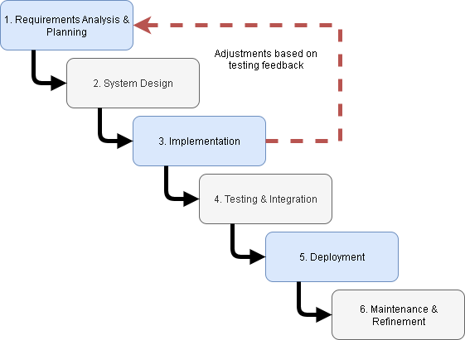

*Figure X. Hybrid SDLC Model employed in the study, combining the structured phases of the Waterfall approach with iterative feedback loops to refine requirements and functionalities during development.*

**3.6.1 Hardware Requirements**

* **Server Infrastructure** – Cloud-based hosting provided via Render, which handles server resources (scalability, uptime, storage, and processing).
* **Client Workstations**: Intel Core i3 or higher, 4GB RAM, modern web browser (Chrome, Edge, Firefox).
* **Mobile Devices**: Android or iOS smartphones with camera support for QR code scanning and internet access.

**3.6.2 Software Requirements**

* **Operating System**: Windows 10/11 for development; cross-platform browser compatibility for deployment.
* **Backend**: Node.js with Express.js framework.
* **Database Management System**: PostgreSQL.
* **Frontend**: React.js with Tailwind CSS for styling.
* **Other Tools/Libraries**: QR code generator and scanner libraries, Chart.js/Recharts for dashboards, and Git for version control.

**3.6.3 Functional Requirements**

* Asset registration, categorization, and tracking.
* Depreciation management using straight-line and declining balance methods.
* Life Cycle Cost Analysis to capture total cost of ownership.
* Predictive Maintenance with trend-based scheduling.
* Asset Utilization Heatmap for visual analysis.
* QR Code generation and inquiry for individual assets and locations.
* User roles and permissions for system administrators, department head, and department officers.
* Request and schedule management with automated assignment of assets.
* Report generation for inventory, maintenance, and procurement process.

**3.6.4 Non-Functional Requirements**

* **Usability**: The system must provide a user-friendly interface with minimal training required.
* **Performance**: System response time should not exceed 2 seconds under normal usage.
* **Security**: Role-based access control and encrypted data storage must be implemented.
* **Scalability**: The system must support expansion for additional users and assets.
* **Reliability**: Daily backup of the database to prevent data loss and ensure recovery.
* **Maintainability**: Modular codebase to allow updates and refinements without disrupting operations.

### 3.7 Technical Background

The development of AssetONE utilized modern web technologies and cloud services to ensure scalability, reliability, and ease of access. The choice of tools and platforms was guided by their compatibility, performance, and suitability for asset management applications.

* **Programming Languages**
  + **JavaScript** – Used both in frontend and backend for a unified development environment. Its asynchronous nature supports responsive and real-time features.
  + **Node.js** – Chosen for the backend because of its event-driven, non-blocking I/O model, which provides efficient performance in handling multiple concurrent requests.
* **Frameworks and Libraries**
  + **React.js** – Selected for the frontend due to its component-based architecture, allowing reusable UI components and efficient rendering.
  + **Tailwind CSS** – Implemented for styling to ensure responsive, modern, and customizable design without bloated CSS.
  + **shadcn/ui** – Used for prebuilt, accessible, and production-ready components that accelerate UI development.
  + **Express.js** – Adopted as the backend framework for its simplicity, flexibility, and seamless integration with Node.js.
* **Database Technology**
  + **PostgreSQL**– Chosen as the relational database management system (RDBMS) for its reliability, structured data handling, and strong community support. It is well-suited for managing interrelated asset, user, and scheduling records.
* **APIs and Services**
  + **QR Code Integration** – Implemented using standard JavaScript libraries to generate and scan codes, enabling quick retrieval of asset information.
  + **Render Cloud Hosting** – Selected as the deployment platform for its automated scaling, HTTPS by default, and simplified DevOps management.
  + **Cloud-based PostgreSQL Provider** – Utilized for database hosting, ensuring high availability and reducing on-site maintenance requirements.
* **Development Tools**
  + **Git & GitHub** – Used for version control and collaborative development.
  + **Visual Studio Code** – Chosen as the main integrated development environment (IDE) for its extensive extensions and debugging tools.

### 3.8 System Architecture / Conceptual Framework

This study is anchored on a system-oriented conceptual framework that emphasizes the logical flow of information through three interconnected stages: input, process, and output. It illustrates how AssetONE, the proposed Campus Asset Management System, functions holistically to support effective asset management, maintenance operations, and data-driven decision-making in an academic institution.

The input phase serves as the foundation of the system, where various types of data are captured and recorded. These include asset data such as identification numbers, descriptions, and categories; maintenance requests submitted by users to report asset-related issues; and user credentials that define the access level and roles of system users. In addition to this, the system gathers usage logs to track how assets are utilized across time and space, as well as maintenance history which provides a detailed record of previous repairs, services, and operational issues. All these inputs are essential for driving the system’s core functionalities and ensuring that each asset is accurately represented and monitored within the platform.

Moving forward, the process phase encapsulates the intelligent operations that transform raw data into structured, actionable information. The system first handles asset registration and categorization to organize resources by type, department, or use case. It also applies user management and access control mechanisms to maintain data integrity and security by assigning permissions based on roles. Maintenance scheduling and tracking modules ensure that assets are serviced regularly and efficiently, while QR code generation and scanning features allow for fast, mobile-friendly asset identification and reporting. The process stage also includes alerts and notifications to proactively inform users of upcoming tasks, issues, or maintenance needs. It further integrates a reporting engine to summarize key events, dashboard analytics for visual monitoring, and advanced modules such as maintenance prediction and depreciation calculations. These features allow the system to anticipate future maintenance demands and evaluate the declining value of assets over time. Additionally, life cycle cost analysis provides a comprehensive view of total ownership costs, helping in budget planning, while continuous monitoring of asset usage offers insights into operational patterns and resource optimization.

Finally, the output phase presents the end results of the system’s internal processes, delivering data in a form that is useful for administrative and strategic purposes. Administrators gain access to real-time dashboards that offer a consolidated view of the entire asset ecosystem. The system also produces maintenance reports and logs that document work completed, asset condition, and operational trends. Automated notifications ensure that users remain informed without requiring manual follow-up. Furthermore, QR code labels can be generated and attached to physical assets, simplifying identification and tracking across campus. Budget forecast reports emerge from the system's analytical capabilities, supporting more informed financial planning and resource allocation. This framework supports the proposed system’s goal of enhancing asset transparency, maximizing lifecycle value, and minimizing manual inefficiencies through the integration of data-driven automation and user-centric design.

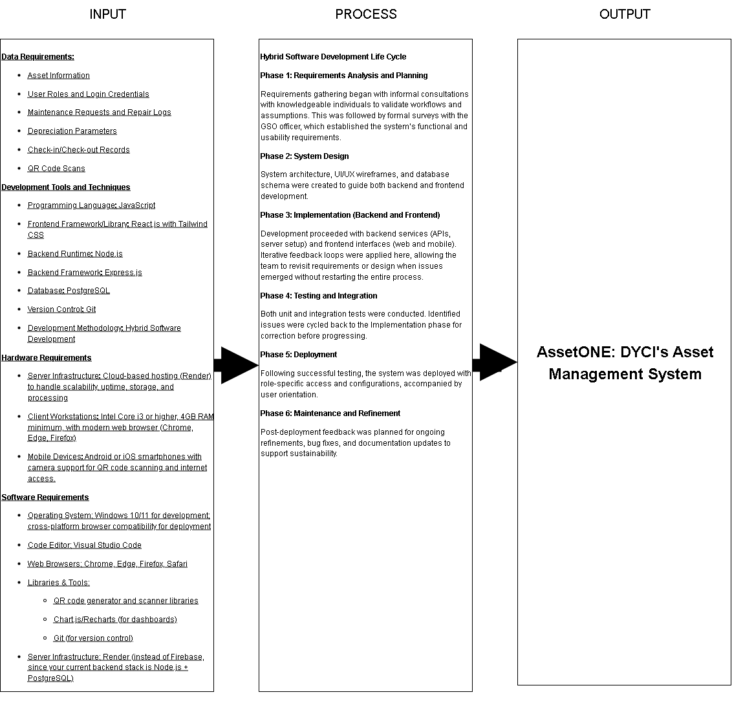

### 3.9 Data Flow Diagram / Use Case Diagram / ERD

* **DFD:** Shows the flow of data from reporting, scheduling, asset updating, and report generation.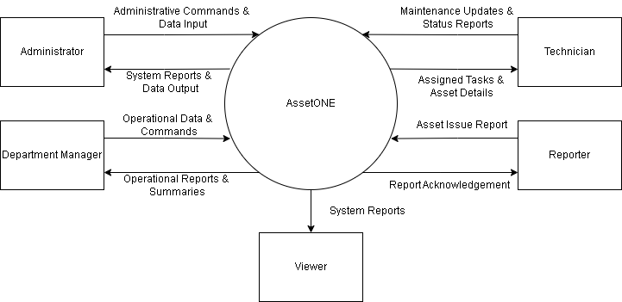
* **ERD:** Defines relationships among tables such as users, assets, requests, vendors, and departments. 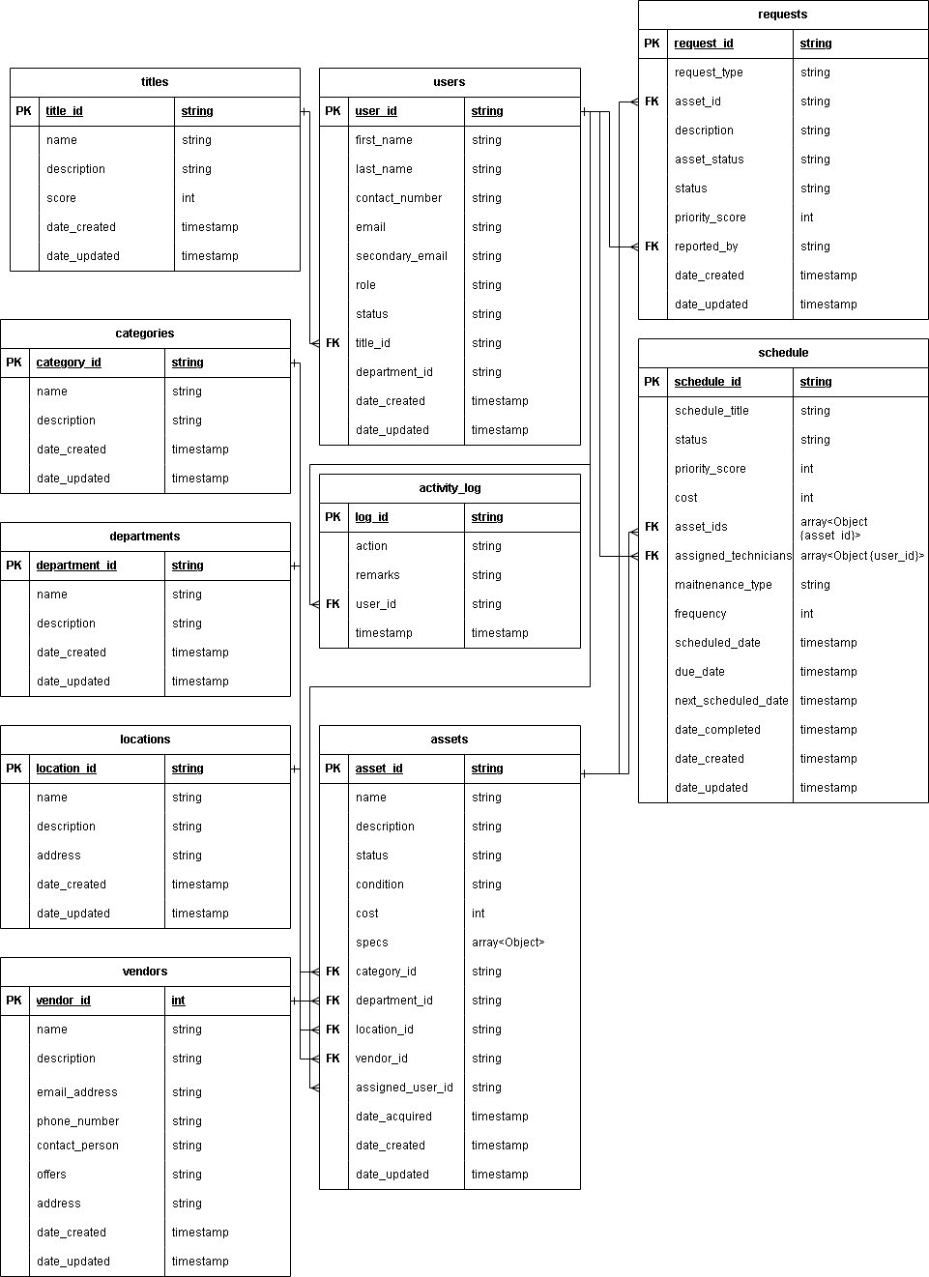

### 3.10 System Design and Features

* Screen Layouts: Responsive dashboards for admins, request submission pages for reporters, and maintenance schedules for technicians.
* Modules: Asset management, user management, request handling, reporting, and analytics.
* Key Features:QR code scanning, predictive maintenance, and audit logging.

### 3.11 Testing Procedures

The system underwent multiple levels of testing to ensure functionality, reliability, and usability. Unit testing was conducted on individual modules to verify correct behavior, such as asset tracking, preventive maintenance, and QR code scanning. Integration testing ensured that these modules worked together seamlessly, allowing updates in one module to reflect across the system. User Acceptance Testing (UAT) was carried out with the GSO officer and selected end-users to validate that AssetONE met operational requirements and expectations. Feedback from UAT will guide iterative refinements prior to full deployment.

### 3.12 Implementation Plan

The implementation of AssetONE will follow a structured approach to ensure smooth adoption by the intended users. AssetONE is a web-based system and will be accessible through web browsers. The system can be hosted either on a school-owned server or a cloud-based platform such as Render.com, depending on the school’s IT infrastructure and final integration requirements. User accounts, roles, and permissions will be configured to ensure secure and appropriate access for all staff members. Following the hosting setup, end-users will undergo training sessions covering all key functionalities, including QR code scanning, asset check-in/check-out, preventive maintenance scheduling, and report generation. Training materials, such as quick reference guides and user manuals, will be provided to support effective learning. Deployment will be conducted in phases, beginning with a pilot implementation for a small group of users to validate system functionality, workflow integration, and usability. After the pilot is successfully evaluated, full deployment will extend to all relevant offices and departments managing assets. Post-deployment support will include troubleshooting, user guidance, and iterative refinements based on feedback. Routine maintenance, performance monitoring, and system updates will ensure that AssetONE remains reliable, efficient, and sustainable for long-term use.

### 3.13 Ethical Considerations

All respondents participated voluntarily after being informed about the purpose of the study and how their input would be used to develop AssetONE. Survey responses and interview notes were kept confidential, stored securely, and used solely for academic purposes. Personal identifiers were not linked to system data, ensuring privacy and anonymity. Data collection was conducted at convenient times to minimize disruption to participants’ regular duties. These measures ensured that the study respected the rights of participants and avoided any form of harm or bias.