Spatio-temporal associations of public negative emotions and social disorder behaviors across multiple natural hazards

Abstract
Natural hazards generate not only physical disruption but also collective emotional and behavioral responses, yet how these responses vary across hazard types remains poorly understood. Here, we integrate natural-language processing of social media data with a latent spatio-temporal autoregressive model to quantify associations between public negative emotions and social disorder behaviors across earthquakes, typhoons, landslides, and debris flows. Using 406,419 post observations from 117 hazard events in China (2022–2024), we find that negative emotions and social disorder behaviors show positive contemporaneous associations across hazards, strongest for typhoons (θ₁ = 0.104), intermediate for earthquakes (0.048), and weaker for landslides (0.028) and debris flows (0.016); typhoons exceeded all other hazards in pairwise posterior comparisons, as did earthquakes over debris flows, whereas the remaining contrasts were not distinguishable. Population density and economic development amplify the association for earthquakes and typhoons, with the strongest population-density moderation for typhoons. A lagged emotion-to-behavior association emerges only for typhoons, whose responses peak around landfall; earthquake responses peak within the first post-event 12-hour window, whereas landslide and debris-flow responses peak later (emotion peaks in 12-hour bins centered at +18 h and +78 h, with behavioral responses peaking later or remaining broadly flat). Spatially, earthquake emotion shows a robust far-distance rebound, typhoon responses are nearly uniform across the 200-km footprint, and mountain-hazard responses are spatially sparse with mid-distance troughs. Maximum rolling 72-h rainfall accumulation and maximum 1-h rainfall within the event date ±1 day are positively associated with negative-emotion intensity for landslides and debris flows, respectively. Independent news reports (27 typhoon incidents from 26 articles) corroborate the model-identified timing, with incidents centered on landfall. These findings demonstrate that collective emotional and behavioral responses are organized by hazard type, population context, and spatial-temporal exposure, providing a quantitative basis for hazard-specific and geographically differentiated disaster response.

Introduction
Natural hazards impose not only physical destruction but also profound psychological and behavioral consequences on affected populations [1,2]. Earthquakes, landslides, debris flows and typhoons disrupt communities, trigger mass evacuations, and generate widespread fear, anxiety, and sadness—emotions that, in turn, accompany how people respond and cooperate on social media [3,4], and sometimes manifest as social disorder behaviors such as rumor propagation and panic buying [9,10].
The theoretical basis for emotion–behavior associations rests on multiple psychological frameworks. The cognitive-motivational-relational theory of emotion holds that emotions arise from cognitive appraisals of perceived threats along two dimensions: primary appraisal concerning whether an encounter is relevant to one's well-being and the extent of potential harm, and secondary appraisal concerning whether sufficient coping resources are available. These appraisals, in turn guide behavior [5]. In disasters, the appraisal process often occur rapidly under shared environmental threats, producing concentrated emotional responses that may be accompanied by coordinated or convergent behavioral reactions. The social sharing of emotion theory posits that emotional experiences create a fundamental tendency to communicate and share those experiences with others, thereby propagating emotional states through interpersonal and media networks [6]. This social transmission amplifies collective anxiety, stimulates interpersonal communication and information seeking, and shapes group-level responses—for example, via the spread of rumours or the coordination of panic responses. Compensatory control theory further suggests that sudden loss of control, as may occur in unpredictable natural hazards, motivate individuals to restore a sense of order and predictability through structured actions, such as rumor propagation and panic buying[7].
Together, these frameworks point to a consistent association between negative emotion and behavior responses through cognitive appraisal, social transmission, and control-seeking mechanisms. These processes operate concurrently and interactively during disasters cognitive appraisal shape emotional and behavioral responses to disaster, social transmission reinforces these responses across populations, and control-seeking motivates actions aimed at restoring perceived order and predictability. While these theories provide compelling explanations for why emotions and behaviors should be related, they do not establish how this relationship manifests at the population level under real-world disasters. For instance, widespread looting and social disorder were reported after Hurricane Katrina in 2005 [8]; rumors of a magnitude 9.2 earthquake emerged after the 2013 Ya'an earthquake in China [9]; and panic buying surged during Typhoon Saola in Hong Kong in 2023 [10]. However, such event-specific observations reveal little about whether the associations are consistent across disasters, how strongly emotions and behaviors are coupled, or how they evolve across time and space.
Social media provides an opportunity to examine public emotion and behavior during crises [11,12]. Platforms like Twitter (X) and Sina Weibo capture large volumes of geo-located, time-stamped posts that reflect real-time emotional reactions and behavioral intentions [13-15,19,20]. Such data have revealed that that negative emotions vary with proximity to disaster epicenters [16], that online activity is reflects the severity of physical damage [4], and that rumors and panic behaviors spread through identifiable social networks [17]. In China, Weibo posts have similarly been used to identify typhoon damage [21], charcterize the spatio-temporal distribution of natural disasters [22], and compare social responses across disaster types [23].
A small but growing body of research has begun to consider these two response dimensions jointly. Studies of individual disasters have linked specific emotions to particular forms of public behavior and traced how these associations change across disaster stages [18], while other work has examined emotional dynamics alongside public attention and behavioral participation [24]. These studies establish that emotional and behavioral signals can be observed together, but their integration remains partial: analyses have largely focused on associations among selected response categories or parallel response trajectories within individual events, rather than directly characterizing emotion–behavior coupling as a joint process.
Here we examine how public negative emotions and social disorder behaviors are associated and jointly evolve across 117 natural-disasters in China between 2022 and 2024, spanning earthquakes, landslides, debris flows, and typhoons. We analyze 406,419 geotagged Weibo post collected from 72 h before to 168 h after each event.. Fine-tuned language models are used to extract negative emotion and social disorder behavior, which are then aggregated into event-centered spatio-temporal observations Using a latent spatio-temporal autoregressive framework, we quantify contemporaneous and lagged emotion-to-behavior associations, characterize the temporal persistence and spatio-temporal response patterns of emotion and behavior, and examine how population density and economic development moderate their contemporaneous association.

Results

Emotion-behavior contemporaneous associations are shared across all disasters but differ in strength and persistence
We derived post-level measures of negative emotion and social disorder behavior from the Weibo corpus using two fine-tuned RoBERTa-based models (see Methods). Negative emotion intensity was defined as the summed probabilities of anger, fear, and sadness, whereas social disorder behavior was represented by the model-estimated likelihood of disorder-related content, P(behavior|text), derived from post text only. The six-class emotion classifier achieved a macro F1 of 0.737, and the behavior extractor achieved a cross-validated binary F1 of 0.820 ± 0.039 and a strict span exact-match F1 of 0.392 ± 0.055 (Supplementary Tables S9, S10). Because the behavior extractor was trained on a comparatively small annotated corpus, its output is treated as a disorder behavior score rather than a calibrated probability of real-world occurrence. Post-level measures were aggregated within event × 12-h time-bin × distance-ring cells, which form the observational units for the analyses below, and cells without posts were not imputed and contributed no observational likelihood (Supplementary Figure S3).
The contemporaneous association parameter (θ₁; Methods), which quantifies the same-window association between negative emotions and social disorder behaviors, was positive across all four hazards (Fig. 1a,b). The association was strongest for typhoons (0.104, 95% CrI 0.091–0.116), followed by earthquakes (0.048, 0.029–0.068), and weaker for landslides (0.028, 0.013–0.042) and debris flows (0.016, 0.002–0.031). Pairwise comparisons of the hazard-specific θ₁ showed four of the six differences had 95% credible intervals excluding zero: typhoons showed stronger contemporaneous associations than earthquakes, landslides, and debris flows, and earthquakes exceeded debris flows. Earthquakes versus landslides (Δθ₁ = 0.020, 95% CrI −0.005 to 0.046) and landslides versus debris flows (Δθ₁ = 0.012, −0.009 to 0.032) were not distinguishable (Supplementary Table S16). Thus, the contemporaneous emotion-behavior association was present across all four hazards, with typhoons clearly separated from the rest and point estimates ordered typhoon > earthquake > landslide ≈ debris flow.

A lagged emotion-to-behavior association parameter (θ₂; Methods) linking negative emotion in one 12-h window to social disorder behavior in the next was detected only for typhoons (0.044, 95% CrI 0.030–0.057); estimates for the other three hazards were small and their 95% credible intervals included zero (Fig. 1b). We also examined persistence within each state across consecutive 12-h windows. Emotional inertia (βₑ), reflecting the association between negative emotion in the previous and current window, was detected for typhoons (0.025, 95% CrI 0.021–0.029), earthquakes (0.019, 0.009–0.029) and debris flows (0.015, 0.004–0.027), whereas the landslide estimate was small with an interval including zero (0.004, −0.009 to 0.019). Behavioral inertia (β_b), reflecting the corresponding persistence of behavioral signals across consecutive windows, was detected for typhoons (0.024, 0.015–0.032) and landslides (0.017, 0.005–0.030), whereas the estimates for earthquakes and debris flows were small with intervals including zero (Fig. 1b). [YELLOW-作者复核: v2 惯性格局与 v1 不同（情绪惯性：台风/地震/泥石流；行为惯性：台风/滑坡），均为弱效应，请复核表述。]
Population context further modified the contemporaneous emotion–behavior association (Fig. 1c; Supplementary Table S6). The population-density moderation (δ_pop; Methods) was positive for earthquakes (0.026, 95% CrI 0.002–0.048) and typhoons (0.047, 0.032–0.061), and strongest for typhoons; the estimates for landslides (0.009, −0.016 to 0.033) and debris flows (0.011, −0.007 to 0.028) were small and included zero. GDP-per-capita moderation was likewise positive for earthquakes (0.023, 0.001–0.044) and typhoons (0.017, 0.002–0.031), whereas the estimates for landslides (0.007, −0.017 to 0.032) and debris flows (0.021, −0.005 to 0.045) included zero. Thus, the association between negative emotion and social disorder behavior became stronger in denser and wealthier settings for earthquakes and typhoons.

A no-coupling sensitivity analysis showed that removing the contemporaneous and lagged emotion-behavior terms (θ₁ and θ₂) reduced agreement with the observed spatial patterns of social disorder behavior for earthquakes and landslides, whereas for debris flows and typhoons the coupled and uncoupled fits were similarly consistent (Supplementary Tables S12, S13). Thus, the emotion–behavior terms contributed additional information to the spatial variation in behavioral responses for earthquakes and landslides. [YELLOW-作者复核: 无耦合对照仅 eq/ls 变差，df/ty 持平，支持性论断已按实际结果限定灾种。]
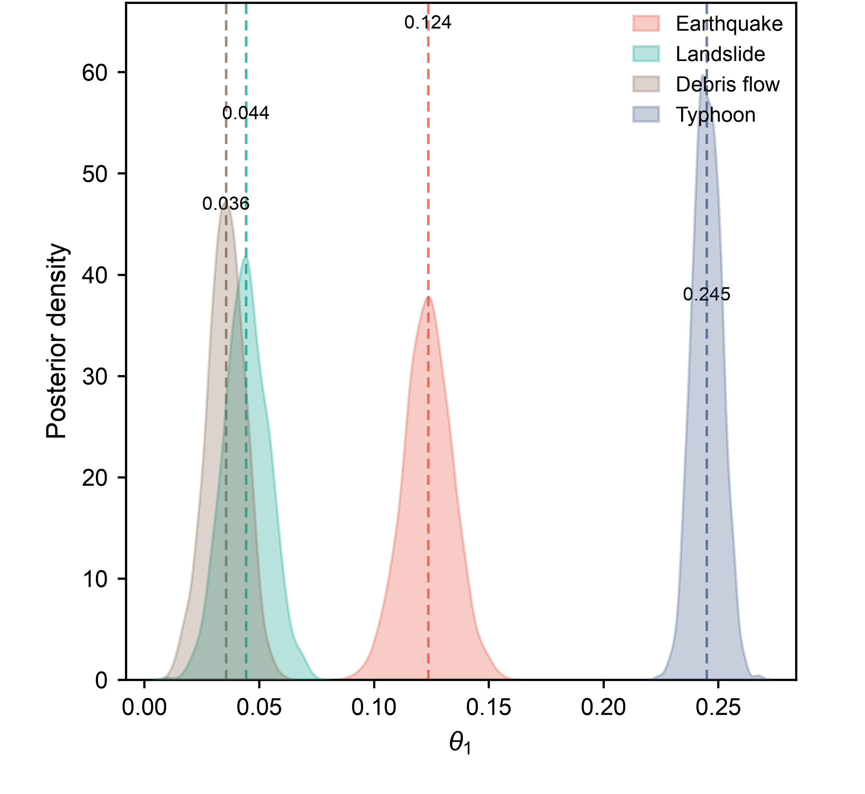
（a）

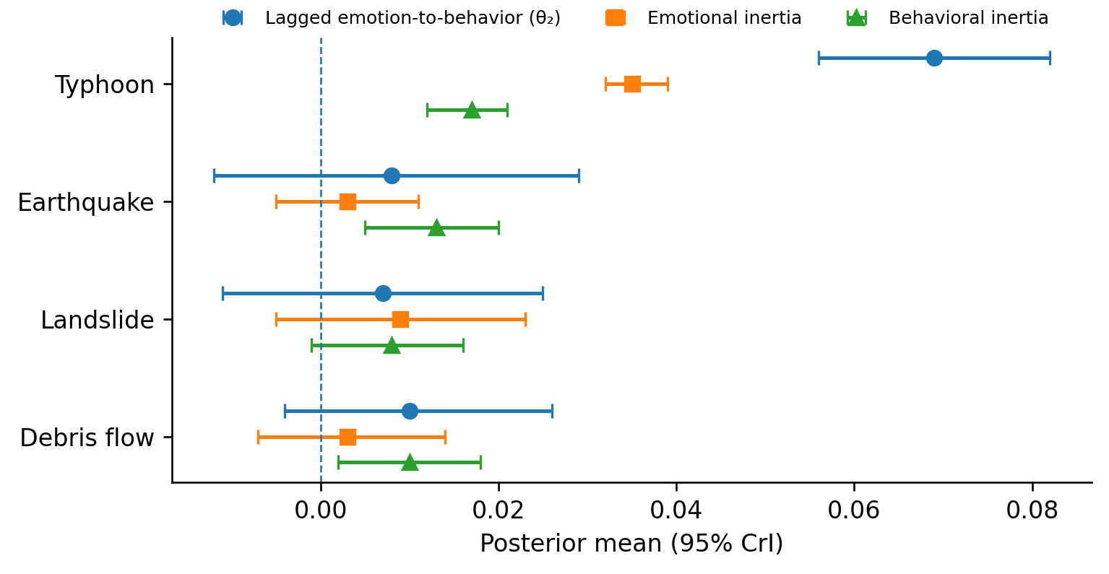
(b)
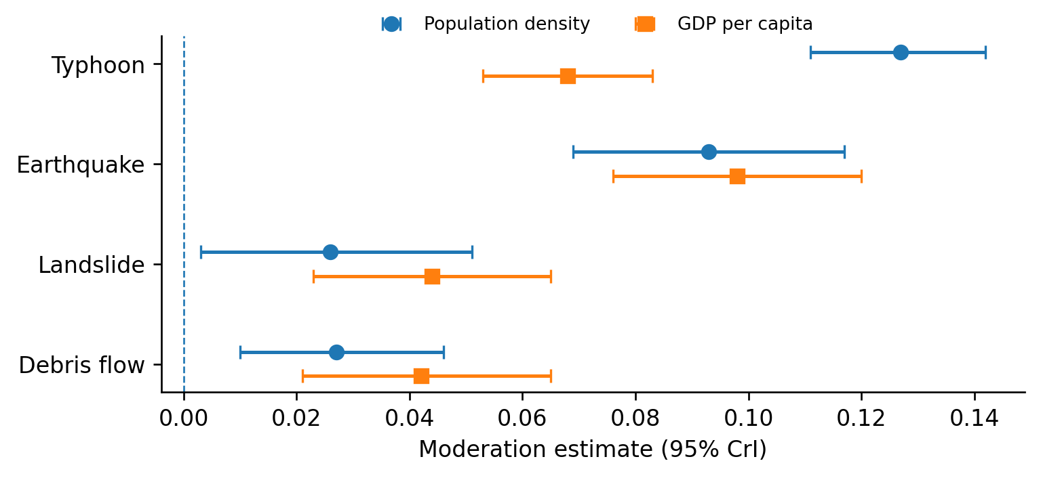
(c)

Fig. 1 | Emotion–behavior associations, temporal persistence and moderation across hazard types. (a) Posterior means and 95% credible intervals for the hazard-specific contemporaneous association coefficient θ₁; hazards are ordered by posterior mean. Pairwise comparisons show that four of the six hazard contrasts exclude zero; earthquake versus landslide and landslide versus debris flow remain indistinguishable. (b) Posterior means and 95% credible intervals for the lagged emotion-to-behavior association θ₂, emotional inertia βₑ, and behavioral inertia βb. (c) Moderation of the contemporaneous association by population density and GDP per capita. Dashed vertical lines indicate zero.

Temporal trajectories and peak separation differ across hazard types

Using the fitted latent spatio-temporal autoregressive framework, we characterized hazard-specific temporal trajectories of negative emotion and social disorder behavior from −72 to +168 h at the reference spatial level (Fig. 2). Earthquake emotion followed a single dominant peak: intensity remained around 0.30–0.33 before rising sharply to 0.376 in the first post-event bin (bin center +6 h) and declining thereafter. Landslide emotion formed an elevated plateau spanning the pre-event and early post-event period (approximately 0.32 around −42 h and +18 h, visible in the empirical means as the highest pre-event levels of any hazard) with a shallow dip at the event time (0.297); after an early decline to 0.278 at +42 h, a secondary rise reached 0.318 at +78 h before declining to 0.261 by +114 h. Typhoon emotion showed a gradual build-up to a single peak at landfall (−6 h; 0.300). Debris-flow emotion was lowest and latest, with a single late peak at +78 h (0.260). At their respective peaks, the difference between the highest and lowest hazard-specific emotion intensity was 0.116 (earthquake 0.376 versus debris flow 0.260), and the ordering of peak magnitude was earthquakes > landslides > typhoons > debris flows.
Social disorder behavioral trajectories occupied a narrower range and showed greater overlap across hazard types (Fig. 2b). Earthquake and typhoon behavioral trajectories each mirrored their emotion curve with a single sharp peak—+6 h for earthquakes (0.226) and −6 h for typhoons (0.232)—rising from baselines of roughly 0.19–0.21 and 0.19–0.23 respectively. Landslide behavioral scores remained flat within approximately 0.18–0.19 throughout the window, and debris-flow scores stayed around 0.17–0.18 with a broad, low-amplitude late elevation. Thus, behavioral responses shared a common narrow range across hazards (roughly 0.17–0.23), and rose sharply only where the emotion curve itself peaked sharply (earthquakes, typhoons). Because the behavior extractor was trained on a comparatively small annotated corpus, these values are interpreted as relative behavioral scores rather than probabilities of real-world disorder occurrence.
The temporal forms differed in peak structure as clearly as in absolute levels. Earthquakes compressed a single emotion and behavioral peak into the first post-event window; typhoons aligned both peaks at landfall after anticipatory build-up; debris flows showed a single late emotion peak (+78 h) with a broad behavioral elevation in the same late window; and landslides combined a pre-to-post-event emotion plateau with a secondary late rise (+78 h) while behavioral scores remained flat. Where the emotion curve peaked sharply (earthquakes, typhoons), the behavioral peak coincided in time; no hazard showed a behavioral peak systematically later than its emotion peak at this resolution. A qualitative comparison with news-reported disorder incidents showed that typhoon incidents were concentrated around landfall, whereas evidence for the other hazards was limited by small and temporally dispersed samples (Supplementary Table S7). [YELLOW-作者复核: 滑坡次峰(+78h, 0.318)摆幅0.04为真实特征已保留；其余小幅波动按噪声未叙述，未设数值化判定门槛。]
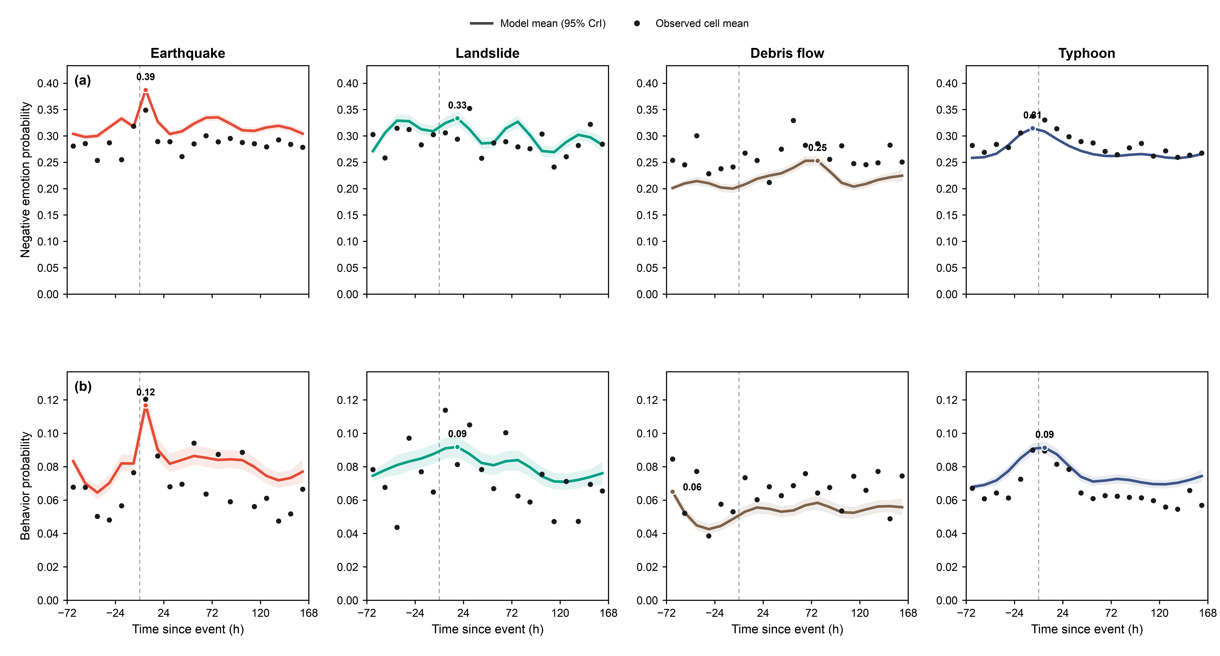
Fig. 2 Temporal trajectories and peak timing of negative emotion and social disorder behavior. (a) Negative emotion intensity. (b) Social disorder behavioral score. Solid lines show conditional posterior means at the reference spatial and covariate levels, ribbons show 95% credible intervals, and black points show empirical means. The dashed vertical line marks event time (t = 0). Time is represented by 12-h bins, so peak times are reported by bin centers.

Table 1 Dominant features of the fitted temporal trajectories by hazard type. Times are 12-h bin centers, and +6 h denotes the 0–12 h post-event bin.
Hazard | Emotion trajectory | Behavioral trajectory | Peak alignment
Earthquake | Single peak, +6 h (0.376) | Single peak, +6 h (0.226) | Same bin
Landslide | Plateau ≈0.32 over −42 h to +18 h with shallow dip at −6 h; secondary rise to 0.318 at +78 h | Flat, 0.18–0.19 (no distinct peak) | Not defined
Debris flow | Single late peak, +78 h (0.260) | Broad low late elevation, 0.17–0.18 | Late window
Typhoon | Single peak at landfall, −6 h (0.300) | Single peak, −6 h (0.232) | Same bin

Spatial response profiles differ across disaster types
Spatial profiles of emotion and behavior differed markedly across hazards (Fig. 3). Earthquakes showed a far-distance rebound in negative emotion, typhoons were nearly uniform across the 200-km footprint, and landslides and debris flows showed mid-distance troughs. Earthquake negative emotion declined from 0.258 at 0–5 km to a trough of 0.179 at 35–40 km, then rebounded to 0.227 at 45–50 km, whereas behavioral scores varied much less with distance (0.176 to 0.156). The rebound is robust: allowing every event its own decay slope leaves the pooled curve essentially unchanged (trough-to-outer-ring increase of 0.052 on the probability scale versus 0.048 in the main model; event-slope heterogeneity posterior 0.008), indicating the rebound is not an artifact of which events contribute far-ring posts. Importantly, the rebound was not accompanied by an outward increase in mean population density: ring-level density declined from 1,417 persons km⁻² at 0–5 km to 637 persons km⁻² at 45–50 km (Supplementary Table S15). Thus, the far-distance elevation cannot be explained by a simple radial population-density gradient. [YELLOW-作者复核: 按批注 A-05/B-26 删除了 urban agglomeration 表述（人口密度≠城市集聚）；如需建设用地面积论证请补充数据后改写。]
Typhoon profiles were strikingly flat: negative emotion intensity (~0.25–0.27) and behavior scores (~0.20) varied by less than 0.02 across 0–200-km. Yet posts were highly unevenly distributed across distance: only 0.71% of typhoon posts occurred within 0–10 km of the assigned track point, compared with 8.73% and 8.72% in the 160–170 and 170–180 km rings, respectively (observational coverage in Supplementary Figure S3). This imbalance was partly attributable to the track configuration, as near-track rings frequently crossed water or sparsely populated coast (Supplementary Fig. S2). Despite this uneven observational density, the fitted emotion and behavioral profiles remained nearly uniform across distance, with no systematic decay from the storm track.
Landslides and debris flows showed a third spatial response profile, distinct from both the far-distance rebound observed for earthquakes and the broad uniformity of typhoons. Both showed elevated responses in the near rings, a decline at intermediate distances, and partial recovery farther from the disaster. Landslide emotion, for example, decreased from 0.294 at 0–5 km to 0.196 at the trough before rising to 0.268 in the outer rings; the debris-flow profile followed the same shape (0.226 to a trough of 0.178, recovering to 0.194). These patterns should be interpreted with the lower observational coverage of the two mountain hazards in mind (approximately 24% of distance–time cells with posts, versus 47% for earthquakes and 62% for typhoons; Supplementary Fig. S3).

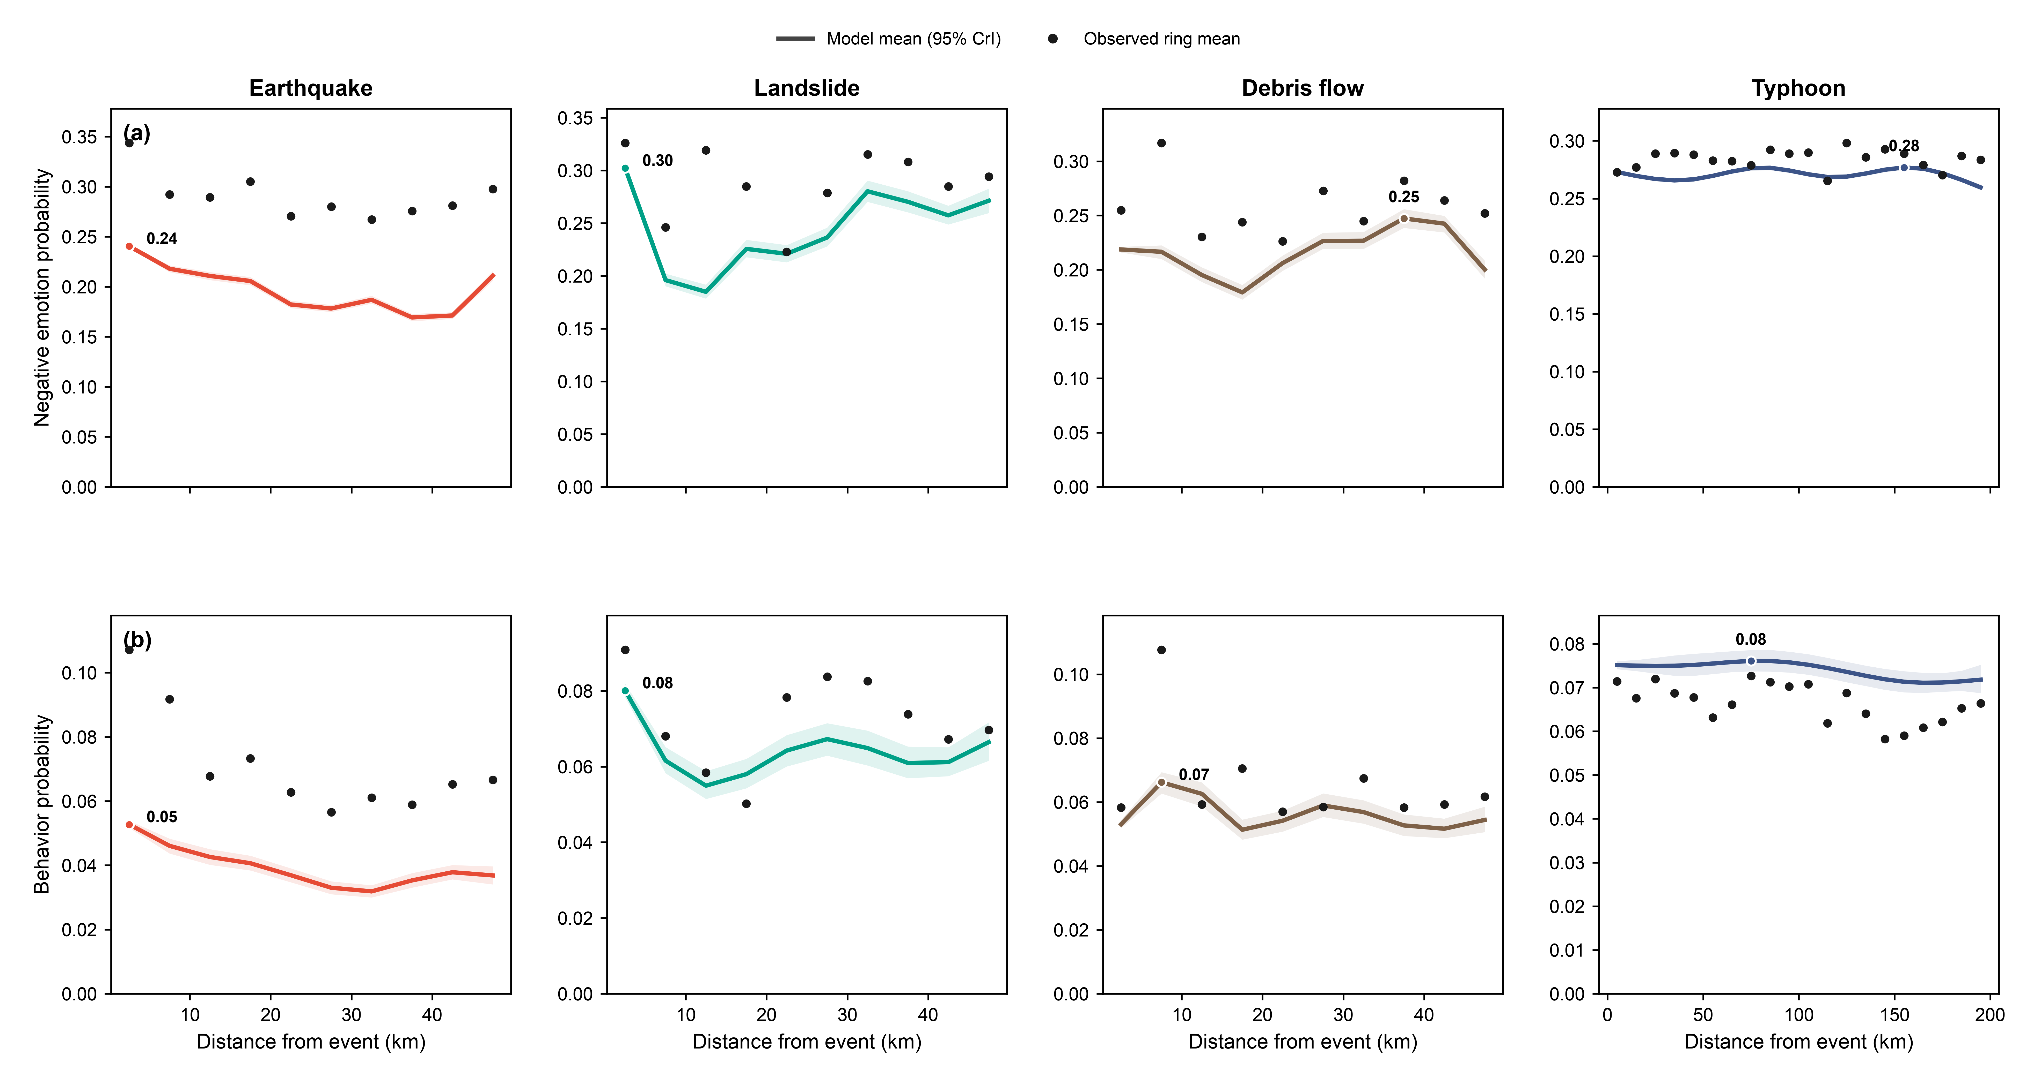
Fig. 3 Spatial profiles of negative emotion and social disorder behavior. (a) Negative emotion intensity. (b) Social disorder behavioral score. Solid lines show conditional posterior means at the reference temporal and covariate levels, ribbons show 95% credible intervals, and black points show empirical means. Distance is measured from the earthquake epicenter, the recorded landslide or debris-flow event location, and the assigned track point for typhoons. Spatial distance is represented by 5-km rings for earthquakes, landslides and debris flows and 10-km rings for typhoons.

Physical characteristics are associated with response magnitude
Beyond differences across hazard types, physical characteristics were also associated with variation in response magnitude among events of the same hazard type (Fig. 4). For earthquakes, higher magnitude was associated with greater negative-emotion intensity (0.045, 95% CrI 0.034–0.056), whereas greater depth was associated with lower negative-emotion intensity (−0.039, −0.051 to −0.027); greater depth was also weakly associated with lower behavioral scores (−0.026, −0.049 to −0.003), whereas magnitude showed no clear association with behavior. For landslides, greater maximum rolling 72-h rainfall accumulation (max72h_win) was positively associated with negative-emotion intensity (0.024, 0.005–0.042), whereas its association with the behavioral score was small with an interval including zero (0.007, −0.021 to 0.034).

For debris flows, greater maximum 1-h rainfall within the event date ±1 day (max1h_pm1d) was positively associated with negative-emotion intensity (0.035, 95% CrI 0.018–0.053), whereas its association with the behavioral score was small with an interval including zero (−0.020, −0.044 to 0.006). Higher typhoon intensity was positively associated with both negative-emotion intensity (0.087, 0.083–0.091) and behavioral score (0.056, 0.043–0.070). Together, these results show that physical characteristics—seismic, rainfall-related, and storm intensity—capture additional variation in emotional responses among events of the same hazard type for all four hazards, whereas associations with behavioral scores were identified only for earthquake depth and typhoon intensity.

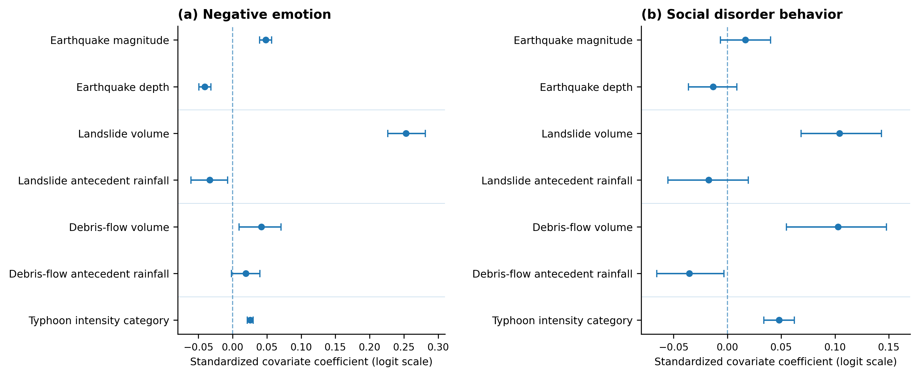
Fig. 4 Associations of physical characteristics with negative emotion and social disorder behavior. (a) Negative-emotion intensity. (b) Social disorder behavioral score. Points show posterior means, horizontal bars show 95% credible intervals, and dashed vertical lines indicate zero. Physical characteristics include earthquake magnitude and depth, landslide max72h_win rainfall, debris-flow max1h_pm1d rainfall, and typhoon intensity category. All physical covariates were standardized within their respective hazard-specific models, and coefficients are reported on the latent logit scale.

Discussion
We found a positive contemporaneous association between public negative emotions and social disorder behavior scores across all four hazard types, but the strength of this association differed substantially by hazard. Typhoons and earthquakes showed markedly stronger associations than landslides and debris flows, while only typhoons showed a clear lagged emotion-to-behavior association; emotional inertia was also detected for earthquakes and debris flows. These results extend prior disaster research by showing that emotion and disorder-related behavior are not simply parallel responses: their degree of co-variation differs across hazard contexts [5,27].
The contrast between typhoons and earthquakes is especially informative. If unpredictability and low perceived control alone determined emotion-behavior coupling, sudden earthquakes might be expected to show the strongest association [7,28-30]. Instead, typhoons showed the largest contemporaneous coefficient, the only clear lagged association, and the strongest moderation by population density. One possible interpretation is that coupling depends not only on suddenness, but also on the duration and social organization of exposure. Typhoons involve an extended warning and anticipation period, repeated risk communication, and widespread population exposure, which may allow emotional responses and behavior-related signals to accumulate across successive time windows. Earthquakes showed a different pattern: both emotion and behavior peaked within the first post-event 12-h window, with no clear lagged association, consistent with a more compressed appraisal to a sudden shock [5]. Because warning time, perceived controllability, and individual exposure were not directly measured, these mechanisms should be treated as interpretations rather than tested causal explanations.

This two-tier structure reframes the role of hazard predictability. A simple reading of compensatory control theory [7,28-30]—that less controllable, sudden threats produce stronger coupling—predicts the opposite ordering, since typhoons are anticipated and warned whereas earthquakes are not. Our results instead suggest that the strength of emotion-behavior coupling tracks the duration and social scale of exposure: typhoons combine days of anticipatory arousal, repeated official warnings, and dense coastal populations—their coupling is the strongest, they are the only hazard with a significant lagged association, and population density amplifies their coupling most (δ_pop = 0.047). Earthquakes represent the complementary regime: a sudden-onset hazard whose emotional and behavioral peaks both fall within the first post-event 12-hour window—the finest resolution the binning supports—producing stronger contemporaneous coupling (0.048) than the mountain hazards, with no lag and no behavioral inertia, consistent with rapid, compressed appraisal [5]. Because warning time and perceived controllability were not directly measured, we present this as a theoretical interpretation of the observed structure.
The lagged emotion-to-behavior association, present only for typhoons, has a practical corollary: real-time emotional monitoring during warned hazards can inform the timing of behavioral risk, which peaks in the same window as emotion around landfall. Related studies of emotional contagion during disasters likewise find that negative emotions are persistent and contagious and that real-time emotional signals can inform intervention timing [31,32].

The temporal and spatial structures align with the same typology. Earthquake emotion and behavior peaked within the first post-event 12-hour window; typhoon emotion and behavior peaked in the same landfall-centered window after anticipatory build-up; landslide emotion peaked around +18 h while behavioral scores remained broadly flat; and debris-flow emotion peaked at +78 h, with a broad, low-amplitude behavioral elevation in the same late period.
The temporal profiles reinforce this distinction. Earthquake responses were concentrated immediately after the event, whereas typhoon emotion and behavior peaked in the same landfall-centered window after anticipatory build-up. Landslide emotion peaked around +18 h while behavior remained broadly flat, and debris-flow emotion peaked later at +78 h with a broad late behavioral elevation. The lagged emotion-to-behavior association, observed only for typhoons, suggests that real-time monitoring of public emotions during warned hazards may help identify behavioral risk across adjacent time windows around landfall. Related studies of emotional contagion during disasters similarly suggest that negative emotions can persist and spread through social networks, highlighting the potential value of real-time emotional signals for informing the timing of interventions [31,32].

Spatially, the four hazards exhibited distinct profiles. Earthquake-related negative emotion declined with distance before rebounding in farther rings, typhoon responses were comparatively uniform across the 200-km footprint, and landslide and debris-flow responses were non-monotone with mid-distance troughs. Whether the earthquake rebound reflects the social sharing of emotion propagating experiences into more distant settlements, media exposure, urban population composition, or other unmeasured processes remains an open question the present data cannot resolve [6,33]; notably, the rebound was not accompanied by an outward increase in mean population density (Supplementary Table S15). Typhoon uniformity plausibly reflects both the genuinely broad physical footprint of the storm and the sampling geometry of track-based collection (near-track rings over water; Supplementary Fig. S2). These results support hazard-specific spatial heterogeneity.

Beyond hazard type and spatial context, event-level physical characteristics were associated with the magnitude of emotional responses—earthquake magnitude and depth, max72h_win rainfall for landslides, max1h_pm1d rainfall for debris flows, and typhoon intensity—whereas associations with behavioral scores were identified only for earthquake depth and typhoon intensity.
Practical implications The results suggest that disaster monitoring strategies should be aligned with hazard-specific temporal and spatial response profiles. For earthquakes, negative emotion and social disorder behavior both peaked within the first post-event 12-h window, highlighting the need for immediate social-media monitoring, rapid rumor verification, and timely public information release after impact. For typhoons, negative emotion and behavioral responses peaked in the same landfall-centered 12-h window, suggesting particular attention to the period immediately before landfall and the first 12 h after landfall. Landslide emotion peaked around +18 h while behavioral scores remained broadly flat, whereas debris-flow emotion peaked at +78 h and behavioral responses showed a broad late elevation, indicating the need for longer post-event monitoring rather than only immediate response. Spatially, the earthquake far-distance rebound suggests that monitoring should extend beyond areas close to the epicenter, while the near-uniform typhoon responses support broader spatial coverage. Finally, the stronger contemporaneous associations for earthquakes and typhoons in areas with higher population density and GDP per capita indicate that local context should be considered when interpreting emotional and behavioral signals.

(1) Coupling strength defines urgency. For earthquakes, psychological first aid and risk communication must be positioned before impact is even assessable; for typhoons, the pre-landfall window—where both emotion and behavior peak—is the actionable interval; for landslides and debris flows the window extends over days. (2) Peak timing schedules intervention. Earthquake capacity requires immediate activation; typhoon responses can be phased from warning through early post-landfall; landslide and debris-flow monitoring must be sustained for days. (3) Spatial patterns allocate resources. Earthquake resources belong near the epicenter with monitoring capacity retained in distant outer rings, where the emotional rebound occurs; typhoon resources should be distributed across the full footprint; mountain-hazard response is inherently local and data-sparse, favoring ground truth over social-media-only surveillance. (4) Contextual amplification targets resources: denser areas and wealthier areas show stronger coupling for earthquakes and typhoons, so the same emotional surge implies more behavioral risk there than elsewhere.

Several limitations should be considered. First, posterior inference relied on ADVI, which is computationally efficient but may underestimate posterior variance; estimates with 95% credible intervals close to zero should therefore be interpreted cautiously. All four hazard-specific models met the ELBO convergence criterion (median relative ELBO improvement below 0.01) well within the 30,000-iteration cap. Second, the behavior extractor was trained on a comparatively small annotated corpus (492 unique posts), so its outputs should be interpreted as relative social disorder behavioral scores rather than calibrated probabilities of real-world disorder occurrence. Third, some posts were included in the collection windows of more than one event; for typhoons, posts shared between track points of the same storm were assigned to the nearest track point, and 8.3% of posts overlapped between event windows of different storms and were therefore not fully independent across events. Fourth, spatial analyses were based on distance rings, population density and GDP per capita, without modelling built-environment characteristics, such as building structure, materials and escaping facilities. For typhoons, near-track rings also frequently intersected water or sparsely populated coastal areas, which may have affected the spatial distribution of posts and contributed to the near-uniform spatial profile. Fifth, external validation focused on typhoons because documented disorder-related incidents were more numerous, limiting external corroboration for the other hazard types. Finally, the analysis was post-hoc and real-time application would require streaming data and sequential Bayesian updating.

Conclusion
Integrating social media analytics with latent spatio-temporal autoregressive modeling reveals hazard-specific profiles in public negative emotion and social disorder behavior. A positive contemporaneous association was observed across all four hazard types, and this association was stronger in areas with higher population density and GDP per capita for earthquakes and typhoons. Only typhoons showed a lagged emotion-to-behavior association, while emotional inertia was detected for typhoons, earthquakes, and debris flows. Temporal and spatial response patterns also differed across hazards: Second, temporal persistence is hazard-specific: only typhoons—the anticipated, prolonged hazards—show a lagged emotion-to-behavior association, whereas earthquake responses compress into the first post-event window despite a small but nonzero emotional-inertia estimate. Earthquake responses were concentrated in the first post-event 12-h window and negative emotion showed a far-distance rebound; typhoon responses developed around landfall and were near-uniform across the 200-km footprint; and landslide and debris-flow responses peaked later and showed non-monotone spatial profiles. Physical event characteristics were also associated with within-hazard variation in response magnitude. Social media, as a large-scale social sensing source, captures not only what people feel but also signals of disorder-related behavioral responses—information invisible to physical sensors and administrative records—providing a quantitative basis for hazard-specific and geographically differentiated disaster governance. Together, these findings suggest that dynamic emotion-behavior responses during disasters are hazard-specific rather than uniform, with the contemporaneous association, temporal persistence, and spatial response patterns varying across hazard types and population contexts. This provides a comparative framework for understanding how public negative emotions and social disorder behaviors are organized across different natural hazards exposure.

Methods

Data collection and preprocessing
Disaster event data We compiled four types of natural hazard events that occurred in China between January 2022 and December 2024: earthquakes (n = 37), landslides (n = 30), debris flows (n = 36), and typhoons (n = 14, represented by 53 track points with posts). Earthquake records were obtained from the China Earthquake Networks Center (CENC, http://www.ceic.ac.cn); landslide records from the National Earth System Science Data Center, National Science & Technology Infrastructure of China (http://www.geodata.cn) [34]; debris flow records from the Resource and Environmental Science Data Center of the Chinese Academy of Sciences (http://www.resdc.cn); and typhoon records from the China Meteorological Administration Tropical Cyclone Data Center (https://tcdata.typhoon.org.cn/) [35], using the CMA best track. For each event, we recorded event location, time, and hazard-specific physical characteristics: earthquake magnitude and depth; typhoon intensity category; landslide maximum rolling 72-h rainfall accumulation (max72h_win); and debris-flow maximum 1-h rainfall within the event date ±1 day (max1h_pm1d). The rainfall variables were derived from ERA5 reanalysis at the event-center point; max72h_win was used for landslides to represent sustained rainfall accumulation, whereas max1h_pm1d was used for debris flows to represent short-duration intense rainfall around the event date.
Social media data We collected Sina Weibo using the official API under institutional data use agreements. For each event, posts were retrieved from 72 h before to 168 h after the event. The spatial search radius was 50 km for earthquakes, landslides, and debris flows, and 200 km along typhoon track points. Retrieved records were first screened for valid post structure and required metadata, with unparsable records excluded before NLP processing. Posts were then retained for aggregation only when both a valid negative-emotion intensity and social disorder behavioral score were available. For typhoons, overlapping search areas among adjacent track points could cause the same post to be retrieved multiple times within a single event. Such within-typhoon duplicates were therefore assigned to the nearest track point and retained only once per typhoon. By contrast, posts that fell within the collection windows of two different typhoons were retained for both events, because they represented overlap between distinct event windows rather than duplicate retrieval within the same event. The final corpus contained 406,419 post observations: 23,590 for earthquakes, 7,886 for landslides, 13,284 for debris flows, and 361,659 for typhoons. Analyses were conducted on aggregated, anonymized data in accordance with the platform's terms of service.
Spatio-temporal gridding We divided observation period into 20 consecutive 12-h bins, with bin centers from -66 to +162 h relatived to the event. Space was represented by concentric distance rings: ten 5-km rings for earthquakes, landslides, and debris flows (centers 2.5–47.5 km), and twenty 10-km rings for typhoons (centers 5–195 km). For each event × 12-h time-bin × distance-ring cells, we computed the number of posts and the mean negative emotion intensity and social disorder behavior score. Reported peak times therefore refer to the bin centers. Cells with no posts were not imputed. Their latent states were retained in the structural model but they contributed no observation likelihood.

NLP-based emotion classification and behavior extraction
We used a fine-tuned RoBERTa-wwm-ext model [25,36,37] for six-class emotion classification (fear, neutral, sad, surprise, angry, happy), fine-tuned on the SMP2020-EWECT dataset (macro F1 0.737). Negative emotion intensity was defined as the sum of anger, fear, and sadness. Social disorder behavior was extracted with a multi-task RoBERTa-based model [26] sharing a single text encoder with a binary head for disorder content and a span head for the expressing text. The behavior model used post text only—no emotion information entered as input or calibration—and was trained on 492 uniquely annotated posts (after group-level deduplication of 552 main and 28 negative annotations; Supplementary Table S11), evaluated under stratified five-fold cross-validation with three random seeds and inverse-frequency class weights rather than resampling or augmentation. Cross-validated binary F1 was 0.820 ± 0.039 and strict span exact-match F1 was 0.392 ± 0.055 (Supplementary Table S10). The behavior score for each post is the model-estimated probability of disorder-related content, aggregated within cells as the post-level mean.

Latent spatio-temporal autoregressive model
We model emotions and behaviors as two coupled continuous latent variables in logit space—e(i) for emotion and b(i) for behavior—for cell i ( an each event × 12-h time-bin × distance-ring), using first-order autoregressive dynamics [38,39]. The structural mean of each state comprises: global intercepts (αₑ, αb); centered natural cubic spline functions of time (8 degrees of freedom) and of distance (6 degrees of freedom; 5 for typhoons; Supplementary Table S5); event-level random intercepts; standardized event characteristics (magnitude and depth for earthquakes; max72h_win for landslides; max1h_pm1d for debris flows; typhoon intensity category for typhoons); autoregressive own-lag terms (βₑ, β_b) representing emotional and behavioral inertia; the contemporaneous emotion–behavior association θ₁ and lagged emotion-to-behavior association θ₂. For earthquakes, additional post-event jump terms (τw,e for emotion and τw,b for behavior) applied to capture the abrupt shift begining in the first post-event 12-h window which could not be fully represented by the smooth emporal spline alone. For typhoons, the event random intercept were specified at both typhoon and track-point levels, so that track points from the same storm were not treated as independent events. Ring-level population density and GDP per capita (each standardized, zₘ; ring-level population means in Supplementary Table S15) were include in the behavioral equation as main effects (γₘ·zₘ) and as an interaction with the latent emotional state (δₘ·zₘ·e(i)). The former capture their direct associations with social disorder behavior, whereas the latter test whether they moderate the contemporaneous emotion–behavior association. δpop and δGDP are the moderation coefficient reported in Fig. 1b and Supplementary Table S6. [RED-待答复(Q-3/A-18): 台风距离样条 df=5、其余 df=6 的差异在项目内无文档依据（config 仅写死数值）；统一 df 需全部重拟合，本轮未动，请作者决定。]

Interpretation of association parameters The contemporaneous association parameter $θ_{1}$ quantifies the association between negative emotion and social disorder behavior within the same 12-h time bin and distance ring, after accounting fortemporal and spatial trends, event-level random intercepts, event characteristics, population density, and GDP per capita. The lagged emotion-to-behavior parameter $θ_{2}$ quantifies the association between negative emotion in one 12-h time bin and social disorder behavior in the following 12-h time bin, while accounting for emotional inertia ($β_{e}$) and behavioral inertia ($β_{b}$). Both parameters describe associations at the aggregated spatio-temporal cell level and should not be interpreted as individual-level or causal effects.

Observation models The cell-level negative-emotion intensity and social disorder behavioral score were treated as noisy measurements of their corresponding latent states. Emotion cell means were logit-transformed and modeled as Gaussian distribution around the latent emotion state, with standard error σobs/√nᵢ, where nᵢ is the cell post count. Thus, cells with more posts have lower observation uncertainty. Behavior cell, bᵢ which remain bounded between 0 and 1, were modeled as Beta with mean invlogit(bᵢ) and precision φ·nᵢ, so that the precision likewise increases with the number of posts in the cell. Observation error (σobs) and latent-process noise (σproc) were modeled as separate parameters. The behavior latent variance is fixed at 1 for identifiability [38]. Weakly informative priors are used throughout, with the full specification provided in Supplementary Table S14. The logit-transformed Gaussian observation model was used for emotion because cell-level emotion means are continuous and, after logit transformation, unbounded, with a Gaussian standard error scaled by the cell post count; the Beta observation model was used for behavior because cell-level behavior scores are probabilities confined to (0, 1), for which the Beta family provides a mean–precision parameterization whose precision increases with the number of posts.
Estimation Posterior distributions of all model parameters were estimated using mean-field variational inference (ADVI) implemented in CmdStanR. Models were fitted with a step size of 0.1 for up to 30,000 iterations, using a relative ELBO improvement threshold of < 0.01 as convergence criterion. 1,000 posterior draws were generated from each fitted posterior using a fixed random seed. All four hazard-specific models met the convergence criterion. Parameters estimated on the logit scale were transformed back to the probability scale using a second-order delta correction. Model curves was calcuated with random effects fixed at zero and covariates held at their reference values. Therefore, they represent conditional model estimates rather than unconditional empirical means..

Sensitivity analyses
We conducted four sensitivity analyses. First, we allowed event-specific deviations in the distance effect to examine whether the hazard-specific spatial profiles were driven by a small number of events. The main spatial profiles, including the earthquake far-distance rebound and the mid-distance troughs of landslides and debris flows, remained essentially unchanged (event-slope heterogeneity posterior 0.008). Second, we removed the contemporaneous (θ₁) and lagged (θ₂) emotion-to-behavior terms from the model. This reduced the consistency between modeled and observed spatial patterns of social disorder behavior for earthquakes and landslides, whereas for debris flows and typhoons the coupled and uncoupled fits were similarly consistent (Supplementary Table S13). Third, for earthquakes, we removed the post-event jump term: the emotion peak shifted from the +6 h bin (0.376) to the pre-event −6 h bin (0.352), indicating that the abrupt post-event increase is carried by the jump term, and the contemporaneous association decreased from 0.048 to 0.021 with marginally overlapping credible intervals. Fourth, we directly compared the key model parameters across hazard types by calculating posterior differences between the hazard-specific models. Posterior mean differences and 95% credible intervals are reported in Supplementary Table S16. All four hazard-specific models met the convergence criterion. Model fit was further evaluated by comparing the modeled and observed temporal and spatial patterns of negative emotion and social disorder behavior using RMSE (Supplementary Table S12).

External validation
External validation. Because the number of documented disorder-related incidents was substantially larger for typhoons than for the other hazard types, the external validation focused on typhoon events. Incident times were coded relative to the corresponding typhoon track point and compared qualitatively with the model-identified behavioral window. Given the limited number of independent reports, no formal statistical test was performed.

Code availability
All code used for data processing, model fitting, and visualization is available at https://github.com/rowen37/disaster-emotion-dbn.git.

Data availability
Sina Weibo data cannot be publicly shared due to platform terms of service. Aggregated spatio-temporal data and processed model outputs are available from the corresponding author upon reasonable request. Disaster event data sources are publicly accessible: earthquake data from CENC (http://www.ceic.ac.cn); landslide data from the National Earth System Science Data Center (http://www.geodata.cn) [34]; debris flow data from the Resource and Environmental Science Data Center of CAS (http://www.resdc.cn); and typhoon data from the CMA Tropical Cyclone Data Center (https://tcdata.typhoon.org.cn/) [35].

References
[1] Arvandi A, Rokne J, Alhajj R. Twitter analysis in emergency management: recent research and trends[J]. Social Network Analysis and Mining, 2024, 14(1): 154. DOI: 10.1007/s13278-024-01308-8.
[2] Wahid J A, Xu M, Ayoub M, et al. AI-driven social media text analysis during crisis: a review for natural disasters and pandemics[J]. Applied Soft Computing, 2025, 171: 112774. DOI: 10.1016/j.asoc.2025.112774.
[3] Vieweg S, Hughes A L, Starbird K, et al. Microblogging during two natural hazards events: what twitter may contribute to situational awareness[C]//Proceedings of the SIGCHI Conference on Human Factors in Computing Systems. ACM, 2010: 1079-1088. DOI: 10.1145/1753326.1753486.
[4] Kryvasheyeu Y, Chen H, Obradovich N, et al. Rapid assessment of disaster damage using social media activity[J]. Science Advances, 2016, 2(3): e1500779. DOI: 10.1126/sciadv.1500779.
[5] Lazarus R S. Emotion and Adaptation[M]. New York: Oxford University Press, 1991.
[6] Rimé B. Emotion elicits the social sharing of emotion: Theory and empirical review[J]. Emotion Review, 2009, 1(1): 60-85. DOI: 10.1177/1754073908097189.
[7] Rao T T, Zhu X W, Yang S L, Bai J. Compensatory control in public emergencies[J]. Advances in Psychological Science, 2022, 30(5): 1119-1130. (in Chinese).
[8] The New York Times. Who's a looter? In storm's aftermath, pictures kick up a different kind of tempest[EB/OL]. (2005-09-05). https://www.nytimes.com/2005/09/05/business/whos-a-looter-in-storms-aftermath-pictures-kick-up-a-different.html
[9] China News Service. Man detained for ten days for spreading a rumor of an M9.2 earthquake striking Chengdu after the Ya'an earthquake[EB/OL]. (2013-04-27). https://www.chinanews.com.cn/fz/2013/04-27/4771643.shtml. (in Chinese).
[10] Takungpao (tkww.hk). Typhoon Saola approaching Hong Kong: shelves cleared across districts as residents rush to stock up[EB/OL]. (2023-08-31). https://www.tkww.hk/a/202308/31/AP64f0935be4b0324f8b27f62f.html. (in Chinese).
[11] Wang Y, Taylor J E. Coupling sentiment and human mobility in natural disasters: a Twitter-based study of the 2014 South Napa Earthquake[J]. Natural Hazards, 2018, 92(2): 907-925. DOI: 10.1007/s11069-018-3231-1.
[12] Karmegam D, Mappillairaju B. Spatio-temporal distribution of negative emotions on Twitter during floods in Chennai, India, in 2015: a post hoc analysis[J]. International Journal of Health Geographics, 2020, 19(1): 19. DOI: 10.1186/s12942-020-00214-4.
[13] Hernandez-Suarez A, Sanchez-Perez G, Toscano-Medina K, et al. Using Twitter data to monitor natural disaster social dynamics: a recurrent neural network approach with word embeddings and kernel density estimation[J]. Sensors, 2019, 19(7): 1746. DOI: 10.3390/s19071746.
[14] Behl S, Rao A, Aggarwal S, et al. Twitter for disaster relief through sentiment analysis for COVID-19 and natural hazard crises[J]. International Journal of Disaster Risk Reduction, 2021, 55: 102101. DOI: 10.1016/j.ijdrr.2021.102101.
[15] Vayansky I, Kumar S A P, Li Z. An evaluation of geotagged Twitter data during Hurricane Irma using sentiment analysis and topic modeling for disaster resilience[C]//2019 IEEE International Symposium on Technology and Society (ISTAS). IEEE, 2019: 1-6. DOI: 10.1109/ISTAS48451.2019.8937859.
[16] Gruebner O, Lowe S R, Sykora M, et al. Spatio-temporal distribution of negative emotions in New York City after a natural disaster as seen in social media[J]. International Journal of Environmental Research and Public Health, 2018, 15(10): 2275. DOI: 10.3390/ijerph15102275.
[17] Vosoughi S, Roy D, Aral S. The spread of true and false news online[J]. Science, 2018, 359(6380): 1146-1151. DOI: 10.1126/science.aap9559.
[18] Wan X, Ding X, Liu S, et al. An emotion-behavior perspective of understanding public and government responses to rainstorm disasters: a case study of Zhengzhou Rainstorm in China[J]. Cities, 2025, 164: 106077. DOI: 10.1016/j.cities.2025.106077.
[19] Desai S, Caragea C, Li J J. Detecting perceived emotions in hurricane disasters[C]//Proceedings of the 58th Annual Meeting of the Association for Computational Linguistics. 2020: 5290-5305. DOI: 10.18653/v1/2020.acl-main.471.
[20] García-Hernández R A, Luna-García H, Celaya-Padilla J M, et al. A systematic literature review of modalities, trends, and limitations in emotion recognition, affective computing, and sentiment analysis[J]. Applied Sciences, 2024, 14(16): 7165. DOI: 10.3390/app14167165.
[21] Yang T F, Xie J B, Li Z Y, Li G Q. A method of typhoon disaster loss identification and classification using micro-blog information[J]. Journal of Geo-Information Science, 2018, 20(7): 906-917. (in Chinese).
[22] Chen Z, Gao T, Luo N X, et al. Social media effectiveness to reflect the spatial and temporal distribution of natural disasters[J]. Science of Surveying and Mapping, 2017, 42(8): 44-48. (in Chinese).
[23] Liu H B, Zhai G F. A comparative study on social response characteristics of different disasters based on social media information[J]. Journal of Catastrophology, 2017, 32(1): 187-193. (in Chinese).
[24] Liu Y, Zhang X, Wang X, et al. Weibo public opinion analysis of emergencies using lexicon-based and deep learning approaches: a case study of the 12.18 Jishishan Seismic Event[J]. Geomatics, Natural Hazards and Risk, 2025, 16(1): 2506470. DOI: 10.1080/19475705.2025.2506470.
[25] Devlin J, Chang M W, Lee K, et al. BERT: pre-training of deep bidirectional transformers for language understanding[C]//Proceedings of the 2019 Conference of the North American Chapter of the Association for Computational Linguistics: Human Language Technologies. 2019: 4171-4186. DOI: 10.18653/v1/N19-1423.
[26] Tan K L, Lee C P, Anbananthen K S M, et al. RoBERTa-LSTM: a hybrid model for sentiment analysis with transformer and recurrent neural network[J]. IEEE Access, 2022, 10: 21517-21525. DOI: 10.1109/ACCESS.2022.3152828.
[27] Frijda N H. The Emotions[M]. Cambridge: Cambridge University Press, 1986.
[28] Kay A C, Whitson J A, Gaucher D, et al. Compensatory control: achieving order through the mind, our institutions, and the heavens[J]. Current Directions in Psychological Science, 2009, 18(5): 264-268. DOI: 10.1111/j.1467-8721.2009.01649.x.
[29] Kay A C, Gaucher D, Napier J L, et al. God and the government: testing a compensatory control mechanism for the support of external systems[J]. Journal of Personality and Social Psychology, 2008, 95(1): 18-35. DOI: 10.1037/0022-3514.95.1.18.
[30] Zhao H, Xu S. Associations between panic buying and choice overload during the public health crisis in China: testing sequential mediation models[J]. Acta Psychologica, 2025, 254: 104800. DOI: 10.1016/j.actpsy.2025.104800.
[31] Chu M, Song W, Zhao Z, et al. Emotional contagion on social media and the simulation of intervention strategies after a disaster event: a modeling study[J]. Humanities and Social Sciences Communications, 2024, 11(1): 968. DOI: 10.1057/s41599-024-03397-4.
[32] Xu J, Lu L, Wei J. The impact of geographic, mobility and social media ties on massive-scale regional public emotional interaction[J]. Humanities and Social Sciences Communications, 2025, 12(1): 883. DOI: 10.1057/s41599-025-05280-2.
[33] Rimé B. The social sharing of emotion in interpersonal and in collective situations[M]//Hołyst J A. Cyberemotions: Collective Emotions in Cyberspace. Cham: Springer, 2017: 53-69. DOI: 10.1007/978-3-319-43639-5_4.
[34] Zhao B R, et al. A high-precision landslide event dataset for mainland China (2008-2024) based on news data[DB/OL]. Version 1. National Earth System Science Data Center, Yangtze River Delta Branch, 2026. DOI: 10.12009/YRDR.2026.1002.ver1.db. (in Chinese).
[35] Ying M, Zhang W, Yu H, et al. An overview of the China Meteorological Administration tropical cyclone database[J]. Journal of Atmospheric and Oceanic Technology, 2014, 31(2): 287-301. DOI: 10.1175/JTECH-D-12-00119.1.
[36] Cui Y, Che W, Liu T, et al. Pre-training with whole word masking for Chinese BERT[J]. IEEE/ACM Transactions on Audio, Speech, and Language Processing, 2021, 29: 3504-3514. DOI: 10.1109/TASLP.2021.3124365.
[37] Liu Y, Ott M, Goyal N, et al. RoBERTa: A robustly optimized BERT pretraining approach[EB/OL]. arXiv:1907.11692, 2019. https://arxiv.org/abs/1907.11692
[38] Murphy K P. Machine learning: a probabilistic perspective[M]. Cambridge, MA: MIT Press, 2012.
[39] Durbin J, Koopman S J. Time series analysis by state space methods[M]. 2nd ed. Oxford: Oxford University Press, 2012.

Supplementary Information

Supplementary Table S1. Complete parameter summaries for the earthquake model (posterior mean, s.d., 95% credible intervals).
parameter | mean | sd | Q2.5 | Q97.5 | significance
$$α_{b}$$ | -2.51064 | 0.00678 | -2.52381 | -2.49687 | TRUE
$$α_{e}$$ | -0.97998 | 0.00215 | -0.98423 | -0.97556 | TRUE
$$β_{b}$$ | 0.01706 | 0.00236 | 0.01224 | 0.02148 | TRUE
$$β_{e}$$ | 0.03500 | 0.00184 | 0.03158 | 0.03862 | TRUE
$$γ_{b, level}$$ | 0.04799 | 0.00724 | 0.03382 | 0.06214 | TRUE
$$γ_{e, level}$$ | 0.02580 | 0.00218 | 0.02157 | 0.02995 | TRUE
$$φ$$ | 5.84612 | 0.07291 | 5.70670 | 5.99348 | TRUE
$$σ_{obs,e}$$ | 2.04430 | 0.01329 | 2.01922 | 2.07117 | TRUE
$$σ_{proc,e}$$ | 0.27009 | 0.00138 | 0.26742 | 0.27272 | TRUE
$$τ_{v,b}$$ | 0.00592 | 0.00465 | 0.00104 | 0.01914 | TRUE
$$τ_{v,e}$$ | 0.11240 | 0.00178 | 0.10902 | 0.11594 | TRUE
$$τ_{w,b}$$ | 0.10845 | 0.00692 | 0.09580 | 0.12246 | TRUE
$$τ_{w,e}$$ | 0.00212 | 0.00157 | 0.00045 | 0.00627 | TRUE
$$θ_{1}$$ | 0.24518 | 0.00624 | 0.23369 | 0.25726 | TRUE
$$θ_{2}$$ | 0.06882 | 0.00658 | 0.05595 | 0.08195 | TRUE

Supplementary Table S5. Spline degrees of freedom.
Spline type | Earthquake | Landslide | Debris flow | Typhoon
Time spline degrees of freedom | 8 | 8 | 8 | 8
Distance spline degrees of freedom | 6 | 6 | 6 | 5

Supplementary Table S6. Moderation of the emotion–behavior association by population density and GDP per capita.
Hazard | Moderator | γ (main effect) | δ (moderation)
Earthquake | Population density | 0.005 [-0.017, 0.029] | 0.026 [0.002, 0.048]
Earthquake | GDP per capita | 0.026 [0.003, 0.049] | 0.023 [0.001, 0.044]
Landslide | Population density | 0.030 [0.005, 0.056] | 0.009 [-0.016, 0.033]
Landslide | GDP per capita | 0.039 [0.014, 0.065] | 0.007 [-0.017, 0.032]
Debris flow | Population density | -0.007 [-0.031, 0.018] | 0.011 [-0.007, 0.028]
Debris flow | GDP per capita | 0.005 [-0.018, 0.028] | 0.021 [-0.005, 0.045]
Typhoon | Population density | 0.036 [0.022, 0.051] | 0.047 [0.032, 0.061]
Typhoon | GDP per capita | 0.020 [0.006, 0.032] | 0.017 [0.002, 0.031]

Supplementary Table S7. News-reported typhoon disorder incidents used for external validation (27 incidents from 26 articles).
Disaster name | Event date | Reported antisocial behaviors | Incident summary | Behavior time | Hours from event | Source
Typhoon Kong-rey | 2024/11/1 | panic buying | Ahead of the typhoon, residents in Taiwan rushed to supermarkets and emptied shelves of leafy vegetables. | 2024/10/29 0:00 | -82 h | (Baijiahao)
Typhoon Doksuri | 2023/7/28 | rumor, disorder, panic buying | As Doksuri's remnants moved north, the rumor of a loud boom over Jinan (Shandong) appeared and its fabricator was punished. | 2023/7/26 13:57 | -57 h | (Tencent News)
Typhoon Haikui | 2023/9/5 | rumor, panic buying | As Haikui made landfall at Dongshan (Fujian), a Quangang netizen received police criticism and education for posting a doctored disaster video. | 2023/9/3 17:30 | -32 h | (China Times)
Typhoon Gaemi | 2024/7/25 | rumor, panic buying | Gaemi caused severe damage in Taiwan, drawing strong opposition criticism of relief efforts; in Zhejiang and Fujian, netizens who fabricated or recycled typhoon videos were punished by police. | 2024/7/24 10:12 | -30 h | (China.com.cn)
Typhoon Saola | 2023/9/1 | rumor, panic buying | During Typhoon Saola a rumor spread in Shenzhen that floodwater would be released to inundate Hong Kong's North District, denied by the HKSAR government; meanwhile panic buying emptied vegetable shelves across Shenzhen supermarkets. | 2023/9/1 0:00 | -21 h | (HK CNA)
Typhoon Bebinca | 2024/9/16 | rumor, panic buying | As Bebinca passed Shanghai, police punished eight people who fabricated or spread the rumor that people were blown off high buildings, with administrative detentions or warnings. | 2024/9/15 12:00 | -21 h | (Jiading District Government)
Typhoon Gaemi | 2024/7/27 | rumor | During Gaemi a Yiwu user posted disaster footage claiming Gaemi had reached Yiwu; the video was not filmed there and the user admitted fabricating the story for attention. | 2024/7/27 0:00 | -20 h | (Yiwu Net)
Typhoon Gaemi | 2024/7/26 | rumor, panic buying | A Quanzhou netizen was punished for passing off a 2023 typhoon video as footage of Gaemi. | 2024/7/25 12:00 | -18 h | (Guangming Daily)
Typhoon Gaemi | 2024/7/26 | rumor | During Gaemi Fujian police handled multiple rumor cases - recycled videos in Quanzhou, a false claim that Shiou Wangzhuang in Fuzhou was flooded, fabricated storm footage in Jinjiang - with several administrative penalties. | 2024/7/26 0:00 | -17 h | (Sichuan Online)
Typhoon Gaemi | 2024/7/25 | rumor, panic buying | Gaemi caused severe damage in Taiwan, drawing strong opposition criticism of relief efforts; in Zhejiang and Fujian, netizens who fabricated or recycled typhoon videos were punished by police. | 2024/7/25 0:00 | -16 h | (Yicai)
Typhoon Doksuri | 2023/7/29 | rumor, disorder, panic buying | As remnants of Typhoon Doksuri moved north, false claims such as a loud boom over Jinan spread online and fabricators were punished; Quanzhou administratively penalized netizens who invented and spread rumors. | 2023/7/29 0:00 | -8 h | (Tencent News)
Typhoon Yagi | 2024/9/6 | rumor | A Yunfu (Guangdong) netizen was administratively penalized for posting a fake video of a stone-market archway toppled by the typhoon. | 2024/9/6 12:00 | -4 h | (Guangzhou Internet Affairs Bureau)
Typhoon Talim | 2023/7/18 | rumor | The rumor that the typhoon blew a whale ashore spread widely before being debunked. | 2023/7/18 0:00 | -1 h | (Sichuan Online)
Typhoon Prapiroon | 2024/7/22 | rumor | During Prapiroon netizens fabricated typhoon-related falsehoods, including passing off a foreign volcanic-eruption video as a Taiwan earthquake, causing panic; officials issued urgent refutations. | 2024/7/22 0:00 | -1 h | (NetEase)
Typhoon Talim | 2023/7/17 | rumor | On the evening of 17 July a video claiming Typhoon Talim had washed a whale ashore drew wide attention; Zhanjiang authorities had received no such reports, and the video was confirmed to date from 2018. | 2023/7/18 0:00 | +1 h | (The Paper)
Typhoon Yagi | 2024/9/6 | rumor | After Typhoon Yagi, users reposted doctored storm and flood footage mislabeled as Guangxi cities to attract traffic; the Guangxi rumor-refutation platform verified and debunked them. | 2024/9/7 0:00 | +1 h | (Gansu Report Platform)
Typhoon Doksuri | 2023/7/28 | rumor, disorder, panic buying | As Doksuri's remnants moved north, the rumor of a loud boom over Jinan (Shandong) appeared and its fabricator was punished. | 2023/7/29 0:00 | +1 h | (Workers Daily)
Typhoon Pulasan | 2024/9/19 | rumor | A video claiming the Huangpu River had overtopped its embankment was shared on social media and debunked. | 2024/9/20 0:00 | +2 h | (Jiefang Daily)
Typhoon Gaemi | 2024/7/25 | rumor | During Gaemi a Quanzhou (Fujian) netizen was administratively penalized for reposting an out-of-province video as local storm footage. | 2024/7/26 0:00 | +3 h | (The Paper)
Typhoon Doksuri | 2023/7/28 | rumor, disorder | The same day saw dense rumor activity around themes such as Jinjing (Jinjiang) and the collapse of the Quanzhou Strait Sports Center, including rumors spread by influencers. | 2023/7/28 16:00 | +4 h | (Guangming Daily)
Typhoon Pulasan | 2024/9/19 | rumor | A video claiming the Huangpu River had overtopped its embankment was shared on social media and debunked. | 2024/9/20 0:00 | +6 h | (Hangzhou News)
Typhoon Bebinca | 2024/9/17 | rumor | As Bebinca passed Shanghai, police punished eight people who fabricated or spread the rumor that people were blown off high buildings, with administrative detentions or warnings. | 2024/9/18 0:00 | +7 h | (China.com.cn)
Typhoon Haikui | 2023/9/6 | rumor | As Haikui made landfall at Dongshan (Fujian), a Quangang netizen received police criticism and education for posting a doctored disaster video. | 2023/9/7 0:00 | +10 h | (Tencent News)
Typhoon Sanba | 2023/10/20 | questioning | During Typhoon Sanba netizens claimed roads and bridges in Dapo, Xindong and Genzi (Gaozhou) had been washed away and blamed shoddy construction for the heavy losses. | 2023/10/22 0:00 | +28 h | (bbs.gdmm.com)
Typhoon Gaemi | 2024/7/28 | rumor | As Gaemi approached Shandong, a user posted a video claiming the typhoon had made landfall in Jinan, showing pedestrians knocked over by wind and rain; the claim was later confirmed false. | 2024/7/30 0:00 | +43 h | (Wuhan Culture & Tourism Bureau)
Typhoon Doksuri | 2023/7/29 | rumor, disorder, panic buying | As remnants of Typhoon Doksuri moved north, false claims such as a loud boom over Jinan spread online and fabricators were punished; Quanzhou administratively penalized netizens who invented and spread rumors. | 2023/8/2 0:00 | +88 h | (The Paper)
Typhoon Saola | 2023/9/1 | rumor, panic buying | During Typhoon Saola a rumor spread in Shenzhen that floodwater would be released to inundate Hong Kong's North District, denied by the HKSAR government; meanwhile panic buying emptied vegetable shelves across Shenzhen supermarkets. | 2023/9/8 0:00 | +147 h | (Tencent News)

Supplementary Table S9. Per-class performance of the six-class RoBERTa-wwm-ext emotion classifier on the official SMP2020-EWECT evaluation set (N = 2,000).
The classifier was fine-tuned on the SMP2020-EWECT usual-track training set; metrics (class-wise precision, recall, and F1) were recomputed from the archived checkpoint on the official labeled evaluation split. [RED-未解决(A-42): 微调前（零样本/初始 checkpoint）性能在项目中无存档评测，无法补充前后对比，只能报告微调后。]
Class | Precision | Recall | F1 | n
fear | 0.570 | 0.793 | 0.664 | 87
neutral | 0.895 | 0.833 | 0.863 | 420
sad | 0.653 | 0.697 | 0.674 | 346
surprise | 0.724 | 0.541 | 0.620 | 170
angry | 0.817 | 0.821 | 0.819 | 586
happy | 0.772 | 0.795 | 0.783 | 391
Supplementary Table S10. Cross-validated performance of the multi-task RoBERTa-based behavior-extraction model (five folds × three seeds; mean ± s.d.).
The model shares a RoBERTa-wwm-ext encoder with a binary head for disorder content and a span head for the expressing text; post text is the only input, and no emotion information is used as input or calibration. Binary metrics are means over 15 cross-validation runs at the fold-specific threshold; span exact-match F1 requires both the start and end boundaries to coincide with the annotation, and token-overlap F1 credits partial overlap.
Criterion | Accuracy | Precision | Recall | F1
Binary (optimal threshold) | 0.740 ± 0.049 | 0.806 ± 0.044 | 0.841 ± 0.081 | 0.820 ± 0.039
Span (exact match) | — | — | — | 0.392 ± 0.055
Span (token overlap) | — | — | micro 0.303 | macro 0.435
Supplementary Table S11. Composition of the behavior-span training corpus.
Each unique text entered every training fold exactly once. Class imbalance was handled by inverse-frequency class weights (the NONE class was up-weighted by N_span/N_NONE within each fold) rather than duplication or downsampling, and no augmentation was applied; this avoids creating within-fold dependence between training and validation rows, which resampling would introduce.
Corpus stage | Rows | Composition
Annotated (raw) | 580 | 552 main-set + 28 negative-set rows
Dropped (incomplete span label) | 23 | —
Final unique training texts | 492 | 349 span-bearing; 143 NONE

Supplementary Table S12. Model–observation consistency of the full model by hazard type (E, emotion; B, behavior).
Hazard | Temporal RMSE (E / B) | Spatial RMSE (E / B)
Earthquake | 0.034 / 0.020 | 0.082 / 0.024
Landslide | 0.025 / 0.009 | 0.053 / 0.009
Debris flow | 0.042 / 0.010 | 0.050 / 0.007
Typhoon | 0.018 / 0.012 | 0.017 / 0.011

Supplementary Table S13. Behavioral spatial consistency under the no-coupling sensitivity analysis.
Hazard | Behavioral spatial RMSE (coupled) | Behavioral spatial RMSE (no coupling)
Earthquake | 0.024 | 0.026
Landslide | 0.009 | 0.012
Debris flow | 0.007 | 0.007
Typhoon | 0.011 | 0.008

Supplementary Table S14. Complete prior specification.
Parameter | Prior | Role in model
$α_{e}$, $α_{b}$ | Normal(0, 1.5) | Global intercepts (logit baseline ±3 covers p ∈ 0.05–0.95)
$ψ_{e}$, $ψ_{b}$ (time splines) | Normal(0, 2) | Natural cubic time-spline coefficients (df 8)
$λ_{e}$, $λ_{b}$ (distance splines) | Normal(0, 2) | Distance-spline coefficients
$β_{e}$, $β_{b}$ | Normal(0, 0.8) | Autoregressive (inertia) coefficients; weak stationarity
$θ_{1}$, $θ_{2}$ | Normal(0, 0.5) | Contemporaneous and lagged emotion-to-behavior coupling
$γ$ (event characteristics) | Normal(0, 1) | Effects of standardized event characteristics
$γ_{m}$ (moderator main effects) | Normal(0, 1) | Population-density / GDP main effects on behavior
$δ_{m}$ (moderation) | Normal(0, 0.5) | Moderator × emotion interaction on behavior ($δ_{pop}$, $δ_{GDP}$)
Jump amplitude (earthquakes) | Normal(0, 1.5) | Instantaneous post-event jump, same scale as intercepts
Event random intercepts | $z$ ~ Normal(0, 1);  $τ_{w}$ ~ half-Cauchy(0, 1) | Non-centered event effects; typhoons add a typhoon level ($τ_{v}$ ~ half-Cauchy(0, 1))
$σ_{obs}$, $σ_{proc}$ | half-Cauchy(0, 1) | Observation and process error scales (emotion)
$φ$ (Beta precision scale) | half-Cauchy(0, 5) | Cell precision = $φ$·$n_{i}$ for behavior observations
Event spatial slopes (sensitivity) | $z$ ~ Normal(0, 1); $τ_{slope}$ ~ half-Cauchy(0, 1) | Event-level distance-slope deviations, sensitivity analysis only

Supplementary Table S15. Mean population density by distance ring for earthquake (left) and typhoon (right) (persons km⁻²).
Ring (km) | Density | Ring (km) | Density
0–5 | 1417 | 0–10 | 603
5–10 | 1337 | 10–20 | 641
10–15 | 1165 | 20–30 | 801
15–20 | 605 | 30–40 | 1039
20–25 | 537 | 40–50 | 727
25–30 | 570 | 50–60 | 640
30–35 | 631 | 60–70 | 836
35–40 | 594 | 70–80 | 760
40–45 | 612 | 80–90 | 752
45–50 | 637 | 90–100 | 693
– | – | 100–110 | 761
– | – | 110–120 | 808
– | – | 120–130 | 761
– | – | 130–140 | 679
– | – | 140–150 | 680
– | – | 150–160 | 728
– | – | 160–170 | 792
– | – | 170–180 | 738
– | – | 180–190 | 643
– | – | 190–200 | 579

Supplementary Table S16. Pairwise posterior differences in DBN parameters between hazard types (posterior mean difference [95% credible interval]).
Comparison | Parameter | Difference (95% CrI)
Earthquake - Landslide | θ₁ | 0.020 [-0.005, 0.046]
Earthquake - Debris flow | θ₁ | 0.032 [0.008, 0.057]
Earthquake - Typhoon | θ₁ | -0.056 [-0.080, -0.030]
Landslide - Debris flow | θ₁ | 0.012 [-0.009, 0.032]
Landslide - Typhoon | θ₁ | -0.076 [-0.096, -0.056]
Debris flow - Typhoon | θ₁ | -0.088 [-0.106, -0.069]
Earthquake - Landslide | θ₂ | -0.003 [-0.028, 0.024]
Earthquake - Debris flow | θ₂ | 0.015 [-0.012, 0.041]
Earthquake - Typhoon | θ₂ | -0.032 [-0.057, -0.009]
Landslide - Debris flow | θ₂ | 0.017 [-0.006, 0.041]
Landslide - Typhoon | θ₂ | -0.030 [-0.052, -0.009]
Debris flow - Typhoon | θ₂ | -0.047 [-0.067, -0.025]
Earthquake - Landslide | βₑ | 0.015 [-0.003, 0.032]
Earthquake - Debris flow | βₑ | 0.004 [-0.010, 0.020]
Earthquake - Typhoon | βₑ | -0.006 [-0.017, 0.005]
Landslide - Debris flow | βₑ | -0.011 [-0.027, 0.007]
Landslide - Typhoon | βₑ | -0.021 [-0.035, -0.006]
Debris flow - Typhoon | βₑ | -0.010 [-0.021, 0.002]
Earthquake - Landslide | β_b | -0.006 [-0.025, 0.011]
Earthquake - Debris flow | β_b | 0.010 [-0.009, 0.030]
Earthquake - Typhoon | β_b | -0.013 [-0.029, 0.003]
Landslide - Debris flow | β_b | 0.016 [-0.003, 0.034]
Landslide - Typhoon | β_b | -0.006 [-0.022, 0.007]
Debris flow - Typhoon | β_b | -0.023 [-0.039, -0.007]

Supplementary Table S17. Additional posterior parameter estimates not reported in the main text (posterior mean [95% credible interval]). Parameters already reported in the main text or Fig. 1 (θ₁, θ₂, βₑ, β_b) are not repeated here.
Parameter | Earthquake | Landslide | Debris flow | Typhoon
αₑ (emotion intercept) | -1.054 [-1.064, -1.044] | -0.876 [-0.894, -0.857] | -1.232 [-1.251, -1.212] | -1.018 [-1.022, -1.015]
α_b (behavior intercept) | -1.544 [-1.568, -1.521] | -1.492 [-1.515, -1.468] | -1.569 [-1.590, -1.548] | -1.395 [-1.411, -1.380]
γ_e, magnitude (emotion) | 0.045 [0.034, 0.056]
γ_e, depth (emotion) | -0.039 [-0.051, -0.027]
γ_e, max72h_win (emotion) |  | 0.024 [0.005, 0.042]
γ_e, max1h_pm1d (emotion) |  |  | 0.035 [0.018, 0.053]
γ_e, intensity category (emotion) |  |  |  | 0.087 [0.083, 0.091]
γ_b, magnitude (behavior) | 0.007 [-0.015, 0.031]
γ_b, depth (behavior) | -0.026 [-0.048, -0.003]
γ_b, max72h_win (behavior) |  | 0.007 [-0.021, 0.034]
γ_b, max1h_pm1d (behavior) |  |  | -0.020 [-0.044, 0.006]
γ_b, intensity category (behavior) |  |  |  | 0.056 [0.043, 0.070]
Jump amplitude, emotion (earthquakes) | 0.407 [0.392, 0.421]
Jump amplitude, behavior (earthquakes) | 0.208 [0.180, 0.234]
σ_obs_e (observation error, emotion) | 2.191 [2.138, 2.240] | 2.093 [2.019, 2.173] | 1.982 [1.918, 2.055] | 2.022 [1.996, 2.046]
σ_proc_e (process noise, emotion) | 0.474 [0.466, 0.482] | 0.754 [0.740, 0.768] | 0.754 [0.740, 0.767] | 0.263 [0.261, 0.266]
φ (Beta precision, behavior) | 89.924 [85.834, 94.099] | 113.300 [104.814, 122.170] | 113.953 [105.758, 122.085] | 50.783 [49.494, 52.085]
τ_w_e (event random-effect scale, emotion) | 0.006 [0.001, 0.018] | 0.009 [0.002, 0.028] | 0.011 [0.003, 0.030] | 0.128 [0.125, 0.131]
τ_w_b (event random-effect scale, behavior) | 0.010 [0.002, 0.031] | 0.010 [0.002, 0.029] | 0.009 [0.002, 0.030] | 0.007 [0.001, 0.019]

Supplementary Figure S1. Ring-level population density overlays for earthquake events. Panels are indexed by the event identifiers used throughout (101–140 for earthquakes; typhoon identifiers of the form 401-1 denote track point 1 of typhoon 401). [YELLOW-待补充(A-53): 事件编号与名称的完整对照清单（list）尚未新增为正式表格，请作者确认后补充。]
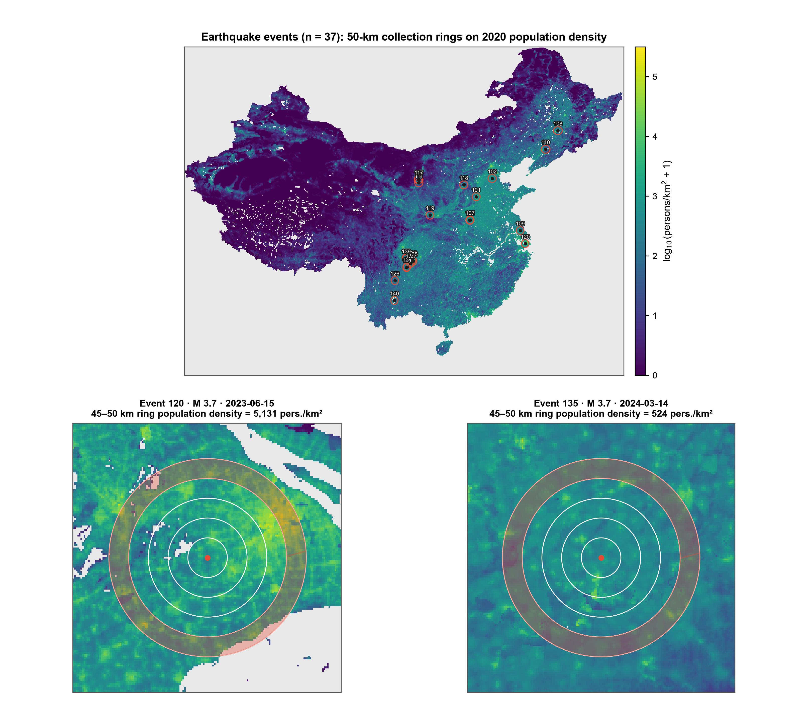

Supplementary Figure S2. Ring-level population density overlays for typhoon events.
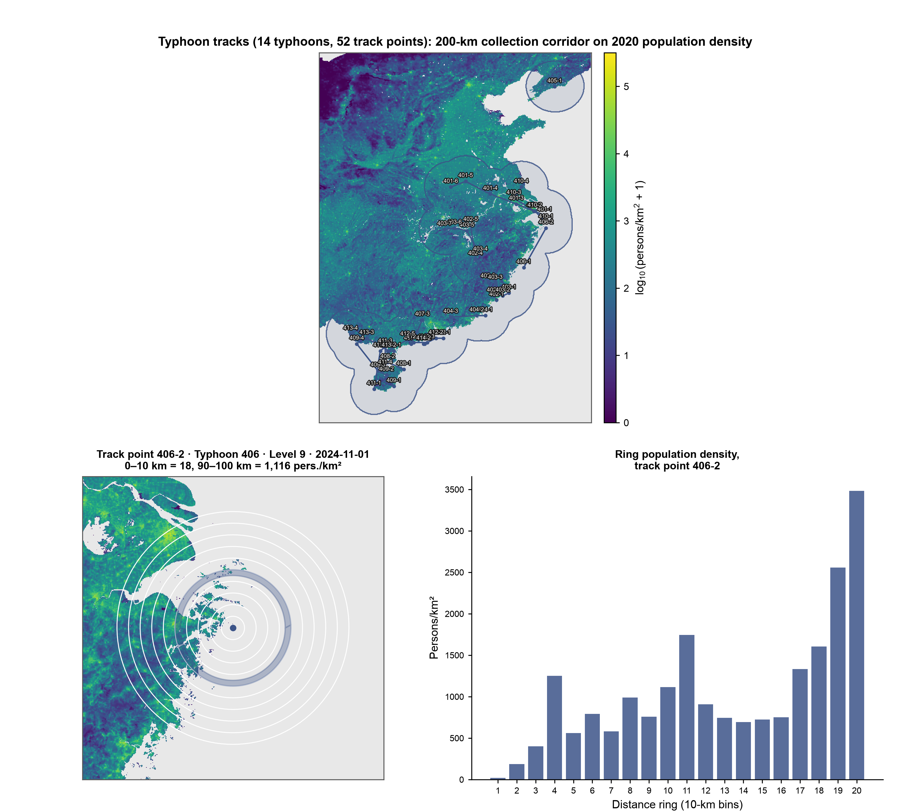

Supplementary Figure S3. Observational coverage by distance ring and time bin (fraction of cells with posts). [RED-图片问题: 本文档中补充图 S2 与 S3 嵌入了同一个图像文件（image8 连续引用两次，渲染后两页完全相同），为原稿遗留问题；请作者重新插入正确的 S3（观测覆盖热图）图片。]
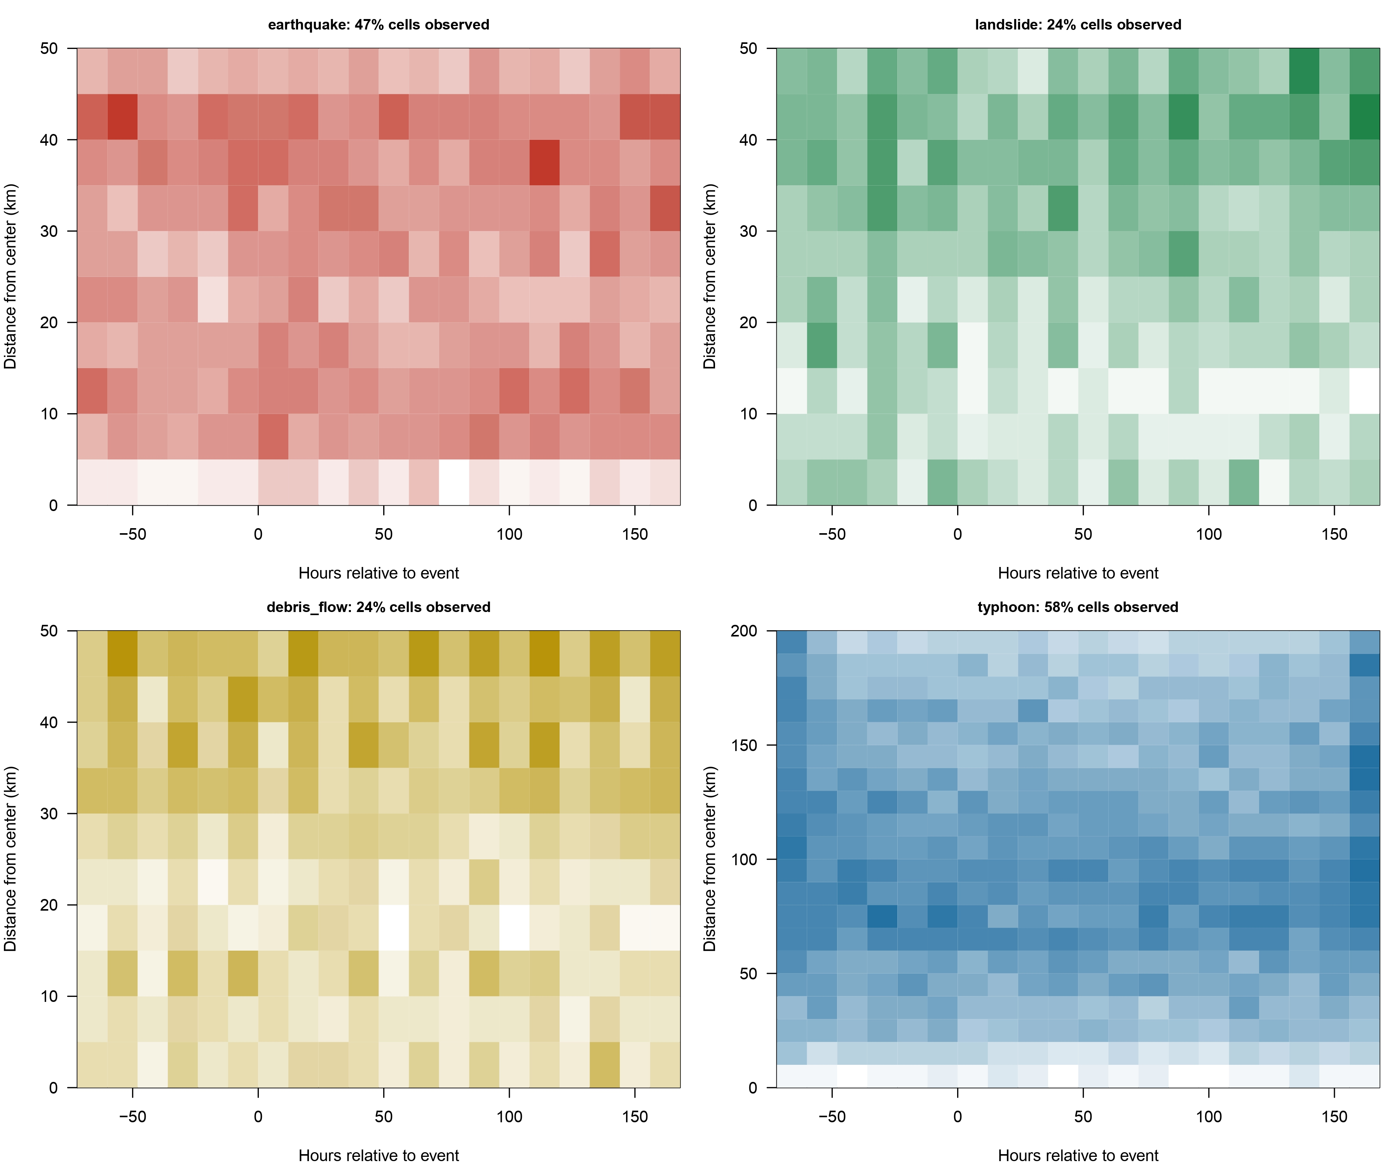

Supplementary Text. Annotation protocol for disorder-related behavior spans.
Posts for behavior-span annotation were drawn from the collected Weibo corpus by stratified sampling across hazard types, event phases, and emotion distributions. Trained annotators worked from a codebook derived from the social-disorder behavior typology and marked, for each post, the contiguous text span that directly expresses or strongly implies a social-disorder behavior intention; posts containing no such content were labeled NONE. Annotation proceeded in two rounds with a between-round consistency check, yielding 580 valid annotation rows; after excluding 23 rows with incomplete span labels and merging duplicate texts, 492 unique posts formed the training corpus. This supplementary text supports the Methods section “NLP-based emotion classification and behavior extraction” by documenting the annotation protocol behind the behavior-extraction corpus. [YELLOW-未完成(A-15): pred_span 跨灾种列举与可比性总结（可选 LDA 主题分类）本轮未完成：需对四灾种 span 做主题分析后新增补充材料，建议下轮补做。]

