**SAS Lab-1**

**Q. 1.) For the Product Category: Children Sports, which are the top 10 cities by Orders?**

Nanterre, Boulogne Billancour, Roma, Paris la Defense, Amsterdam, Milano, Barcelona, London, Madrid, Paris

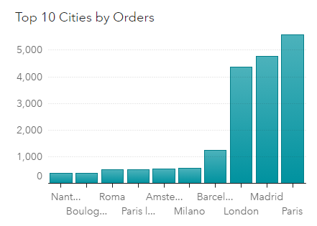

**Q.2.) What is the Total number of Orders for Children Sports?**

Total = 1,904

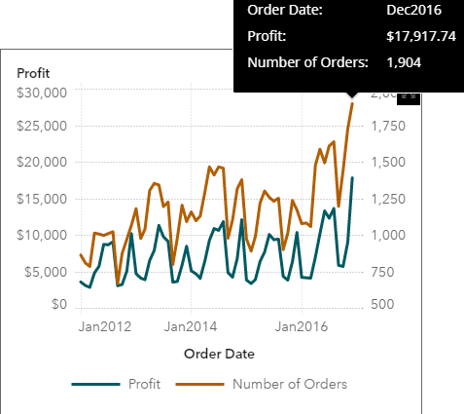

**Q.3.) What are the top 10 cities by Profit for the Product Category- Shoes?**

Munchen, Frankfurt am Main, Berlin, Amsterdam, Barcelona, Milano, Roma, Paris, London, Madrid

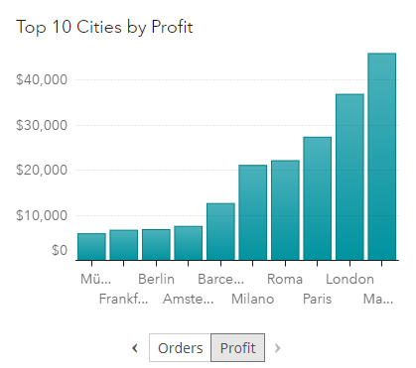

**Q. 4.) In the line chart that shows the Profit and Number of Orders by Order Date, show how you will export the data to an Excel workbook? Attach the Exported Excel workbook.**

Right click the line chart and select ‘Export Data’ via Excel Workbook.

