**EXP NO:** **10**

**Custom Text Styler with Toast Notification in Android**

**AIM:**

Develop an application to change the font and color of the text and display toast message when the user presses the button.

**CODE:**

**MainActivity.kt**

package com.example.myapplication\_rohit\_79  
  
import android.graphics.Color  
import android.os.Bundle  
import android.widget.Button  
import android.widget.TextView  
import android.widget.Toast  
import androidx.activity.enableEdgeToEdge  
import androidx.appcompat.app.AppCompatActivity  
import androidx.core.view.ViewCompat  
import androidx.core.view.WindowInsetsCompat  
  
class MainActivity : AppCompatActivity() {  
 override fun onCreate(savedInstanceState: Bundle?) {  
 super.onCreate(savedInstanceState)  
 enableEdgeToEdge()  
 setContentView(R.layout.activity\_main)  
 var txt:TextView=findViewById(R.id.textView)  
 var btn:Button=findViewById(R.id.button)  
  
 var count=0  
 btn.setOnClickListener {  
 count++  
 txt.text=count.toString()  
 txt.setTextColor(Color.RED)  
 txt.setBackgroundColor(Color.BLACK)  
 Toast.makeText(this,"Color Change and font",Toast.LENGTH\_LONG).show()  
 txt.textSize=18f  
 }  
  
  
 }  
}

**activity\_main.xml**

<?xml version="1.0" encoding="utf-8"?>  
<androidx.constraintlayout.widget.ConstraintLayout xmlns:android="[http://schemas.android.com/apk/res/android](http://schemas.android.com/apk/res/android" \t "_blank)"  
 xmlns:app="[http://schemas.android.com/apk/res-auto](http://schemas.android.com/apk/res-auto" \t "_blank)"  
 xmlns:tools="[http://schemas.android.com/tools](http://schemas.android.com/tools" \t "_blank)"  
 android:id="@+id/main"  
 android:layout\_width="match\_parent"  
 android:layout\_height="match\_parent"  
 tools:context=".MainActivity">  
  
 <TextView  
 android:id="@+id/textView"  
 android:layout\_width="wrap\_content"  
 android:layout\_height="wrap\_content"  
 android:text="Hello World!"  
 app:layout\_constraintBottom\_toBottomOf="parent"  
 app:layout\_constraintEnd\_toEndOf="parent"  
 app:layout\_constraintHorizontal\_bias="0.461"  
 app:layout\_constraintStart\_toStartOf="parent"  
 app:layout\_constraintTop\_toTopOf="parent"  
 app:layout\_constraintVertical\_bias="0.186" />  
  
 <Button  
 android:id="@+id/button"  
 android:layout\_width="wrap\_content"  
 android:layout\_height="wrap\_content"  
 android:layout\_marginTop="172dp"  
 android:text="Count"  
 app:layout\_constraintEnd\_toEndOf="@+id/textView"  
 app:layout\_constraintHorizontal\_bias="0.0"  
 app:layout\_constraintStart\_toStartOf="@+id/textView"  
 app:layout\_constraintTop\_toBottomOf="@+id/textView" />  
  
</androidx.constraintlayout.widget.ConstraintLayout>

**OUTPUT: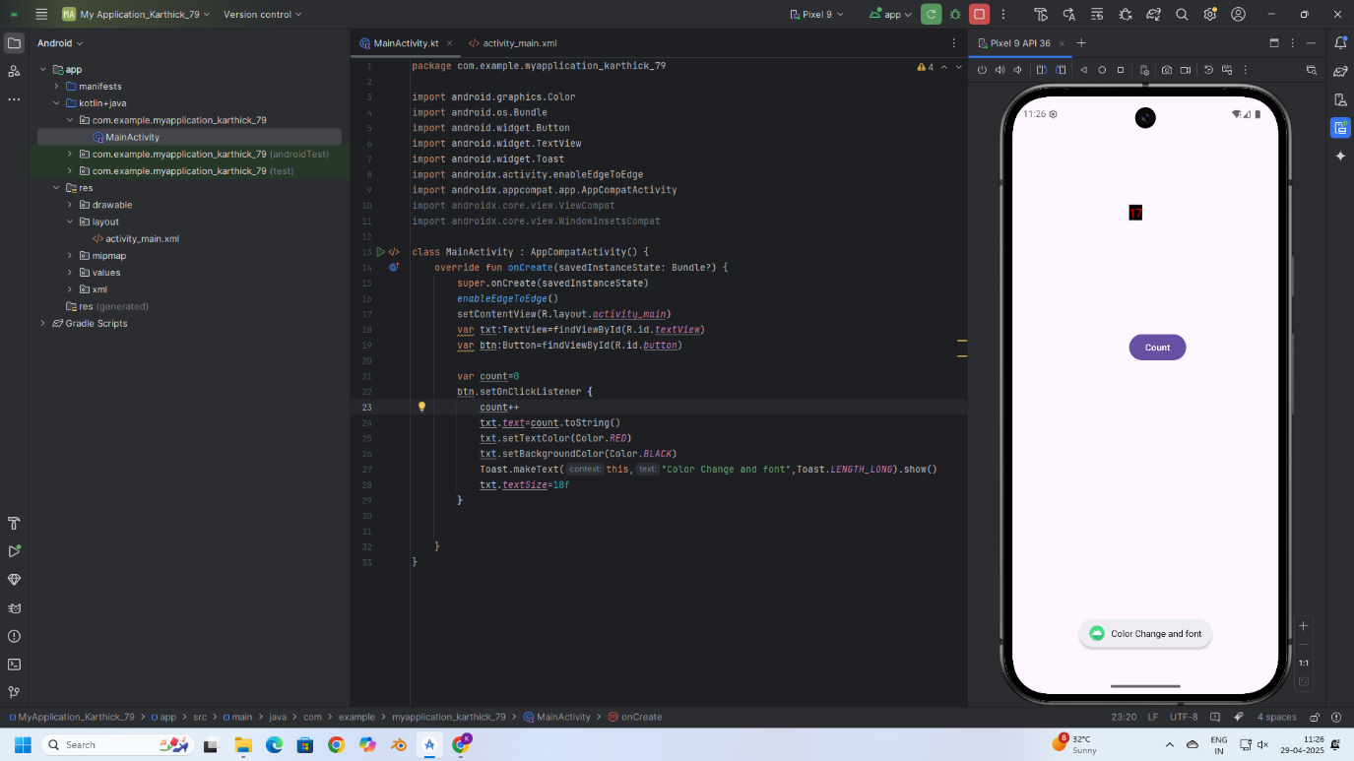**

**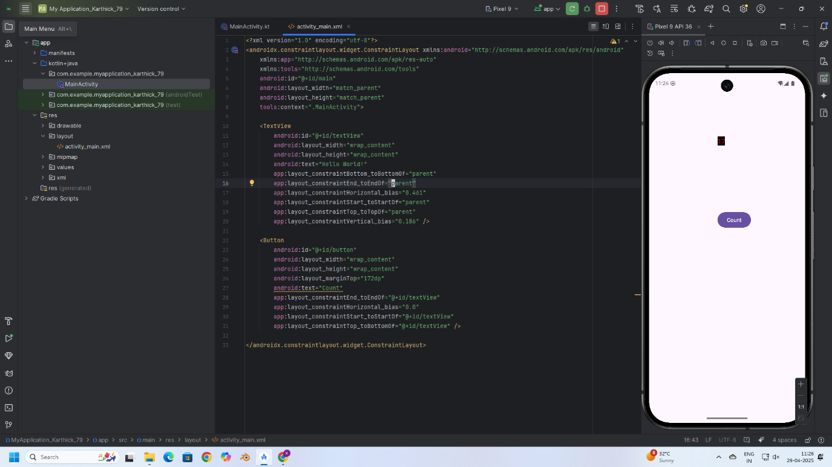**

**RESULT:**

Thus, text customization and user interaction were successfully implemented by changing font and color, and displaying a Toast message on button click in the application.