|  |  |
| --- | --- |
| **Exp No: 3**  **Date: 23.2.25** | **HELLO WORLD IN SERVLET** |

**AIM:**

To write a servlet program that prints “Hello World !” when accessed through a browser.

**PROGRAM:**

<%@ page language=*"java"* contentType=*"text/html; charset=ISO-8859-1"*

pageEncoding=*"ISO-8859-1"*%>

<!DOCTYPE html>

<html>

<head>

<meta charset=*"ISO-8859-1"*>

<title>hello</title>

</head>

<body>

<h1>Hello World</h1>

</body>

</html>

**OUTPUT:**

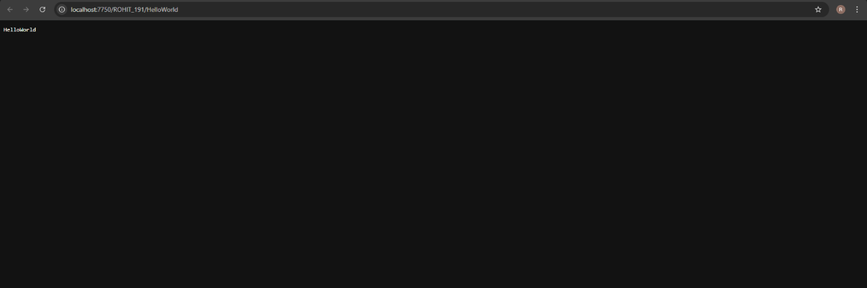

**RESULT :**Thus the experiment to print “Hello world “ using servlet when accessed through a browser has been implemented and verified successfully