Ex: 1 | Private Cloud using OpenStack
Date:24/06/2026 | Private Cloud using OpenStack

Aim
To create a private cloud environment by installing and configuring OpenStack (MicroStack) on a single Ubuntu system. The experiment also helps in learning how cloud resources such as virtual machines, networking, and storage are managed in a private cloud.
What is OpenStack?
OpenStack is an open-source cloud platform used to build and manage cloud infrastructure. It is mainly used for Infrastructure as a Service (IaaS), where users can create and control virtual machines whenever required. It provides services for computing, networking, and storage in a cloud environment.
What is MicroStack?
MicroStack is a lightweight version of OpenStack that runs on a single computer. It is mainly used for learning, testing, and small-scale development. Since it requires only minimal configuration, it is a good choice for beginners who want to understand how OpenStack works.
Procedure
Step 1 — Create the virtual machine
Create a new Ubuntu virtual machine using Oracle VirtualBox with the following configuration:
- Memory: 8 GB RAM
- Processor: 4 CPU Cores
- Storage: 20 GB Virtual Disk
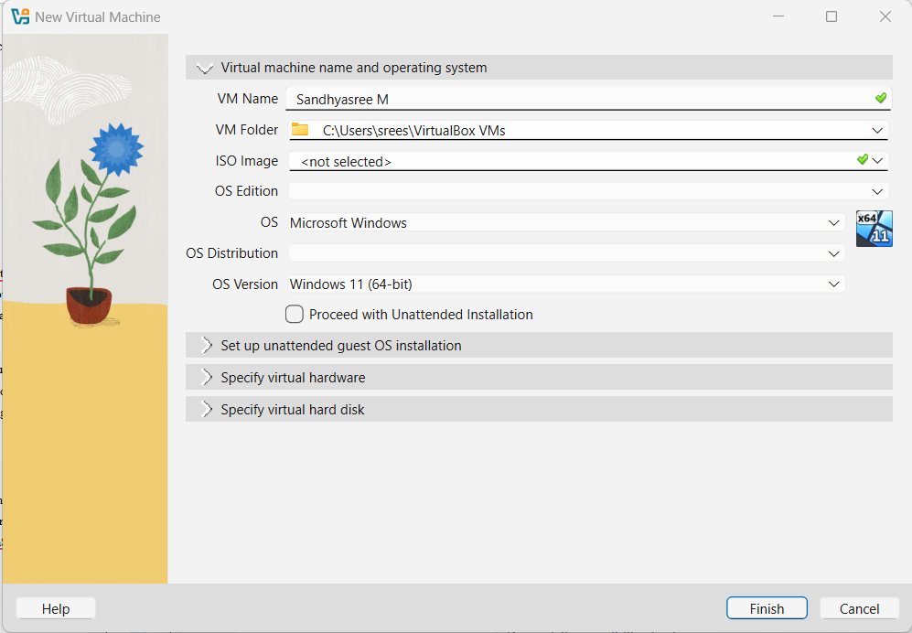
Step 2 — Install Ubuntu
Install the Ubuntu operating system and log in using the username and password created during installation.
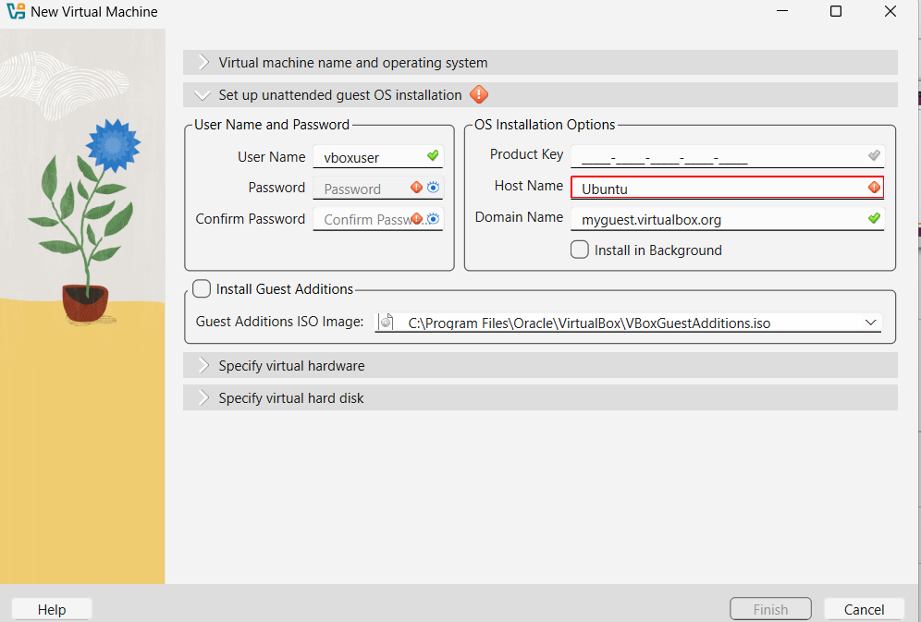
Step 3 — Update the system
Update the Ubuntu packages:
sudo apt update
sudo apt upgrade
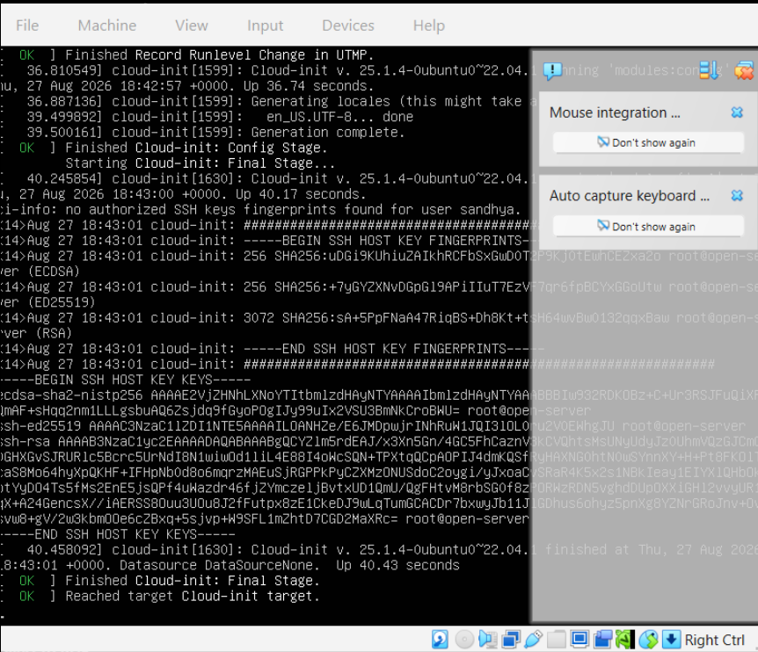
Step 4 — Install MicroStack
Install MicroStack (Beta channel):
sudo snap install microstack --beta
Step 5 — Confirm the installation
Check whether MicroStack has been installed successfully.
snap list microstack
Step 6 — Initialize OpenStack
Initialize the OpenStack services automatically by executing the following command.
sudo microstack init --auto --control
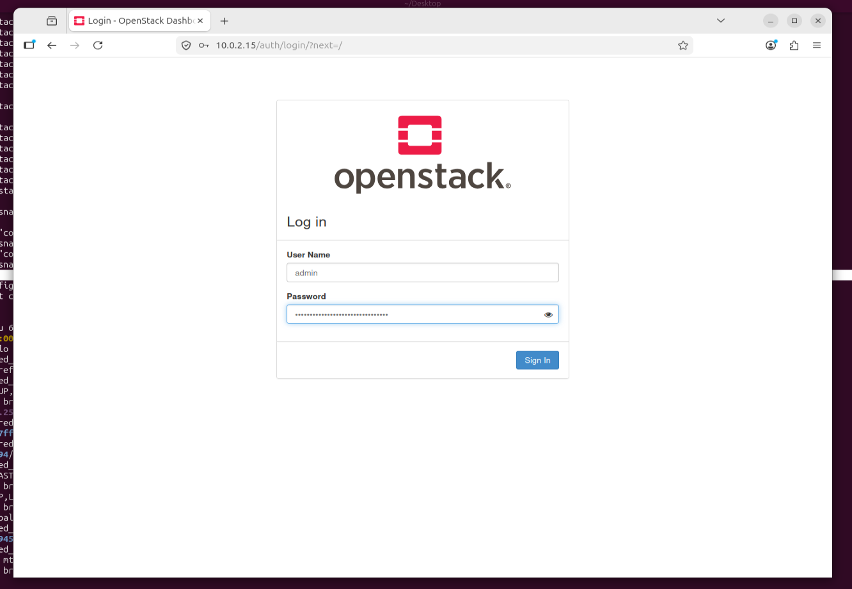
Step 7 — Verify the version
Verify the installed OpenStack version:
microstack.openstack --version

Step 8 — Retrieve the administrator password
Retrieve the Keystone administrator password:
sudo snap get microstack config.credentials.keystone-password

Step 9 — Log in to the Horizon Dashboard
Open the OpenStack Horizon Dashboard in the web browser using the IP address provided after initialization and log in using:
- Username: admin
- Password: (obtained from the previous command)
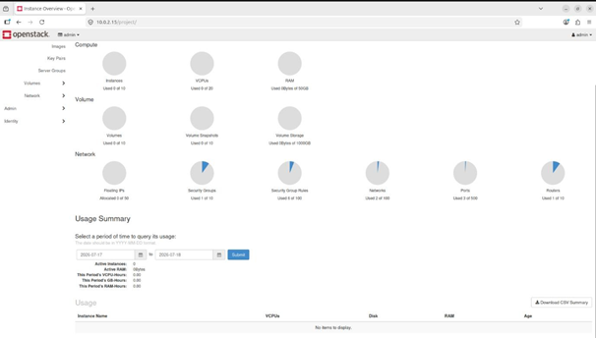

Conclusion
OpenStack (MicroStack) was successfully installed and configured on Ubuntu, and the Horizon Dashboard was accessed.

Ex: 2 | PaaS in Public Cloud Using Render
Date:08/07/2026 | PaaS in Public Cloud Using Render

Aim
To build a basic Python Flask web application and deploy it on the Render cloud platform. This experiment helps in understanding how a Platform as a Service (PaaS) allows applications to run online without manually setting up or maintaining servers.
What is PaaS?
Platform as a Service (PaaS) is a cloud service that provides everything needed to develop, deploy, and run an application. It takes care of server management, software installation, and deployment, allowing developers to focus only on writing the application.
Why Render?
Render is an easy-to-use cloud hosting platform that supports web application deployment directly from GitHub. It automatically builds and hosts the application, making deployment simple even for beginners.
Procedure
Step 1 — Sign in to GitHub
Sign in to your GitHub account, or create one if you do not already have an account.
Step 2 — Create the project folder
Create a project folder named RenderHelloApp.
Step 3 — Create the project files
Inside the project folder, create the following files:
- app.py
- requirements.txt
Step 4 — Write the Flask application
Write the Flask application code in the app.py file.
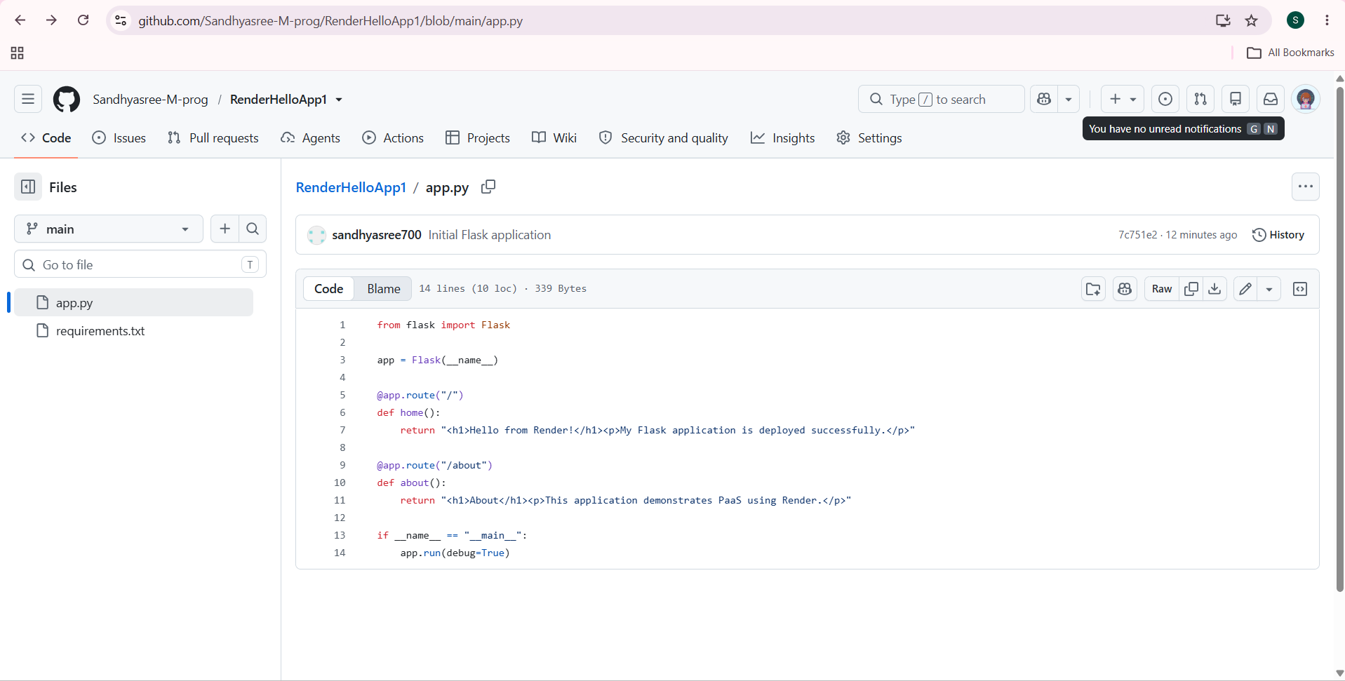
Step 5 — Add dependencies
Add the required Python packages such as Flask and Gunicorn to the requirements.txt file.
Step 6 — Create the GitHub repository
Create a new public repository called RenderHelloApp on GitHub.
Step 7 — Push the project
Upload both project files to the repository and commit the changes.
Step 8 — Connect Render to GitHub
Create an account on Render and connect it to your GitHub account.
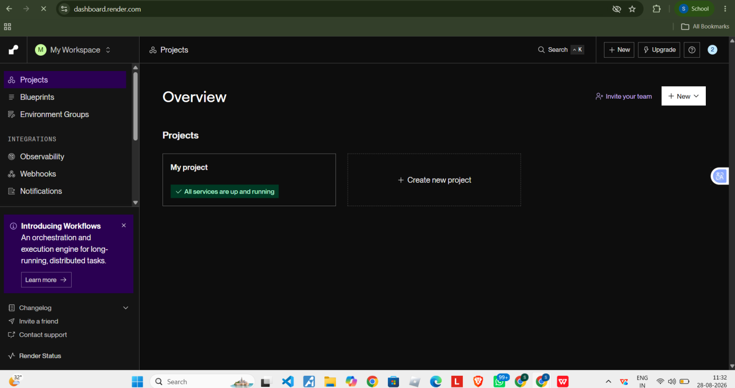
Step 9 — Create a Web Service
Create a new Web Service in Render.
Step 10 — Select the repository
Select the RenderHelloApp repository from GitHub.
Step 11 — Enter the deployment details
- Language: Python
- Branch: main
- Root Directory: Leave empty
- Build Command: pip install -r requirements.txt
- Start Command: gunicorn app:app
- Instance Type: Free (if available)
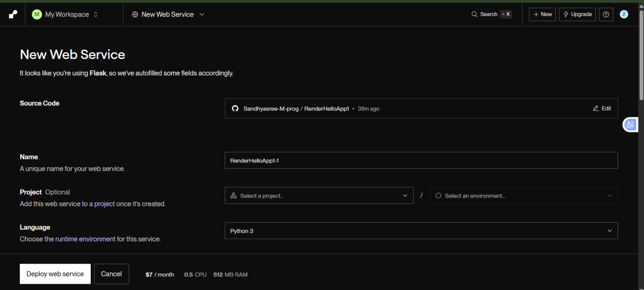
Step 12 — Deploy
Click Deploy Web Service and wait for the deployment to complete.
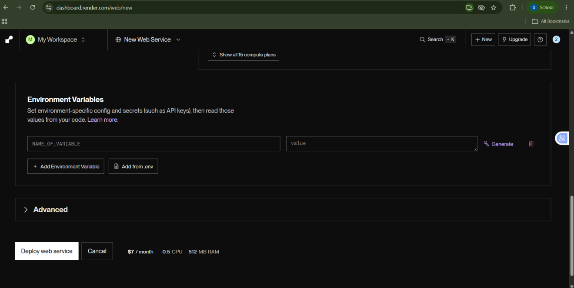
Step 13 — Verify the home page
After deployment, open the URL generated by Render and check whether the home page is displayed correctly.
Step 14 — Verify the second route
Add /about at the end of the application URL to verify that the second route is also working properly.
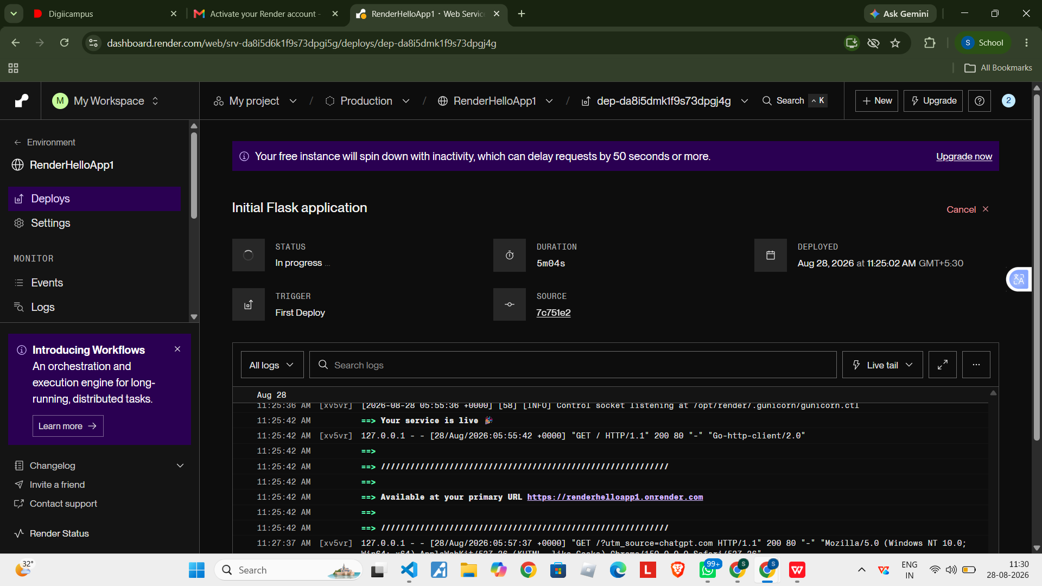
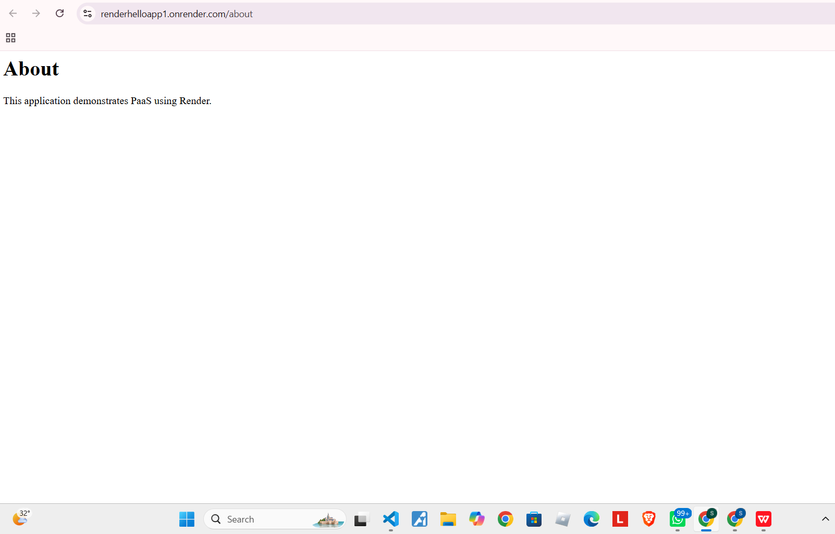

Conclusion
This experiment demonstrated how a Flask application can be deployed using Render, a Platform as a Service. PaaS simplifies application deployment by handling the server setup and hosting, allowing developers to publish applications quickly without managing infrastructure.

Ex: 3 | Setting Up Hybrid Cloud Connectivity Using Cisco Packet Tracer (Simulation)
Date:22/07/2026

Aim
To simulate a secure hybrid cloud connection between an on-premises data centre and a cloud network using routers, switches, subnets, and routing in Cisco Packet Tracer.
Procedure
Step 1 — Open Cisco Networking Academy
Go to: https://www.netacad.com
Step 2 — Create a free account
Create a free account, or sign in with your Google account.
- Click Create an account (or Sign up).
- Enter your First Name, Last Name, Email Address and Password.
- Verify your email if prompted.
- Sign in.
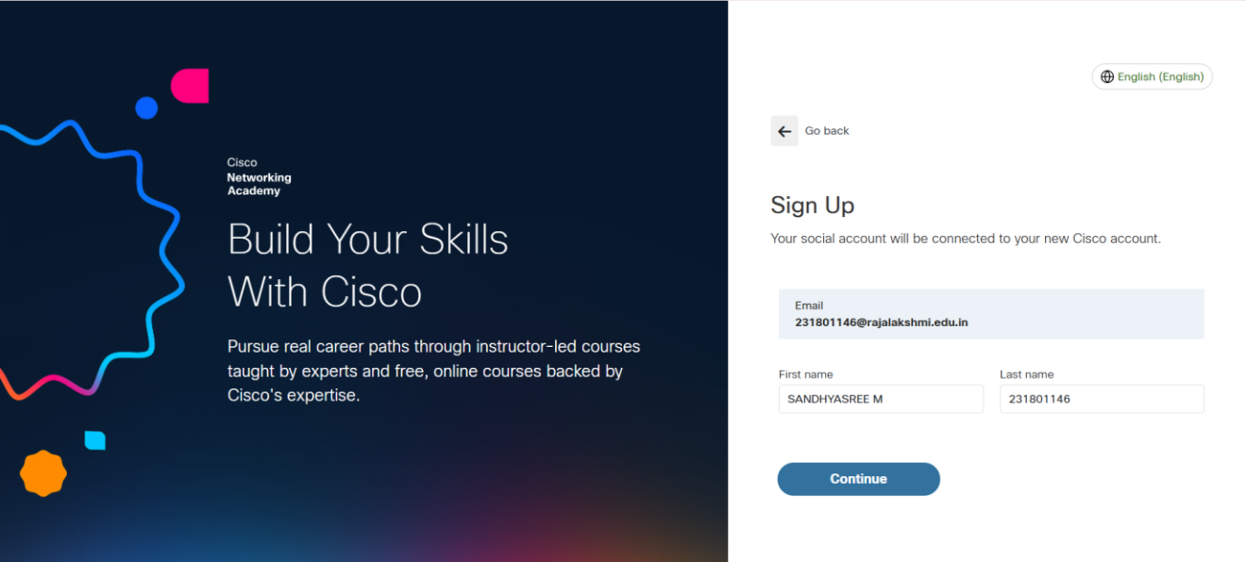
Step 3 — Enroll in the Packet Tracer course
Enroll in the free “Getting Started with Cisco Packet Tracer” course on NetAcad.
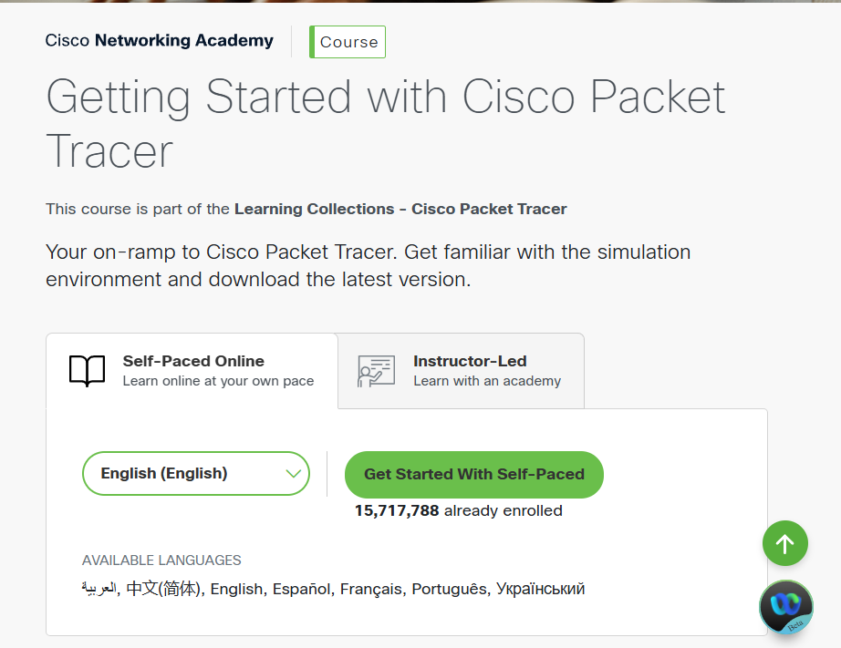
Step 4 — Download Packet Tracer
After enrolling:
- Go to your NetAcad Dashboard.
- Open the Getting Started with Cisco Packet Tracer course.
- Navigate to the Resources or Downloads section.
- Download the version for your operating system: Windows 64-bit, macOS, or Linux.
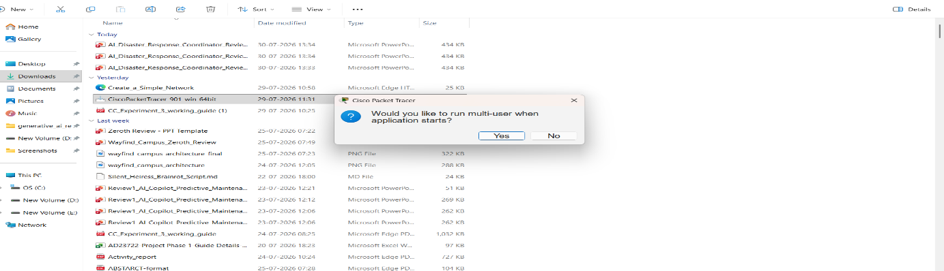
Step 5 — Install Packet Tracer
- Open the downloaded installer (.exe on Windows).
- Click Next.
- Accept the license agreement.
- Click Next until installation completes.
- Click Finish.
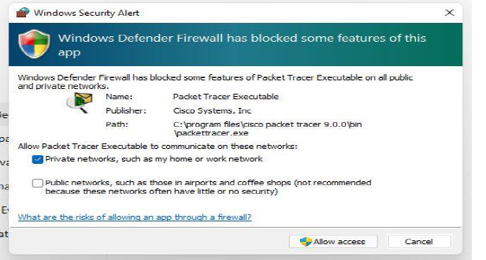
Step 6 — Start Packet Tracer
Open Cisco Packet Tracer from the Start Menu and sign in with your Cisco NetAcad account, or with your Google account.
Step 7 — Place two routers
At the bottom-left of Packet Tracer you will see several device icons.
- Click Network Devices (the router icon).
- Click Routers.
- Choose 2911 (or 1941 if 2911 isn't available).
- Click once in the blank workspace to place the first router, then again to place the second.
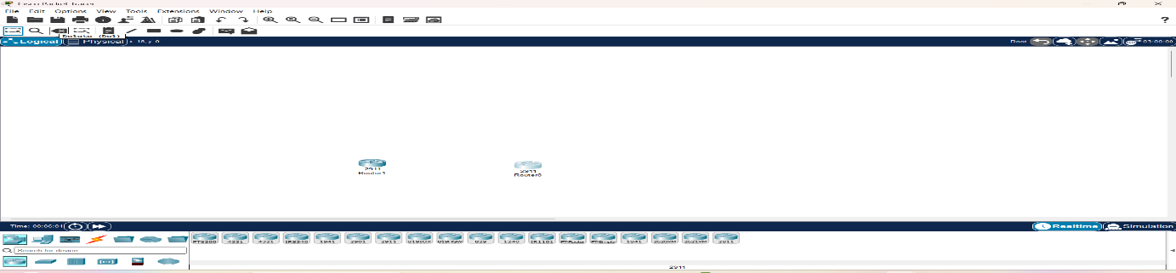
Step 8 — Place two switches
- At the bottom-left, click Network Devices.
- Click Switches.
- Select 2960 (for example, 2960-24TT).
- Place one switch below Router0.
- Place another switch below Router1.
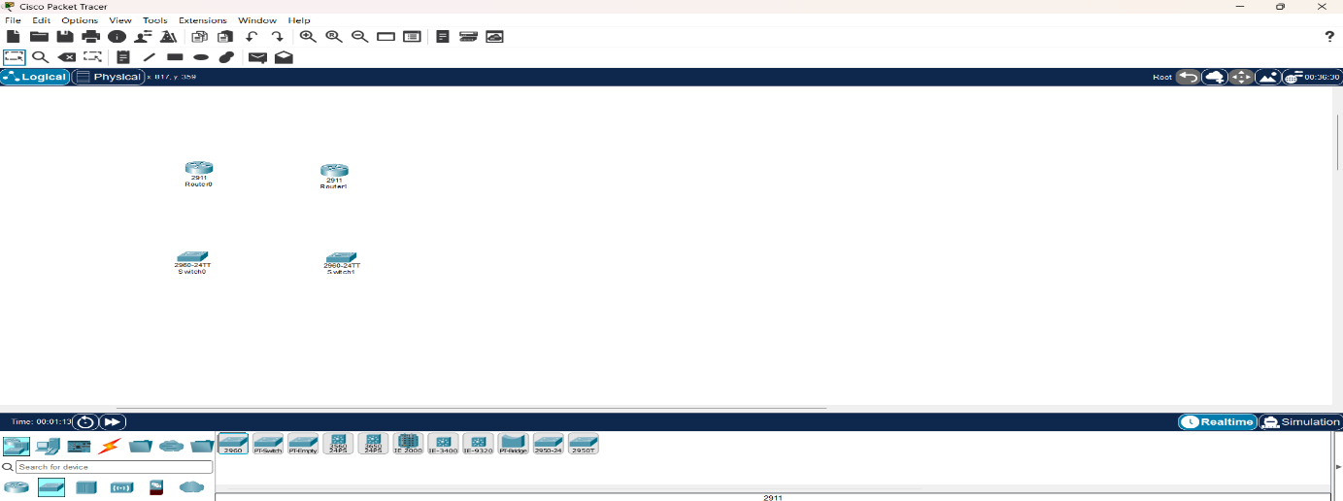
Step 9 — Place one PC and one server
- At the bottom-left, click End Devices (computer icon).
- Select PC and place it to the left of Switch0.
- Select Server and place it to the right of Switch1.
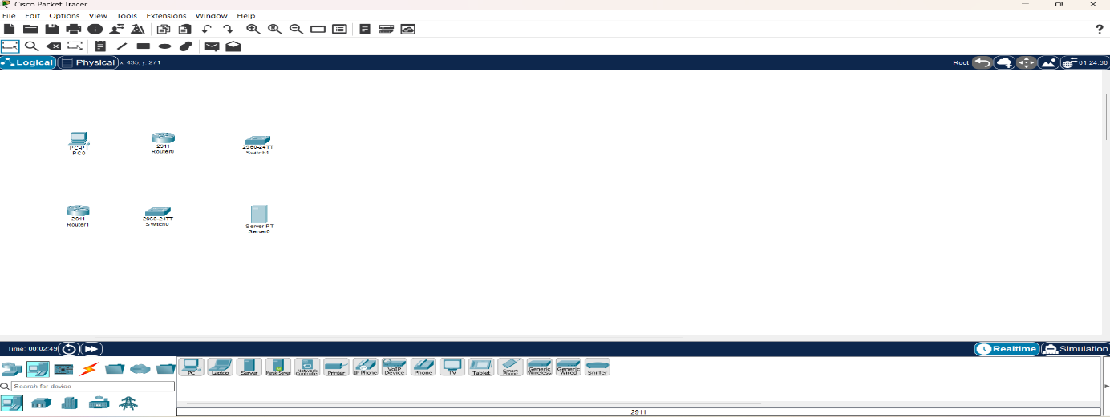
Step 10 — Connect the devices
At the bottom-left, click the Connections icon (lightning bolt) and choose Copper Straight-Through (usually the first black cable).
Connection 1: PC to Switch0
- Click PC and select FastEthernet0.
- Click Switch0 and select FastEthernet0/1 (or any free FastEthernet port).
Connection 2: Switch0 to Router0
- Click Switch0 and select FastEthernet0/2.
- Click Router0 and select GigabitEthernet0/0.
Connection 3: Server to Switch1
- Click Server and select FastEthernet0.
- Click Switch1 and select FastEthernet0/1.
Connection 4: Switch1 to Router1
- Click Switch1 and select FastEthernet0/2.
- Click Router1 and select GigabitEthernet0/0.
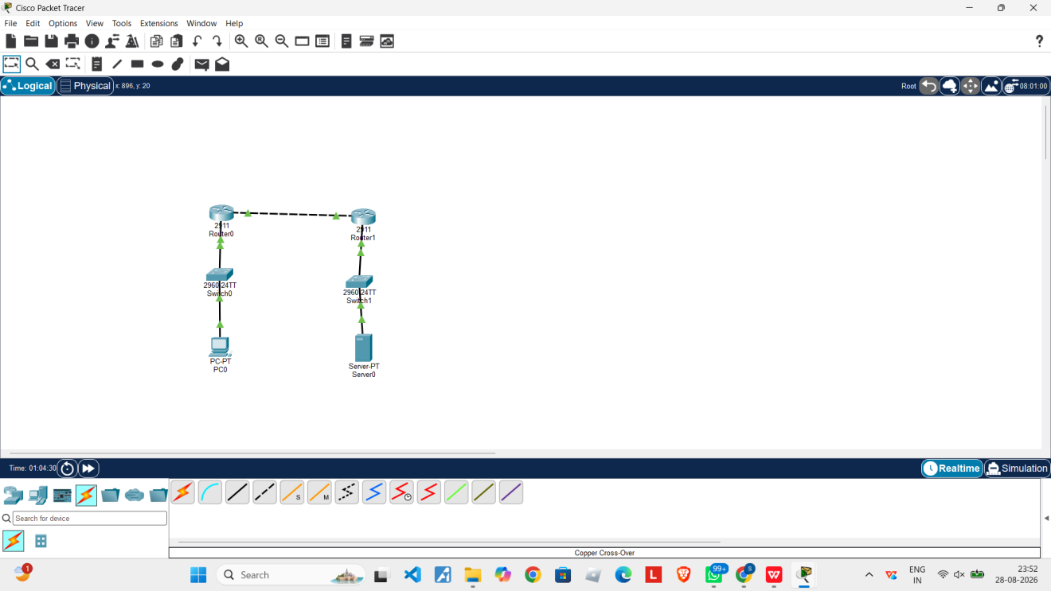
Step 10.1 — Connect Router0 to Router1
Use a Copper Cross-Over cable to connect the two routers directly.
- Click the Connections icon and select Copper Cross-Over.
- Click Router0 and select GigabitEthernet0/1.
- Click Router1 and select GigabitEthernet0/1.
The topology now shows both routers, switches, the PC and the server connected as one network (see the diagram above).
Step 10.2 — Open the router CLI
In the workspace, left-click Router0 once.
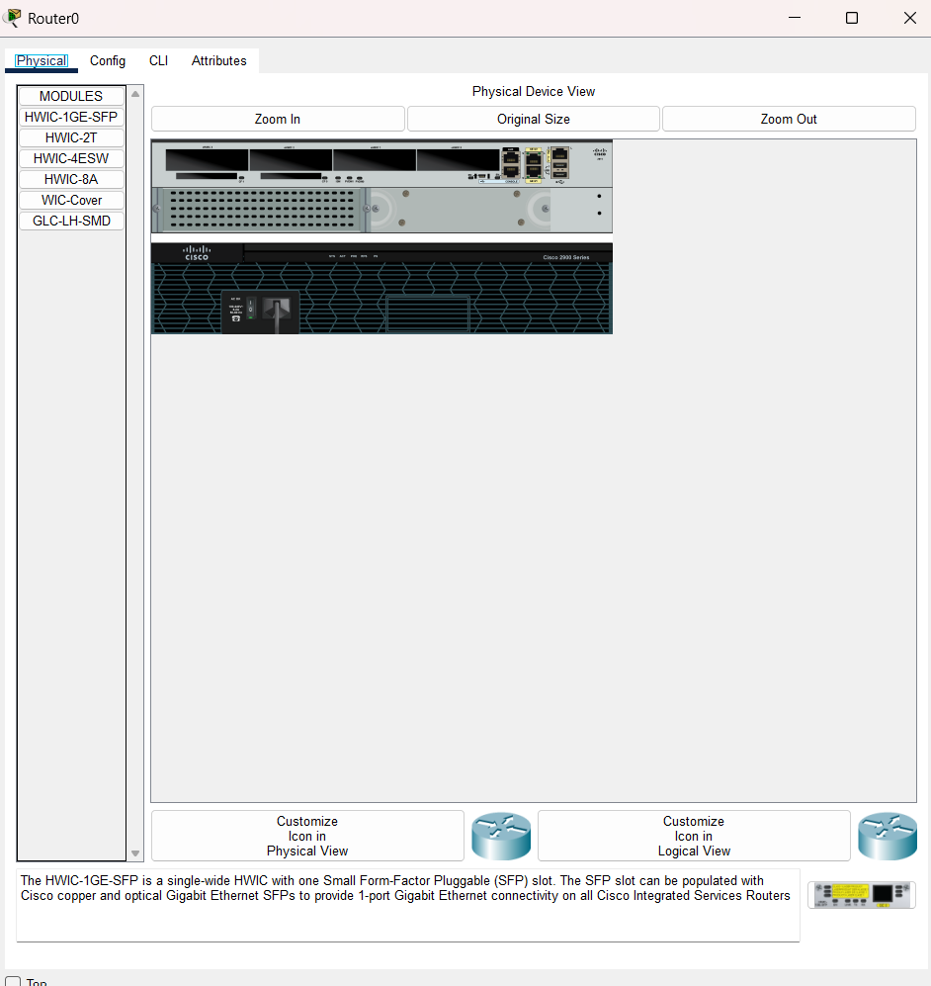
- Click the CLI tab.
- If prompted “Continue with configuration dialog? [yes/no]:”, type no and press Enter.
- Wait until you see the Router> prompt.
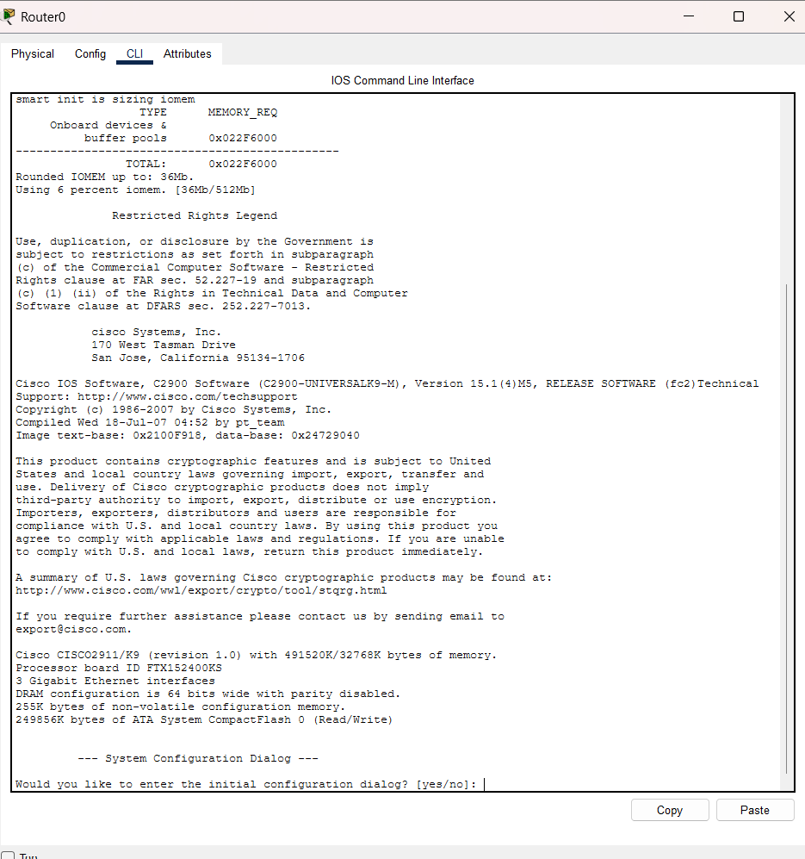
Step 10.3 — Configure the LAN interface (connected to Switch0)
At the Router(config)# prompt, type the following commands one at a time, pressing Enter after each line:
interface gigabitEthernet0/0
ip address 192.168.1.1 255.255.255.0
no shutdown
The interface should come up with a confirmation message.
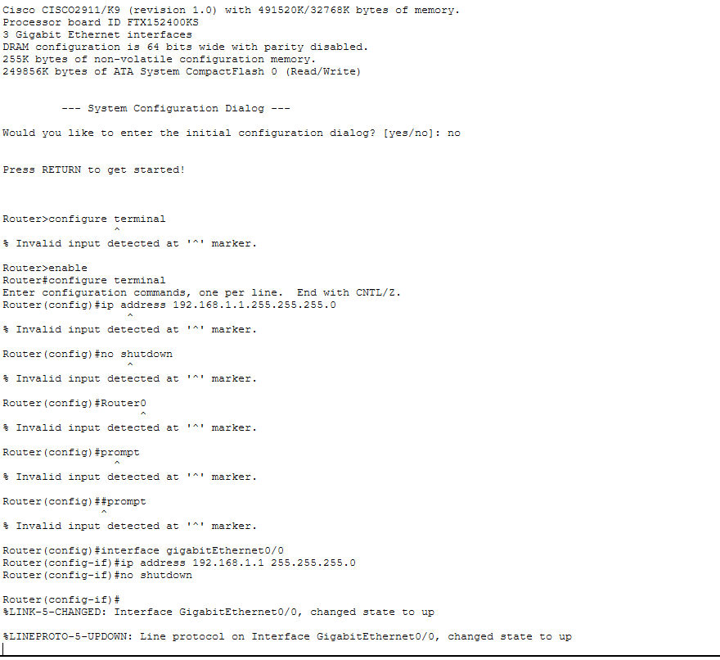
Step 10.4 — Configure the router-to-router interface
interface gigabitEthernet0/1
ip address 10.10.10.1 255.255.255.252
no shutdown
exit
Wait for the interface to come up; you should return to the Router(config)# prompt.
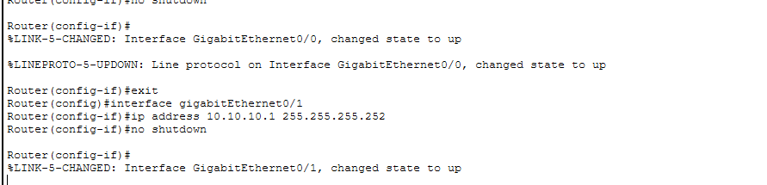
Step 10.5 — Verify the configuration
In configuration mode, prefix show commands with do:
do show ip interface brief
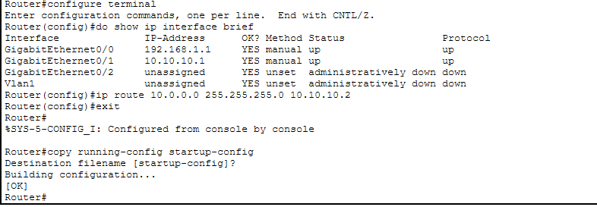
Step 10.6 — Configure Router1
Click Router1 → CLI. Press Enter if prompted, and type no if asked to continue with the configuration dialog. Then enter the following commands one by one:
enable
configure terminal
interface gigabitEthernet0/0
ip address 10.0.0.1 255.255.255.0
no shutdown
exit
interface gigabitEthernet0/1
ip address 10.10.10.2 255.255.255.252
no shutdown
exit
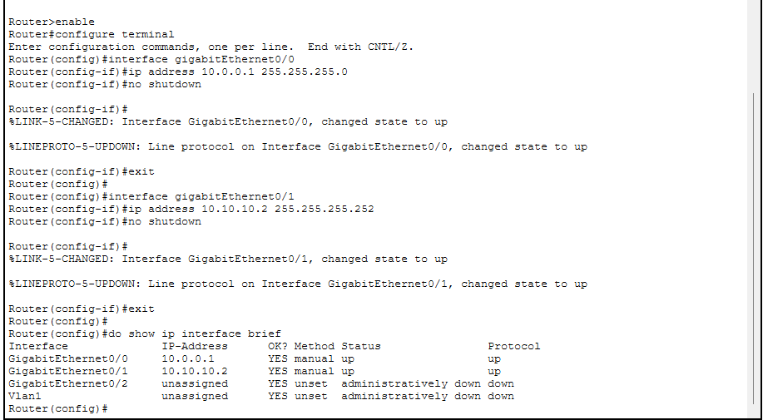
Step 10.7 — Configure the PC
- Click PC.
- Select Desktop.
- Click IP Configuration and set the IP address, subnet mask, and gateway for the 192.168.1.0/24 network.
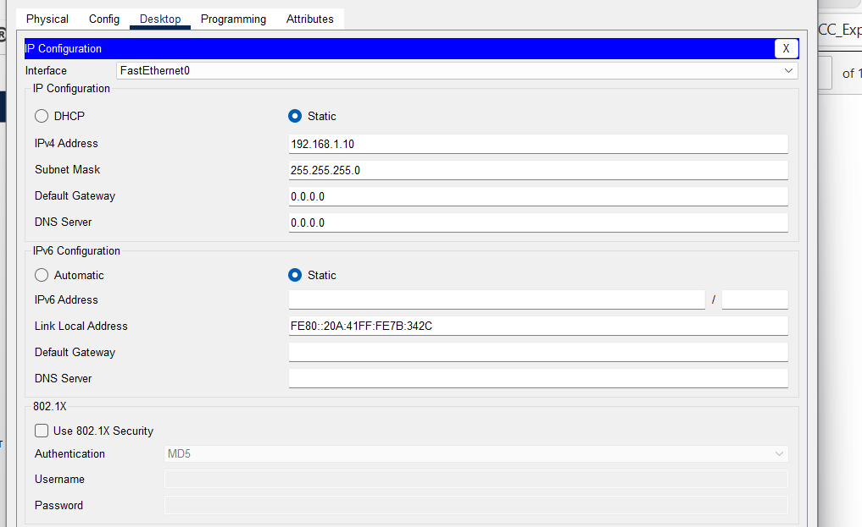
Step 10.8 — Configure the server
- Click Server.
- Select Desktop.
- Click IP Configuration and set the IP address, subnet mask, and gateway for the 10.0.0.0/24 network.
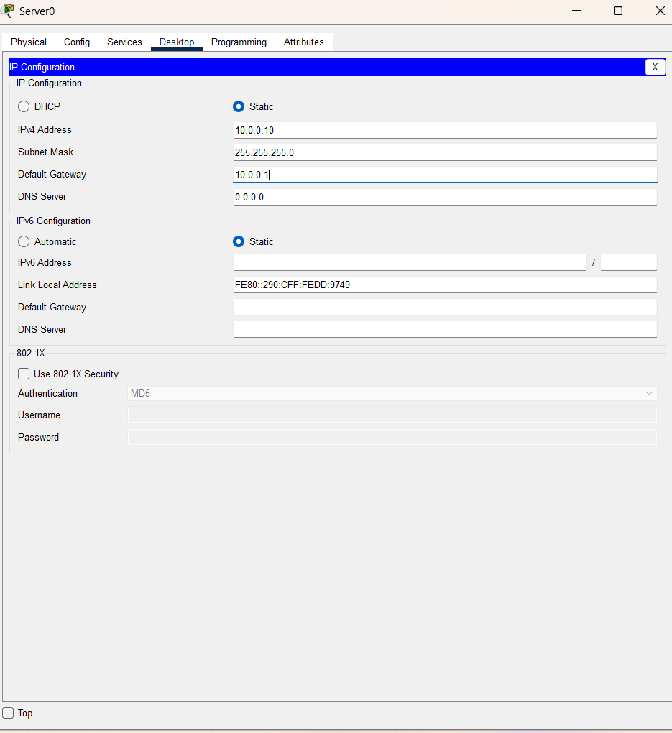
Step 11 — Configure static routes
A. Static route on Router0
configure terminal
ip route 10.0.0.0 255.255.255.0 10.10.10.2
exit
copy running-config startup-config
When prompted for the destination filename, press Enter to accept the default.
B. Static route on Router1
configure terminal
ip route 192.168.1.0 255.255.255.0 10.10.10.1
exit
copy running-config startup-config
C. Verify the route
On Router1, type show ip route. You should see a line similar to:
S 192.168.1.0/24 [1/0] via 10.10.10.1
The “S” indicates that the static route has been added successfully.
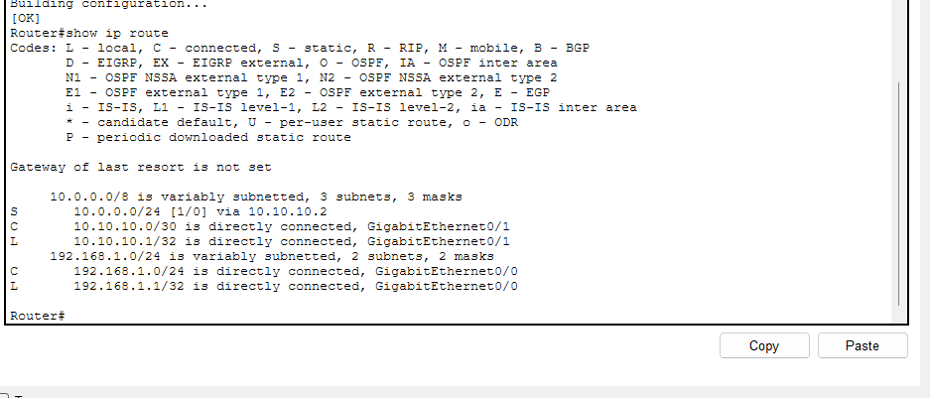
On Router0, type show ip route. You should see a line similar to:
S 10.0.0.0/24 [1/0] via 10.10.10.2
If the route is missing, add it directly and save the configuration again:
configure terminal
ip route 10.0.0.0 255.255.255.0 10.10.10.2
end
copy running-config startup-config
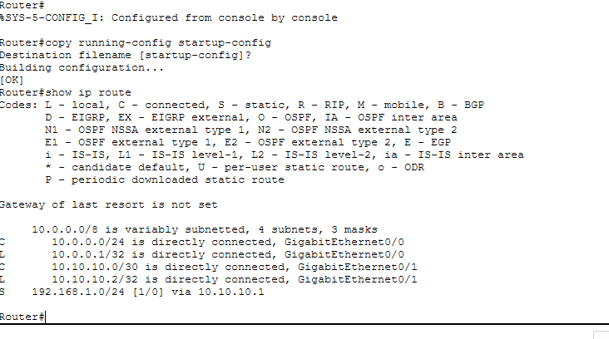
Step 12 — Test connectivity
From the PC:
- Click PC → Desktop → Command Prompt.
- Type ping 10.0.0.10 and press Enter.
- Repeat the ping to confirm the connection is stable.
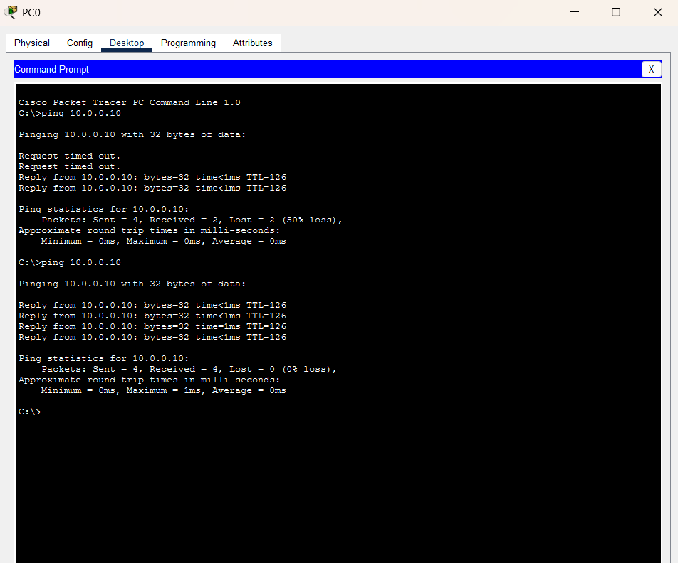
Architecture diagram of the simulation
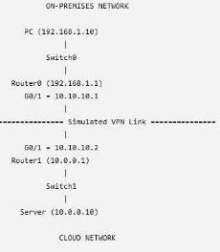

Conclusion
A hybrid cloud network was successfully simulated using Cisco Packet Tracer. The on-premises network and cloud network were interconnected through routers configured with static routing. Communication between the PC and the cloud server was verified successfully using the ping command, demonstrating end-to-end connectivity.

Ex: 4 | Provisioning a VPS and Configuring Network Settings
Date:05/08/2026 | Provisioning a VPS and Configuring Network Settings

Aim
To provision a Virtual Private Server (VPS) using VirtualBox, install Ubuntu Server, configure network settings (IP address, subnet mask, gateway, DNS), and enable SSH remote access.
What is a VPS?
A Virtual Private Server (VPS) is a software-based server created using virtualization technology. It operates independently with its own operating system, storage, memory, and network configuration while sharing the physical hardware with other virtual machines. Virtualization allows efficient utilization of resources and forms the foundation of cloud computing platforms.
Network configuration parameters
IP Address | A unique address assigned to a device on a network.
Subnet Mask | Determines the network and host portions of an IP address.
Gateway | Provides access to networks outside the local network.
DNS (Domain Name System) | Converts domain names into IP addresses.
SSH (Secure Shell) | A secure protocol used for remote administration of Linux systems.

Procedure
Step 1 — Verify the internet connection
Open the Ubuntu terminal and verify the internet connection using the ping google.com command.
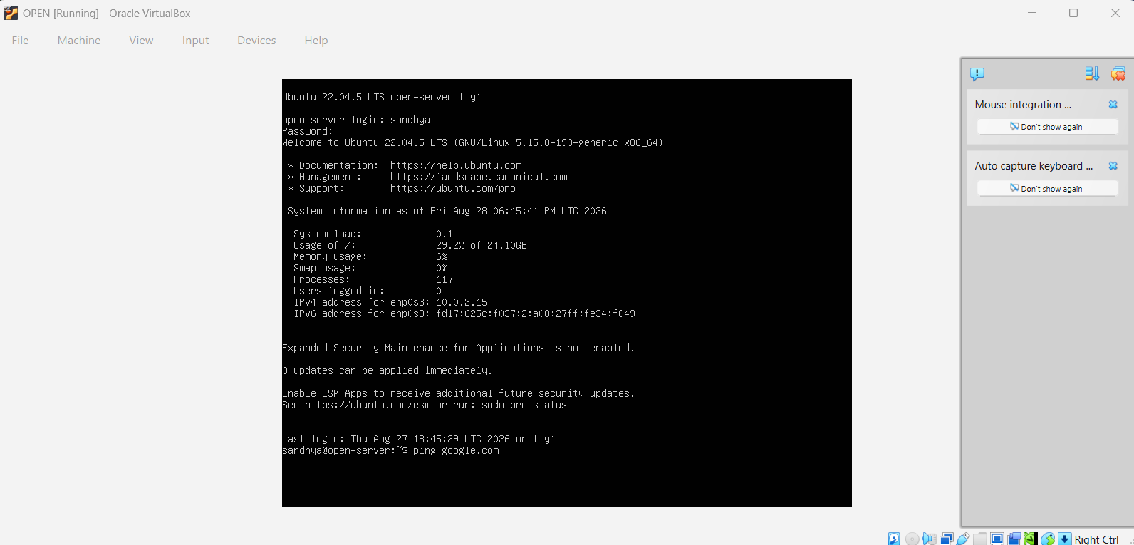
Step 2 — Check network routing
Check the network routing information using the ip route command.
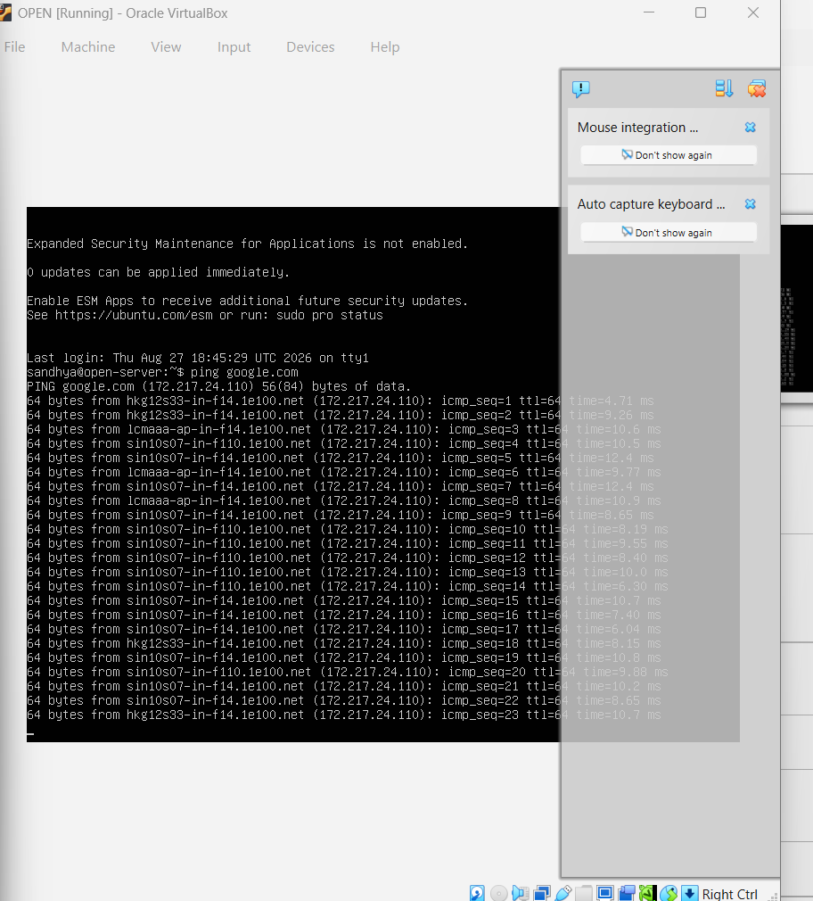
Step 3 — Verify the DNS configuration
Verify the DNS configuration of the system using the cat /etc/resolv.conf command.
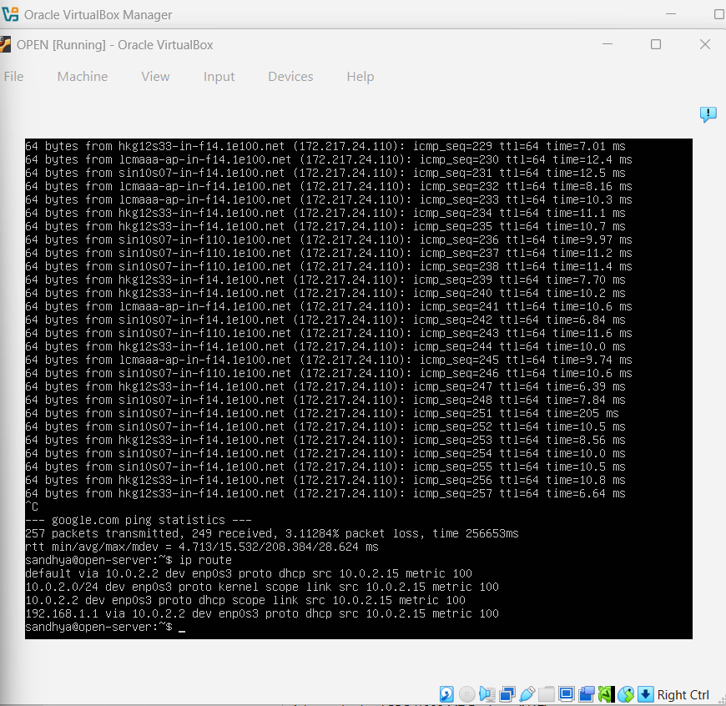
Step 4 — Update the package list
Update the Ubuntu package list, if required:
sudo apt update
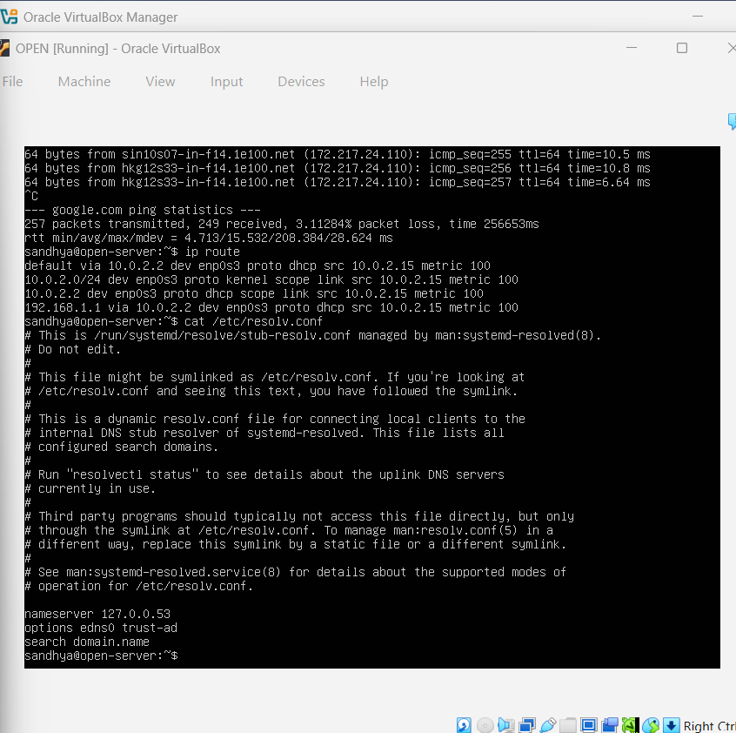
Step 5 — Install the OpenSSH server
sudo apt install openssh-server -y
Step 6 — Enable and start the SSH service
sudo systemctl enable ssh
sudo systemctl start ssh
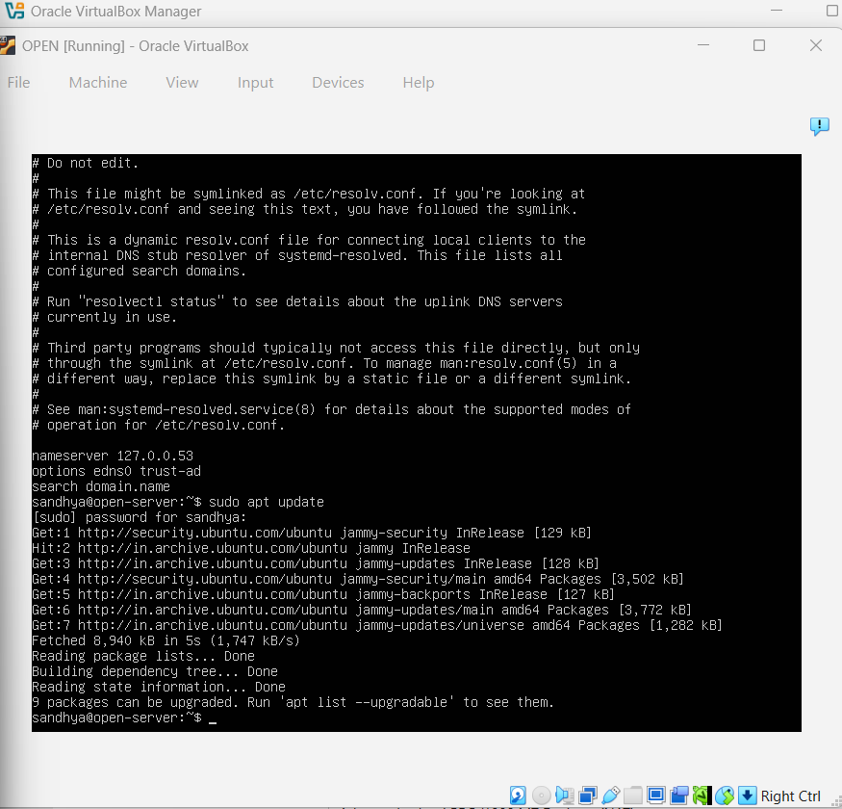
Step 7 — Check the SSH service status
sudo systemctl status ssh
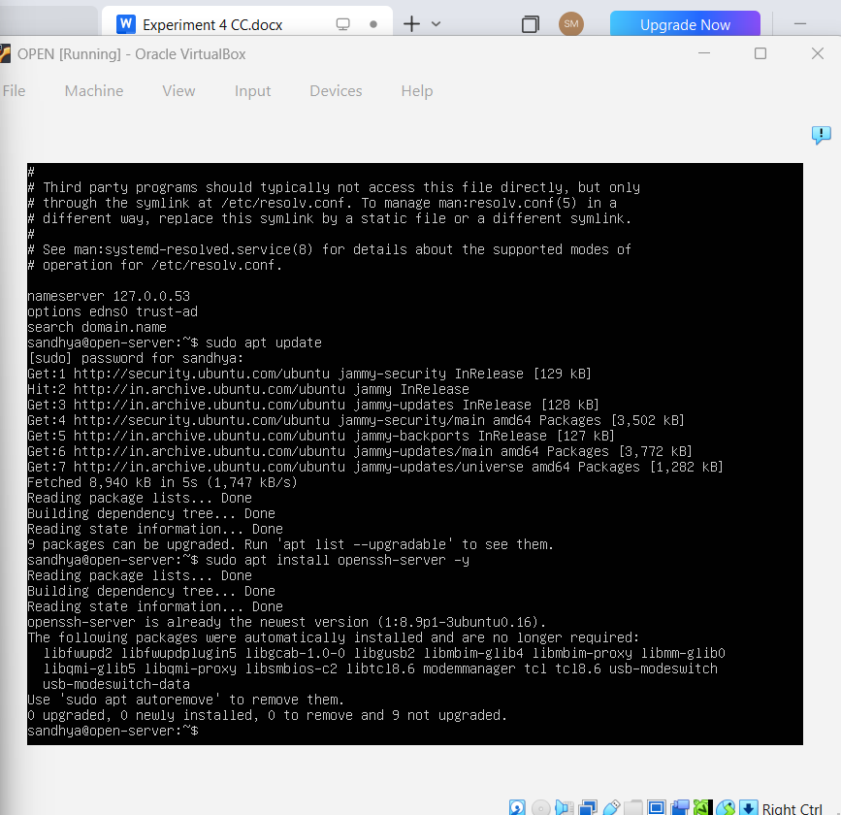
Step 8 — Find the system's IP address
hostname -I
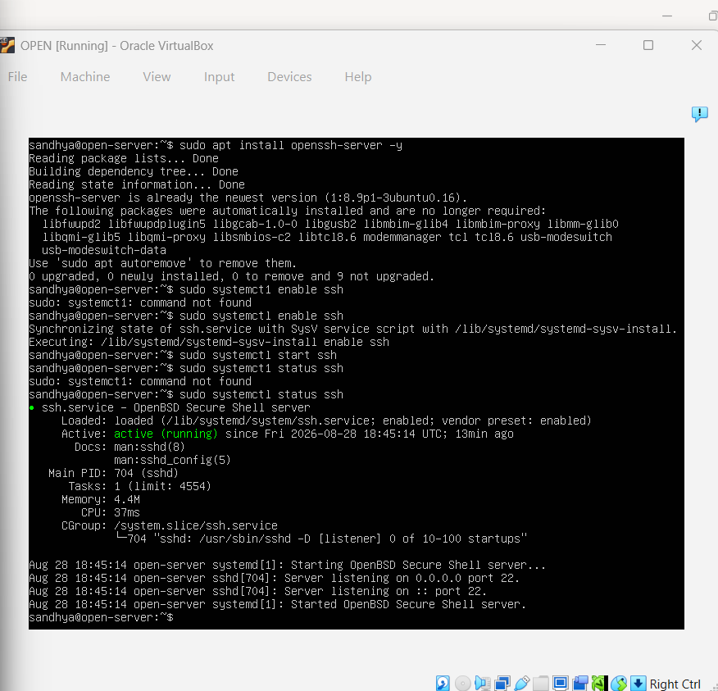
Step 9 — Establish an SSH connection
ssh <username>@<IP_address>
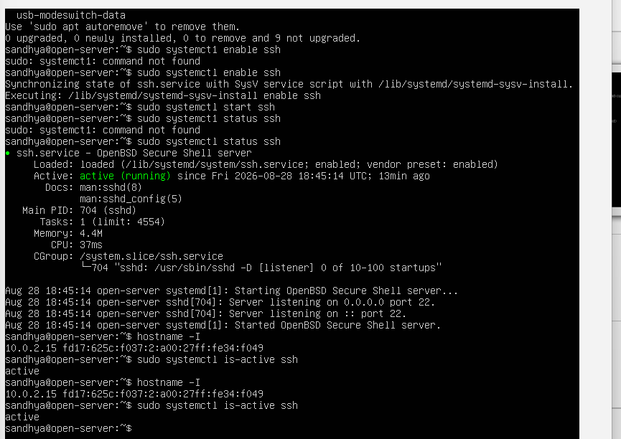
Step 10 — Verify the login
Verify the successful SSH login by checking the “Welcome to Ubuntu” message displayed on the terminal.
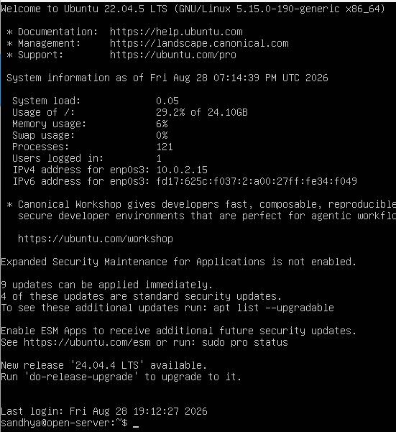

Conclusion
The Ubuntu system was successfully configured and verified for network connectivity. The OpenSSH server was installed and enabled, and the SSH service was confirmed to be running. The system's IP address was obtained, and a successful SSH login was performed. Secure remote access to the Ubuntu system was thereby established and verified.

Ex: 5 | Cloud Migration — Backup Setup Using Google Drive
Date:14/08/2026 | Cloud Migration — Backup Setup Using Google Drive

Aim
To create a cloud backup system by storing important files in Google Drive, scheduling automatic backups, and verifying successful backup completion.
Procedure
Part A, Step 1 — Create the sample folder
Create a folder named OfficeData on the Desktop.
Part A, Step 2 — Create sample files
Inside the folder, create three text files with sample content:
- Student.txt
- Attendance.txt
- Marks.txt
OfficeData
├── Student.txt
├── Attendance.txt
└── Marks.txt
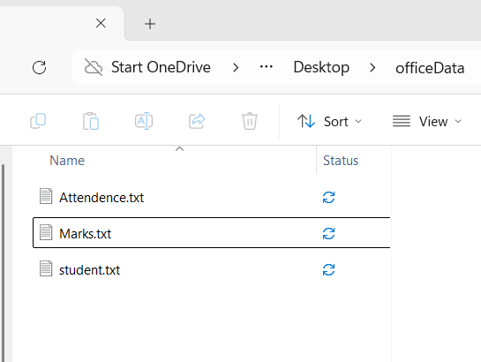
Part B, Step 3 — Open Google Drive
Open https://drive.google.com and log in with your Google account.
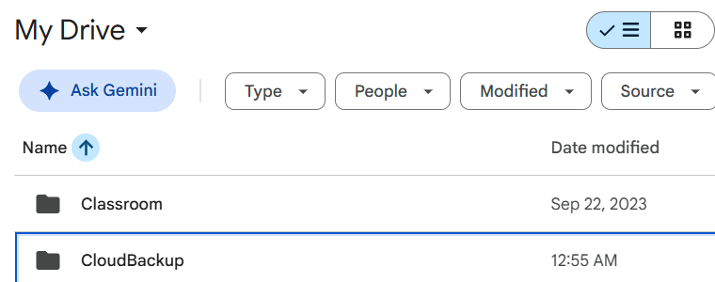
Part B, Step 4 — Create the cloud folder
Click + New → Folder, and create a folder named CloudBackup.
Part C, Step 5 — Upload the files
Open CloudBackup → click + New → File Upload, and choose all three files. Click Open. Google Drive uploads the files, resulting in:
Google Drive
└── CloudBackup
├── Student.txt
├── Attendance.txt
└── Marks.txt
The files have now been migrated to the cloud.
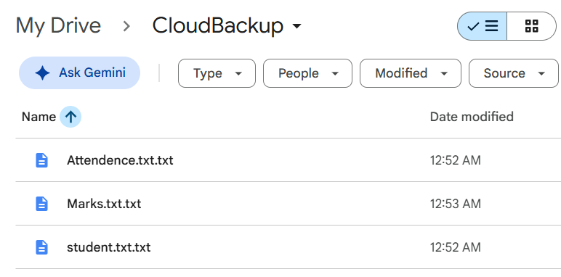
Part D, Step 6 — Install Google Drive for Desktop
Open https://www.google.com/drive/download/, download Google Drive for Desktop, install it, and log in using the same Google account.
Part E, Step 7 — Enable folder synchronization
Open Google Drive settings, click Add Folder, select Desktop → OfficeData, enable Sync with Google Drive, and click Done.
Verification Step 1 — Confirm the files in the cloud
Click Open Drive web to open Google Drive in the browser, and confirm that the synchronized OfficeData folder contains Marks.txt, Attendance.txt and Student.txt.
Verification Step 2 — Perform the backup test
In the local OfficeData folder, open Student.txt, add the line below at the bottom, and save the file:
Cloud Backup Test - Successfully Synchronized
Verification Step 3 — Wait for synchronization
Wait about 10–30 seconds, then reopen the Google Drive application. The file should show as “Successfully uploaded / Up to date”.
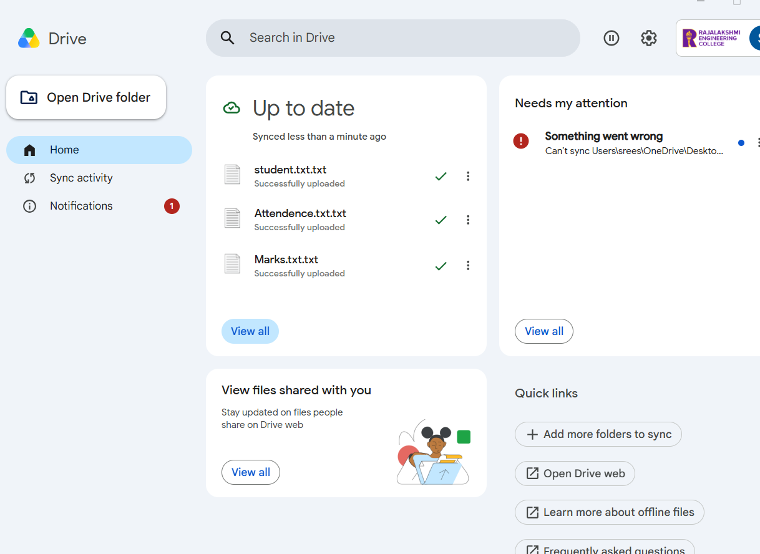
Verification Step 4 — Verify from Google Drive web
Refresh Google Drive in the browser and open Student.txt. The added line should now be visible, proving that the local change was automatically backed up to the cloud:
Cloud Backup Test - Successfully Synchronized
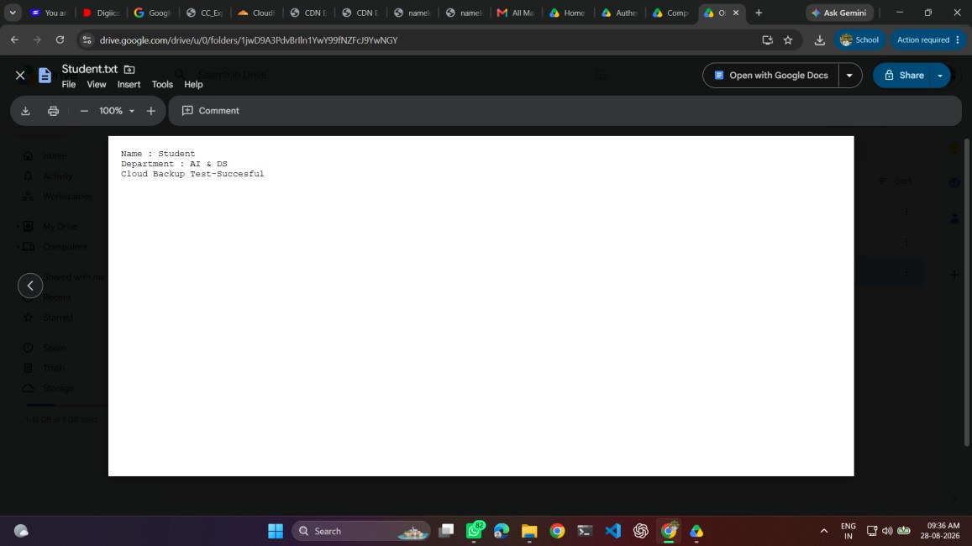

Conclusion
The cloud backup setup was successfully completed using Google Drive. Local files were migrated to cloud storage, automatic synchronization was enabled, and updates to local files were successfully reflected in the cloud, demonstrating an effective cloud backup mechanism.

Ex: 6 | CDN Service Selection and CDN Configuration
Date:21/08/2026 | CDN Service Selection and CDN Configuration

Aim
To select a Content Delivery Network (CDN) provider, deploy a simple web application using Cloudflare, access the application through Cloudflare's edge network, and verify the HTTP response and Cloudflare-specific headers using browser Developer Tools.
What is a Content Delivery Network?
A Content Delivery Network (CDN) is a distributed network of servers, or edge locations, used to deliver web content closer to users. Instead of every request travelling directly to a distant origin server, CDN/edge infrastructure can process and deliver content from locations distributed across the network, reducing latency and improving the user experience. Cloudflare also provides edge compute through Workers, where application code executes on Cloudflare's network.
Why do we need a CDN?
Suppose a website's origin server is in the USA, but a student in Chennai accesses it.
Without a CDN  Student in Chennai  │  ▼ (long-distance internet hop)  Server in USA  │  ▼  Website  The request has to travel a long distance. | With a CDN  Student in Chennai  │  ▼  Nearby CDN / Edge Location  │  ▼  Website content  The CDN has servers distributed across many locations, reducing the distance content needs to travel and improving performance.

What is Cloudflare?
Cloudflare is a cloud platform that provides services such as CDN, DNS, security, and edge computing. In this experiment, we used Cloudflare Workers to deploy a simple application on Cloudflare's distributed edge network and demonstrated how a user's request can be processed and served through the cloud edge. Cloudflare operates a large distributed network of edge locations across regions such as India, Singapore, and the USA — when a website uses Cloudflare's CDN/proxy services, Cloudflare can handle user requests at its nearest edge location.
Why did we use Cloudflare?
We researched and compared three CDN providers:
Provider | Purpose
Cloudflare | CDN + security + DNS + edge computing
Amazon CloudFront | AWS CDN
Akamai | Enterprise CDN
We selected Cloudflare because it was the easiest option for a practical experiment.
Procedure
PART A — Deploying the Worker
Step 1 — Select the CDN/edge provider
Cloudflare was selected as the CDN/edge provider. Create or log into a Cloudflare account. Do not add or change any DNS/nameserver settings yet.
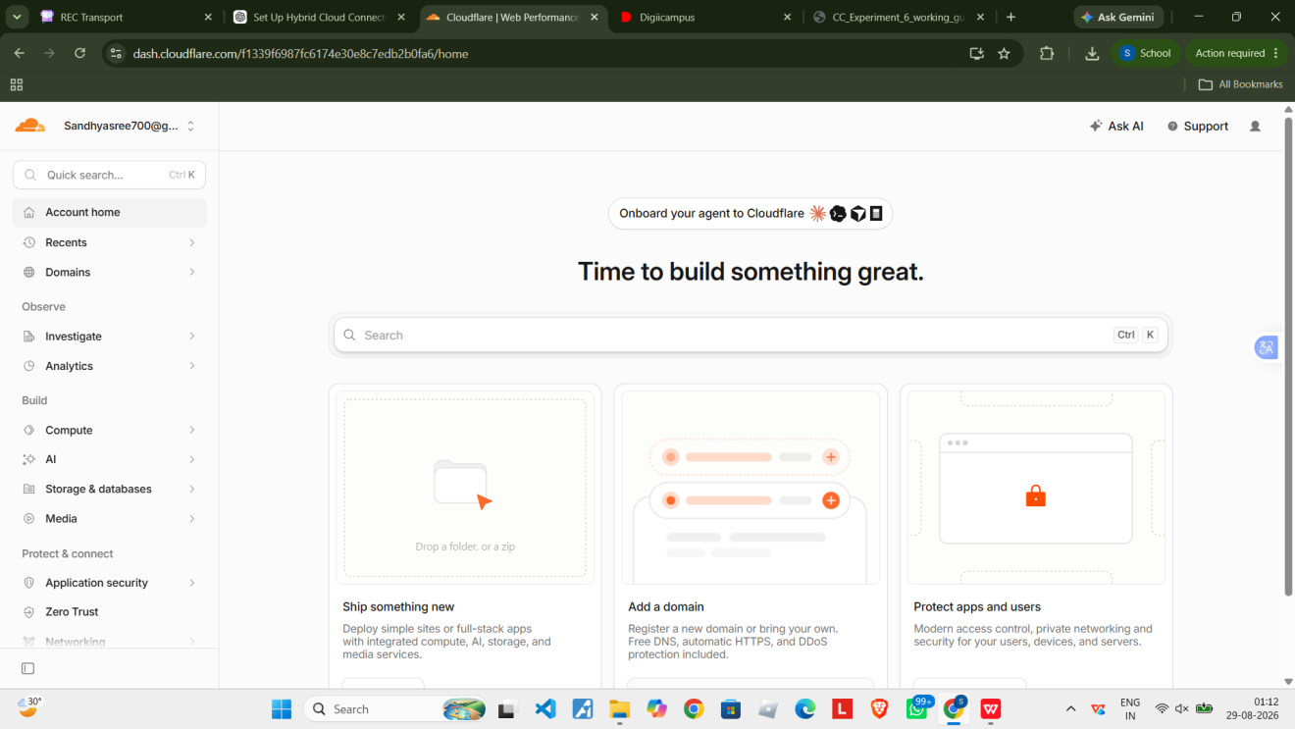
Step 2 — Open the dashboard
On the “Ship something new” screen, click Create app.
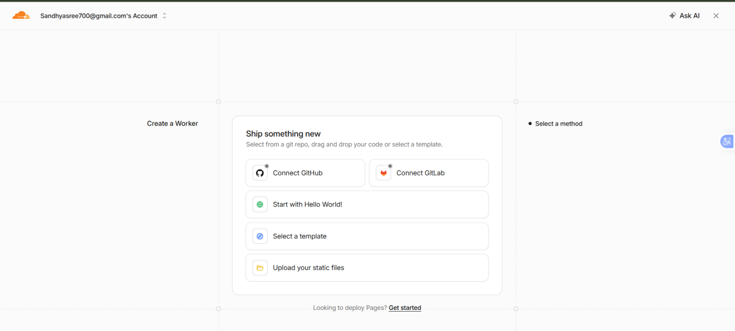
Step 3 — Choose the application option
The dashboard offers several starting points: Connect GitHub, Connect GitLab, Start with Hello World!, Select a template, or Upload your static files.
Step 4 — Start with Hello World!
Click Start with Hello World! — this is the simplest option for the CDN experiment, since it does not require GitHub or GitLab.
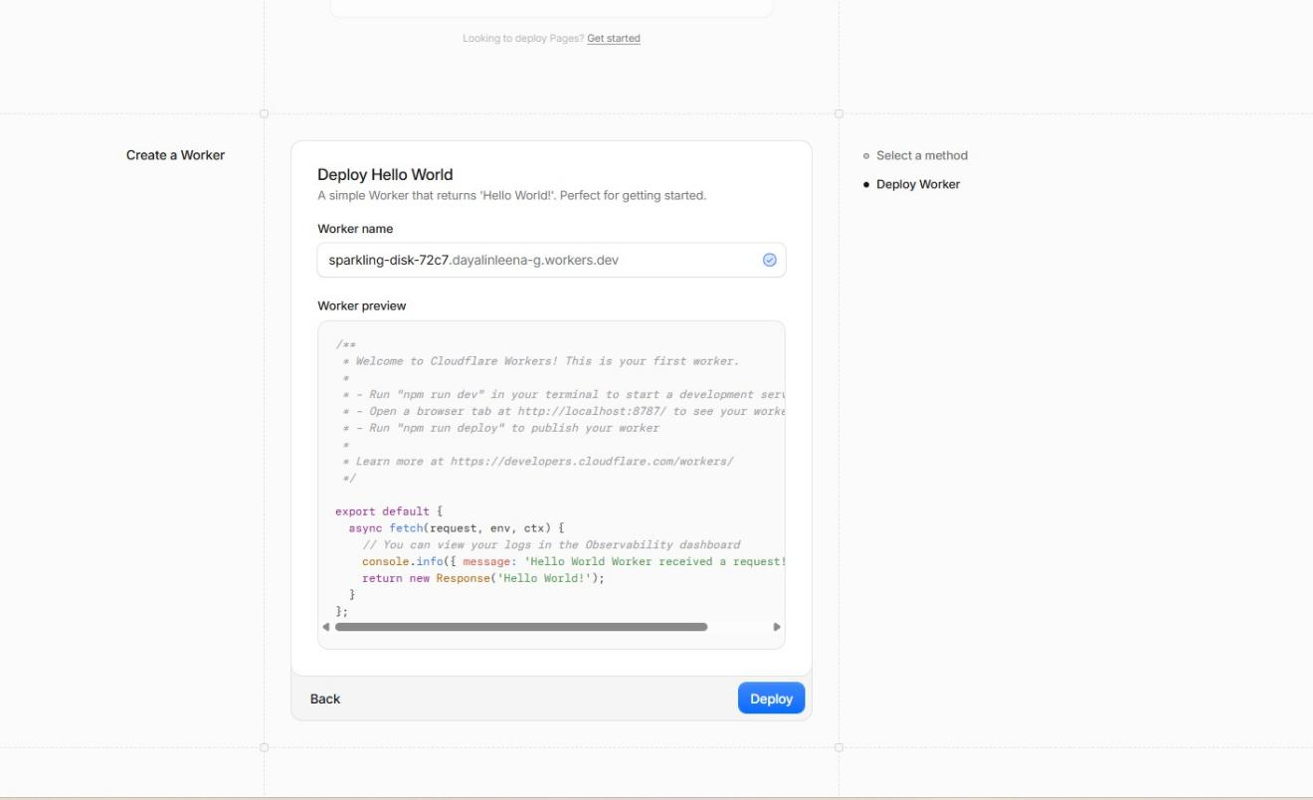
Step 5 — Note the generated Worker name
Cloudflare generates a name similar to sparkling-disk-72c7.<account>.workers.dev — leave it unchanged.
Step 6 — Leave the default code as is
The default Worker code is a simple script that returns the text “Hello World!”:
return new Response('Hello World!');
Step 7 — Deploy
Click the blue Deploy button at the bottom-right and wait for Cloudflare to finish deploying. Cloudflare creates the application and returns a public address ending in workers.dev, for example https://sparkling-disk-72c7.workers.dev. The deployment screen confirms the Worker name, that a workers.dev domain has been created, 0 errors, and 0 invocations (since nobody has visited it yet).
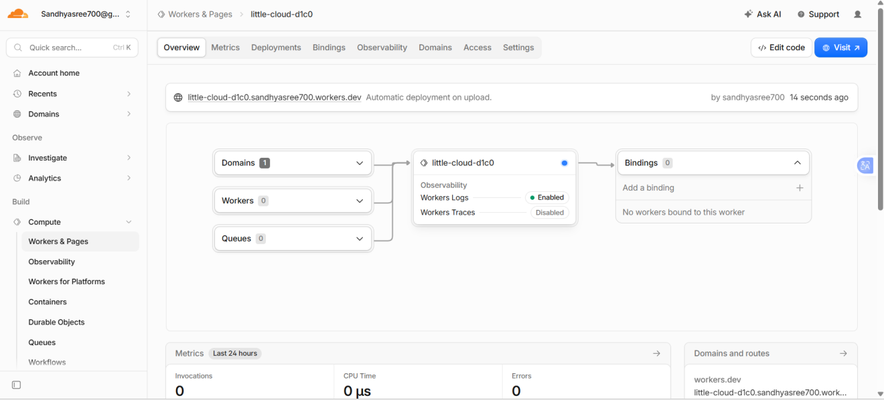
PART B — Testing and inspecting the response
Step 1 — Visit the deployed Worker
At the top-right of the screen, click Visit. This opens the Worker in a new browser tab, which should display “Hello World!”.
Step 2 — Confirm the result
Seeing “Hello World!” confirms that the Cloudflare application is working successfully.
Step 3 — Check the invocation count
Return to the Cloudflare dashboard. After visiting the URL, the invocation count should increase to at least 1 — a practical demonstration that a request reached the Cloudflare-hosted service.
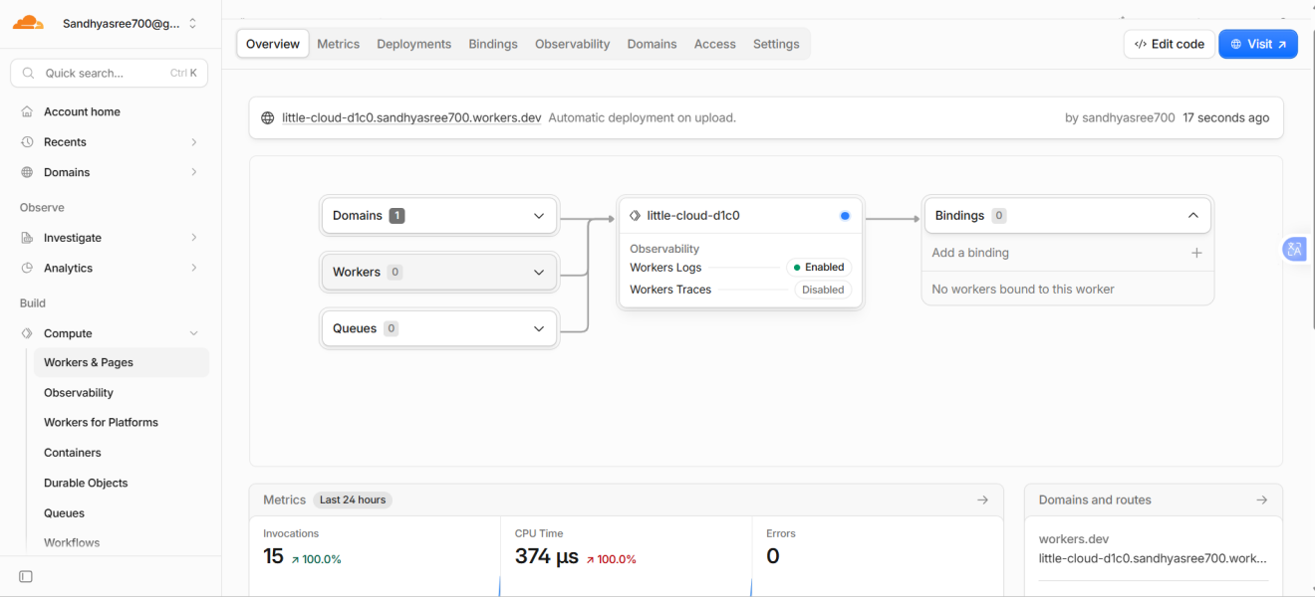
Step 4 — Build a CDN demonstration page
Return to the Worker dashboard and click Edit code. Replace the existing “Hello World!” response with an HTML page that explains the content is being delivered through Cloudflare:
export default {
async fetch(request, env, ctx) {
return new Response(`
<!DOCTYPE html>
<html>
<head><title>CDN Experiment</title></head>
<body>
<h1>CDN Service Experiment</h1>
<h2>Cloudflare Content Delivery</h2>
<p>This webpage is being delivered through Cloudflare.</p>
<p>CDN reduces the distance between users and content.</p>
<p>Status: Successfully Deployed</p>
</body>
</html>
`, { headers: { "content-type": "text/html" } });
}
};
Click Deploy.
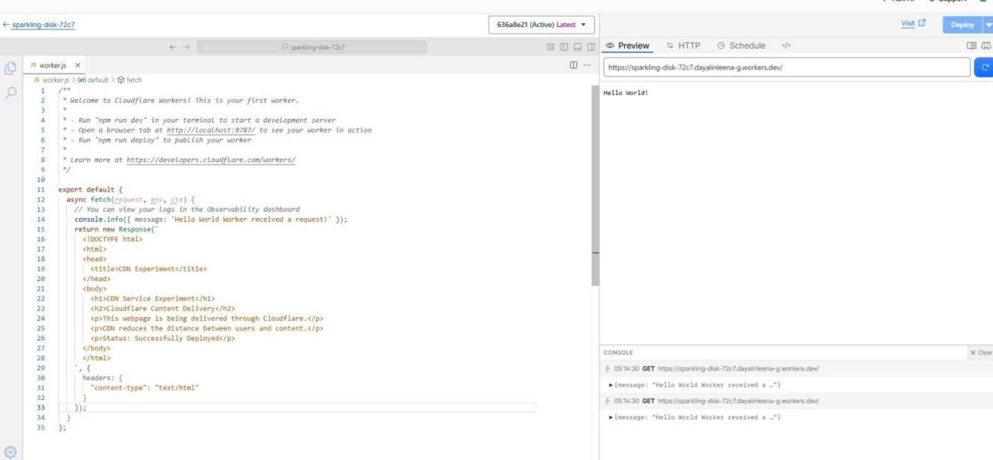
Step 5 — Test again
Click Visit again. The page should now display the CDN Service Experiment heading, the Cloudflare Content Delivery message, and the “Status: Successfully Deployed” line.
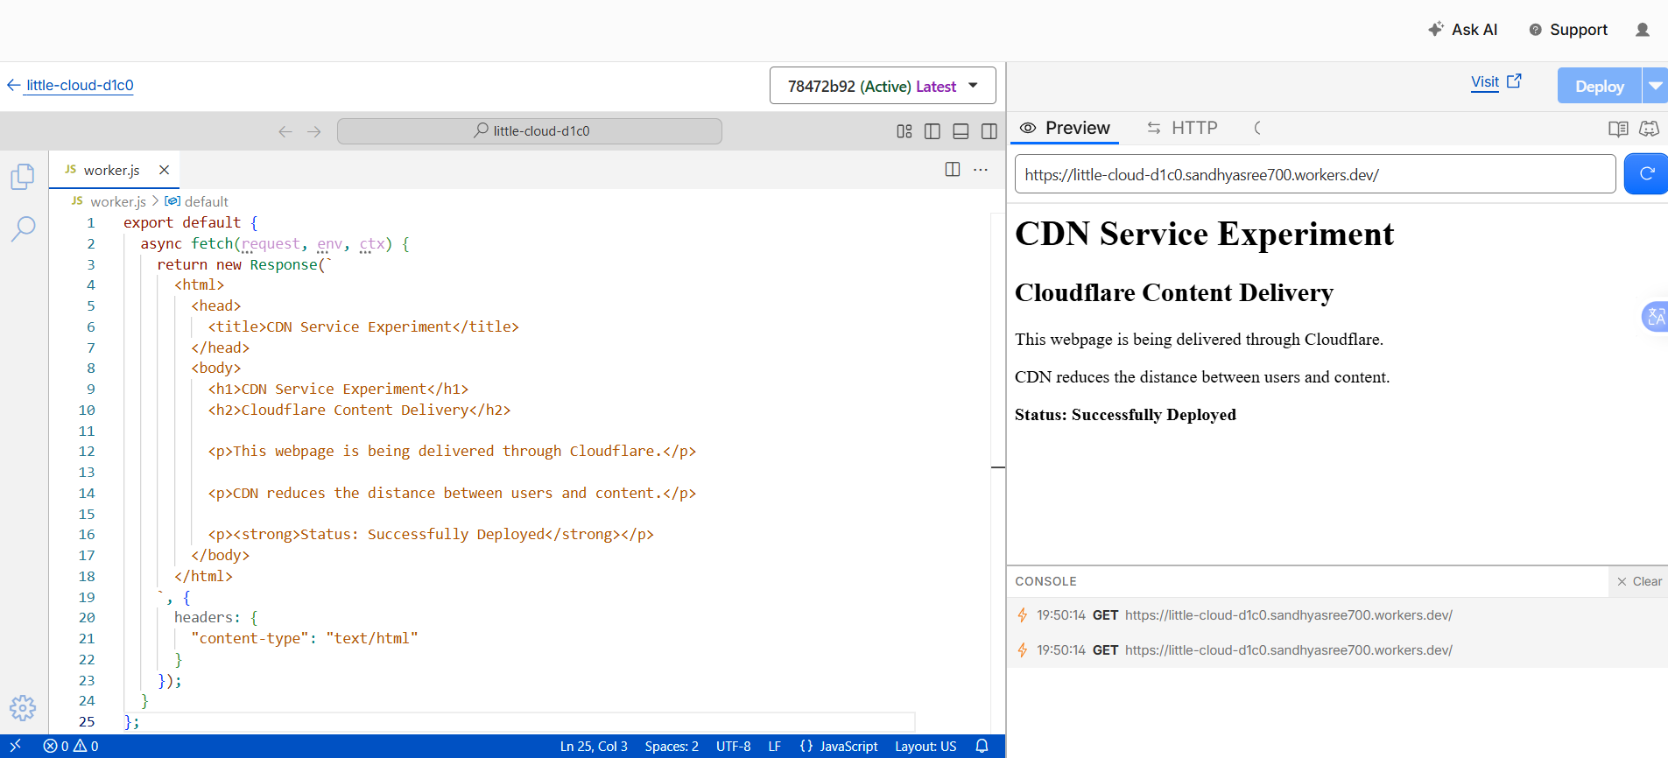
Step 6 — Inspect the response headers
With the new CDN experiment page open in the browser, press F12 → Network → Ctrl+R, then click the request for the workers.dev address to inspect its headers.
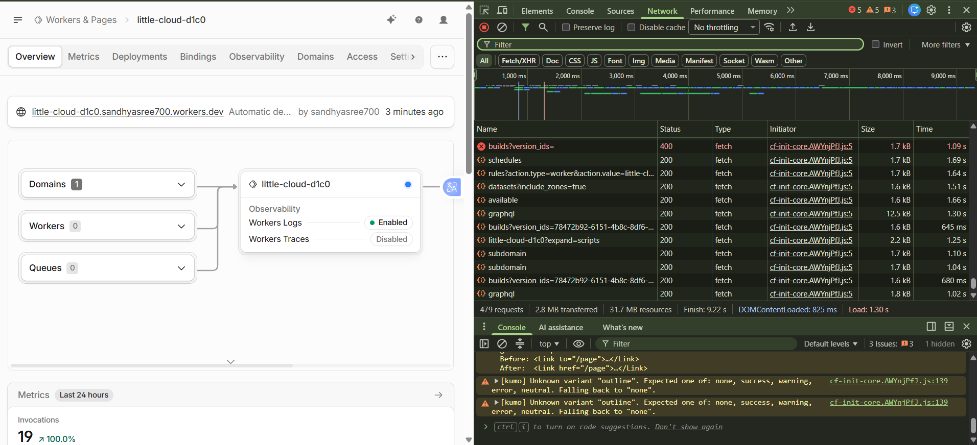
- Request URL — the request went to https://sparkling-disk-72c7.workers.dev, confirming the browser successfully contacted the Cloudflare Worker.
- Request Method: GET — the browser requested the webpage.
- Status Code: 200 OK — the server successfully received the request and returned the webpage.
- Server: cloudflare — strong evidence that the response was handled by Cloudflare.
- CF-Ray — a Cloudflare request identifier used to identify and trace a request through its network.
- Content-Type: text/html — the response is an HTML webpage.

Conclusion
A Cloudflare-based edge content delivery experiment was successfully implemented. A Worker was deployed on the Cloudflare network and accessed through a public workers.dev URL. The browser successfully received the webpage with HTTP status 200 OK. The response headers included Cloudflare-specific information such as Server: cloudflare and CF-Ray, confirming that the request was processed through Cloudflare's network.

