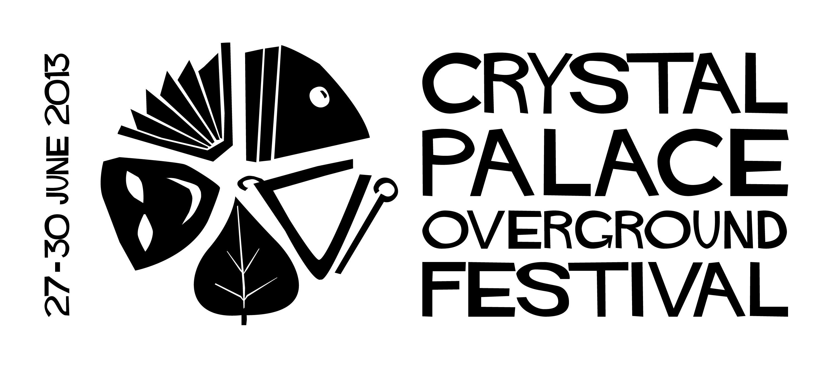For media enquiries, interviews and hi-res pic requests please call Carol Ann Walters on 07780 703 600 at anytime or on email press@crystalpalacefestival.org

CRYSTAL PALACE OVERGROUND FESTIVAL ANNOUNCES 2013 DATES

Crystal Palace Festival director Noreen Meehan announced today that the 7th Crystal Palace Overground Festival will take place from Thursday 27 June until Sunday 30 June 2013 with the main festival hubs at Westow Park on 29 June and around the Upper Norwood Triangle on 30 June. Fringe events will be held around Crystal Palace in the run up to the big festival weekend.

The festival that champions community is calling on local people who want to help the festival to get in touch.

Festival director, Noreen Meehan, said: “The festival has been growing each year with more and more visitors and volunteers but we need help to ensure its future.

“Our local businesses have done an amazing job of supporting the festival so far but funding is getting tighter in the current climate of cuts and continuing economic woes.

“Our festival is special and helps our community come together as one so it’s important that it continues. If you can help with fundraising, grants or would like to sponsor or advertise with the festival, then do get in touch and help make the festival even bigger and better in 2013.”

The Crystal Palace Overground Festival is a free event that relys on volunteers, sponsorship, fundraising and the support of the local community.

An estimated 4,500 people attended last year’s event, attracted by the huge variety of free events across the various festival hubs which included performing arts, crafts, holistic and sports activities, live music, DJs and food, an ale and cider festival plus antique, craft and vintage shopping throughout the Crystal Palace Triangle. Festival organisers are anticipating an increase in number for this year’s event.

The festival is now accepting submissions for 2013 and the full programme will be announced in May.

For more information and to get involved in this year's event, visit
www.crystalpalacefestival.org .

Find on Facebook: Crystal Palace Overground Festival
Follow on Twitter: @SE19festival
-ENDS-

Notes for editors

For media enquiries, interviews and hi-res pic requests please call Carol Ann Walters on 07780 703 600 at anytime or on email press@crystalpalacefestival.org

About the Crystal Palace Overground Festival

The Crystal Palace Overground Festival was launched in 2007 by the Crystal Palace Triangle traders and has gone from strength to strength with 4,500 people attending last year’s event.

The 4-day free family friendly festival is a platform for the many creative and diverse people, musicians, traders and artists of Crystal Palace, and showcases Crystal Palace, its people and all it has to offer to visitors from across London, and beyond!

FIND OUT MORE www.crystalpalacefestival.org

