**Supplementary Material 1. Detailed search strategies.**

1. PubMed: total 179 studies

(("Metformin"[Mesh]) OR (Dimethylbiguanidine[Title/Abstract]) OR (Dimethylguanylguanidine[Title/Abstract]) OR (Glucophage[Title/Abstract])) OR (Metformin Hydrochloride[Title/Abstract]) OR (Hydrochloride, Metformin[Title/Abstract]) OR (Metformin HCl[Title/Abstract]) OR (HCl, Metformin[Title/Abstract])) AND (("Endometrial Neoplasms"[Mesh]) OR (Endometrial Neoplasm[Title/Abstract]) OR (Neoplasm, Endometrial[Title/Abstract]) OR (Neoplasms, Endometrial[Title/Abstract]) OR (Endometrial Carcinoma[Title/Abstract]) OR (Carcinoma, Endometrial[Title/Abstract]) OR (Carcinomas, Endometrial[Title/Abstract]) OR (Endometrial Carcinomas[Title/Abstract]) OR (Endometrial Cancer[Title/Abstract]) OR (Cancer, Endometrial[Title/Abstract]) OR (Cancers, Endometrial[Title/Abstract]) OR (Endometrial Cancers[Title/Abstract]) OR (Endometrium Cancer[Title/Abstract]) OR (Cancer, Endometrium[Title/Abstract]) OR (Cancers, Endometrium[Title/Abstract]) OR (Cancer of the Endometrium[Title/Abstract]) OR (Carcinoma of Endometrium[Title/Abstract]) OR (Endometrium Carcinoma[Title/Abstract]) OR (Endometrium Carcinomas[Title/Abstract]) OR (Cancer of Endometrium[Title/Abstract]) OR (Endometrium Cancers[Title/Abstract]))

2.Web of Science: total 590 studies

Query #1 (TS=(metformin) OR TS=(Dimethylbiguanidine) OR TS=(Dimethylguanylguanidine) OR TS=(Glucophage) OR TS=(Metformin Hydrochloride) OR TS=(Hydrochloride, Metformin) OR TS=(Metformin HCl) OR TS=(HCl, Metformin)) NOT (SILOID==("PPRN"))

Query #2(TS=(Endometrial Neoplasms) OR TS=(Endometrial Neoplasm) OR TS=(Neoplasm, Endometrial) OR TS=(Neoplasms, Endometrial) OR TS=(Endometrial Carcinoma) OR TS=(Carcinoma, Endometrial) OR TS=(Carcinomas, Endometrial) OR TS=(Endometrial Carcinomas) OR TS=(Endometrial Cancer) OR TS=(Cancer, Endometrial) OR TS=(Cancers, Endometrial) OR TS=(Endometrial Cancers) OR TS=(Endometrium Cancer) OR TS=(Cancer, Endometrium) OR TS=(Cancers, Endometrium) OR TS=(Cancer of the Endometrium) OR TS=(Carcinoma of Endometrium) OR TS=(Endometrium Carcinoma) OR TS=(Endometrium Carcinomas) OR TS=(Cancer of Endometrium) OR TS=(Endometrium Cancers)) NOT (SILOID==("PPRN"))

#2 AND #1

3.Embase: total 997 studies

#3. #1 AND #2

#2. endometrial AND neoplasms OR (endometrial AND neoplasm) OR (neoplasm, AND endometrial) OR (neoplasms, AND endometrial) OR (endometrial AND carcinoma) OR (carcinoma, AND endometrial) OR (carcinomas, AND endometrial) OR (endometrial AND carcinomas) OR (endometrial AND cancer) OR (cancer, AND endometrial) OR (cancers, AND endometrial) OR (endometrial AND cancers) OR (endometrium AND cancer) OR (cancer, AND endometrium) OR (cancers, AND endometrium) OR (cancer AND of AND the AND endometrium) OR (carcinoma AND of AND endometrium) OR (endometrium AND carcinoma) OR (endometrium AND carcinomas) OR (cancer AND of AND endometrium) OR (endometrium AND cancers)

#1. metformin OR dimethylbiguanidine OR dimethylguanylguanidine OR glucophage OR (metformin AND hydrochloride) OR (hydrochloride, AND metformin) OR (metformin AND hcl) OR (hcl, AND metformin)

4.Cochrane Library: total 82studies

#1 MeSH descriptor: [Metformin] explode all trees

#2 (Metformin or Dimethylbiguanidine or Dimethylguanylguanidine or Glucophage or Metformin Hydrochloride or Hydrochloride, Metformin or Metformin HCl or HCl, Metformin)

#3 #1 or #2

#4 MeSH descriptor: [Endometrial Neoplasms] explode all trees

#5 (Endometrial Neoplasms or Endometrial Neoplasm or Neoplasm, Endometrial or Neoplasms, Endometrial or Endometrial Carcinoma or Carcinoma, Endometrial or Carcinomas, Endometrial or Endometrial Carcinomas or Endometrial Cancer or Cancer, Endometrial or Cancers, Endometrial or Endometrial Cancers or Endometrium Cancer or Cancer, Endometrium or Cancers, Endometrium or Cancer of the Endometrium or Carcinoma of Endometrium or Endometrium Carcinoma or Endometrium Carcinomas or Cancer of Endometrium or Endometrium Cancers)

#6 #4 or #5

#7 #3 and #6

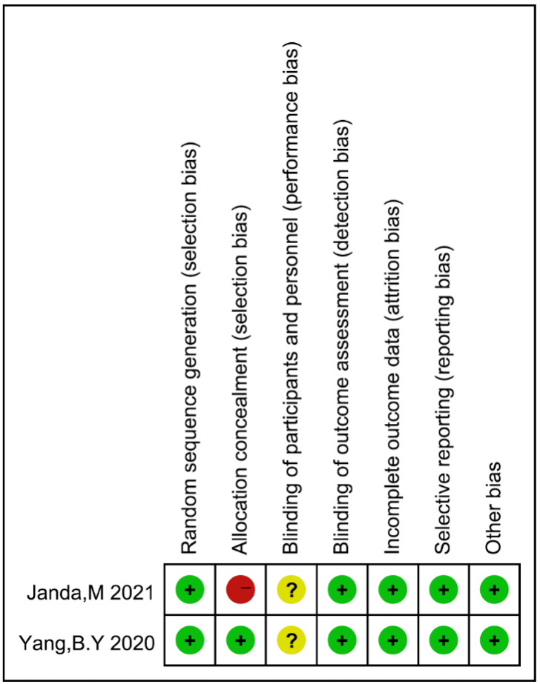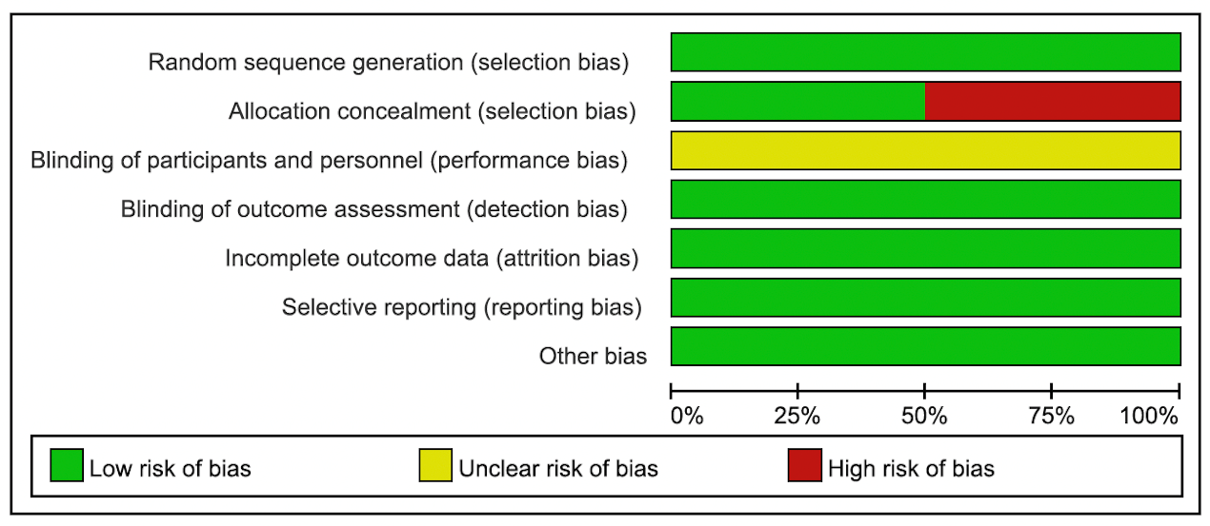 **Supplementary Material 2. Assessment of risk of bias for randomized controlled trials.**

**Supplementary Material 3. Quality assessment of retrospective cohort studies with Newcastle-Ottawa Scale.**

|  |  |  |  |  |  |  |  |  |  |
| --- | --- | --- | --- | --- | --- | --- | --- | --- | --- |
|  | Selection | | | Comparability | | | Outcome | | |
| Study | Representative-ness | Selection of  non-exposed | Ascertainment  of exposure | Outcome not  present at start | Comparability on  most important  factors | Comparability  on other risk  factors | Assessment of outcome | Long enough  follow-up (median≥ 6  months) | Adequacy  (completeness) of follow-up |
| Ushijima, K et al | * | * | * | * | - | - | * | * | * |
| Drevinskaite, M et al | * | * | * | * | - | - | * | * | * |
| Ida Pino et al | * | * | * | * | * | - | * | * | * |
| Lara S. Lemon et al | * | * | * | * | * | * | * | * | * |
| Urpilainen, E et al | * | * | * | * | * | - | * | * | * |
| Feng, J. L et al | * | * | * | * | * | * | * | - | * |
| Deng, Y et al | * | * | * | * | * | * | * | * | * |
| Acosta-Torres, S et al | * | * | * | * | - | - | * | * | * |
| Putsarat Insin et al | * | * | * | * | - | - | * | * | * |
| Arima, R et al | * | * | * | * | * | * | * | * | * |
| Seebacher, V et al | * | * | * | * | * | * | * | * | * |
| Chritopher Hall et al | * | * | * | * | - | * | * | * | * |
| Ezewuiro, O et al | * | * | * | * | * | * | * | * | * |
| Al Hilli, M. M et al | * | * | * | * | * | * | * | * | * |
| Lemańska, A et al | * | * | * | * | * | * | * | * | * |
| Ko, E. M et al | * | * | * | * | * | * | * | * | * |
| Nevadunsky, N. S et al | * | * | * | * | * | * | * | * | * |