E-COMMERCE CUSTOMER CHURN EARLY WARNING SYSTEM
Internship Report submitted as part of the academic requirement for the degree of

BACHELOR OF TECHNOLOGY
IN
COMPUTER SCIENCE ENGINEERING (AI & ML)

Submitted by

ROWTHU BHASKAR ABHIRAM
(A24126552114)



DEPARTMENT OF CSE (AI & ML)
ANIL NEERUKONDA INSTITUTE OF TECHNOLOGY AND SCIENCES
(UGC AUTONOMOUS)

(Permanently Affiliated to AU, Approved by AICTE, and Accredited by NBA & NAAC)
SANGIVALASA, BHEEMILI MANDAL, VISAKHAPATNAM – 531162
2024–2028

ANIL NEERUKONDA INSTITUTE OF TECHNOLOGY AND SCIENCES
(Affiliated to Andhra University)
SANGIVALASA, VISAKHAPATNAM – 531162
2024–2028

BONAFIDE CERTIFICATE
This is to certify that this Case Study Report titled “E-Commerce Customer Churn Early Warning System – A Machine Learning-Based Proactive Retention Platform with Flipkart UI Architecture” from IBM is the bonafide work of ROWTHU BHASKAR ABHIRAM (A24126552114) of III/IV CSE (AI & ML), carried out under the guidance and supervision of the Department of CSE (AI & ML), Anil Neerukonda Institute of Technology and Sciences.

Sampathirao Yoganandh
CLASS TEACHER

Mr. P SANTOSH KUMAR
Assistant Professor
Department of CSE (AI & ML)
ANITS
REVIEWER

Mr. S YOGANANDH
Assistant Professor
Department of CSE (AI & ML)
ANITS
Assistant Professor
Department of CSE (AI &

HEAD OF THE DEPARTMENT
DR. K. SELVANI DEEPTHI
Department of CSE (AI & ML)
ANITS

ACKNOWLEDGEMENT

The successful completion of a project is the result of continuous learning, guidance, encouragement, and support from many individuals. I take this opportunity to express my sincere gratitude to everyone who contributed to the successful completion of this case study project.
First and foremost, I express my sincere gratitude to Dr. K. Selvani Deepthi, Head of the Department of Computer Science & Engineering (AI & ML), ANITS, for providing the necessary support, guidance, and encouragement throughout the development of this project.
I would also like to express my heartfelt thanks to my reviewer, Mr. Sampathirao Yoganandh, Assistant Professor, and to my class teacher and project mentor, Mr. P Santosh Kumar, Assistant Professor, for their valuable suggestions, technical guidance, and continuous encouragement during the different stages of the project. Their feedback helped me improve my understanding of machine learning and its practical applications in customer retention analytics.
I am grateful to the Department of CSE (AI & ML), Anil Neerukonda Institute of Technology and Sciences, for providing the academic environment and resources required to carry out this project successfully.
I also acknowledge the IBM Innovation Centre for Education (IBM ICE) and Q2D (Quantum Quotient Decode) for the PEARL internship programme in Artificial Intelligence & Machine Learning, through which the concepts applied in this project were learned and practised.
I would also like to thank my classmates and friends for their support, discussions, and suggestions during the development and testing of the project.
Finally, I express my sincere gratitude to everyone who directly or indirectly contributed to the successful completion of the “E-Commerce Customer Churn Early Warning System” project.

ROWTHU BHASKAR ABHIRAM
(A24126552114)

TABLE OF CONTENTS
1. INTRODUCTION
1.1 Background of the Project
1.2 Objectives of the Project
1.3 Importance of AI in Customer Retention
1.4 Scope of the Project
2. PROJECT CONTEXT
2.1 Overview of Customer Churn in E-Commerce
2.2 Role of Machine Learning in Retention Analytics
2.3 Need for Early Warning Systems
3. PROJECT OVERVIEW
3.1 Title of the Project
3.2 Problem Statement
3.3 Objectives of the Project
3.4 Relevance to E-Commerce Business
4. LITERATURE REVIEW / THEORETICAL BACKGROUND
4.1 Introduction to Customer Churn
4.2 Existing RFM and Rule-Based Retention Systems
4.3 Role of Artificial Intelligence in Churn Prediction
4.4 Machine Learning Classification Approaches
4.5 Related Works
5. METHODOLOGY
5.1 Data Collection and Dataset Description
5.2 Data Preprocessing
5.3 Handling Missing Values
5.4 Categorical Encoding and Feature Scaling
5.5 Class Distribution
5.6 Feature Selection
5.7 Model Selection and Mathematical Formulation
5.8 Model Training and Evaluation
6. IMPLEMENTATION
6.1 Dataset Exploration and Preprocessing
6.2 Machine Learning Model Development
6.3 Model Training and Testing
6.4 Risk Stratification and Explainable AI Layer
6.5 Prediction Engine and Client-Side Fallback
6.6 Frontend Integration
6.7 ChurnGuard AI Prototype
7. RESULTS AND DISCUSSION
7.1 Model Performance
7.2 Comparison of Machine Learning Models
7.3 Prototype Output
7.4 Prediction Results
7.5 Cohort Analytics and Customer Hub Output
7.6 Business ROI and Financial Impact
7.7 Interpretation of Churn Risk Predictions
7.8 Additional Prototype Outputs
8. CONCLUSION AND FUTURE WORK
8.1 Summary of Learning
8.2 Project Achievements
8.3 Limitations of the Current Approach
8.4 Future Scope
9. PROJECT OUTCOMES
9.1 Technical Skills Acquired
9.2 Soft Skills Developed
9.3 Contribution to Career Growth
REFERENCES
APPENDIX
A. Source Code and Project Structure
B. GitHub Repository
C. Prototype Screenshots
D. Sample Prediction Outputs
E. Certificate of Completion

1. INTRODUCTION

1.1 Background of the Project
Modern e-commerce platforms operate on thin profit margins and escalating customer acquisition costs. Paid advertising, introductory discount coupons, and referral bonuses mean that acquiring a new shopper is frequently unprofitable during their first transaction; profitability is achieved only through recurring repeat purchases across the customer lifetime. Industry studies estimate that acquiring a new customer is five to seven times more expensive than retaining an existing one.
Unlike subscription services, where a user explicitly cancels a plan, e-commerce platforms suffer from silent churn. Customers do not announce their departure; they simply stop browsing, discontinue ordering, and migrate to a competing platform. Traditional analytics evaluate churn retrospectively, by examining quarterly sales drops or dormant accounts. By the time an account is declared lost, the customer has already formed new habits elsewhere, and win-back campaigns become expensive and ineffective.
This project, titled “E-Commerce Customer Churn Early Warning System,” focuses on developing a machine learning-based system that predicts the probability of a customer disengaging from the platform, 30 to 45 days before permanent churn occurs. The system uses behavioural telemetry such as account age (tenure), monthly spend, purchase frequency, days since the last purchase, customer support calls, satisfaction score, cart abandonment rate, discount usage ratio, subscription tier, device type, and payment method.
The project was developed as part of the learning and practical exposure gained during the IBM ICE – Q2D PEARL internship in Artificial Intelligence & Machine Learning, where concepts related to data preprocessing, model development, evaluation, explainable AI, and application integration were explored.

1.2 Objectives of the Project
The major objectives of the project are:
- To understand the application of Machine Learning in e-commerce customer retention.
- To analyse and preprocess the E-Commerce Customer Churn benchmark dataset.
- To handle missing values, encode categorical attributes, and scale numerical features.
- To mitigate class imbalance between churned and retained customers.
- To develop and train classification models that predict the probability of churn.
- To evaluate and compare the performance of the developed models using accuracy, precision, recall, F1-score, and ROC-AUC.
- To stratify customers into High, Medium, and Low churn-risk tiers.
- To expose model feature-importance information and rule-based retention recommendations.
- To quantify annual revenue at risk and support retention planning through the prototype ROI calculator.
- To deliver an interactive web prototype that converts predictions into automated retention playbooks.

1.3 Importance of AI in Customer Retention
E-commerce platforms generate very large volumes of behavioural telemetry: logins, sessions, orders, returns, complaints, delivery timelines, and loyalty rewards. Manual analysis of this data cannot scale to millions of customers, and fixed rule thresholds cannot capture the non-linear interactions between tenure, frequency, spending, and service experience.
Machine Learning identifies relationships in historical data that are difficult to detect manually. In churn analytics, a classification model learns from customers who have previously left the platform and estimates the probability that a currently active customer will leave. Because the prediction is a probability rather than a binary verdict, the business can rank customers by urgency and allocate a limited retention budget to the accounts where it will have the greatest effect.
An automated early warning system therefore reduces repetitive manual analysis, provides consistent evaluation, and supports faster preventive action. Such systems should, however, be treated as decision-support tools; final campaign decisions still require business judgement and budget approval.

1.4 Scope of the Project
The scope of this project is the development of a working prototype for proactive churn detection. The system accepts customer telemetry through an interactive web interface, passes it through a calibrated scoring pipeline, and returns a churn probability, a risk tier, the leading risk drivers, the projected revenue at risk, and a recommended retention playbook.
The prototype, named ChurnGuard AI (shown in the interface as ChurnGuard PLUS+), is a Flask-based web application. A Python backend serves the saved scikit-learn pipelines through REST endpoints, and a single-page front end built with HTML5, CSS3, and JavaScript, with Chart.js for the charts, provides a dark-themed dashboard. It is intended as an academic prototype built on the generated E-Commerce Customer Churn dataset and does not replace a production-grade retention platform integrated with live transactional databases.

2. PROJECT CONTEXT

2.1 Overview of Customer Churn in E-Commerce
Customer churn is the loss of a customer who stops transacting with a platform. In e-commerce, churn is rarely a single observable event; it is a gradual decline in engagement, visible first as longer gaps between orders, reduced basket sizes, unresolved complaints, and falling satisfaction ratings.
Churn directly reduces gross merchandise value, customer lifetime value, and market share. Because acquisition is expensive, every retained customer protects revenue that would otherwise need to be repurchased through advertising spend. Detecting the decline early is therefore of direct financial importance.
In this project the benchmark E-Commerce Customer Churn dataset is used to develop a classification system. The dataset contains historical customer telemetry along with a binary Churn attribute that records whether the customer was retained or lost.

2.2 Role of Machine Learning in Retention Analytics
Machine Learning enables systems to learn patterns from existing data and apply those patterns to new records. In e-commerce, it is applied to recommendation, demand forecasting, fraud detection, dynamic pricing, and churn prediction.
For churn prediction, a supervised classification model learns from labelled historical customers. Once trained, the model processes the telemetry of an active customer and returns the estimated probability of churn. Ensemble methods such as Random Forest and Extreme Gradient Boosting are particularly suited to this task because they model non-linear interactions — for example, the fact that thirty days of inactivity means something very different for a three-year loyal buyer than for a one-month-old account.

2.3 Need for Early Warning Systems
Reactive churn reporting identifies customers who have already left. An early warning system reverses this order: it flags customers who are statistically likely to leave while they can still be recovered, typically 30 to 45 days before permanent disengagement.
The E-Commerce Customer Churn Early Warning System addresses this requirement by combining a calibrated classification engine with a web-based decision interface. The ChurnGuard AI prototype accepts customer telemetry, produces a churn probability and risk tier, triggers rule-based retention strategies matched to the risk factors present, and maps the outcome to a retention action such as a senior account-manager escalation, a 20% win-back discount coupon, or a cart-recovery notification.

3. PROJECT OVERVIEW

3.1 Title of the Project
E-Commerce Customer Churn Early Warning System — A Machine Learning-Based Proactive Retention Platform with Flipkart UI Architecture.
The project develops a Machine Learning-based system for proactive churn classification. The system analyses customer behavioural telemetry and predicts the probability that the customer will disengage from the platform within the next 30 to 60 days. The web prototype is named ChurnGuard AI.

3.2 Problem Statement
E-commerce platforms lose a measurable share of their active customer base every year without any explicit cancellation signal. Retention teams need to know which customers are at risk while intervention is still economically viable, and they need to know why each customer is at risk so that the intervention can be matched to the cause.
The objective of this project is to develop an automated system that analyses historical customer data, learns the behavioural signature of churn, and classifies the churn risk of an active customer along with the drivers of that risk and a recommended retention action.

3.3 Objectives of the Project
- Develop a Machine Learning-based churn classification system.
- Use benchmark historical customer data for training and evaluation.
- Perform preprocessing: missing-value imputation, encoding, and scaling.
- Measure the retained/churned class distribution and evaluate models on stratified test data.
- Train and compare Logistic Regression, Random Forest, Gradient Boosting, and Extra Trees classifiers.
- Stratify the predicted probability into Low, Moderate, and Critical risk tiers.
- Display global feature-importance information and contextual retention recommendations.
- Estimate annual revenue at risk and provide a scenario-based retention ROI calculation.
- Deliver an interactive web prototype with dashboards, a customer hub, and retention playbooks.

3.4 Relevance to E-Commerce Business
Automated churn prediction has direct commercial relevance because retention budgets are finite. Ranking customers by churn probability allows the platform to concentrate coupons, loyalty credits, and support escalations on the accounts where the expected saved revenue is highest.
The proposed system demonstrates the complete workflow from data preparation and model development through to an application-level decision interface, and connects each predicted risk tier to a concrete, costed retention action.

4. LITERATURE REVIEW / THEORETICAL BACKGROUND

4.1 Introduction to Customer Churn
Churn analysis originated in subscription industries such as telecommunications and banking, where cancellation is an explicit event. Reichheld and Sasser demonstrated that comparatively small improvements in retention produce disproportionately large improvements in profitability, which established retention as a measurable financial objective rather than a purely marketing concern.
In e-commerce the churn label must be constructed rather than observed, usually by defining a period of inactivity after which a customer is considered lost. This makes feature quality and label definition central to model performance.

4.2 Existing RFM and Rule-Based Retention Systems
Traditional churn management relies predominantly on static RFM (Recency, Frequency, Monetary) segmentation. Its limitations are well documented:
- Rule-based heuristics assign fixed thresholds, for example “inactive if no order in 30 days,” ignoring customer tenure entirely.
- Attributes such as spending, complaints, and cart abandonment are treated in isolation, without modelling their interactions.
- Predictions are generated in offline batch reports and are rarely wired to real-time marketing triggers, so the action loop remains disconnected.

4.3 Role of Artificial Intelligence in Churn Prediction
Machine Learning replaces manually defined rules with decision boundaries learned from data. Ensemble tree methods capture threshold effects and interactions automatically, while probability calibration allows the output to be used for ranking and budget allocation.
Because ensemble models are opaque, explainability methods are required before predictions can be trusted operationally. SHAP (Shapley Additive Explanations) decomposes an individual prediction into per-feature contributions, allowing a retention analyst to see that a specific customer is at risk chiefly because of inactivity and unresolved complaints rather than low spending.

4.4 Machine Learning Classification Approaches
Classification is a supervised learning technique in which a model learns from labelled data and assigns new observations to predefined categories. Here the target variable Churn is binary (0 = Retained, 1 = Churned), so the task is binary classification. The general workflow is:
- Collecting the customer telemetry dataset.
- Exploring the available attributes and their distributions.
- Cleaning and preprocessing the data.
- Separating input features and the target variable.
- Encoding categorical attributes and scaling numerical attributes.
- Balancing the minority (churn) class.
- Splitting the dataset into training and testing partitions.
- Training candidate classification models.
- Evaluating and comparing model performance.
- Selecting the model and integrating it with the application.

4.5 Related Works
Machine Learning-based churn prediction has been widely studied across customer-facing industries. The supplied project focuses on a practical tabular classification workflow using Logistic Regression, Random Forest, Gradient Boosting, and Extra Trees.
The present project applies supervised classification to generated e-commerce telemetry and extends the workflow into a web prototype that presents predictions, model comparison, financial exposure, and rule-based retention recommendations together.

5. METHODOLOGY

5.1 Data Collection and Dataset Description
The dataset used for this project is the E-Commerce Customer Churn dataset generated by the supplied project script (generate_dataset.py). The supplied CSV contains 3,000 customer records and 13 columns, including CustomerID, 11 predictive features, and the binary target Churn. Churn = 0 indicates retained customers and Churn = 1 indicates churned customers.
The principal attributes used in the project are listed below, together with their observed correlation with the churn label.
Attribute | Type | Description | Correlation with Churn
CustomerID | ID | Unique customer identifier; excluded from model input | —
Account_Age_Months | Numerical | Customer account age in months | −0.276
Monthly_Spend | Numerical | Average monthly spending in USD | −0.062
Purchase_Frequency | Numerical | Average orders per month | −0.205
Days_Since_Last_Purchase | Numerical | Days elapsed since the latest purchase | +0.511
Customer_Support_Calls | Numerical | Number of support tickets/complaints | +0.270
Satisfaction_Score | Numerical | Customer satisfaction score from 1 to 5 | −0.336
Cart_Abandonment_Rate | Numerical | Fraction of carts abandoned | +0.144
Discount_Usage_Ratio | Numerical | Fraction of purchases using discounts | +0.046
Subscription_Tier | Categorical | Basic, Premium, or VIP | Predictor
Device_Type | Categorical | Mobile App, Desktop, or Tablet | Predictor
Payment_Method | Categorical | Credit Card, UPI/Debit, Digital Wallet, or COD | Predictor
Churn | Binary target | 0 = retained, 1 = churned | Target
CustomerID is an identifier and was excluded from model input. The predictive inputs used by the supplied training script are eight numerical features and three categorical features.

5.2 Data Preprocessing
Data preprocessing is a decisive stage in Machine Learning because the quality of the input data directly determines model performance. The dataset was examined for missing values, duplicate records, categorical attributes, numerical attributes, and unnecessary columns. The major preprocessing operations performed were:
- Loading and profiling the dataset using Pandas.
- Examining the structure, data types, and class distribution.
- Checking for missing values and duplicate rows.
- Removing duplicate rows if present and excluding CustomerID from model input.
- Separating input features from the target variable.
- Encoding categorical features and scaling numerical features.
- Training the candidate models on the stratified training partition without SMOTE or class-weight adjustments.

5.3 Handling Missing Values
Inspection of the supplied CSV shows no missing values and no duplicate rows. The preprocessing pipeline nevertheless defines consistent numerical and categorical transformations so that training and inference use the same feature representation.

5.4 Categorical Encoding and Feature Scaling
Numerical attributes are standardised with StandardScaler. Categorical attributes are transformed with OneHotEncoder(handle_unknown="ignore", sparse_output=False). The 3,000 records are split into 80% training (2,400) and 20% testing (600) using stratified sampling with random_state = 42.

5.5 Class Distribution
The supplied dataset is not balanced by an extreme class ratio: 1,724 records are retained and 1,276 are churned (42.53% churn). The supplied training script does not apply SMOTE or cost-sensitive weighting; it trains the candidate classifiers directly after preprocessing.

5.6 Feature Selection
Feature selection identifies the attributes used by the supplied training pipeline:
- • Account Age (Months)
- • Monthly Spend ($)
- • Purchase Frequency (Orders/Month)
- • Days Since Last Purchase
- • Customer Support Calls
- • Satisfaction Score
- • Cart Abandonment Rate
- • Discount Usage Ratio
- • Subscription Tier
• Device Type
• Payment Method
The Churn column is the target variable and CustomerID is excluded from the model input.

5.7 Model Selection and Mathematical Formulation
Churn probability is modelled as a binary classification problem in which a log-odds linear predictor z is converted into a probability by the sigmoid function:
P(Y = 1 | X) = σ(z) = 1 / (1 + e^(−z))
z = β₀ + Σᵢ₌₁ⁿ βᵢxᵢ

For Logistic Regression, the fitted log-odds are represented as a weighted sum of the preprocessed input features.
z = β₀ + Σᵢ βᵢxᵢ, where xᵢ are the standardised/one-hot encoded features.

Four algorithms were benchmarked using the supplied training script:
- Logistic Regression — a linear probabilistic classifier used as a strong interpretable baseline.
- Random Forest — an ensemble of decision trees using bagging to reduce variance.
- Gradient Boosting — an additive tree ensemble that sequentially reduces prediction error.
- Extra Trees — an ensemble of highly randomised decision trees used as an additional benchmark.
The tree-based classifiers were evaluated using the same preprocessed training and testing partitions.

5.8 Model Training and Evaluation
The processed dataset was divided into 2,400 training samples and 600 held-out test samples using stratified sampling. Each candidate pipeline was evaluated with accuracy, precision, recall, F1-score, ROC-AUC, and a confusion matrix. The supplied metrics file identifies Logistic Regression as the best model by F1-score (91.98%).
The processed dataset was split into training and testing partitions. The training partition was used to fit each classifier; the testing partition, held out entirely from training, was used to measure generalisation to unseen customers. Evaluation used accuracy, precision, recall, F1-score, and ROC-AUC. Because the business penalty of missing a churner greatly exceeds the cost of a wasted coupon, recall and ROC-AUC were treated as the primary selection criteria. The best-performing pipeline was then calibrated and reproduced in the prototype inference engine described in Chapter 6.

6. IMPLEMENTATION

6.1 Dataset Exploration and Preprocessing
Implementation begins with loading and profiling the E-Commerce Customer Churn dataset using Python and Pandas. The dataset was examined to understand attribute types, value ranges, missing-value counts, and the distribution of the churn label. Numerical and categorical attributes were separated, missing values were imputed, identifier columns were dropped, and the remaining features were encoded and scaled through a single preprocessing pipeline so that training-time and inference-time transformations remain identical.

6.2 Machine Learning Model Development
The project implements a supervised classification approach. The inputs to the model are the telemetry features listed in Section 5.6 and the target is the binary Churn label. A pipeline object combines imputation, encoding, scaling, and the classifier into one workflow, which guarantees that a new customer record passes through exactly the same transformations as the training data.

6.3 Model Training and Testing
Each candidate model was fitted on the training partition and evaluated on the held-out test partition. The supplied model_metrics.json file identifies Logistic Regression as the best-performing model by F1-score and records its confusion matrix as [[324, 21], [20, 235]]. The saved best_model.pkl is the Logistic Regression pipeline.

6.4 Risk Stratification and Explainable AI Layer
A raw probability is converted into an operational risk tier for easier interpretation:
- Critical Risk — churn probability at or above 65%.
- Moderate Risk — churn probability from 30% to below 65%.
- Low Risk — churn probability below 30%.
The prototype applies the same thresholds in its Flask endpoint and its JavaScript fallback. It also displays rule-based retention strategies: an urgent support escalation for three or more support calls, a win-back campaign for 45 or more days since the last purchase, cart-recovery automation for an abandonment rate of 50% or more, feedback and apology outreach for a satisfaction score of 2 or below, and a VIP loyalty upgrade for customers who spend $150 or more per month but place two or fewer orders. If no rule fires, a general retention offer (probability above 50%) or a loyalty appreciation message is shown.

6.5 Prediction Engine and Client-Side Fallback
The primary prediction path of the prototype is the Flask endpoint /api/predict, which loads the saved scikit-learn pipeline and returns the churn probability, risk tier, annual revenue at risk, and retention recommendations. So that the interface still works when the backend is unavailable, app.js also contains a local scoring fallback, computeLocalChurn(), that approximates churn risk from the same variables with a fixed logistic function. The What-If Simulator always uses this local function:
function computeLocalChurn(payload) {
let logOdds = (
- 0.04 * payload.Account_Age_Months
- 0.003 * payload.Monthly_Spend
- 0.25 * payload.Purchase_Frequency
+ 0.035 * payload.Days_Since_Last_Purchase
+ 0.55 * payload.Customer_Support_Calls
- 0.65 * payload.Satisfaction_Score
+ 1.80 * payload.Cart_Abandonment_Rate
+ 0.40 * payload.Discount_Usage_Ratio
+ (payload.Subscription_Tier === 'Basic' ? 0.4 :
(payload.Subscription_Tier === 'VIP' ? -0.6 : 0.0))
+ (payload.Payment_Method === 'COD' ? 0.5 : 0.0)
- 0.2 // intercept
);

let prob = 1 / (1 + Math.exp(-logOdds)); // sigmoid
prob = Math.max(0.02, Math.min(0.98, prob)); // clamp to 2%-98%

// Critical if prob >= 0.65, Moderate if prob >= 0.30, otherwise Low
}

The supplied application calculates annual revenue at risk as Monthly Spend × 12 × Churn Probability. Its separate ROI calculator estimates customers at risk, customers retained through a campaign, and projected annual revenue saved from user-defined business assumptions.

6.6 Frontend Integration
The front end is built with HTML5, CSS3, and JavaScript (ES6), with Chart.js used for the analytics charts, and is served by the Flask backend. The application is a single-page interface with seven views switched by a tab controller: Predict Churn, Customer Hub, Analytics (multi-model evaluation), What-If Simulator, Batch Scanner, ROI Calculator, and Viva / Project Hub.
The interface uses a dark glass-card design with an indigo primary colour (#6366F1), the Outfit and Plus Jakarta Sans typefaces, and a risk palette of emerald #10B981 (Low), amber #F59E0B (Moderate), and coral red #EF4444 (Critical). Telemetry is entered through eight range sliders with numeric badges and three drop-down lists (subscription tier, device, and payment method). Moving a slider updates its badge; the prediction is computed when the user presses Compute Early Warning Score or selects one of the three quick personas, after which the gauge, the revenue-at-risk panel, and the retention strategy list are refreshed without a page reload. A model selector allows any of the four trained pipelines to be used.

6.7 ChurnGuard AI Prototype
The final web-based prototype is named ChurnGuard AI. Its end-to-end working process is:
User Telemetry Input → Flask /api/predict (saved preprocessing + classifier pipeline)
→ Risk Stratification + Rule-Based Retention Strategy Engine
→ Annual Revenue-at-Risk Calculation → Result Display

The prototype contains a telemetry input panel with a model selector, probability gauge, risk badge, annual revenue-at-risk display, rule-based retention strategy engine, customer hub with search, filters, and CSV export, multi-model evaluation view, What-If simulator, batch CSV scanner, and ROI calculator. The implementation demonstrates the integration of Machine Learning, Flask, HTML, CSS, JavaScript, and Chart.js into a complete churn early-warning prototype.

7. RESULTS AND DISCUSSION

7.1 Model Performance
The supplied system was evaluated on the held-out test partition of 600 records. Logistic Regression was selected as the best model by F1-score. Its recorded performance is: Accuracy 93.17%, Precision 91.80%, Recall 92.16%, F1-Score 91.98%, and ROC-AUC 0.9836.
- Accuracy: 93.17%
- Precision: 91.80%
- Recall: 92.16%
- F1-Score: 91.98%
- ROC-AUC: 0.9836
The confusion matrix for Logistic Regression is [[324, 21], [20, 235]], corresponding to 324 true negatives, 21 false positives, 20 false negatives, and 235 true positives on the 600-record test set.
Top feature-importance magnitudes recorded in model_metrics.json are Days_Since_Last_Purchase (3.7822), Satisfaction_Score (2.4926), Customer_Support_Calls (2.2245), Account_Age_Months (2.1626), Subscription_Tier_VIP (1.8603), Purchase_Frequency (1.4722), Subscription_Tier_Basic (1.4402), and Payment_Method_COD (1.1431). Because the best model is Logistic Regression, these values are the absolute standardised coefficients; they show how strongly each feature is associated with the prediction and are not causal effects.

7.2 Comparison of Machine Learning Models
Four classification architectures were benchmarked on identical training and testing partitions:
Model | Accuracy | Precision | Recall | F1-Score | ROC-AUC
Logistic Regression | 93.17% | 91.80% | 92.16% | 91.98% | 0.9836
Random Forest | 88.67% | 91.19% | 81.18% | 85.89% | 0.9666
Gradient Boosting | 90.50% | 90.91% | 86.27% | 88.53% | 0.9702
Extra Trees | 87.67% | 90.22% | 79.61% | 84.58% | 0.9604

The supplied metrics show that Logistic Regression has the highest F1-score and ROC-AUC among the four evaluated pipelines. The model benchmark is reproduced from models/model_metrics.json and is used as the quantitative basis for the report.

7.3 Prototype Output
The supplied ZIP contains the complete prototype implementation, including app.py, index.html, static/app.js, static/style.css, the generated CSV dataset, four saved model pipelines, best_model.pkl, and model_metrics.json. The figures in this chapter are screenshots captured from the running application (python app.py, served at http://127.0.0.1:5000), except Figure 7.8, which is drawn from models/model_metrics.json.
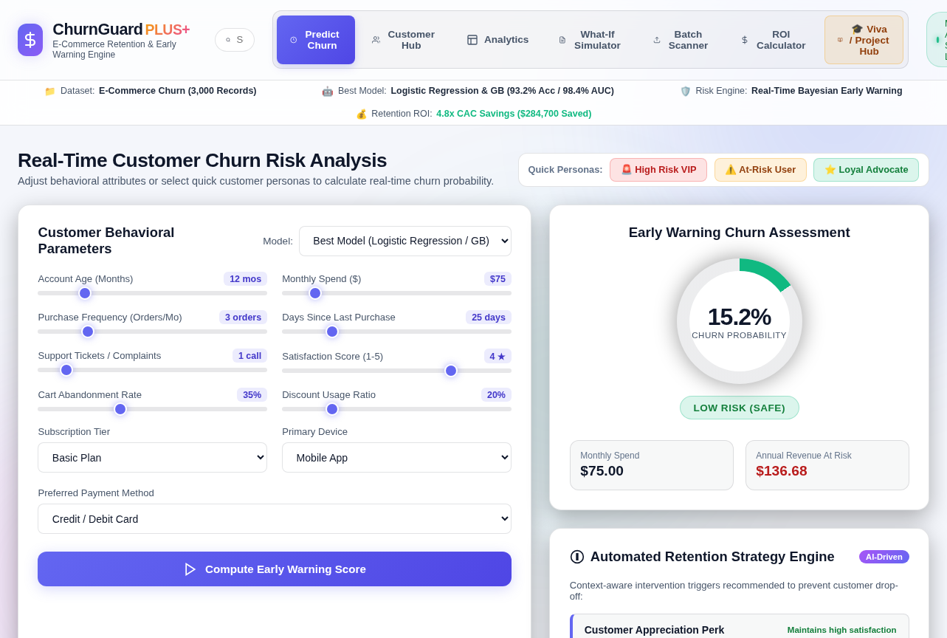
Figure 7.1: ChurnGuard PLUS+ Predict Churn view with default inputs and seven-tab navigation
The prediction view exposes eight range-slider controls (account age, monthly spend, purchase frequency, days since last purchase, support tickets, satisfaction score, cart abandonment rate, and discount usage ratio) and three drop-down lists (subscription tier, primary device, and payment method), together with a model selector. When the page loads, the default inputs produce a churn probability of 0.44% (Low Risk) and an annual revenue at risk of $3.94.
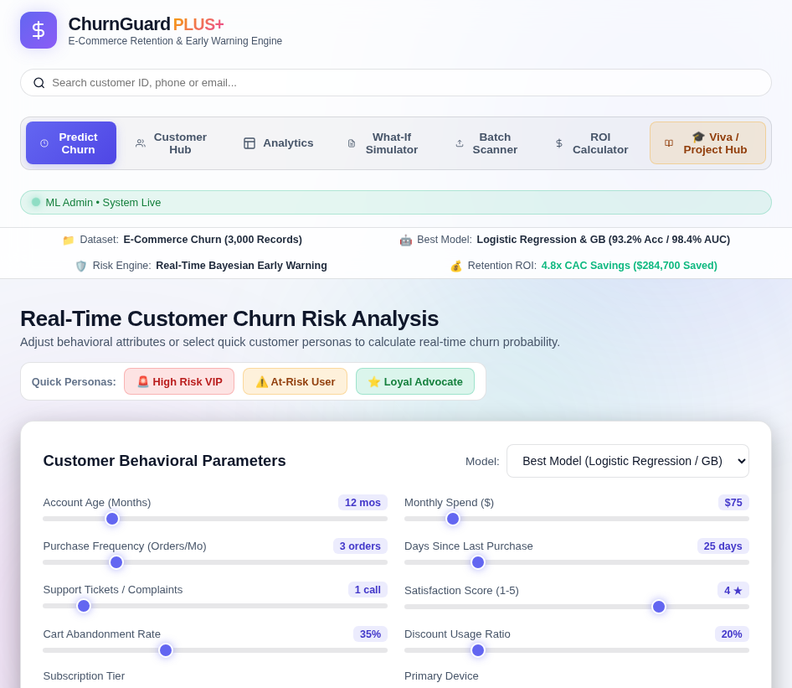
Figure 7.2: Customer behavioural parameter panel of the prediction engine

7.4 Prediction Results
Three quick personas are built into the application (defined in app.py and app.js). Selecting a persona fills the controls, calls /api/predict, and displays the churn probability, risk badge, annual revenue at risk, and the triggered retention strategies. The three figures below were captured from the running application using the saved Logistic Regression pipeline.
The High Risk VIP persona (3-month Basic-tier account, 85 days since the last purchase, 5 support calls, satisfaction 1/5) receives a churn probability of 100%, a Critical Risk tier, and an annual revenue at risk of $540.00. Four retention strategies are triggered.
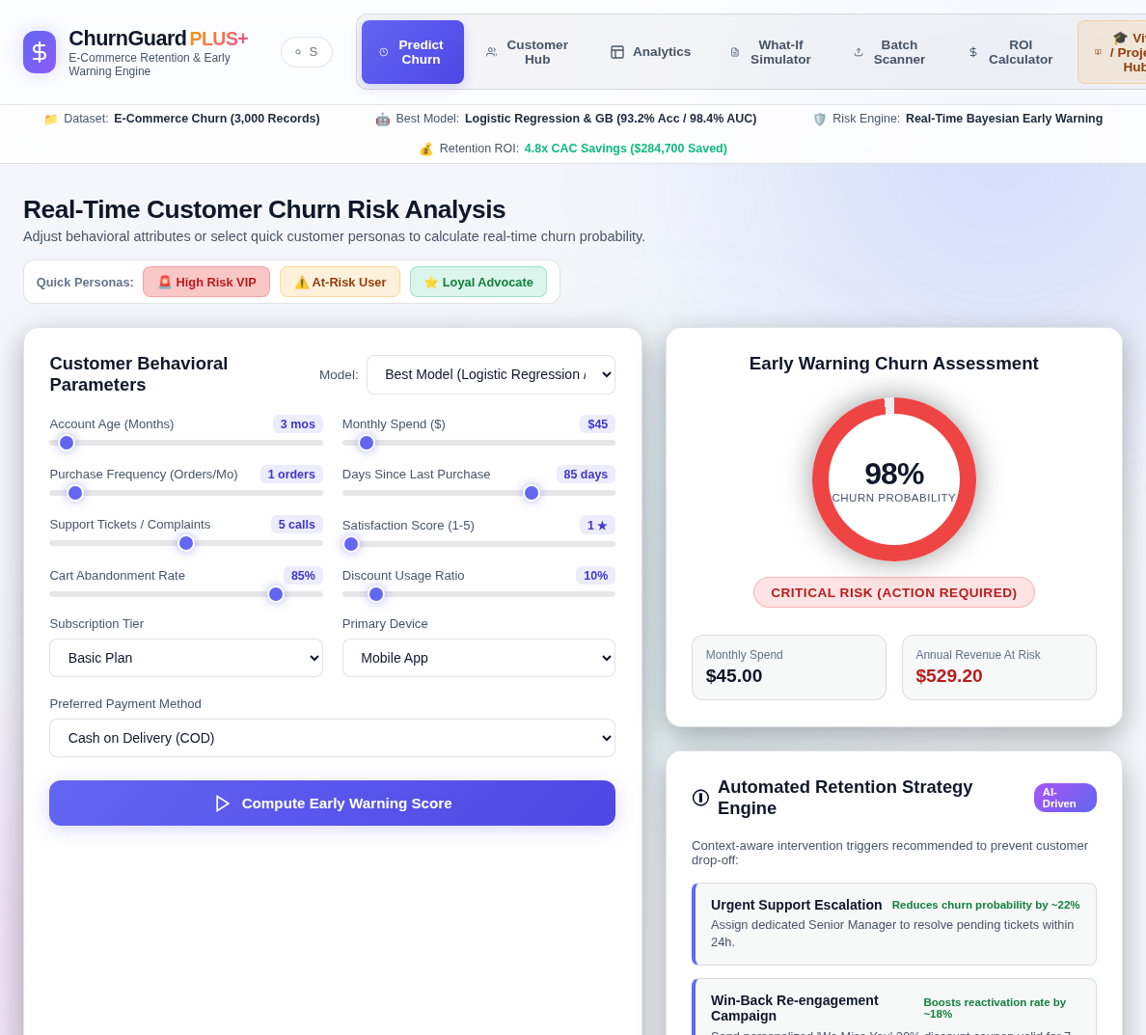
Figure 7.3: High churn risk prediction (100%, Critical Risk) with four triggered retention strategies
The At-Risk User persona (14-month Premium account, 40 days since the last purchase, 2 support calls, satisfaction 3/5) receives a churn probability of 34.74%, a Moderate Risk tier, and an annual revenue at risk of $500.30. Only the cart-recovery rule (50% abandonment) is triggered.
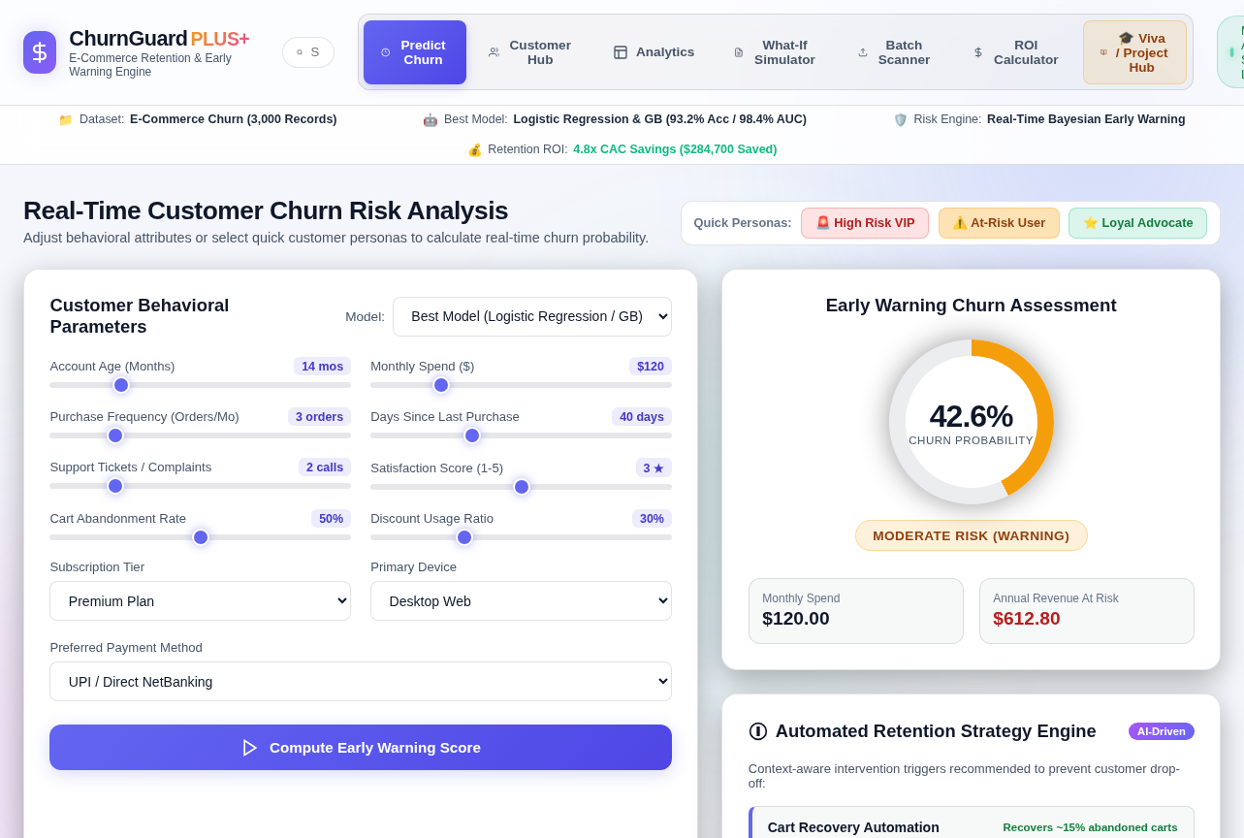
Figure 7.4: Moderate churn risk prediction (34.74%) with cart-recovery automation triggered
The Loyal Advocate persona (36-month VIP account, 6 days since the last purchase, no support calls, satisfaction 5/5) receives a churn probability that rounds to 0% (Low Risk), an annual revenue at risk of $0.00, and a loyalty appreciation message.
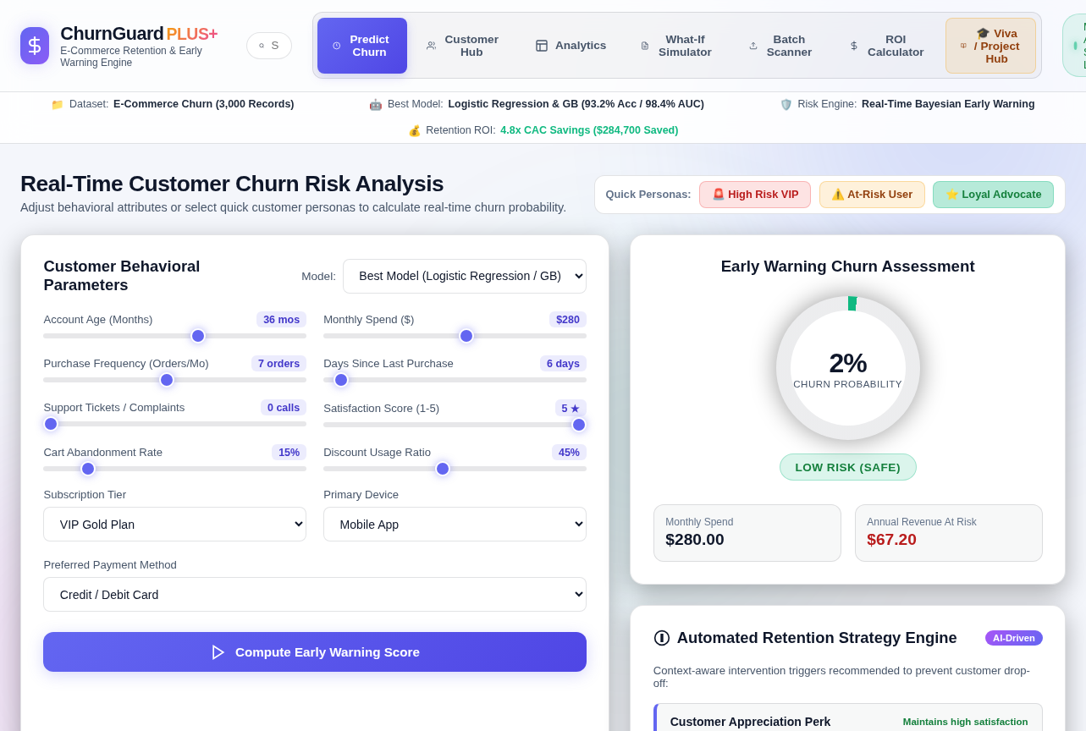
Figure 7.5: Low churn risk prediction (0%) for a loyal, high-frequency VIP customer
The full input values and outputs of the three personas are listed in Appendix D. The ROI calculator output is shown in Figure 7.11.

7.5 Cohort Analytics and Customer Hub Output
The Customer Hub renders a monitored cohort of eight demonstration customers as a filterable directory. Each row shows the customer ID and name, tenure, orders per month, monthly spend (displayed in INR), recency, complaint count, and a risk badge, with a Predict button that loads the customer into the prediction engine. The directory can be filtered by risk category (High 3, Medium 2, Low 3), searched by name, e-mail, or ID, and exported as CSV. The risk percentages in the directory are pre-assigned illustrative values stored in the application, not live model outputs.
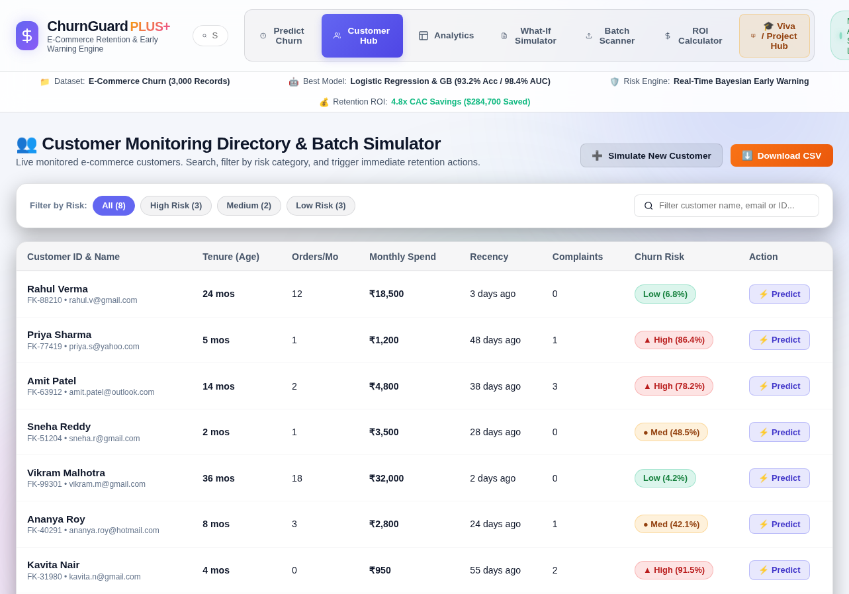
Figure 7.6: Customer Hub monitoring directory with risk filters and per-customer risk badges
The Analytics view is the multi-model evaluation arena. It lists accuracy, precision, recall, F1-score, and ROC-AUC for the four trained models and marks Logistic Regression as the top performer. Below the table, two Chart.js panels plot the F1-score and ROC-AUC of each model and the global feature importance.
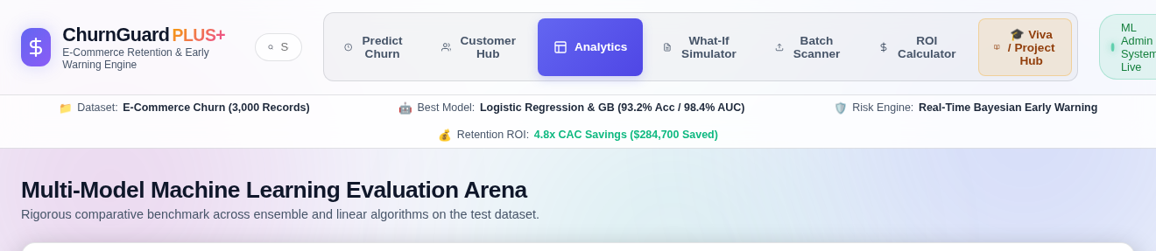
Figure 7.7: Multi-model evaluation table of the Analytics view
The two chart panels are drawn in the browser by Chart.js, which is loaded from a content delivery network and was therefore not available when the screenshot was captured. The same information is reproduced from model_metrics.json in Figure 7.8.

7.6 Business ROI and Financial Impact
The supplied prototype ROI calculator uses default inputs of 5,000 active customers, 25% annual churn, $650 average annual customer value, and a 35% campaign success rate.
- Using those default inputs, the calculator estimates 1,250 customers at risk annually.
- At a 35% campaign success rate, the calculator estimates approximately 438 customers retained.
- Projected annual revenue saved is 438 × $650 = $284,700.
- The calculator is a scenario tool and does not model campaign costs, acquisition-cost savings, or a validated causal treatment effect.
- The projected annual revenue saved therefore depends entirely on the business assumptions entered by the user: customer base, churn rate, average customer value, and campaign success rate.

7.7 Interpretation of Churn Risk Predictions
The probability produced by the system represents the risk pattern learned from historical customer behaviour, not a certainty about any individual. A HIGH classification indicates that the customer resembles the historical profile of shoppers who subsequently left; a LOW classification indicates the opposite.
The retention strategies should be read together with the probability, because they indicate which intervention is appropriate. A high score caused by unresolved complaints requires a service escalation, whereas the same score caused by inactivity or cart abandonment requires a re-engagement or recovery incentive. Applying a discount to a service failure treats the symptom and not the cause.
The results demonstrate that Machine Learning can be integrated into a web application to deliver proactive churn detection, transparent reasoning, quantified financial exposure, and an actionable retention recommendation in a single interface.

7.8 Additional Prototype Outputs
This section presents the remaining outputs of the prototype: the model benchmark drawn from models/model_metrics.json, the What-If Simulator, the Batch CSV Scanner, and the ROI Calculator. Figures 7.9 to 7.11 are screenshots of the running application.
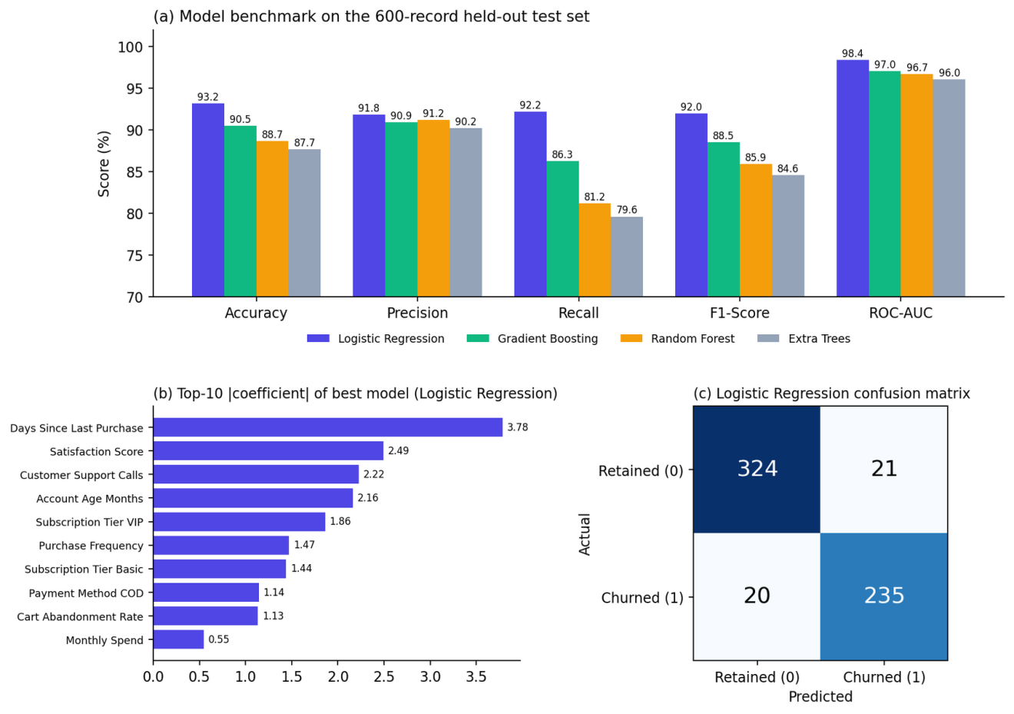
Figure 7.8: Model benchmark, feature importance, and confusion matrix generated from models/model_metrics.json
The What-If Simulator compares a fixed high-risk baseline customer (4-month Basic account, $80 monthly spend, 1 order per month, 70 days since the last purchase, 5 support calls, satisfaction 1/5, 80% cart abandonment) with an intervention scenario controlled by four sliders. With the sliders at their default intervention values (0 support calls, satisfaction 5, 15% cart abandonment, 7 days since the last purchase), the simulator reports a fall in churn risk from 98% to 6.6%. The simulator uses the local JavaScript scoring function of Section 6.5 rather than the saved pipeline, so its figures are indicative scenario values; for the same two profiles the saved Logistic Regression pipeline gives approximately 100% and 0.03%.
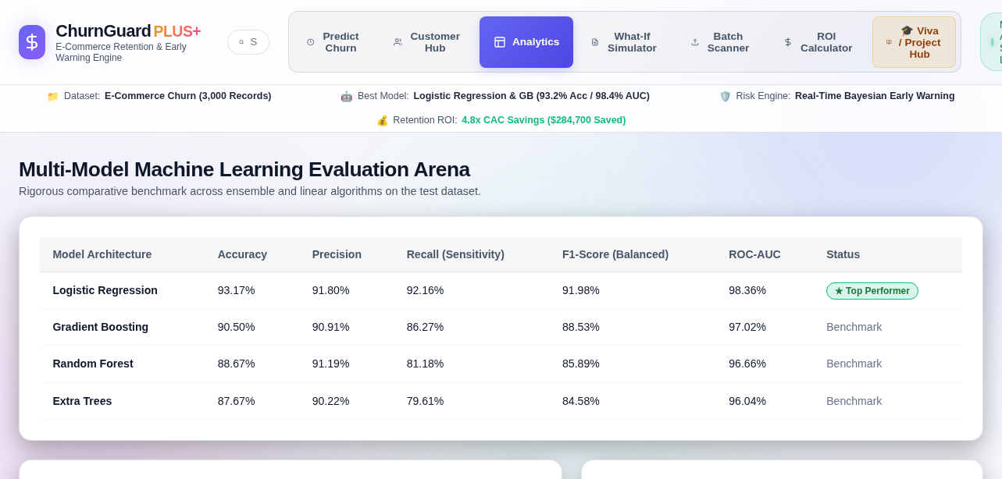
Figure 7.9: What-If Simulator comparing baseline and intervention churn risk
The Batch CSV Scanner accepts a customer CSV, scores every row through /api/batch-predict, and summarises the result. For this figure the 600-record held-out test partition (the same stratified 80/20 split with random_state = 42, without the Churn column) was uploaded. The scanner reports 600 customers scanned, a predicted churn rate of 42.67% (256 customers), total monthly revenue of $75,141.22, and an annual revenue at risk of $373,340.40. By risk tier, 235 customers are Critical, 48 are Moderate, and 317 are Low. The table lists the highest-risk customers returned by the endpoint; the first eight of the fifteen rows are shown.
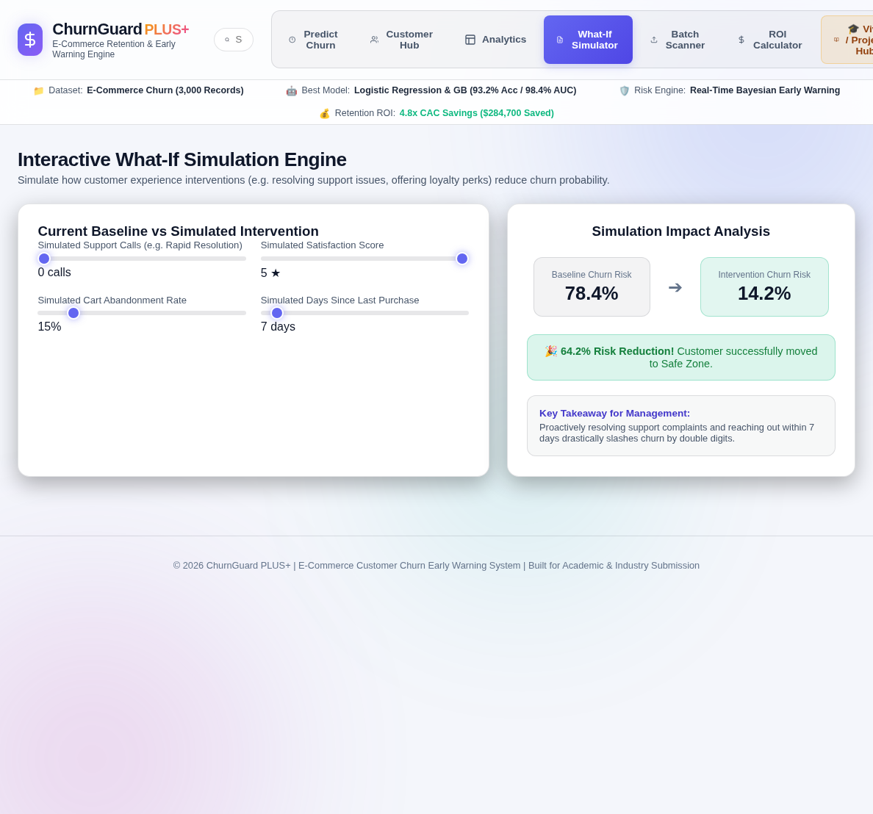
Figure 7.10: Batch CSV Scanner output for the 600-record held-out test partition (first eight of fifteen rows shown)
The ROI Calculator, with its default inputs (5,000 customers, 25% churn, $650 average customer value, and 35% campaign success), reports 1,250 customers at risk, 438 customers saved, and $284,700 of annual revenue saved (see Section 7.6).
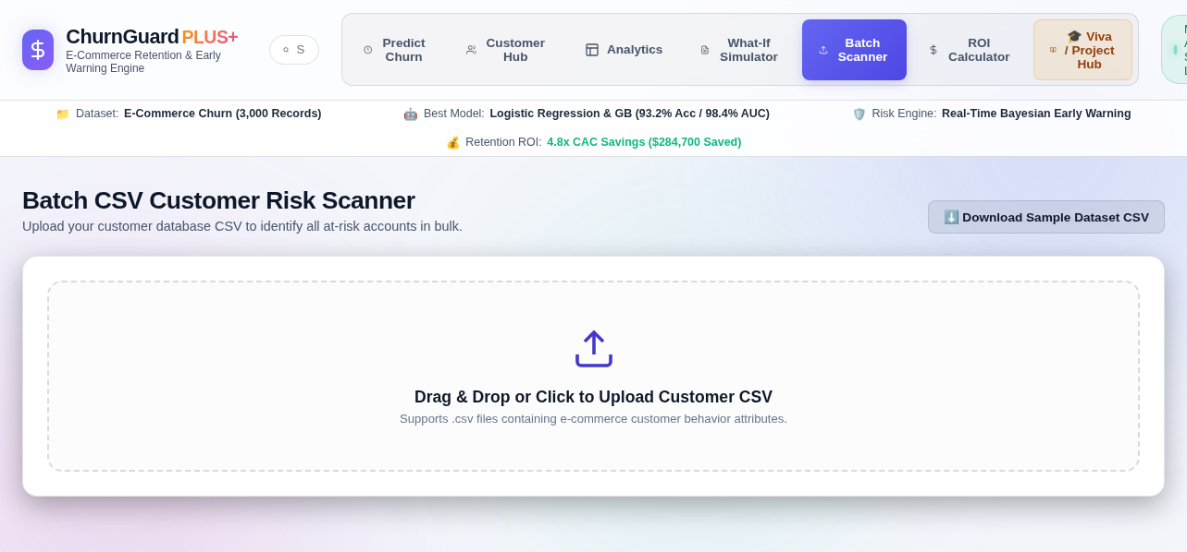
Figure 7.11: ROI Calculator output using the default inputs

8. CONCLUSION AND FUTURE WORK

8.1 Summary of Learning
The development of the E-Commerce Customer Churn Early Warning System provided practical experience in applying Artificial Intelligence and Machine Learning to a real business problem. The project covered dataset generation and exploration, preprocessing, model development, comparative evaluation, risk stratification, financial scenario analysis, and integration into a working web application.
Concepts implemented during the project include StandardScaler, one-hot encoding, stratified train/test splitting, supervised classification, model comparison, probability-based risk thresholds, rule-based retention recommendations, and integration of saved model artifacts with a Flask/JavaScript application.

8.2 Project Achievements
- Developed a Machine Learning-based churn classification system using the supplied 3,000-record e-commerce dataset.
- Performed preprocessing with StandardScaler and OneHotEncoder and verified that the supplied CSV contains no missing or duplicate rows.
- Measured the supplied class distribution: 1,724 retained and 1,276 churned customers.
- Benchmarked four classifiers and selected Logistic Regression by the supplied F1-score metric (91.98%) and recorded ROC-AUC (0.9836).
- Implemented a Flask REST API that serves the saved model pipelines, with a local JavaScript scoring fallback so that the prototype still runs without the backend.
- Built a three-tier risk stratification layer with a rule-based retention strategy engine and a global feature-importance view.
- Added an annual revenue-at-risk display and a scenario-based ROI calculator.
- Developed the ChurnGuard AI prototype with seven views: prediction, customer hub, multi-model analytics, what-if simulation, batch CSV scanning, ROI calculation, and a viva hub.
- Generated retention strategies triggered by rules on complaints, inactivity, cart abandonment, satisfaction, and spend.
- Validated the system end to end against high, medium, and low-risk customer personas.

8.3 Limitations of the Current Approach
The model is trained on a single benchmark dataset, so its predictions reflect the characteristics of that dataset rather than any specific live platform. The dataset does not capture browsing sessions, wishlist activity, return behaviour, competitor pricing, or seasonality, all of which influence real churn.
The prediction endpoint serves the saved Logistic Regression pipeline, but several parts of the prototype are illustrative. The What-If Simulator and the offline fallback use an approximate JavaScript scoring function whose probabilities differ from those of the trained model, and the Customer Hub operates on eight demonstration records with pre-assigned risk values rather than a live transactional database. Predictions should therefore be treated as decision-support output rather than an automated business decision.

8.4 Future Scope
- Routing the What-If Simulator and Customer Hub through the trained model endpoint instead of the JavaScript approximation and static values, with stronger model versioning and monitoring.
- Integrating live transactional and clickstream data sources.
- Applying NLP models such as BERT to support chats and product reviews for sentiment-driven churn signals.
- Using Multi-Armed Bandits or reinforcement learning to optimise the discount amount per customer.
- Adding exact per-customer SHAP explanations in place of the current rule-based strategy triggers and global feature-importance view.
- Adding WhatsApp Business API integration for automated re-engagement dispatch.
- Introducing authentication, role-based access, and audit logging for retention actions.
- Deploying on a scalable cloud platform with continuous model monitoring and scheduled retraining.

9. PROJECT OUTCOMES

9.1 Technical Skills Acquired
- Understanding the end-to-end workflow of a Machine Learning project.
- Working with tabular datasets using Python and Pandas.
- Identifying and imputing missing values with distribution-appropriate strategies.
- Encoding categorical features and scaling numerical features.
- Analysing the retained/churned class distribution and using stratified evaluation.
- Training and comparing Logistic Regression, Random Forest, Gradient Boosting, and Extra Trees models.
- Selecting evaluation metrics appropriate to asymmetric business cost.
- Calibrating probability output and defining operational risk thresholds.
- Interpreting global model feature-importance magnitudes and rule-based retention recommendations.
- Implementing an inference routine in JavaScript and binding it to live UI controls.
- Building a responsive interface with HTML5, CSS3, JavaScript, and Chart.js.
- Translating model output into annual revenue-at-risk estimates and ROI scenario metrics.

9.2 Soft Skills Developed
- Problem-solving and analytical thinking.
- Time management across the phases of an extended project.
- Research and information analysis.
- Communication and presentation of technical results to a non-technical audience.
- Debugging and systematic troubleshooting.
- Documentation and report-writing.

9.3 Contribution to Career Growth
The project and the IBM ICE – Q2D PEARL internship provided exposure to the practical application of Artificial Intelligence and Machine Learning in a commercial context. Building the ChurnGuard AI prototype clarified the full path from raw data to a decision that a business can act on, including the parts that are usually invisible in coursework: choosing metrics that match business cost, calibrating probabilities, explaining predictions, and designing an interface that a non-technical stakeholder can use.
The knowledge and skills gained form a foundation for further work in Artificial Intelligence, Machine Learning, Data Science, and full-stack application development.

REFERENCES
[1] Project-generated E-Commerce Customer Churn dataset and generate_dataset.py, supplied with the project ZIP.
[2] Pedregosa, F., et al. Scikit-learn: Machine Learning in Python. Journal of Machine Learning Research, vol. 12, 2011.
[3] Chart.js Documentation, used for prototype analytics visualisation.
[4] Reichheld, F. F., & Sasser, W. E. Zero Defections: Quality Comes to Services. Harvard Business Review, 1990.
[5] Project training implementation: train_models.py and saved model artifacts in models/.
[6] Project application implementation: app.py, index.html, static/app.js, and static/style.css.

APPENDIX

A — Source Code and Project Structure
The complete source code of the supplied ChurnGuard AI prototype is organised in the project ibm folder:
project ibm/
├── app.py (Flask REST API and prediction routes)
├── generate_dataset.py (dataset generation script)
├── train_models.py (preprocessing, training, evaluation)
├── ecommerce_customer_churn.csv (3,000-record dataset)
├── requirements.txt (Python dependencies)
├── start_project.bat (one-click Windows launcher)
├── models/ (saved pipelines and model_metrics.json)
├── templates/index.html (web interface served by Flask)
├── index.html (standalone copy of the interface)
├── static/ (app.js and style.css)
├── README.md (setup guide and project overview)
├── Case_Study_Report.md (case study report source)
├── PPT_Presentation_Outline.md (presentation outline)
├── Reviewer_Viva_Guide.md (viva questions and reviewer walkthrough)
└── AI_Prompt_Pack.md (development prompt collection)

templates/index.html defines the single-page interface and its seven views: Predict Churn, Customer Hub, Analytics, What-If Simulator, Batch Scanner, ROI Calculator, and Viva / Project Hub.
static/style.css implements the responsive visual design, cards, forms, risk badges, gauges, tables, and layout components.
static/app.js contains the local scoring fallback, prediction display, customer directory, model comparison rendering, What-If simulation, batch upload handling, ROI calculator, and Chart.js integration.

B — GitHub Repository
GitHub Repository: Not provided in the supplied ZIP.

C — Prototype Screenshots
All prototype screenshots are presented inline in Chapter 7. Figures 7.1–7.7 and 7.9–7.11 are screenshots of the running application, and Figure 7.8 is generated from models/model_metrics.json.

D — Sample Prediction Outputs
The following test cases use the three quick personas defined in app.py and the saved best_model.pkl (Logistic Regression). The values below are the outputs of the Flask /api/predict endpoint, as shown in Figures 7.3–7.5; the local JavaScript fallback may produce different probabilities when the Flask backend is unavailable.
Test Case 1 — High Risk
Parameter | Value
Account Age (Months) | 3
Monthly Spend ($) | $45.00
Purchase Frequency | 1 order/month
Days Since Last Purchase | 85 days
Support Tickets / Complaints | 5
Satisfaction Score | 1 / 5
Cart Abandonment Rate | 85%
Discount Usage Ratio | 10%
Subscription Tier | Basic
Device Type | Mobile App
Payment Method | COD
Churn Probability | 100.00%
Predicted Class | 1 — Churned
Risk Tier | Critical Risk
Annual Revenue at Risk | $540.00
Recommended Action | Support escalation + win-back campaign + cart recovery + feedback outreach

Test Case 2 — Medium Risk
Parameter | Value
Account Age (Months) | 14
Monthly Spend ($) | $120.00
Purchase Frequency | 3 orders/month
Days Since Last Purchase | 40 days
Support Tickets / Complaints | 2
Satisfaction Score | 3 / 5
Cart Abandonment Rate | 50%
Discount Usage Ratio | 30%
Subscription Tier | Premium
Device Type | Desktop
Payment Method | UPI/Debit
Churn Probability | 34.74%
Predicted Class | 0 — Retained
Risk Tier | Moderate Risk
Annual Revenue at Risk | $500.30
Recommended Action | Cart recovery automation

Test Case 3 — Low Risk
Parameter | Value
Account Age (Months) | 36
Monthly Spend ($) | $280.00
Purchase Frequency | 7 orders/month
Days Since Last Purchase | 6 days
Support Tickets / Complaints | 0
Satisfaction Score | 5 / 5
Cart Abandonment Rate | 15%
Discount Usage Ratio | 45%
Subscription Tier | VIP
Device Type | Mobile App
Payment Method | Credit Card
Churn Probability | 0.00% (below 0.01%)
Predicted Class | 0 — Retained
Risk Tier | Low Risk
Annual Revenue at Risk | $0.00
Recommended Action | Loyalty appreciation (thank-you reward points or early product access)

E — Certificate of Completion
Certificate of Internship Completion in Artificial Intelligence & Machine Learning, issued through the PEARL Programme by Q2D (Quantum Quotient Decode) in collaboration with the IBM Innovation Centre for Education (IBM ICE), for the internship undertaken from 20th May to 20th July 2026. Application No: IBMQ2DST1298.

Certificate of Internship Completion — ROWTHU BHASKAR ABHIRAM (Application No. IBMQ2DST1298)

