CS 340 – Grazioso Salvare Rescue Dashboard

About the Project
This project is an interactive client/server dashboard developed for Grazioso Salvare to support data-driven identification of search-and-rescue training candidates. The application connects to a MongoDB database through a custom CRUD Python module and dynamically filters and visualizes animal data based on defined rescue criteria.

The dashboard follows a structured, layered design. MongoDB serves as the model layer, storing and retrieving animal outcome records. The CRUD Python module acts as the controller logic, handling database queries and maintaining separation between data access and presentation. The Dash framework provides the view layer, rendering the interactive data table, geolocation map, and breed distribution chart. This separation of concerns improves maintainability, scalability, and long-term adaptability.

Each rescue filter triggers a direct MongoDB query rather than filtering the dataset in memory. This ensures that only relevant records are retrieved from the database, reinforcing proper client/server architecture principles and improving efficiency when working with larger datasets. The returned records are then used to update all dashboard components in real time.

Motivation
The goal of this project was not just to display data, but to build a functional client/server workflow that reflects real-world database-driven applications. Instead of performing filtering solely within a Pandas DataFrame, the dashboard was intentionally designed to leverage MongoDB as the primary data engine. By pushing filtering logic to the database layer, the application aligns with best practices for performance and scalability.

Another priority was stability and usability. The dashboard needed to remain synchronized across all components when filters were applied. This required careful callback design to ensure that the data table, pie chart, and map always reflected the same filtered dataset. Special attention was given to handling edge cases, such as invalid coordinate values and row selection resets, so that the application would behave predictably and reduce user confusion. The end result is a dashboard that not only meets the functional requirements, but also demonstrates thoughtful design and defensive programming practices. This approach directly reflects core database systems principles covered in CS 340, including separation of concerns, server-side filtering, and controlled client interaction with persistent storage.

Application Architecture
This dashboard follows a layered client/server architecture:
- Model: MongoDB database storing the Austin Animal Center Outcomes dataset
- Controller: Custom CRUD Python module and Dash callback functions that construct and execute database queries
- View: Dash DataTable, geolocation map (Dash Leaflet), and dynamic pie chart

This structure ensures that changes to database logic do not require modifications to the presentation layer, reinforcing modular and maintainable system design.
MongoDB was selected because of its flexible, document-based structure, which aligns naturally with semi-structured JSON-style animal records. Its integration with Python through PyMongo allows efficient querying and straightforward conversion of results into Pandas DataFrames for visualization.
The Dash framework was chosen because it enables the development of interactive web applications entirely in Python. Dash simplifies the connection between backend data operations and frontend components, allowing real-time UI updates without requiring separate JavaScript development.

Getting Started
To reproduce and run this dashboard, you need a working MongoDB environment with the Austin Animal Center Outcomes dataset imported into the correct database and collection. This project was developed in the CS 340 Codio environment using Jupyter Notebook and JupyterDash, but the same setup can be recreated locally as long as MongoDB and the required Python packages are installed.

Before running the notebook, confirm that MongoDB is active and that the aac database contains an animals collection populated with the modified dataset. The dataset used for this project includes the additional fields location_lat, location_long, and age_upon_outcome_in_weeks, which are required for map visualization and filtering logic.

Once the database is ready:
- Open ProjectTwoDashboard.ipynb.
- Run the notebook cells in order.
- Confirm the dashboard launches successfully in the browser.

The notebook instantiates the CRUD module, retrieves records from MongoDB, converts them into a Pandas DataFrame, and launches the Dash application. From there, users can apply rescue-type filters using the radio buttons, and all dashboard components will update dynamically.

Installation
This project was developed using Python, MongoDB, and the Dash framework. To run the dashboard locally, Python 3 and MongoDB must be installed and running.

Required Python libraries:
- PyMongo (database connectivity)
- Dash (interactive web application framework)
- Dash DataTable
- Dash Leaflet (geolocation visualization)
- Pandas (data manipulation)
- Plotly (chart rendering)

Install dependencies using:

pip install pymongo dash dash-leaflet pandas plotly

Ensure MongoDB is running before launching the dashboard. The aac database must contain the animals collection with the imported dataset, and authentication credentials must match those defined in the CRUD Python module.

Usage
The dashboard is launched from a Jupyter Notebook using JupyterDash.

Users can:
- Select a rescue type from radio buttons
- View filtered results in the data table
- See breed distribution in a dynamic pie chart
- View animal location on an interactive map

Each interaction follows a structured data flow. User input triggers a Dash callback, which constructs a MongoDB query using the CRUD module. The filtered results are retrieved from the database and used to update the data table, pie chart, and map simultaneously. This ensures all components remain synchronized and reflect the same filtered dataset. The radio-button interface was intentionally selected because the rescue categories are mutually exclusive, which reduces ambiguity and improves clarity for non-technical users.

Challenges and Solutions
Several technical challenges were encountered during development.
One challenge involved handling geolocation data. Latitude and longitude values were sometimes returned as strings or contained missing values, which caused the map to fail when rendering markers. This was resolved by explicitly converting coordinate values to floats and adding exception handling to prevent application crashes.
Another challenge involved keeping all dashboard components synchronized. When filters were applied, the data table, chart, and map needed to reflect the same subset of records. This required careful use of Dash’s derived_virtual_data and selected_rows properties to maintain consistency across callbacks.
Finally, managing the reset state required re-querying the full dataset from MongoDB rather than relying on cached data. This ensured that the dashboard reliably returned to its original state and prevented inconsistencies after multiple filter applications.
These challenges reinforced the importance of defensive programming and thoughtful callback design when building interactive data applications. Addressing these issues improved the reliability of the application and reinforced the importance of anticipating edge cases in client/server development.

Screenshots
Figure 1. Initial Dashboard State (Reset – All Records)
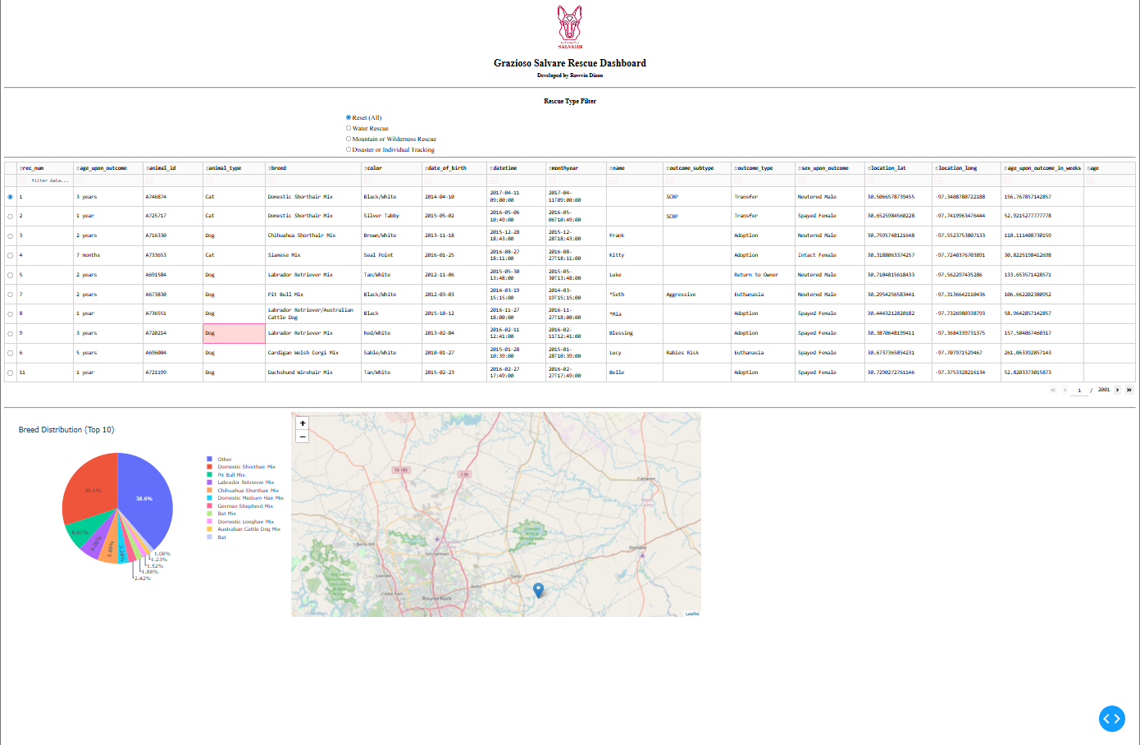
This screenshot shows the dashboard on initial load with all records displayed. The table, pie chart, and map are visible and fully functional.
Figure 2. Water Rescue Filter Applied
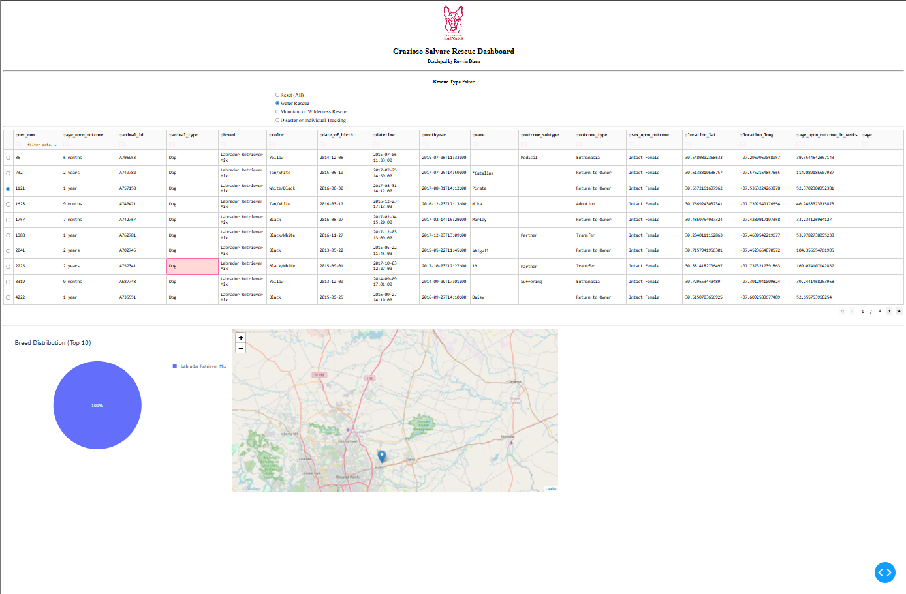
This screenshot demonstrates the Water Rescue filter applied. The table narrows to matching records, the pie chart updates, and the map reflects the selected row.
Figure 3. Mountain or Wilderness Rescue Filter Applied
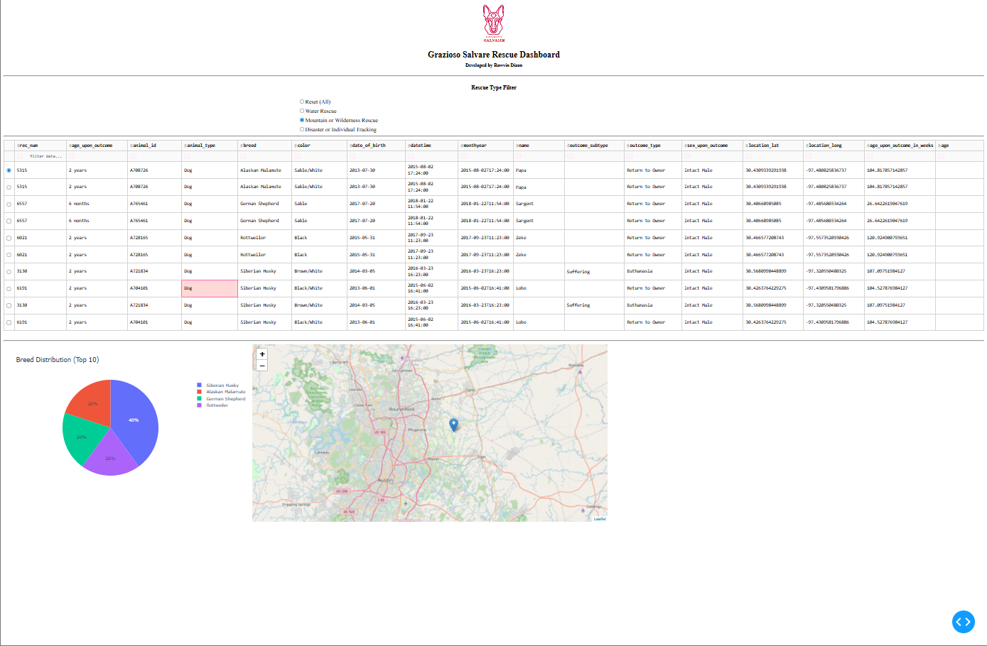
This screenshot shows the dashboard after applying the Mountain or Wilderness Rescue filter. All visual components update dynamically.
Figure 4. Disaster or Individual Tracking Filter Applied
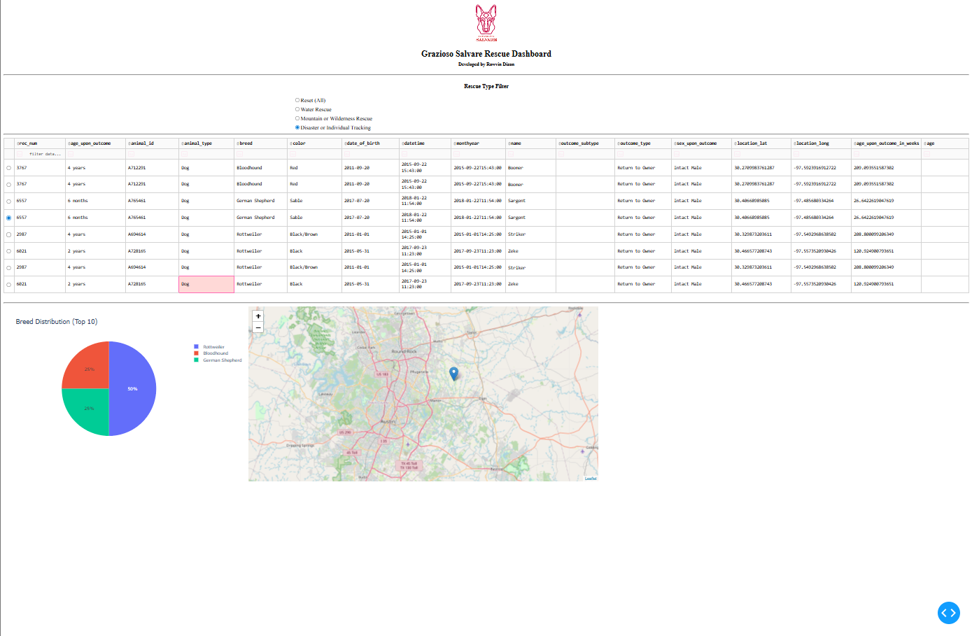
This screenshot demonstrates the Disaster or Individual Tracking filter applied. The data table narrows to the appropriate breeds and age range, the pie chart updates to reflect the filtered distribution, and the map updates to the selected record.
Figure 5. Reset Filter Applied
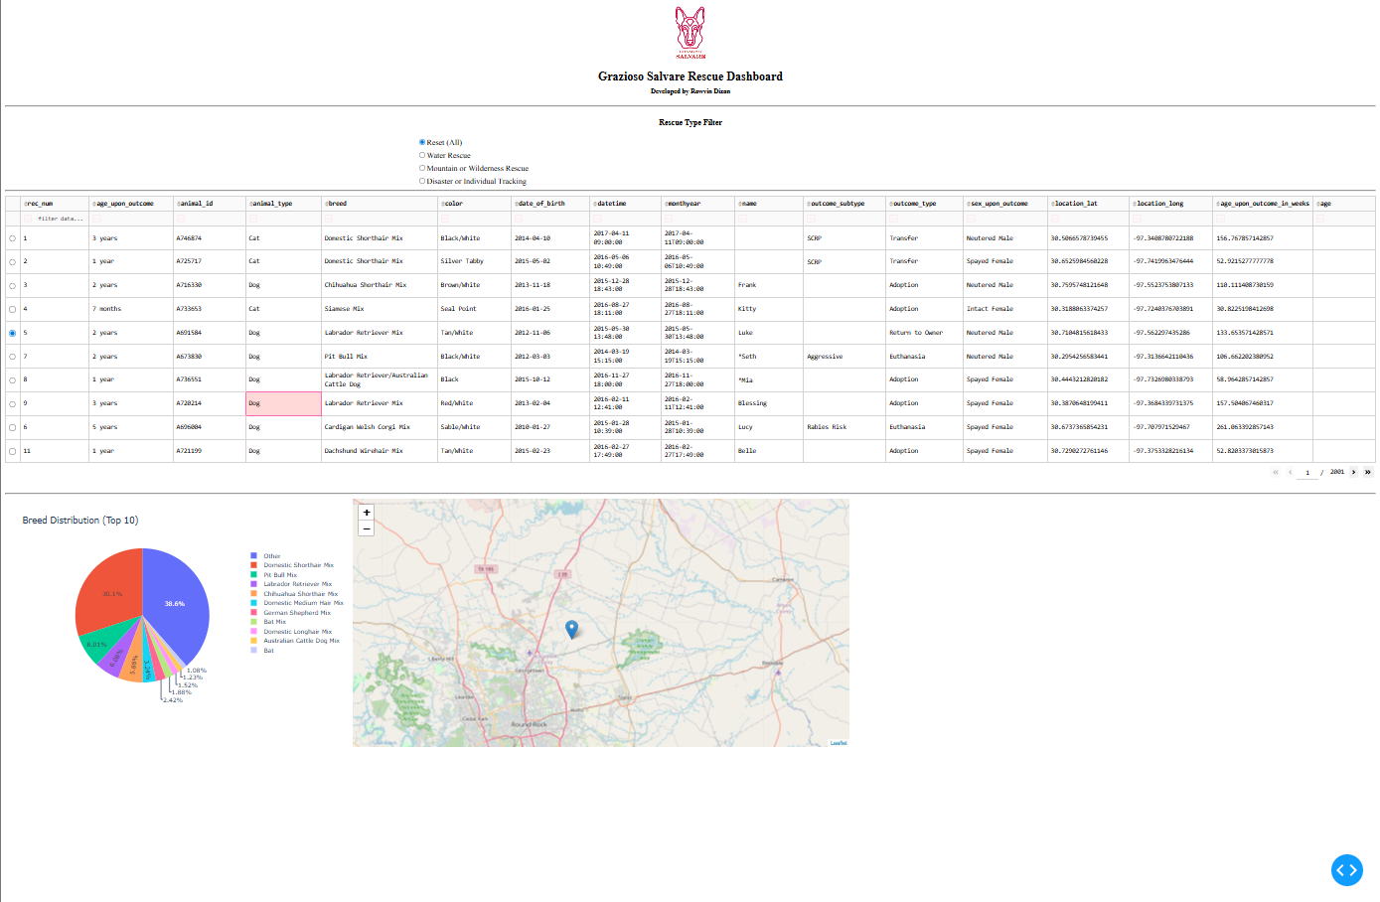
This screenshot confirms that selecting Reset restores the dashboard to its original full dataset state. The table, chart, and map return to displaying all available records.

Contact
Rowvin Dizon
CS 340 – Client/Server Development
Southern New Hampshire University

