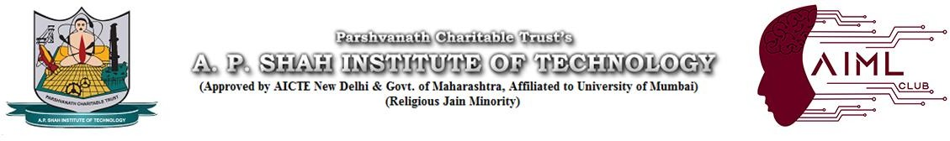

Department of Computer Science & Engineering
(Artificial Intelligence & Machine Learning)

Academic Year 2026-27 Date:25/09/2026

Notice

All AIML Club Learners are hereby informed that a session on “GENERATIVE AI AGENTIC WORKFLOWS” will be conducted on 28th September 2026 from 2:00 PM - 4:30 PM in Seminar Hall 2 by:

- Mr. Alex Turner (AI Architect)
Miss. Priya Sharma (Lead Researcher)

Prof. Vijesh Nair Dr. Jaya Gupta
Departmental Coordinator Head of Department

AI-ML CLUB | APSIT

