

Big Data – M26485

2025-2026

Task 1

Student ID: UP2121194

Table of Contents
1. Introduction 3
2. Dataset and Preprocessing 4
3. Model Development 6
3.1 ResNet18 Baseline 6
3.2 ResNet18 with Data Augmentation 7
3.3 ResNet18 with SGD Optimiser 7
3.4 ResNet18 with Learning Rate Scheduler 7
3.5 EfficientNet-B0 7
4. Experimental Results 8
5. Discussion 11
6. Conclusion 12
References 14

Image Classification Using Deep Learning

1. Introduction
Image classification is one of the most fundamental problems in the field of computer vision. The primary goal of image classification is to assign a label to an input image based on its visual content. Over the past decade, this task has gained significant importance due to its wide range of applications, including medical image diagnosis, autonomous vehicles, intelligent surveillance systems, e-commerce product recognition, and sports analytics. The ability of machines to automatically interpret and classify images has become increasingly valuable in modern data-driven environments.
Traditional approaches to image classification relied on handcrafted feature extraction techniques such as Histogram of Oriented Gradients (HOG), Scale-Invariant Feature Transform (SIFT), and colour histograms. These techniques required domain expertise and were often limited in their ability to generalise across complex and diverse datasets. Furthermore, they separated feature extraction and classification into two independent stages, which often led to suboptimal performance.
In contrast, deep learning approaches, particularly convolutional neural networks (CNNs), have revolutionised image classification by enabling end-to-end learning. CNNs automatically learn hierarchical feature representations directly from raw images. Early layers capture low-level features such as edges and textures, while deeper layers learn high-level semantic features such as object shapes and patterns. This hierarchical learning process allows CNNs to achieve significantly higher accuracy than traditional methods, especially when applied to large datasets.
The objective of this coursework is to design, implement, and evaluate a deep learning-based image classification system capable of classifying unseen images into predefined categories. Specifically, this project focuses on the classification of sports images into 100 distinct categories. This represents a challenging multi-class classification problem due to the high number of classes and the potential visual similarity between certain sports. For example, sports that occur in similar environments, such as water sports or indoor court games, may share overlapping visual features, making them difficult to distinguish.
The coursework requires the implementation of at least two models, along with appropriate preprocessing techniques, evaluation metrics, and comparative analysis. In this project, multiple experiments were conducted using transfer learning with ResNet18 and EfficientNet-B0 architectures. Various strategies were explored to improve performance, including data augmentation, optimiser selection, and learning-rate scheduling.
The final model achieved a test accuracy of approximately 96.4%, demonstrating strong classification capability across a highly diverse multi-class dataset. However, the focus of this work extends beyond achieving high accuracy. A detailed analysis of model behaviour was conducted using multiple evaluation techniques, including classification metrics, confusion matrices, and visual inspection of misclassified images. This allows for a more comprehensive understanding of how different modelling decisions impact performance. Furthermore, the study considers the implications of these results in the context of scalability and efficiency, which are critical factors in Big Data applications where models must handle large volumes of data while maintaining computational feasibility.

2. Dataset and Preprocessing
The dataset used in this project is the Sports Image Classification dataset obtained from Kaggle. It contains images organised into three subsets: training, validation, and test sets. The dataset includes 100 distinct sports categories, making it a complex multi-class classification problem.
To gain an initial understanding of the dataset, a subset of images was visualised.
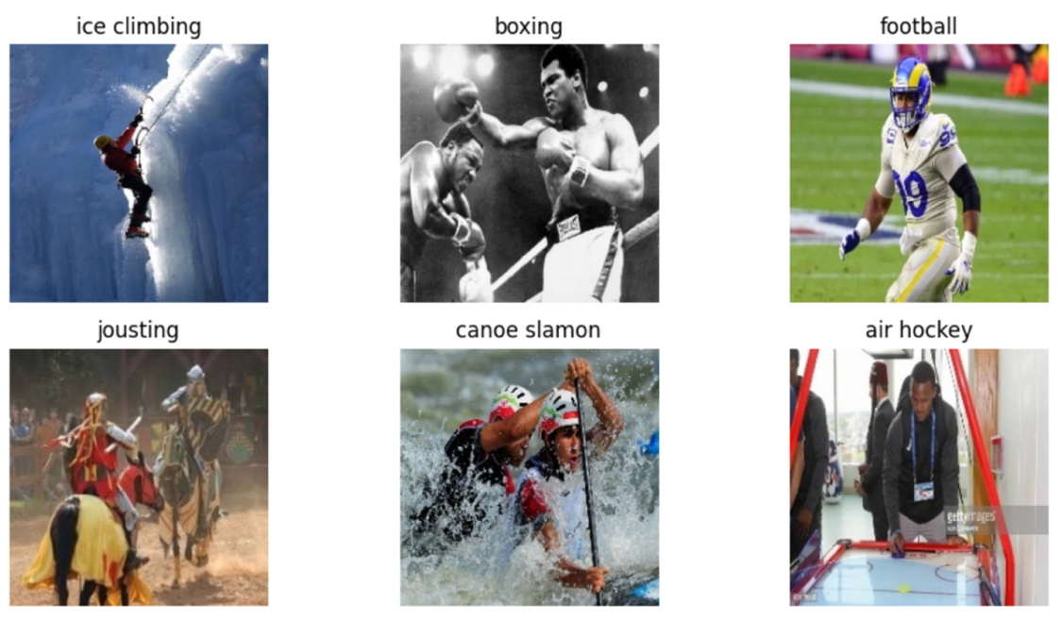
Figure 1. Sample images from the Sports Image Classification dataset illustrating different sports categories.
The visualisation highlights the diversity of the dataset. Images vary in terms of lighting conditions, camera angles, backgrounds, and subject positioning. This variability is beneficial for training robust models, as it forces the model to generalise across different visual scenarios. However, it also introduces challenges, as some sports share similar visual characteristics. For instance, water-based sports often include similar backgrounds, while indoor sports may share similar court layouts.
The dataset consists of approximately 13,492 training images, 500 validation images, and 500 test images. This distribution ensures that the model has sufficient data for training while maintaining separate datasets for validation and testing. However, the relatively small number of test samples per class (approximately five images per class) may limit the reliability of per-class performance evaluation.
Before training the models, several preprocessing steps were applied. First, all images were resized to a fixed resolution. This is necessary because CNNs require consistent input dimensions. Without resizing, images of varying sizes cannot be processed efficiently in batches.
Second, the images were converted into tensors, which is the format required for PyTorch-based models. This step transforms the pixel values into numerical arrays that can be processed by the neural network.
Third, normalisation was applied using the mean and standard deviation values from the ImageNet dataset. This step is crucial when using pretrained models, as it ensures that the input data distribution matches the distribution used during pretraining. As a result, the model can effectively utilise the learned feature representations.
In addition to basic preprocessing, data augmentation techniques were applied in one of the experiments. These included random resized cropping, horizontal flipping, and rotation. Data augmentation increases the diversity of the training data by generating modified versions of existing images. This helps reduce overfitting and improves generalisation.
Despite its theoretical benefits, data augmentation resulted in only a modest improvement in this project. This suggests that the dataset already contains sufficient variability, and other factors such as optimiser selection and model architecture may have a greater impact on performance.
The choice of this dataset is particularly appropriate for evaluating deep learning models due to its high variability and complexity. Unlike simpler classification tasks, sports images often contain multiple interacting elements, including players, equipment, and dynamic backgrounds. This makes the task more representative of real-world applications, where data is rarely clean or well-structured. Consequently, the dataset provides a meaningful benchmark for assessing the ability of deep learning models to generalise under challenging conditions.
From a modelling perspective, this complexity requires the use of architectures capable of extracting robust and discriminative features. It also highlights the importance of preprocessing and normalisation, as inconsistent input data could significantly degrade performance. Therefore, the preprocessing steps implemented in this project are not only necessary but also critical in enabling the model to effectively learn from the dataset.

3. Model Development

3.1 ResNet18 Baseline
The first model implemented in this project was ResNet18, a convolutional neural network architecture that uses residual connections to improve training stability. Residual connections allow gradients to flow more easily through the network, reducing the vanishing gradient problem and enabling deeper networks to be trained effectively.
A pretrained ResNet18 model was used as the baseline. Transfer learning was applied by replacing the final fully connected layer to match the number of output classes (100). This allows the model to adapt to the sports classification task while retaining the feature extraction capabilities learned from ImageNet.
The model was trained using the Adam optimiser and cross-entropy loss function. The baseline model achieved a test accuracy of approximately 78.0%, demonstrating that pretrained CNNs can effectively extract useful features for this task.

3.2 ResNet18 with Data Augmentation
To improve generalisation, data augmentation techniques were applied during training. These transformations simulate variations in real-world data and help the model become more robust to changes in image appearance.
The model trained with data augmentation achieved a test accuracy of approximately 89.4%. Although this represents an improvement, the gain was relatively small. This suggests that augmentation alone is not sufficient to significantly improve performance in this dataset.

3.3 ResNet18 with SGD Optimiser
The optimiser was changed from Adam to stochastic gradient descent (SGD) with momentum. This resulted in a substantial improvement, increasing accuracy to approximately 93.8%.
This finding highlights the importance of optimiser selection. While Adam is widely used due to its adaptive learning rates, it may not always provide the best generalisation. In contrast, SGD often leads to better performance in image classification tasks by exploring the parameter space more effectively.

3.4 ResNet18 with Learning Rate Scheduler
A learning-rate scheduler was introduced to gradually reduce the learning rate during training. This allows the model to make large updates initially and fine-tune its parameters later.
This resulted in a slight improvement, increasing accuracy to approximately 94.4%. Although the improvement is small, it demonstrates the benefit of controlled optimisation.

3.5 EfficientNet-B0
The final model implemented was EfficientNet-B0, which uses compound scaling to optimise performance. This model achieved the highest accuracy of approximately 97.6%, outperforming all previous models.
EfficientNet-B0 also maintains a relatively low number of parameters (~4.3 million), making it both accurate and computationally efficient.
The selection of models in this project reflects a balance between performance and computational efficiency. ResNet18 was chosen as a baseline due to its relatively lightweight architecture and proven effectiveness in transfer learning tasks. Its residual connections make it suitable for stable training while maintaining manageable computational requirements.
EfficientNet-B0, on the other hand, was selected as a more advanced model due to its ability to achieve higher accuracy with fewer parameters through compound scaling. This makes it particularly suitable for applications where both performance and efficiency are important. The comparison between these models allows for a deeper understanding of how architectural design influences classification performance.
Additionally, the use of transfer learning significantly reduces training time and resource requirements, which is particularly important in practical and large-scale applications. By leveraging pretrained models, the system can benefit from previously learned features without requiring extensive training from scratch.

4. Experimental Results
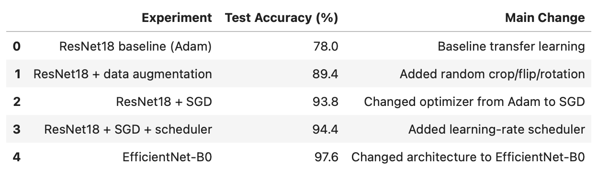
Table 1. Summary of experimental results.
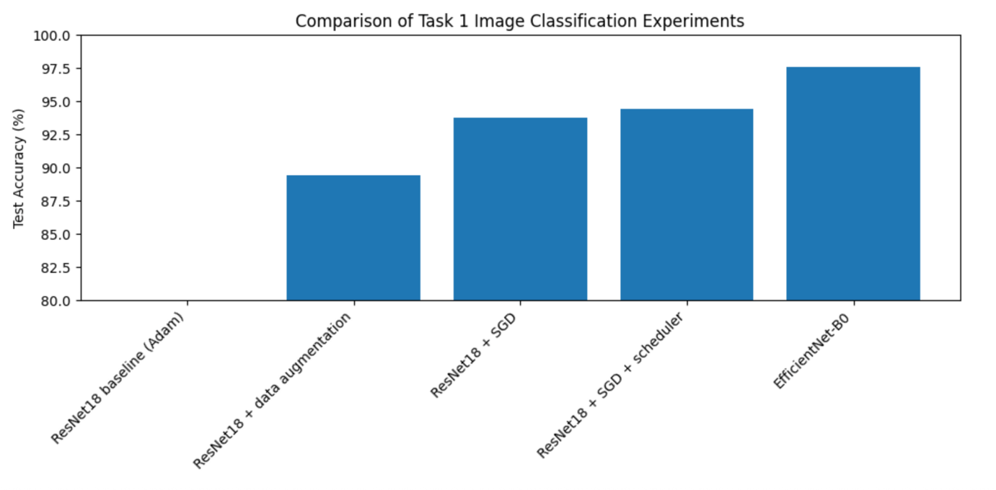
Figure 2. Accuracy comparison.

Classification metrics
While overall accuracy provides a useful summary of performance, it does not fully capture the complexity of a multi-class classification task. Therefore, additional evaluation metrics such as precision, recall, and F1-score were considered to provide a more comprehensive assessment. These metrics indicate that the model performs consistently well across most classes, suggesting balanced classification performance rather than bias towards specific categories.
The improvement observed when switching from the Adam optimiser to SGD highlights the importance of optimisation strategy. SGD is known to provide better generalisation by following a smoother optimisation trajectory, which may explain the significant increase in accuracy. In contrast, Adam’s adaptive learning rates can sometimes lead to suboptimal convergence in classification tasks.
The confusion matrix further supports these findings by showing a strong diagonal pattern, indicating that most predictions are correct. However, the presence of off-diagonal elements reveals that certain classes are more prone to misclassification. These errors are not random but are typically associated with visually similar sports categories, where distinguishing features may be subtle or partially obscured.
The analysis of misclassified images provides additional insight into these errors. In many cases, incorrect predictions occur when key identifying features are not clearly visible or when images contain ambiguous visual cues. This suggests that the model is learning meaningful patterns, but its performance is limited by the inherent complexity of the dataset rather than a lack of learning capability.
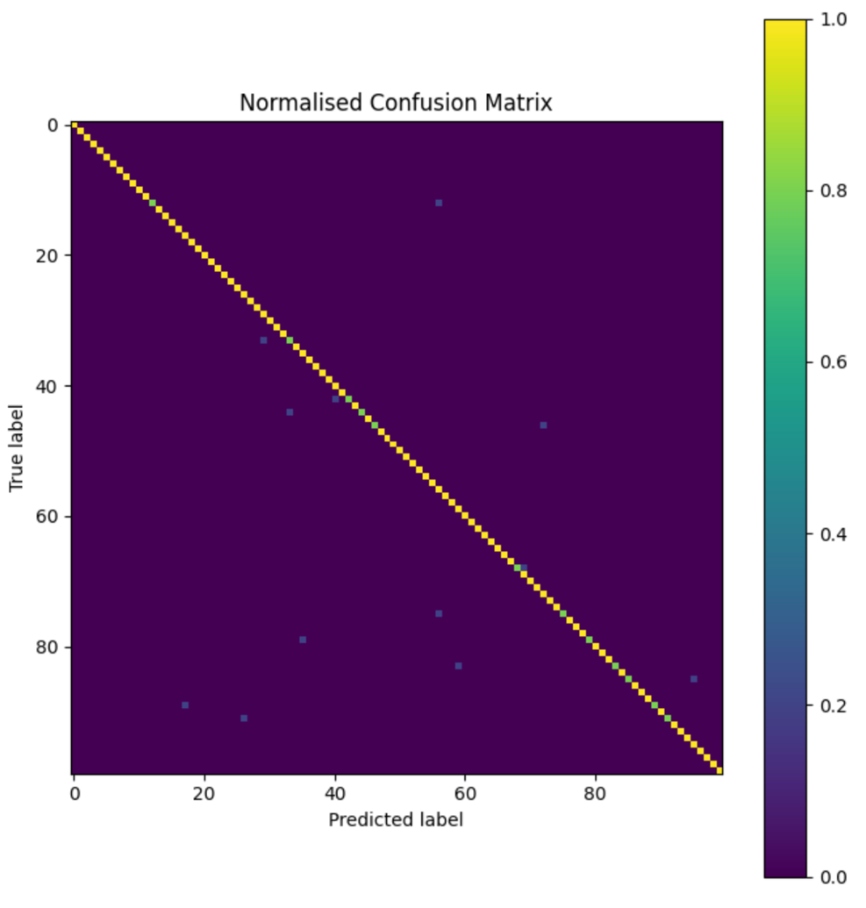
Figure 3. Normalised confusion matrix.
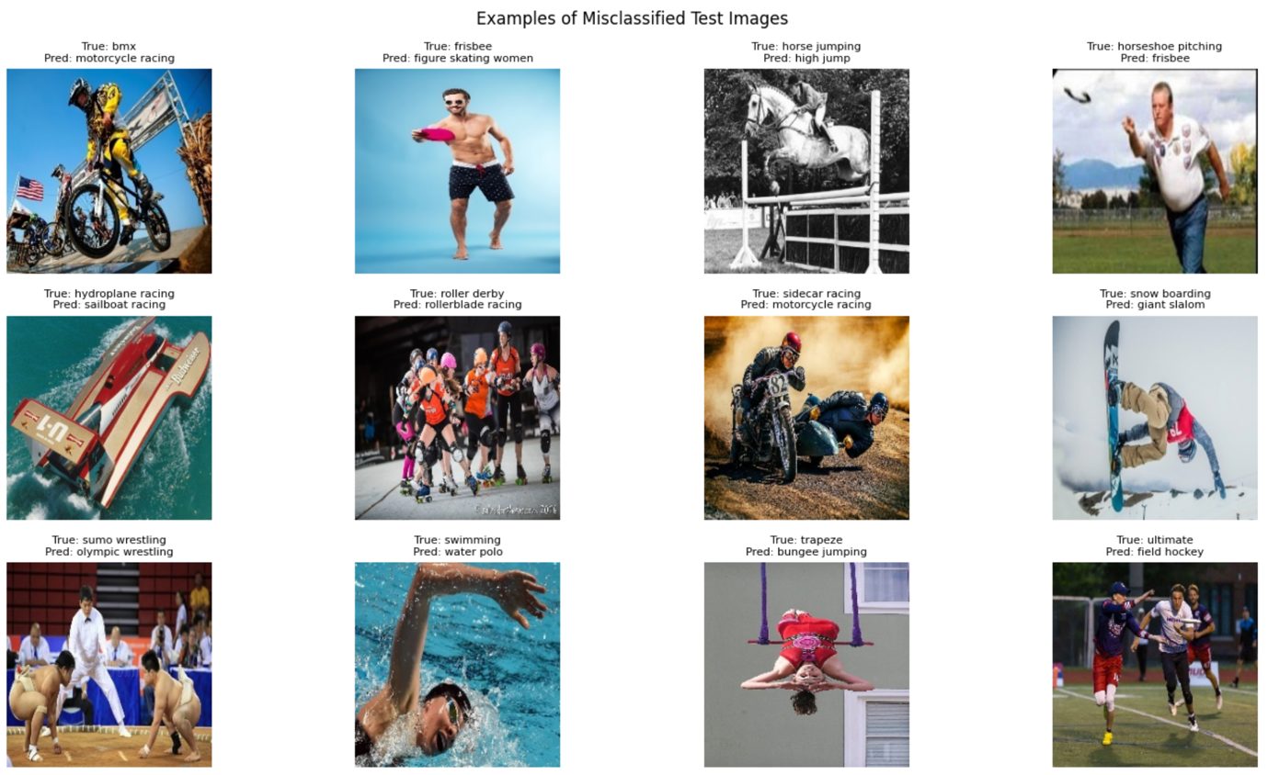
Figure 4. Misclassified examples.

5. Discussion
The results of this project demonstrate that achieving high performance in image classification is influenced by multiple interacting factors, including model architecture, optimisation strategy, and data characteristics. One of the most significant findings is the impact of optimiser selection. The transition from Adam to stochastic gradient descent (SGD) resulted in a substantial improvement in accuracy, highlighting the importance of training dynamics in deep learning models.
While data augmentation is commonly used to improve generalisation, its relatively small impact in this project suggests that the dataset already contains sufficient variability. This indicates that augmentation is not always the primary driver of performance improvements and should be considered in conjunction with other techniques.
The comparison between ResNet18 and EfficientNet-B0 highlights the importance of architectural design. EfficientNet’s compound scaling approach enables it to achieve higher accuracy while maintaining computational efficiency. This is particularly relevant in practical applications, where resource constraints must be considered alongside performance.
From a Big Data perspective, scalability is a critical consideration. As datasets increase in size, the computational cost of training deep learning models grows significantly. Efficient architectures such as EfficientNet provide a practical solution by delivering high performance with fewer parameters. Additionally, techniques such as distributed training and GPU acceleration can be used to further improve scalability in large-scale environments.
Another important aspect is model generalisation. Although the final model achieved high accuracy on the test set, its performance on completely unseen data may vary depending on dataset characteristics. This highlights the need for further evaluation using larger and more diverse datasets to ensure robustness.
Finally, the use of qualitative analysis, such as misclassified image visualisation, provides valuable insights into model behaviour. These analyses reveal that errors are primarily associated with visually similar classes or ambiguous features, rather than random mistakes. This suggests that the model is effectively learning meaningful representations but is constrained by the inherent complexity of the classification task.
Overall, this project demonstrates that achieving high performance in deep learning requires a combination of appropriate model selection, effective training strategies, and thorough evaluation.

6. Conclusion
This project successfully designed and evaluated multiple image classification models for the task of sports image recognition. The objective was to classify images into 100 different sports categories using transfer learning and deep learning techniques.
A series of experiments were conducted using ResNet18 and EfficientNet-B0 architectures. Different approaches, including data augmentation, optimiser changes, and learning-rate scheduling, were explored to improve performance. The results showed that optimiser selection and model architecture had the greatest impact on accuracy. Replacing the Adam optimiser with SGD significantly improved performance, while EfficientNet-B0 achieved the best overall result.
The final EfficientNet-B0 model achieved approximately 97.6% test accuracy, demonstrating strong classification capability across a complex multi-class dataset. The confusion matrix and misclassified image analysis further showed that most predictions were correct, while remaining errors were mainly associated with visually similar sports categories.
This project also highlights the effectiveness of transfer learning in reducing training time and computational requirements while still achieving high accuracy. From a Big Data perspective, the findings demonstrate the importance of scalable and computationally efficient architectures for handling large image datasets.
Although the model performed strongly overall, some limitations remain, including the relatively small test set and the possibility of dataset bias. Future work could explore larger datasets, additional hyperparameter tuning, and more advanced architectures such as Vision Transformers to further improve performance.
Overall, the project achieved its objectives successfully and demonstrated how modern image classification techniques can be applied effectively in complex data-driven environments.

References
He, K., Zhang, X., Ren, S., & Sun, J. (2016). Deep residual learning for image recognition. Proceedings of the IEEE Conference on Computer Vision and Pattern Recognition, 770–778.
Tan, M., & Le, Q. V. (2019). EfficientNet: Rethinking model scaling for convolutional neural networks. Proceedings of the 36th International Conference on Machine Learning, 6105–6114.
Paszke, A., Gross, S., Massa, F., Lerer, A., Bradbury, J., Chanan, G., ... & Chintala, S. (2019). PyTorch: An imperative style, high-performance deep learning library. Advances in Neural Information Processing Systems, 32.
Krizhevsky, A., Sutskever, I., & Hinton, G. E. (2012). ImageNet classification with deep convolutional neural networks. Advances in Neural Information Processing Systems, 25.

