**Lab 8 FLEX**

Demo:

P1:

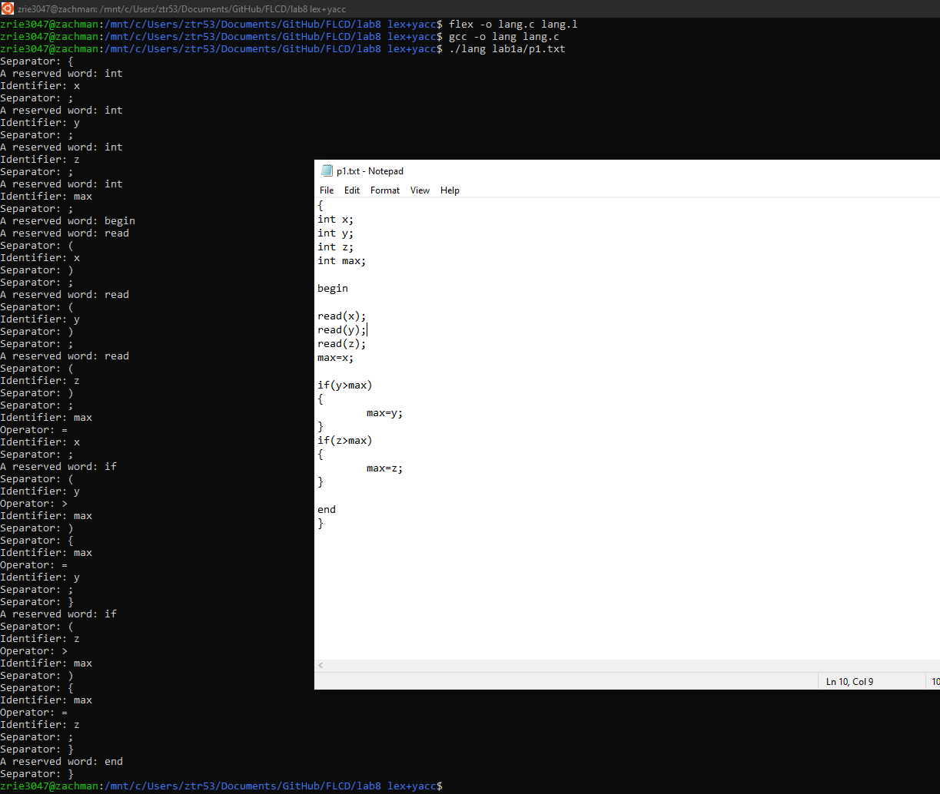

P2:

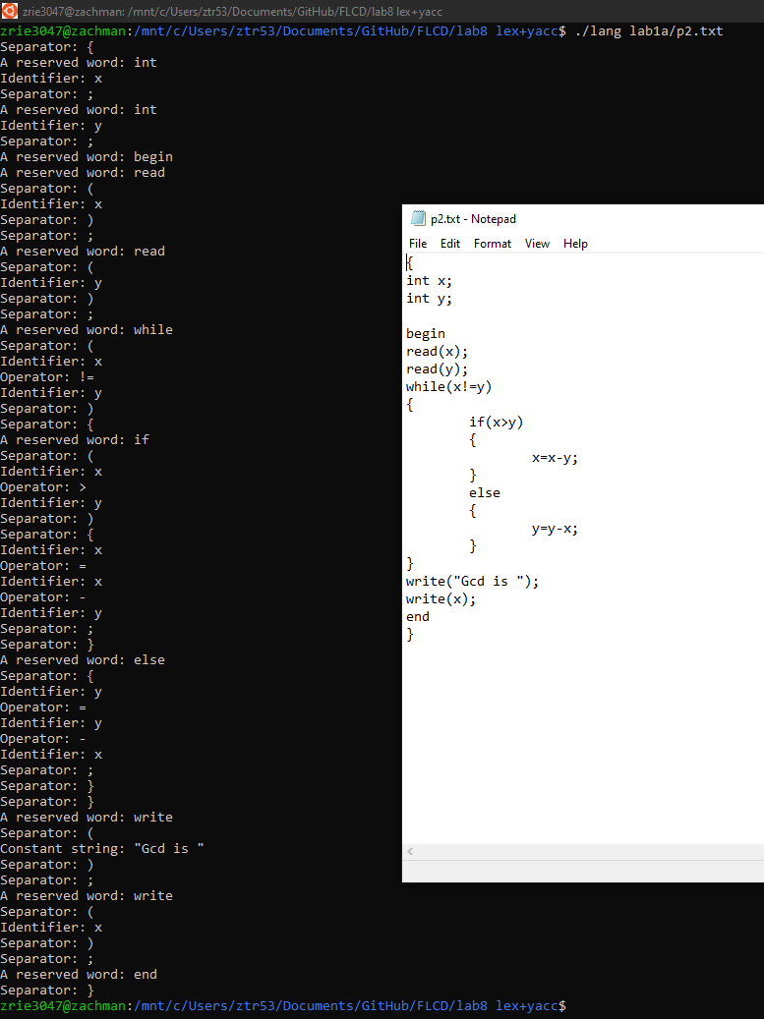

P3:

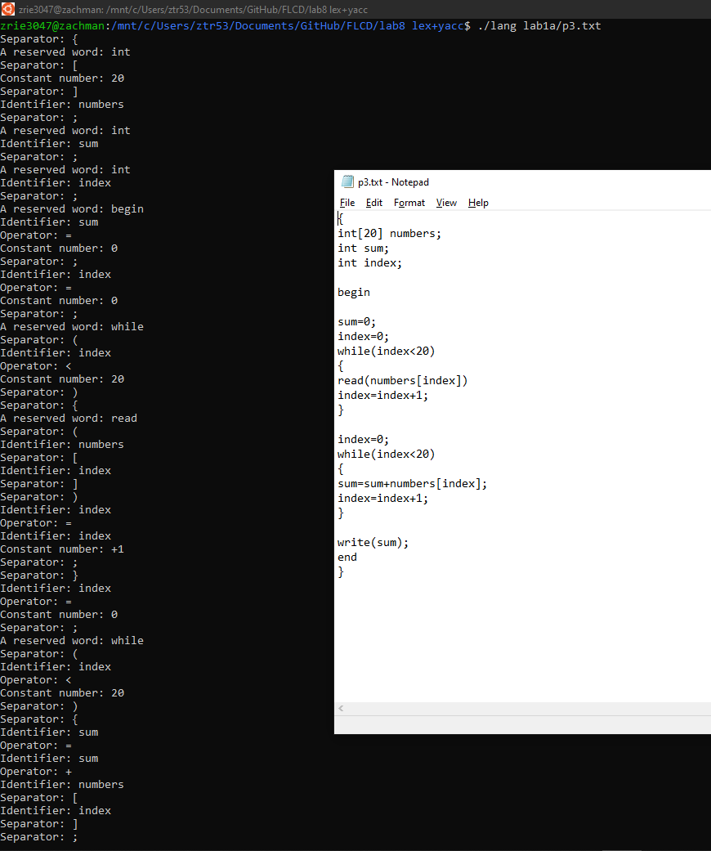

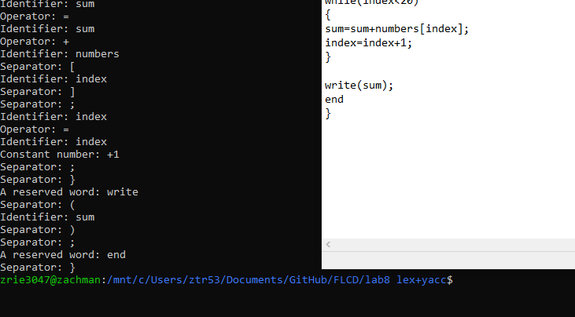

P1err:

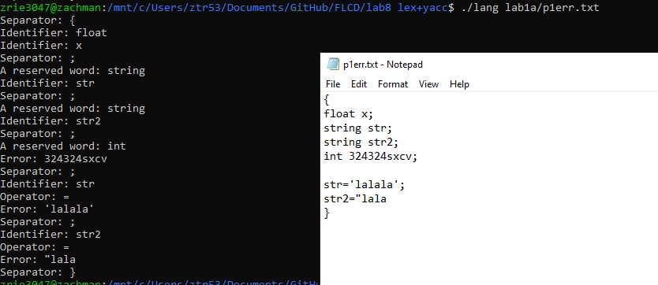

Flex file:

%option noyywrap

%{

#include <stdio.h>

%}

identifier (_|[a-zA-Z])([a-zA-Z]|[0-9])*

constnr (0|([-+]?([1-9][0-9]*)))

char [a-zA-Z ]

constchar "\'"{char}"\'"

conststring \"{char}*\"

separator " "|"("|")"|"["|"]"|"{"|"}"|";"|"\n"|"\t"|"\r"

operator "+"|"-"|"*"|"/"|"<="|"<"|">="|">"|"!="|"=="|"="|"%"

reserved "char"|"string"|"int"|"const"|"if"|"else"|"read"|"write"|"while"|"begin"|"end"

%%

[-+]?0{constnr} printf("Error: %s\n", yytext);

{constnr}{identifier} printf("Error: %s\n", yytext);

{separator} {

if(*yytext!='\r' && *yytext!=' ' && *yytext!='\n' && *yytext!='\t')

printf("Separator: %s\n",yytext);

}

{operator} printf("Operator: %s\n",yytext);

{reserved} printf( "A reserved word: %s\n", yytext);

{identifier} printf("Identifier: %s\n",yytext);

{constnr} printf("Constant number: %s\n",yytext);

{constchar} printf("Constant char: %s\n",yytext);

{conststring} printf("Constant string: %s\n",yytext);

(\'{char}*\')|(\'{char}*)|({char}*\')|(\"{char}*)|({char}*\") printf("Error: %s\n", yytext);

. printf("Error: '%s'\n", yytext);

%%

int main( argc, argv )

int argc;

char **argv;

{

++argv, --argc; /* skip over program name */

if ( argc > 0 )

yyin = fopen( argv[0], "r" );

else

yyin = stdin;

yylex();

}