
rxTools
-with Pasta-

Contents
Building 3
Using Theme Tool 4
Installing rxTools 5
Launching rxTools 5
Launching via the browser 5
Launching via MSET 6
Launching via Ninjhax 6
The first boot 6
The menu 7
rxMode 7
Decryption Options 7
Injection Options 8
Advanced Options 8
Settings 9
Credits 9

Building
To build rxTools, you need the following programs:

- git (download for Debian/Ubuntu here)
- devkitPRO with devkitARM (tutorial for Linux here)
- armips
- ImageMagick (download for Debian/Ubuntu here)

On Windows, you also need:

- GCC
- Python 2.7

Before proceeding, you should make sure that devkitARM/bin is in your PATH.

On GNU/Linux, open a Terminal and type:
echo $PATH
Look for /opt/devkitpro/devkitARM. If it is missing, run the following command:
echo "export PATH=\$PATH:\$DEVKITARM/bin" >> ~/.bashrc
then close the Terminal and try again.

On Windows, open a Command Prompt and type:
echo %path%
Look for C:\devkitPro\devkitARM\bin. If it is missing, run the following command:
setx PATH "%PATH%;C:\devkitPro\devkitARM\bin”
then close the Command Prompt and check again.

In some cases, you may need to log off or reboot in order to apply the changes.

To clone the repository, run the following command:
git clone --recursive https://github.com/roxas75/rxTools.git
Then cd to the rxTools folder:
cd rxTools
And build rxTools:
make
make theme

Using Theme Tool
Theme Tool allows theme creators (and developers) to convert all images to PNG or BGR (.bin), to reduce the size of the PNG files and to create a preview of a theme (animated GIFs and static PNGs). It is included in the theme/0 folder of rxTools, so you can start creating your theme right away. You can also find it in the tools folder of the repository.

Theme Tool must be run via a Terminal/Command Prompt inside the theme folder.

In order to use Theme Tool, you need to install:
- ImageMagick (download for Debian/Ubuntu here)

List of available commands for Theme Tool:
- makebgr <file.png>: converts a .png file to .bin (BGR).
- makebgr-all: converts all .png files to .bin (BGR).
- makepng-all: converts all .bin (BGR) files to .png. If you are creating a theme and you need a template, this is the first command you should use.
- makeprev [gif-delay]: creates a preview (animated GIFs and static PNGs) of your theme in the "Preview" folder. An Internet connection is recommended the first time to download the New Nintendo 3DS XL frame, which will be saved as "~/hero-new-3ds.png".
- strippng-all: removes unnecessary data from all PNG files.

For instance, to convert all .bin files of a theme to .png, run:
sh themetool.sh makepng-all

Then you can start working on your theme. Once you are done with that, you probably want to convert the new theme to .bin, generate a preview and remove the .png files:
sh themetool.sh makebgr-all
sh themetool.sh makeprev
rm *.png

A folder containing several GIF and PNG files will be created.

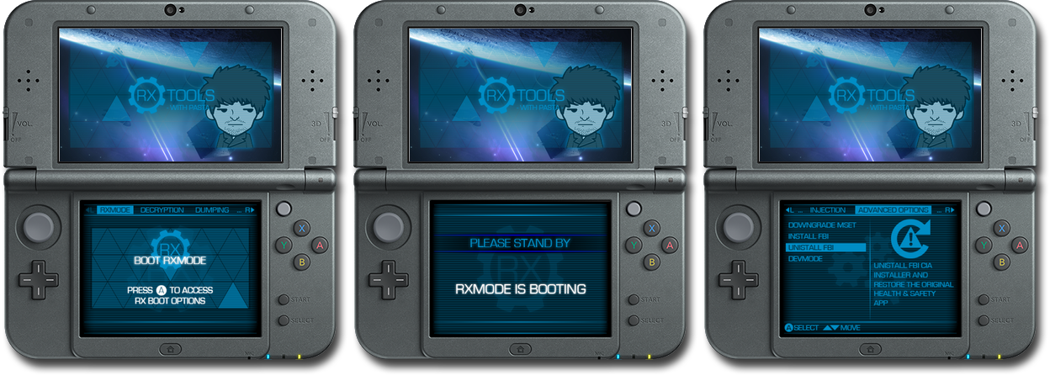

Installing rxTools
To install rxTools, simply copy rxTools.dat and the rxTools folder to your SD card. Put any additional themes to rxTools/theme/n (where n is the a number from 0 to 9). If you are using Ninjhax, copy rxTools.3dsx and rxTools.smdh to the 3ds folder.

Launching rxTools
There are several ways to launch rxTools. None of them currently work on if the console's firmware is above 9.2 or below 4.0.

Launching via the browser
If you have a classic Nintendo 3DS or Nintendo 2DS, you can launch rxTools via the browser. The last digit of your console's firmare version must not be 0 (e.g. 9.2.0-20E is compatible, whilst 9.2.0-0E is not).

- Open the browser settings and select Clear All Save Data.
- Turn off Wi-Fi and go to the URL http://launch.rxtools.net.
- Close the browser, turn on Wi-Fi and open the browser again.
- The next time you open the browser, it will load rxTools automatically.
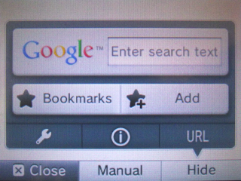
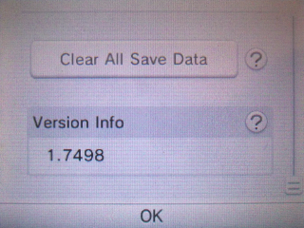
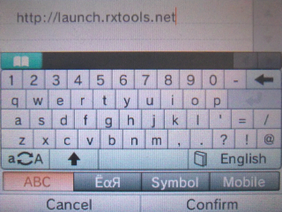

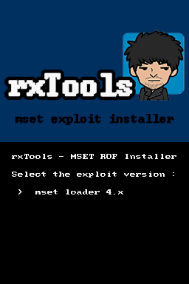
Launching via MSET
This method only works on Nintendo 3DS, Nintendo 2DS and New Nintendo 3DS.
If your console's firmware is above 4.5, you need to downgrade the System Settings app from the rxTools menu. Also, not all firmware versions are supported. If it doesn't work for you, then downgrade to 4.5 or upgrade to 9.2.

In order to install the MSET exploit, you need to copy rxinstaller.nds to the microSD of a DS-mode flashcard or, if you have Sudokuhax installed, to the SD of your console.

Run rxinstaller.nds, then select the exploit version to install and press A. The exploit gets removed every time you launch a Nintendo DS(i) or DSiWare game. In that case, you will have to repeat the procedure before trying to launch rxTools via the MSET exploit.

To launch rxTools via the MSET exploit, open System Settings, then go to Other Settings → Profile → Nintendo DS Profile.

Launching via Ninjhax
Like the browser exploit, this method does not currently work if your console's firmware version's last digit is 0. You need an Internet connection to install Ninjhax to your save.

Put rxtools.3dsx and rxtools.smdh into the 3ds folder of your SD card (create it if it does not exist). If you have not yet, install Ninjhax to your save of Cubic Ninja.

To launch rxTools, open Cubic Ninja, then go to Create → QR Code → rxtools.3dsx.

The first boot
When you launch rxTools for the first time, it will install additional data to speed up the next boots.

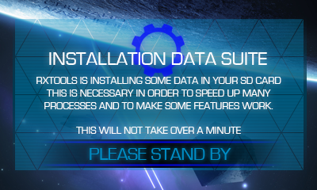

The menu
When you launch rxTools, it will automatically boot into rxMode. To show the menu, simply hold R while launching rxTools.

rxMode
This mode patches the signature checks, allowing you to launch unsigned software, and reboots to emuNAND or sysNAND.
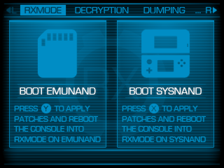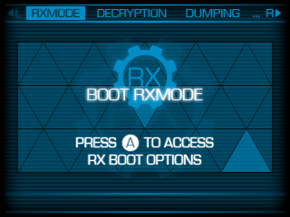

Decryption Options
Within this menu you can:
- Decrypt CTR Titles – Decrypt 3DS Titles directly on the console.
- Decrypt Title Keys – Decrypt the Title Keys stored in the tickets, which are needed to decrypt CDN content.
- Decrypt encTitleKeys – Decrypt the Private Key of a game.
- Generate XORpads – Generate the XORpads needed to decrypt/encrypt 3DS games.
- Decrypt Partitions – Dump and decrypt all the partitions stored in the sysNAND/emuNAND, except TWL ones.
- Generate FAT16 XORpads – Generate the XORpads needed to decrypt the NAND.
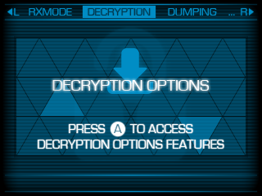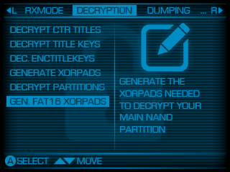
Dumping Options
Within this menu you can:
- Backup NAND – Backup the emuNAND or the sysNAND.
- Dump System Titles – Dump all the 3DS Titles stored on the sysNAND.
- Dump NAND Files – Dump various important files from the emuNAND/sysNAND.
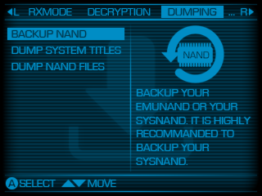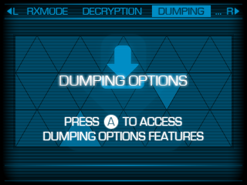

Injection Options
Within this menu you can:
- Inject emuNAND – Place and encrypt the partitions on the SD card in the SD card in the emuNAND, except TWL ones.
- Inject NAND Files – Inject various important files from the SD card to the emuNAND/sysNAND.
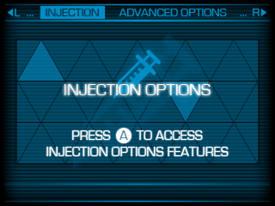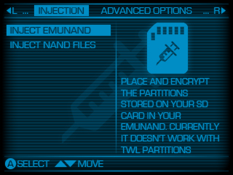

Advanced Options
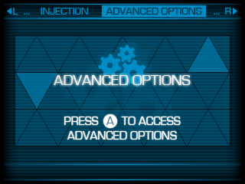

Settings
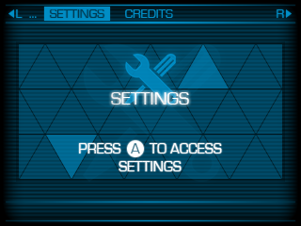

Credits
Shows the people who contributed to the development of rxTools.
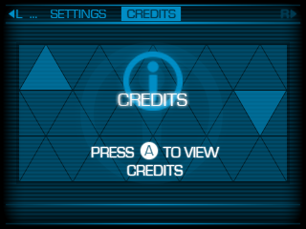

Windows: with suboptions installed. In case make.exe fails with stack trace dump, install GnuWin Make and place it in path before devkitPRO/msys/bin.
GNU/Linux: you can download a precompiled version here. Place it in any folder in your PATH, e.g. /bin, and make sure you set the executable bit.
MinGW with mingw32-base is fine.
Change this with the path where you have installed devkitPro.
On Windows, replace this with themetool.bat.
An Internet connection is recommended the first time.
On Windows, replace this with del.

