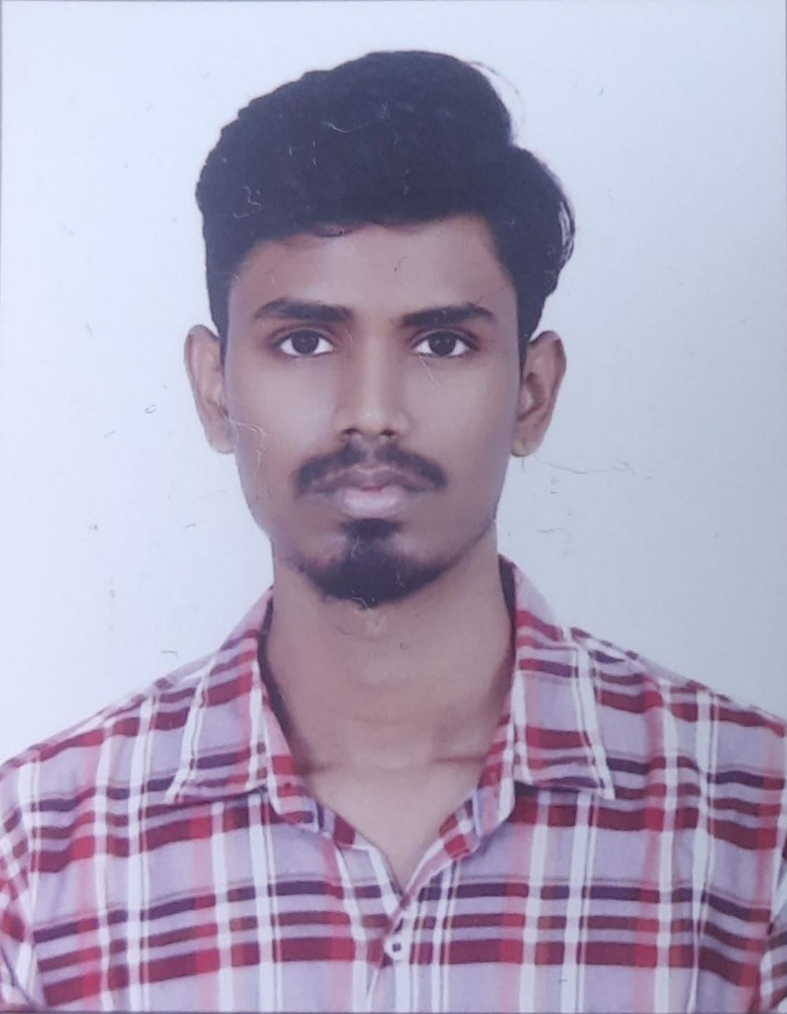  PROFILE  As an aspiring student, my programming skills are fueled by self motivation, sportsmanship. and insatiable curiosity These qualities drive me to constantly push myself and embrace challenges.  driven by enthusiasm and curiosity to learn the latest and contributing technologies of the present day evolution for providing solutions, services in the aspects of problems and requirements.  I will be honored to take part in software companies craft their products and services. Being part of your organization would not only allow me to contribute effectively but also support the companies mission in innovative and impactful ways.  Contact  PHONE:+91 9390563508  LINKEDIN: AbhinavBeetla  GitHub : My GitHub  EMAIL:Abhinavbeetla118@gmail.com  SKLLS  - C(programming for problem solving)  - C++ , JAVA and Python.  - SQL , PL/SQL , DBMS.  - Hands on Linux commands , Bash script.  - HTML, CSS, JavaScript .  - .MERN stack , Vue JS and Flask.  - Data Structures and Algorithms  Hobbies  - Playing regular Sports Cricket , Basketball , badminton etc..  - Spending quality time with friends and family. |  | EDUCATION AND TRAINING  Schooling( 2019)  SRI SAI SIDDHATHA TECHNO HIGH SCHOOL - Rajeev Nagar Srinagar colony. Hyderabad  - 9.7 CGPA (SSC of 10th)  - 3rd prize in primary school drawing contest Recipient.  - 1st prize in primary school running race  - Ranked in Top 5 of class  Intermediate MPC. 2021  Narayana Junior College CV Raman Campus - SR Nagar panjagutta.  - Mathematics , Physics and Chemistry.  - JEE : 74%ile  - EAMCET: 14,151 Rank  - IPE score:943/1000  Bachelor of Engineering Technology. Information Technology.  Expected in 2025  Mahatma Gandhi Institute Of Technology Gandlpet,Shankerpally,Hyderabad  - continuing education in Information Technology Branch  7. 17CGPA  - Completed coursework in programming for problem solving.  Computer Organization, C++ ,JAVA ,DBMS ,Operating System.  - Actively learning at present Java Script , CSS , MERN stack , Design and Analysis of Algorithms , Computer Networks  PERSONAL WORK EXPERIENCE  I, myself have been actively working on several projects since August of 2023 here:  JavaScript Project  Python Project  MERNSTACK project  Etc..  CERTIFICATION AND ACHIEVEMENTS  Several completion certificates and achievements are uploaded here :  Click here

