SCHUR_DECOMP PROJECT BRIEF
Methods, rationale, current outputs, and advisor discussion points
Project: schur_decomp
Prepared for: Advisor review
Prepared by: [Name]
Date: August 24, 2026
Primary matrix: matrices/mij_matrix.csv
Primary outputs: outputs/schur_modes, outputs/schur_mode_greedy_trees, outputs/network_linear_systems, outputs/inhibitory_schur_modulation

Executive Summary
The schur_decomp project analyzes a signed, directed hippocampal-entorhinal connectivity matrix as a linear dynamical system. Its central purpose is to move from a dense source-to-receiver connectivity table to interpretable modes, propagation routes, and candidate circuit mechanisms.
The project uses Schur decomposition because Schur vectors provide an orthonormal, numerically stable modal basis while the upper-triangular Schur matrix preserves directional coupling between modes. This makes it possible to study both what the dominant activity patterns are and how upstream modes drive downstream modes.
- The primary matrix contains 85 cell classes, 1,641 nonzero directed entries, and 22.7% density.
- The netlist labels 32 excitatory and 53 inhibitory cell classes across regions including CA1, CA3, DG, MEC, EC, CA2, LEC, and SUB.
- Major analysis branches include Schur/eigenmode characterization, signal propagation, self-connection comparison, greedy subnetwork reconstruction, linear systems metrics, and inhibitory Schur-complement modulation.
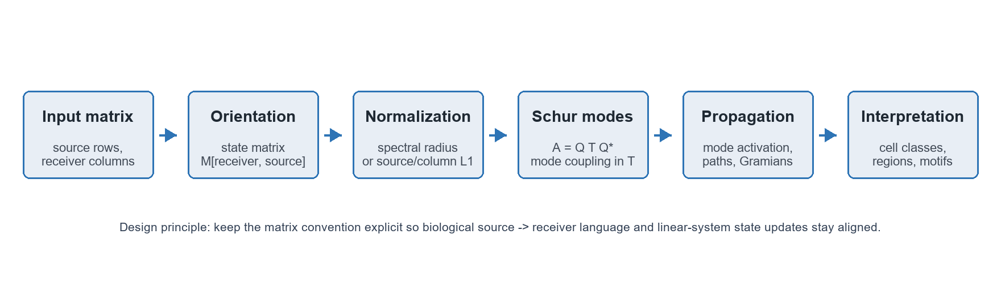
Figure 1. High-level workflow used throughout the schur_decomp project.

Project Structure
File or module | Role in the project
schur_analysis_utils_script.py | Core Schur/eigenmode utilities: matrix loading, normalization, Schur decomposition, mode summaries, E/I routing ratios, spectra, heatmaps, dominant-mode comparisons, and validation checks.
schur_signal_propagation_script.py | Prepares a Schur propagation model, creates initial activity signals, propagates cell-type and Schur-mode activations, summarizes mode and region loadings, and saves reusable Schur-mode outputs.
schur_mode_greedy_trees_script.py | Extracts the top cell-type contributors for each Schur mode and reconstructs compact source-to-receiver subnetworks using greedy directed trees.
network_linear_systems_tools_script.py | Provides path-power, controllability, Gramian, and frequency-response tools for asking how activity can move through the network as a linear system.
inhibitory_schur_modulation_script.py | Specialized branch for partitioning E/I blocks, Schur-eliminating inhibitory nodes, testing perturbations, motif enrichment, and disinhibitory path ranking.

Data and Matrix Convention
The raw M_ij CSV is a source-by-receiver table: rows are outgoing source cell classes and columns are receiver cell classes. Therefore, the analyses do transpose the input matrix before using it as a state-update operator. The state matrix is A = M_ij.T, so A[receiver, source] gives the effect of source j on receiver i in the column-vector update x[t + 1] = A x[t]. This is the convention used consistently in the Schur, propagation, path-power, linear-systems, and inhibitory-modulation analyses.
The primary Schur-mode and signal-propagation analyses use spectral-radius normalization. The raw oriented matrix is scaled by a single scalar so that the achieved spectral radius is 0.95; this keeps the discrete-time propagation stable while preserving the relative pattern of directed weights. The with-self matrix uses scale factor 3.624e-05, while the no-self matrix uses 6.403e-05 because removing diagonal/self entries lowers the raw spectral radius.
The matrix is strongly non-normal, meaning A A^T differs substantially from A^T A. This matters because non-normal systems can show large transient amplification and directional sensitivity even after spectral-radius scaling places the eigenvalues inside a stable radius. In the normalized project outputs, the with-self matrix has non-normality 5,869.9, and the no-self matrix has non-normality 18,319.8; removing self-connections therefore increases non-normality by about 3.1x.
Diagnostic | With self | No self | Interpretation
Input orientation | Raw rows = sources; raw columns = receivers; transposed to A[receiver, source] | Same orientation, with diagonal set to zero before scaling | The input needed to be transposed for the state-update analyses.
Raw spectral radius | 26,213.13 | 14,837.87 | The unscaled matrix is far outside the stable discrete-time range.
Scaling strategy | Spectral-radius scaling to 0.95 using scale factor 3.624e-05 | Spectral-radius scaling to 0.95 using scale factor 6.403e-05 | Scaling keeps eigenvalue magnitude comparable across variants.
Normalized non-normality | 5,869.9 | 18,319.8 | The no-self variant is about 3.1x more non-normal after scaling.
Raw non-normality | 4.469e12 | 4.469e12 | The original weighted matrix is highly non-normal before normalization.

Dataset fact | Value
Cell classes | 85
Nonzero directed weights | 1,641
Matrix density | 22.7%
Excitatory classes | 32
Inhibitory classes | 53
Largest region counts | CA1: 28, CA3: 14, DG: 14, MEC: 11, EC: 9

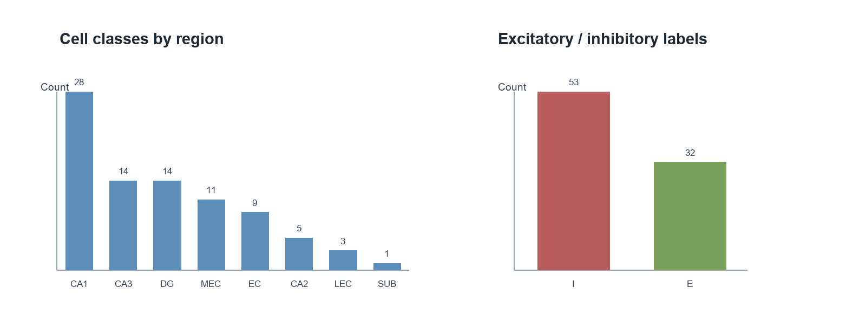
Figure 2. Composition of the primary connectivity matrix by region and E/I label.

Methods Used and Why
Method | What was done | Why it was used | Notebook / section
Orientation correction | The raw source-row matrix is transposed into M[receiver, source]. | This aligns biological source -> receiver language with the standard linear update x[t + 1] = M x[t]. | 01_schur_eigenmodes.ipynb: Section 2, Matrix Orientation and Normalization; 09_linear_systems.ipynb: Section 2, Load Matrix and Unmask the Orientation Step; 07_inhibitory_modulation.ipynb: Load, orient, and normalize.
Spectral-radius normalization | Most analyses scale the matrix to a target spectral radius, commonly 0.95. | This prevents trivial blow-up in discrete propagation and allows comparisons across with-self and no-self variants. | 01_schur_eigenmodes.ipynb: Section 2, Matrix Orientation and Normalization; 02_schur_eigenmodes_compare.ipynb: Run the matched comparison; 03_schur_signal.ipynb: Prepare all Schur modes; 10_linear_systems_compare.ipynb: Run the matched comparison.
Schur decomposition | The project computes A = Q T Q* in complex or real Schur form. | Schur vectors are orthonormal and numerically stable; T preserves upper-triangular mode-to-mode coupling. | 01_schur_eigenmodes.ipynb: Section 3, Schur Decomposition, and Schur Decomposition: Upper-Triangular Coupling Map; 03_schur_signal.ipynb: Prepare all Schur modes.
Eigenvalue and dominant-mode analysis | Eigenvalues, dominant eigenvectors, and Schur-vector loadings are ranked and summarized by cell type and region. | Eigenvalues describe growth/decay and oscillation, while loadings connect abstract modes back to biological cell classes. | 01_schur_eigenmodes.ipynb: Section 4, Visualizing the Eigenvalue Spectrum, and Section 6, Dominant Eigenvalue and True Dominant Eigenvector; 02_schur_eigenmodes_compare.ipynb: Eigenvalue spectra.
Left-action/readout analysis | Several notebooks distinguish Schur vectors from true eigenvectors and left eigenvector action/readout directions. | This avoids overinterpreting Schur vectors as eigenvectors and improves interpretation of mode sensitivity. | 01_schur_eigenmodes.ipynb: Section 6, Dominant Eigenvalue and True Dominant Eigenvector; Section 8, Manual Coupling Trace; archive/eigenmode_analysis_mij_schur_corrected_left_action.ipynb for the earlier left-action-focused version.
E/I routing ratios and regimes | Active edges within high-loading mode contributors are classified by E/E, E/I, I/E, and I/I routing. | The goal is to describe whether a mode behaves like excitatory recurrence, inhibitory feedback, disinhibition, or mixed routing. | schur_analysis_utils_script.py: build_mode_routing_table and compute_ei_routing_ratios; archive/eigenmode_analysis_mij_schur.ipynb: Section 6, E/I Routing Ratios Across Schur Modes; 07_inhibitory_modulation.ipynb for explicit E/I block analysis.
Signal propagation in Schur coordinates | Initial activity in selected cell classes is mapped into Schur coordinates and advanced by T. | This shows how a perturbation spreads through the modal coupling hierarchy rather than only through raw edges. | 03_schur_signal.ipynb: Prepare all Schur modes, Propagate every mode, Inspect one cascade mode, and Compare cascade propagation with the isolated mode; 04_schur_signal_compare.ipynb: Run all-mode propagation.
Path-power analysis | The project computes M^k and cumulative weighted path matrices. | Powers of M aggregate all length-k walks from source to receiver, revealing indirect propagation channels. | 09_linear_systems.ipynb: Part I, Structural Path Analysis: Matrix Power Series; Section 4, Enumerate Top Paths at Each Length; Section 5, Cumulative Path Reachability.
Controllability and frequency response | Discrete Gramians, continuous-time shifted systems, and transfer-function gains are computed. | These methods ask which nodes are influential drivers and which frequencies produce large network responses. | 09_linear_systems.ipynb: Part II, Controllability Gramian Analysis, and Part III, Frequency Response; 10_linear_systems_compare.ipynb: Path and controllability rankings and Frequency-response curves.
Greedy mode trees | Top contributors to each Schur mode are reduced to compact source-to-receiver trees. | This turns dense modal loadings into inspectable candidate subnetworks for advisor discussion. | 05_schur_greedy_trees.ipynb: Build the top-7 subnetworks and greedy trees, Print every mode's greedy information-flow tree, Inspect one mode interactively; 06_schur_mode_case_studies.ipynb: Merge propagation and greedy-tree views.
Inhibitory Schur complement | The inhibitory block is eliminated to form an effective excitatory matrix. | This separates direct excitatory recurrence from inhibitory feedback and chained disinhibitory effects. | 07_inhibitory_modulation.ipynb: Perturbation, Schur complement, Motif enrichment and stability, Neumann series, and E-I-E/E-I-I-E configuration sections; 08_inhibitory_compare.ipynb: Core inhibitory results and Motifs and disinhibitory chains.

Current Outputs and Interpretation

Schur modes
The saved Schur archive contains 85 modes from the normalized state matrix. The output tables summarize each mode by eigenvalue, dominant region, dominant cell type, loading magnitude, and the number of high-loading excitatory/inhibitory contributors.
Mode | |lambda| | Dominant cell type | Region | E/I | Tree edges
0 | 0.950 | MEC LIII Superficial Multipolar Interneuron | MEC | I | 5
1 | 0.370 | MEC LIII Superficial Multipolar Interneuron | MEC | I | 4
2 | 0.311 | DG AIPRIM | DG | I | 4
3 | 0.311 | CA1 Trilaminar | CA1 | I | 6
4 | 0.310 | DG HICAP | DG | I | 5
5 | 0.182 | CA1 Perforant Path Associated | CA1 | I | 4

A recurring pattern in the saved summaries is that many high-loading modes are dominated by CA1 and inhibitory cell classes. That does not mean the network is purely inhibitory; rather, inhibitory classes often have large modal participation in the normalized dynamics.

Eigenmodes and left/right eigenvectors
Yes: the project does include notebooks that look directly at eigenmodes and at the distinction between Schur vectors, right eigenvectors, and left eigenvectors. The core notebook treats Schur vectors as stable orthonormal modal coordinates, then computes true eigenvectors separately when the question is about a genuine eigenmode of the state matrix.
For interpretation, the right eigenvector is the state-space activity pattern associated with an eigenvalue, while the left eigenvector is the action/readout direction that measures sensitivity or projection onto that mode. This distinction is important because non-normal matrices can have strongly different right and left modal structure; relying only on right eigenvectors or only on Schur-vector loadings can miss how a perturbation is read out by the system.
Notebook | Relevant section(s) | What to look for
01_schur_eigenmodes.ipynb | Section 3, Schur Decomposition; Section 4, Visualizing the Eigenvalue Spectrum; Section 6, Dominant Eigenvalue and True Dominant Eigenvector; Section 8, Manual Coupling Trace | Defines Schur vectors vs. true eigenvectors, plots eigenvalues, computes the dominant eigenvalue/eigenvector, and uses left-vector/action labels in coupling traces.
02_schur_eigenmodes_compare.ipynb | Run the matched comparison; Eigenvalue spectra; Upstream-mode summaries | Repeats the eigenmode/Schur analysis for with-self and no-self variants and reports dominant eigenvector overlap.
individual_analyses/070826_mij_schur_wself.ipynb and 070826_mij_schur_noself.ipynb | Section 6, Dominant Eigenvalue and True Dominant Eigenvector; Section 8, Manual Coupling Trace | Earlier single-condition notebooks for checking the with-self and no-self eigenmode interpretations independently.
archive/eigenmode_analysis_mij_schur_corrected_left_action.ipynb | Dominant Eigenvalue and True Dominant Eigenvector; Manual Coupling Trace | Prior corrected left-action version; useful if you want to trace how the left-vector/action interpretation evolved.

Self-connection comparison
Variant | Raw spectral radius | Achieved radius | Frobenius norm | Non-normality
with_self | 26,213.1 | 0.95 | 77.2 | 5,869.9
no_self | 14,837.9 | 0.95 | 136.3 | 18,319.8

The no-self variant reaches the same target spectral radius but has larger Frobenius norm and substantially higher non-normality. This matters because non-normal matrices can show strong transient amplification even when eigenvalues are kept inside a stable radius.
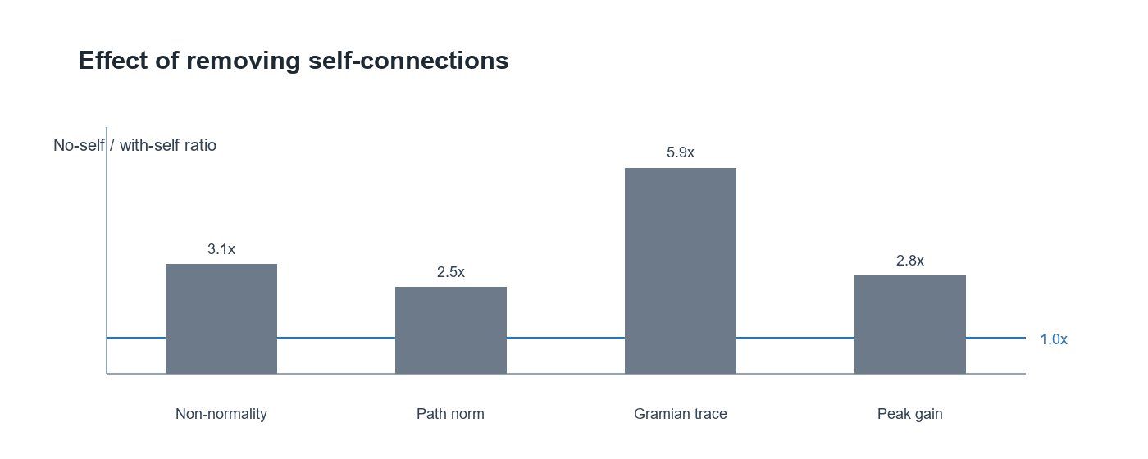
Figure 3. No-self to with-self ratios for selected linear-systems summaries.

Linear systems branch
Variant | Cumulative path norm | Gramian trace | Gramian condition | Peak gain
with_self | 132.0 | 9,546.6 | 5,767.2 | 69.4
no_self | 323.9 | 56,245.6 | 42,740.4 | 193.4

The linear-systems outputs suggest that removing self-connections increases indirect path strength, controllability energy, and low-frequency gain. This makes the self/no-self comparison a genuine modeling decision rather than a cosmetic preprocessing step.

Inhibitory modulation branch
Variant | Effective E radius | Feedback radius | Selected I-I order | alpha rho(M_II)
with_self | 1.000 | 0.116 | 2 | 0.155
no_self | 1.000 | 0.365 | 1 | 0.116

The inhibitory branch should be presented as a focused extension of the main Schur project. It uses the same state convention but partitions the matrix into E and I blocks, then asks how inhibitory feedback reshapes effective excitatory dynamics.

Interpretive Value for Advisor Discussion
- The project provides a consistent mathematical convention for a biologically directed matrix, reducing ambiguity about source and receiver roles.
- Schur decomposition gives a stable modal coordinate system that supports both eigenvalue interpretation and directed mode-coupling traces.
- Self/no-self comparisons show that diagonal entries materially affect spectral scale, non-normality, and propagation strength.
- Greedy trees and top-contributor tables translate high-dimensional modes into cell-class hypotheses that can be checked against neuroanatomy.
- The inhibitory Schur-complement branch connects broad linear algebra results to mechanistic questions about feedback and disinhibition.

Limitations
- The model is linear and static; it does not include spiking dynamics, nonlinear activation, synaptic delays, or state-dependent gain changes.
- Some E/I labels are inferred by string patterns or netlist metadata, so final biological claims should verify labels against the source dataset.
- Schur vectors are orthonormal modal coordinates, not ordinary eigenvectors; interpretation should preserve that distinction.
- Spectral-radius normalization is useful for comparison and stability, but normalized values should not be read as direct physiological magnitudes.
- Greedy trees are interpretive summaries of high-loading subnetworks, not guaranteed optimal circuit reconstructions.

Recommended Next Steps
- Choose a primary matrix convention and include a short convention statement in every notebook and figure caption.
- Decide whether the advisor-facing analysis should prioritize with-self, no-self, or a formal side-by-side treatment.
- Validate the top Schur-mode and greedy-tree cell classes against known hippocampal-entorhinal pathways.
- Add a constrained null model for motif and path analyses that preserves region and E/I block structure.
- Package the most important outputs into a compact figure panel: spectrum, Schur T heatmap, mode contributors, self/no-self comparison, and inhibitory feedback summary.

Source Files Used
- eigenmode_analysis_mij_schur_corrected_left_action.ipynb and related notebooks: exploratory analysis and interpretive notes.
- schur_analysis_utils_script.py: reusable Schur decomposition and modal interpretation functions.
- schur_signal_propagation_script.py: propagation and saved Schur-mode outputs.
- schur_mode_greedy_trees_script.py: mode contributor subnetworks and greedy tree summaries.
- network_linear_systems_tools_script.py: path powers, controllability, and frequency-response summaries.
- inhibitory_schur_modulation_script.py: E/I block analysis and inhibitory Schur-complement branch.
- outputs/schur_modes, outputs/schur_mode_greedy_trees, outputs/network_linear_systems, and outputs/inhibitory_schur_modulation: generated result tables used in this brief.

