INHIBITORY MODULATION VIA SCHUR COMPLEMENT ANALYSIS
Project brief for advisor review
Project: inhib_modulation / inhibitory_schur_modulation
Prepared for: Advisor review
Prepared by: [Name]
Date: August 24, 2026
Primary data: matrices/mij_matrix.csv and matrices/mij_netlist.csv
Analysis outputs: outputs/inhibitory_schur_modulation

Executive Summary
This project asks how inhibitory circuitry modulates the stability and propagation structure of a signed, directed, weighted hippocampal connectivity matrix. The analysis treats the network as a discrete linear system, partitions neurons into excitatory and inhibitory populations, and uses Schur complement reduction to express the effective excitatory dynamics after mathematically eliminating inhibitory nodes.
The main result is that direct excitatory recurrence is the dominant source of growth in the linearized network, while inhibitory routing acts as a stabilizing and modulatory interface. In both self-connection and no-self variants, removing the E-to-E block strongly decreases the dominant real eigenvalue. Removing the E/I interface instead increases the dominant real eigenvalue, consistent with inhibitory feedback suppressing or shaping the excitatory mode.
- The matrix contains 85 cell classes, with 32 excitatory and 53 inhibitory classes.
- The current matrix has 1,641 nonzero directed weights, for 22.7% density.
- The analysis compares with-self and no-self variants so diagonal/self effects do not drive the interpretation.

Project Purpose
The scientific goal is to identify which inhibitory motifs and cell classes regulate the dominant network mode, rather than simply ranking strong synaptic weights. The project therefore combines spectral stability diagnostics with explicit circuit motifs. The result is a bridge between linear systems analysis and biologically interpretable inhibitory pathways.
In practical terms, the project produces a reusable workflow for asking whether candidate inhibitory routes behave as stabilizing feedback, disinhibitory relays, or minor local structure. The output tables identify both broad circuit blocks and specific candidate cell classes for follow-up inspection.

Data Representation
The raw CSV stores rows as sources and columns as receivers. The analysis transposes this table into the state convention M[receiver, source], so the linear update is x[t + 1] = M x[t]. Under this convention, each column is an outgoing source channel and each row is an incoming receiver channel.
E/I labels are recovered from the netlist metadata. If metadata are missing, the code can infer labels from the sign pattern of each source row; this is a fallback, not the preferred path. Blocks are named source-to-receiver: EE, EI, IE, and II.
Block | Meaning | Why it matters
EE | Excitatory source -> excitatory receiver | Direct recurrent excitation and principal amplification route.
EI | Excitatory source -> inhibitory receiver | Recruitment of inhibitory cells by excitatory activity.
IE | Inhibitory source -> excitatory receiver | Feedback from inhibitory cells onto excitatory cells.
II | Inhibitory source -> inhibitory receiver | Internal inhibitory chaining that enables disinhibition.

Methods and Rationale
Method | What was done | Why this method was used
Matrix normalization | Each variant is independently spectral-radius normalized. | This makes with-self and no-self variants comparable by putting them on the same stability scale before perturbation and resolvent calculations.
Dominant eigenvalue diagnostics | The spectral radius and dominant real eigenvalue summarize whether a block increases or suppresses growth in the linearized dynamics. | The dominant mode is the cleanest first-order summary of network stability and amplification.
Block-removal perturbation | Each E/I block is zeroed and the exact dominant eigenvalue shift is compared with a first-order eigenvalue estimate. | This turns broad connectivity classes into causal perturbation tests rather than descriptive counts.
Schur complement reduction | Inhibitory nodes are eliminated to form M_eff_E(z) = M_EE + M_EI (zI - M_II)^-1 M_IE. | This separates direct E-to-E dynamics from inhibitory feedback, while retaining all chained I-to-I paths through the resolvent.
Population excitation response | The response (I - alpha M)^-1 u is computed after exciting all E or all I nodes. | This identifies high-response cell classes and candidate disinhibitory effects under stable propagation.
Motif enrichment and stability | Observed motifs are compared against weight-shuffled nulls, then motif edge sets are removed to test stability effects. | Enrichment alone can be misleading; the stability test asks whether enriched motifs matter dynamically.
Neumann model selection | The inhibitory feedback term is expanded by I-I chain order. | This estimates how many chained inhibitory links are needed before higher-order disinhibitory terms become negligible.
Path and source ranking | Strong E-I-E and E-I-I-E configurations and high-scoring inhibitory cells are enumerated. | This translates matrix-level effects into cell-class hypotheses for advisor discussion and biological follow-up.

Current Findings

1. Excitatory recurrence dominates the growth mode
Variant | Removed block | Delta dominant real | Delta spectral radius
with_self | EE | -0.926 | -0.633
with_self | EI | +0.042 | +0.042
with_self | IE | +0.042 | +0.042
with_self | II | -0.007 | -0.007
no_self | EE | -0.883 | -0.354
no_self | EI | +0.172 | +0.172
no_self | IE | +0.172 | +0.172
no_self | II | -0.014 | -0.014

The negative EE-removal shift shows that direct excitatory recurrence is the principal contributor to the normalized dominant mode. By contrast, removing EI or IE increases the dominant real eigenvalue, which indicates that the recruited inhibitory interface was suppressing the dominant growth direction.
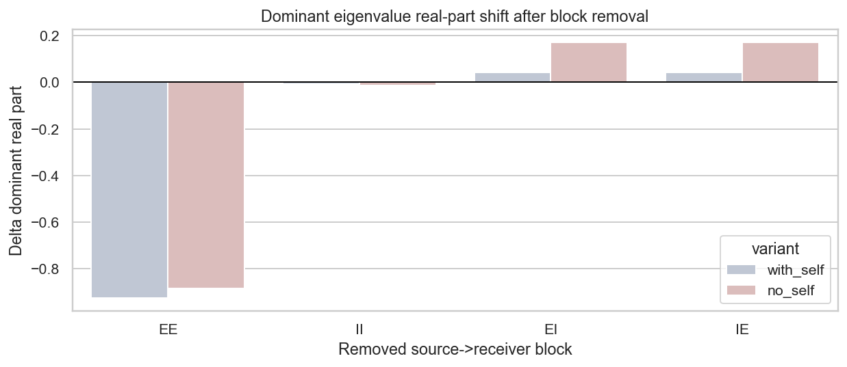
Figure 1. Dominant real eigenvalue shift after removing each E/I block.

2. Schur reduction isolates inhibitory feedback from direct E dynamics
Variant | Component | Spectral radius | Dominant real | rho(M_II / z)
with_self | M_EE | 1.042 | 1.042 | 0.182
with_self | inhibitory_feedback | 0.116 | 0.006 | 0.182
with_self | M_eff_E | 1.000 | 1.000 | 0.182
no_self | M_EE | 1.172 | 1.172 | 0.137
no_self | inhibitory_feedback | 0.365 | 0.018 | 0.137
no_self | M_eff_E | 1.000 | 1.000 | 0.137

The Schur complement keeps the effective excitatory mode at the normalized scale while exposing that the inhibitory feedback component itself has much smaller spectral radius than direct E-to-E recurrence. This supports the interpretation that inhibition is not the primary amplifier but a structured feedback channel.
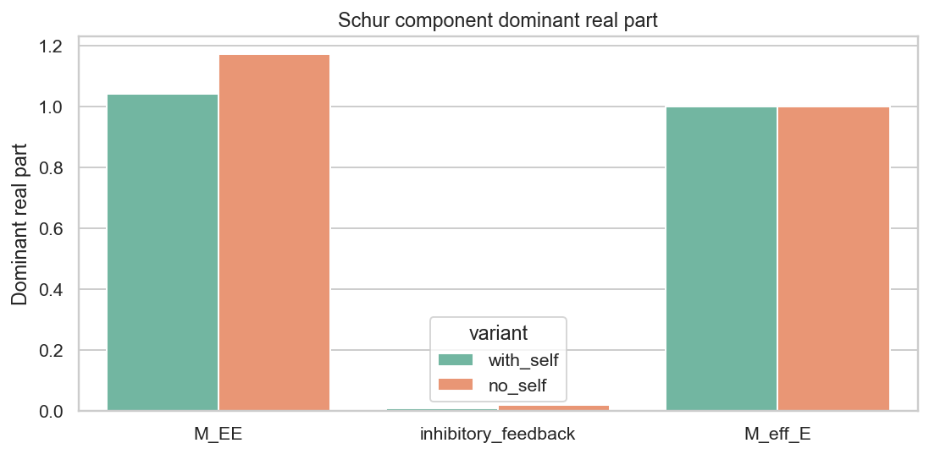
Figure 2. Spectral summaries for direct E dynamics, inhibitory feedback, and effective E dynamics.

3. Disinhibitory motifs are strongly enriched
Variant | Motif | Observed count | Null z-score | Empirical p >= observed
with_self | E_to_I_to_I_to_E_loop | 12,468 | 56.2 | 0.0040
with_self | disinhibitory_I_to_I_to_E | 1,956 | 29.4 | 0.0040
no_self | E_to_I_to_I_to_E_loop | 11,255 | 54.4 | 0.0040
no_self | disinhibitory_I_to_I_to_E | 1,805 | 29.2 | 0.0040

The E-I-I-E motif and related I-to-I-to-E disinhibitory structure are far above shuffled-weight null expectations. This indicates that the signed placement of inhibitory edges is nonrandom with respect to disinhibitory routes.
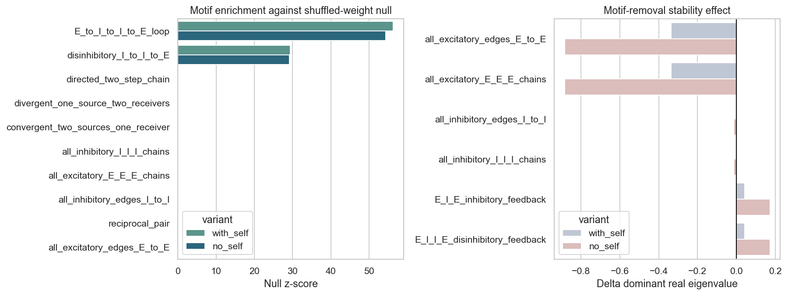
Figure 3. Motif enrichment and dominant-eigenvalue stability effects by variant.

4. Chained inhibitory effects appear short-range
Variant | Selected I-I chain order | alpha rho(M_II)
with_self | 2 | 0.155
no_self | 1 | 0.116

The selected Neumann order is 2 with self-connections and 1 without self-connections. This suggests that the most relevant inhibitory contribution is local to short I-I chains rather than very deep inhibitory walks.
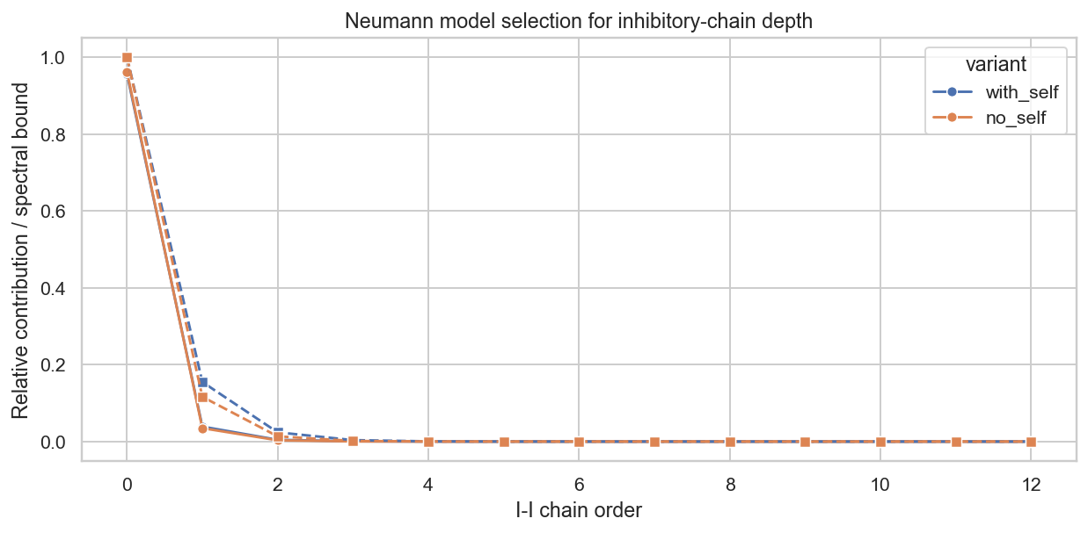
Figure 4. Neumann contribution by I-I chain order.

Candidate Follow-Up Targets
Variant | Candidate inhibitory cell class | Score | I-I order
with_self | CA1 Perforant Path Associated | 2.758 | 2
with_self | MEC LIII Superficial Multipolar Interneuron | 1.542 | 2
with_self | DG AIPRIM | 0.489 | 2
with_self | CA1 Basket CCK+ | 0.222 | 2
with_self | CA1 Back Projection | 0.178 | 2
no_self | CA1 Perforant Path Associated | 10.264 | 1
no_self | MEC LIII Superficial Multipolar Interneuron | 5.142 | 1
no_self | DG AIPRIM | 2.209 | 1
no_self | CA1 Basket CCK+ | 1.032 | 1
no_self | CA1 Back Projection | 0.860 | 1

These rankings should be treated as hypotheses, not final biological claims. They combine I-to-E strength, E-to-I recruitment, and participation in the selected I-I chain order. The next advisor-facing step would be to inspect whether the top-ranked cell classes are anatomically plausible relays in the hippocampal circuit.
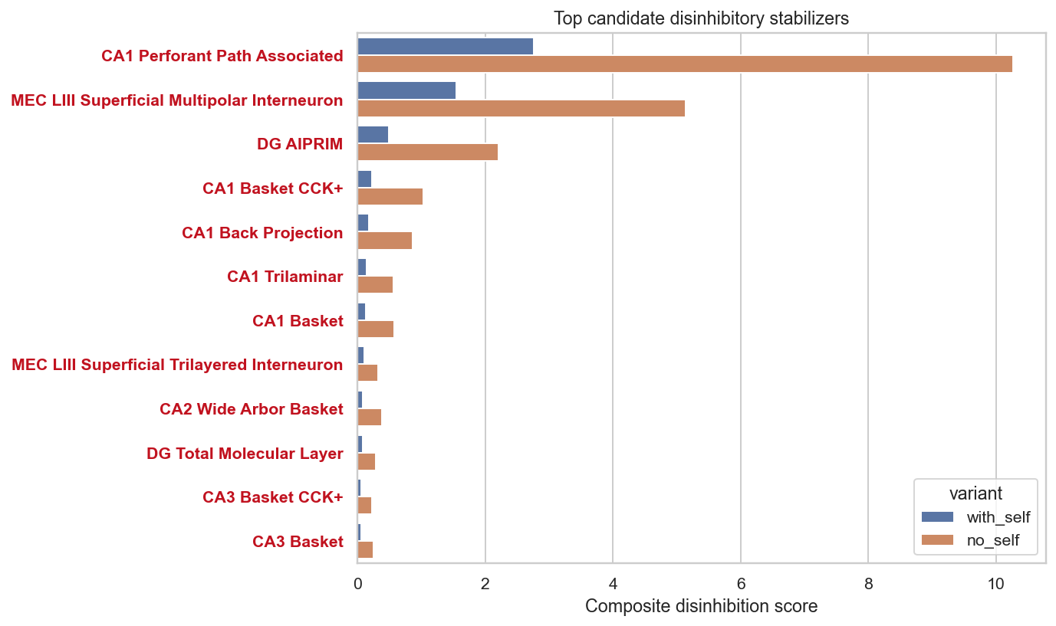
Figure 5. Highest-ranked candidate inhibitory sources by variant.

Limitations
- The analysis is linear and static; it does not yet include spiking nonlinearities, synaptic delays, saturation, or time-varying state dependence.
- The shuffled null preserves the nonzero support and global weight distribution but does not preserve every biological constraint, such as region-level connection rules.
- Current path products are useful for ranking candidate motifs, but they should be checked against anatomical directionality and biological plausibility.
- Normalization enables comparison across variants, but absolute scale should not be interpreted as an uncalibrated physiological gain.

Recommended Next Steps
- Validate the top disinhibitory cell classes with region-level metadata and known hippocampal pathway constraints.
- Repeat the null model with stricter constraints, such as preserving source/receiver E-I block membership or degree/strength by cell class.
- Use perturbation sensitivity on individual high-ranking cell classes, not only broad blocks and motif edge sets.
- Compare the Schur-derived effective E matrix with simulation-based responses from a nonlinear or spiking network model.
- Prepare a short figure panel for advisor discussion: block-removal effect, Schur summary, motif enrichment/stability, and top disinhibitory sources.

Source Files Used
- inhibitory_schur_modulation.ipynb: narrative notebook and saved analysis sections.
- inhibitory_schur_modulation_script.py: reusable Python implementation of the methods.
- matrices/mij_matrix.csv and matrices/mij_netlist.csv: connectivity weights and E/I metadata.
- outputs/inhibitory_schur_modulation: generated tables and figures included in this brief.

